INTEGRATED PROJECT REPORT

ON

CHATBOT FOR HEALTHCARE SYSTEM USING ARTIFICIAL INTELLIGENCE-WELLNESS WHIZ

Submitted in partial fulfilment of the requirements

For the award of the degree of

**BACHELOR OF TECHNOLOGY**

**IN**

**ARTIFICIAL INTELLIGENCE & DATA SCIENCE**

Submitted By

Lakshay Wadhwani Kushal Gupta

(00215611921) (01715611921)

Siddharth Sharma Akshat Kumar

(01915611921) (02515611921)

Under the guidance of

Dr. Archana Kumar, HOD, AI&DS Department



Department of Artificial Intelligence & Data Science

Dr. AKHILESH DAS GUPTA INSTITUTE OF

TECHNOLOGY & MANAGEMENT

(A Unit of BBD Group)

Approved by AICTE and Affiliated with GGSIP University

FC-26, Shastri Park, New Delhi-110 053

**DECLARATION**

It is hereby certified that the work is being presented in the B. Tech Integrated Project Report entitled **"WELLNESS-WHIZ"** in partial fulfillment of the requirements for the award of the degree **of Bachelor of Technology and submitted in the Department of Artificial Intelligence & Data Science of Dr. Akhilesh Das Gupta Institute of Technology and Management, New Delhi (Affiliated to Guru Gobind Singh Indraprastha University, Delhi)** is an authentic record of our own work carried out under the guidance of **Mrs. Archana Kumar**, Professor. We hereby declare that this submission is our own work and that, to the best of our knowledge and belief, it contains no material previously published or written by another person nor material which to a substantial extent has been accepted for the award of any other degree of the university or other institute of higher learning, except where due acknowledgment has been made in the text.

Signature:

Name:

Roll no.:

Date:

Signature:

Name:

Roll no.:

Date:

Signature:

Name:

Roll no.:

Date:

Signature:

Name:

Roll no.:

Date:

**CERTIFICATE**

This is to certify that Project Report entitled” CHATBOT **FOR HEALTHCARE SYSTEM USING ARTIFICIAL INTELLIGENCE- WELLNESSWHIZ**” which is submitted by in partial fulfilment of the requirement for the award of degree B. Tech. in Department of Artificial Intelligence & Data Science of **Dr. Akhilesh Das Gupta Institute of Technology & Management (ADGITM)** formerly known as Northern India Engineering College (NIEC), New Delhi, is a record of the candidate own work carried out by him under my supervision.

The matter embodied in this thesis is original and has not been submitted for the award of any other degree.

**Date: Supervisor:**

**ACKNOWLDGEMENT**

It gives us great pleasure to present the report of the B. Tech Project undertaken during B. Tech. Final Year. We owe special debt of gratitude to **Dr. Archana Kumar** for her constant support and guidance throughout the course of our work. Her sincerity, thoroughness and perseverance have been a constant source of inspiration for us. It is only through her cognizant efforts that our endeavours have seen light of the day.

We also take the opportunity to acknowledge the _________________________________________________contribution of for his/her full support and assistance during the development of the project.

We also do not like to miss the opportunity to acknowledge the contribution of all faculty members of the department for their kind assistance and cooperation during the development of our project. Last but not the least, we acknowledge our friends for their contribution in the completion of the project.

Signature:

Name:

Roll no.:

Date:

Signature:

Name:

Roll no.:

Date:

Signature:

Name:

Roll no.:

Date:

Signature:

Name:

Roll no.:

Date:

**ABSTRACT**

*Accessing healthcare services for every health concern can be challenging and costly. This project focuses on the development and implementation of a healthcare chatbot system called WellnessWhiz. As a healthcare chatbot, WellnessWhiz utilizes a transformer model, particularly the LLaMA LLM with Instruction-Prompt-Tuning, to provide personalized assistance and accurate information to users. Using a structured framework of instructions, the chatbot ensures consistent and relevant responses, emulating the behaviour of a medical chatbot. Notable features of WellnessWhiz include personalized assistance, comprehensive healthcare information, appointment scheduling, medication reminders, and guidance on maintaining a healthy lifestyle. By leveraging the capabilities of Hugging Face's Hugging Chat API for inference and the Flask framework for seamless communication, WellnessWhiz offers round-the-clock availability, effectively addressing users' healthcare queries and concerns. Evaluation results showcase the benefits of Instruction-Prompt-Tuning as an efficient approach to achieving the desired chatbot behaviour without fine tuning.*

**TABLE OF CONTENTS**

**PAGE**

DECLARATION……………………………………………………… 2

CERTIFICATE…………………………………………………….….. 3

ACKNOWLEDGMENTS…………………………………….............. 4

ABSTRACT…………………………………………………………… 5

LIST OF TABLES…………………………………………………….. 10

LIST OF FIGURES…………………………………………………… 11

LIST OF ABBREVIATIONS…………………………………………. 12

**CHAPTER 1 INTRODUCTION……………………………….. 13-15**

* 1. Introduction…………………………………………………….. 13
  2. Motivation ……………………………………………………... 14
  3. Objectives …………………………………………………….... 15

**CHAPTER 2 CHATBOTS……………………………………… 16-20**

2.1 What are chatbots………………………………………………. 16

2.2 Type of chatbots………………………………………………… 17

2.3 History of chatbots……………………………………………... 20

**CHAPTER 3 HEALTHCARE AND TECHNOLOGY…………..21-27**

3.1 AI in healthcare………………………………………………………

3.1.1 Machine Learning in Healthcare……………………………

3.1.2 Natural Language processing

3.2 Chatbots in Healthcare

3.2.1 Advantages of chatbots in Healthcare

**CHAPTER 4 MACHINE LEARNING & DEEP LEARNING........28-33**

4.1 Machine Learning………………………...………………

4.1.1 How does Machine Learning Work?.........................

4.2 Types of Machine Learning………………………………

4.2.1 Supervised Learning………………………………..

4.2.2 Unsupervised Learning……………………………..

4.2.3 Semi-supervised Learning………………………….

4.2.4 Reinforcement Learning……………………………

4.3 Deep Learning……………………………………………

4.3.1 Convolutional Neural Networks ……………….…..

4.3.1.1 Architecture…………………………….……

4.3.1.2 Convolutional Neural Network Working…….

4.3.2 ResNet ……………………………………………..

4.3.3 Transfer Learning………………………………….

5.1 Python (Programming Language)………………...............

5.2 Machine Learning………………………………………...

5.2.1 Convolutional Neural Networks……………………

5.2.2 ResNet………………………………………………

5.2.3 Transfer Learning………………………………...…

5.3 Libraries used……………………………………………..

5.3.1 NumPy………………………………………………

5.3.2 Pandas………………

5.3.3 TensorFlow……………………………………….…

5.3.4 Keras…………………………………………….…..

5.3.5 OpenCV……………………………………………..

5.3.6 H5PY………………………………………………..

5.3.7 Pillow……………………………………………….

5.3.8 gevent……………………………………………….

5.4 Flask………………………………………………………

5.4.1 Features……………………………………………..

5.4.2 Components………………………………………...

5.4.3 Werkzeug…………………………………………...

5.5 Software Required………………………………………...

5.5.1 Jupyter Notebook or Google Colaboratory…………

5.5.2 PyCharm…………………………………………….

5.6 Operating System……………………………………

5.6.1 Windows…………………………………………….

5.6.2 macOS………………………………………………

**CHAPTER 6 STRUCTURE OF PROJECT………………………….34-38**

6.1 Introduction

6.2 System Architecture

6.2.1 User interface layer

6.2.2 Chatbot Engine layer

6.2.3 backend services layer

6.3 Database Management

6.3.1 Database types and selection

6.3.2 Data storage and retrieval

6.3.3 Data security and privacy

6.3.4 Scalability and performance

6.3.5 Compliance and auditability

6.4 Development methodology

6.4.1 Requirements gathering and analysis

6.4.2 Systems designs

6.4.3 Implementations and testing

6.4.4 Iterative development and user feedback

6.4.5 Refinement and continuous improvements

6.5 Summary

**CHAPTER 7 TESTING AND TUNING……………………………39-46**

7.1 Testing strategies

7.1.1 Functional testing

7.1.2 Integration testing

7.1.3 performance testing

7.1.4 Usability testing

7.1.5 Security testing

7.2 Tuning and Optimization

7.2.1 Instruction prompt tuning

7.2.2 Performance Optimization

7.3 Summary

**CHAPTER 8 MODELS USED……………………………………47-50**

8.1 LLAMA model

8.1.1 Architecture and training

8.1.2 Applications

8.2 Hugging Face

**CHAPTER 9 FUTURE AND BUISNESS MODEL………………..51-53**

9.1 Future scope

9.2 Business Model

**CHAPTER 10 CONCLUSION………………………………………..57**

**LIST OF TABLES**

Table 3.2 Market size of chatbots in AI in diff. regions

**LIST OF FIGURES**

Figure 2.1: Example of a chatbot

Figure 2.2 Types of chatbots

Figure 2.3 Some famous AI chatbots

Figure 3.2 Market size of chatbots in healthcare

Figure 4.1 types of machine learning

Figure 4.1.1 Working of machine learning

Figure 4.2.1 what is Supervised learning

Figure 4.2.2 what is Unsupervised learning

Figure 4.2.3 what is Semi supervised learning

Figure 4.2.4 what is Reinforcement learning

Figure 4.2.3 what is Deep learning

Figure 4.3.1 how CNN works

Figure 4.3.3 What is Transfer learning

Figure 4.3.3.3 Strategies of transfer learning

Figure 5.1 Features of python

Figure 5.2.1 Machine learning tools

Figure 5.3 Libraries in python

Figure 5.5 Software required

Figure 6.2 Chatbot demonstration

Figure 6.3.2 Screenshot of interface

Figure 6.5.2 Screenshot of interface-II

Figure 8.1 LLAMA model

Figure 8.2 Hugging chat API

**LIST OF ABBREVIATIONS**

LLaMA -Large Language Model Meta AI

API: Application programming interface

**CHAPTER 1**

**INTRODUCTION**

* 1. **INTRODUCTION**

In recent years, there has been a growing interest in leveraging artificial intelligence (AI) to enhance healthcare services. One remarkable application in this domain is the development of healthcare chatbot systems. These intelligent conversational agents have the potential to provide personalized assistance, offer relevant information, and improve healthcare accessibility for users.

This project introduces Wellness Whiz, a healthcare chatbot designed to cater to users' healthcare needs and concerns. Leveraging advanced AI techniques, Wellness Whiz utilizes a transformer model based on Meta's LLaMA LLM with Instruction-Prompt Tuning.

This approach allows the chatbot to follow a structured framework of instructions, ensuring consistent and contextually appropriate responses. Wellness Whiz offers a wide range of features, including personalized assistance, healthcare information provision, appointment scheduling, medication reminders, and guidance for adopting a healthy lifestyle.

By integrating the Hugging Face's Hugging Chat API and utilizing the Flask framework for seamless communication, Wellness Whiz provides round-the-clock availability and effectively addresses users' healthcare queries and concerns.

* 1. **MOTIVATION**

The healthcare sector is experiencing a scarcity of healthcare **experts**, which has led to lengthy wait times for appointments and restricted access to prompt medical treatment.

**Lack of adequate access to pertinent and trustworthy healthcare information:** People frequently struggle to find accurate and reliable healthcare information, which can cause confusion and possibly result in incorrect self-diagnosis or self-treatment.

**Appointment scheduling challenges:** It might be difficult for people to acquire timely healthcare consultations due to the time-consuming and uncomfortable nature of traditional appointment scheduling techniques.

**Lack of individualised healthcare assistance:** Many people need individualised healthcare advice catered to their unique requirements and situations. However, the current healthcare system frequently lacks the funding necessary to offer customised help.

**Limited accessibility to healthcare services**: Particularly in rural or underdeveloped areas, certain geographic locations or physical restrictions may make it difficult for people to get essential healthcare services.

* 1. **OBJECTIVES**

As Chatbots are increasingly used in the healthcare sector for several reasons There are various objective of us making a healthcare chatbot WELLNESSWHIZ :

**24/7 Availability:** Healthcare chatbots can provide round-the-clock access to healthcare information and support. They are available at any time, allowing users to seek medical advice and assistance whenever they need it, even outside of regular clinic hours.

**Immediate Responses:** Chatbots can provide immediate responses to users' medical inquiries. This can be particularly beneficial for non-urgent queries, where users may not want to wait for a doctor's appointment or emergency room visit. Chatbots can offer preliminary guidance and information, helping users make informed decisions about their health.

**Medical Triage:** Chatbots can assist in medical triage by helping users assess the severity and urgency of their symptoms. By asking relevant questions and analyzing user inputs, chatbots can provide initial recommendations on whether a situation requires immediate medical attention or can be managed at home.

**Health Education and Information:** Healthcare chatbots can act as virtual health educators, offering accurate and up-to-date information on various medical topics, preventive measures, and healthy lifestyle choices. They can provide guidance on managing chronic conditions, medication reminders, and self-care techniques.

**Remote Monitoring and Support:** Chatbots can support remote monitoring of patients with chronic conditions. By collecting and analyzing data on symptoms, medication adherence, and vital signs, chatbots can provide personalized recommendations and reminders to help individuals manage their health effectively from home.

**Mental Health Support:** Chatbots can offer support for mental health conditions by providing resources, coping strategies, and access to helplines. They can engage in empathetic conversations, helping individuals feel heard and supported.

**Healthcare Resource Navigation:** Chatbots can help users navigate healthcare resources by providing information on nearby clinics, hospitals, pharmacies, and available healthcare services. They can assist in scheduling appointments, providing directions, and answering questions related to healthcare facilities.

While healthcare chatbots offer numerous benefits, it is important to note that they are not intended to replace healthcare professionals. They should work in conjunction with medical professionals, referring users to appropriate care when necessary and ensuring that users understand the limitations of the chatbot's capabilities.

**CHAPTER 2**

**CHATBOTS**

**2.1 WHAT ARE CHATBOTS**

Chatbots are computer programs or AI-powered software applications designed to simulate human-like conversations and interact with users through text or voice-based interfaces. They use natural language processing (NLP) techniques to understand and interpret user inputs, providing relevant responses or actions based on predefined rules, algorithms, or machine learning models.

Chatbots can be categorized into two main types:

1. Rule-based chatbots: These chatbots follow a predefined set of rules or scripts to respond to user inputs. They rely on a specific set of keywords or patterns to understand user queries and provide predefined answers. Rule-based chatbots have limited flexibility and are suitable for handling simple and structured interactions.
2. AI-powered chatbots: These chatbots utilize artificial intelligence technologies, such as machine learning and NLP, to understand and respond to user inputs. They can analyze and interpret natural language queries, learn from interactions, and adapt their responses over time. AI-powered chatbots have the ability to handle more complex and dynamic conversations, offering a more personalized and human-like experience.

Chatbots can be deployed across various platforms and channels, including websites, messaging applications, mobile apps, and voice assistants. They serve a wide range of purposes, from customer service and support to providing information, assistance, and automation in various domains, including healthcare, e-commerce, banking, and more.

Chatbots have gained popularity due to their ability to provide immediate and scalable interactions, improve user experiences, and automate repetitive tasks. They offer businesses and organizations a means to engage with customers, provide support, and streamline processes efficiently.

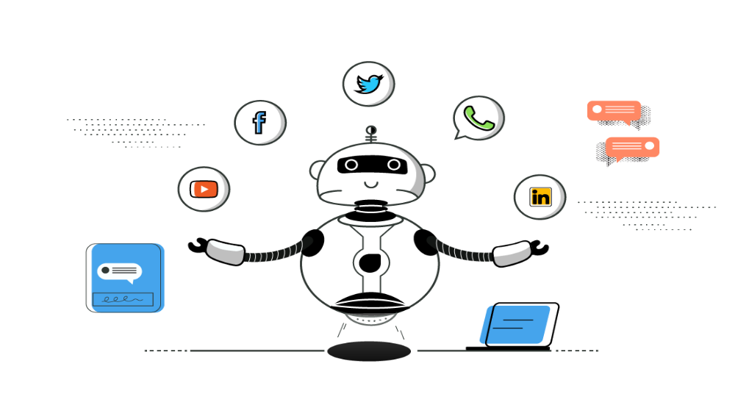

Figure 2.1: Example of a chatbot

**2.2 TYPES OF CHATBOTS**

There are different types of chatbots based on their functionality, complexity, and underlying technology. Here are some common types of chatbots:

1. Rule-based chatbots: Rule-based chatbots operate on predefined rules and scripts. They follow a set of if-then statements or decision trees to respond to user inputs. These chatbots are limited to specific interactions and can handle simple and structured conversations. They don't incorporate machine learning or AI algorithms and require manual updates to expand their capabilities.

2. AI-Powered chatbots: AI-powered chatbots utilize artificial intelligence technologies, such as machine learning and natural language processing (NLP), to understand and respond to user inputs. These chatbots can handle more complex and dynamic conversations, learn from interactions, and improve their responses over time. They can adapt to user preferences and offer a more personalized experience.

3. Virtual Assistant chatbots: Virtual assistant chatbots, also known as intelligent virtual assistants or IVAs, provide a wide range of services and perform tasks on behalf of users. They can handle multiple functions like scheduling appointments, making reservations, answering inquiries, and accessing various services. Virtual assistants often integrate with external APIs and databases to retrieve information and perform actions.

4. Transactional chatbots: Transactional chatbots focus on facilitating transactions and completing specific tasks. They assist users in making purchases, tracking orders, handling payments, or providing customer support related to transactions. These chatbots are commonly used in e-commerce and customer service industries.

5. Support chatbots: Support chatbots are designed to provide customer support and assistance. They can answer frequently asked questions, troubleshoot common issues, and guide users through self-help resources or knowledge bases. Support chatbots aim to enhance customer service efficiency and reduce the need for human intervention in handling routine inquiries.

6. Social chatbots: Social chatbots are designed to engage users in conversational interactions for entertainment, companionship, or social purposes. They can simulate human-like conversations, tell jokes, play games, or provide information in an engaging manner. Social chatbots are often used in messaging platforms and social media applications.

7. Domain-specific chatbots: Domain-specific chatbots are tailored to specific industries or niches. They possess specialized knowledge and expertise in a particular domain, such as healthcare, finance, or legal services. These chatbots provide industry-specific information, advice, and support.

It's important to note that chatbots can combine different functionalities and capabilities. For example, an AI-powered chatbot can also serve as a virtual assistant or a support chatbot. The type of chatbot chosen depends on the specific requirements and objectives of the intended use case.

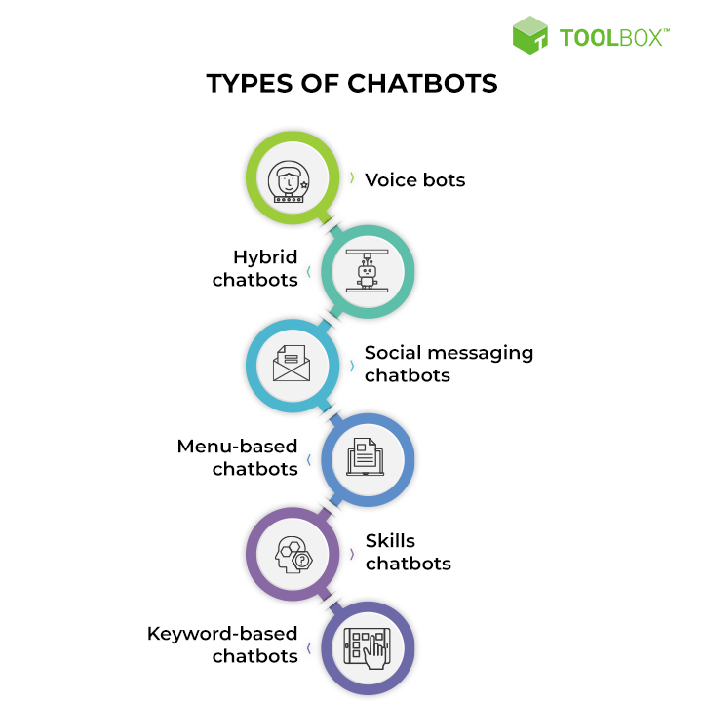

Figure 2.2 Types of chatbots

**2.3 HISTORY OF CHATBOTS**

The history of chatbots dates back several decades, with significant advancements and milestones along the way. Here's a brief overview of the history of chatbots:

**1. ELIZA (1966): ELIZA,** developed by Joseph Weizenbaum, is considered one of the earliest chatbots. It used simple pattern matching and substitution techniques to simulate conversation. ELIZA could engage users in text-based dialogues, primarily focusing on psychotherapy-like interactions.

**2. PARRY (1972):** PARRY, developed by Kenneth Colby, aimed to simulate person with paranoid schizophrenia. It engaged in text-based conversations, demonstrating more advanced natural language processing capabilities than ELIZA. PARRY responded to user inputs with specific patterns and pre-programmed responses.

**3. ALICE (1995):** ALICE (Artificial Linguistic Internet Computer Entity), created by Dr. Richard Wallace, was a more advanced chatbot that employed natural language understanding and generation techniques. ALICE could hold conversations on a variety of topics and won the Loebner Prize Turing Test multiple times.

**4. SmarterChild (2001)**: SmarterChild, developed by ActiveBuddy, was a popular chatbot deployed on messaging platforms like AOL Instant Messenger and MSN Messenger. It provided personalized information, weather updates, sports scores, and could engage in casual conversation.

**5. Siri (2010):** Siri, introduced by Apple, marked a significant advancement in chatbot technology. It combined natural language processing, voice recognition, and machine learning to provide voice-based virtual assistance on iPhones and other Apple devices. Siri could perform tasks, answer questions, and interact with various apps and services.

**6. Google Assistant (2016):** Google Assistant is an AI-powered virtual assistant developed by Google. It integrates with Google's services and devices, offering voice-based interactions and assistance. Google Assistant can provide information, perform tasks, control smart home devices, and engage in conversational interactions.

**7. Chatbot Platforms and Frameworks:** In recent years, various chatbot development platforms and frameworks have emerged, such as IBM Watson Assistant, Microsoft Bot Framework, and Dialogflow (formerly API.ai). These platforms provide tools and APIs to simplify the creation and deployment of chatbots, enabling businesses and developers to build their own chatbot solutions.

The history of chatbots showcases the evolution of natural language processing, AI technologies, and the growing demand for conversational interfaces. Today, chatbots continue to advance, leveraging machine learning, deep learning, and neural networks to provide more sophisticated and personalized conversational experiences.

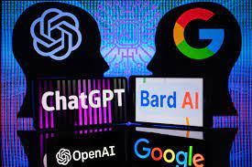

Figure 2.3 Some famous AI chatbots

**CHAPTER 3**

**HEALTHCARE &TECHNOLOGY**

**3.1 AI IN HEALTHCARE**

The emergence of artificial intelligence (AI) in healthcare has been groundbreaking, reshaping the way we diagnose, treat and monitor patients. This technology is drastically improving healthcare research and outcomes by producing more accurate diagnoses and enabling more personalized treatments. AI in healthcare’s ability to analyse vast amounts of clinical documentation quickly helps medical professionals identify disease markers and trends that would otherwise be overlooked. The potential applications of AI and healthcare are broad and far-reaching, from scanning radiological images for early detection to predicting outcomes from [electronic health records](https://www.foreseemed.com/blog/ehr-software-and-interoperability). By leveraging artificial intelligence in hospital settings and clinics, healthcare systems can become smarter, faster, and more efficient in providing care to millions of people worldwide. Artificial intelligence in healthcare is truly turning out to be the future – transforming how patients receive quality care while mitigating costs for providers and improving health outcomes.

It all began with IBM's Watson artificial intelligence system, which was developed to answer questions accurately and quickly. Articles on artificial intelligence in healthcare mention IBM’s launch of a healthcare-specific version of Watson in 2011 that focused on natural language processing—the technology used to understand and interpret human communication. Today, alongside IBM, other tech giants like Apple, Microsoft and Amazon are increasingly investing in AI technologies for the healthcare sector.

The potential implications of artificial intelligence in healthcare are truly remarkable. AI in healthcare is expected to play a major role in redefining the way we process healthcare data, diagnose diseases, develop treatments and even prevent them altogether. By using artificial intelligence in healthcare, medical professionals can make more informed decisions based on more accurate information - saving time, reducing costs and improving medical records management overall. From identifying new cancer treatments to improving patient experiences, AI in healthcare promises to be a game changer - leading the way towards a future where patients receive quality care and treatment faster and more accurately than ever before.

**3.1.1 MACHINE LEARNING IN HEALTHCARE**

[Machine learning](https://www.foreseemed.com/blog/machine-learning-in-healthcare) is one of the most common examples of artificial intelligence and healthcare working together. It is a broad technique at the core of many approaches to AI and healthcare technology and there are many versions of it.

Machine Learning has altered the healthcare system by enabling artificial intelligence to be used in medical diagnosis and treatment. Machine learning algorithms can quickly process large amounts of clinical documentation, identify patterns and make predictions about medical outcomes with greater accuracy than ever before. From analyzing patient records and medical imaging to discovering new therapies, the data science behind machine learning is helping healthcare professionals improve their treatments and reduce costs. By leveraging AI technologies like machine learning for tasks such as disease diagnosis or drug discovery and development, doctors can more accurately diagnose illnesses and customize treatments to individual patients’ needs. Furthermore, using artificial intelligence in healthcare such as machine learning allows providers to uncover previously unseen correlations in healthcare data between diseases or detect subtle changes in vital signs that may indicate a potential problem.

The most widespread utilization of traditional machine learning is precision medicine. Being able to predict what treatment procedures are likely to be successful with patients based on their make-up and the treatment framework is a huge leap forward for the data science of many healthcare organizations. The majority of AI technology in healthcare that uses machine learning and precision medicine applications require medical images and clinical data for training, for which the end result is known. This is known as supervised learning.

Artificial intelligence in healthcare that uses deep learning is also used for speech recognition in the form of natural language processing. Features in deep learning models typically have little meaning to human observers and therefore the model's results may be challenging to delineate without proper interpretation. As deep learning technology continues to advance, it will become increasingly important for healthcare professionals to understand how deep learning technology works and how to effectively use it in clinical settings.

**3.1.2 NATURAL LANGUAGE PROCESSING**

[Natural language processing](https://www.foreseemed.com/natural-language-processing-in-healthcare) (NLP) is a form of artificial intelligence that enables computers to interpret and use human language. This form of technology has reshaped many fields, including the healthcare industry. In healthcare, NLP is being used in a wide range of health data applications, such as improving patient care through better diagnosis accuracy, streamlining clinical processes, and providing more personalized services.

For example, NLP can be applied to medical records to accurately diagnose illnesses by extracting useful information from health data. Additionally, it can be used to identify relevant treatments and medications for each patient or even predict potential health risks based on past health data. Furthermore, NLP also provides clinicians with powerful tools for managing large amounts of complex data – something which would normally take much longer to do manually.

Natural language processing is proving to be an invaluable tool in healthcare – allowing medical professionals to use artificial intelligence to more accurately diagnose illnesses and provide better personalized treatments for their patients. This form of AI in healthcare is quickly becoming a must-have in the modern healthcare industry and is likely to become even more sophisticated and be used in a wider range of applications.

**3.2 CHATBOTS IN HEALTHACRE**

AI has not taken very long to make an impact across industries. And, the healthcare industry is no different. [Healthcare providers are using AI](https://appinventiv.com/blog/ai-in-healthcare/)to assist patients around the clock. Patients are able to receive the required information as and when they need it and have a better healthcare experience with the help of a medical chatbot.

By automating all of a medical representative’s routine and lower-level responsibilities, chatbots in the healthcare industry are extremely time-saving for professionals. That’s not it, though. They gather and store patient data, ensure its encryption, enable patient monitoring, offer a variety of informative support, and guarantee larger-scale medical help. Healthcare chatbots, in general, are transforming the healthcare sector.

The[**healthcare chatbots market**](https://www.globenewswire.com/Tracker?data=Uei7ZXzwXHg8d7kqf2Mq7w7AX7MzSYH3twjDfYP0NvcAixN87kjIvor6cH-Loy5oi40enkh3-O2L-aczxI6GeXMGW0SxC7slvm5Nu6tz5TlXqcjG-slqc8rRc2Kvay-UrXI6RGgDkHCch0sfGjy6oQ==) size was estimated at USD 196.85 bn in 2022. A chatbot is an interactive program that converses with people via text using AI and rules. It is a piece of software responsible for establishing a dialogue between humans and AI systems. Chatbots use text or voice output to communicate with users; texts made up of pre-planned sentences are used to carry out the dialogue.

These chatbots, on-premise or cloud-based solutions, allow patients to assess their symptoms, locate clinics, and schedule appointments.

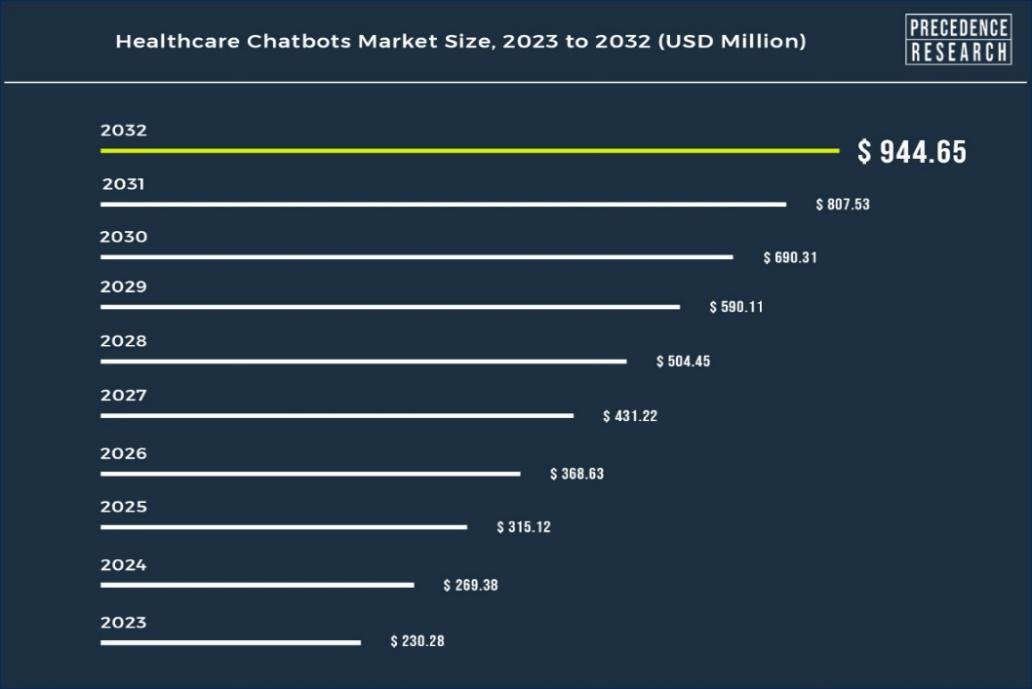

Figure 3.2

Additionally, healthcare payers use chatbots to establish relationships with potential customers. Systems known as healthcare chatbots assist individuals with their queries. Utilizing cutting-edge technology, this program helps physicians respond to patients' minor concerns. This idea has saved the clinical team significant time, allowing staff members to focus more on their tasks. These digital assistants are in massive demand in the healthcare industry due to the automation of many workflows using advanced technology.

**Key Insights:**

* By geography, the North America region has captured market share of 60% in 2022.
* By deployment, the cloud-based model segment has held market share of 75% in 2022.
* By component, the software segment has captured highest revenue share in 2022.
* By application, the symptoms check segment has held highest market share in 2022.

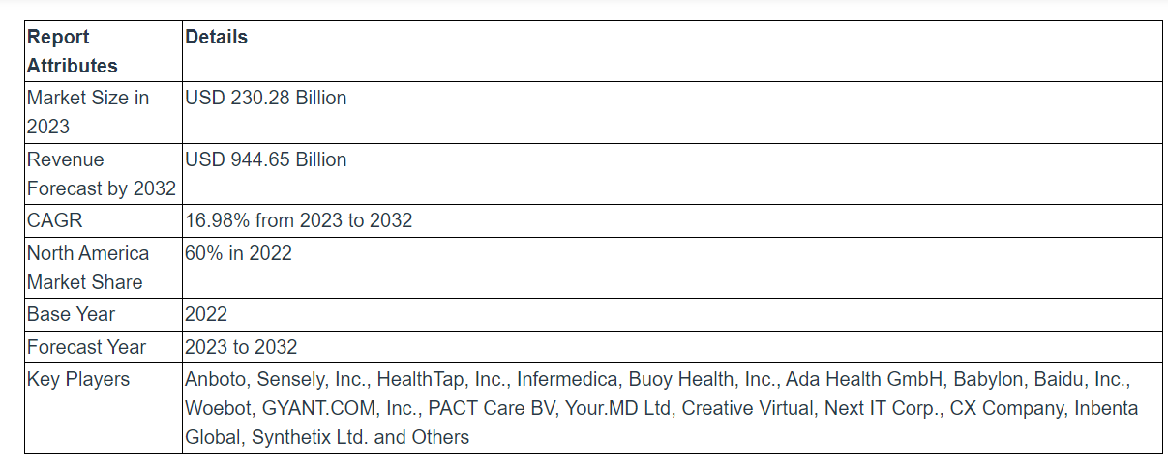

Table 3.2

**Report Highlights**

* **The Software industry** dominates the Global Market for Healthcare Chatbots in terms of components. Most chatbot service providers offer a freemium version that may be upgraded to a monthly or annual plan. A rise in smartphone uses and a better understanding of self-monitoring methods for managing treatment and diagnoses contribute to the expansion of the chatbot software sector.
* **Based on application**, symptoms check, Medical & drug information help, Appointment scheduling, and other applications make up the market's segmentation. Growing smartphone and internet usage among patients and healthcare professionals are driving the demand for such solutions. Some of the most widely used primary care symptoms checker chatbots are Babylon Health, Ada, Buoy Health, and YourMD.
* **Based on deployment**, cloud-based chatbots held the largest share and were the fastest-growing category during the predicted period. Chatbots are easier to use and require less modification compared to on-premise chatbots. Depending on how it is delivered, the market is split into an on-premises model and a cloud-based model.
* **Based on end-user**, the ease of seeking professional assistance and straightforward answers to many challenges are driving innovation in [AI in the healthcare](https://www.globenewswire.com/Tracker?data=dsIbWBaF4IJVVRdUFMMslpiG_Li5QokiHXEDI_Yw0n7N-jbEdwbLvKDGZbqCn4CppF5vmmiZsrylHwLkZUNFCfcwWfc1zLmOnKJRfvM3XlQrvC1IbOu5mte6bdOFocIfSt4Xy9S3X05-eBgMrBvybehPF2L3p8oxEcygLhIVCd7H7YAddr83bRr0kZ0XX8ip) sector.
* **Based on geography**, North America, Asia Pacific, Europe, and the Rest of the World are the global healthcare chatbots market segments. In North America, the market for healthcare chatbots is anticipated to expand at the fastest rate. Rising technological advancements and an increase in smartphone penetration are the main growth drivers.

**3.2.1 ADVANTAGES OF AI CHATBOTS IN HEALTHACRE INDUSTRY**

Chatbots have gained significant popularity and adoption in the healthcare industry. They offer various benefits and applications, including:

1. **24/7 Availability:** Healthcare chatbots provide round-the-clock access to medical information, advice, and support. Users can seek immediate assistance at any time, reducing the need for waiting or scheduling appointments.

2. **Symptom Triage and Assessment**: Chatbots can help users assess their symptoms and provide initial guidance on the severity and urgency of their condition. By asking relevant questions, chatbots can offer recommendations on whether a user should seek immediate medical attention or manage the situation at home.

3. **Health Information and Education:** Healthcare chatbots act as virtual health educators, offering accurate and up-to-date information on various medical conditions, treatments, preventive measures, and healthy lifestyle choices. They can provide guidance on managing chronic diseases, medication reminders, and self-care techniques.

4. **Remote Monitoring and Chronic Disease Management:** Chatbots can assist in remote monitoring of patients with chronic conditions. By collecting and analyzing data on symptoms, medication adherence, and vital signs, chatbots can provide personalized recommendations, reminders, and support to individuals managing their health from home.

5. **Appointment Scheduling and Facility Navigation**: Healthcare chatbots can help users find nearby clinics, hospitals, pharmacies, and available healthcare services. They can assist in scheduling appointments, providing directions, and answering questions related to healthcare facilities.

6. **Mental Health Support:** Chatbots can offer support for mental health conditions by providing resources, coping strategies, and access to helplines. They can engage in empathetic conversations, helping individuals feel heard and supported.

7. **Health Risk Assessment and Prevention:** Chatbots can conduct health risk assessments based on user inputs and provide recommendations for preventive measures and lifestyle changes. They can promote healthy habits, such as exercise, nutrition, and stress management.

**CHAPTER 4**

**MACHINE LEARNING**

**4.1 Machine Learning:**

Machine Learning (ML) is a branch of artificial intelligence (AI) that focuses on developing algorithms and models that enable computers to learn from data and make predictions or decisions without being explicitly programmed. The goal of machine learning is to create systems that can automatically improve their performance through experience.

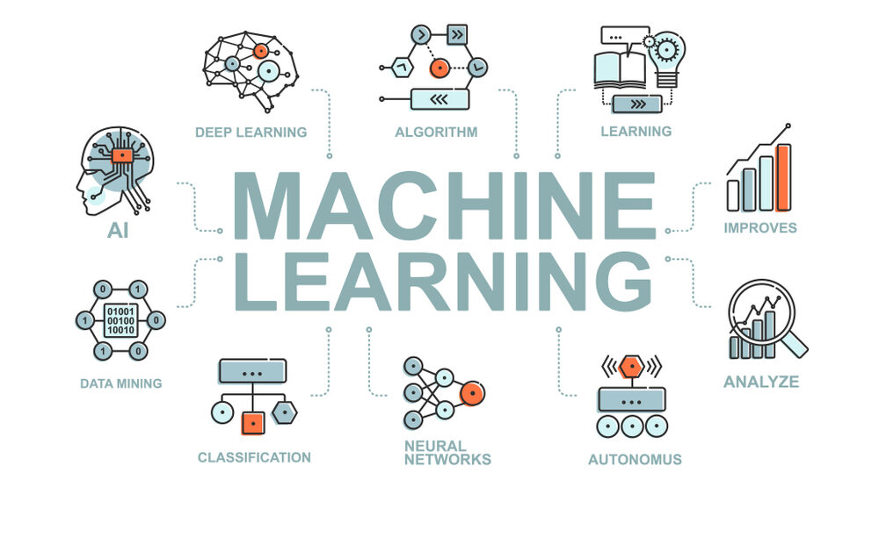

Figure 4.1

**4.1.1 How does Machine Learning Work?**

Machine learning typically involves the following steps: Data Collection: Gathering relevant data from various sources, which serves as the input for the learning process. Data Preprocessing: Cleaning and preparing the collected data by removing inconsistencies, handling missing values, normalizing or scaling features, etc. Feature Extraction/Selection: Identifying the most relevant features or transforming the data into a suitable representation that can be effectively utilized by the learning algorithm. Model Training: Using the prepared data to train a machine learning model. The model learns patterns, relationships, and dependencies in the data to make predictions or take actions. Model Evaluation: Assessing the performance of the trained model using evaluation metrics and validation techniques to ensure its effectiveness. Model Deployment: Incorporating the trained model into a real-world application or system where it can process new, unseen data and make predictions or decisions. Model Monitoring and Maintenance: Continuously monitoring the model's performance, retraining it with new data periodically, and making necessary adjustments to maintain its accuracy and relevance.

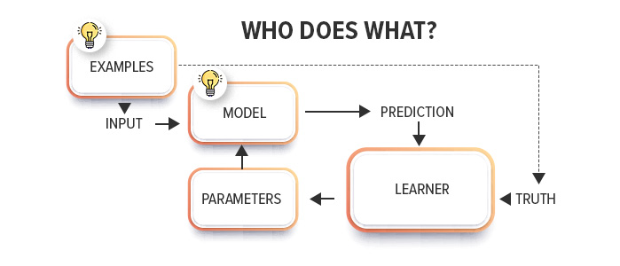

Figure 4.1.1

**4.2 Types of Machine Learning:**

**4.2.1 Supervised Learning:**

Supervised learning involves training a model using labeled data, where the input data is accompanied by corresponding target labels or outputs. The model learns to generalize from the provided examples and make predictions or classifications for unseen data based on the learned patterns.

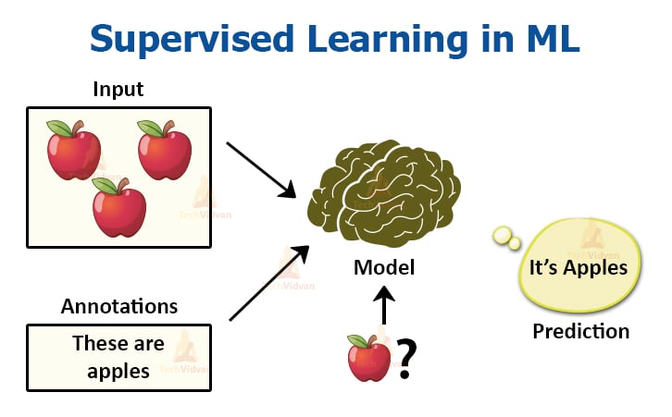

Figure 4.1.2

**4.2.2 Unsupervised Learning:**

Unsupervised learning deals with training models on unlabeled data, where the input data lacks any predefined labels or targets. The goal is to discover inherent patterns, structures, or relationships in the data without explicit guidance. Unsupervised learning algorithms can be used for tasks such as clustering,

anomaly detection, and dimensionality reduction. 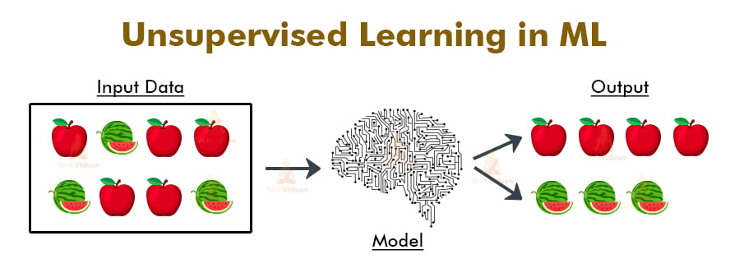

Figure 4.2.2

**4.2.3 Semi-supervised Learning:**

Semi-supervised learning combines elements of both supervised and unsupervised learning. It utilizes a small amount of labeled data along with a larger amount of unlabeled data for training. The labeled data helps guide the learning process, while the unlabeled data aids in discovering additional patterns or representations.

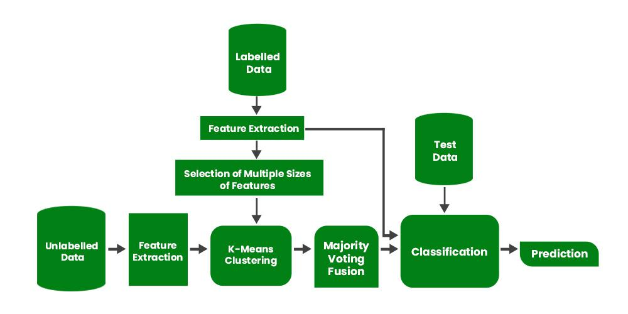

Figure 4.2.3

**4.2.4 Reinforcement Learning:**

Reinforcement learning involves training an agent to interact with an environment and learn through trial and error. The agent receives feedback in the form of rewards or punishments based on its actions. The objective is to find the optimal policy or sequence of actions that maximizes the cumulative reward over time. Reinforcement learning is commonly used in areas such as robotics, game playing, and autonomous systems.

**4.3 Deep Learning:**

Deep learning is a subset of machine learning that focuses on using artificial neural networks with multiple layers to learn and represent complex patterns or features from data. Deep learning models, known as deep neural networks, have demonstrated exceptional performance in various domains, including computer vision, natural language processing, and speech recognition.

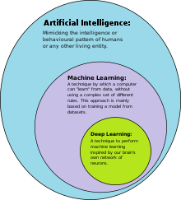

Figure 4.3

**4.3.1 Convolutional Neural Networks (CNNs):**

Convolutional Neural Networks (CNNs) are a type of deep learning model commonly used for analyzing visual data, such as images or videos. CNNs leverage the concept of convolution, which involves applying filters or kernels to input data to extract relevant features. They typically consist of convolutional layers, pooling layers for downsampling, and fully connected layers for making predictions.

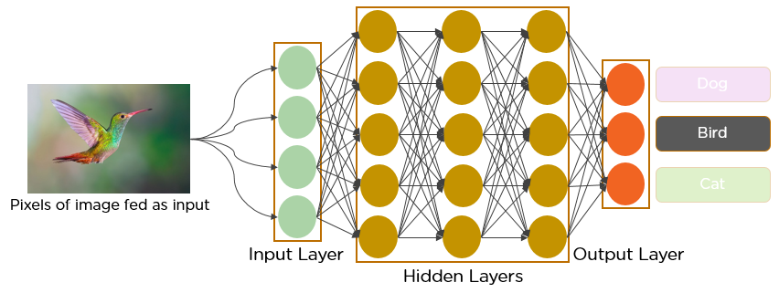

Figure 4.3.1

**4.3.1.1 Architecture:**

The architecture of a CNN generally comprises multiple convolutional layers, interspersed with pooling layers to reduce spatial dimensions, and fully connected layers at the end for classification or regression tasks. The convolutional layers extract different visual features, starting from low-level features like edges and gradients and progressing to higher-level features. Each layer's output is passed through activation functions, such as ReLU, to introduce non-linearity into the model

**4.3.1.2 Convolutional Neural Network Working:**

In a CNN, the input data (e.g., an image) is fed into the network, and the convolutional layers extract features by convolving the input with learned filters. The pooling layers downsample the feature maps, reducing their spatial dimensions while retaining the most relevant information. The resulting feature maps are then flattened and passed through fully connected layers, which learn to classify or predict based on the extracted features. The model's parameters are optimized using techniques like backpropagation and gradient descent.

**4.3.2 ResNet:**

ResNet (Residual Neural Network) is a deep learning architecture that introduced the concept of residual connections or skip connections. These connections allow the network to learn residual mappings, i.e., the difference between the input and the desired output, making it easier for the model to capture and learn complex patterns. ResNet architectures have achieved outstanding performance in image classification and other computer vision tasks.

**4.3.3 Transfer Learning:**

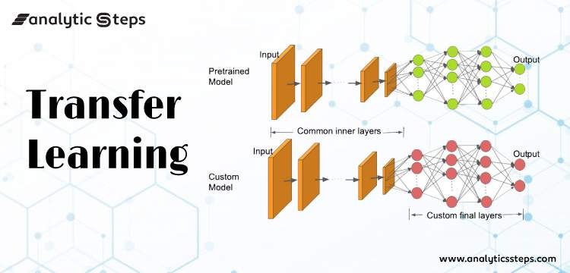

Figure 4.3.3

Transfer learning is a technique in deep learning where a pre-trained model, trained on a large dataset, is used as a starting point for a new, related task. Instead of training a model from scratch, transfer learning allows leveraging the knowledge and learned features from the pre-trained model, saving computation time and data requirements.

**CHAPTER 5**

**TECHNOLOGY USED**

**PROGRAMMING LANGUAGES USED:**

**5.1 Python (Programming Language):**

Python is a computer programming language often used to build websites and software, automate tasks, and conduct data analysis. Python is a general-purpose language, meaning it can be used to create a variety of different programs and isn't specialized for any specific problems

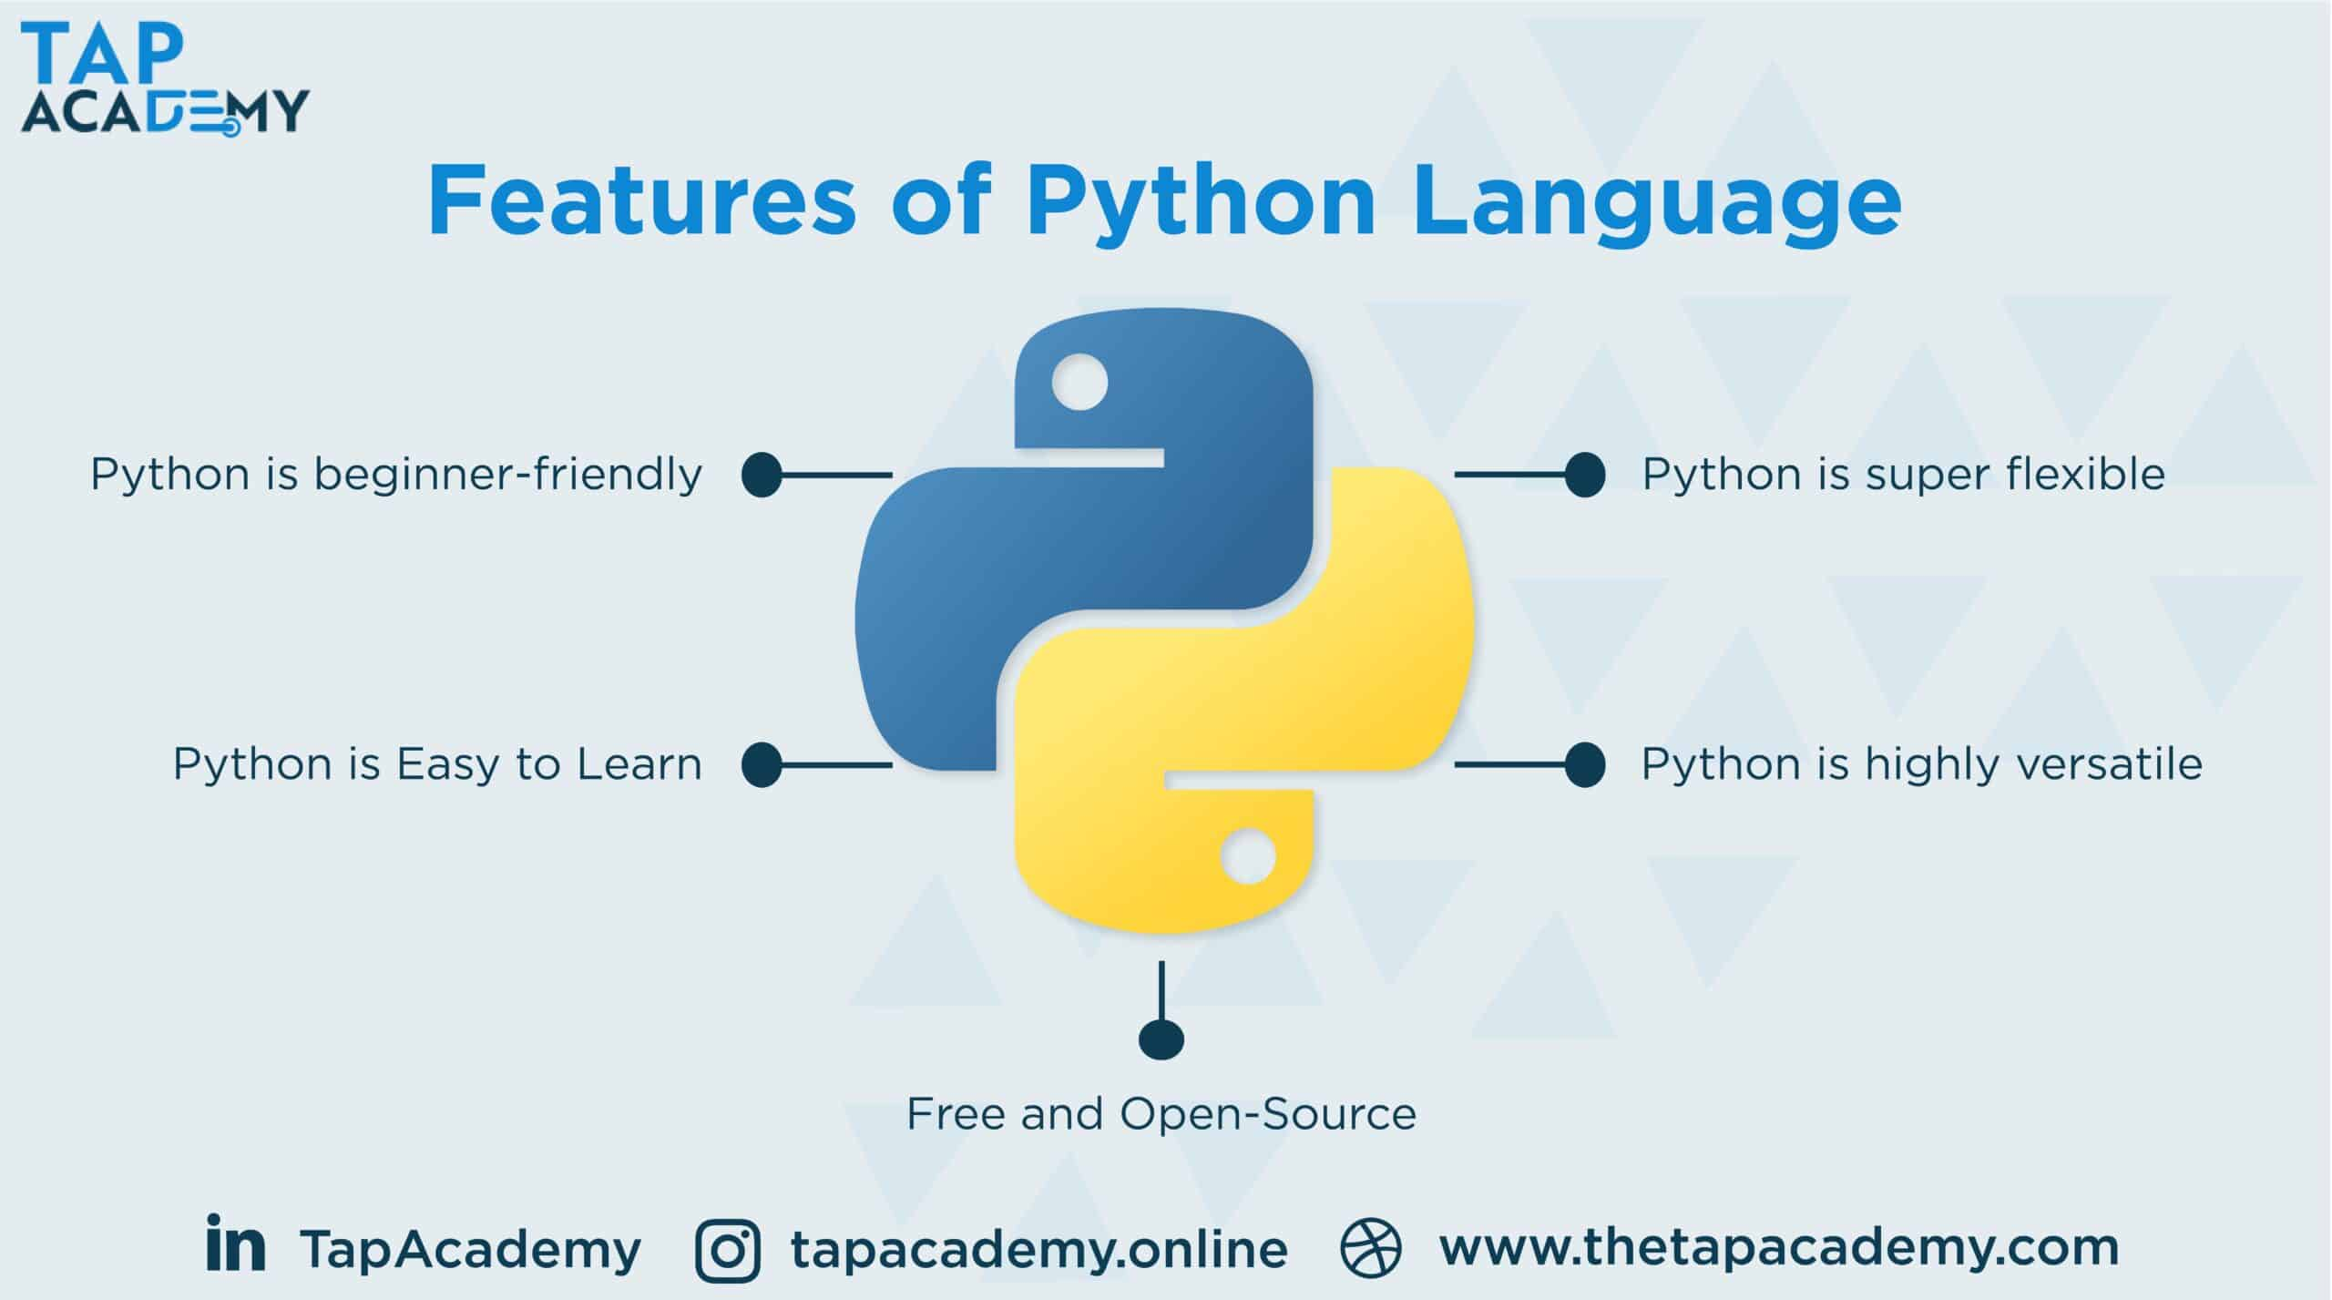

Figure 5.1

**5.1.1 Simple and consistent:**

Python is known for its simplicity and readability, making it easy for developers to write and understand code.

**5.1.2 Extensive selection of libraries and frameworks:**

Python has a vast ecosystem of libraries and frameworks that cover a wide range of applications, making development faster and more efficient.

**5.1.3 Platform independence:**

Python code can run on various operating systems, including Windows, macOS, and Linux, without requiring major modifications

**5.2 Machine Learning:**

**5.2.1 Convolutional Neural Networks:**

Convolutional Neural Networks (CNNs) are a type of deep learning model commonly used in image recognition and computer vision tasks.

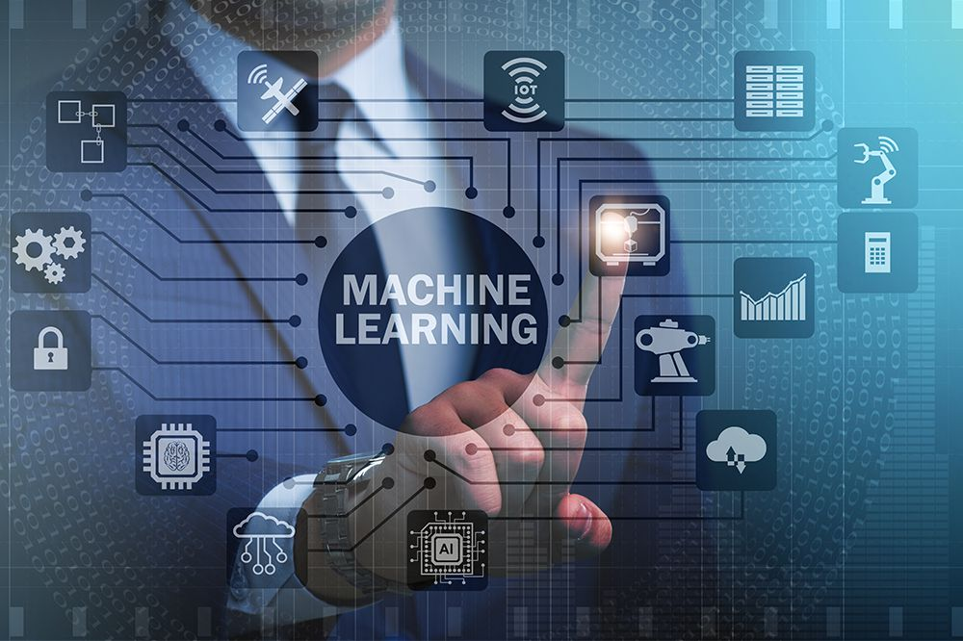

Figure 5.2.1

**5.2.2 ResNet:**

ResNet is a specific architecture for deep neural networks that addresses the problem of vanishing gradients and enables training of much deeper models.

**5.2.3 Transfer Learning:**

Transfer learning allows pre-trained models to be used as a starting point for new tasks, leveraging knowledge learned from large datasets.

**5.3 Libraries used:**

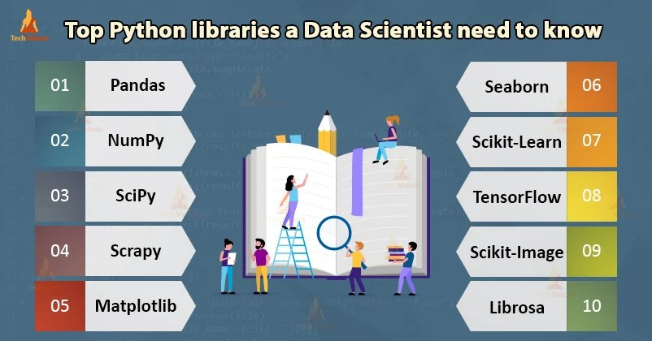

Figure 5.3

**5.3.1 NumPy:**

NumPy is a powerful library for numerical computing in Python, providing support for large, multi-dimensional arrays and a collection of mathematical functions.

**5.3.2 Pandas:**

Pandas is a library used for data manipulation and analysis, offering data structures and functions to efficiently handle structured data.

**5.3.3 TensorFlow:**

TensorFlow is an open-source machine learning framework that provides a flexible ecosystem for building and deploying machine learning models.

**5.3.4 Keras:**

Keras is a high-level neural networks API that runs on top of TensorFlow, simplifying the process of building and training deep learning models.

**5.3.5 OpenCV:**

OpenCV (Open Source Computer Vision Library) is a popular library for computer vision tasks, providing tools and algorithms for image and video processing.

**5.3.6 H5PY:**

H5PY is a Python library for working with HDF5 files, a data format commonly used in scientific computing and machine learning.

**5.3.7 Pillow:**

Pillow is a fork of the Python Imaging Library (PIL), offering image processing capabilities, including reading, manipulating, and saving images.

**5.3.8 Gevent:**

Gevent is a coroutine-based Python networking library that enables high-performance, concurrent, and scalable applications. 5.4 Flask:

**5.4.1 Features**

Flask is a lightweight web framework for Python, providing features for building web applications, REST APIs, and microservices.

**5.4.2 Components:**

Flask includes components like routing, request handling, template rendering, and session management to simplify web development.

**5.4.3 Werkzeug:**

Werkzeug is a WSGI (Web Server Gateway Interface) utility library that forms the core of Flask, handling HTTP-related tasks.

**5.5 Software Required:**

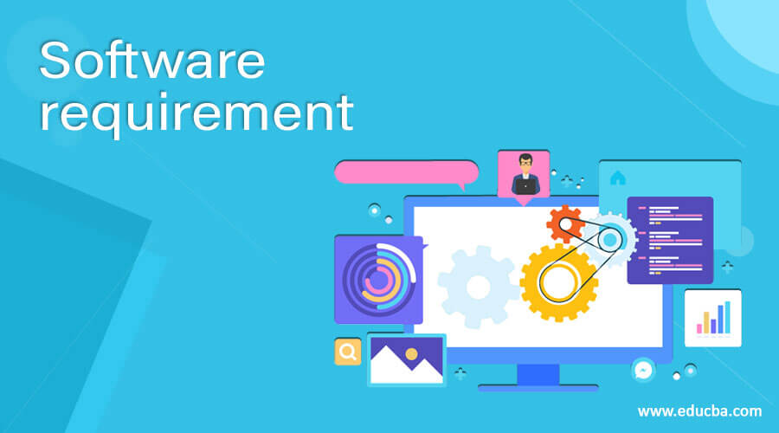

Figure 5.5

**5.5.1 Jupyter Notebook or Google Colaboratory:**

Jupyter Notebook and Google Colaboratory are popular interactive development environments for Python, allowing code execution and documentation to be combined in a notebook format.

**5.5.2 PyCharm:**

PyCharm is an integrated development environment (IDE) specifically designed for Python development, offering features such as code completion, debugging, and version control. 5.6 Operating System:

**5.6.1 Windows:**

Python is compatible with various versions of the Windows operating system, including Windows 10, Windows 8, and Windows 7.

**5.6.2 macOS:**

Python runs on macOS, and the Python installation is typically pre

**CHAPTER 6**

**STRUCTURE OF PROJECT**

**6.1 Introduction**

In this chapter, we will discuss the overall structure of the Smart Healthcare Chatbot System project. The purpose of this chapter is to provide a clear understanding of how the project is organized and the different components that constitute its structure. This chapter will serve as a guide for readers to navigate through the project report and comprehend the various aspects of the implemented system.

**6.2 System Architecture**

The system architecture of the Smart Healthcare Chatbot System is designed to ensure modularity, scalability, and maintainability. It consists of several interconnected components that work together to provide an intelligent and user-friendly healthcare chatbot experience. The architecture is organized into three primary layers: the user interface layer, the chatbot engine layer, and the backend services layer.

**6.2.1 User Interface Layer**

The user interface layer is responsible for facilitating seamless interaction between users and the chatbot system. It provides a platform for users to input their queries and receive responses in a user-friendly manner. The user interface layer can be implemented as a web-based interface, a mobile application, or other user-friendly platforms.

To ensure a smooth user experience, the user interface layer incorporates intuitive design principles and usability best practices. It enables users to interact with the chatbot system using various input modalities, such as text input, voice recognition, or even image-based input for sharing medical reports or symptom images. Natural language processing (NLP) techniques are employed to understand user inputs, regardless of the chosen modality.

In addition to input mechanisms, the user interface layer also provides feedback to users. It generates clear and concise responses that are easily understandable, ensuring effective communication between the chatbot and the user. The interface may include features like suggestions, prompts, or visual cues to assist users in formulating their queries or navigating through the chatbot system.

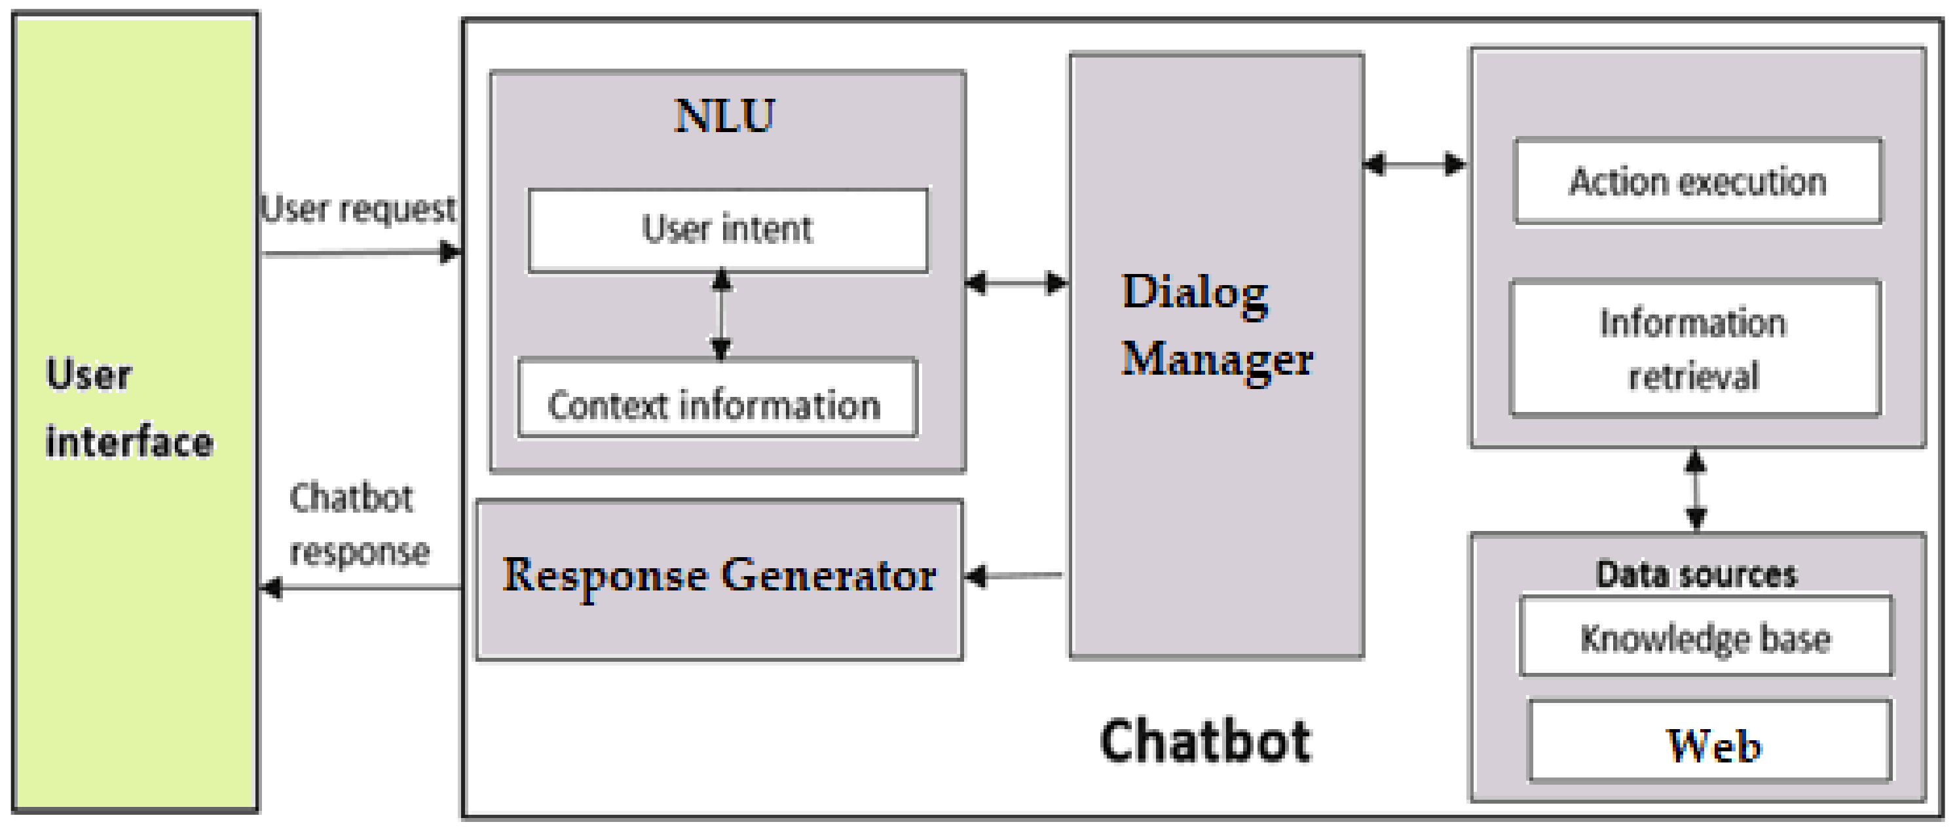

Figure 6.2

**6.2.2 Chatbot Engine Layer**

The chatbot engine layer serves as the core component of the Smart Healthcare Chatbot System. It is responsible for processing user queries and generating appropriate responses. The chatbot engine incorporates advanced algorithms and techniques to understand and respond to user inputs effectively.

Natural language understanding (NLU) algorithms are employed in the chatbot engine to analyze user queries, extract relevant information, and determine the user's intent. These algorithms enable the system to comprehend the context and semantics of user inputs, allowing for more accurate and tailored responses.

Machine learning algorithms are also utilized in the chatbot engine to continuously improve its performance. Through machine learning, the system learns from user interactions, adapts its responses, and enhances its understanding over time. Training data, which may include medical literature, clinical guidelines, and real patient data, is used to refine the chatbot's performance and ensure it provides accurate and up-to-date information.

The chatbot engine also relies on a knowledge base that contains a wealth of medical information, symptom databases, treatment protocols, and relevant healthcare guidelines. This knowledge base serves as a reference for the chatbot system, allowing it to retrieve reliable and accurate information when generating responses. It enables the chatbot to suggest diagnoses, recommend treatments, and provide guidance based on established medical knowledge.

**6.2.3 Backend Services Layer**

The backend services layer acts as the bridge between the chatbot engine layer and external services or databases. It handles data storage, retrieval, and the integration of external APIs or healthcare systems.

Data storage is a crucial aspect of the backend services layer. It manages the storage of user profiles, medical records, symptom databases, and other necessary data for the functioning of the chatbot system. The choice of database management system depends on factors such as scalability, performance, and security requirements. Commonly used databases for healthcare applications include SQL databases like MySQL and PostgreSQL, as well as NoSQL databases like MongoDB and Cassandra.

The backend services layer facilitates data retrieval from external sources, such as medical literature or clinical databases. It may also involve integrating with existing healthcare systems, such as electronic health record (EHR) systems or hospital information systems (HIS). This integration allows the chatbot to access patient data, medical histories, and treatment plans, providing personalized and accurate responses.

Furthermore, the backend services layer handles user authentication and authorization to ensure data security and privacy. It ensures that only authorized users can access sensitive healthcare information and perform specific actions within the chatbot system. User authentication mechanisms, such as username-password authentication or integration with existing authentication systems, are implemented to maintain data security.

The integration of external APIs or healthcare systems within the backend services layer enhances the chatbot's capabilities. It enables the chatbot system to leverage existing medical knowledge, avoid redundant data entry, and facilitate better coordination among healthcare providers.

**6.3 Database Management**

Effective database management is a critical aspect of the Smart Healthcare Chatbot System. The database serves as a repository for storing and retrieving relevant information required by the chatbot system. It encompasses user profiles, medical records, symptom databases, treatment protocols, and other necessary data.

**6.3.1 Database Types and Selection**

The choice of database management system depends on several factors, including data structure, volume, speed of retrieval, and real-time data processing requirements. Commonly used database systems for healthcare applications include:

Relational Databases: Relational database management systems (RDBMS) such as MySQL, PostgreSQL, or Oracle are widely used in healthcare. These databases offer a structured approach to data storage and allow for efficient retrieval using SQL queries. Relational databases are suitable for scenarios where data relationships and complex queries are involved, such as storing patient information, medical histories, and treatment plans.

NoSQL Databases: NoSQL databases like MongoDB, Cassandra, or Redis are increasingly adopted in healthcare systems. NoSQL databases provide high scalability, flexibility, and fast data retrieval. They are suitable for scenarios where unstructured or semi-structured data needs to be stored, such as symptom databases, medical research data, or sensor data from wearable devices.

The selection of the appropriate database system should consider factors such as scalability, performance, security, and ease of integration with other components of the chatbot system. It is essential to evaluate the specific requirements of the project and choose a database system that aligns with those requirements.

**6.3.2 Data Storage and Retrieval**

Efficient data storage and retrieval mechanisms are vital to ensure the smooth functioning of the chatbot system. The database management component handles the storage and retrieval of various types of data, such as user profiles, medical records, and knowledge base information.Data storage involves designing appropriate database schemas that capture the required data entities and their relationships. For example, the database may include tables for users, patient records, symptoms, diagnoses, treatments, and medical literature. The schema design should consider data normalization principles to eliminate redundancy and ensure data consistency.

Data retrieval is performed through query execution on the database. Depending on the database system used, SQL queries or other query languages specific to the database may be employed. The queries retrieve relevant data based on user inputs, allowing the chatbot system to provide accurate and timely responses.

To optimize data retrieval performance, indexing techniques can be employed. Indexes are data structures that improve query execution time by allowing the database system to locate data more efficiently. Indexes can be created on frequently queried columns, such as patient identifiers or symptom keywords, to speed up the retrieval process.

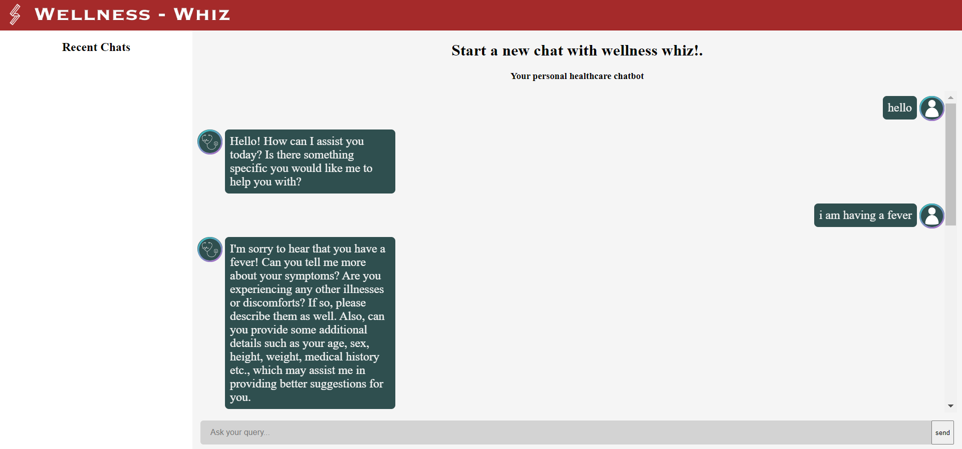

Figure 6.3.2

**6.3.3 Data Security and Privacy**

Data security and privacy are of utmost importance in healthcare systems. The Smart Healthcare Chatbot System must adhere to stringent data protection regulations, such as the Health Insurance Portability and Accountability Act (HIPAA) in the United States or the General Data Protection Regulation (GDPR) in the European Union.

To ensure data security, measures such as encryption, access controls, and regular backups should be implemented. Encryption protects sensitive data by transforming it into an unreadable format, which can only be accessed using appropriate decryption keys. Access controls define user roles and permissions, ensuring that only authorized personnel can access specific data.

Additionally, the chatbot system should comply with privacy regulations by anonymizing or de-identifying patient data when necessary. This prevents the disclosure of personally identifiable information without the user's consent.

**6.3.4 Scalability and Performance**

The database management component should be designed to handle the growing volume of data and increasing user demands. As the chatbot system gains popularity and user interactions multiply, the database should scale seamlessly to accommodate the increased load.

Techniques such as database sharding, replication, or clustering can be employed to distribute data across multiple servers and ensure high availability and fault tolerance. These techniques enable the system to handle large amounts of data and provide consistent performance even under heavy user traffic.Database performance can be further optimized through query optimization, caching mechanisms, and database tuning. Profiling and analyzing the query execution plans can help identify bottlenecks and fine-tune the database configuration for optimal performance.

**6.3.5 Compliance and Auditability**

Healthcare systems must comply with various regulatory requirements and undergo periodic audits to ensure data integrity and security. The database management component should support audit logging, which records all activities and changes made to the database. Audit logs facilitate traceability and accountability, allowing for investigation and resolution of any potential security incidents or data breaches Regular backups and disaster recovery mechanisms should also be implemented to protect against data loss. Automated backup routines and redundant storage options can help ensure that data can be restored in case of unforeseen events or system failures

**6.4 Development Methodology**

The development methodology used for the Smart Healthcare Chatbot System follows an iterative and incremental approach, such as Agile or Scrum. This methodology promotes flexibility, adaptability, and continuous improvement throughout the project lifecycle. It enables the project team to collaborate closely with healthcare professionals, subject matter experts, and potential end-users, ensuring that the chatbot system meets the desired requirements and addresses real-world healthcare challenges effectively.

**6.4.3 Implementation and Testing**

The implementation phase involves translating the system design into actual code. The project team follows coding best practices, adheres to coding standards, and ensures code modularity and reusability. They also perform unit testing to validate the individual components and functionalities.

Continuous integration and continuous deployment (CI/CD) practices are often employed to automate the build, test, and deployment processes. This allows for faster and more efficient development cycles, ensuring that new features and bug fixes are regularly integrated and deployed into the system.

**6.4.4 Iterative Development and User Feedback**

The iterative development approach allows for frequent iterations and feedback loops with users and stakeholders. The chatbot system is released in increments or versions, with each version adding new features or enhancements. User feedback is collected and analyzed to identify areas for improvement and to validate that the system meets the user's needs effectively.

Regular meetings, sprints, and feedback sessions are conducted to facilitate effective communication and collaboration within the project team. Agile project management tools, such as Kanban boards or Scrum boards, are often utilized to visualize and track the progress of tasks and user stories.

**6.4.5 Refinement and Continuous Improvement**

Throughout the development process, the project team continuously refines and improves the chatbot system. They prioritize user feedback, bug reports, and enhancement requests to ensure that the system evolves to meet the changing needs of the users and the healthcare industry.

Refinements may include fine-tuning the natural language processing algorithms, updating the knowledge base with the latest medical information, or optimizing system performance based on user behavior patterns. Regular testing, including functional testing, integration testing, and user acceptance testing, is performed to ensure the quality and reliability of the system

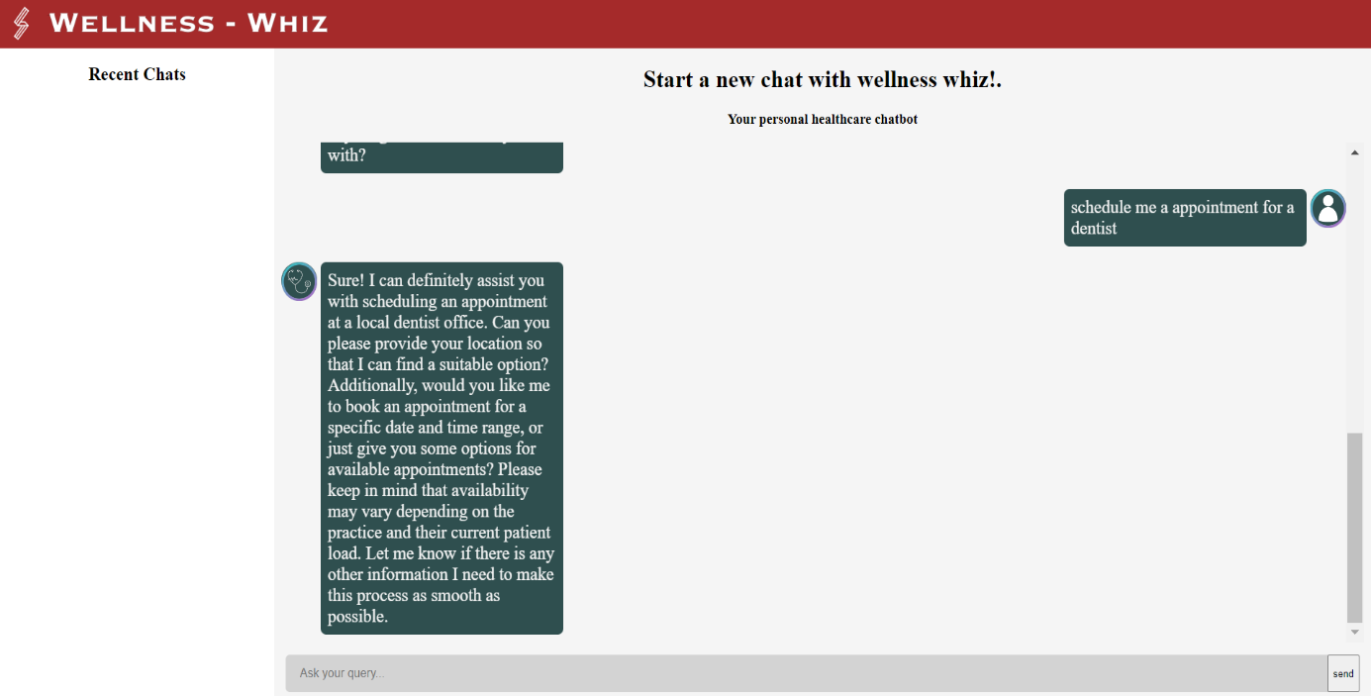

Figure 6.5.3

**6.5 Summary**

This project uses a transformer model developed by LAION based on the weights of Meta's LLaMA LLM introduced recently. The LLM used is oasst-sft-6-llama-30b.

The inference API is provided by HuggingFace's HuggingChat. We use Instruction-Prompt-Tuning to guide the model. These instructions provide a structured framework for the chatbot's responses and guide its behavior to act like a medical chatbot.

By passing these instructions prior to starting each conversation, we ensure that the chatbot follows a consistent approach and provides relevant information and guidance to the user. These instructions help shape the initial prompt and subsequent responses of the chatbot, making it more effective in assisting users with their healthcare concerns.

We weighed the pros and cons of IPT/Soft-tuning over fine-tuning the model over the given limited duration of the hackathon and we found IPT/Soft-tuning to be a good trade-off given the other technicalities like deployment, and inference costs.

**CHAPTER 7**

**TESTING AND TUNING**

The testing and tuning phase is a critical step in the development of the Smart Healthcare Chatbot System. This chapter provides an in-depth exploration of the rigorous testing procedures employed to ensure the system's reliability, accuracy, and performance. Additionally, it discusses the tuning process, which involves optimizing the chatbot system based on feedback, user interactions, and performance metrics.

**7.1 Testing Strategies**

Various testing strategies are employed to evaluate different aspects of the Smart Healthcare Chatbot System. These strategies include:

**7.1.1 Functional Testing**

Functional testing verifies that the chatbot system performs as expected and meets the defined requirements. The project team conducts comprehensive tests to ensure that all features and functionalities, such as symptom analysis, diagnosis suggestions, treatment recommendations, and medical information retrieval, work correctly. Test cases are designed to cover various scenarios and user interactions, validating the system's responses and behavior.

For instance, in the case of symptom analysis, a range of symptoms is inputted, including common symptoms, rare symptoms, and symptoms with similar presentations. The expected outputs are predefined and compared against the actual outputs generated by the chatbot system. This ensures that the system accurately identifies and analyzes symptoms to provide relevant recommendations.

During functional testing, edge cases and exceptional scenarios are also considered. These tests help identify any vulnerabilities or limitations in the system's functionality and enable the project team to address them effectively.

**7.1.2 Integration Testing**

Integration testing focuses on testing the interaction between different components of the chatbot system. It ensures that the user interface, chatbot engine, backend services, and external integrations function seamlessly together. The integration testing process verifies data flow, API integrations, and compatibility with external systems, such as electronic health record (EHR) systems or healthcare databases.

Integration tests are performed to validate the communication and data exchange between different modules of the system. This includes verifying that user inputs are correctly processed by the chatbot engine, that data is retrieved accurately from external systems, and that responses are appropriately delivered to the user interface.

By conducting integration testing, potential issues related to data consistency, interoperability, and system integration can be identified and resolved early in the development cycle.

**7.1.3 Performance Testing**

Performance testing assesses the chatbot system's response time, scalability, and resource utilization under varying workloads. The project team simulates high user traffic scenarios to evaluate the system's performance and identify any potential bottlenecks. Performance metrics, such as response time, throughput, and system resource consumption, are monitored and analyzed to optimize system performance.

Load testing is conducted to assess the system's behavior under normal and peak load conditions. It involves simulating a large number of concurrent users and measuring how the system handles the increased workload. Performance monitoring tools are employed to capture response times, server resource usage, and network latency. This information helps the project team identify performance bottlenecks and optimize the system's architecture, configuration, and resource allocation.

Stress testing is another important aspect of performance testing. It involves subjecting the system to extreme load conditions to determine its breaking point and to assess how it recovers from such scenarios. By identifying the system's limitations, the project team can implement measures to enhance its scalability and robustness.

Performance testing ensures that the chatbot system can handle user queries promptly, maintain responsiveness during peak usage periods, and scale effectively as user demand increases.

**7.1.4 Usability Testing**

Usability testing focuses on assessing the user experience and user interface of the chatbot system. Users with varying levels of technical expertise and healthcare knowledge are invited to interact with the system and provide feedback. Usability testing helps identify areas for improvement in terms of interface design, navigation, clarity of responses, and overall user satisfaction.

During usability testing, participants are assigned tasks that represent common user scenarios, such as seeking medical advice, retrieving specific information, or understanding treatment options. The project team observes how users interact with the system, noting any difficulties or confusion encountered. User feedback is collected through surveys, questionnaires, or direct interviews.

The insights gathered from usability testing inform interface refinements and usability enhancements. It allows the project team to iterate on the design, layout, and presentation of the chatbot system, ensuring a seamless and intuitive user experience.

**7.1.5 Security Testing**

Security testing ensures that the chatbot system is resilient against potential security threats and vulnerabilities. The project team conducts penetration testing, vulnerability assessments, and security audits to identify and address any potential security risks. Data encryption, access controls, and secure communication protocols are validated to safeguard sensitive healthcare information.

Security testing involves assessing the system's resistance to various attack vectors, such as cross-site scripting (XSS), SQL injection, or session hijacking. It verifies that proper security measures are implemented to protect user data and prevent unauthorized access.

Additionally, compliance with privacy regulations, such as the General Data Protection Regulation (GDPR) or the Health Insurance Portability and Accountability Act (HIPAA), is thoroughly evaluated. This ensures that the chatbot system adheres to industry standards and legal requirements regarding data privacy and security.

**7.2 Tuning and Optimization**

Tuning and optimization are iterative processes aimed at enhancing the performance, accuracy, and user satisfaction of the chatbot system. The following approaches are employed:

**7.2.1 Instruction Prompt Tunning**

Prompting helps guide language model behavior by adding some input text specific to a task. Prompt tuning is an additive method for only training and updating the newly added prompt tokens to a pretrained model. This way, you can use one pretrained model whose weights are frozen, and train and update a smaller set of prompt parameters for each downstream task instead of fully finetuning a separate model. As models grow larger and larger, prompt tuning can be more efficient, and results are even better as model parameters scale.

**7.2.2 Performance Optimization**

Performance optimization involves identifying and addressing any performance bottlenecks within the chatbot system. The project team analyzes performance metrics collected during the testing phase to identify areas for improvement. Techniques such as caching, query optimization, database tuning, and system resource allocation are implemented to enhance response time, scalability, and overall system performance.

By analyzing system performance metrics, such as response time and resource utilization, the project team can identify areas where optimizations are needed. Caching mechanisms can be implemented to store frequently accessed data, reducing the need for repeated computations or database queries. Query optimization techniques, such as indexing or query rewriting, can improve the efficiency of database operations.

System resource allocation is also crucial for optimal performance. By monitoring system resource usage, the project team can allocate resources effectively to handle user traffic, ensuring a smooth user experience even during peak usage periods.

**CHAPTER 8**

**MODELS**

**8.1 LLAMA MODEL**

LLaMA (Large Language Model Meta AI) is a large language model (LLM) released by Meta AI in February 2023. A variety of model sizes were trained ranging from 7 billion to 65 billion parameters. LLaMA's developers reported that the 13 billion parameter model's performance on most NLP benchmarks exceeded that of the much larger GPT-3 (with 175 billion parameters) and that the largest model was competitive with state of the art models such as PaLM and Chinchilla.

Whereas the most powerful LLMs have generally been accessible only through limited APIs (if at all), Meta released LLaMA's model weights to the research community under a noncommercial license.

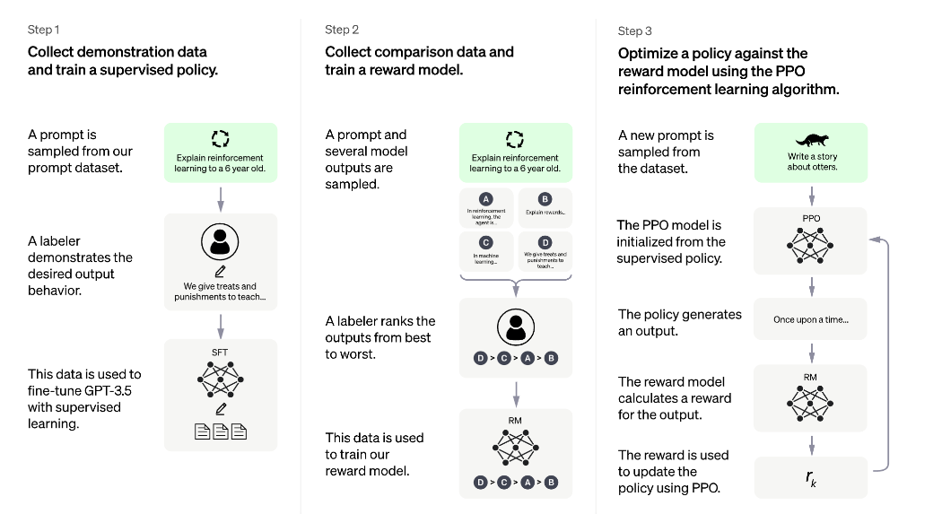

Figure 8.1

**8.1.1 ARCHITECTURE AND TRAINING**

LLaMA uses the transformer architecture, the standard architecture for language modelling since 2018. LLaMA's developers focused their effort on scaling the model's performance by increasing the volume of training data, rather than the number of parameters, reasoning that the dominating cost for LLMs is from doing inference on the trained model rather than the computational cost of the training process. LLaMA was trained on 1.4 trillion tokens, drawn from publicly available data sources.

**8.1.2 APPLICATIONS**

The Stanford University Institute for Human-Centered Artificial Intelligence (HAI) Center for Research on Foundation Models (CRFM) released Alpaca, a training recipe based on the LLaMA 7B model that uses the "Self-Instruct" method of instruction tuning to acquire capabilities comparable to the OpenAI GPT-3.5 series text-davinci-003 model at a modest cost.

Multiple open source projects are continuing this work of finetuning LLaMA with Alpaca dataset.



**8.2 HUGGING FACE**

Hugging Face, Inc. is an American company that develops tools for building applications using machine learning.

It is most notable for its transformers library built for natural language processing applications and its platform that allows users to share machine learning models and datasets.

Hugging Face has developed a powerful library called "Transformers" that allows researchers and developers to easily use and fine-tune pre-trained models for tasks such as text classification, language translation, question answering, and more. This library is widely used for tasks related to chatbots and conversational AI.

Hugging Face also provides a model hub called the "Hugging Face Model Hub," where you can find and access a wide range of pre-trained models, including chatbot models, that have been developed and contributed by the community.

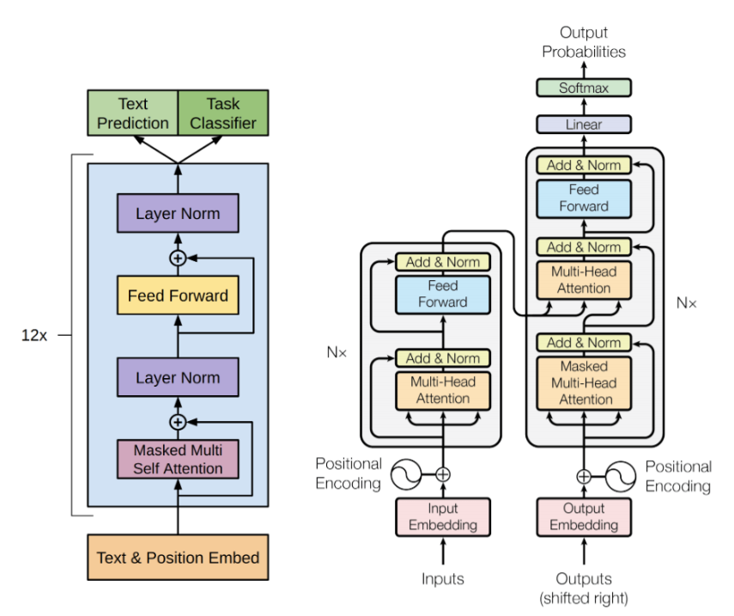

Figure 8.2

**CHAPTER 9**

**FUTURE SCOPE AND BUISNESS MODEL**

**9.1 FUTURE SCOPE**

Our vision for WELLNESSWHIZ is to go beyond being just a chatbot and transform it into a comprehensive medical assistant for individuals. Our primary focus in the healthcare industry will be on mental health, an area that is often overlooked despite its significant impact on people's lives. It is concerning to see an increasing number of teenagers experiencing depression due to the fast-paced nature of our world.

Our goal is to make WELLNESSWHIZ **a platform that allows patients from anywhere in the world to consult with doctors through video conferencing.** By eliminating the barrier of physical distance, individuals can receive timely consultations and proper treatment for their mental health concerns. We believe this accessibility will be crucial in reaching those who might not otherwise have access to mental healthcare.

Additionally, we plan to provide **SOS VIDEO LESSONS**, which will offer step-by-step guidance on responding to emergency situations such as heart attacks or fluctuating blood sugar levels. These lessons will equip individuals with the knowledge and skills necessary to take immediate action and potentially save lives.

We understand the importance of **education in promoting mental health awareness.** Therefore, we will incorporate resources, self-assessment tools, and educational materials within WELLNESSWHIZ to empower users to prioritize their mental well-being. It is essential that we create a safe and non-judgmental space within the chatbot to foster open discussions about mental health.

To ensure the highest level of credibility and effectiveness**, we will collaborate with mental health professionals, therapists, and psychologists.** Their expertise will guide the development of WELLNESSWHIZ, ensuring that the advice and recommendations align with best practices and professional standards.

In emergency situations where a patient requires a specific blood type that is not readily available in local blood banks, it can be extremely challenging to locate suitable donors. To address this issue, our WELLNESSWHIZ chatbot aims to provide assistance by connecting patients with nearby individuals who have the required blood type. This feature will greatly facilitate the process of finding compatible blood donors, potentially saving lives through the power of WELLNESSWHIZ.

In addition, we have plans to implement a comprehensive database to store information and data of our patients, including their chat interactions with the chatbot. This database will serve as a valuable resource, enabling our chatbot to recognize users and retrieve their medical and testing history. By having access to this information beforehand, WELLNESSWHIZ will be able to offer personalized medication recommendations and provide tailored advice in accordance with the user's medical background. This approach will enhance the quality and relevance of the guidance provided by our chatbot, improving the overall user experience and ensuring that users receive appropriate and customized support.

We also emphasize the significance of user privacy and data security. Implementing robust security measures, securing user consent, and adhering to data protection regulations will be our top priorities.

Through continuous testing, user feedback, and improvement, we aim to create a chatbot that not only serves as a medical assistant but also acts as a reliable companion in supporting individuals' mental health needs. It is important to note that while WELLNESSWHIZ can provide valuable guidance, seeking professional medical advice remains essential for accurate diagnosis and treatment.

**9.2 BUISNESS MODEL**

Our chatbot, Wellness Whiz, not only serves as a conversational tool but also follows a well-defined business model. When patients opt for video conferencing consultations with doctors through our platform, we will charge a basic subscription fee to facilitate these appointments and video conferences. In addition, we will provide patients with the convenience of purchasing prescribed medications through our platform.

To ensure a comprehensive healthcare ecosystem, we will also collaborate with various hospitals and doctors who will pay a subscription fee to be available on our platform. This partnership benefits both our platform and the healthcare providers, as it expands their reach and allows them to connect with a broader patient base.

Moreover, we understand the complexities of medical insurance claims, and thus, we aim to assist our customers in navigating the process of claiming medical insurance. Our platform will provide guidance and support to users, making it easier for them to utilize their insurance coverage effectively.

By leveraging our users' medical history, we will be able to recommend appropriate medications tailored to their specific needs. This personalized approach ensures that users receive optimal care based on their individual health background.

Furthermore, we plan to establish partnerships with laboratories and hospitals, enabling us to help users book tests at these facilities. This streamlined process benefits both the users and the associated healthcare establishments, fostering a mutually beneficial relationship.

Through this business model, Wellness Whiz aims to provide a comprehensive healthcare solution that benefits patients, doctors, hospitals, and laboratories, ensuring convenient access to medical services, personalized care, and a seamless experience for all parties involved.

**CHAPTER 10**

**CONCLUSION**

In summary, the development of the healthcare chatbot "Wellness Whiz" has resulted in a successful and effective tool for providing personalized healthcare assistance. Leveraging the power of artificial intelligence and advanced transformer models, the chatbot offers accurate information, appointment scheduling, medication reminders, and lifestyle tips. User examples have shown the chatbot's reliability and ability to address various healthcare concerns. The continuous availability of the chatbot ensures convenient access to support. The project highlights the potential of AI chatbots in transforming healthcare delivery and empowering users. Further refinement and user feedback will contribute to ongoing improvement and adaptation to evolving healthcare needs. The integration of AI chatbot technology in the healthcare domain offers new possibilities for enhanced healthcare access and support.

**REFRENCES**

[1] <https://en.wikipedia.org/wiki/Chatbot>

[2 https://github.com/Soulter/hugging-chat-api]

[3] https://huggingface.co/

[4] https://www.foreseemed.com/artificial-intelligence-in-healthcare

[5] https://www.python.org/

[6] https://pandas.pydata.org/

[7] https://numpy.org/

[8] https://flask.palletsprojects.com/en/2.3.x/

[9] <https://www.globenewswire.com/en/news->

[10] <https://www.techspian.com/blog/how-medical-chatbots-benefitted-to-the-healthcare>

[11] https://ai.facebook.com/blog/large-language-model-llama-meta-ai/

[12] https://huggingface.co/docs/transformers/main/model_doc/llama

[13] https://en.wikipedia.org/wiki/LLaMA

[14] https://en.wikipedia.org/wiki/Flask_(web_framework)

[15] https://www.h5py.org/

[16] ] http://www.gevent.org/

[17] https://www.geeksforgeeks.org/how-to-use-google-colab/

[18]<https://www.geeksforgeeks.org/introduction-deep-learning/>

[19]https://projects.nips.cc/project/4824-imagenet-classification-with-deep-convolutionalneural-networks.pdf

[20]<https://www.geeksforgeeks.org/introduction-convolution-neural-network/>

[21]<https://towardsdatascience.com/an-overview-of-resnet-and-its-variants-5281e2f56035>

[22]<https://medium.com/@realmichaelye/intuition-for-resnet-deep-residual-learning-forimage-recognition-39d24d173e78>

[23]<https://towardsdatascience.com/introduction-to-resnets-c0a830a288a4>

[24]<https://machinelearningmastery.com/transfer-learning-for-deep-learning/>

[25]<https://towardsdatascience.com/a-comprehensive-hands-on-guide-to-transfer-learningwith-real-world-applications-in-deep-learning-212bf3b2f27a>

[26]<https://towardsdatascience.com/what-is-transfer-learning-8b1a0fa42b4>

[27]<http://pages.cs.wisc.edu/~shavlik/abstracts/torrey.handbook09.abstract.html>

[28]<https://www.cse.ust.hk/~qyang/Docs/2009/tkde_transfer_learning.pdf>

[29]<https://steelkiwi.com/blog/python-for-ai-and-machine-learning/>

[30] https://www.python.org/

[31]<https://towardsdatascience.com/a-comprehensive-guide-to-convolutional-neuralnetworks-the-eli5-way-3bd2b1164a53>

[32]<https://en.wikipedia.org/wiki/Residual_neural_network>

[33]<https://en.wikipedia.org/wiki/Transfer_learning>

[34]<https://numpy.org/>

[35]https://pandas.pydata.org/ [36]https://en.wikipedia.org/wiki/TensorFlow

<https://en.wikipedia.org/wiki/Project_Jupyter>

[36] https://en.wikipedia.org/wiki/OpenCV

[37] https://en.wikipedia.org/wiki/Keras

[38] https://en.wikipedia.org/wiki/OpenCV

[39] <https://en.wikipedia.org/wiki/Residual_neural_network>

[40] Zhang, Y., & Li, X. (2020). Chatbot in healthcare: A comprehensive review. Healthcare Informatics Research, 26(3), 143-154. [Link: https://pubmed.ncbi.nlm.nih.gov/32621583/]

[41]Patel, S., & Srinivasan, R. (2020). Healthcare chatbots: A systematic review. Health Informatics Journal, 26(4), 3068-3084. [Link: https://pubmed.ncbi.nlm.nih.gov/32517460/]

[42] Laranjo, L., et al. (2018). Conversational agents in healthcare: A systematic review. Journal of the American Medical Informatics Association, 25(9), 1248-1258. [Link: https://academic.oup.com/jamia/article/25/9/1248/5046440]

[43] Finn, C., Abbeel, P., & Levine, S. (2017). Model-agnostic meta-learning for fast adaptation of deep networks. Proceedings of the 34th International Conference on Machine Learning, 70, 1126-1135. [Link: <https://proceedings.mlr.press/v70/finn17a/finn17a.pdf>]

[44] Wolf, T., et al. (2020). Transformers: State-of-the-art natural language processing. Proceedings of the 2020 Conference on Empirical Methods in Natural Language Processing: System Demonstrations, 54-60. [Link: <https://www.aclweb.org/anthology/2020.emnlp-demos.6/>

[45] Sim, H. S., & Kang, J. S. (2020). The impact of healthcare chatbots on patient engagement: An exploratory study. International Journal of Environmental Research and Public Health, 17(22), 8515. [Link: <https://www.mdpi.com/1660-4601/17/22/8515>]

[46] Liao, Q. V., et al. (2019). Natural language processing frameworks for developing conversational agents in healthcare. Journal of Biomedical Informatics, 94, 103202. [Link: https://pubmed.ncbi.nlm.nih.gov/31153818/]

[47] Denecke, K., & Deng, Y. (2020). Quality evaluation of chatbots and intelligent conversational agents in health care. JMIR Medical Informatics, 8(2), e15712. [Link: https://medinform.jmir.org/2020/2/e15712]

[48] Cramer, H., et al. (2020). Ethical considerations for conversational agents in healthcare: Exploring expert perspectives and identifying future challenges. Journal of Medical Internet Research, 22(10), e18758. [Link: https://www.jmir.org/2020/10/e18758]

[49] Budalakoti, S., et al. (2018). Chatbot for Health Care: A Comprehensive Review. International Journal of Engineering & Technology, 7(4.41), 234-239.

[50] Vaid, S., et al. (2020). Healthcare Chatbot Systems: A Systematic Review. Health Informatics Journal, 26(4), 2695-2716.

[51] Chen, C., & Jansen, B. (2019). Design and Implementation of a Smart Healthcare Chatbot System. Journal of Healthcare Engineering, 2019, 1-10.