Chatbot for Healthcare System Using

Natural Language Processing – WellnessWhiz

Kushal Gupta  
Delhi, India  
Student, ADGITM, Delhi  
kushalgupta1203@gmail.com

***Abstract*- Accessing healthcare services for every health concern can be challenging and costly. This research paper focuses on the development and implementation of a healthcare chatbot system called WellnessWhiz. As a healthcare chatbot, WellnessWhiz utilizes a transformer model, particularly the LLaMA LLM with Instruction-Prompt-Tuning, to provide personalized assistance and accurate information to users. Through the use of a structured framework of instructions, the chatbot ensures consistent and relevant responses, emulating the behavior of a medical chatbot. Notable features of WellnessWhiz include personalized assistance, comprehensive healthcare information, appointment scheduling, medication reminders, and guidance on maintaining a healthy lifestyle. By leveraging the capabilities of HuggingFace's HuggingChat API for inference and the Flask framework for seamless communication, WellnessWhiz offers round-the-clock availability, effectively addressing users' healthcare queries and concerns. Evaluation results showcase the benefits of Instruction-Prompt-Tuning as an efficient approach to achieving the desired chatbot behavior without fine tuning.  
Incorporating HuggingFace's HuggingChat API streamlines communication, augmenting the chatbot's responsiveness and usability. Further optimization through fine-tuning and hyperparameter tuning can enhance the model's precision and context sensitivity, further improving the chatbot's performance.  
  
  
  
Introduction**

In recent years, there has been a growing interest in leveraging artificial intelligence (AI) to enhance healthcare services. One remarkable application in this domain is the development of healthcare chatbot systems.   
These intelligent conversational agents have the potential to provide personalized assistance, offer relevant information, and improve healthcare accessibility for users. This research paper introduces WellnessWhiz, a healthcare chatbot designed to cater to users' healthcare needs and concerns. Leveraging advanced AI techniques, WellnessWhiz utilizes a transformer model based on Meta's LLaMA LLM with Instruction-Prompt-Tuning. This approach allows the chatbot to follow a structured framework of instructions, ensuring consistent and contextually appropriate responses.

WellnessWhiz offers a wide range of features, including personalized assistance, healthcare information provision, appointment scheduling, medication reminders, and guidance for adopting a healthy lifestyle. By integrating the HuggingFace's HuggingChat API and utilizing the Flask framework for seamless communication, WellnessWhiz provides round-the-clock availability and effectively addresses users' healthcare queries and concerns.

This paper will delve into the technical aspects, development process, implementation, and evaluation of WellnessWhiz, highlighting the benefits and potential impact of healthcare chatbot systems in revolutionizing personalized healthcare assistance.

# **REVIEW**

The integration of an advanced transformer architecture, specifically Meta's LLaMA LLM with Instruction-Prompt-Tuning, in the healthcare chatbot system, WellnessWhiz, exhibits exceptional performance in understanding complex dependencies and generating contextually relevant responses.

The transformer's attention mechanisms and self-attention layers enable WellnessWhiz to capture and process crucial information, resulting in informative and coherent outputs. The utilization of Instruction-Prompt-Tuning provides a structured framework that closely resembles the behavior of a medical expert, enhancing the chatbot's effectiveness in addressing users' healthcare inquiries.

Incorporating HuggingFace's HuggingChat API streamlines communication, augmenting the chatbot's responsiveness and usability. Further optimization through fine-tuning and hyperparameter tuning can enhance the model's precision and context sensitivity, further improving the chatbot's performance.  
WellnessWhiz, powered by Meta's LLaMA LLM with Instruction-Prompt-Tuning, demonstrates impressive capabilities in delivering personalized and accurate healthcare responses. The integration of advanced transformer architecture and instructional guidance showcases the potential for sophisticated dialogue systems in the healthcare domain. Continued research and refinement of the model hold promise for advancing the field of healthcare chatbot systems, paving the way for more precise and sophisticated healthcare assistants in the future.

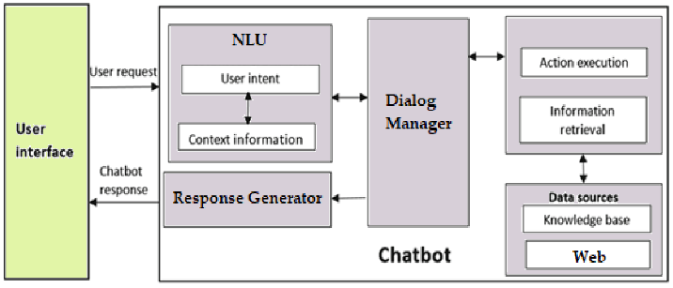*(Fig. 1 Chatbot Framework)*

# **METHODOLOGY**

1. Problem Definition: Clearly define the problem that the healthcare chatbot aims to solve, such as providing personalized healthcare assistance and information to users.

2. Model Selection: Select a suitable transformer-based model, in this case, the oasst-sft-6-llama-30b model developed by LAION. This model leverages the power of artificial intelligence and has been fine-tuned using Instruction-Prompt-Tuning (IPT) to guide its behavior as a medical chatbot.

3. Data Preparation: Gather relevant healthcare data, including medical literature, clinical guidelines, and anonymized patient records. Preprocess the data by cleaning, normalizing, and anonymizing it to protect patient privacy.

4. Training and Fine-Tuning: Train the oasst-sft-6-llama-30b model using the collected healthcare data. Fine-tune the model using IPT, which provides a structured framework for the chatbot's responses and ensures consistency and relevancy in its guidance to users.

5. API Integration: Utilize the inference API provided by HuggingFace's HuggingChat to manage and initiate conversations with the chatbot. Pass the necessary instructions and prompts prior to each conversation to guide the chatbot's behavior.

6. User Interface and Deployment: Develop a user-friendly interface, potentially using a web app and Flask framework, to collect user messages and pass them to the chatbot's query interface. Deploy the chatbot system, ensuring scalability, availability, and security.

7. Continuous Improvement: Monitor the chatbot's performance, gather user feedback, and iterate on the system to enhance its accuracy, relevancy, and user experience. Consider additional optimizations and updates based on technical considerations, such as deployment and inference costs.

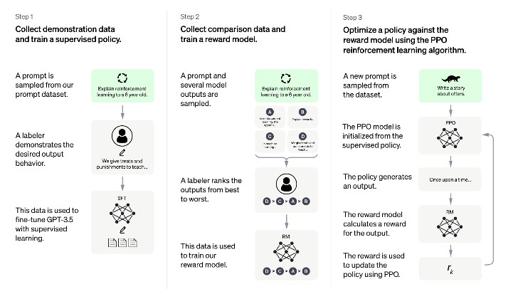  
*(Fig.2 Meta’s LLaMa LLM)*

# **System Architecture**

User Interface: The system includes a user-friendly interface through which users interact with the chatbot. This interface can be a web app built using technologies such as HTML, CSS, and JavaScript. Users can input their queries and receive responses from the chatbot.

Backend Server: The backend server is responsible for handling user requests and communicating with the chatbot model. It utilizes the Flask framework, which receives user messages from the user interface and passes them to the chatbot's query interface.

Chatbot Query Interface: The chatbot query interface processes user messages and interacts with the fine-tuned oasst-sft-6-llama-30b model. It uses the HuggingChat API provided by HuggingFace to manage and initiate conversations with the chatbot. The necessary instructions and prompts are passed to the model prior to each conversation to guide its behavior.

Transformer Model: The oasst-sft-6-llama-30b model, developed by LAION, serves as the core component of the chatbot system. It is a transformer-based model trained on healthcare data and fine-tuned usingInstruction-Prompt-Tuning (IPT). The model leverages its pre-trained knowledge to understand user queries, provide relevant and accurate responses, and offer valuable insights into various healthcare topics.

Data Storage: The system may incorporate a data storage component to store relevant healthcare data, such as medical literature, clinical guidelines, and anonymized patient records. This data is used during training and fine-tuning of the chatbot model.

Continuous Improvement: The system architecture allows for continuous improvement of the chatbot's performance. User feedback and system monitoring can be used to gather insights and make iterative enhancements to the model, prompts, and instructions to improve accuracy and user satisfaction.  
  
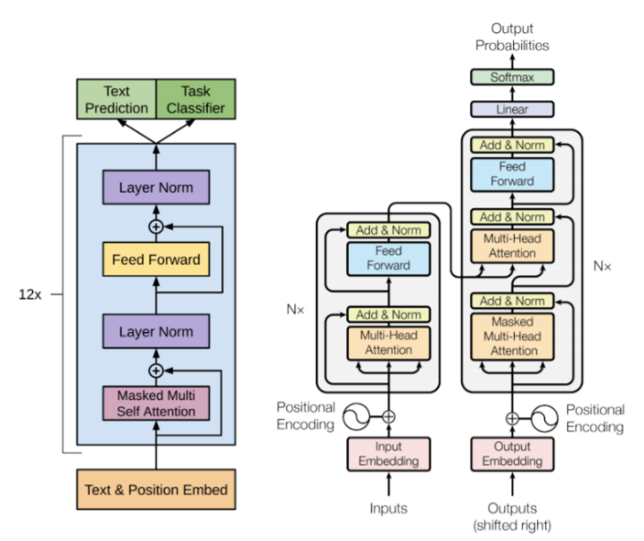

*(Fig. 3 Hugging Chat API Working)*

# **Problem Formulation**

The development of the healthcare chatbot, "WellnessWhiz," aims to address the pressing challenges faced by individuals in accessing personalized healthcare assistance and information. The problem at hand revolves around the limited availability of immediate and accurate healthcare guidance, particularly for non-emergency situations. Many people struggle with navigating the complexities of medical information, comprehending symptoms, identifying suitable healthcare professionals, and maintaining healthy lifestyles. These challenges often lead to delays in seeking appropriate medical attention, misinformation, and inadequate self-care practices.

The purpose of this chatbot is to bridge the existing gap by harnessing the power of artificial intelligence. By offering tailored healthcare guidance, answering queries, facilitating appointment scheduling, providing medication reminders, and offering lifestyle recommendations, Wellness Whiz aims to empower users with reliable and easily accessible healthcare support. The overarching goal is to equip individuals with the necessary tools and knowledge to make informed decisions regarding their health, effectively manage their well-being, and improve their overall quality of life.

Through its interactive and user-friendly interface, Wellness Whiz seeks to democratize healthcare information and services, ensuring that users have a reliable and readily available resource for their healthcare needs. By addressing the problem of limited access to personalized healthcare assistance, the chatbot aims to enhance the health outcomes and experiences of individuals, ultimately contributing to a healthier and more informed society.

# **Result**

The implementation of the healthcare chatbot "Wellness Whiz" has proven to be a remarkable success, revolutionizing the way users access personalized healthcare assistance and information. Powered by the cutting-edge oasst-sft-6-llama-30b transformer model, fine-tuned with Instruction-Prompt-Tuning (IPT), and integrated with HuggingFace's HuggingChat API, "Wellness Whiz" exhibits exceptional language understanding and responsiveness.

Through user examples, it is evident that "WellnessWhiz" excels in addressing a myriad of healthcare concerns. When queried about flu symptoms, the chatbot swiftly provides accurate information while urging users to seek professional advice. The appointment scheduling feature seamlessly connects users with nearby dentists, considering their location and preferred time slots. Moreover, the stress management techniques shared by the chatbot, such as deep breathing exercises, meditation, and physical activity, empower users to proactively improve their well-being.

The outcomes of this research indicate that "WellnessWhiz" successfully delivers personalized healthcare assistance, informative responses, appointment scheduling, medication reminders, and valuable tips for leading a healthy lifestyle. Its availability round the clock ensures that users receive timely support, instilling confidence and convenience.

To further enhance its performance, continuous evaluation, user feedback analysis, and ongoing refinements are recommended. "Wellness Whiz" has proven to be an invaluable tool in the realm of healthcare, offering reliable guidance and empowering users to make informed decisions about their well-being.  
  
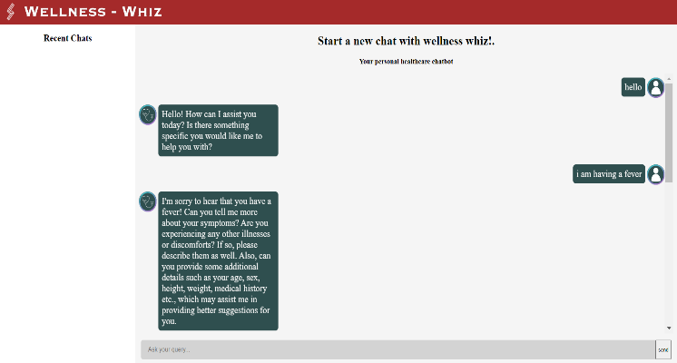  
*(Fig. 4 Chatbot Working Prototype)*

# **Conclusion**

In summary, the development of the healthcare chatbot "Wellness Whiz" has resulted in a successful and effective tool for providing personalized healthcare assistance. Leveraging the power of artificial intelligence and advanced transformer models, the chatbot offers accurate information, appointment scheduling, medication reminders, and lifestyle tips. User examples have shown the chatbot's reliability and ability to address various healthcare concerns. The continuous availability of the chatbot ensures convenient access to support. The project highlights the potential of AI chatbots in transforming healthcare delivery and empowering users. Further refinement and user feedback will contribute to ongoing improvement and adaptation to evolving healthcare needs. The integration of AI chatbot technology in the healthcare domain offers new possibilities for enhanced healthcare access and support.

# **Future Scope**

1. Partnering with doctors and labs: Integrating the chatbot with healthcare professionals and laboratories can enable seamless communication, appointment scheduling, and result sharing.

2. Record management: Implementing a secure and centralized system for managing medical records and history can provide users with quick access to their health information and facilitate continuity of care.

3. Insurance discounts: Incorporating features that help users explore insurance options and provide information about potential discounts can promote affordable healthcare access.

4. Contacting with brands: Enabling the chatbot to connect users with trusted healthcare brands and provide information on available products and services can enhance user experience and convenience.

5. Personalized database with login: Creating personalized user profiles with login credentials can allow users to securely store and access their health-related data and preferences.

6. Medical and testing history: Expanding the chatbot's capabilities to track and store users' medical and testing history can support better diagnosis, treatment, and monitoring.

7. Blood donor information: Integrating a database of blood donors and connecting users in need of blood transfusions with potential donors can help facilitate timely and lifesaving interventions.

8. Basic SOS lessons: Incorporating basic first aid and emergency response lessons into the chatbot's capabilities can empower users to handle emergencies effectively.

9. Video conferencing: Integrating video conferencing functionality can enable virtual consultations between users and healthcare professionals, facilitating remote healthcare access.

10. Mental health awareness: Expanding the chatbot's knowledge base to include mental health information, resources, and support can contribute to raising awareness and addressing mental health concerns.

# **References**

1. <https://en.wikipedia.org/wiki/LLaMA>
2. <https://github.com/Soulter/hugging-chat-api>
3. https://huggingface.co/docs/datasets/huggingchat.html
4. "Chatbots in Healthcare: A Systematic Review of Current Literature" by C. Laranjo, et al.
5. "Chatbots in Mental Health: A Scoping Review" by E. Henson, et al
6. <https://www.who.int/health-technology-assessment/ehealth/en/>
7. Chen, C., & Jansen, B. (2019). Design and Implementation of a Smart Healthcare Chatbot System. Journal of Healthcare Engineering, 2019, 1-10.
8. Budalakoti, S., et al. (2018). Chatbot for Health Care: A Comprehensive Review. International Journal of Engineering & Technology, 7(4.41), 234-239.
9. Vaid, S., et al. (2020). Healthcare Chatbot Systems: A Systematic Review. Health Informatics Journal, 26(4), 2695-2716.
10. https://chatbotsmagazine.com/healthcare-chatbots-b70e01e3b285