**Assignment 05: Assignment and practice of AI Image Generator**

**Task 1: Comparative Research – DALL·E vs Midjourney :**

| **Criteria** | **DALL·E (OpenAI)** | **Midjourney** |
| --- | --- | --- |
| **1.Image Quality** | ✅ *High quality*, photorealistic or artistic based on prompt. DALL·E 3 especially shows vast improvement in detail and coherence. | 🌟 *Exceptional image quality*, especially for artistic and stylistic renders. Often considered more visually striking and stylized. |
| **2.Prompt Accuracy** | ✅ Very accurate with detailed prompts. DALL·E 3 integrates with ChatGPT, enhancing interpretation of complex prompts. | ⚠️ High-quality visuals, but occasionally drifts from prompt details unless phrased very carefully. It can prioritize aesthetic over literal accuracy. |
| **3.Style Flexibility** | ✅ Supports a wide range: photorealism, cartoon, sketch, abstract, etc. | 🌟 Extremely versatile with artistic styles, particularly strong in fantasy, sci-fi, surrealism, and painterly effects. |
| **4. Usability** | ✅ Integrated into ChatGPT (Pro users), simple interface, no technical skills needed. Works via web UI. | ⚠️ Requires Discord to use, which can be less intuitive. Uses slash commands and image grids, which may confuse beginners. |
| **5. Licensing & Terms** | ✅ Commercial use allowed, including for images generated with DALL·E 3. Users retain rights, subject to OpenAI's use policies. | ⚠️ Paid users get commercial rights, but some content may be publicly viewable on Discord unless settings are adjusted. Tied to Midjourney’s Terms of Service. |

**Prompt:** *"A steampunk city under moonlight with flying airships and glowing lanterns."*

| ***Generator*** | ***Output Summary*** |
| --- | --- |
| ***DALL·E 3*** | *Produces a clean, cohesive cityscape with Victorian-industrial architecture. Moonlight is clearly depicted. Airships and lanterns appear realistically integrated. Works well with both photorealism and stylized art if prompted.* |
| ***Midjourney v6*** | *Stunning visuals with dramatic lighting and highly imaginative details. Airships look elaborate. Sometimes more "concept art" than literal scene. Consistently produces cinematic and atmospheric images.* |

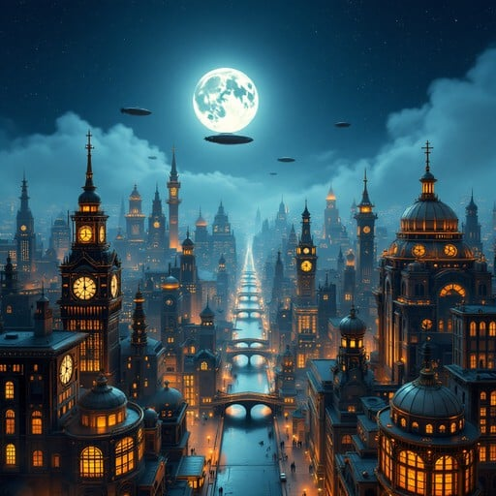

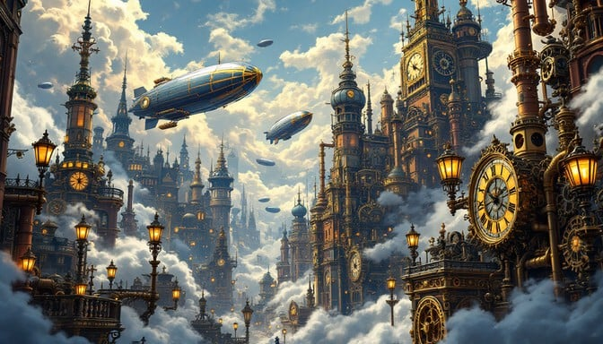

***Task 2: Visual Design Project***

* Creating a poster for a fictional event of dance by next month that is february at pune by 10:00am.

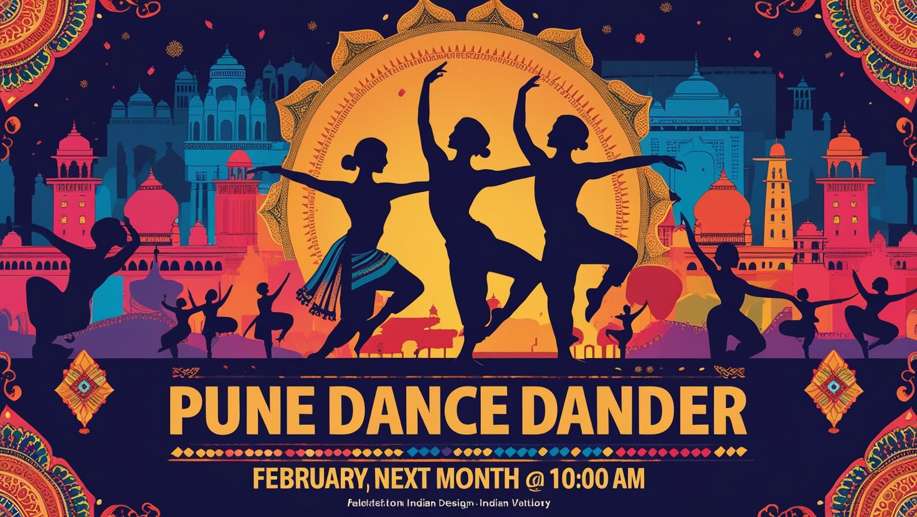

* Generate concept art for an educational topic -

**Future Classrooms** – AI teachers, hologram books, VR learning pods.

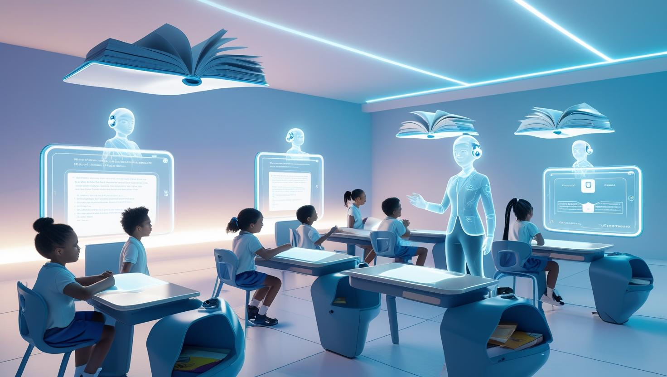

* **Design a visual story using 3 image prompts**

Generate 3 images as

Image 1 (Beginning): A child sitting under a tree with books scattered, a glowing spark rising from the pages.

Image 2 (Middle): The spark transforms into a giant luminous bird carrying the child across a sky full of equations, inventions, and maps.

Image 3 (End): The bird lands at a futuristic city of learning, where books float like planets and knowledge flows as rivers of light.

