**INDEX**

|  |  |  |  |
| --- | --- | --- | --- |
| **SR.NO** | **NAME OF THE PROGRAM** | **DATE** | **SIGNATURE** |
| **1.** | **Working with basic C# and ASP .NET** |  |  |
| a. | Create an application that obtains four int values from the user and displays the product. |  |  |
| b. | Create an application to demonstrate string operations. |  |  |
| c. | Create an application to demonstrate following operations  i. Generate Fibonacci series. ii. Test for prime numbers.  iii. Test for vowels. iv. Use of foreach loop with arrays  v. Reverse a number and find sum of digits of a number. |  |  |
| **2.** | **Working with Object Oriented C# and ASP**  **.NET** |  |  |
| a. | Create simple application to perform following operations  i . Finding factorial Value  ii. Money Conversion  Iii.Quadratic Equation  iv.Temperature Conversion |  |  |
| **3.** | **Working with Web Forms and Controls** |  |  |
| a. | Create a simple web page with various sever controls to demonstrate setting and use of their properties. (Example : AutoPostBack) |  |  |
| b. | Demonstrate the use of Calendar control to perform following operations.  a) Display messages in a calendar control b)  Display vacation in a calendar control  Selected day in a calendar control using style  Difference between two calendar dates . |  |  |
| c. | Demonstrate the use of Treeview control perform following operations.  a) Treeview control and datalist b) Treeview operations . |  |  |
| **4.** | **Working with Form Controls** |  |  |
| a. | Create a Registration form to demonstrate use of  various Validation controls. |  |  |
| b. | Create Web Form to demonstrate use of  Adrotator Control . |  |  |
| c. | Create Web Form to demonstrate use User Controls. |  |  |
| **5** | **Working with Navigation, Beautification and**  **Master page.** |  |  |
| a. | Create Web Form to demonstrate use of Website Navigation controls and Site Map. |  |  |
| b. | Create a web application to demonstrate use of Master Page with applying Styles and Themes for page beautification. |  |  |
| c. | Create a web application to demonstrate various states of ASP.NET Pages. |  |  |

|  |  |  |  |
| --- | --- | --- | --- |
| **6.** | **Working with Database.** |  |  |
| a. | Create a web application bind data in a multiline textbox by querying in another textbox. |  |  |
| b. | Create a web application to display records by using database. |  |  |
| c. | Demonstrate the use of Datalist link control. |  |  |
| 7. | **Working with Database** |  |  |
| a. | Create a web application to display Databinding  using dropdownlist control. |  |  |
| b. | Create a web application for to display the phone no of an author using database. |  |  |
| c. | Create a web application for inserting and  deleting record from a database. (Using Execute- Non Query). |  |  |
| 8. | **Working with data controls** |  |  |
| a. | Create a web application to demonstrate various uses and properties of SqlDataSource. |  |  |
| b. | Create a web application to demonstrate data binding using DetailsView and FormView Control. |  |  |
| c. | Create a web application to demonstrate data binding using DetailsView and FormView Control. |  |  |

# **Practical No:01**

# **Working with basic C# and ASP .NET**

1. **Create an application that obtains four int values from the user and displays the product.**

#### **pract1a.aspx-**

<%@ Page Language="C#" AutoEventWireup="true" CodeFile="Default.aspx.cs" Inherits="_Default" %>

<!DOCTYPE html PUBLIC "-//W3C//DTD XHTML 1.0 Transitional//EN" ["http:/](http://www.w3.org/TR/xhtml1/DTD/xhtml1-transitional.dtd)/[www.w3.org/TR/xhtml1/DTD/xhtml1-transitional.dtd](http://www.w3.org/TR/xhtml1/DTD/xhtml1-transitional.dtd)">

<html xmlns="<http://www.w3.org/1999/xhtml>">

<head runat="server">

<title></title></head>

<body>

<form id="form1" runat="server"><div>

<asp:Label ID="label1" runat="server">Enter First Number</asp:Label>

<asp:TextBox ID="textBox1" runat="server"></asp:TextBox><br />

<asp:Label ID="label2" runat="server">Enter Second Number</asp:Label>

<asp:TextBox ID="textBox2" runat="server"></asp:TextBox><br />

<asp:Label ID="label3" runat="server">Enter Third Number</asp:Label>

<asp:TextBox ID="textBox3" runat="server"></asp:TextBox><br />

<asp:Label ID="label4" runat="server">Enter Fourth Number</asp:Label>

<asp:TextBox ID="textBox4" runat="server"></asp:TextBox>

<br /><br />

<asp:Button ID="submit" runat="server" Text="Calculate"

onclick="submitButton_Click"/>

<br /><br />

<asp:Label ID="result" runat="server"></asp:Label>

</div></form></body>

</html>

#### **pract1a.aspx.cs-**

using System;

using System.Collections.Generic; using System.Linq;

using System.Web; using System.Web.UI;

using System.Web.UI.WebControls;

public partial class _Default : System.Web.UI.Page

{

protected void Page_Load(object sender, EventArgs e)

{

}

protected void submitButton_Click(object sender, EventArgs e)

{

Int num1 = Convert.ToInt32(textBox1.Text.ToString()); int num2 = Convert.ToInt32(textBox2.Text.ToString()); int num3 = Convert.ToInt32(textBox3.Text.ToString()); int num4 = Convert.ToInt32(textBox4.Text.ToString());

int product = num1 * num2 * num3 * num4; result.Text = "Product of numbers : " + product;

}}

#### **Output:**

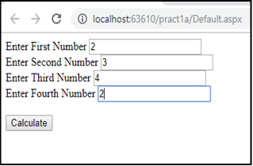 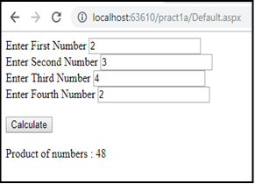

## **Create an application to demonstrate string operations.**

#### **Deafult.aspx**

<%@ Page Language="C#" AutoEventWireup="true" CodeFile="Default.aspx.cs" Inherits="pract1b" %>

<!DOCTYPE html PUBLIC "-//W3C//DTD XHTML 1.0 Transitional//EN" ["http:/](http://www.w3.org/TR/xhtml1/DTD/xhtml1-transitional.dtd)/[www.w3.org/TR/xhtml1/DTD/xhtml1-transitional.dtd](http://www.w3.org/TR/xhtml1/DTD/xhtml1-transitional.dtd)">

<html xmlns="<http://www.w3.org/1999/xhtml>">

<head id="Head1" runat="server">

<title></title>

</head>

<body>

<form id="form1" runat="server"><div>

<asp:Label ID="label1" runat="server">Enter First String</asp:Label>

<asp:TextBox ID="textBox1" runat="server" ></asp:TextBox>

<br /><br />

<asp:Label ID="label2" runat="server">Enter Second String</asp:Label>

<asp:TextBox ID="textBox2" runat="server"></asp:TextBox>

<br /><br />

<asp:DropDownList ID="DropDownList1" runat="server" AutoPostBack="true"

onselectedindexchanged="DropDownList1_SelectedIndexChanged">

<asp:ListItem >Concate</asp:ListItem>

<asp:ListItem>UpperCase</asp:ListItem>

<asp:ListItem>LowerCase</asp:ListItem>

<asp:ListItem>Reverse</asp:ListItem>

<asp:ListItem>Length</asp:ListItem>

<asp:ListItem>IsEmpty</asp:ListItem>

</asp:DropDownList>

<br /><br />

<asp:Button ID="Submit" runat="server" Text="Submit" onclick="Submit_Click" style="height: 26px" />

<br /><br />

<asp:Label ID="result" runat="server"></asp:Label>

</div>

</form>

</body>

</html>

#### **Design**

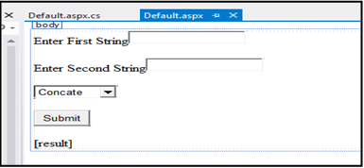

**Default.aspx.cs**

using System;

using System.Collections.Generic; using System.Linq;

using System.Web; using System.Web.UI;

using System.Web.UI.WebControls;

public partial class pract1b : System.Web.UI.Page

{

protected void Page_Load(object sender, EventArgs e)

{

}

protected void DropDownList1_SelectedIndexChanged(object sender, EventArgs e)

{

}

protected void Submit_Click(object sender, EventArgs e)

{

String str1 = textBox1.Text.ToString(); String str2 = textBox2.Text.ToString();

if (DropDownList1.SelectedItem.Text.Equals("Concate"))

{

result.Text = "Concatinate String : " + (str1 + str2);

}

else if (DropDownList1.SelectedItem.Text.Equals("UpperCase"))

{

result.Text = "<br>" + "Upper case of String :" + "<br>" + (str1.ToUpper() + " " + str2.ToUpper());

}

else if (DropDownList1.SelectedItem.Text.Equals("LowerCase"))

{

result.Text = "<br>" + "Lower case of String :" + "<br>" + str1.ToLower() + " " + str2.ToLower();

}

else if (DropDownList1.SelectedItem.Text.Equals("Length"))

{

result.Text = "<br>" + "Length of first string " + str1 + ":<br>" + str1.Length;

}

else if (DropDownList1.SelectedItem.Text.Equals("IsEmpty"))

{

if (String.IsNullOrEmpty(str1) && String.IsNullOrEmpty(str2))

{

result.Text = "<br>" + "Both the textbox is empty";

}

else if (String.IsNullOrEmpty(str1))

{

result.Text = "TextBox 1 is Empty";

}

else if (String.IsNullOrEmpty(str2))

{

result.Text = "TextBox 2 is Empty";

}

else

{

result.Text = "None of the TextBox is Empty";

} }

else

{

String reverse1 = new string(str1.Reverse().ToArray()); String reverse2 = new string(str2.Reverse().ToArray()); result.Text = "Reverse of 1st string :" + reverse1;

} } }

**Output:**

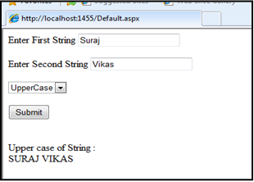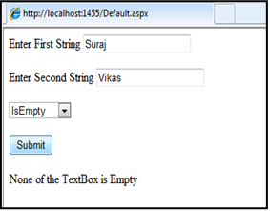

## **Create an application to demonstrate following operations**

### i. Generate Fibonacci series. ii. Test for prime numbers.

iii. Test for vowels. iv. Use of foreach loop with arrays

### v. Reverse a number and find sum of digits of a number.

#### **Default.apsx**

<%@ Page Language="C#" AutoEventWireup="true" CodeFile="Default.aspx.cs" Inherits="pract1c" %>

<!DOCTYPE html PUBLIC "-//W3C//DTD XHTML 1.0 Transitional//EN" ["http:/](http://www.w3.org/TR/xhtml1/DTD/xhtml1-transitional.dtd)/[www.w3.org/TR/xhtml1/DTD/xhtml1-transitional.dtd](http://www.w3.org/TR/xhtml1/DTD/xhtml1-transitional.dtd)">

<html xmlns="<http://www.w3.org/1999/xhtml>">

<head id="Head1" runat="server">

<title></title>

</head><body>

<form id="form1" runat="server">

<div>

<asp:Label ID="label1" runat="server">Enter First String</asp:Label> &nbsp;&nbsp;&nbsp;

<asp:TextBox ID="textBox1" runat="server"></asp:TextBox><br />

<br />

select your operation :

<br />

<asp:DropDownList ID="DropDownList1" runat="server" AutoPostBack="true"

>

<asp:ListItem >Fibonacci</asp:ListItem>

<asp:ListItem>prime</asp:ListItem>

<asp:ListItem>vowels</asp:ListItem>

<asp:ListItem> foreach loop</asp:ListItem>

<asp:ListItem>Reverse and Find sum of Digit</asp:ListItem>

</asp:DropDownList>

<br /><br />

<asp:Button ID="Submit" runat="server" Text="Submit" onclick="Submit_Click"

/>

<br /><br />

<asp:Label ID="result" runat="server"> </asp:Label>

</div>

</form></body>

</html>

#### **Design**:

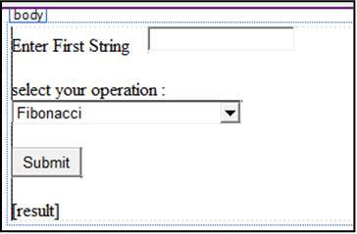

**Deafult.aspx.cs**

using System;

using System.Collections.Generic; using System.Linq;

using System.Web; using System.Web.UI;

using System.Web.UI.WebControls;

public partial class pract1c : System.Web.UI.Page

{

protected void Page_Load(object sender, EventArgs e)

{

}

protected void Submit_Click(object sender, EventArgs e)

{

if (DropDownList1.SelectedItem.Text.Equals("Fibonacci"))

{

int usrInputNumber = Convert.ToInt32(textBox1.Text.ToString()); int firstNo = 0;

int secondNo = 1; int sum = 0;

Response.Write("fibonnaci series : " + firstNo + ", " + secondNo); int i = 2;

while (i < usrInputNumber)

{

sum = firstNo + secondNo; Response.Write(", " + sum); firstNo = secondNo; secondNo = sum;

i++;

} }

else if (DropDownList1.SelectedItem.Text.Equals("prime"))

{

int num1 = Convert.ToInt32(textBox1.Text.ToString()); int i;

for (i = 2; i < num1 - 1; i++)

{

if (num1 % i == 0) break;

}

if (i < num1 - 1)

{

result.Text = "IS NOT A PRIME NUMBER";

}

else

{

result.Text = "A PRIME NUMBER";

}}

else if (DropDownList1.SelectedItem.Text.Equals("vowels"))

{

string str = textBox1.Text.ToString().ToLower(); int c = 0;

for (int i = 0; i < str.Length; i++)

{

if ((str.Substring(i, 1)) == "a" || (str.Substring(i, 1)) == "e" || (str.Substring(i, 1)) == "i" || (str.Substring(i, 1)) == "o" || (str.Substring(i, 1)) == "u")

{ c++;

} }

result.Text = ("Total number of vowels in " + str + " is " + c);

}

else if (DropDownList1.SelectedItem.Text.Equals("Reverse and Find sum of Digit"))

{

int num1 = Convert.ToInt32(textBox1.Text.ToString()); int reverse = 0;

int sum = 0;

while (num1 != 0)

{

int remainder = num1 % 10; reverse = reverse * 10 + remainder; sum = remainder + sum;

num1 = num1 / 10;

}

result.Text = "<br>" + "Reverse of entered number is " + reverse + "<br>" + "Sum of digits is" + sum;

}

else{

String s = textBox1.Text.ToString(); foreach (char c in s)

{

Response.Write("<br>" + c);

} } } }

Output:

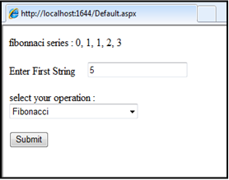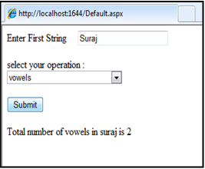

# **Practical No:02**

## **Working with Object Oriented C# and ASP .NET**

**a) Create simple application to perform following operations**

### i. Finding factorial Value ii. Money Conversion

iii. Quadratic Equation iv. Temperature Conversion

#### **Finding factorial Value**

**Default.aspx**

<%@ Page Language="C#" AutoEventWireup="true" CodeFile="Default.aspx.cs" Inherits="Default" %>

<!DOCTYPE html PUBLIC "-//W3C//DTD XHTML 1.0 Transitional//EN" ["http:/](http://www.w3.org/TR/xhtml1/DTD/xhtml1-transitional.dtd)/[www.w3.org/TR/xhtml1/DTD/xhtml1-transitional.dtd](http://www.w3.org/TR/xhtml1/DTD/xhtml1-transitional.dtd)">

<html xmlns="<http://www.w3.org/1999/xhtml>">

<head id="Head1" runat="server">

<title></title></head>

<body>

<form id="form1" runat="server">

<div align="center">

<asp:Label ID="Label1" runat="server" Text="Enter a Number:"></asp:Label>

<asp:TextBox ID="TextBox1" runat="server" Width="147px"></asp:TextBox>

<br />

<asp:Button ID="Button1" runat="server" onclick="Button1_Click" Text="Factorial" /><br />

<asp:Label ID="Label2" runat="server"></asp:Label>

</div></form>

</body>

</html>

#### **Design**

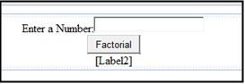

**Default.aspx.cs**

using System;

using System.Collections.Generic;

using System.Linq; using System.Web; using System.Web.UI;

using System.Web.UI.WebControls;

public partial class Default : System.Web.UI.Page

{

protected void Page_Load(object sender, EventArgs e)

{

}

protected void Button1_Click(object sender, EventArgs e)

{

int n = Int32.Parse(TextBox1.Text); int num, i, f = 1;

num = n;

for (i = 1; i <= n; i++)

{

f = f * i;

}

Label2.Text = "Factorial is: " + f.ToString();

}

}

Output:

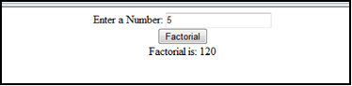

#### **Money Conversion a2.aspx**

<%@ Page Language="C#" AutoEventWireup="true" CodeFile="a2.aspx.cs" Inherits="a2" %>

<!DOCTYPE html PUBLIC "-//W3C//DTD XHTML 1.0 Transitional//EN" ["http:/](http://www.w3.org/TR/xhtml1/DTD/xhtml1-transitional.dtd)/[www.w3.org/TR/xhtml1/DTD/xhtml1-transitional.dtd](http://www.w3.org/TR/xhtml1/DTD/xhtml1-transitional.dtd)">

<html xmlns="<http://www.w3.org/1999/xhtml>">

<head id="Head1" runat="server">

<title></title></head>

<body>

<form id="form1" runat="server">

<div align="center">

<asp:Label ID="Label1" runat="server" Text="Amount"></asp:Label>

<asp:TextBox ID="TextBox1" runat="server"></asp:TextBox><br />

<asp:Button ID="Button1" runat="server" onclick="Button1_Click" Text="Convert" /><br />

<asp:Label ID="Label2" runat="server" Text="Rupees to dollar"></asp:Label>

<asp:TextBox ID="TextBox2" runat="server"></asp:TextBox>

<br />

<asp:Label ID="Label3" runat="server" Text="Dollar to rupees"></asp:Label>

<asp:TextBox ID="TextBox3" runat="server"></asp:TextBox>

<br />

<asp:Label ID="Label4" runat="server" Text="Rupees to Euro"></asp:Label>

<asp:TextBox ID="TextBox4" runat="server"></asp:TextBox>

<br />

<asp:Label ID="Label5" runat="server" Text="Euro to Rupees"></asp:Label>

<asp:TextBox ID="TextBox5" runat="server"></asp:TextBox>

</div></form>

</body>

</html> Design:

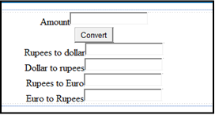

#### **a2.aspx.cs**

using System;

using System.Collections.Generic; using System.Linq;

using System.Web; using System.Web.UI;

using System.Web.UI.WebControls;

public partial class a2 : System.Web.UI.Page

{

protected void Page_Load(object sender, EventArgs e)

{

}

public class conv

{

public double d, r, e, a; public conv(double amount)

{

a = amount;

}

public void rtd()

{

d = a / 69;

}

public void dtr()

{

r = a * 69;

}

public void rte()

{

e = a / 82.36;

}

public void etr()

{

r = a * 82.36;

}

}

protected void Button1_Click(object sender, EventArgs e)

{

double a = Double.Parse(TextBox1.Text); conv obj = new conv(a);

obj.rtd();

TextBox2.Text = Convert.ToString(obj.d); obj.dtr();

TextBox3.Text = Convert.ToString(obj.r); obj.rte();

TextBox4.Text = Convert.ToString(obj.e); obj.etr();

TextBox5.Text = Convert.ToString(obj.r);

}

}

Output:

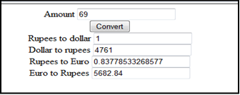

|  |  |  |
| --- | --- | --- |
| **Temperature Conversion.** |  | |
| **a4.aspx-** |
| <%@ Page Language="C#" Inherits="a4" %> | AutoEventWireup="true" | CodeFile="a4.aspx.cs" |
| <!DOCTYPE html PUBLIC | "-//W3C//DTD XHTML | 1.0 Transitional//EN" |

["http:/](http://www.w3.org/TR/xhtml1/DTD/xhtml1-transitional.dtd)/[www.w3.org/TR/xhtml1/DTD/xhtml1-transitional.dtd](http://www.w3.org/TR/xhtml1/DTD/xhtml1-transitional.dtd)">

<html xmlns="<http://www.w3.org/1999/xhtml>">

<head runat="server">

<title></title></head>

<body>

<form id="form1" runat="server">

<div align="center">

<asp:Label ID="Label1" runat="server" Text="Celcius:"></asp:Label>

<asp:TextBox ID="TextBox1" runat="server"></asp:TextBox><br />

<asp:Button ID="Button1" runat="server" onclick="Button1_Click" Text="Celcius to Fahrenheit" /><br />

<asp:Label ID="Label2" runat="server" Text="Fahrenheit:"></asp:Label>

<asp:TextBox ID="TextBox2" runat="server"></asp:TextBox>

<br /><br />

<asp:Label ID="Label3" runat="server" Text="Fahrenheit:"></asp:Label>

<asp:TextBox ID="TextBox3" runat="server"></asp:TextBox><br />

<asp:Button ID="Button2" runat="server" onclick="Button2_Click" Text="Fahrenheit to Celcius" /><br />

<asp:Label ID="Label4" runat="server" Text="Celcius:"></asp:Label>

<asp:TextBox ID="TextBox4" runat="server"></asp:TextBox>

</div></form></body>

</html>

Design-

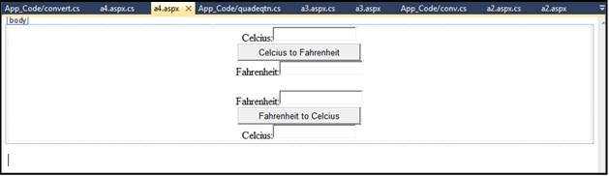

#### **a4.aspx.cs-**

using System;

using System.Collections.Generic; using System.Linq;

using System.Web; using System.Web.UI;

using System.Web.UI.WebControls;

public partial class a4 : System.Web.UI.Page

{

protected void Page_Load(object sender, EventArgs e)

{ }

public class convert

{

public double temp, f, c; public convert(double t)

{

temp=t;

}

public void ctf()

{

f = ((temp * 9 / 5)) + 32;

}

public void ftc() {

c = ((temp - 32) * 5) / 9;

} }

protected void Button1_Click(object sender, EventArgs e)

{

double c = Double.Parse(TextBox1.Text); convert obj = new convert(c);

obj.ctf();

TextBox2.Text = obj.f.ToString();

}

protected void Button2_Click(object sender, EventArgs e)

{

double c = Double.Parse(TextBox3.Text); convert obj = new convert(c);

obj.ftc();

TextBox4.Text = obj.c.ToString();

} }

Output-

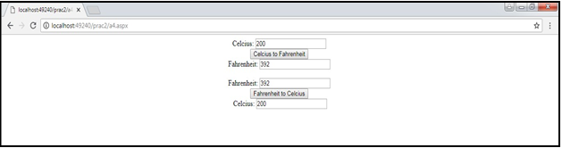

# **Practical No:03**

## **Working with Web Forms and Controls**

### Create a simple web page with various sever controls to demonstrate setting and use of their properties. (Example : AutoPostBack)

### **Default.aspx**

<%@ Page Language="C#" AutoEventWireup="true" CodeFile="Default.aspx.cs" Inherits="Default" %>

<!DOCTYPE html PUBLIC "-//W3C//DTD XHTML 1.0 Transitional//EN" "<http://www.w3.org/TR/xhtml1/DTD/xhtml1-transitional.dtd>">

<html xmlns="<http://www.w3.org/1999/xhtml>">

<head id="Head1" runat="server">

<title></title></head>

<body>

<form id="form1" runat="server"><div>

<asp:Label ID="Label1" runat="server" Text="Name :"></asp:Label>

<asp:TextBox ID="TextBox1" runat="server"></asp:TextBox>

<br /><br />

<asp:Label ID="Label2" runat="server" Text="RNo."></asp:Label> &nbsp;:

<asp:TextBox ID="TextBox2" runat="server"></asp:TextBox>

<br /><br />

<asp:Label ID="Label3" runat="server" Text="Class"></asp:Label>

&nbsp; :<asp:RadioButton ID="RadioButton1" runat="server" Text="FY" /> &nbsp;<asp:RadioButton ID="RadioButton2" runat="server" Text="SY" /> &nbsp;<asp:RadioButton ID="RadioButton3" runat="server" Text="TY" />

<br /><br />

<asp:Label ID="Label4" runat="server" Text="Course :"></asp:Label>

<asp:DropDownList ID="DropDownList1" runat="server" onselectedindexchanged="DropDownList1_SelectedIndexChanged" AutoPostBack="true">

<asp:ListItem>B.SC(IT)</asp:ListItem>

<asp:ListItem>M.SC(IT)</asp:ListItem>

<asp:ListItem>MCA</asp:ListItem>

</asp:DropDownList>

<br /><br /> &nbsp;&nbsp;&nbsp;&nbsp;&nbsp;&nbsp;&nbsp;

<asp:Button ID="Button1" runat="server" Text="Submit" onclick="Button1_Click"/>

<br />

<asp:Label ID="Label5" runat="server"></asp:Label>

</div> </form> </body>

</html>

Output:

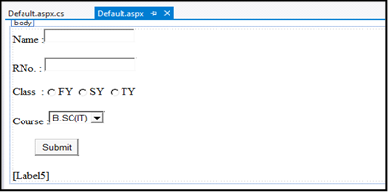

#### **Default.aspx.cs**

using System;

using System.Collections.Generic; using System.Linq;

using System.Web; using System.Web.UI;

using System.Web.UI.WebControls;

public partial class Default : System.Web.UI.Page

{

protected void Page_Load(object sender, EventArgs e)

{

}

protected void DropDownList1_SelectedIndexChanged(object sender, EventArgs e)

{

Label5.Text = "You have been enrolled " + DropDownList1.SelectedItem;

}

protected void Button1_Click(object sender, EventArgs e)

{

string s;

if (RadioButton1.Checked == true)

{

s = RadioButton1.Text;

}

else if (RadioButton2.Checked == true)

{

s = RadioButton2.Text;

}

else

{

s = RadioButton3.Text;

}

Label5.Text = "You have been enrolled in " + s + " " + DropDownList1.SelectedItem;

} }

Output:

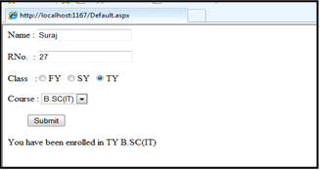

## **B)Demonstrate the use of Calendar control to perform following operations.**

### i) Display messages in a calendar control ii) Display vacation in a calendar control

iii) Selected day in a calendar control using style iv) Difference between two calendar dates

#### **CalndrCntrl.aspx**

<%@ Page Language="C#" AutoEventWireup="true" CodeBehind="CalndrCntrl.aspx.cs" Inherits="Calendar.WebForm1" %>

<!DOCTYPE html>

<html xmlns="<http://www.w3.org/1999/xhtml>">

<head runat="server">

<title></title>

<style type="text/css"> #form1 {

height: 407px;

}

</style></head>

<body>

<form id="form1" runat="server">

<div style="height: 585px">

<asp:Calendar ID="Calendar1" runat="server" BackColor="#FFFFCC" BorderColor="#FFCC66" BorderWidth="1px" DayNameFormat="Shortest" FirstDayOfWeek="Sunday" Font-Names="Verdana" Font-Size="8pt" ForeColor="#663399" Height="400px" NextPrevFormat="ShortMonth" OnDayRender="Calendar1_DayRender" ShowGridLines="True" Width="1000px">

<DayHeaderStyle BackColor="#FFCC66" Font-Bold="True" Height="1px" />

<NextPrevStyle BorderStyle="Solid" BorderWidth="2px" Font-Size="9pt" ForeColor="#FFFFCC" />

<OtherMonthDayStyle BackColor="#FFCC99" BorderStyle="Solid" ForeColor="#CC9966" />

<SelectedDayStyle BackColor="Red" Font-Bold="True" />

<SelectorStyle BackColor="#FFCC66" />

<TitleStyle BackColor="#990000" Font-Bold="True" Font-Size="9pt" ForeColor="#FFFFCC" />

<TodayDayStyle BackColor="#FFCC66" ForeColor="White" />

<WeekendDayStyle Height="50px" />

</asp:Calendar><br />

<asp:Label ID="Label1" runat="server"></asp:Label><br />

<asp:Label ID="Label2" runat="server"></asp:Label><br />

<asp:Label ID="Label3" runat="server"></asp:Label><br />

<asp:Label ID="Label4" runat="server"></asp:Label><br />

<asp:Label ID="Label5" runat="server"></asp:Label><br />

<asp:Button ID="Button1" runat="server" OnClick="Button1_Click" style="margin-top: 0px" Text="RESULT" /> &nbsp;&nbsp;&nbsp;&nbsp;&nbsp;&nbsp;&nbsp;&nbsp;&nbsp;&nbsp;

<asp:Button ID="Button2" runat="server" OnClick="Button2_Click" Text="RESET" />

<br />

</div>

</form>

</body>

</html>

#### **Design:**

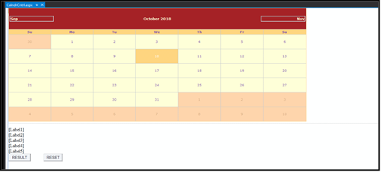

**CalndrCntrl.aspx.cs**

using System;

using System.Collections.Generic; using System.Linq;

using System.Web; using System.Web.UI;

using System.Web.UI.WebControls; namespace Calendar

{

public partial class WebForm1 : System.Web.UI.Page

{

protected void Page_Load(object sender, EventArgs e)

{

}

protected void Button1_Click(object sender, EventArgs e)

{

Calendar1.Caption = "Vikas Pandey"; Calendar1.FirstDayOfWeek = FirstDayOfWeek.Sunday; Calendar1.NextPrevFormat = NextPrevFormat.ShortMonth; Calendar1.TitleFormat = TitleFormat.Month;

Label1.Text = "Your Selected Date:" + Calendar1.SelectedDate.ToString(); Label2.Text = "Todays Date:" + Calendar1.TodaysDate.ToShortDateString(); Label3.Text = "Ganpati Vacation Start: 09-13-2018";

TimeSpan d = new DateTime(2018, 09, 13) - DateTime.Now;

Label4.Text = "Days Remaining For Ganpati Vacation:" + d.Days.ToString(); TimeSpan d1 = new DateTime(2018, 12, 31) - DateTime.Now;

Label5.Text = "Days Remaining For New Year:" + d1.Days.ToString(); if (Calendar1.SelectedDate.ToShortDateString() == "09-13-2018")

Label3.Text = "<b>Ganpati Festival Start</b>";

if (Calendar1.SelectedDate.ToShortDateString() == "09-23-2018") Label3.Text = "<b>Ganpati Festival End<b>";

}

protected void Calendar1_DayRender(object sender, DayRenderEventArgs e)

{

if (e.Day.Date.Day == 15 && e.Day.Date.Month == 8)

{

e.Cell.BackColor = System.Drawing.Color.GreenYellow; Label lbl1 = new Label();

lbl1.Text = "<br>Independance Day!<br>"; e.Cell.Controls.Add(lbl1);

Image g1 = new Image(); g1.ImageUrl = "id.jpg"; g1.Height = 40;

g1.Width = 75; e.Cell.Controls.Add(g1);

}

if (e.Day.Date.Day == 5 && e.Day.Date.Month == 9)

{

e.Cell.BackColor = System.Drawing.Color.Yellow; Label lbl1 = new Label();

lbl1.Text = "<br>Teavhers Day!<br>"; e.Cell.Controls.Add(lbl1);

Image g1 = new Image(); g1.ImageUrl = "td.jpg"; g1.Height = 40;

g1.Width = 75; e.Cell.Controls.Add(g1);

}

if (e.Day.Date.Day == 13 && e.Day.Date.Month == 9)

{

Calendar1.SelectedDate = new DateTime(2018, 09, 12); Calendar1.SelectedDates.SelectRange(Calendar1.SelectedDate, Calendar1.SelectedDate.AddDays(10));

Label lbl1 = new Label(); lbl1.Text = "<br>Ganpati!<br>"; e.Cell.Controls.Add(lbl1); Image g2 = new Image(); g2.ImageUrl = "gc.jpg";

g2.Height = 40;

g2.Width = 75; e.Cell.Controls.Add(g2);

} }

protected void Button2_Click(object sender, EventArgs e)

{

Label1.Text = ""; Label2.Text = ""; Label3.Text = ""; Label4.Text = ""; Label5.Text = "";

Calendar1.SelectedDates.Clear();

} } }

**Output:**

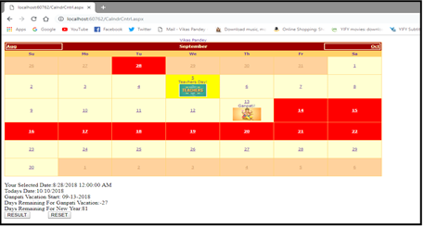

## **C) Demonstrate the use of Treeview control perform following operations.**

### a) Tree view operations

#### **Prac3b2.aspx**

<%@ Page Language="C#" AutoEventWireup="true" CodeFile="prac3b2.aspx.cs" Inherits="prac3b2" %>

<!DOCTYPE html PUBLIC "-//W3C//DTD XHTML 1.0 Transitional//EN" "<http://www.w3.org/TR/xhtml1/DTD/xhtml1-transitional.dtd>">

<html xmlns="<http://www.w3.org/1999/xhtml>">

<head id="Head1" runat="server">

<title></title></head>

<body>

<form id="form1" runat="server"><div>

<asp:TreeView ID="TreeView1" runat="server" onselectednodechanged="TreeView1_SelectedNodeChanged" ShowLines="True" ontreenodecollapsed="TreeView1_TreeNodeCollapsed">

<Nodes>

<asp:TreeNode Text="I.T. Department" Value="I.T. Department">

<asp:TreeNode Text="Class Room" Value="Class Room">

<asp:TreeNode Text="601" Value="601"></asp:TreeNode>

<asp:TreeNode Text="602" Value="602"></asp:TreeNode>

</asp:TreeNode>

<asp:TreeNode Text="Lab" Value="Lab">

<asp:TreeNode Text="Lab-1" Value="Lab-1"></asp:TreeNode>

<asp:TreeNode Text="Lab-2" Value="Lab-2"></asp:TreeNode>

</asp:TreeNode>

</asp:TreeNode>

</Nodes>

</asp:TreeView>

</div></form>

</body></html>

#### **Design:**

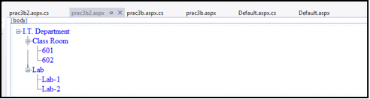**prac3b2.aspx.cs**

using System;

using System.Collections.Generic; using System.Linq;

using System.Web; using System.Web.UI;

using System.Web.UI.WebControls;

public partial class prac3b2 : System.Web.UI.Page

{

protected void Page_Load(object sender, EventArgs e)

{

}

protected void TreeView1_SelectedNodeChanged(object sender, EventArgs e)

{

Response.Write("You have selected the option:" + TreeView1.SelectedValue);

}

protected void TreeView1_TreeNodeCollapsed(object sender, TreeNodeEventArgs e)

{

Response.Write("The value Collapsed was:" + e.Node.Value);

}

}

Output:

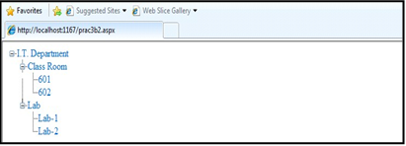

* Output after collapsing a value

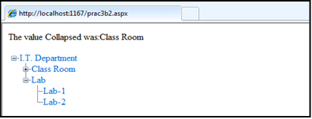

* Output after selecting a value

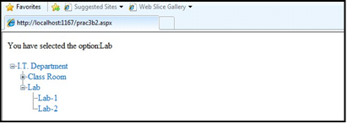

# **Practical No:04**

## **Working with Form Controls**

1. **Create a Registration form to demonstrate use of various Validation controls.**

#### **WebForm1.aspx**

<%@ Page Language="C#" AutoEventWireup="true" CodeBehind="WebForm1.aspx.cs" Inherits="_4a.WebForm1" %>

<!DOCTYPE html>

<html xmlns="<http://www.w3.org/1999/xhtml>">

<head runat="server">

<title></title></head>

<body>

<form id="form1" runat="server">

<div>

<asp:Label ID="Label1" runat="server" Text="Your Name"></asp:Label> &nbsp;&nbsp;&nbsp;&nbsp;&nbsp;&nbsp;&nbsp;&nbsp;&nbsp;&nbsp;&nbsp;& nbsp;&nbsp;&nbsp;&nbsp;&nbsp;&nbsp;

<asp:TextBox ID="TextBox1" runat="server"></asp:TextBox>

<asp:RequiredFieldValidator ID="RequiredFieldValidator1" runat="server" ControlToValidate="TextBox1" ErrorMessage="Please Enter Your Name" ForeColor="Red"></asp:RequiredFieldValidator>

<br /><br />

<asp:Label ID="Label2" runat="server" Text="Enter Age"></asp:Label> &nbsp;&nbsp;&nbsp;&nbsp;&nbsp;&nbsp;&nbsp;&nbsp;&nbsp;&nbsp;&nbsp;& nbsp;&nbsp;&nbsp;&nbsp;&nbsp;&nbsp;&nbsp;&nbsp;

<asp:TextBox ID="TextBox2" runat="server"></asp:TextBox>

<asp:RequiredFieldValidator ID="RequiredFieldValidator2" runat="server" ControlToValidate="TextBox2" ErrorMessage="Please Enter Your Age" ForeColor="Red"></asp:RequiredFieldValidator>

<asp:RangeValidator ID="RangeValidator1" runat="server" ControlToValidate="TextBox2" ErrorMessage="Enter Valid Age" ForeColor="Red" MaximumValue="100" MinimumValue="18" Type="Integer"></asp:RangeValidator>

<br /><br />

<asp:Label ID="Label3" runat="server" Text="Password"></asp:Label>

<asp:TextBox ID="TextBox3" runat="server" TextMode="Password"></asp:TextBox>

<asp:RequiredFieldValidator ID="RequiredFieldValidator3" runat="server" ControlToValidate="TextBox3" ErrorMessage="Please Enter Password" ForeColor="Red"></asp:RequiredFieldValidator>

<br /><br />

<asp:Label ID="Label4" runat="server" Text="Confirm Password"></asp:Label> &nbsp;&nbsp;&nbsp;&nbsp;&nbsp;&nbsp;&nbsp;

<asp:TextBox ID="TextBox4" runat="server" TextMode="Password"></asp:TextBox>

<asp:RequiredFieldValidator ID="RequiredFieldValidator4" runat="server" ControlToValidate="TextBox4" ErrorMessage="Please Confirm Password" ForeColor="Red"></asp:RequiredFieldValidator>

<asp:CompareValidator ID="CompareValidator1" runat="server" ControlToCompare="TextBox3" ControlToValidate="TextBox4" ErrorMessage="Password Not Matched" ForeColor="Red"></asp:CompareValidator>

<br /><br />

<asp:Label ID="Label5" runat="server" Text="Email ID"></asp:Label> &nbsp;&nbsp;&nbsp;&nbsp;&nbsp;&nbsp;&nbsp;&nbsp;&nbsp;&nbsp;&nbsp;& nbsp;&nbsp;&nbsp;&nbsp;&nbsp;&nbsp;&nbsp;&nbsp;&nbsp;&nbsp;&nbsp;

<asp:TextBox ID="TextBox5" runat="server"></asp:TextBox>

<asp:RequiredFieldValidator ID="RequiredFieldValidator5" runat="server" ControlToValidate="TextBox5" ErrorMessage="Please Enter Email Address" ForeColor="Red"></asp:RequiredFieldValidator>

<asp:RegularExpressionValidator ID="RegularExpressionValidator1" runat="server" ControlToValidate="TextBox5" ErrorMessage="Please Enter Valid Email Address" ForeColor="Red" ValidationExpression="\w+([-+.']\w+)*@\w+([-

.]\w+)*\.\w+([-.]\w+)*"></asp:RegularExpressionValidator>

<br /><br />

<asp:Label ID="Label6" runat="server" Text="Custom Text"></asp:Label> &nbsp;&nbsp;&nbsp;&nbsp;&nbsp;&nbsp;&nbsp;&nbsp;&nbsp;&nbsp;&nbsp;& nbsp;&nbsp;&nbsp;&nbsp;&nbsp;

<asp:TextBox ID="TextBox6" runat="server"></asp:TextBox>

<asp:RequiredFieldValidator ID="RequiredFieldValidator6" runat="server" ControlToValidate="TextBox6" ErrorMessage="Please Enter Text" ForeColor="Red"></asp:RequiredFieldValidator>

<asp:CustomValidator ID="CustomValidator2" runat="server" ClientValidationFunction="ServerValidation" ControlToValidate="TextBox6" ErrorMessage="CustomValidator" ForeColor="Red"></asp:CustomValidator>

<br /><br />

<asp:Button ID="Button1" runat="server" OnClick="Button1_Click" Text="Validate" />

<br />

<asp:Label ID="Label7" runat="server"></asp:Label>

<br />

<asp:ValidationSummary ID="ValidationSummary1" runat="server" />

</div></form>

</body>

</html>

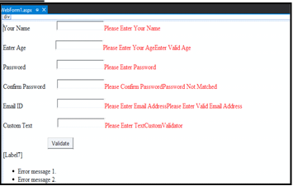

**Design:**

**WebForm1.aspx.cs**

using System;

using System.Collections.Generic; using System.Linq;

using System.Web; using System.Web.UI;

using System.Web.UI.WebControls; namespace _4a

{

public partial class WebForm1 : System.Web.UI.Page

{

protected void Page_Load(object sender, EventArgs e)

{

}

protected void Button1_Click(object sender, EventArgs e)

{

if(Page.IsValid)

{

Label7.Text = "Thank You";

}

else

{

Label7.Text = "The text must be exactly 8 characters long!";

}

}

void ServerValidation(object source,ServerValidateEventArgs e)

{

if (e.Value.Length == 8) e.IsValid = true;

else

e.IsValid = false;

} } }

**Output:**

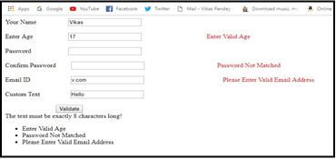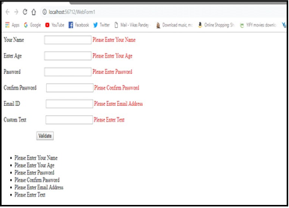

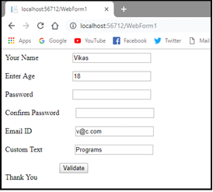

## **Create Web Form to demonstrate use of Adrotator Control.**

#### **WebForm1.aspx**

<%@ Page Language="C#" AutoEventWireup="true" CodeBehind="WebForm1.aspx.cs" Inherits="_4b.WebForm1" %>

<!DOCTYPE html>

<html xmlns="<http://www.w3.org/1999/xhtml>">

<head runat="server">

<title></title></head>

<body>

<form id="form1" runat="server"><div>

<asp:ScriptManager ID="ScriptManager1" runat="server">

</asp:ScriptManager><br />

<asp:Timer ID="Timer1" Interval="2000" runat="server">

</asp:Timer><br />

<asp:UpdatePanel ID="UpdatePanel1" runat="server">

</asp:UpdatePanel><br />

<asp:AdRotator ID="AdRotator1" runat="server" AdvertisementFile="~/XMLFile1.xml" Height="200px" Width="200px" />

<br /></div></form></body></html>

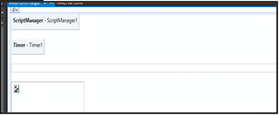

**Design:**

**XMLFile1.xml**

<?xml version="1.0" encoding="utf-8" ?>

<Advertisements><Ad>

<ImageUrl>~/v.png</ImageUrl>

</Ad><Ad>

<ImageUrl>~/v1.png</ImageUrl>

</Ad><Ad>

<ImageUrl>~/v2.jpg</ImageUrl>

</Ad><Ad>

<ImageUrl>~/v3.jpg</ImageUrl>

</Ad><Ad>

<ImageUrl>~/v4.jpg</ImageUrl>

</Ad><Ad>

<ImageUrl>~/v5.jpg</ImageUrl>

</Ad><Ad>

<ImageUrl>~/v6.jpg</ImageUrl></Ad>

</Advertisements>

#### **Output:**

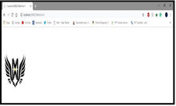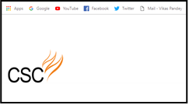

1. **Create Web Form to demonstrate use User Controls. Defult.aspx**

<%@ Page Language="C#" AutoEventWireup="true" CodeFile="Default.aspx.cs" Inherits="_Default" %>

<!DOCTYPE html>

<html xmlns="<http://www.w3.org/1999/xhtml>">

<head runat="server">

<title></title></head>

<body>

<form id="form1" runat="server"><div><br />

<asp:Label ID="Label1" runat="server" Text="This is User Control"></asp:Label><br /><br />

&nbsp;&nbsp;

<asp:Label ID="Label2" runat="server" Text="Enter Your Name:"></asp:Label> &nbsp;&nbsp;&nbsp;

<asp:TextBox ID="TextBox1" runat="server"></asp:TextBox><br /> &nbsp;&nbsp;

<asp:Label ID="Label3" runat="server" Text="Enter Your City: "></asp:Label> &nbsp;&nbsp;&nbsp;&nbsp;&nbsp;

<asp:TextBox ID="TextBox2" runat="server"></asp:TextBox><br />

<asp:Button ID="Button1" runat="server" OnClick="Button1_Click" Text="Save"

/><br />

<asp:Label ID="Label4" runat="server"></asp:Label><br />

</div></form></body>

</html>

#### **Design :**

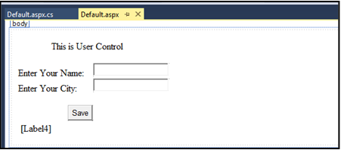

**Default.acpx.cs**

using System;

using System.Collections.Generic; using System.Linq;

using System.Web; using System.Web.UI;

using System.Web.UI.WebControls;

public partial class _Default : System.Web.UI.Page

{

protected void Page_Load(object sender, EventArgs e)

{ }

protected void Button1_Click(object sender, EventArgs e)

{

Label4.Text = "Your Name is " + TextBox1.Text + " and you are from " + TextBox2.Text;

}}

Output:

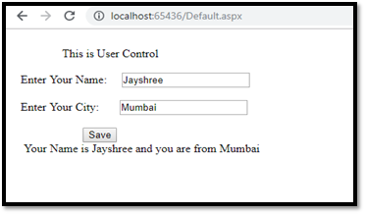

# **Practical No:05**

**Working with Navigation, Beautification and Master page.** a)Create Web Form to demonstrate use of Website Navigation controls and Site Map.

#### **Pract5a.aspx**

<%@ Page Language="C#" AutoEventWireup="true" CodeBehind="Pract5a.aspx.cs" Inherits="Practical5a.Pract5a" %>

<!DOCTYPE html>

<html xmlns="<http://www.w3.org/1999/xhtml>">

<head runat="server">

<title></title></head>

<body>

<form id="form1" runat="server">

<div>

<asp:SiteMapDataSource ID="SiteMapDataSource1" runat="server" />

<br />

<asp:Menu ID="Menu1" runat="server" DataSourceID="SiteMapDataSource1">

</asp:Menu></div>

</form>

</body>

</html>

#### **Design**

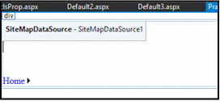

**Pract5a.aspx.cs**

using System;

using System.Collections.Generic; using System.Linq;

using System.Web; using System.Web.UI;

using System.Web.UI.WebControls;

namespace Practical5a

{

public partial class Pract5a : System.Web.UI.Page

{

protected void Page_Load(object sender, EventArgs e)

{

}}}

#### **Web.sitemap**

<?xml version="1.0" encoding="utf-8" ?>

<siteMap xmlns="<http://schemas.microsoft.com/AspNet/SiteMap-File-1.0>" >

<siteMapNode url="Pract5a.aspx" title="Home" description="Home page of our website">

<siteMapNode url="clsProp.aspx" title="Page2" description="Page2" />

<siteMapNode url="Default2.aspx" title="Page3" description="Page3" />

<siteMapNode url="Default3.aspx" title="Page4" description="Page4" />

</siteMapNode>

</siteMap>

* Add 3 more .aspx files with “*Welcome”* message Output:

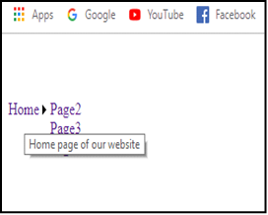 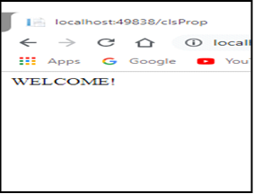

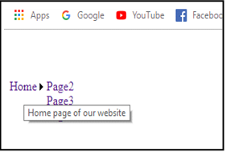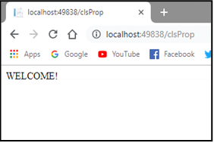

#### **Create a web application to demonstrate use of Master Page with applying Styles and Themes for page beautification.**

* + **Adding Master Page**

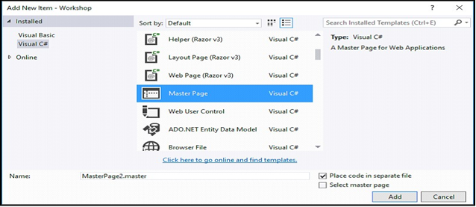

Adding Web page For Master page

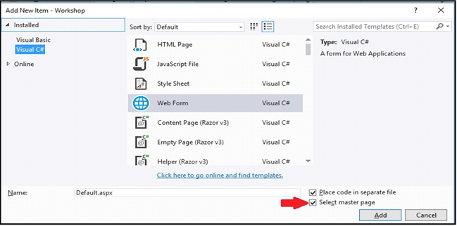

#### **MasterPage.master**

<%@ Master Language="C#" AutoEventWireup="true" CodeFile="MasterPage.master.cs" Inherits="MasterPage" %>

<!DOCTYPE html>

<html xmlns="<http://www.w3.org/1999/xhtml>">

<head runat="server">

<title>Master Page</title>

<link href="css/my.css" rel="stylesheet" />

<asp:ContentPlaceHolder ID="head" runat="server">

</asp:ContentPlaceHolder>

<style type="text/css">

.auto-style1 { position: absolute; top: 373px;

left: 1028px; bottom: 303px;

}

.auto-style2 { position: absolute; top: 537px;

left: 1016px; z-index: 1;

}

</style></head>

<body>

<!DOCTYPE html>

<form id="form1" runat="server">

<html><head>

<title>Master</title>

<link rel="stylesheet" type="text/css" href="StyleSheet.css">

</head>

<body><header id="header">

<h1>Demo Of Master Page</h1>

</header>

<nav id="nav">

<ul>

<li><a href="home.aspx">Insight</a></li>

<li><a href="#">Products</a></li>

<li><a href="#">Downloads</a></li>

<li><a href="#">Contact Us</a></li>

</ul></nav>

<aside id="side">

<h1>Info</h1>

<a href="#"><p>Product Type 1</p></a>

<a href="#"><p>Product Type 2</p></a>

<a href="#"><p>Product Type 3<a href="#"><asp:ScriptManager ID="ScriptManager1" runat="server">

</asp:ScriptManager></a></p>

<asp:Button ID="Button2" runat="server" CssClass="auto-style1" style="z-index: 1" Text="Button" />

<asp:Button ID="Button1" runat="server" CssClass="auto-style2" Text="Button"

/>

</aside><div id="con">

<asp:ContentPlaceHolder ID="ContentPlaceHolder1" runat="server">

</asp:ContentPlaceHolder>

</div>

<footer id="footer"> copyright @Sambare

</footer></body>

</html></form>

</body></html>

#### **MasterDisplay.aspx**

<%@ Page Title="" Language="C#" MasterPageFile="~/MasterPage.master" AutoEventWireup="true" CodeFile="MasterDisplay.aspx.cs" Inherits="MasterDisplay" %>

<asp:Content ID="Content1" ContentPlaceHolderID="head" runat="server">

</asp:Content>

<asp:Content ID="Content2" ContentPlaceHolderID="ContentPlaceHolder1" runat="server">

<h1>Home page</h1>

</asp:Content> StyleSheet.css #header{

color: blueviolet; text-align: center; font-size: 20px;

}

#nav{

background-color:darkseagreen; padding: 5px;

}

ul{

list-style-type: none;

}

li a { color:crimson ; font-size: 30px; column-width: 5%;

}li

{

display: inline; padding-left: 2px; column-width: 20px;

}

a{

text-decoration: none; margin-left:20px

}

li a:hover{

background-color: aqua; color:coral ; padding:1%;

}

#side{

text-align: center; float: right; width: 15%;

padding-bottom: 79%; background-color: #F1FAEE;

}

#article{

background-color: burlywood; padding: 10px;

padding-bottom: 75%;

}

#footer{

background-color: #C7EFCF; text-align:center;

padding-bottom: 5%; font-size: 20px;

}

#con{ border:double;

border-color:burlywood; }

**Create a web application to demonstrate various states of ASP.NET Pages.**

#### **Default.aspx**

<%@ Page Language="C#" AutoEventWireup="true" CodeFile="Default.aspx.cs" Inherits="_Default" %>

<!DOCTYPE html>

<html xmlns="<http://www.w3.org/1999/xhtml>">

<head runat="server">

<title></title></head>

<body>

<form id="form1" runat="server">

<div style="height: 393px">

Username:<asp:TextBox ID="TextBox2" runat="server"></asp:TextBox>

<br /><br/>

Password:<asp:TextBox ID="TextBox3" runat="server"></asp:TextBox>

<br /><br/>

<asp:Button ID="Button4" runat="server" Text="submit" onclick="Button4_Click" />

&nbsp;&nbsp;

<asp:Button ID="Button5" runat="server" Text="restore" onclick="Button5_Click" />

<asp:HiddenField ID="HiddenField1" runat="server" />

<asp:Label ID="Label1" runat="server"></asp:Label><br/>

<asp:Label ID="Label2" runat="server" ></asp:Label><br/>

<asp:Button ID="Button1" runat="server" Text="ViewState" onclick="Button1_Click" /><br/><br/>

<asp:Button ID="Button2" runat="server" Text="HiddenField" onclick="Button2_Click" />

<br /><br />

<asp:TextBox ID="TextBox1" runat="server"></asp:TextBox><br /><br /><br />

<asp:Button ID="Button3" runat="server" Text="Cookies" onclick="Button3_Click" />

</div>

</form>

</body>

</html>

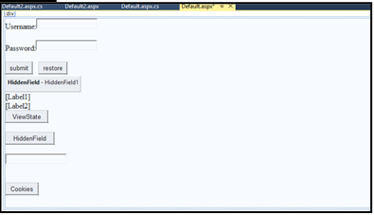

**Design:**

**Deafult.aspx.cs**

using System;

using System.Collections.Generic; using System.Linq;

using System.Web; using System.Web.UI;

using System.Web.UI.WebControls;

public partial class _Default : System.Web.UI.Page

{

protected void Page_Load(object sender, EventArgs e)

{

if (IsPostBack)

{

if (ViewState["count"] != null)

{

int viewstateval = Convert.ToInt32(ViewState["count"]) + 1; Label1.Text = "ViewState:" + viewstateval.ToString(); ViewState["count"] = viewstateval.ToString();

} }

else {

ViewState["count"] = "1";

} }

protected void Button1_Click(object sender, EventArgs e)

{

Label2.Text = ViewState["count"].ToString();

}

protected void Button2_Click(object sender, EventArgs e)

{

Page.EnableViewState = true;

HiddenField1.Value = "welcome to our website:[http://www.google.com](http://www.google.com/)" + "<br/>";

Label1.Text = HiddenField1.Value; HiddenField1.Value = "0";

int i = 0;

i = (int.Parse(HiddenField1.Value)) + 1; Label2.Text = i.ToString(); HiddenField1.Value = i.ToString();

}

protected void Button3_Click(object sender, EventArgs e)

{

HttpCookie c1 = new HttpCookie("name"); c1.Value = TextBox1.Text; Response.Cookies.Add(c1); Response.Redirect("Default2.aspx");

}

protected void Button4_Click(object sender, EventArgs e)

{

ViewState["name"] = TextBox2.Text; ViewState["password"] = TextBox3.Text; TextBox2.Text = TextBox3.Text = string.Empty;

}

protected void Button5_Click(object sender, EventArgs e)

{

if (ViewState["name"] != null)

{

TextBox2.Text = ViewState["name"].ToString();

}

if (ViewState["password"] != null)

{

TextBox3.Text = ViewState["password"].ToString();

}

} }

#### **Default2.aspx.cs**

using System;

using System.Collections.Generic; using System.Linq;

using System.Web; using System.Web.UI;

using System.Web.UI.WebControls;

public partial class Default2 : System.Web.UI.Page

{

protected void Page_Load(object sender, EventArgs e)

{

if (Request.Cookies["name"] != null)

{

Response.Write("Welcome:" + Request.Cookies["name"].Value);

}

}}

Output:

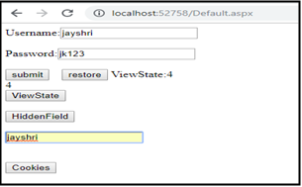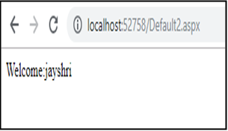

# **Practical No:06**

## **Working with Database**

1. Create a web application bind data in a multiline textbox by querying in another textbox.

#### **Deafult.aspx**

<%@ Page Language="C#" AutoEventWireup="true" CodeFile="Default.aspx.cs" Inherits="_Default" %>

<!DOCTYPE html>

<html xmlns="<http://www.w3.org/1999/xhtml>">

<head runat="server">

<title></title>

</head>

<body>

<form id="form1" runat="server">

<div>

<br /> &nbsp;&nbsp;&nbsp;

<asp:Button ID="Button1" runat="server" Text="Button" onclick="Button1_Click" />

<br /> &nbsp;&nbsp;

<asp:TextBox ID="TextBox1" runat="server" Text="<%# str %>" TextMode="MultiLine"></asp:TextBox>

&nbsp;<br />

<br /><br />

</div><br /><br />

</form>

</body></html>

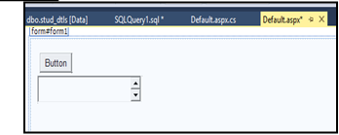

**Design:**

**Deafult.aspx.cs**

using System;

using System.Collections.Generic; using System.Linq;

using System.Web; using System.Web.UI;

using System.Web.UI.WebControls; using System.Data;

using System.Data.SqlClient;

public partial class _Default : System.Web.UI.Page

{

protected String str;

SqlConnection cn = new SqlConnection("Data Source=(LocalDB)\\MSSQLLocalDB;AttachDbFilename=F:\\jkwebsite\\pract6a2\

\App_Data\\Database.mdf;Integrated Security=True"); protected void Page_Load(object sender, EventArgs e)

{

}

protected void Button1_Click(object sender, EventArgs e)

{

SqlCommand cmd = new SqlCommand("select * from stud_dtls", cn); cn.Open();

SqlDataReader dr = cmd.ExecuteReader(); while (dr.Read())

{

str += dr["id"] + " " + dr["name"] + "\n";

}

this.DataBind();

} }

#### **Query to create database**

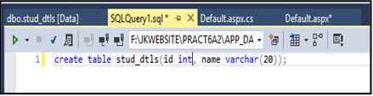

Output:

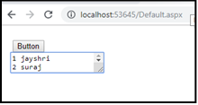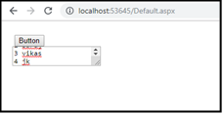

## **Create a web application to display records by using database.**

#### **Default.aspx**

<%@ Page Language="C#" AutoEventWireup="true" Debug="true" CodeFile="Default2.aspx.cs" Inherits="Default2" %>

<!DOCTYPE html>

<html xmlns="<http://www.w3.org/1999/xhtml>">

<head runat="server">

<title></title></head>

<body>

<form id="form1" runat="server">

<div>

<asp:Label ID="Label1" runat="server" Text="Customer Details:"></asp:Label>

<br /><br />

<asp:Label ID="Label2" runat="server"></asp:Label>

<br /><br />

<asp:Button ID="Button1" runat="server" Text="Display records" OnClick="Button1_Click" />

&nbsp;&nbsp;

</div>

</form>

</body>

</html>

#### **Design**

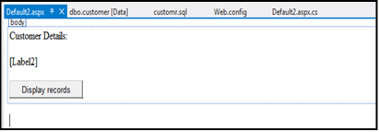

**Web .config**

<configuration>

<system.web>

<compilation debug="true" strict="false" explicit="true" targetFramework="4.5"

/>

<httpRuntime targetFramework="4.5" />

</system.web>

<connectionStrings>

<add name="connStr" connectionString="Data Source=(LocalDB)\v11.0;AttachDbFilename=C:\Users\Deepak\Documents\Visual Studio 2012\WebSites\Prac 6b\App_Data\Database2.mdf;Integrated Security=True"/>

</connectionStrings>

</configuration>

#### **Design.apsx.cs**

using System; using System.Data;

using System.Collections.Generic; using System.Configuration; using System.Data.SqlClient; using System.Linq;

using System.Web; using System.Web.UI;

using System.Web.UI.WebControls;

public partial class Default2 : System.Web.UI.Page

{

protected void Page_Load(object sender, EventArgs e)

{

}

protected void Button1_Click(object sender, EventArgs e)

{

string connStr = ConfigurationManager.ConnectionStrings["connStr"].ConnectionString; SqlConnection con = new SqlConnection(connStr);

SqlCommand cmd = new SqlCommand("Select * from customer", con); con.Open();

SqlDataReader reader = cmd.ExecuteReader(); while (reader.Read())

{

Label1.Text += reader["c_name"].ToString() + " " + reader["c_city"].ToString()

+ " " + reader["c_state"].ToString()+"<br>";

}

reader.Close(); con.Close();

} }

Output:

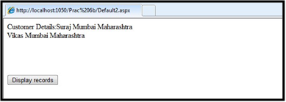

## **Demonstrate the use of Datalist link control**.

#### **Default.aspx**

<%@ Page Language="C#" AutoEventWireup="true" CodeFile="Default.aspx.cs" Inherits="_Default" %>

<!DOCTYPE html>

<html xmlns="<http://www.w3.org/1999/xhtml>">

<head runat="server">

<title></title></head>

<body>

<form id="form1" runat="server">

<div style="height: 310px">

<asp:DataList ID="DataList1" runat="server" DataSourceID="SqlDataSource1">

<ItemTemplate>

id:<asp:Label ID="idLabel" runat="server" Text='<%# Eval("id") %>' /><br /> name:<asp:Label ID="nameLabel" runat="server" Text='<%# Eval("name") %>'

/><br /><br />

</ItemTemplate>

</asp:DataList>

<asp:SqlDataSource ID="SqlDataSource1" runat="server" ConnectionString="<%$ ConnectionStrings:ConnectionString %>" SelectCommand="SELECT * FROM [student]"></asp:SqlDataSource>

</div></form></body>

</html>

#### **Design**

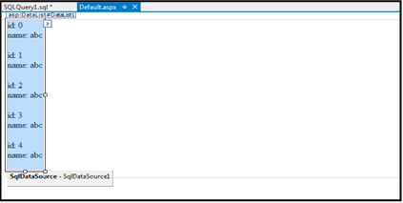

Output:

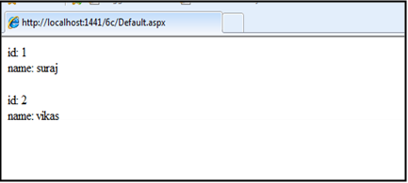

# **Practical No:07**

## **Create a web application to display Databinding using dropdownlist control**.

#### **Design**

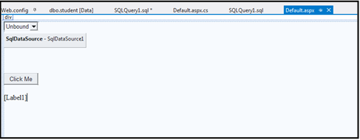

**Web.config**

<configuration>

<connectionStrings>

<add name="DatabaseConnectionString" connectionString="Data Source=(LocalDB)\v11.0;AttachDbFilename=&quot;C:\Users\Deepak\Documents\ Visual Studio 2012\WebSites\6c\App_Data\Database.mdf&quot;;Integrated Security=True;Connect Timeout=30"

providerName="System.Data.SqlClient" />

<add name="ConnectionString" connectionString="Data Source=(LocalDB)\v11.0;AttachDbFilename=|DataDirectory|\Database2.mdf;Integ rated Security=True"

providerName="System.Data.SqlClient" />

</connectionStrings>

<system.web>

<compilation debug="false" strict="false" explicit="true" targetFramework="4.5"

/>

<httpRuntime targetFramework="4.5" />

</system.web>

</configuration>

#### **Default.aspx.cs**

using System;

using System.Collections.Generic;

using System.Configuration; using System.Data.SqlClient; using System.Linq;

using System.Web; using System.Web.UI;

using System.Web.UI.WebControls;

public partial class _Default : System.Web.UI.Page

{

protected void Page_Load(object sender, EventArgs e)

{

if (IsPostBack == false)

{

string DatabaseConnectionString = ConfigurationManager.ConnectionStrings["DatabaseConnectionString"].Connectio nString;

SqlConnection con = new SqlConnection(DatabaseConnectionString); SqlCommand cmd = new SqlCommand("select name from student", con); con.Open();

SqlDataReader reader = cmd.ExecuteReader(); DropDownList1.DataSource = reader; DropDownList1.DataTextField = "name"; DropDownList1.DataBind();

reader.Close(); con.Close();

} }

protected void Button1_Click(object sender, EventArgs e)

{

Label1.Text = "You have selected " + DropDownList1.SelectedValue;

}}

Output:

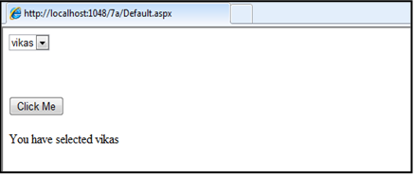

## **Create a web application for to display the phone no of an author using database.**

#### **Default.aspx**

<%@ Page Language="C#" AutoEventWireup="true" CodeFile="Default.aspx.cs" Inherits="_Default" %>

<!DOCTYPE html>

<html xmlns="<http://www.w3.org/1999/xhtml>">

<head runat="server">

<title></title></head>

<body>

<form id="form1" runat="server">

<div>&nbsp;&nbsp;&nbsp;&nbsp;&nbsp;&nbsp;<br /><br />

<asp:Label ID="Label1" runat="server" Text="Enter Author's ID:"></asp:Label> &nbsp;&nbsp;&nbsp;&nbsp;&nbsp;&nbsp;&nbsp;&nbsp;&nbsp;&nbsp;

<asp:TextBox ID="TextBox1" runat="server"></asp:TextBox>

<br /><br />

<asp:Label ID="Label2" runat="server" Text="Author's Phone Number"></asp:Label>&nbsp;

<asp:TextBox ID="TextBox2" runat="server"></asp:TextBox>

<br /><br />

<asp:Button ID="Button1" runat="server" OnClick="Button1_Click" Text="Button" /><br /><br />

<asp:SqlDataSource ID="SqlDataSource1" runat="server" ConnectionString="<%$ ConnectionStrings:ConnectionString %>" DeleteCommand="DELETE FROM [authors] WHERE [author_id] = @author_id"

InsertCommand="INSERT INTO [authors] ([author_id], [phoneno]) VALUES (@author_id, @phoneno)" SelectCommand="SELECT * FROM [authors]" UpdateCommand="UPDATE [authors] SET [phoneno] = @phoneno WHERE [author_id] = @author_id">

<DeleteParameters>

<asp:Parameter Name="author_id" Type="Int32" />

</DeleteParameters>

<InsertParameters>

<asp:Parameter Name="author_id" Type="Int32" />

<asp:Parameter Name="phoneno" Type="Int32" />

</InsertParameters>

<UpdateParameters>

<asp:Parameter Name="phoneno" Type="Int32" />

<asp:Parameter Name="author_id" Type="Int32" />

</UpdateParameters>

</asp:SqlDataSource></div>

</form></body></html>

#### **Design**

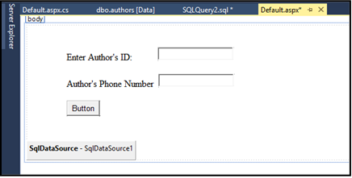

**Database:**

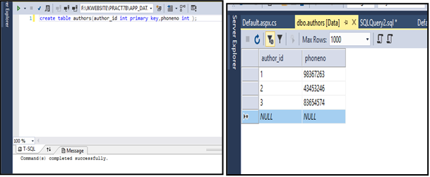

#### **Defult.aspx.cs**

using System;

using System.Collections.Generic; using System.Linq;

using System.Web; using System.Web.UI;

using System.Web.UI.WebControls; using System.Data;

using System.Data.SqlClient;

public partial class _Default : System.Web.UI.Page

{

SqlConnection cn = new SqlConnection("Data Source=(LocalDB)\\MSSQLLocalDB;AttachDbFilename=F:\\jkwebsite\\pract7b\\ App_Data\\Database.mdf;Integrated Security=True");

SqlDataReader dr;

protected void Page_Load(object sender, EventArgs e)

{ }

protected void Button1_Click(object sender, EventArgs e)

{

SqlCommand cmd = new SqlCommand("select * from authors where author_id="

+ TextBox1.Text + "", cn); cn.Open();

dr = cmd.ExecuteReader(); while (dr.Read())

{

TextBox2.Text = Convert.ToString(dr["phoneno"]);

}}}

Output:

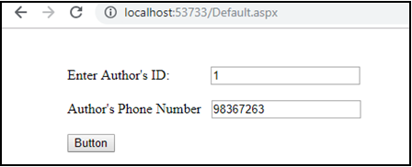

## **Create a web application for inserting and deleting record from a database. (Using Execute-Non Query).**

#### **Default.aspx**

<%@ Page Language="C#" AutoEventWireup="true" CodeFile="7c.aspx.cs" Inherits="_7c" %>

<!DOCTYPE html>

<html xmlns="<http://www.w3.org/1999/xhtml>">

<head runat="server">

<title></title></head>

<body>

<form id="form1" runat="server">

<div style="height: 331px">

<asp:Label ID="Label1" runat="server" Text="Bank Address"></asp:Label> &nbsp;&nbsp;&nbsp;&nbsp;&nbsp;&nbsp;&nbsp;&nbsp;&nbsp;

<asp:TextBox ID="TextBox1" runat="server"></asp:TextBox>

<br />

<asp:Label ID="Label2" runat="server" Text="Bank City"></asp:Label>

<asp:TextBox ID="TextBox2" runat="server"></asp:TextBox><br />

<asp:Label ID="Label3" runat="server" Text="Bank Branch Name"></asp:Label> &nbsp;

<asp:TextBox ID="TextBox3" runat="server"></asp:TextBox><br />

<asp:Label ID="Label4" runat="server" Text="State"></asp:Label>

<asp:TextBox ID="TextBox4" runat="server"></asp:TextBox><br />

<asp:Label ID="Label5" runat="server" Text="ZIP Code"></asp:Label>

<asp:TextBox ID="TextBox5" runat="server"></asp:TextBox>

<br /><br />

<asp:Button ID="Button1" runat="server" OnClick="Button1_Click" Text="Insert" />

&nbsp;&nbsp;&nbsp;&nbsp;

<asp:Button ID="Button2" runat="server" Text="Delete" />

<br /><br />

<asp:Label ID="Label6" runat="server"></asp:Label>

</div>

</form>

</body>

</html>

#### **Design:**

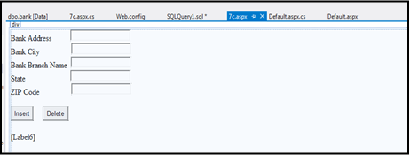

**Default.aspx.cs**

using System;

using System.Collections.Generic; using System.Configuration; using System.Data.SqlClient; using System.Linq;

using System.Web; using System.Web.UI; using System.Data;

using System.Web.UI.WebControls;

public partial class _7c : System.Web.UI.Page

{

protected void Page_Load(object sender, EventArgs e)

{

}

protected void Button1_Click(object sender, EventArgs e)

{

string connStr = ConfigurationManager.ConnectionStrings["connStr"].ConnectionString; SqlConnection con = new SqlConnection(connStr);

string InsertQuery = "insert into bank values(@b_add,@b_city,@b_name,@b_state,@b_zip)"; SqlCommand cmd = new SqlCommand(InsertQuery,con); cmd.Parameters.AddWithValue("@b_add", TextBox1.Text); cmd.Parameters.AddWithValue("@b_city", TextBox2.Text); cmd.Parameters.AddWithValue("@b_name", TextBox3.Text); cmd.Parameters.AddWithValue("@b_state", TextBox4.Text); cmd.Parameters.AddWithValue("@b_zip", TextBox5.Text); con.Open();

cmd.ExecuteNonQuery();

Label6.Text = "Record Inserted Successfully"; TextBox1.Text = "";

TextBox2.Text = ""; TextBox3.Text = ""; TextBox4.Text = ""; TextBox5.Text = ""; con.Close();

}

protected void Button2_Click(object sender, EventArgs e)

{

string connStr = ConfigurationManager.ConnectionStrings["connStr"].ConnectionString; SqlConnection con = new SqlConnection(connStr);

string deleteQuery = "delete from bank where b_add=@b_add"; SqlCommand cmd = new SqlCommand(deleteQuery, con); cmd.Parameters.AddWithValue("@b_add", TextBox1.Text); con.Open();

cmd.ExecuteNonQuery();

Label6.Text = "Record Deleted Successfully"; TextBox1.Text = "";

TextBox2.Text = ""; TextBox3.Text = ""; TextBox4.Text = ""; TextBox5.Text = ""; con.Close();

}}

Output:

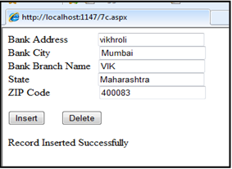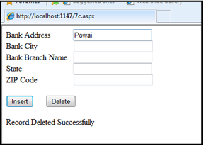

# **Practical No:08**

## **Working with data controls**

### Create a web application to demonstrate various uses and properties of SqlDataSource.

#### **Default.aspx**

<%@ Page Language="C#" AutoEventWireup="true" CodeFile="Default.aspx.cs" Inherits="_Default" %>

<!DOCTYPE html>

<html xmlns="<http://www.w3.org/1999/xhtml>">

<head runat="server">

<title></title>

</head><body>

<form id="form1" runat="server">

<div><br /> &nbsp;

<asp:Label ID="Label1" runat="server" Text="Enter Your Roll_No:"></asp:Label>

&nbsp;<asp:TextBox ID="TextBox1" runat="server"></asp:TextBox><br />

<asp:Label ID="Label2" runat="server" Text="Enter Your Name:"></asp:Label> &nbsp;&nbsp;&nbsp;

<asp:TextBox ID="TextBox2" runat="server"></asp:TextBox><br />

<asp:Label ID="Label3" runat="server" Text="Enter Your Class:"></asp:Label> &nbsp;&nbsp;&nbsp;&nbsp;

<asp:TextBox ID="TextBox3" runat="server"></asp:TextBox><br /><br />

<asp:GridView ID="GridView1" runat="server" AutoGenerateColumns="False" DataKeyNames="rollno" DataSourceID="SqlDataSource1">

<Columns>

<asp:BoundField DataField="rollno" HeaderText="rollno" ReadOnly="True" SortExpression="rollno" />

<asp:BoundField DataField="Name" HeaderText="Name" SortExpression="Name" />

<asp:BoundField DataField="class" HeaderText="class" SortExpression="class"

/>

</Columns>

</asp:GridView><br /> &nbsp;

<asp:Button ID="Button1" runat="server" OnClick="Button1_Click" Text="Insert" />&nbsp;&nbsp;

<asp:Button ID="Button2" runat="server" OnClick="Button2_Click" Text="Delete" /><br /><br /><br />

<asp:SqlDataSource ID="SqlDataSource1" runat="server" ConnectionString="<%$ ConnectionStrings:ConnectionString %>" SelectCommand="SELECT * FROM [student]" DeleteCommand="DELETE FROM [student] WHERE [rollno] = @rollno" InsertCommand="INSERT INTO [student] ([rollno], [Name], [class]) VALUES (@rollno, @Name, @class)" UpdateCommand="UPDATE [student] SET [Name] = @Name, [class] = @class WHERE [rollno] = @rollno">

<DeleteParameters>

<asp:Parameter Name="rollno" Type="Int32" />

</DeleteParameters>

<InsertParameters>

<asp:Parameter Name="rollno" Type="Int32" />

<asp:Parameter Name="Name" Type="String" />

<asp:Parameter Name="class" Type="String" />

</InsertParameters>

<UpdateParameters>

<asp:Parameter Name="Name" Type="String" />

<asp:Parameter Name="class" Type="String" />

<asp:Parameter Name="rollno" Type="Int32" />

</UpdateParameters></asp:SqlDataSource>

<br /><br />

</div></form>

</body></html>

#### **Design:**

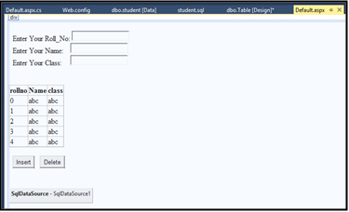

**Web.config**

<?xml version="1.0"?>

<!--

For more information on how to configure your ASP.NET application, please visit <http://go.microsoft.com/fwlink/?LinkId=169433>

-->

<configuration>

<connectionStrings>

<add name="ConnectionString" connectionString="Data Source=(LocalDB)\MSSQLLocalDB;AttachDbFilename=|DataDirectory|\Databas e.mdf;Integrated Security=True"

providerName="System.Data.SqlClient" />

</connectionStrings>

<system.web>

<compilation debug="true" targetFramework="4.5.2" />

<httpRuntime targetFramework="4.5.2" />

</system.web>

</configuration>

#### **Default.aspx.cs**

using System;

using System.Collections.Generic; using System.Linq;

using System.Web; using System.Web.UI;

using System.Web.UI.WebControls; using System.Data;

using System.Data.SqlClient; using System.Configuration;

public partial class _Default : System.Web.UI.Page

{

protected void Page_Load(object sender, EventArgs e)

{

string ConnectionString = ConfigurationManager.ConnectionStrings["ConnectionString"].ConnectionString; SqlConnection con = new SqlConnection(ConnectionString);

SqlCommand cmd = new SqlCommand("Select * from student", con); con.Open();

SqlDataAdapter adapter = new SqlDataAdapter(cmd); DataSet ds = new DataSet();

adapter.Fill(ds, "student");

}

protected void Button1_Click(object sender, EventArgs e)

{

SqlDataSource1.InsertParameters["rollno"].DefaultValue = TextBox1.Text; SqlDataSource1.InsertParameters["Name"].DefaultValue = TextBox2.Text; SqlDataSource1.InsertParameters["class"].DefaultValue = TextBox3.Text; SqlDataSource1.Insert();

}

protected void Button2_Click(object sender, EventArgs e)

{

SqlDataSource1.DeleteParameters["rollno"].DefaultValue = TextBox1.Text; SqlDataSource1.Delete();

} }

Output:

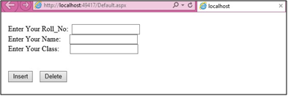

* **Insert: Delete :**

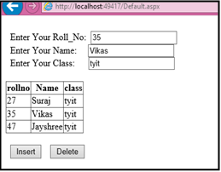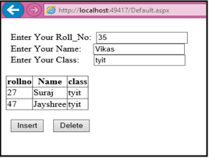

## **Create a web application to demonstrate data binding using DetailsView and FormView Control.**

#### **Default.aspx**

<%@ Page Language="C#" AutoEventWireup="true" CodeFile="Default.aspx.cs" Inherits="_Default" %>

<!DOCTYPE html PUBLIC "-//W3C//DTD XHTML 1.0 Transitional//EN" ["http:/](http://www.w3.org/TR/xhtml1/DTD/xhtml1-transitional.dtd)/[www.w3.org/TR/xhtml1/DTD/xhtml1-transitional.dtd](http://www.w3.org/TR/xhtml1/DTD/xhtml1-transitional.dtd)">

<html xmlns="<http://www.w3.org/1999/xhtml>">

<head id="Head1" runat="server">

<title></title></head>

<body>

<form id="form1" runat="server">

<div align="center">

<asp:SqlDataSource ID="SqlDataSource1" runat="server" ConnectionString="<%$ ConnectionStrings:ConnectionString %>" SelectCommand="SELECT * FROM [student]" ConflictDetection="CompareAllValues" DeleteCommand="DELETE FROM [student] WHERE [id] = @original_id AND (([name] = @original_name) OR ([name] IS NULL AND @original_name IS NULL))" InsertCommand="INSERT INTO [student] ([id], [name]) VALUES (@id, @name)" OldValuesParameterFormatString="original_{0}" UpdateCommand="UPDATE [student] SET [name] = @name WHERE [id] = @original_id AND (([name] = @original_name) OR ([name] IS NULL AND @original_name IS NULL))">

<DeleteParameters>

<asp:Parameter Name="original_id" Type="Int32" />

<asp:Parameter Name="original_name" Type="String" />

</DeleteParameters>

<InsertParameters>

<asp:Parameter Name="id" Type="Int32" />

<asp:Parameter Name="name" Type="String" />

</InsertParameters>

<UpdateParameters>

<asp:Parameter Name="name" Type="String" />

<asp:Parameter Name="original_id" Type="Int32" />

<asp:Parameter Name="original_name" Type="String" />

</UpdateParameters>

</asp:SqlDataSource>

<br />

<asp:DetailsView ID="DetailsView1" runat="server" AllowPaging="True"

DataSourceID="SqlDataSource1" Height="50px" Width="125px" AutoGenerateRows="False" DataKeyNames="id">

<Fields>

<asp:BoundField DataField="id" HeaderText="id" ReadOnly="True" SortExpression="id" />

<asp:BoundField DataField="name" HeaderText="name" SortExpression="name"

/>

<asp:CommandField ShowDeleteButton="True" ShowEditButton="True" ShowInsertButton="True" />

</Fields>

</asp:DetailsView><br />

<asp:SqlDataSource ID="SqlDataSource2" runat="server" ConnectionString="<%$ ConnectionStrings:ConnectionString %>" SelectCommand="SELECT * FROM [student]" ConflictDetection="CompareAllValues" DeleteCommand="DELETE FROM [student] WHERE [id] = @original_id AND (([name] = @original_name) OR ([name] IS NULL AND @original_name IS NULL))" InsertCommand="INSERT INTO [student] ([id], [name]) VALUES (@id, @name)" OldValuesParameterFormatString="original_{0}" UpdateCommand="UPDATE [student] SET [name] = @name WHERE [id] = @original_id AND (([name] = @original_name) OR ([name] IS NULL AND @original_name IS NULL))">

<DeleteParameters>

<asp:Parameter Name="original_id" Type="Int32" />

<asp:Parameter Name="original_name" Type="String" />

</DeleteParameters>

<InsertParameters>

<asp:Parameter Name="id" Type="Int32" />

<asp:Parameter Name="name" Type="String" />

</InsertParameters>

<UpdateParameters>

<asp:Parameter Name="name" Type="String" />

<asp:Parameter Name="original_id" Type="Int32" />

<asp:Parameter Name="original_name" Type="String" />

</UpdateParameters>

</asp:SqlDataSource><br />

<asp:FormView ID="FormView1" runat="server" AllowPaging="True" DataSourceID="SqlDataSource2" DataKeyNames="id">

<EditItemTemplate> id:

<asp:Label ID="idLabel1" runat="server" Text='<%# Eval("id") %>' /><br />

name:

<asp:TextBox ID="nameTextBox" runat="server" Text='<%# Bind("name") %>'

/><br />

<asp:LinkButton ID="UpdateButton" runat="server" CausesValidation="True" CommandName="Update" Text="Update" />

&nbsp;<asp:LinkButton ID="UpdateCancelButton" runat="server" CausesValidation="False" CommandName="Cancel" Text="Cancel" />

</EditItemTemplate>

<InsertItemTemplate> id:

<asp:TextBox ID="idTextBox" runat="server" Text='<%# Bind("id") %>' />

<br />

name:

<asp:TextBox ID="nameTextBox" runat="server" Text='<%# Bind("name") %>'

/><br />

<asp:LinkButton ID="InsertButton" runat="server" CausesValidation="True" CommandName="Insert" Text="Insert" />

&nbsp;<asp:LinkButton ID="InsertCancelButton" runat="server" CausesValidation="False" CommandName="Cancel" Text="Cancel" />

</InsertItemTemplate>

<ItemTemplate>

id:<asp:Label ID="idLabel" runat="server" Text='<%# Eval("id") %>' /><br /> name:<asp:Label ID="nameLabel" runat="server" Text='<%# Bind("name") %>'

/><br />

<asp:LinkButton ID="EditButton" runat="server" CausesValidation="False" CommandName="Edit" Text="Edit" />

&nbsp;<asp:LinkButton ID="DeleteButton" runat="server" CausesValidation="False" CommandName="Delete" Text="Delete" /> &nbsp;<asp:LinkButton ID="NewButton" runat="server" CausesValidation="False" CommandName="New" Text="New" />

</ItemTemplate>

</asp:FormView>

</div>

</form>

</body>

</html>

#### **Design.aspx**

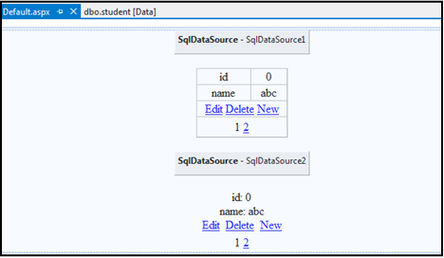

**Default.aspx.cs**

using System;

using System.Collections.Generic; using System.Linq;

using System.Web; using System.Web.UI;

using System.Web.UI.WebControls;

public partial class _Default : System.Web.UI.Page

{

protected void Page_Load(object sender, EventArgs e)

{ } }

Output:

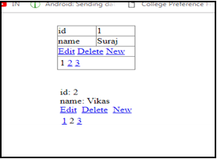

## **Create a web application to display Using Disconnected Data Access and Databinding using GridView.**

#### **Default.aspx**

<%@ Page Language="C#" AutoEventWireup="true" CodeFile="Default.aspx.cs" Inherits="_Default" %>

<!DOCTYPE html PUBLIC "-//W3C//DTD XHTML 1.0 Transitional//EN" ["http:/](http://www.w3.org/TR/xhtml1/DTD/xhtml1-transitional.dtd)/[www.w3.org/TR/xhtml1/DTD/xhtml1-transitional.dtd](http://www.w3.org/TR/xhtml1/DTD/xhtml1-transitional.dtd)">

<html xmlns="<http://www.w3.org/1999/xhtml>">

<head id="Head1" runat="server">

<title></title></head>

<body>

<form id="form1" runat="server">

<div align="center">

<asp:GridView ID="GridView1" runat="server" AllowSorting="True" AutoGenerateColumns="False" DataSourceID="ObjectDataSource1" DataKeyNames="id">

<Columns>

<asp:BoundField DataField="id" HeaderText="id" SortExpression="id" ReadOnly="True" />

<asp:BoundField DataField="name" HeaderText="name" SortExpression="name"

/>

</Columns>

</asp:GridView><br />

<asp:ObjectDataSource ID="ObjectDataSource1" runat="server" InsertMethod="Insert" OldValuesParameterFormatString="original_{0}" SelectMethod="GetData" TypeName="DataSetTableAdapters.studentTableAdapter" DeleteMethod="Delete" UpdateMethod="Update">

<DeleteParameters>

<asp:Parameter Name="Original_id" Type="Int32" />

</DeleteParameters>

<InsertParameters>

<asp:Parameter Name="id" Type="Int32" />

<asp:Parameter Name="name" Type="String" />

</InsertParameters>

<UpdateParameters>

<asp:Parameter Name="name" Type="String" />

<asp:Parameter Name="Original_id" Type="Int32" />

</UpdateParameters>

</asp:ObjectDataSource>

</div></form></body>

</html>

#### **Design:**

* 1. **Default.aspx** **ii)DataSet.xsd**

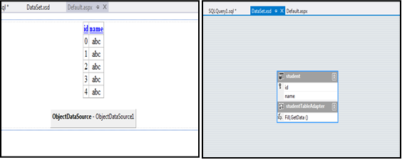

#### **Default.aspx.cs**

using System;

using System.Collections.Generic; using System.Linq;

using System.Web; using System.Web.UI;

using System.Web.UI.WebControls;

public partial class _Default : System.Web.UI.Page

{

protected void Page_Load(object sender, EventArgs e)

{ }

}Output:

