***Program-4:***

**Develop and demonstrate a HTML5 file that includes JavaScript script that uses functions for the following problems:**

**a. Parameter: A string | Output: The numbers of vowels in the string**

**b. Parameter: A number | Output: The number with its digits in the reverse order and Product of both number and its Reverse**

1. **HTML CODE:**

<!DOCTYPE html>

<html>

<head>

<title>Challenge-4</title>

</head>

<body>

<script>

var str = prompt("Enter the Input", "");

if (!(isNaN(str)))

{

var num, rev = 0, remainder;

num = parseInt(str);

while (num != 0) {

remainder = num % 10;

num = parseInt(num / 10);

rev = rev * 10 + remainder;

}

const product = str * rev;

alert("Reverse of " + str + " is " + rev + " and the product is " + product);

}

else {

str = str.toUpperCase();

function vowels(string) {

var vowels = 'AEIOUaeiou';

var count = 0;

for (i = 0; i < string.length; i++) {

if (vowels.indexOf(string[i]) !== -1) {

count += 1;

}

}

return count;

}

n = vowels(str)

alert("The given string " + str + " has " + n + " Vowels in it")

}

</script>

</body>

</html>

1. **TEST CASES:**

|  |  |  |  |
| --- | --- | --- | --- |
| **Test no** | **Test Case** | **Expected output** | **Actual Output** |
| **1** | a. Integer Value: 123456  b. Text Value:  ABCD | a. Reverse of 123456 is 654321 and the product is 80779853376  b. The given string ABCD has 1 Vowels in it | a. Reverse of 123456 is 654321 and the product is 80779853376  b. The given string ABCD has 1 Vowels in it |
| **2** | a. Negative Integer value: -46  b. Text Value: -DEAF | a. Reverse of -46 is -64 and the product is 2944  b. The given string -DEAF has 2 Vowels in it | a.Reverse of -46 is -64 and the product is 2944  b. The given string -DEAF has 2 number of Vowels |
| **3** | Alpha numerical value: VR46A | The given string VR46A has 1 number of Vowels | The given string VR46A has 1 number of Vowels |
| **4** | Non vowel string: KLGN | The given string KLGN has 0 Vowels in it | The given string KLGN has 0 Vowels in it |

**SNAPSHOTS:**

1. **INPUTS**

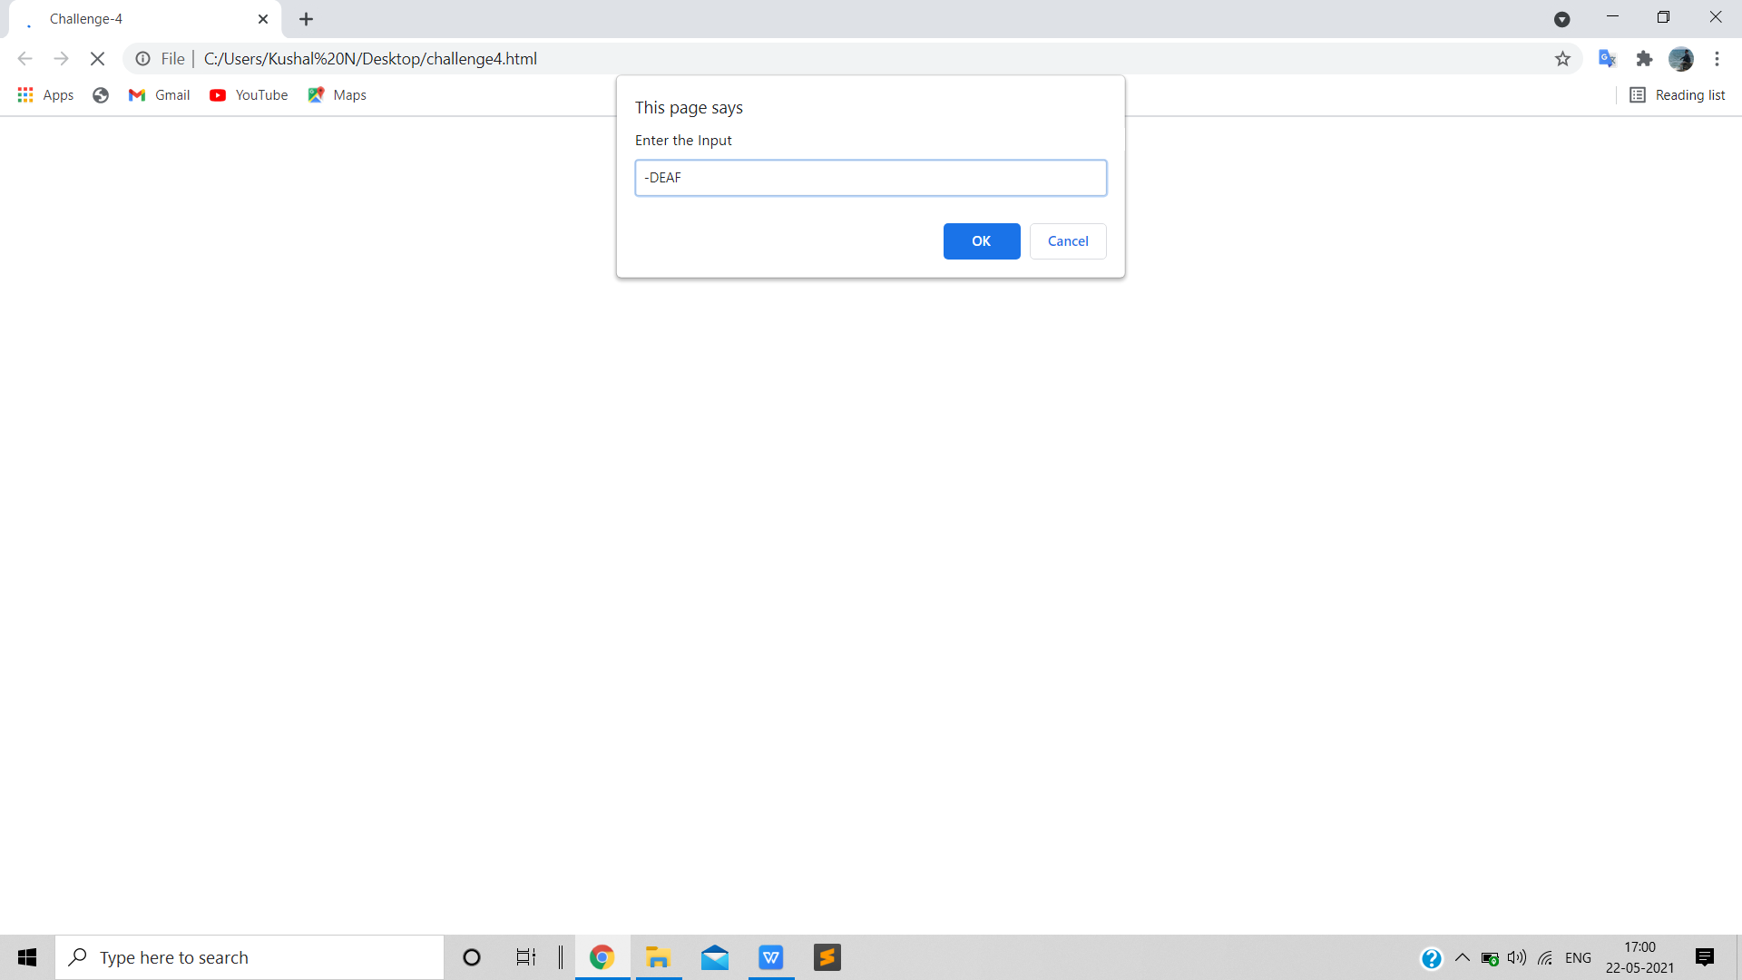

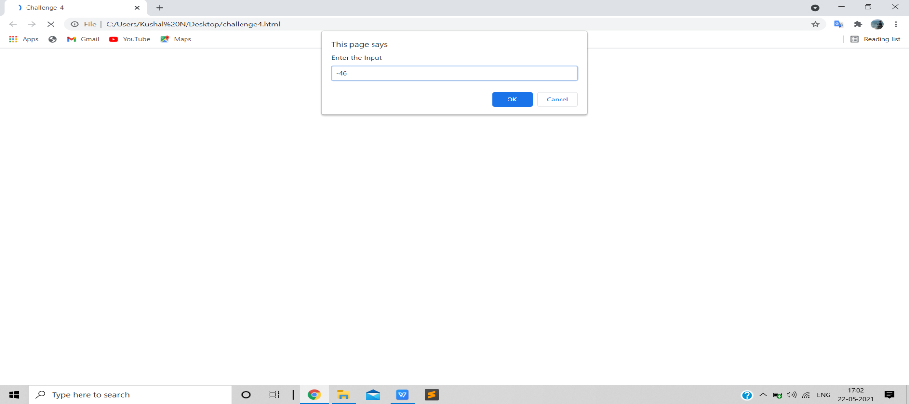

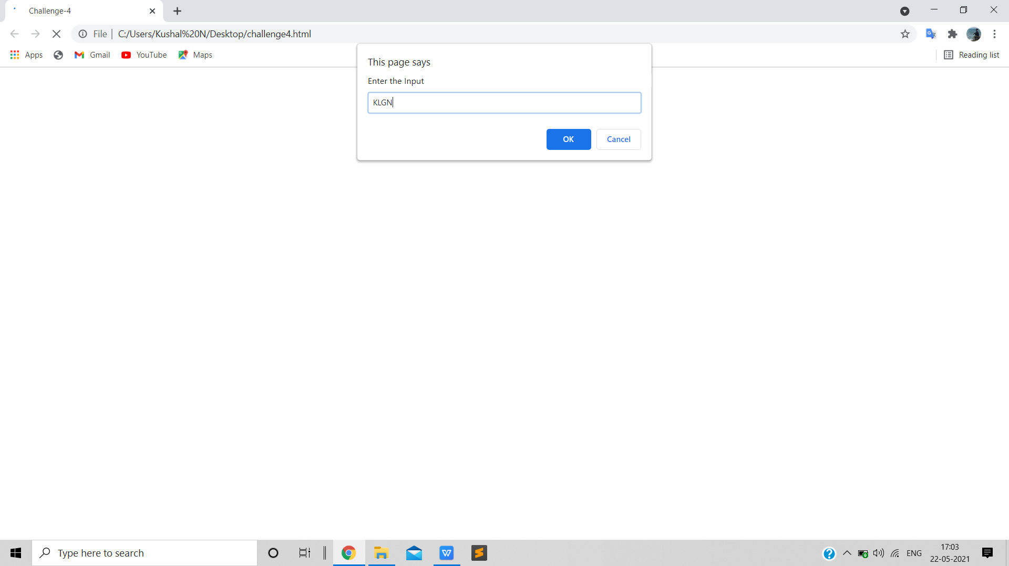

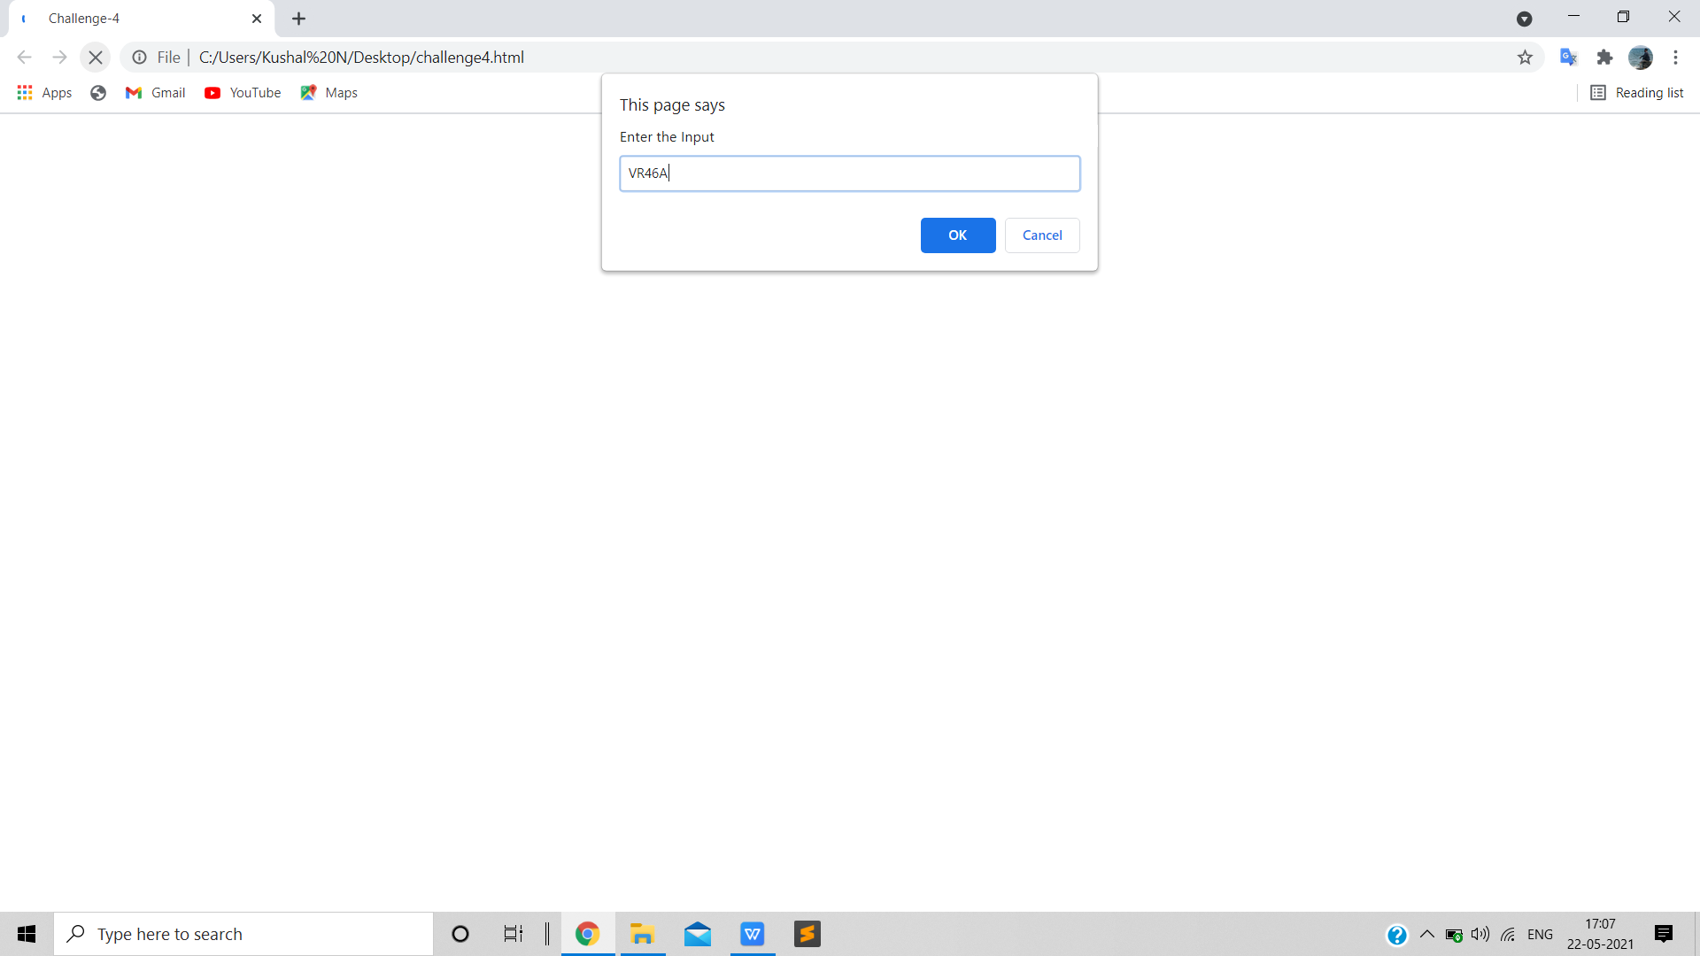

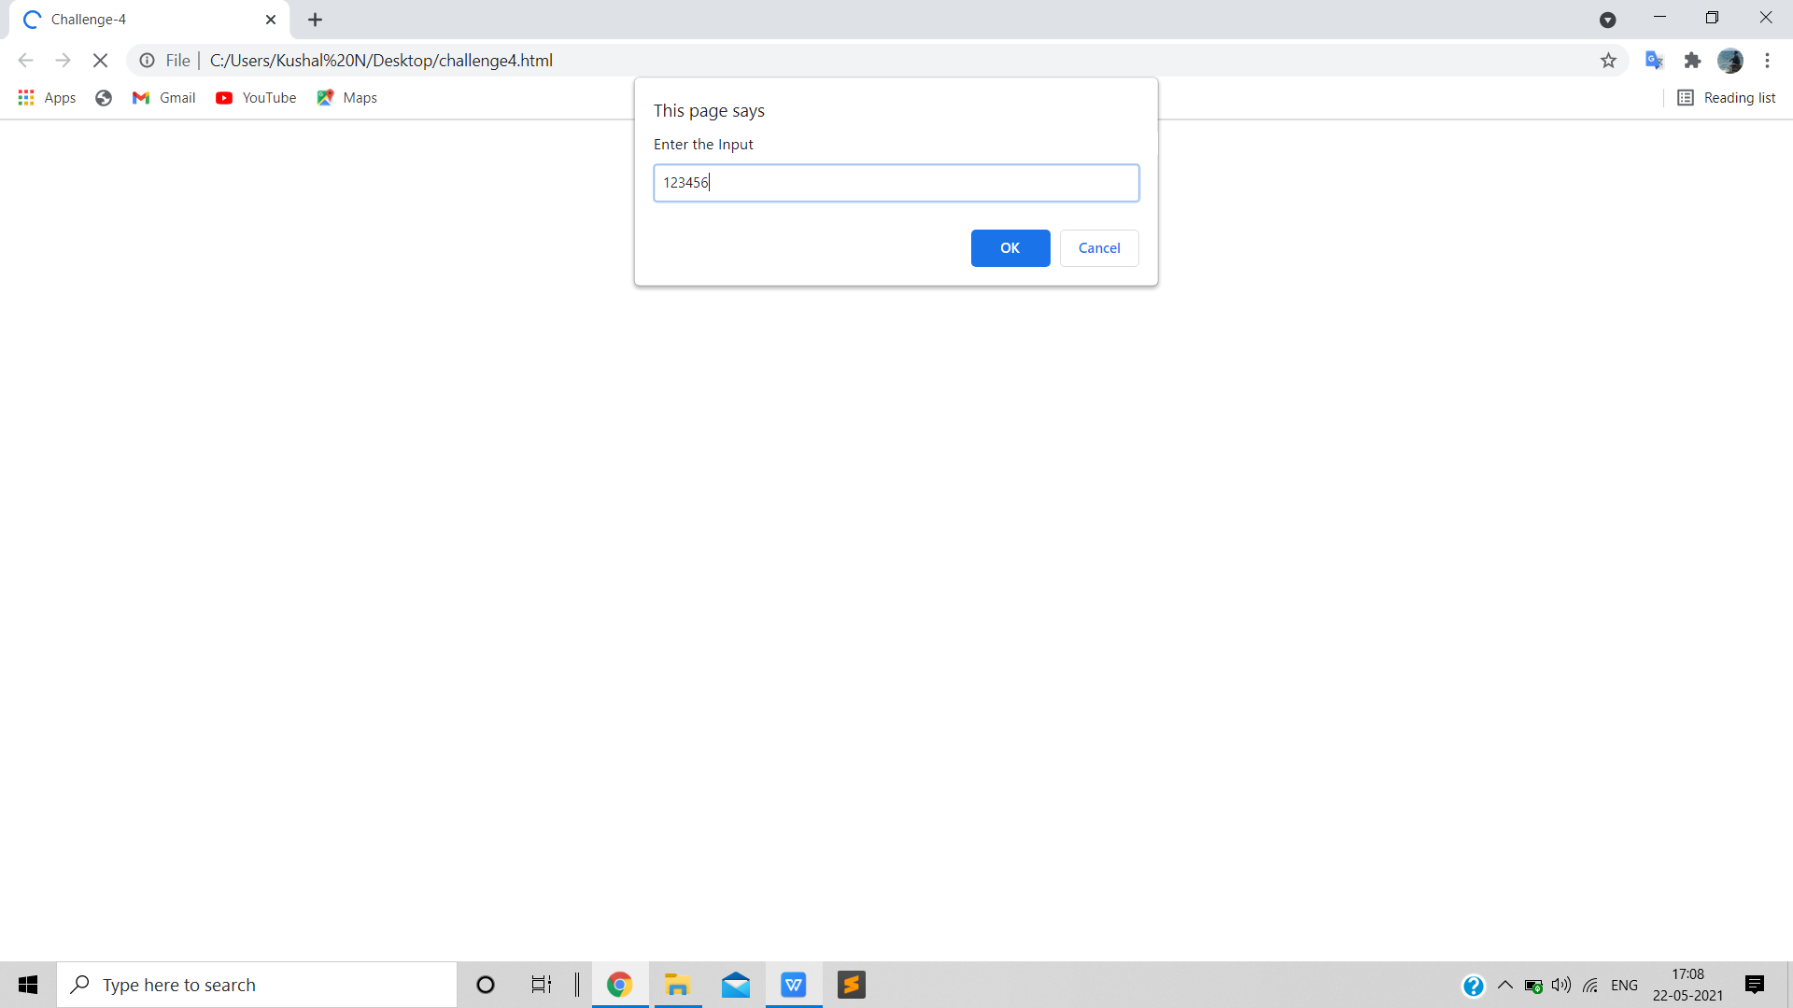

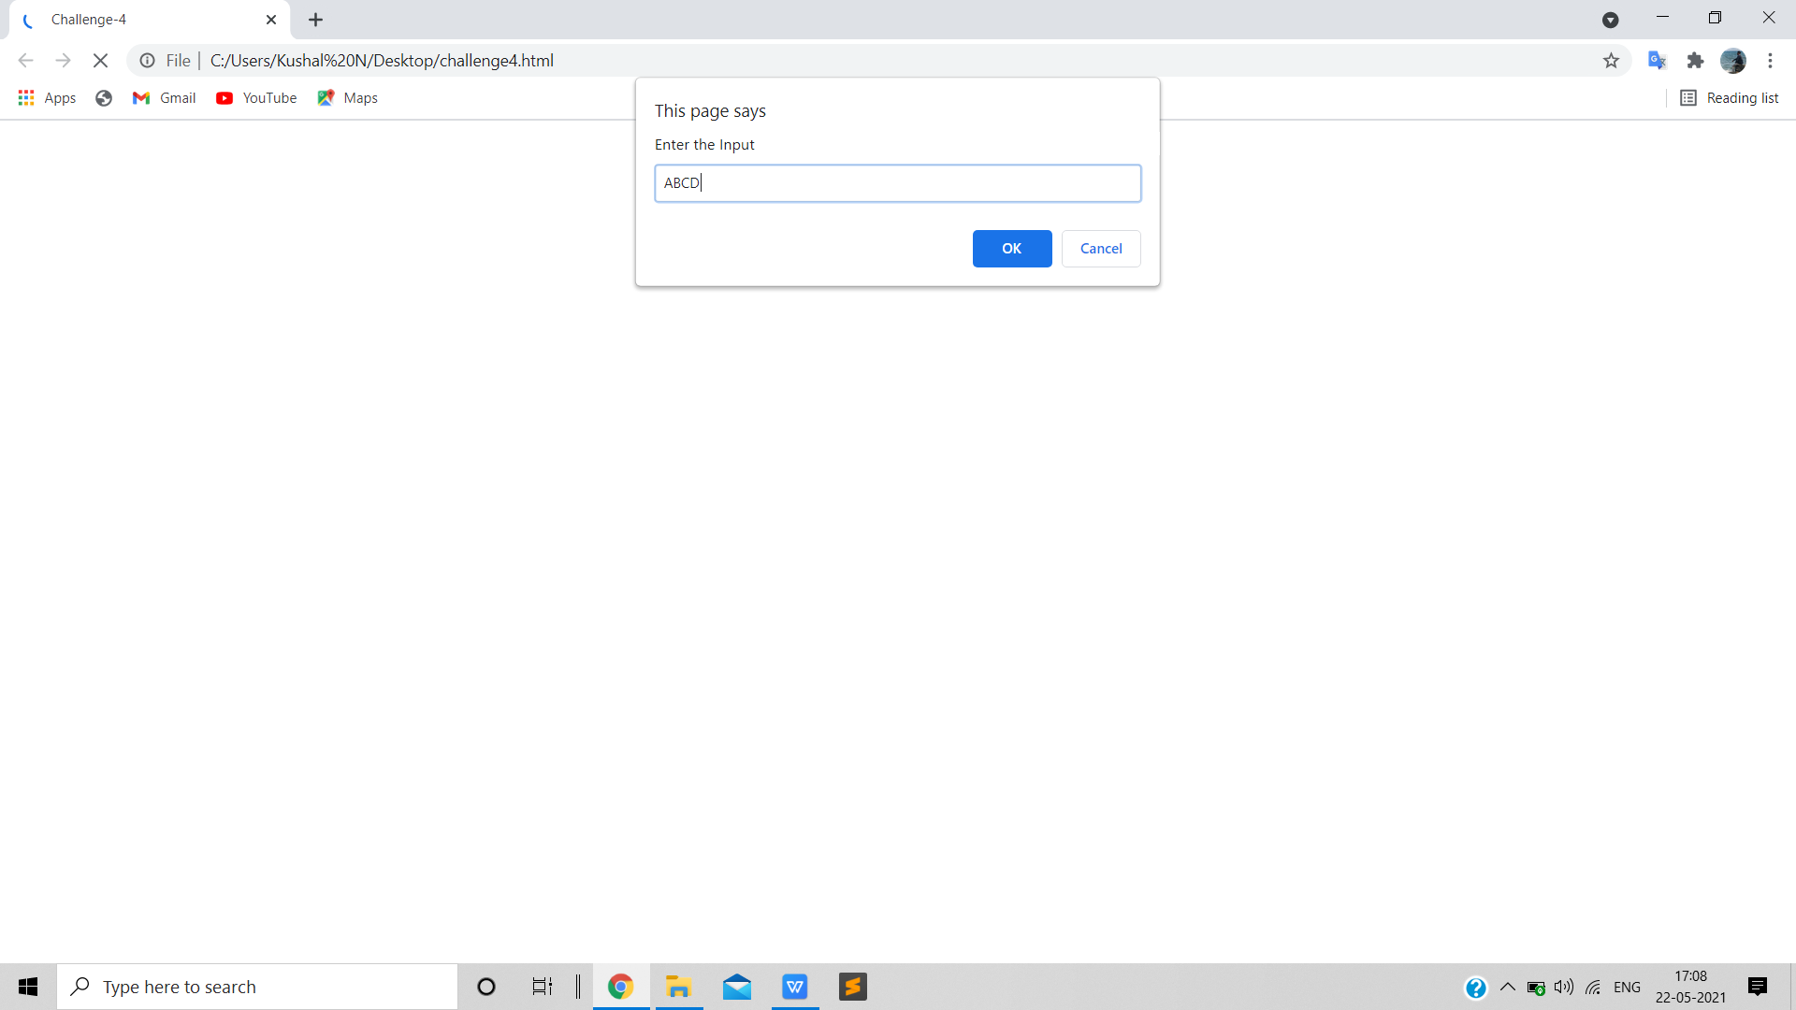

1. **OUTPUTS**

