



VISVESVARAYA TECHNOLOGICAL UNIVERSITY
“JNANA SANGAMA” BELAGAVI-590018

BDA Mini Project Report On
“Healthcare Patient Management System”

In the partial fulfillment of the requirement for 6th Semester BACHELOR OF ENGINEERING
IN
Computer Science and Engineering (Data Science)
BY
BHOOMIKA RATHOD [1JB22CD012] KALPANA V K [1JB22CD028]
SPOORTHY. R [1JB22CD053]
VAISHNAVI. Y U [1JB22CD059]
VINATHA N [1JB22CD063] UNDER THE GUIDANCE OF
Ms.Bhoomika S Babu
Assistant Professor Department of CSE (Data Science)
SJBIT, Bengaluru

DEPARTMENT OF COMPUTER SCIENCE AND ENGINEERING (DATA SCIENCE) SJB INSTITUTE OF TECHNOLOGY
No.67, B G S Health and Education city, Dr.Vishnuvardhan road Kengeri, Bengaluru-560060.
2024-2025
TABLE OF CONTENTS

Chapter No. Title Page no.
- INTRODUCTION 1 - 2
- REQUIREMENTS SPECIFICATION 3 - 4
- DESIGN AND ARCHITECTURE 5 - 6
- IMPLEMENTATION 7 - 9
- RESULTS 10 - 11
- CONCLUSION 12

CHAPTER 1

INTRODUCTION

The Hospital Management System (HMS) is a modern, full-featured web application engineered to digitize and optimize the critical operations of healthcare institutions. Built on the MERN stack comprising MongoDB for NoSQL data storage, Express.js for scalable backend routing, React.js for dynamic frontend development, and Node.js for efficient server side execution the system ensures both performance and flexibility. It provides an integrated platform for managing a wide range of hospital activities, including patient admission and discharge, electronic medical records, appointment scheduling, billing and invoicing, inventory tracking, and staff administration. By leveraging Redux, the system ensures that application state remains consistent and predictable across all user interactions, which is crucial for maintaining accuracy in multi-user environments. In addition, TailwindCSS allows for a highly responsive and aesthetically pleasing user interface that adapts seamlessly across devices, making the system accessible from desktops, tablets, and smartphones.
Security and user experience are at the heart of this solution. The application features JWT-based authentication to enforce secure, role-based access control for different user types such as administrators, doctors, nurses, and clerical staff, ensuring that sensitive data remains protected and accessible only to authorized personnel. Furthermore, Framer Motion enhances the UI with smooth transitions and animations, offering an engaging user experience without compromising on performance or functionality. The system is architected to allow modular scalability, making it easy to integrate additional features or third-party services in the future. Altogether, this Hospital Management System not only reduces administrative overhead and human error but also empowers healthcare providers with actionable insights and real-time data, ultimately leading to improved operational efficiency and higher standards of patient care.
Designed with scalability and maintainability in mind, this Hospital Management System adheres to modern development practices including modular code structure, environment-based configuration management, and seamless integration with MongoDB Atlas or local instances.

Developers can quickly get started with minimal setup thanks to clear documentation and pre configured scripts. In real-world applications, this system can be customized for various healthcare setups from small clinics to large hospitals and can integrate with third-party APIs for advanced features like SMS notifications, e-prescriptions, or external reporting tools. With a focus on user experience, performance, and security, this project stands as a solid foundation for a production-grade medical management platform.

CHAPTER 2

REQUIREMENTS SPECIFICATION

SOFTWARE REQUIREMENT

CATEGORY | SPECIFICATION
Operating System | Linux
Frontend Technologies | React.js, Redux, TailwindCSS, Framer Motion
Backend Technologies | Node.js, Express.js
Database | MongoDB
Package Manager | npm
Development Tools | VS Code

    - Operating System: Linux

Linux is a robust, secure, and open-source operating system widely used for software development and server deployment. It provides a stable environment for running Node.js servers and MongoDB databases, and it supports tools like npm and VS Code efficiently. It is also preferred for deploying scalable web applications in production environments.
    - Frontend Technologies: React.js, Redux, TailwindCSS, Framer Motion

      - React.js: A powerful JavaScript library for building user interfaces using reusable components. It allows developers to create dynamic and responsive UIs.
      - Redux: A predictable state management tool that helps manage application state across multiple components, making the UI more consistent and easier to debug.
      - TailwindCSS: A utility-first CSS framework used to build responsive and customizable UIs quickly without writing traditional CSS.
      - Framer Motion: A React animation library that adds smooth transitions and animations

to the interface, enhancing the overall user experience.

    - Backend Technologies: Node.js, Express.js

      - Node.js: A JavaScript runtime built on Chrome's V8 engine that allows developers to run JavaScript on the server-side. It is known for its speed and scalability.
      - Express.js: A lightweight and flexible Node.js framework that simplifies the creation of server-side routes and APIs, and handles HTTP requests and middleware effectively.
2.14 Database: MongoDB

MongoDB is a NoSQL, document-oriented database used to store structured and unstructured data in JSON-like format. It is scalable and integrates seamlessly with Node.js through Mongoose, enabling rapid data manipulation and querying.
2.1.5 Package Manager: npm (Node Package Manager)

npm is a command-line tool that helps manage JavaScript packages and dependencies required for the project. It allows developers to install, update, and manage third-party libraries essential for both frontend and backend development.
2.1.6 Development Tools: Visual Studio Code (VS Code)

VS Code is a popular, lightweight code editor that offers features such as syntax highlighting, debugging, version control, and an integrated terminal. It supports extensions for React, Node.js, MongoDB, and other technologies, enhancing developer productivity and collaboration.
2.1 HARDWARE REQUIREMENT

CATEGORY | SPECIFICATION
Processor | Intel i5
RAM | 8 GB
Storage | 10 GB

CHAPTER 3

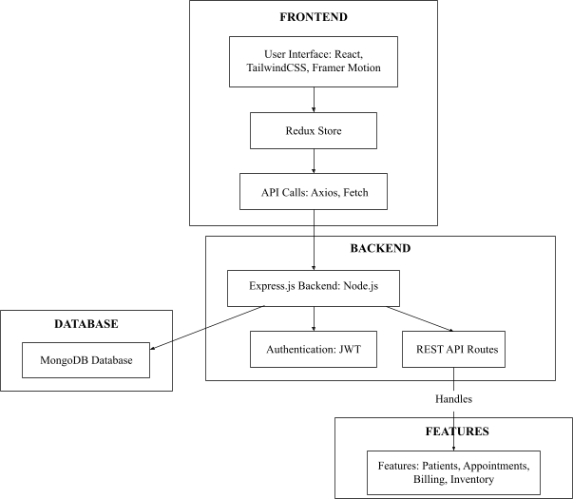
DESIGN AND ARCHITECTURE

Figure 3.1: Architecture diagram

Figure 3.1 represents the structure of the Hospital Management System developed using the MERN stack (MongoDB, Express.js, React, Node.js), along with Redux, TailwindCSS, and Framer Motion. At the top level, the frontend layer consists of a user interface built with React.js, styled using TailwindCSS for responsiveness, and enhanced with Framer Motion for animations. Application state is managed using Redux, and communication with the backend occurs via API calls using Axios or Fetch.

The backend is powered by Node.js with Express.js, which handles routing and server logic. It includes a JWT-based authentication mechanism to ensure secure access to protected resources. The backend exposes REST API routes that interact with the MongoDB database, storing and retrieving data related to patients, appointments, billing, and inventory.
Finally, the features block highlights the core functional modules that the system supports: patient management, appointment scheduling, billing system, and inventory tracking all coordinated through the flow between frontend, backend, and the database. The diagram clearly separates responsibilities and demonstrates the scalable and modular design of the application.

UI/UX Design Overview

The Healthcare Patient Management System features a modern and intuitive design aimed at enhancing user interaction and operational efficiency. The interface uses a clean layout with a soft color palette that ensures readability and visual comfort. The homepage welcomes users with a professional design showcasing healthcare professionals and a powerful tagline, establishing trust and clarity in purpose. The navigation bar at the top provides quick access to key sections such as Home, Appointments, About Us, and Contact, ensuring a smooth user journey.
The appointment booking page is carefully structured, allowing users to easily fill in necessary details such as personal information, preferred doctor, date, and reason for consultation. The form is responsive and optimized for both desktop and mobile devices, with proper input validation for user safety and accuracy.
The admin dashboard is designed with a sidebar menu and modular cards that display real-time statistics on doctors, nurses, patients, departments, and queries. This layout supports fast decision-making and role-based access, offering a seamless experience for administrators. Overall, the system’s user interface is developed with TailwindCSS and Framer Motion to provide responsive design and smooth transitions, resulting in an aesthetically pleasing and highly functional platform suitable for daily healthcare management.

CHAPTER 4
IMPLEMENTATION

Frontend (React.js + Redux + TailwindCSS + Framer Motion)

The frontend is developed using React.js, providing a component-based architecture. Redux is used for efficient and centralized state management, ensuring smooth data flow across components. TailwindCSS is implemented to enable fast and responsive UI development, while Framer Motion adds fluid animations and transitions for enhanced user experience.
Key Modules:

  - Authentication Pages: Login and registration interfaces for admins, doctors, and staff.
  - Dashboard: Role-based dashboard displaying relevant metrics and quick actions.
  - Patient Module: Add, update, and view patient records and medical histories.
  - Appointment Scheduling: Calendar interface to book and manage doctor appointments.
  - Inventory and Billing: Interfaces to manage hospital inventory and generate bills.
  - Reports: Visual representation of data using charts for analytics.

Backend (Node.js + Express.js)

The backend is powered by Node.js with Express.js to handle HTTP routes and server logic. The API follows RESTful principles, providing structured endpoints for data exchange between client and server.
Core Functionality:

  - Authentication: Implemented using JWT (JSON Web Tokens) for secure user login sessions.
  - API Endpoints: For patients, doctors, appointments, inventory, billing, and reports.
  - Middleware: Used for authentication checks and error handling.

Database (MongoDB)

A NoSQL MongoDB database is used to store structured and semi-structured data, including:

  - User credentials and roles
  - Patient medical records
  - Appointment details
  - Inventory stocks
  - Billing and payment information

The schema is designed using Mongoose for model definition and validation.

Security

  - JWT-based authentication for protected routes and session management.
  - Password hashing using bcrypt.
  - Input validation on both client and server to prevent injection attacks.

Deployment

  - Frontend Deployment: Vercel or Netlify for the React frontend.
  - Backend Deployment: Hosted on services like Render, Railway, or Heroku.
  - Database Hosting: MongoDB Atlas for cloud-hosted database service.

Example Database Schema

const patientSchema = new mongoose.Schema({ name: String,
age: Number, gender: String,
medicalHistory: [String], createdAt: {

type: Date, default: Date.now,
},
});

Collections include:

- users (admins, doctors, staff)
- patients
- appointments
- inventory
- bills

CHAPTER 5


RESULT

Figure 5.1: Frontpage

Figure 5.1 shows the homepage of HMS introduces the platform with a welcoming interface, featuring healthcare professionals and a clear navigation menu. It highlights the system’s mission: delivering specialized, holistic healthcare services to all sections of society.

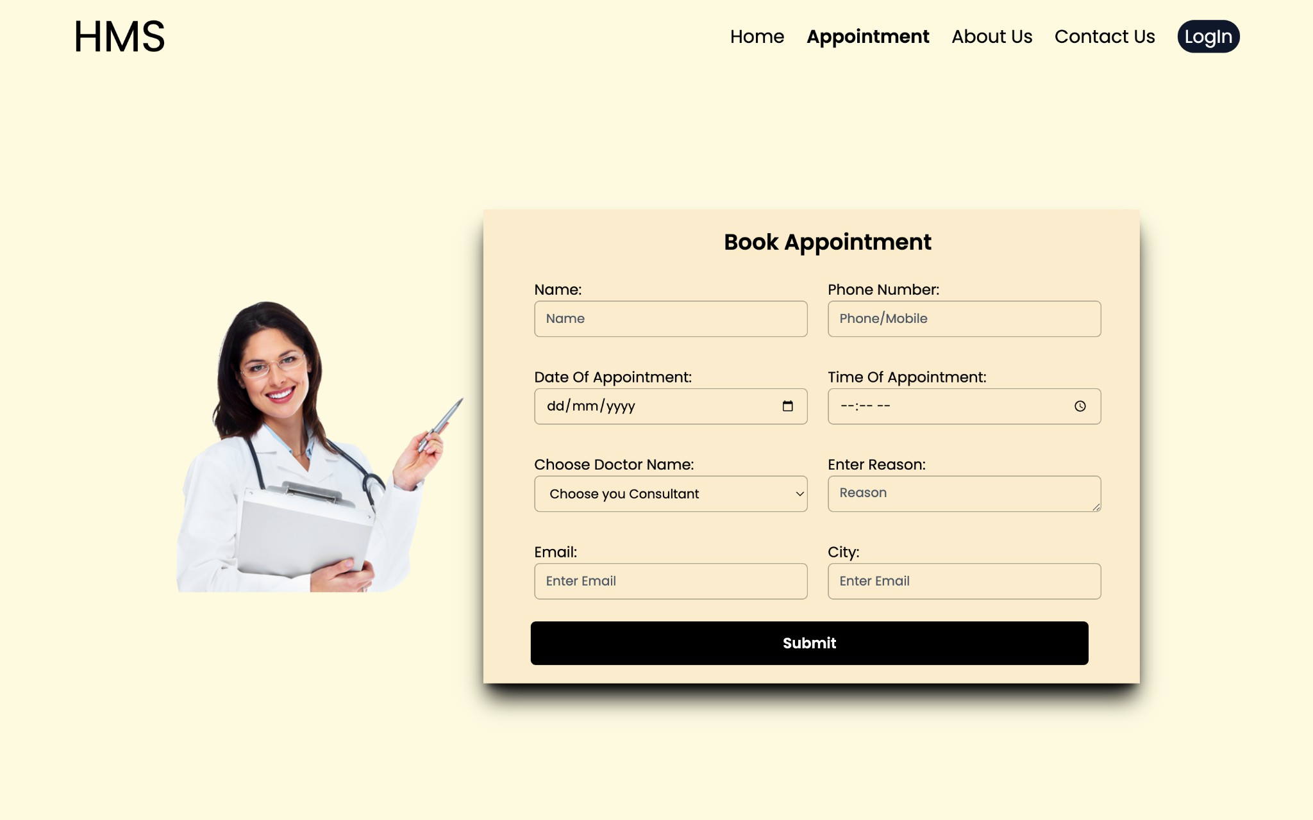

Figure 5.2 : Book Appointment

Figure 5.2 shows this page provides a user-friendly form for patients to book medical appointments by entering personal details, preferred date/time, and doctor information. The clean layout ensures a smooth booking experience, streamlining the process of accessing healthcare services efficiently.
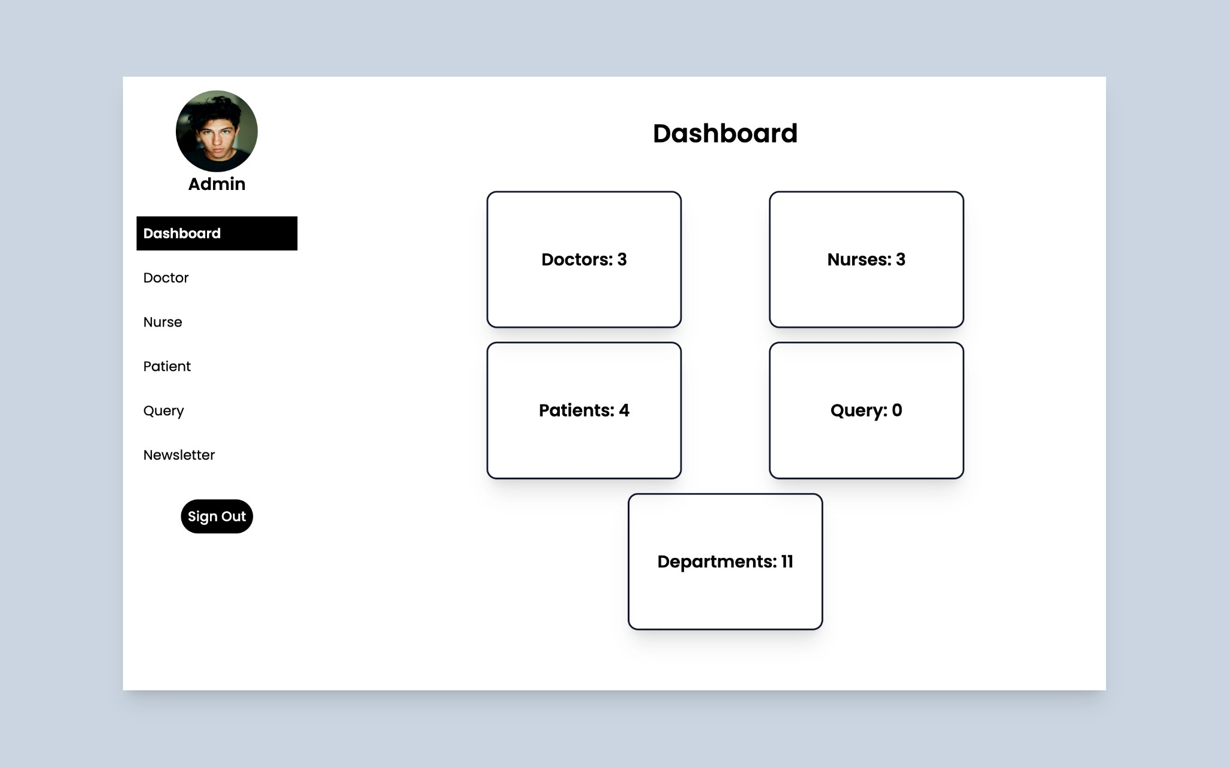

Figure 5.3 : Admin Dashboard

Figure 5.1 shows the admin dashboard provides a quick overview of hospital resources, including counts of doctors, nurses, patients, departments, and queries. With easy navigation and real-time data, it enables efficient management and monitoring of healthcare operations.

CHAPTER 6
CONCLUSION

The Healthcare Patient Management System successfully demonstrates the potential of modern web technologies in revolutionizing hospital operations and patient care. Built on the MERN stack with supplementary tools such as Redux, TailwindCSS, and Framer Motion, the system provides a seamless, secure, and efficient interface for managing various healthcare functions including patient records, appointment scheduling, billing, and inventory. By incorporating features such as JWT-based authentication, role-based access control, and responsive design, the application ensures data privacy, accessibility across devices, and ease of use for different user roles like administrators, doctors, and staff. The use of MongoDB allows for flexible data handling, and deployment on platforms such as Vercel and MongoDB Atlas ensures scalability and real-time access. Overall, the project highlights the effectiveness of full-stack development in addressing the complexities of healthcare systems, offering a foundation for future enhancements such as integration with third-party APIs, mobile support, and advanced analytics. This project not only met the academic objectives but also provided valuable hands-on experience in building production-grade software systems.

