Project Management Milestone-01

Group - 4

Project title:
Eventz (Events happening around your location)

Project Description:
The project is all about the events. This website will contain two types of end users one is event organizer and event visitors. The event organizer will upload all the events they are conducting, and the event visitors will check the available events nearby. The events are shown according to the specifications given by visitors.

Team name:
Millennium Management Solutions

Team member names:

- Syed Abdul Suboor
- Vineetha Batchu
- Jaya Shankar Mangina
- Vinay Kumar Paspula
- Kushal Satya Durgaji Katari

Client: Dr. Aziz Fellah

Team Logo:


Working as a team together:
As a team, we will take responsibility for completing the project on time without compromise on quality.

Team meetings:
We will meet daily on zoom calls and check if anyone has any issues, and we will try to resolve these issues in the daily meetings. Along with this, we will also discuss our future works.

Contacting each other:
We will be communicating via Northwest Email, Microsoft teams.

Dealing with a non-participating team member:
As a team, we will check whether the project is on track and if any team member is non-participating, we will try to resolve those issues by talking to him. If he is not interested in given work, we will assign the work in which they are interested.

Roles | Responsible Team members
Developer | Syed Abdul Subbor
Developer | Vineetha Batchu
Developer | Jaya Shankar Mangina
Tester | Vinay Kumar Paspula
Stake holder | Kushal Satya Durgaji Katari

Team Roles:
- Arranging regular stand-up meetings
- Arranging Monday Sprint meetings
- Motivating Team
- Analyzing the scope
- Managing the risks
- Keeping track of all requirements
- Assigning tasks
- Communicating with other stakeholders
- Providing encouragement to team
- Providing guidance and instructions to team members
User Interface Developer:
- Creating user interface for the website
- Upgrade is given to both Android and iOS
- Communicating with other stakeholders
- Knowledge on different tools and technologies
- Meeting the requirements
Back end Developer:
- Regularly inspect server code for speed optimization.
- Conceptualize and implement solutions for data storage.
- Improve the quality of the team’s code through writing unit tests and automation.
- Collaborate and work closely with the product and design team to understand better the end-user requirements.
- Configure the backend usability of all front side application.
Tester:
- Reviewing software requirements and preparing test scenarios.
- Executing tests on software usability.
- Analyzing test results on database impacts, errors or bugs, and usability.
- Preparing reports on all aspects related to the software testing carried out and reporting to the design team.
- Interacting with clients to understand product requirements.
- Participating in design reviews and providing input on requirements, product design, and potential problems.

Project Charter
Date:05/17/2021

Project Title: Eventz ((Events happening around your location)
Project Start Date: May - 11 - 2021 Projected Finish Date: Jun – 03 - 2021
Budget Information: Sponsors

Project Manager:
Name :Syed Abdul Suboor
Phone : 660-528-1243
E-mail : S542047@nwmissouri.edu
Project Objectives:
To create a website which will displays the data about the events happening around your location and description about it.

Success Criteria:
Finishing the project before the deadline and should be live without any errors and with responsive and user-friendly design.

Approach:
Agile approach

Roles and Responsibilities
Name and Signature | Role | Position | Contact Information
Syed Abdul Suboor | Project manager / Web application developer | Developer | S542047@nwmissouri.edu
Vineetha Batchu | Team lead / Backend developer | Developer | S541991@nwmissouri.edu
Jaya Shankar Mangina | Content & User Interface Developer | Developer | S542044@nwmissouri.edu
Vinay Kumar Paspula | Testing manager | Tester | S541769@nwmissouri.edu
Kushal Satya Durgaji Katari | Stakeholder | Design Engineer | S541904@nwmissouri.edu
Stakeholder Register for Eventz

Prepared by: Vinay Kumar Paspula Date: 05/15/2021

Name | Position | Internal/External | Project Role | Contact Information
Syed Abdul Suboor | Developer | Internal | Project manager / Web application Developer | S542047@nwmissouri.edu
Vineetha Batchu | Developer | Internal | Team lead / Backend Developer | S541991@nwmissouri.edu
Jaya Shankar Mangina | Developer | Internal | Content & User Interface Developer | S542044@nwmissouri.edu
Vinay Kumar Paspula | Tester | Internal | Testing manager | S541769@nwmissouri.edu
Kushal Satya Durgaji Katari | Stakeholder | Internal | Stakeholder | S541904@nwmissouri.edu
Aziz Fellah | Client | External | End User | afellah@nwmissouri.edu

Signatures:
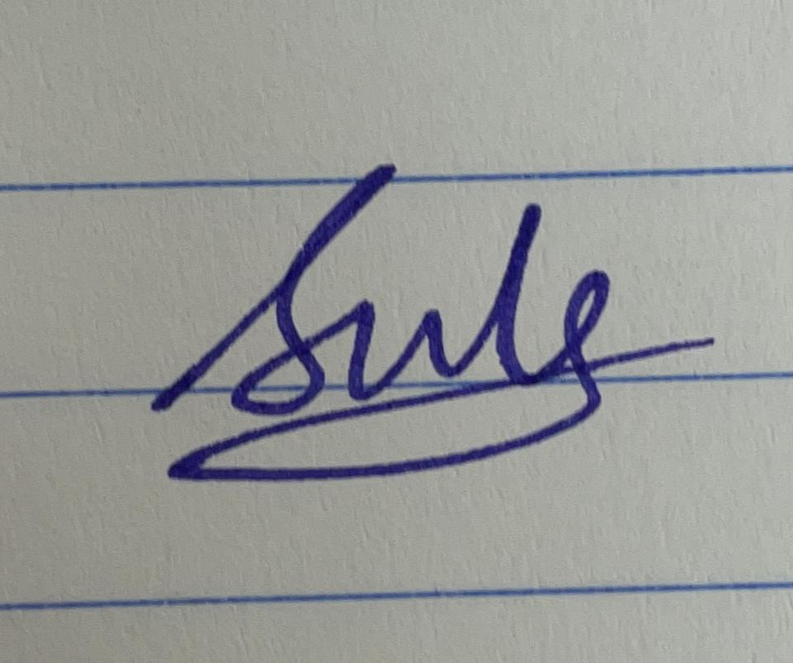
Syed Abdul Suboor

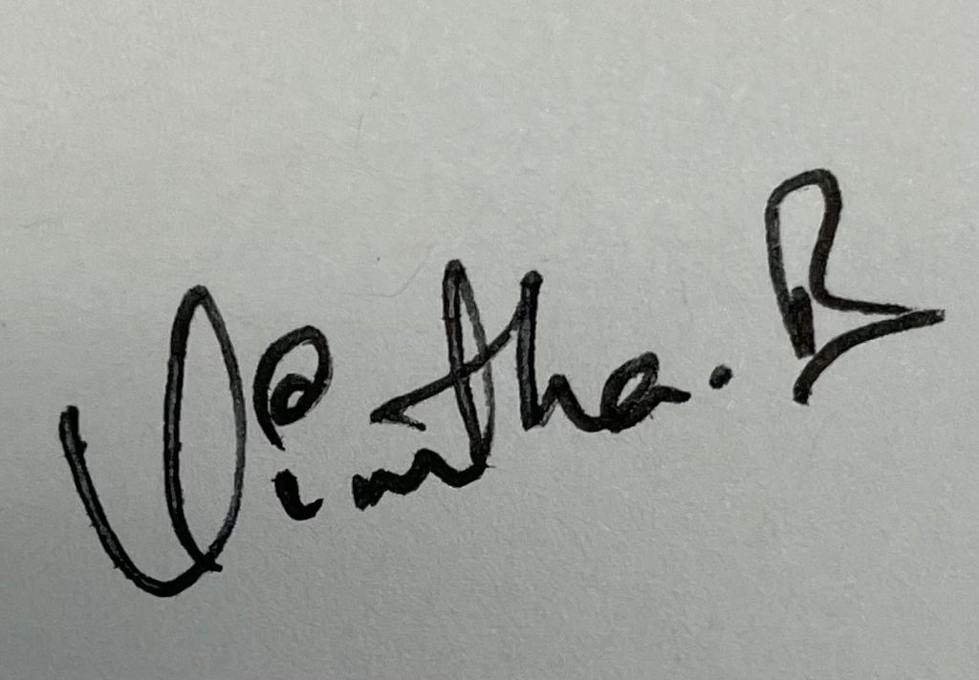
Vineetha batchu

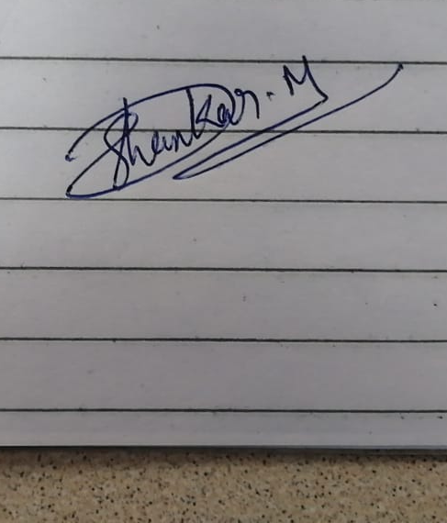
Jaya Shankar Mangina

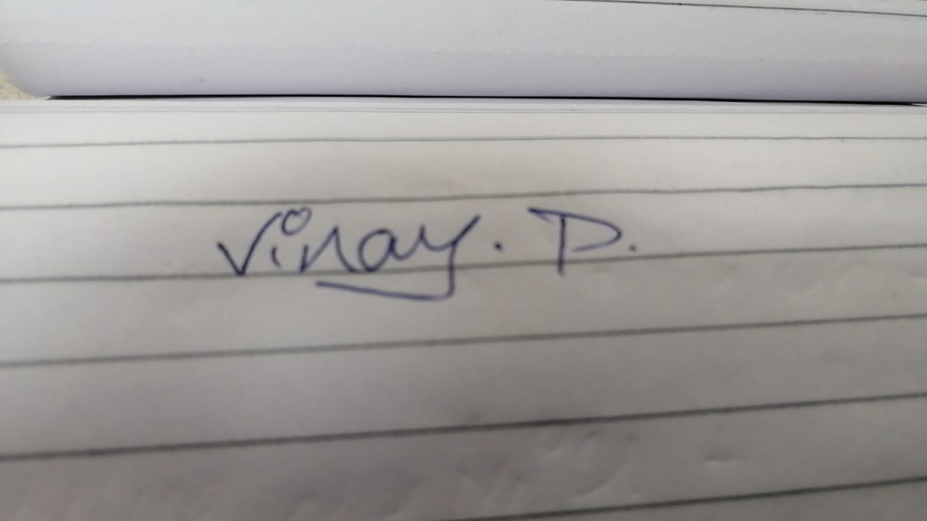
Vinay Kumar Pasupula

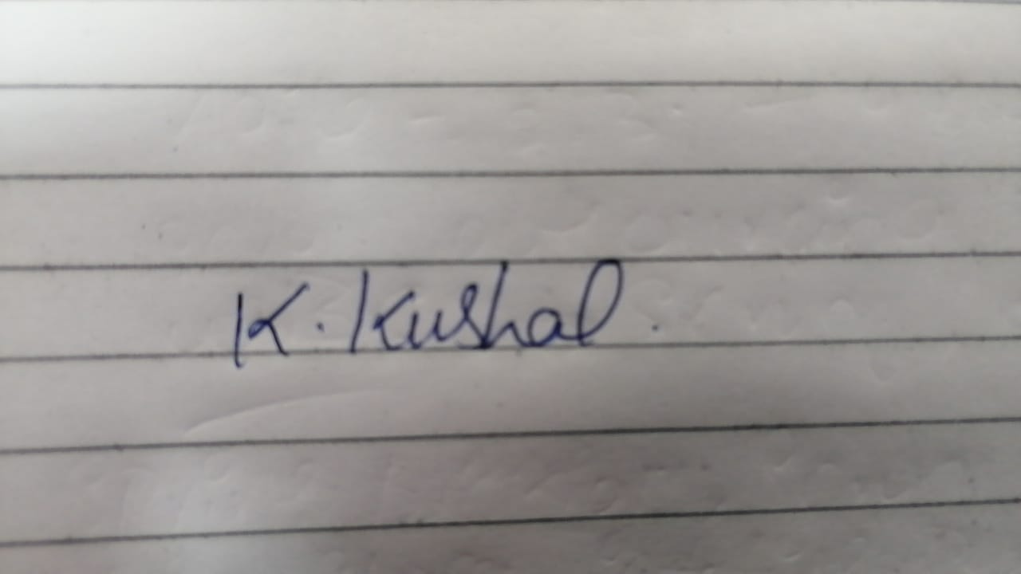
Kushal Satya Durgaji Katari

