Lab Program Number: 01 Date: 2082-12-16
Title: Implementation of Caesar Cipher
OBJECTIVE:
To understand how the Caesar Cipher works by encrypting and decrypting text using character shifting, and to evaluate its basic security and limitations.
THEORY:
The Caesar Cipher is a simple substitution encryption technique in which each letter in the plaintext is shifted by a fixed number of positions in the alphabet. This method is based on the concept of replacing each character with another character that lies a certain number of steps ahead or behind it, depending on the chosen key. It is one of the earliest known cryptographic systems and demonstrates the basic principles of encryption and decryption. Despite its simplicity and ease of implementation, the Caesar Cipher is not secure against modern cryptographic attacks, as it can be easily broken using brute force or frequency analysis.
CODE:
def caesar_cipher(text, shift):
result = ""
for char in text:
if char.isalpha():
if char.isupper():
shifted_char = chr((ord(char) - ord('A') + shift) % 26 + ord('A'))
else:
shifted_char = chr((ord(char) - ord('a') + shift) % 26 + ord('a'))
result += shifted_char
else:
result += char
return result
#Take input, call function and show OUTPUT
plaintext = input("Enter the plain text: ")
shift = int(input("Enter the no of shift: "))
encrypted_text = caesar_cipher(plaintext, shift)
print("Encrypted:", encrypted_text)
decrypted_text = caesar_cipher(encrypted_text, -shift)
print("Decrypted:", decrypted_text)
OUTPUT:
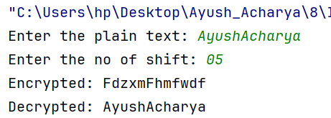
CONCLUSION: -
In this lab, we implemented the Caesar Cipher to explore basic principles of encryption and decryption. By applying specific shift values to alphabetic characters, we transformed plaintext into ciphertext and then reversed the shifts to recover the original message. The lab demonstrated how symmetric key encryption works and highlighted the limitations of the Caesar Cipher, including its susceptibility to brute-force attacks due to the small key space. Overall, the lab provided practical experience with fundamental cryptographic methods and laid the foundation for studying more advanced encryption techniques.

Lab Program Number: 02 Date: 2082-12-16
Title: Implementation of Playfair Cipher
OBJECTIVE:
To understand the Playfair Cipher’s encryption and decryption using a key, and to evaluate its strengths and limitations.
THEORY:
The Playfair Cipher is a classical substitution cipher that encrypts data in pairs of letters instead of single characters, making it more secure than simple methods like the Caesar Cipher. It uses a 5×5 matrix generated from a secret key, where the letter J is combined with I to fit 25 letters. Before encryption, the plaintext is converted to uppercase, divided into pairs, and filler letters (usually X) are added if needed. This method improves security by reducing the effectiveness of basic frequency analysis. The encryption and decryption processes follow specific rules:
- Same Row Rule: Replace each letter with the letter to its right (encryption) or left (decryption).
- Same Column Rule: Replace each letter with the letter below it (encryption) or above it (decryption).
- Rectangle Rule: Replace each letter with the letter in the same row but in the column of the other letter.
- Repeated Letters Rule: Insert X between identical letters in a pair.
- Odd Length Rule: Add X at the end if the message length is odd.
CODE:
def create_matrix(key):
key = key.upper().replace("J", "I")
matrix = []
letters_added = []
# Add key letters
for letter in key:
if letter not in letters_added and letter.isalpha():
letters_added.append(letter)

# Add remaining alphabet
for letter in range(65, 91):
char = chr(letter)
if char == 'J':
continue
if char not in letters_added:
letters_added.append(char)

# Create 5x5 matrix
index = 0
for i in range(5):
row = []
for j in range(5):
row.append(letters_added[index])
index += 1
matrix.append(row)
return matrix

def separate_same_letters(message):
message = message.upper().replace("J", "I")
index = 0
while index < len(message):
if index == len(message) - 1:
message += 'X'
break
if message[index] == message[index + 1]:
message = message[:index+1] + 'X' + message[index+1:]
index += 2
return message

def indexOf(letter, matrix):
for i in range(5):
if letter in matrix[i]:
return i, matrix[i].index(letter)
def playfair(key, message, encrypt=True):
matrix = create_matrix(key)
message = message.upper().replace(" ", "")
message = separate_same_letters(message)

cipher_text = ""
inc = 1 if encrypt else -1
for i in range(0, len(message), 2):
l1, l2 = message[i], message[i+1]
row1, col1 = indexOf(l1, matrix)
row2, col2 = indexOf(l2, matrix)

if row1 == row2:
cipher_text += matrix[row1][(col1 + inc) % 5]
cipher_text += matrix[row2][(col2 + inc) % 5]
elif col1 == col2:
cipher_text += matrix[(row1 + inc) % 5][col1]
cipher_text += matrix[(row2 + inc) % 5][col2]
else:
cipher_text += matrix[row1][col2]
cipher_text += matrix[row2][col1]
return cipher_text

if __name__ == "__main__":
plaintext = input("Enter message: ")
secret_key = input("Enter secret key: ")

cipher = playfair(secret_key, plaintext)
print("Encrypted:", cipher)
decrypted = playfair(secret_key, cipher, False)
print("Decrypted:", decrypted)
OUTPUT:
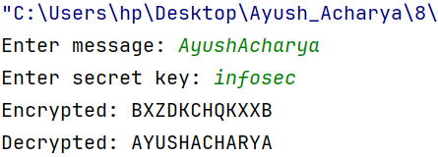
CONCLUSION: -
In this lab, we implemented the Playfair Cipher to explore an advanced substitution-based encryption technique. Using a 5×5 key matrix, we encrypted plaintext in letter pairs, applying rules for same row, same column, and rectangle cases. The lab highlighted the importance of pre-processing steps, such as handling repeated letters and adding filler characters, to ensure correct encryption. By performing decryption with the same key, we recovered the original message, reinforcing the concept of symmetric key cryptography. Overall, the lab provided practical experience with the Playfair Cipher, demonstrated its strengths and limitations, and offered a foundation for understanding more complex cryptographic methods.

Lab Program Number: 03 Date: 2082-12-16
Title: Implementation of Rail Fence – Row & Column Transformation Techniques
OBJECTIVE:
To understand how the Rail Fence Cipher encrypts and decrypts text by rearranging characters.
THEORY:
The Rail Fence Cipher is a transposition cipher in which the plaintext is written in a zigzag pattern across a number of rows, known as “rails,” and then read row by row to form the ciphertext. This rearrangement of characters rather than substitution provides better security compared to simple ciphers because the positions of letters are altered in a non-linear way. Row and Column Transformation techniques are additional transposition methods. In row transformation, the plaintext is written row-wise into a matrix and then read column-wise to create the ciphertext. In column transformation, the plaintext is arranged into columns based on a key, and the columns are reordered according to the key before reading the message row-wise. Both methods increase security by scrambling the original order of characters. These techniques help demonstrate how encryption can rely on the structure and position of characters rather than substituting them. They are useful for understanding more complex encryption methods where the message pattern plays a key role in confidentiality.
CODE:
def rail_fence_encrypt(plaintext, rails):
# Create matrix for rails
rail_matrix = [['' for _ in range(len(plaintext))] for _ in range(rails)]
direction = 1 # Direction for moving down or up
row, col = 0, 0
for char in plaintext:
# Place the character
rail_matrix[row][col] = char
col += 1

# Change direction at top or bottom rail
if row == 0:
direction = 1
elif row == rails - 1:
direction = -1
row += direction
# Collect characters row by row
ciphertext = []
for r in rail_matrix:
for ch in r:
if ch != '':
ciphertext.append(ch)
return ''.join(ciphertext)

def rail_fence_decrypt(ciphertext, rails):
rail_matrix = [['' for _ in range(len(ciphertext))] for _ in range(rails)]
direction = 1
row, col = 0, 0

# Mark the zigzag pattern
for i in range(len(ciphertext)):
rail_matrix[row][col] = '*'
col += 1
if row == 0:
direction = 1
elif row == rails - 1:
direction = -1
row += direction

# Fill the letters into the pattern
index = 0
for r in range(rails):
for c in range(len(ciphertext)):
if rail_matrix[r][c] == '*' and index < len(ciphertext):
rail_matrix[r][c] = ciphertext[index]
index += 1

# Read the matrix in zigzag order
plaintext = ''
row, col = 0, 0
direction = 1
for i in range(len(ciphertext)):
plaintext += rail_matrix[row][col]
col += 1

if row == 0:
direction = 1
elif row == rails - 1:
direction = -1

row += direction

return plaintext

# Call Function
plaintext = input("Enter the plain text: ")
rails = int(input("Enter the number of rails/depths: "))
encrypted_text = rail_fence_encrypt(plaintext, rails)
print("Encrypted:", encrypted_text)
decrypted_text = rail_fence_decrypt(encrypted_text, rails)
print("Decrypted:", decrypted_text)

OUTPUT:
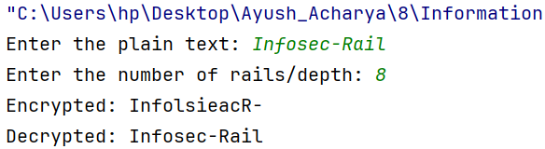
CONCLUSION: -
In this lab, we implemented the Rail Fence Cipher to understand a transposition-based encryption technique. By writing the plaintext in a zigzag pattern across multiple rails, we encrypted the message and increased security compared to simple substitution ciphers. We applied the zigzag pattern during both encryption and decryption to successfully retrieve the original message. This lab also demonstrated how the number of rails affects the encryption process and the importance of following the correct path while reading the matrix. Overall, this experiment provided a clear understanding of how the Rail Fence Cipher works, its strengths in rearranging characters, and helped build a foundation for learning more advanced transposition-based cryptographic techniques.

Lab Program Number: 06 Date: 2082-12-20
Title: Implementation of Euclidean Algorithm
OBJECTIVE:
To implement the Euclidean Algorithm and understand its role in information security
THEORY:
The Euclidean Algorithm is a method used to find the Greatest Common Divisor (GCD) of two integers, which is the largest number that divides both without leaving a remainder. It is based on the principle that the GCD of two numbers remains the same if the larger number is replaced by the remainder when divided by the smaller number, i.e., GCD(a, b) = GCD(b, a % b). The process is repeated until the remainder becomes zero, and the last non-zero value is the GCD. This algorithm is efficient and widely used in mathematics and computer science.
CODE:
def euclidean_gcd(a, b):
while b != 0: a, b = b, a % b
return a
num1 = int(input("Enter the 1st number: "))
num2 = int(input("Enter the 2nd number: "))
result = euclidean_gcd(abs(num1), abs(num2))
print(f"GCD of {num1} and {num2} is: {result}")
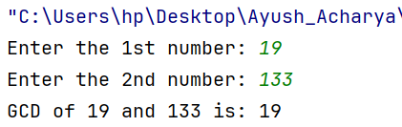
OUTPUT:

CONCLUSION: -
In this lab, we implemented which Euclidean Algorithm is a simple and efficient method for finding the GCD of two integers. By repeatedly applying the division process, it reduces the problem step by step until the result is obtained. It is faster and more practical than traditional methods of finding divisors, especially for large numbers. This algorithm is widely used in mathematics, computer science, and applications such as simplifying fractions and cryptography.
Lab Program Number: 07 Date: 2082-12-20
Title: Implementation of RSA Algorithm
OBJECTIVE:
To implement the RSA algorithm and understand its role in information security
THEORY:
RSA (Rivest–Shamir–Adleman) is an asymmetric cryptographic algorithm that uses a public key for encryption and a private key for decryption. The security of RSA relies on the difficulty of factoring large prime numbers. The algorithm works by selecting two prime numbers p and q, computing n = p * q and Euler’s totient φ(n) = (p-1)*(q-1). A public exponent e is chosen such that gcd(e, φ(n)) = 1, and the private key d is calculated as the modular inverse of e modulo φ(n). A message is encrypted using C = M^e mod n and decrypted using M = C^d mod n. RSA ensures confidentiality, authentication, and integrity in digital communication.
CODE:
def power(base, expo, mod):
result = 1; base = base % mod
while expo > 0:
if expo & 1: result = (result * base) % mod
base = (base * base) % mod
expo = expo // 2
return result

def gcd(a, b):
while b != 0:a, b = b, a % b
return a
def mod_inverse(e, phi):
for d in range(2, phi):
if (e * d) % phi == 1:return d
return -1

def generate_keys():
p = 7919; q = 1009;n = p * q
phi = (p - 1) * (q - 1)
for e in range(2, phi):
if gcd(e, phi) == 1:break
d = mod_inverse(e, phi); return e, d, n

def encrypt_text(message, e, n):
ciphertext = [power(ord(char), e, n) for char in message]
return ciphertext
def decrypt_text(ciphertext, d, n):
message = ''.join([chr(power(c, d, n)) for c in ciphertext])
return message

if __name__ == "__main__":
e, d, n = generate_keys()
message = input("Enter a message: ")
encrypted_msg = encrypt_text(message, e, n)
print(f"Encrypted Message: {encrypted_msg}")
decrypted_msg = decrypt_text(encrypted_msg, d, n)
print(f"Decrypted Message: {decrypted_msg}")
OUTPUT:
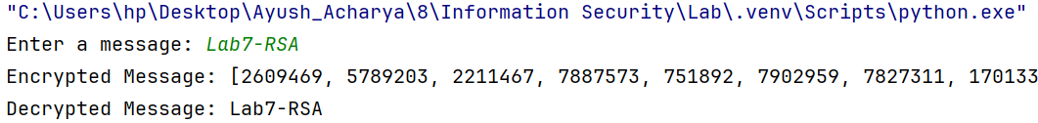
CONCLUSION: -
In this lab, we implemented the RSA algorithm to encrypt and decrypt messages using a pair of public and private keys. We converted text messages into numbers, applied encryption, and then decrypted them to recover the original messages. The lab demonstrated how RSA ensures secure communication by providing confidentiality, authentication, and data integrity, highlighting its critical role in modern information security systems.
Lab Program Number: 08 Date: 2082-12-20
Title: Implementation of MD5 Hashing Algorithm
OBJECTIVE:
To implement the MD5 hashing algorithm and understand how it generates fixed-length hashes to ensure data integrity.
THEORY:
MD5 (Message Digest Algorithm 5) is a cryptographic hash function developed by Ronald Rivest in 1991 that produces a fixed 128-bit (32 hexadecimal characters) hash value from input data of any size. It works by first padding the input message so its length becomes congruent to 448 modulo 512, then appending the original message length as a 64-bit value. The algorithm initializes four 32-bit buffers (A, B, C, D) and processes the data in 512-bit blocks using nonlinear functions, bitwise operations, and modular arithmetic. It is deterministic, fast, and exhibits the avalanche effect, but due to collision vulnerabilities, it is no longer considered secure for cryptographic purposes and is mainly used for data integrity and educational purposes.
CODE:
import hashlib
input_str = input("Enter string to encrypt using MD5: ")
# Convert string to bytes and generate MD5 hash
hash_hex = hashlib.md5(input_str.encode()).hexdigest()
print("MD5 hash of '{}' is: {}".format(input_str, hash_hex))
OUTPUT:
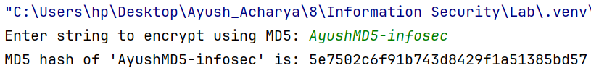
CONCLUSION: -
In this lab, we implemented the MD5 hashing algorithm to generate fixed-length hashes from input text. Even small changes in input produced completely different hashes, demonstrating the avalanche effect. This shows MD5’s usefulness in verifying data integrity, though it is no longer secure for modern cryptographic purposes.

