NEW SUMMIT COLLEGE
Santinagar, Kathmandu
(Affiliated to Tribhuvan University)



Laboratory Report of
Multimedia System (CACS457)

Submitted by: Submitted to:
Name: Kushal Khanal Instructor: Indra Chaudhary
Symbol No: 47602093
Semester: Eight
Faculty: Humanities and Social Science
Level: Bachelor
Program: Computer Application

2026
BCA 8TH SEMESTER | MULTIMEDIA SYSTEM
Laboratory Assignment Log Sheet

Name: Kushal Khanal Symbol No: 47602093

Task No. | Title | Signature
Sound and Audio
1 | Sound Digitization & Visualization
2 | Audio Modification Effects
3 | Audio Editing & Synthesis
Images and Graphics
4 | Image Representation & Abstraction
5 | Histogram Analysis
6 | Image Dithering
7 | Image Morphing
Video and Animation
8 | Video Editing & Signal Representation
9 | Mathematical Animation
10 | Timeline & Tweening Animation
11 | GIF Creation
Data Compression
12 | Entropy Coding (RLE)
13 | Entropy Coding (Huffman)
14 | Lossy Compression (JPEG)
Web Integration
15 | Web-Based Multimedia Elements

Task 1: Simulate Sound Digitization & Visualization
Objective: To understand the fundamentals of digital audio by loading an existing audio file, displaying its waveform, and analyzing sampling and quantization.
Tasks: Write a Python program to simulate sound digitization. The program should:
- Accept an uploaded digital audio file (e.g., .wav) into the environment.
- Display the audio continuous waveform visually.
- Simulate and demonstrate the sampling and quantization processes (e.g., by reducing the bit depth and plotting the discrete steps).

Source Code:
%pip install librosa matplotlib numpy
import librosa
import numpy as np
import matplotlib.pyplot as plt

print("Name: KUSHAL KHANAL | Symbol No: 47602093 | Subject: MULTIMEDIA")
file_name = r"D:\KUSHAL KHANAL\8thsem\Multimedia\MULTIMEDIA LAB\audiolab.wav"

audio_data, fs = librosa.load(file_name, sr=None)
print(f"Sampling Rate: {fs} Hz")

quantized_data = np.round(audio_data * 127) / 127.0

time = np.linspace(0, len(audio_data) / fs, len(audio_data))

plt.figure(figsize=(12, 6))
plt.subplot(2, 1, 1)
plt.plot(time, audio_data, color='blue', alpha=0.7)
plt.title("Original Continuous Audio Signal")
plt.ylabel("Amplitude")

plt.subplot(2, 1, 2)
plt.step(time, quantized_data, color='red', alpha=0.7)
plt.title("Quantized Audio Signal (Discrete Steps)")
plt.xlabel("Time (s)")
plt.ylabel("Amplitude")

plt.tight_layout()
plt.suptitle("BY KUSHAL KHANAL | Multimedia | BCA 8th Sem", fontsize=9, y=0)
plt.show()

Output:

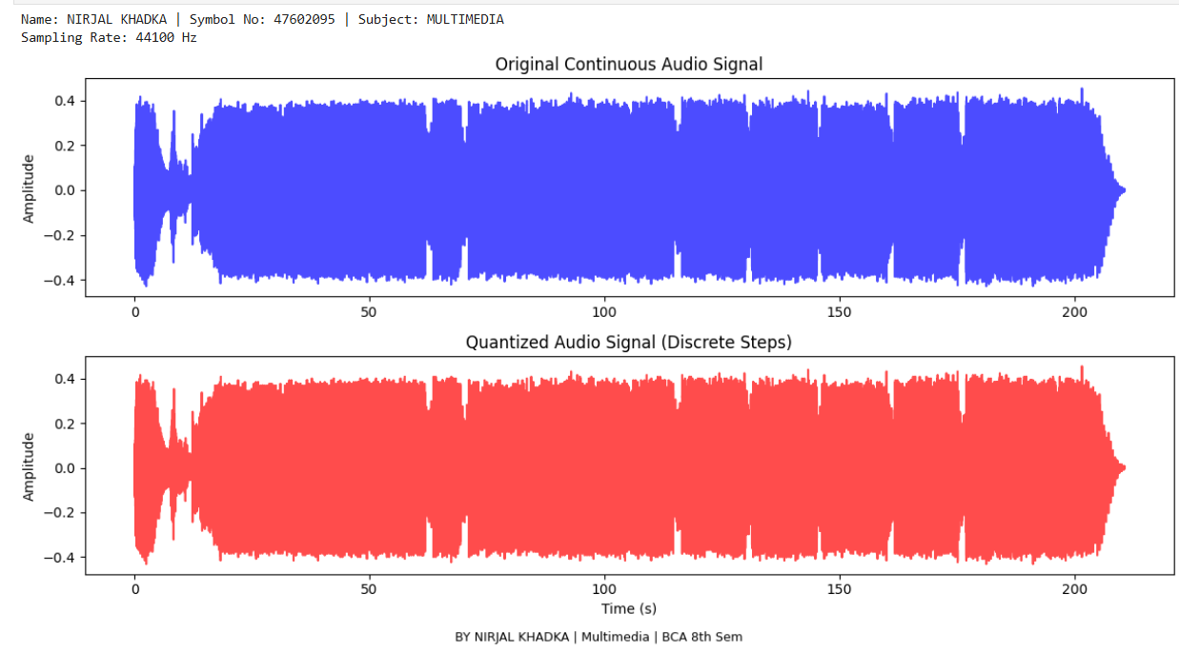

Task 2: Simulate Audio Modification Effects
Objective: To alter sound properties and understand digital audio manipulation effects.
Tasks: Write a Python program to apply audio modification effects. The program should:
- Accept an audio file as input.
- Apply amplifying, fade-in, and fade-out effects.
- Alter the pitch and speed of the audio, saving the modified file.

Source Code:
from pydub import AudioSegment
import os

print("Name: KUSHAL KHANAL | Symbol No: 47602093 | Subject: MULTIMEDIA\n")
file_name = r"D:\KUSHAL KHANAL\8thsem\Multimedia\MULTIMEDIA LAB\audiolab.wav"

if not os.path.exists(file_name):
print(f" Error: Could not find the file at {file_name}")
print("Please check the path and try again.")
else:
print("File found! Processing audio effects...")

audio = AudioSegment.from_file(file_name)

amplified_audio = audio + 10

faded_audio = amplified_audio.fade_in(2000).fade_out(2000)

modified_audio = faded_audio._spawn(faded_audio.raw_data, overrides={
"frame_rate": int(faded_audio.frame_rate * 1.5)
}).set_frame_rate(faded_audio.frame_rate)

pure_filename = os.path.basename(file_name)
output_name = "modified_" + pure_filename
modified_audio.export(output_name, format="wav")

print(f"\n🎉 Success! Saved as '{output_name}' in your notebook folder.")
print("BY KUSHAL KHANAL | Multimedia | BCA 8th Sem")

Output:

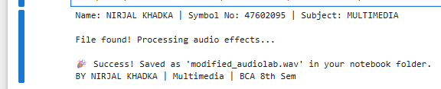
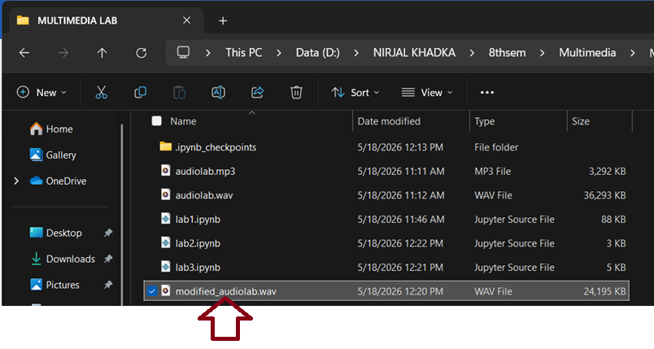
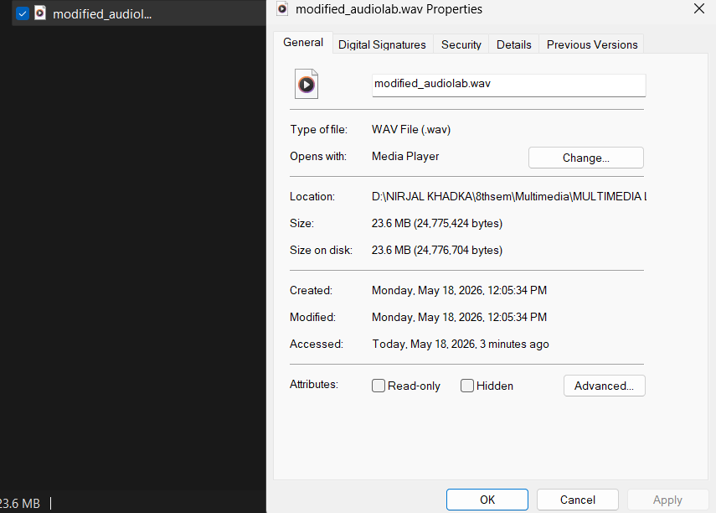
Task 3: Simulate Audio Editing & Synthesis
Objective: To perform structural changes on audio files and implement Text-to-Speech synthesis.
Tasks: Write a Python program to edit audio and synthesize speech. The program should:
- Trim, cut, merge, and mix multiple audio tracks together.
- Accept text input and synthesize it into spoken audio using Text-to-Speech (TTS).

Source Code:

from pydub import AudioSegment
import os

print("Name: KUSHAL KHANAL | Symbol No: 47602093 | Subject: MULTIMEDIA\n")
file_name = r"D:\KUSHAL KHANAL\8thsem\Multimedia\MULTIMEDIA LAB\audiolab.wav"

if not os.path.exists(file_name):
print(f" Error: Could not find the file at {file_name}")
print("Please check the path and try again.")
else:
print("File found! Processing audio effects...")

audio = AudioSegment.from_file(file_name)

amplified_audio = audio + 10

faded_audio = amplified_audio.fade_in(2000).fade_out(2000)

modified_audio = faded_audio._spawn(faded_audio.raw_data, overrides={
"frame_rate": int(faded_audio.frame_rate * 1.5)
}).set_frame_rate(faded_audio.frame_rate)

pure_filename = os.path.basename(file_name)
output_name = "modified_" + pure_filename
modified_audio.export(output_name, format="wav")

print(f"\n🎉 Success! Saved as '{output_name}' in your notebook folder.")
print("BY KUSHAL KHANAL | Multimedia | BCA 8th Sem")

Output:
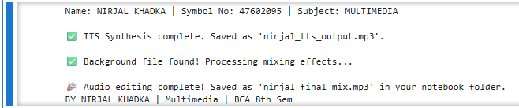
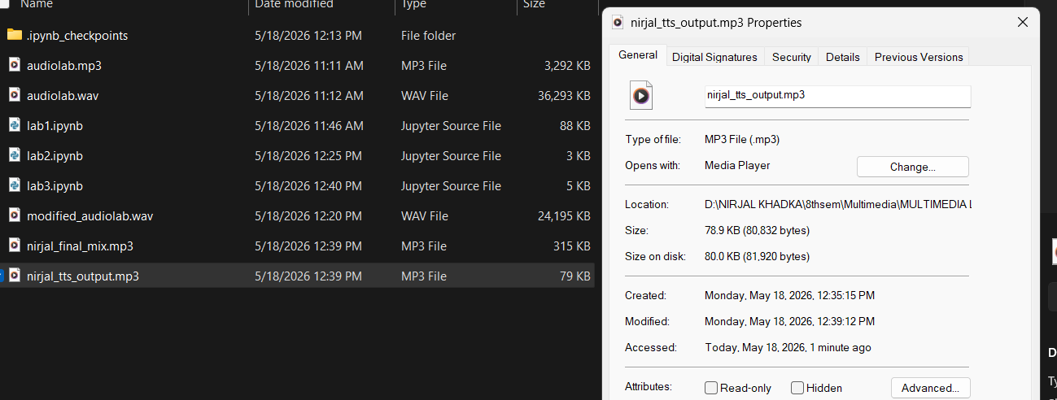
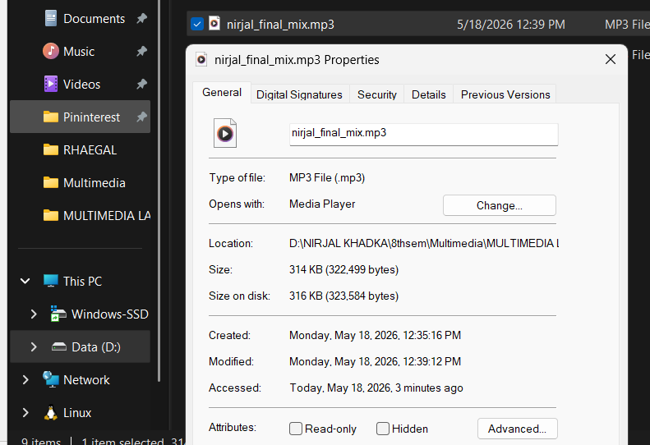

Task 4: Simulate Image Representation & Abstraction
Objective: To process digital images using OpenCV and understand digital pixel representation without relying on live hardware.
Tasks: Write a Python program to process digital images. The program should:
- Accept and load an uploaded digital image file using OpenCV abstraction.
- Display the original loaded image on the screen.
- Process the image to demonstrate digital pixel representation (e.g., extracting and displaying the 8th bit-plane or splitting color channels).

Source Code:
Output:

Task 5: Simulate Histogram Analysis
Objective: To calculate and plot pixel intensity distributions of digital images.
Tasks: Write a Python program to perform image histogram analysis. The program should:
- Accept a digital image as input.
- Calculate the pixel intensity distributions.
- Plot and display the resulting histogram alongside the image.

Source Code:
Output:

Task 6: Simulate Image Dithering
Objective: To implement 2×2 Cluster Dot Halftoning mathematically.
Tasks: Write a Python program to simulate image dithering. The program should:
- Accept a grayscale digital image as input.
- Apply a 2×2 Cluster Dot Halftoning algorithm to the image pixels.
- Display the resulting dithered/halftoned image.

Source Code:
Output:

Task 7: Simulate Image Morphing
Objective: To write and apply an algorithm that morphs one image into another.
Tasks: Write a Python program to morph images. The program should:
- Accept a source image and a target image.
- Implement an algorithm to morph the source image into the target image.
- Provide and display before, during, and after examples of the morphing process.

Source Code:
Output:

Task 8: Simulate Video Editing & Signal Representation
Objective: To analyze video signal properties and perform basic video editing operations.
Tasks: Write a Python program to edit video files. The program should:
- Calculate and display the frame rate and total frame count of a video.
- Trim specific unwanted sections from the video.
- Overlay custom text onto the video frames and save the output.

Source Code:
Output:

Task 9: Simulate Mathematical Animation
Objective: To program the motion of a graphic using trigonometric functions to simulate circular motion.
Tasks: Write a Python program to simulate mathematical animation. The program should:
- Generate a graphic object.
- Calculate its positional coordinates over time using Sine and Cosine functions.
- Render and display the object moving in a continuous circular animation.

Source Code:
Output:

Task 10: Simulate Timeline & Tweening Animation
Objective: To implement linear in-betweening (tweening) techniques for timeline-based animation.
Tasks: Write a Python program to simulate tweening animation. The program should:
- Define start and end states (coordinates/properties) for an object.
- Apply linear tweening to generate the intermediate frames automatically.
- Display the resulting smooth animation sequence.

Source Code:
Output:

Task 11: Simulate GIF Creation
Objective: To export frame-by-frame sequences into a compiled animated GIF.
Tasks: Write a Python program to create an animated GIF. The program should:
- Generate or load a sequence of frame-by-frame images.
- Compile the individual sequences into a single animation timeline.
- Export and save the compiled sequence as an animated .gif file.

Source Code:
Output:

Task 12: Simulate Entropy Coding (RLE)
Objective: To isolate and implement the Run-Length Encoding (RLE) algorithm for lossless data compression.
Tasks: Write a Python program to simulate RLE. The program should:
- Accept input data (text string or binary sequence).
- Apply the Run-Length Encoding algorithm to compress the data.
- Display the original size, the compressed output, and the compression ratio.

Source Code:
Output:

Task 13: Simulate Entropy Coding (Huffman)
Objective: To isolate and implement the Huffman encoding algorithm, including building the binary tree.
Tasks: Write a Python program to simulate Huffman Encoding. The program should:
- Calculate character frequencies from an input string.
- Build a Huffman binary tree based on those frequencies.
- Generate and display the Huffman encoded binary string.

Source Code:
Output:

Task 14: Simulate Lossy Compression (JPEG)
Objective: To implement JPEG compression and decompression using OpenCV.
Tasks: Write a Python program to simulate JPEG-style lossy compression. The program should:
- Accept a digital image as input.
- Implement JPEG compression using OpenCV parameters to simulate lossy encoding.
- Decompress and display the image to observe the visual degradation and file size differences.

Source Code:
Output:

Task 15: Web-Based Multimedia Integration
Objective: To design and implement a web-based multimedia interface, integrating various media types into a single application.
Tasks: Write HTML, CSS, and JavaScript code to develop a web multimedia page. The program should:
- Insert text, images, tables, dropdown lists, radio buttons, and a submit button.
- Embed audio and video elements directly into the page.
- Implement a drag-and-drop event and a form action to simulate sending an email.

Source Code:
Output:

