

NEW SUMMIT COLLEGE
Affilated To Tribhuwan University

An Internship Report
On

Frontend Developer At

Hyberlab I.T. Solutions Pvt. Ltd

Submitted to:
Department of Humanities and Social Science
New Summit College Shanti Nagar, Kathmandu, Nepal

In The Partial Fulfillment of Requirements for the Bachelor Degree in Computer Application , Seventh Semester Internship Report

Submitted by:
Kushal Khanal (T.U. Regd. No: 6-2-476-62-2021)
January 2026

Under the supervision of
Mr. Prawesh Dhungana

Affiliated To Tribhuvan University

Faculty of Humanities and Social Sciences

New Summit College

Supervisor’s Recommendation

I hereby recommend that the forthcoming Internship project report prepared under my supervision by Kushal Khanal is satisfactory in the partial fulfillment of the requirements for the degree of Bachelor of Computer Application and be processed for the final evaluation.

………………………………………..
Mr. Prawesh Dhungana
Internship Supervisor
Department of Computer Application New Summit College
Shantinagar, Kathmandu, Nepal

Affiliated To Tribhuvan University
Faculty of Humanities and Social Sciences New Summit College

Certificate of Approval
This is to certify that this project by Kushal Khanal entitled “Frontend Web Developer Intern” in partial fulfillment of the requirements for the degree of Bachelor in Computer Application is recommended for the final evaluation. In our opinion it is satisfactory in terms of scope and quality as a project for the required degree.

………………………………..  Mr. Chok Raj Dawadi Principal  New Summit College  Shantinagar, Kathmandu, Nepal | ………………………………..  Mr. Prawesh Dhungana Supervisor  New Summit College  Shantinagar, Kathmandu, Nepal
………………………………..  SIGNATURE  Internal Examiner | ………………………………..  SIGNATURE  External Examiner

ACKNOWLEDGEMENT
Apart from Apart from the effort from me, the successful completion of this internship report would not have been possible without the support of many individuals and organizations. I take this opportunity to express my gratitude to the people who have been instrumental in the successful completion of this internship. Without their encouragement and guidance, it would have been difficult to work on. I would like to explicitly thank each and every individual for their priceless contribution to the project. First and foremost, I am highly thankfull to Samir KC who took confidence in me and provided me with the opportunity and resources to work as an Intern at Hyberlab I.T. Solutions Pvt. Ltd.
I would like to express my sincere gratitude to my industry mentor, Mr. Samir KC, for his exemplary guidance, technical support, and valuable suggestions throughout the development lifecycle. His mentorship was crucial in helping me bridge the gap between academic theory and professional application.
I am also deeply grateful to the supervisor of this Internship Program at New Summit College, Mr. Prawesh Dhungana, for his guidance, support, and coordination. I would like to take this opportunity to thank him for his continuous encouragement throughout the academic supervision of this project.
Finally, my thanks and appreciation go to each one of my colleagues and the entire Hyberlab I.T. Solutions team, who irrespective of the situation, always encouraged and supported me throughout this internship.
Thank you.
Kushal Khanal (6-2-476-62-2021)

ABSTRACT
As a Frontend Web Developer intern at Hyberlab I.T. Solutions Pvt. Ltd., I use TypeScript, Next.js, and React to work on the Liquor Stop eCommerce website. By offering a smooth interface for perusing and buying goods while effectively handling inventory and orders on the backend, this web application improves the online shopping experience. My primary responsibility is to design and create the application's full-stack architecture. I make responsive and interactive frontend layouts using React and Next.js to guarantee a seamless and aesthetically pleasing user experience. I use TypeScript and Node.js on the backend to create reliable RESTful APIs and use PostgreSQL to handle data persistence. Writing type-safe code, maintaining data integrity, and enhancing application performance are my main priorities. My knowledge of the contemporary JavaScript ecosystem and backend programming has improved as a result of working on this project. Additionally, it has provided me practical experience in resolving issues with database modeling, API integration, and UI/UX design. I'm building a strong basis for a future career in frontend development with this internship.
Keywords: Frontend, Next.js, React, Node.js, TypeScript.

Table of Contents
ACKNOWLEDGEMENT ..........................................................................................iv ABSTRACT .................................................................................................................v
Chapter 1: INTRODUCTION 1
1.1. Introduction 1
1.2. Problem Statement 1
1.3. Objectives 2
1.4. Scope and Limitation 2
1.5. Report Organization 3
Chapter 2: INTRODUCTION TO ORGANIZATION 4
2.1. Organizational Details 4
2.2. Contact Information 4
2.3. Organizational Hierarchy 5
2.4. Working Domains of Organization 5
2.5. Description of Internship 5
Chapter 3: BACKGROUND STUDY AND LITERATURE REVIEW 7
3.1. Background Study 7
3.2. Literature Review 7
Chapter 4: INTERNSHIP ACTIVITIES 9
4.1. Roles and Responsibilities 9
4.2. Weekly Log (Technical Details of Activities) 9
4.3. Description of the Project’s Involved During Internship 11
4.4. Tasks / Activities Performed 11
Chapter 5: CONCLUSION AND LEARNING OUTCOMES 12
5.1. Conclusion 12
5.2. Learning Outcomes 12
Reference 14
APPENDIX I 15
APPENDICES II 17

List Of Figures
Figure 2:1 Organizational Hierarchy ........................................................................... 15

List of Abbreviations
CSS |  | Cascading Style Sheets
CRUD |  | Create, Read, Update, Delete
HTML |  | Hyper Text Markup Language
HTTP |  | Hypertext Transfer Protocol
IDE |  | Integrated Development Environment
JS |  | JavaScript
JSON |  | JavaScript Object Notation
JWT |  | JSON Web Token
PERN |  | PostgreSQL, Express, React, Node.js
REST |  | Representational State Transfer
SDLC |  | Software Development Life Cycle
SSR |  | Server-Side Rendering
UI |  | User Interface
UX |  | User Experience

List of Tables
Table 1: Internship Time Details ............................................................................... 17
Table 2: Weekly Log and Technical details of an internship .................................... 22
Table 3: Detailed Activity Log .................................................................................. 29

Chapter 1: INTRODUCTION

1.1. Introduction
An internship is a professional learning opportunity where students can work on real-world projects that are relevant to their subject of study or desired career path. A student can explore and expand their career as well as acquire new skills through an internship. It gives the business the chance to develop talent, generate new ideas and energy into the company, and even create a pipeline for future full-time employees. My internship assignment is to design and develop the Liquor Stop eCommerce Website, a comprehensive platform aimed at modernizing the retail experience for liquor products. I am gaining a great deal of practical knowledge and experience from this internship that I could not have learned from books or libraries. Liquor Stop functions as a digital marketplace designed to manage inventory and present products in a user-friendly way. A core component of the system is its robust frontend architecture, utilizing Next.js and React for a dynamic frontend. The application is written in TypeScript to ensure type safety and code maintainability. Working on the Liquor Stop project has provided me with invaluable exposure to the practical aspects of Frontend web development, API integration, and modern UI/UX design patterns.
Working on the Liquor Stop project has provided me with invaluable exposure to the practical realities of frontend web development, including API integration, state management, responsive design implementation, and modern UI/UX design patterns. Beyond the technical skills, I have also developed a deeper understanding of project workflows, version control practices, and cross-functional collaboration. This internship experience has not only strengthened my technical competencies but also reinforced my passion for building impactful digital solutions. The following sections of this report will detail the background of the organization, the methodologies employed, the development process, and a reflection on the key learnings gained throughout this internship journey.

1.2. Problem Statement
Traditional methods of managing liquor retail are often inefficient, as they rely heavily on physical storefronts and manual inventory tracking, limiting the customer base to a specific geographic location and making stock management prone to human error. Without a centralized digital solution, customers lack the convenience of browsing extensive catalogs or verifying product availability from their homes, while manual order processing can lead to discrepancies and delays that hinder the overall customer experience. To address these challenges and improve business efficiency, a user-friendly and interactive eCommerce platform is needed. The Liquor Stop eCommerce Website aims to provide this solution by enabling users to easily browse, search, and purchase products, offering a seamless and efficient experience through a dynamic catalog while equipping administrators with powerful tools to accurately manage inventory.

1.3. Objectives
- Create a user-friendly interface that allows customers to filter liquor products.
- Develop a Functional Liquor eCommerce Platform.
- Build a secure checkout system that ensures alcohol purchases include location based delivery validation and ID verification at checkout.

1.4. Scope and Limitation

1.4.1 Scope
- User Interface & Experience: A responsive and intuitive design ensuring seamless navigation, accessibility, and consistent user experience across devices
- Product Interaction: Efficient product browsing, searching, and filtering with detailed product views for informed decision-making.
- User Operations Interface: Interactive components for authentication, cart management, and checkout to facilitate smooth user transactions.

1.4.2 Limitations
- Limited Device Optimization: The interface may not be fully optimized for all screen sizes or older browsers during the initial development phase.
- Basic UI Interactions: Advanced animations and highly dynamic user interactions may be limited to maintain simplicity and performance.
- Dependency on Backend Services: Frontend functionality such as real-time updates and data accuracy is dependent on backend integration and may be limited during early stages.

1.5. Report Organization
The report is organized into 5 chapters:
Chapter 1: Introduction
This chapter provides a brief overview of the project, its scope, and problem statement, and objectives.
Chapter 2: Introduction to organization
This chapter provides details about the organization, its hierarchy, the departments involved, and a description of the intern’s department.
Chapter 3: Internship Activities
This section outlines the roles and responsibilities assigned during the internship. explains the technical task carried out, offering a clear description of the project and the different activities completed throughout the internship period.
Chapter 4: Conclusion and Learning Outcome
The final chapter wraps up the internship experience, highlighting the main lessons learned and the skills developed throughout the project. Technical task carried out, offering a clear description of the project and the different activities completed throughout the internship period.

Chapter 2: INTRODUCTION TO ORGANIZATION

2.1. Organizational Details
Hyberlab I.T. Solutions Pvt. Ltd. is a dynamic technology company dedicated to providing cutting-edge digital solutions, including custom web development, mobile application development, and AI-driven automation. Established with a vision to transform ideas into reality for startups and enterprises, the company has been instrumental in delivering scalable software solutions and empowering businesses with technology that drives growth.
Currently, I am interning at Hyberlab I.T. Solutions Pvt. Ltd., actively working on the Liquor Stop eCommerce Website using a modern Frontend technologies. My role focuses on the end-to-end development lifecycle, from designing the Frontend architecture to building responsive user interfaces using React and Next.js. I am responsible for implementing RESTful APIs in Frontend, ensuring type safety with TypeScript, and optimizing the application for performance and scalability. This internship has provided valuable hands-on experience in Frontend web development, and API integration, significantly enhancing my technical expertise. Working on a real-world commercial project has deepened my understanding of the software development life cycle (SDLC), preparing me for future career opportunities in the tech industry.

2.2. Contact Information
CEO: Samir K.C
Hyberlab I.T. Solutions Private Limited.
Koteshwor, Kathmandu
Email: info@hyberlab.com

2.3. Organizational Hierarchy
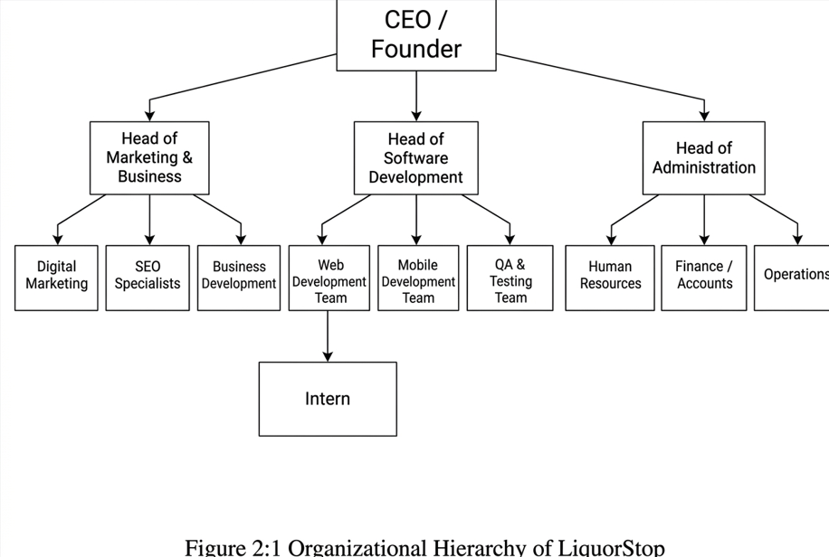
Figure 2:1 Organizational Hierarchy

2.4. Working Domains of Organization
Hyberlab I.T. Solutions provides a wide range of services focused on digital transformation and business automation:
- Web Application Development: Custom websites and web apps using React, Node.js, and modern frameworks.
- eCommerce Solutions: Building scalable online stores with automation to boost sales (Custom, WooCommerce, Shopify).
- Mobile App Development: Cross-platform mobile applications using Flutter and React Native.
- SaaS Development: Scalable software-as-a-service platforms with billing integrations.

2.5. Description of Internship

Internship Work
During my internship at Hyberlab I.T. Solutions Pvt. Ltd., I had the opportunity to work in the Web Development Unit, a supportive and collaborative environment that emphasizes agile methodologies. The company fosters a professional yet engaging atmosphere, where I felt comfortable seeking assistance whenever I encountered challenges in frontend rendering. My mentor, Mr. Samir KC, played a crucial role in guiding me through complex frontend concepts, Scalability, and secure API architecture. This collaborative approach made my internship both enriching and productive, equipping me with valuable industry ready skills.

Internship Project (Liquor Stop eCommerce)
As part of my internship, I worked on the Liquor Stop eCommerce Website, a FullStack web application designed to streamline the online retail of liquor products. My primary responsibilities involved:
- Frontend Development: Creating a visually appealing and responsive UI using React and Next.js, ensuring an intuitive shopping experience across devices.
- API Integration: Connecting the frontend with backend services to enable dynamic content loading, cart management, and administrative control.
Working on this project allowed me to gain hands-on experience in the React and Next,js and improve my debugging skills, and understand the complexities of building secure commercial web applications.

Internship Duration
The internship was structured and well-guided, with mentors providing continuous support and resources to help interns overcome development hurdles. I received regular code reviews and evaluations from my mentor, which provided valuable .Throughout the internship, supervisors closely monitored my growth, ensuring I gained practical experience applicable to real-world software engineering.

Table 2.1. Internship Time Details
Table 2:1 Internship Time Details
Start Date | 13/11/2025
Period of Internship | 3 Months
Office Hours | 10AM – 6PM
Average Working Hours | 8hrs

Chapter 3: BACKGROUND STUDY AND LITERATURE REVIEW

3.1. Background Study
In the rapidly evolving landscape of digital commerce, the selection of underlying technologies is a fundamental determinant of an application's scalability, security, and user experience. The Liquor Stop eCommerce Website is engineered to revolutionize the traditional liquor retail model by providing a seamless, secure, and highly interactive online shopping platform. The application is meticulously architected using the PERN stack (PostgreSQL, Express, React, Node.js) with Next.js as the frontend framework. This choice enables the development of a high-performance web application that leverages Server-Side Rendering (SSR) for superior Search Engine Optimization (SEO) and faster initial page loads, ensuring that customers experience minimal latency even on mobile networks.
The backend infrastructure is built upon Node.js and TypeScript, providing a robust runtime environment that handles asynchronous operations efficiently crucial for processing multiple orders simultaneously. PostgreSQL serves as the relational database management system, chosen for its ACID compliance and reliability in handling complex transactions and inventory data, which is non-negotiable for an eCommerce platform. Furthermore, the integration of TypeScript across the entire stack ensures type safety, significantly reducing runtime errors and improving code maintainability during the development lifecycle.
The UI/UX design of Liquor Stop prioritizes intuitive navigation and visual clarity, allowing users to effortlessly filter products by category, price, or brand. By moving away from traditional, manual retail processes to a centralized digital solution, the platform automates inventory tracking and order management. Overall, Liquor Stop integrates modern web technologies to create a secure and scalable ecosystem that not only enhances the consumer purchasing journey but also provides administrators with powerful tools to manage business operations effectively.

3.2. Literature Review
The paradigm of retail has shifted significantly over the last decade, moving from brickand-mortar exclusivity to an omni-channel approach where digital presence is paramount. Traditional retail models relied heavily on physical storefronts, which were limited by geographical reach and operating hours, restricting business growth and customer accessibility. In response to the growing consumer demand for convenience and global connectivity, eCommerce solutions have emerged as the standard for modern business. To understand the strategic positioning of the Liquor Stop project within this digital ecosystem, it is essential to analyze existing platforms like WooCommerce, Daraz, and Shopify, which currently dominate the market but possess distinct limitations in terms of scalability, customization, and cost-efficiency[1].
WooCommerce (WordPress): WooCommerce is a widely used open-source plugin for WordPress that allows users to convert a standard website into an eCommerce store. It is popular due to its ease of setup and vast ecosystem of plugins. However, WooCommerce often suffers from performance issues as the product catalog grows. It relies heavily on a generic database structure that can become bloated, leading to slow page load times—a critical factor in user retention [2].
In the context of Nepal, Daraz stands as a dominant online marketplace where various vendors list their products. While it offers a massive user base, it presents significant challenges for niche brands. For a specialized liquor retailer, listing on a generic marketplace like Daraz means a loss of brand identity and direct customer relationship ownership. The platform imposes high commission fees on sales and offers limited control over the storefront's design and user experience. Additionally, the competitive nature of a shared marketplace often leads to price wars that erode profit margins, without offering tailored features required for age-restricted product sales [3].
Blanxer is a growing Nepali SaaS (Software as a Service) platform that enables businesses to launch online stores quickly with local payment integration. While it lowers the technical barrier to entry, Blanxer operates on a recurring subscription model. As a business scales, these monthly fees, combined with potential transaction fees, can become a significant overhead. Furthermore, being a template-based platform, Blanxer limits the extent of customization. Businesses are often restricted to pre-built themes and cannot modify the underlying backend logic to accommodate specific operational workflows, such as complex age verification or custom inventory syncing required for a regulated liquor business [4].

Chapter 4: INTERNSHIP ACTIVITIES
4.1. Roles and Responsibilities
During my internship at Hyberlab I.T. Solutions Pvt. Ltd., I was responsible for the fullstack development of the "Liquor Stop" eCommerce platform. My role required a balance of backend architectural planning and frontend user interface implementation. My key responsibilities included:
- Frontend Implementation: Creating responsive and interactive UI components using React and Next.js, translating designs from Figma into code.
- API Integration: Connecting the frontend client with backend services to enable dynamic data rendering and state management.
- Type Safety: Implementing TypeScript across the entire stack to ensure code reliability and reduce runtime errors.
- Optimization: Optimizing database queries and frontend asset loading for improved application performance.
My primary focus was to build a scalable architecture that ensures smooth data flow between the server and the client while maintaining an intuitive user experience.

4.2. Weekly Log (Technical Details of Activities)
Table 4:1 Weekly Log and Technical details of an internship
Week | Tasks  Completed | Technical Details of Activities | Skills Learned
Week  1-2 | Project Setup &  Frontend System Design | Initialized Next.js project with  TypeScript. Setup Packages and Library. | Environment Config, Git  Workflow, System Architecture  .
Week  3-4 | Frontend Auth &  Frontend UI | Implemented JWT-based authentication (Login/Register). Designed reusable UI components (Navbar, Cards) using Tailwind CSS based on Figma wireframes. | Node.js, JWT, React Components, Tailwind  CSS, Responsive Design.
Week  5-6 | API Integration  & Cart Logic | Developed REST APIs for product fetching. Integrated APIs with frontend. Implemented shopping cart functionality with local storage persistence and state management. | API Integration,  Async/Await, State  Management,  LocalStorage.
Week  7-8 | Checkout &  Admin  Dashboard | Built Checkout forms with validation. Developed Admin Panel for CRUD operations  (Add/Edit/Delete products) and implemented file uploads for images. | Form Validation (Zod), CRUD Operations, File Handling (Multer).
Week  9-10 | Advanced  Features &  Security | Implemented search and filtering logic (by price, category)using Packages and library. | Payment Integration.

 |  | payment gateway integration.
Week  11-12 | Deployment &  Final  Documentation | Deployed frontend to Vercel and backend to a cloud VPS. Conducted final load testing, bug fixing, and prepared the final technical report. | CI/CD Pipelines, Cloud  Deployment  (Vercel), Technical Writing, Load Testing.

4.3. Description of the Project’s Involved During Internship
As an intern at Hyberlab I.T. Solutions Pvt. Ltd., I was entrusted with the end-to-end development of the Liquor Stop eCommerce Website. My role required me to acquire and apply core knowledge of modern web technologies such as Next.js, React, Node.js, and TypeScript.
I utilized Visual Studio Code as my primary development environment and Postman for testing API endpoints. My primary focus was on creating a cohesive system where the frontend interface effectively communicated with the backend database to provide a seamless shopping experience. I designed intuitive interfaces for product browsing and cart management while ensuring the backend securely handled user data and order processing. Additionally, I actively participated in code reviews and utilized GitHub for version control, which further honed my skills in collaborative software development practices.

4.4. Tasks / Activities Performed
- Frontend Architecture: Using Next.js and React, I architected the client-side application. I created modular, reusable components such as product cards and navigation bars, ensuring the UI was responsive and code was maintainable.
- API Validation: I utilized Postman extensively to validate backend API endpoints. This ensured that the data flow between the server and the frontend was secure, efficient, and consistent with the required JSON structure.
- Technical Documentation: I maintained comprehensive documentation for the API routes and environment setup. This included recording the configuration steps for the payment gateway and database connections to assist in future maintenance.

Chapter 5: CONCLUSION AND LEARNING OUTCOMES

5.1. Conclusion
My internship at Hyberlab I.T. Solutions Pvt. Ltd. has been a transformative experience that allowed me to bridge the gap between academic theory and professional application. Working on the Liquor Stop eCommerce Website enabled me to master modern web technologies and methodologies while significantly enhancing my problem-solving abilities and technical proficiency.
I gained invaluable hands-on experience in frontend development, focusing on designing intuitive and responsive user interfaces and building interactive web applications using Next.js and React. I worked on translating UI/UX designs into clean, efficient code while ensuring cross-browser compatibility and performance optimization. Beyond development, I learned how to integrate third-party services such as the Nepal Payment Solution from a frontend perspective, manage complex state logic for features like shopping carts, and implement secure authentication flows to enhance user experience and application security.
Throughout the internship, I experienced the vital importance of teamwork and effective communication, which helped foster a collaborative environment and improve overall project outcomes. My mentor, Mr. Samir Kc, provided invaluable guidance and technical support, ensuring that I could overcome architectural challenges and develop a scalable, user-friendly application. Overall, this internship has not only enriched my technical expertise in Frontend web development but also prepared me for future professional endeavors by reinforcing the value of innovation, code quality, and adaptability in the fast-paced software industry.

5.2. Learning Outcomes
The most significant lesson I have learned throughout my internship period is that technical skills must be complemented by a positive attitude and strong interpersonal skills to succeed in a professional environment. Working in coordination with the development team, rather than in isolation, helped me resolve bugs and logic errors much more efficiently. I learned how to communicate technical concepts clearly to seniors and how to absorb constructive feedback to improve my code quality.
Most of all, I have gained substantial experience working within a professional workflow, adhering to deadlines, and fulfilling all the responsibilities of a developer. Some of the key learning outcomes from this period include:
- Frontend Proficiency: Gained deep expertise in the Frontend stack (React, Next.js), understanding how frontend and backend components interact in a commercial application.
- Professional Collaboration: Enhanced my ability to work collaboratively using tools like Git and GitHub, which improved my problem-solving speed and code integration skills.
- Business Logic Implementation: Understood how to translate business requirements (like inventory management and checkout flows) into functional software logic.
- Soft Skills Development: Built strong interpersonal skills and professionalism through daily stand-ups and interactions with colleagues and mentors.

Reference
Hasti, N., Lesari, S., & Gustiana, I. (2019). Web-based internship information system. IOP Conference Series: Materials Science and Engineering, *662*(2), 1–6.
https://www.researchgate.net/publication/337401210_Web-Based_Internship_Information_System

Jaic, D. (2025). Frontend development internship report. Digital Dai.
https://www.scribd.com/presentation/862082939/Internship-Report-on-Frontend

Shrestha, S. (2024). Internship report on frontend development (React JS) . Academia International College.
https://www.studocu.com/row/document/academia-international-college/internship-report/internship-report-on-frontend-development-react-js-bca-2024/148670433

Sen, S. (2020). Web development internship report. GGSIPU.
https://studylib.net/doc/25959943/internship-report-final.pdf--1-

M. T. Raghu, "Web Development Internship Report (HTML, CSS, JavaScript)," VTU, 2021. [Online].
https://www.slideshare.net/slideshow/web-development-internship-report/249488149

Coursera, "Front-End Web Development with React," 2023.
https://www.coursera.org/learn/front-end-react

freeCodeCamp, "Responsive Web Design Certification," 2024.
https://www.freecodecamp.org/learn/2022/responsive-web-design/

APPENDIX I
Table 5:1 Detailed Activity Log
S. No. | Date | Hours worked / day | Total hours worked | Activities
1 | 13/11/2025 | 8x6 | 48 | Orientation and onboarding. Setting up Next.js project structure, configuring Tailwind CSS, and understanding the Figma design system for the Liquor Stop application.
2 | 20/11/2025 | 8x6 | 48 | Designing responsive layout components. Creating reusable UI elements (buttons, forms, modals) and implementing the main application shell with navigation structure.
3 | 27/11/2025 | 8x6 | 48 | Developing authentication frontend pages. Building Login and Register forms with client-side validation using React Hook Form and Zod schema validation.
4 | 04/12/2025 | 8x6 | 48 | Designing Frontend UI components (Navbar, Footer, Product Cards) using Tailwind CSS based on Figma wireframes.
5 | 11/12/2025 | 8x6 | 48 | Developing Product Listing APIs. Integration of backend APIs with the frontend to display dynamic product data.
6 | 18/12/2025 | 8x6 | 48 | Implementing Shopping Cart logic using React Context API and LocalStorage for session persistence.
7 | 25/12/2025 | 8x6 | 48 | Developing multi-step Checkout form with progress indicator. Creating address collection forms with real-time validation and order summary review component.
8 | 01/01/2026 | 8x6 | 48 | Building Admin Dashboard frontend. Creating product management interface with image preview, drag-and-drop uploads, and data tables with sorting/filtering capabilities.
9 | 08/01/2026 | 8x6 | 48 | Implementing advanced filtering components. Building price range slider, category filter checkboxes, and search bar with debounced input for optimal performance.
10 | 15/01/2026 | 8x6 | 48 | Integrating payment gateway UI components. Creating payment method selection interface and implementing secure iframe embedding for "Nepal Payment Solution" checkout.

 |  |  |  | (Sandbox environment). Verifying cryptographic signatures and payment flow.
11 | 22/01/2026 | 8x6 | 48 | Developing coupon application interface. Building "My Orders" page with order history cards, status badges, and order detail views with timeline components
12 | 29/01/2026 | 8x6 | 48 | Deploying frontend to Vercel. Conducting load testing and fixing UI bugs.
13 | 05/02/2026 | 8x6 | 48 | Final technical documentation of APIs. Code review with mentor. Preparation for final internship presentation and exit formalities.

APPENDICES II

Appendices A: Screen Shots
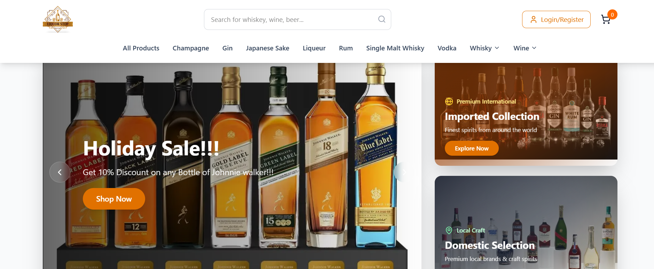
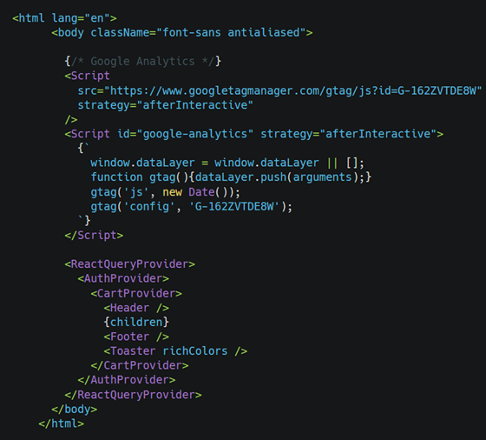
Homepage
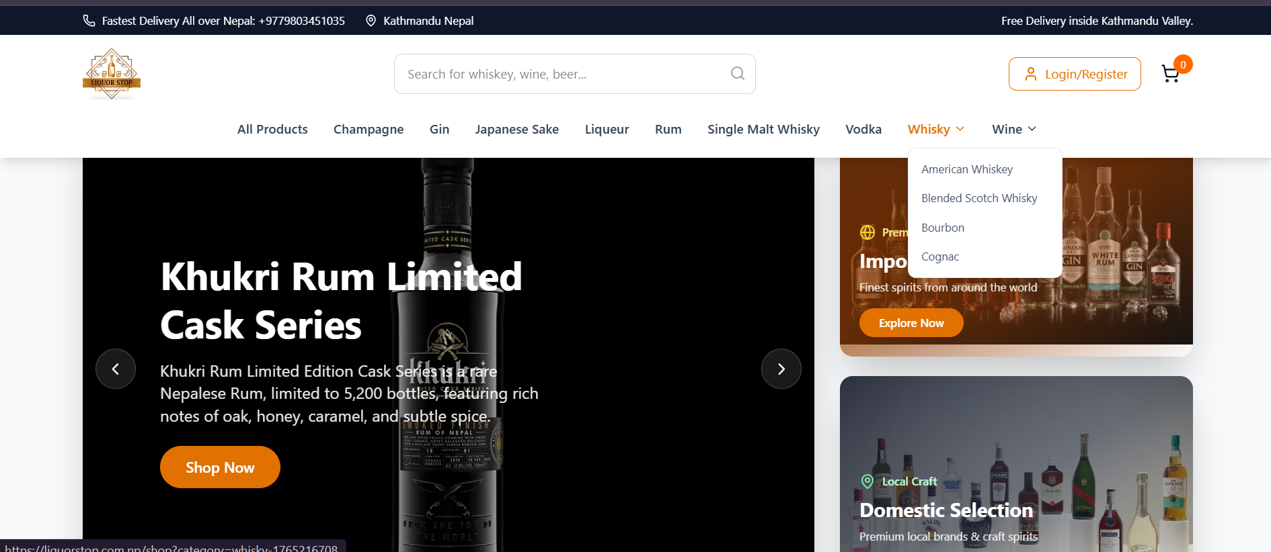
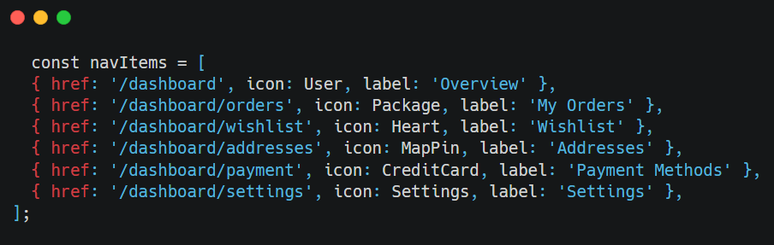
Navigation structure of the website

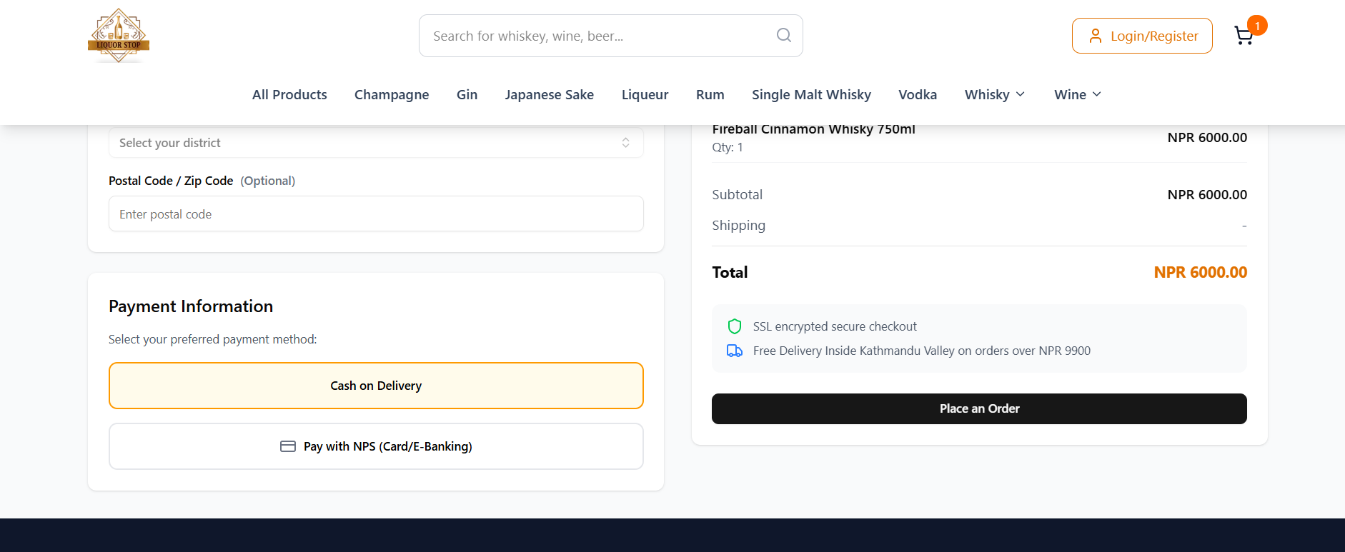
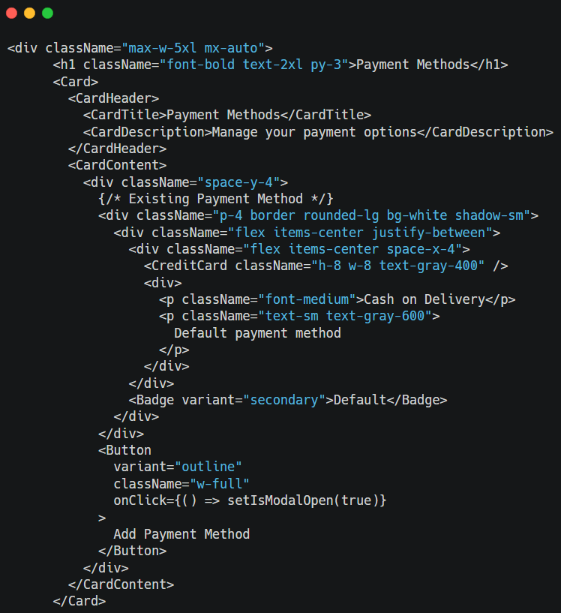
Payment Integertion

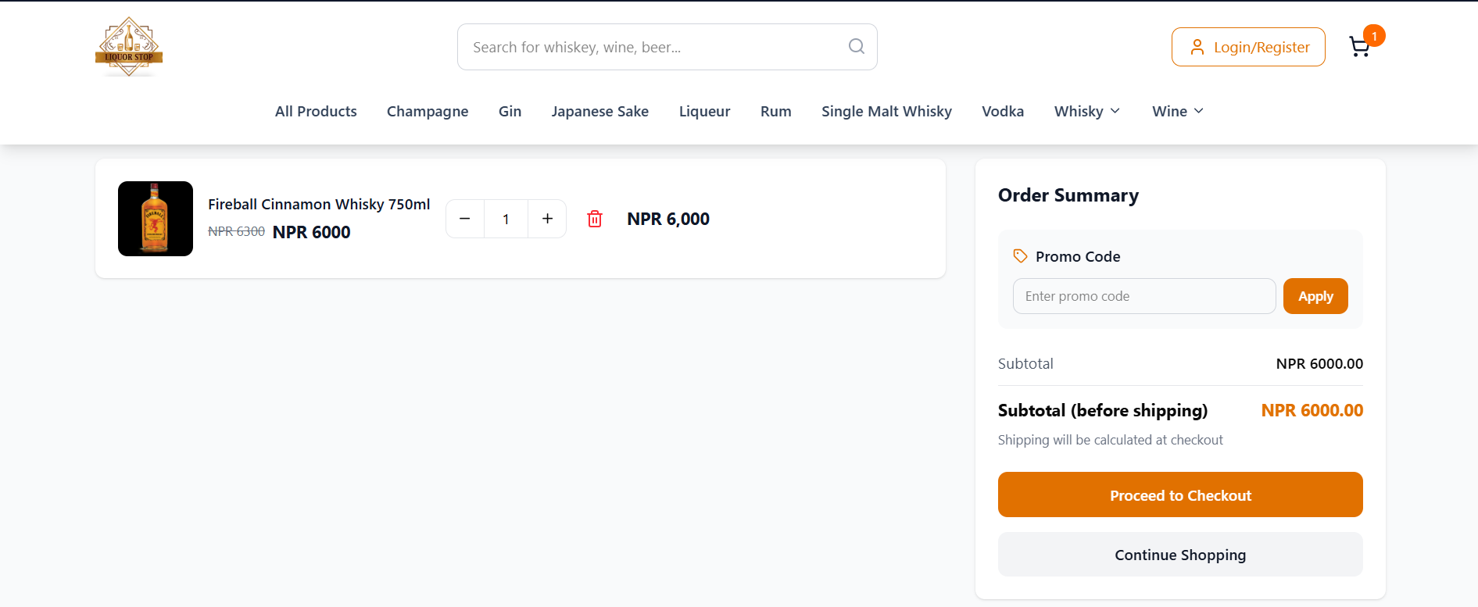
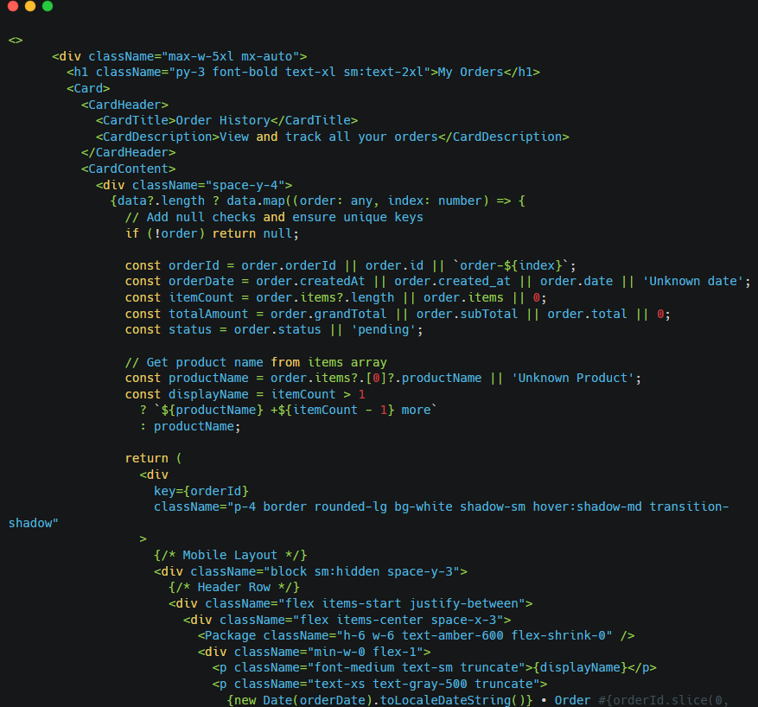
Product Cart

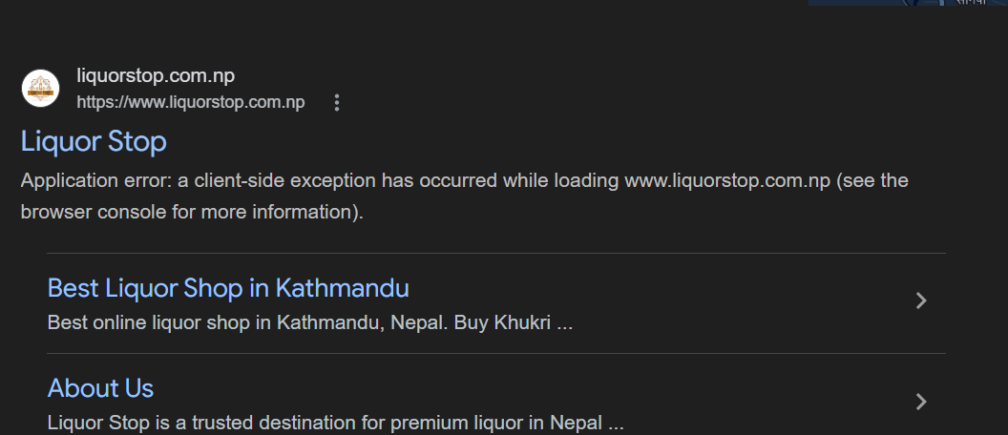
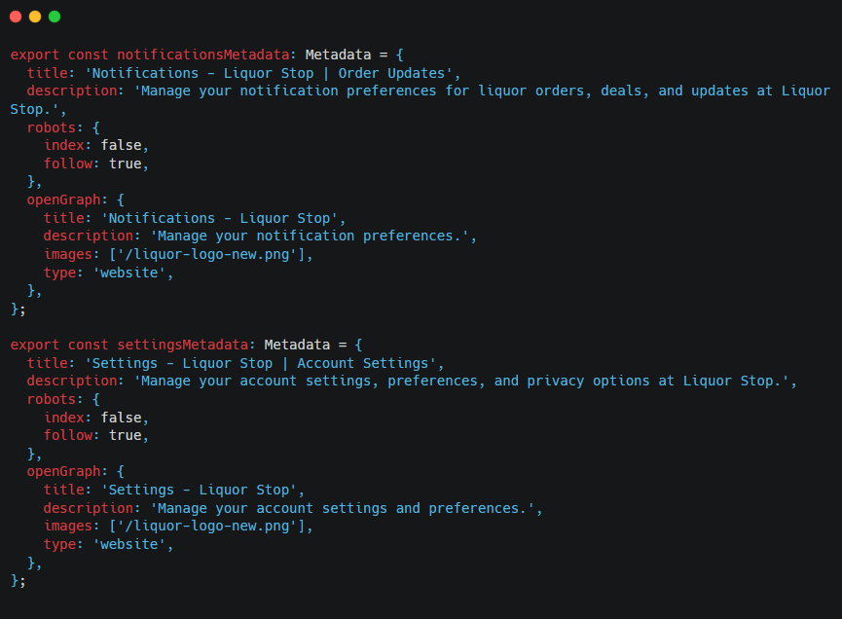
Site MetaData

