New Summit College
Shantinagar, Kathmandu


A Project Proposal on
Virtual File System
In the partial fulfillment of the requirements for the completion of
sixth semester project of Bachelor’s Degree in Computer Application

Submitted To
Faculty of Humanities and Social Sciences
New Summit College
Submitted by
Ayush Acharya (T.U Regd No: 6-2-476-53-2021)
Kushal Khanal (T.U Regd No: 6-3-476-59-2021)

04 March,2025

ABSTRACT
Cloud Storage solution changed the way the users manage and have access to their digital content. This project aims to design a cloud-based storage solution that enables users to store and manage their photos, videos, and files. Another vital feature is its categorized search function, which sorts results by file type i.e. if you search for “photos” only image files will show up. The platform will protect user data from unwanted access by implementing access controls, authentication, and encryption to guarantee safe storage. With extra features like file previews and sharing choices to improve data accessibility, users may access their files from any device. The system will incorporate different algorithms to enhance search accuracy and file classification, allowing for more effective content recognition. The goal of this project is to provide a reliable, scalable, and user-friendly Virtual File solution that optimizes file organization and retrieval and offer a seamless digital storage experience to the users.
Keywords: Virtual File, categorized search, access controls, authentication, encryption, data accessibility, search accuracy, user-freindly.
Table of Contents
ABSTRACT ii
LIST OF FIGURES iii
LIST OF TABLES iv
1. Introduction 1
2. Problem Statement 1
3. Objectives 2
4. Methodology 2
4.1 Requirement Identification 2
4.1.1. Study of existing system 2
4.1.2 Literature Review 2
4.1.3 Requirement analysis 3
4.2 Feasibility Study: 4
4.2.1 Technical Feasibility: 5
4.2.2 Economic Feasibility: 5
4.2.3 Operational Feasibility: 5
4.2.4 Schedule Feasibility: 5
4.3 High Level Design of System 5
4.3.1 Methodology of the proposed system 5
4.3.2 Flowchart: 6
4.3.3 Algorithms: 7
5 Gantt Chart 7
6 Expected Outcome 8
7 References 9

LIST OF FIGURES
Figure 4.1: Use Case Diagram 4
Figure 4.2: Iterative Waterfall Model 6
Figure 4.3: Flowchart for Proposed System 6

LIST OF TABLES
Table 1: Gantt Chart………………………………………………………………………7

Introduction
Nowadays, Technology and digital content is improving day by day, Users need an effective way to store, organize, and safely access their data the number of things. Since Virtual File enable users to upload and retrieve files from any device, they have become important. However, it might be difficult to organise and search for particular file types using typical Virtual File systems. Users usually have trouble finding specific content fast in congested file systems where documents, movies, and photographs are all presented simultaneously.
We aim to create an efficient Virtual File platform that offers an accurate categorised search function and allows users to store files, videos, and images. Unlike traditional storage services, we would like to ensure a quick and easy retrieval process by filtering search results according to file type. Additionally, we will use different algorithms to increase search accuracy and file classification and will also incorporate encryption and authentication for increased security. We aim to provide a secure Virtual File platform with an efficient, quick and user-friendly way to save, retrieve, search and share files, videos and images.

Problem Statement
Despite the advancement in technology and digital content, Existing Virtual File solutions provide basic search functionalities that display all file types together, often leading to difficulty in finding specific content. These platforms lack intelligent file categorization and security-focused features, increasing the risk of data mismanagement and unauthorized access. Many platforms apply storage virtualization by abstracting and managing physical storage resources in a way that makes them appear as a unified Virtual File system. Thus, allowing users to have limited control over where their data is stored, potentially raising concerns about data privacy and security in certain regions. As a result, there is a pressing need for a secure and intelligent Virtual File system with a categorized search feature, with enhance file organization, security, and accessibility, providing a seamless and user-friendly storage experience.

Objectives
- To create a secure and scalable platform that allows users to store photos, videos, and files, with an intelligent search feature that filters results based on file type for easy retrieval.
- To implement encryption, authentication, and access controls to protect user data from unauthorized access, ensuring a safe and reliable Virtual File experience.

Methodology

Requirement Identification

Study of existing system
- Google Drive: Google Drive is a Virtual File service offering 15GB (Giga Byte) of free space and it allows you to scale your storage effortlessly up to 5TB (Tera Byte) per user, plus the ability to request additional storage. Storage costs vary. It allows users to store, organize, and share files, with a powerful search engine to find files based on names, content, and metadata. Integration with Google Workspace apps enables easy collaboration [1]. However, it lacks categorized search, leading to mixed file results, and its file organization depends on manual folder structures, which can be challenging to manage with large volumes of data.
- Dropbox: Dropbox is a Virtual File solution, equipped with features to help you save time, improve your productivity, and collaborate with others. When you store a file in your Dropbox Virtual File, it is uploaded to our secure servers. Once the upload is complete, the file can then be accessed from anywhere, using any computer, phone, tablet, or other compatible device [2]. Dropbox also provides advanced collaboration tools, file versioning, and third-party integrations. While it includes search by keywords and metadata, it lacks categorized search for different file types.

Literature Review
Cloud computing combines traditional computer and network technologies like grid, distributed, and parallel computing, along with virtualization, to reduce the processing burden on user terminals. Users can access powerful computing functions from the cloud, simplifying their devices to basic input-output functions. Virtual File, a key component of cloud computing, provides data storage and access through a system that integrates various storage devices. It can be seen as a cloud computing system with large-capacity storage. The architecture of Virtual File includes the storage layer, basic management layer, application interface layer, and access layer [3].
Amazon Web Services (AWS), Microsoft Azure, and Google Cloud are the three major cloud service providers, each offering unique strengths. AWS is known for its vast range of services, scalability, and global infrastructure, making it ideal for enterprises and startups across various industries. Microsoft Azure excels in hybrid cloud solutions and seamless integration with Microsoft products, making it a top choice for organizations using Microsoft technologies. Google Cloud stands out in data analytics, machine learning, and AI, offering powerful tools for developers and researchers working with big data. While AWS provides a comprehensive solution for a wide variety of needs, Azure is optimal for businesses seeking hybrid cloud environments, and Google Cloud is particularly suited for data-driven applications and machine learning projects [4].
Cloud computing offers benefits like cost savings and increased efficiency but also introduces security risks. These include issues with data confidentiality, integrity, and availability, as well as challenges related to data storage across different jurisdictions with varying laws. Vulnerabilities in cloud systems include insecure APIs, improper resource allocation, and risks like incomplete data deletion. Virtual machine and network vulnerabilities, such as uncontrolled VM migration, snapshots leading to data leakage, and shared virtual bridges, also pose significant security threats. Addressing these vulnerabilities is crucial for the continued growth and security of cloud computing [5].

Requirement analysis
- Functional Requirements
- User:
  - User Registration, Login and Logout
  - Upload, Delete, View Files and Create Folders
- Admin:
  - Admin Login and Logout
  - Monitor Usage, Manage Storage and View Logs
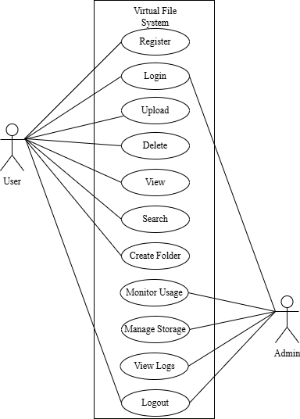
Figure 4. 1: Use Case Diagram
- Non-Functional Requirements
- Security
- Data Backup and Recovery
- Performance Monitoring
- Availability

Feasibility Study:
A feasibility study sometimes called a feasibility analysis or feasibility report A feasibility study is an evaluation and analysis of a project or system that somebody has proposed. Following feasibilities were studied before building the system to see if the system could be built with exact requirements in required time.

Technical Feasibility:
The process involves assessing the technology infrastructure for scalability, integration with existing systems, and security measures to ensure compliance with regulations. Additionally, it involves evaluating the system's hardware, software, and network capabilities to accommodate potential user growth and data volume.

Economic Feasibility:
The system does not require extra software and hardware i.e. it uses open-source technologies. So, there is no recurring cost than just the internet connection. The project's return on investment (ROI) and payback period is calculated. Hence, the proposed system is economically feasible.

Operational Feasibility:
It's important to identify the user base and evaluate their needs and readiness for the system. Then, organizational readiness must be assessed, and the impact on existing business processes must be analyzed. Finally, user training and support resources should be considered. his system uses simple technologies to design. So, it is user friendly.

Schedule Feasibility:
Creating a detailed project schedule by evaluating resource availability, identifying potential risks, and forming strategies to mitigate them. It is important to keep all stakeholders engaged throughout the project to ensure that the expense tracker system initiative is completed within the desired timeframe.

High Level Design of System

Methodology of the proposed system
Iterative waterfall model will be used to make the system due to its flexibility to incorporate changes and feedback throughout the development process. The iterative waterfall model is a software development methodology that builds upon the traditional waterfall model by incorporating iterative feedback loops between phases, allowing for adjustments and improvements throughout the development process.
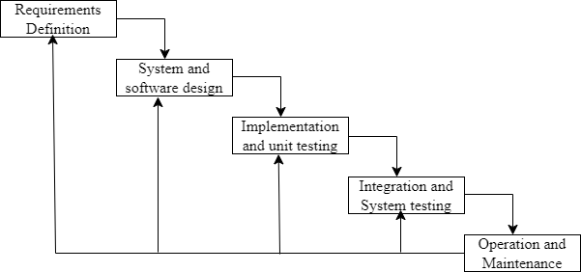
Figure 4. 2: Iterative Waterfall Model

Flowchart:
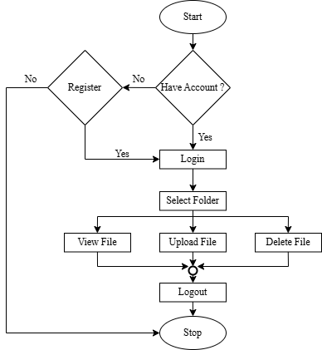
Figure 4. 3: Flowchart for Proposed System

Algorithms:
- Put what algorithms will you use here

Gantt Chart
Table 1: Gantt Chart
Working Time | 14th Mar | 22nd Mar | 7th Apr | 18th Apr | 21th Apr
Requirement Definition
System and Software Design
Implementation and Unit Testing
Integration and System Testing
Operation and Maintenance
Documentation

Expected Outcome
- Easy file access and sharing from anywhere, boosting collaboration.
- Flexible and secure storage that satisfies user needs.
- Automated backups and quick data recovery to prevent loss.

[1] | Google, "Google Workspace," Google, [Online]. Available: https://workspace.google.com/products/drive/. [Accessed 30 March 2025].
[2] | Dropbox, "Dropbox," Dropbox, [Online]. Available: https://www.dropbox.com/features. [Accessed 30 March 2025].
[3] | K. Liu and L.-j. Dong, "Research on Cloud Data Storage Technology and Its Architecture Implementation," Procedia Engineering, vol. 29, pp. 133-137, 2022.
[4] | M. Saraswat and R. C. Tripathi, "Cloud Computing: Comparison and Analysis of Cloud Service Providers-AWS, Microsoft and Google," in Proceedings of the 2020 9th International Conference on System Modeling and Advancement in Research Trends, SMART 2020, Lisbon, Portugal, 2020.
[5] | S. R. K. a. R. Sharma., ""Security Risks and Challenges in Virtual File Virtualization"," vol. 4, pp. 9-11, 2023.

References

