CSE 587B - Project Phase 1 and Phase 2
Title: LendWise - SBA Approved Loan Amount Prediction
Dataset: SBA National Loan Dataset
Target: GrAppv, the gross approved loan amount
Date: August 7, 2026

Problem Statement:
The goal of this project is to predict the approved loan amount for small business loans using the SBA National dataset. The target variable is GrAppv, which represents the gross amount approved by the bank. This keeps the project as a regression problem, but changes the business context from personal or property loan sanctioning to small business lending.
This version of LendWise is focused on estimating how much money may be approved, not whether a borrower will default. That distinction is important because default fields such as MIS_Status and ChgOffPrinGr describe loan performance after approval and should not be used to predict the approval amount.

The problem and why we need to investigate it:
Loan approval is usually influenced by many related factors: the business location, industry, number of employees, loan term, bank, program type, and whether the business is new or existing. A data-driven estimate can make the early loan screening process more transparent and can help borrowers and lenders understand typical approved amount patterns across similar SBA loans.
The SBA dataset is useful for this question because it contains many years of lending records across banks, states, industries, loan terms, and business profiles. The dataset does not include every ideal borrower attribute, such as credit score or revenue, so the model is best understood as an approval amount estimator based on the available SBA loan record fields.

Impact of the project and why our contribution is valuable:
A model that predicts approved loan amount can support faster preliminary decisions. It can help borrowers form realistic expectations and help lenders identify records that may need closer review. Even if the final approval process remains manual, this model gives a quick statistical estimate that can be compared with the actual requested or approved amount.
In this project, the best model was LightGBM, with a test RMSE of $190,979, MAE of $102,262, and R2 of 0.544. The error is still large in dollar terms, but it is a clear improvement over the dummy baseline and shows that the available SBA fields do contain useful signal.

Data Source:
Kaggle SBA National Dataset: https://www.kaggle.com/datasets/maddraf/sbanational-csv
The raw file used in the notebook is src/data/SBAnational.csv. It contains 899,164 rows and 27 columns before cleaning. After target cleanup and preprocessing checks, 899,164 rows remain for analysis and modeling.

Data Cleaning:

1. Check for missing values
The first step was to inspect missing values in the SBA columns. Some fields have only small gaps, while charge-off related fields have many missing values because not every loan charged off. For this project, post-loan performance columns were removed from the model because they would leak future information into the approval amount prediction.
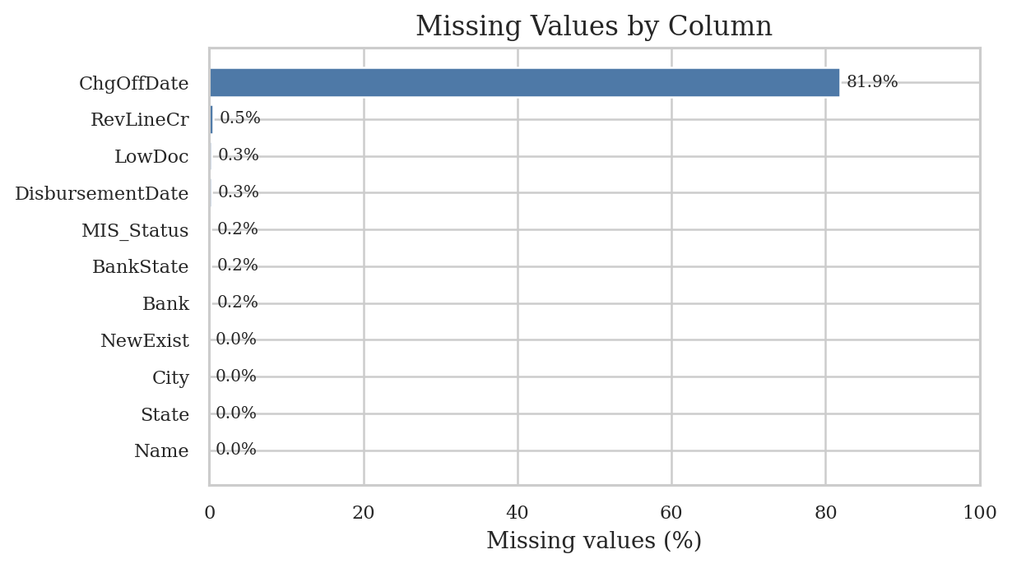
Figure 1: Percentage of missing values in the raw SBA dataset.

2. Clean currency and date fields
The money columns were stored as currency strings, so symbols, commas, and whitespace were removed before converting them to numeric values. The target GrAppv was checked for missing and non-positive values because regression on approved dollar amount requires a valid positive target. Approval and disbursement dates were parsed so that year and month features could be derived.

3. Treat missing values without replacing everything by zero
The preprocessing does not fill all missing values with zero. Numeric features are filled with their median values, while categorical features are filled with Unknown. This keeps missing categories separate from real numeric zeros. Later, one-hot encoding creates many 0 and 1 columns. Those zeros are normal dummy-variable indicators and do not mean that all missing values were changed to zero.

4. Engineer SBA-specific features
- NAICS was converted into NAICS_sector using the first two digits of the industry code.
- FranchiseCode was simplified into an is_franchise indicator.
- RevLineCr, LowDoc, NewExist, and UrbanRural were normalized into readable categories.
- City, Zip, and Bank were converted to frequency features to avoid very wide high-cardinality encoding.
- Approval date was converted into approval_year and approval_month.

Exploratory Data Analysis:

1. Univariate analysis
The approved amount is highly skewed. The median approved amount is $90,000, while the mean is $192,687, which shows that a smaller number of large loans pull the average upward. The median term is 84 months. The top state by loan count is CA, and the most common NAICS sector code is Unknown.
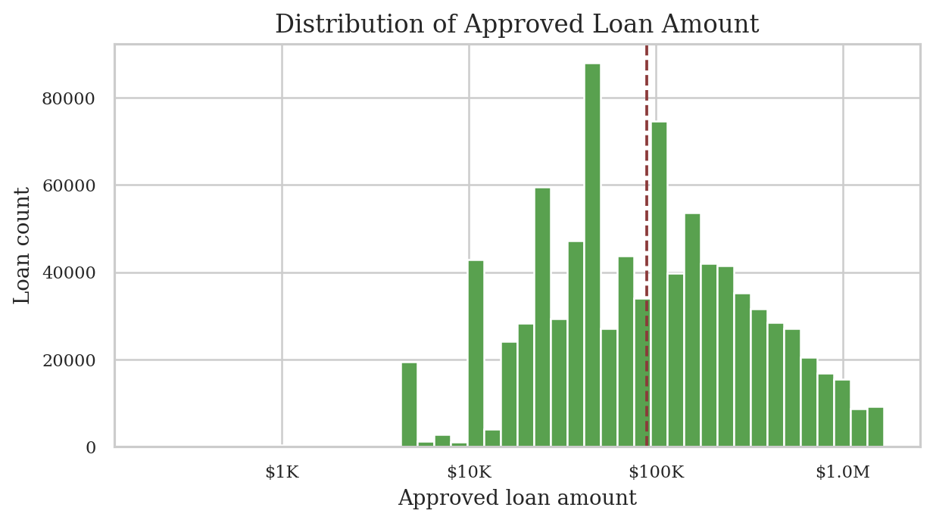
Figure 2: Distribution of the approved SBA loan amount after currency cleanup.
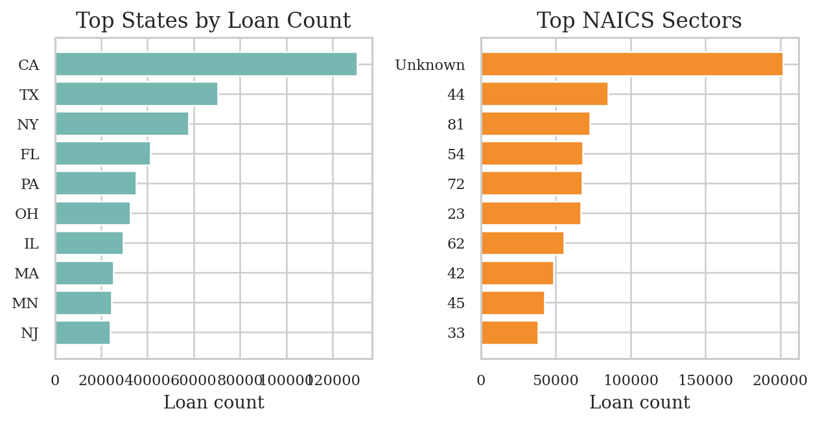
Figure 3: Loan counts by common states and industry sectors.

2. Multivariate analysis
The correlation analysis shows that the target is more connected to loan term and business size fields than to job creation fields alone. The scatter plot also shows that longer loan terms often appear with larger approved amounts, but the relationship is noisy, so nonlinear models are helpful.
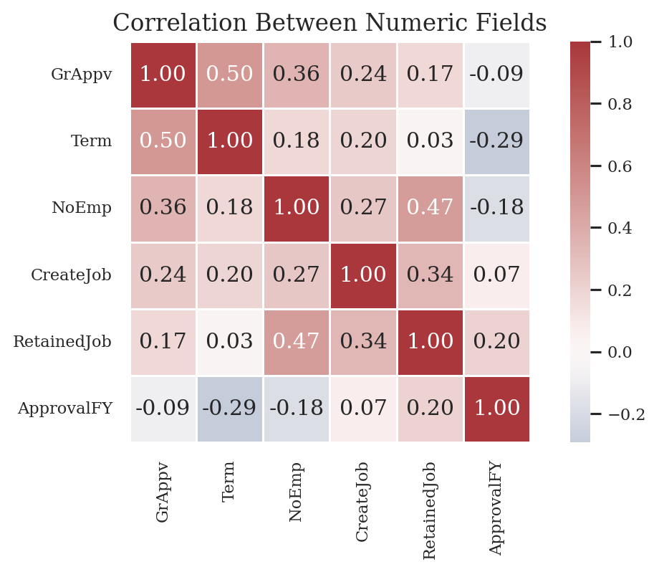
Figure 4: Correlation heatmap for key numeric SBA fields.
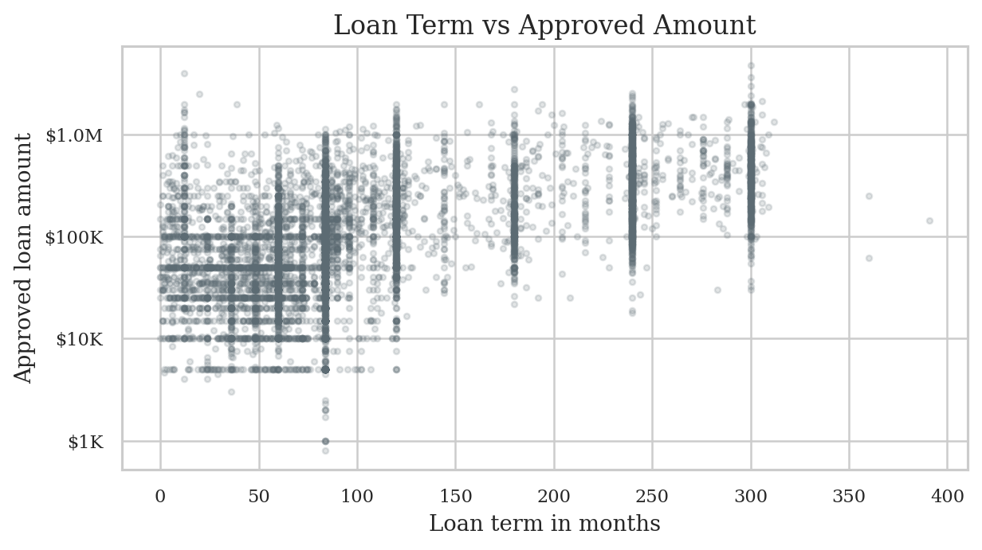
Figure 5: Relationship between loan term and approved amount on a log dollar scale.

Feature Selection and Encoding:
The original property-loan columns were replaced with SBA-specific features. Identifier, name, post-approval performance, and direct leakage columns were removed. The model uses loan term, employment fields, approval year and month, business geography, industry sector, program flags, and frequency-encoded city, ZIP, and bank fields.
After encoding, the modeling file contains 158 input features plus the target column. Categorical values were one-hot encoded so linear and tree models could consume them consistently. Numeric features were scaled for models that benefit from scaling.

Selected numeric features
- Term, NoEmp, CreateJob, RetainedJob
- ApprovalFY, approval_year, approval_month
- City_freq, Zip_freq, Bank_freq

Selected categorical features
- State and BankState
- NewExist, UrbanRural, RevLineCr, LowDoc
- NAICS_sector and is_franchise

Model Implementation:
The project keeps the original regression-model idea but updates the model set for a larger tabular lending dataset. Linear Regression, Random Forest, Gradient Boosting, PCA Regression, and Neural Network models were adapted first. Ridge Regression was added as a stronger linear baseline. HistGradientBoosting, LightGBM, XGBoost, and CatBoost were added because they generally perform well on structured tabular data.
- Dummy Regressor gives a simple baseline for comparison.
- Linear Regression and Ridge test whether a simple linear pattern is enough.
- Random Forest and Gradient Boosting capture nonlinear relationships.
- LightGBM, XGBoost, and CatBoost provide stronger boosted-tree models for tabular data.
- The Neural Network is included as an additional nonlinear model, but tabular boosting models are expected to be more competitive here.

Evaluation:
All models are evaluated as regression models on the original dollar scale. MAE is easy to interpret because it shows the average dollar error. RMSE penalizes larger mistakes more strongly. R2 shows explained variance, and RMSLE is useful because approved loan amounts are highly skewed.
Model | MAE | RMSE | R2 | RMSLE | Fit Sec.
LightGBM | $102,262 | $190,979 | 0.544 | 0.887 | 7.24
XGBoost | $102,434 | $191,836 | 0.540 | 0.872 | 7.31
HistGradientBoosting | $103,407 | $192,361 | 0.537 | 0.876 | 4.24
Random Forest | $102,674 | $195,008 | 0.524 | 0.818 | 22.21
CatBoost | $105,286 | $195,335 | 0.523 | 0.882 | 1.18
Gradient Boosting | $112,960 | $206,178 | 0.468 | 0.961 | 21.44
Neural Network | $112,993 | $212,052 | 0.437 | 2.134 | 7.30
Ridge Regression | $131,472 | $221,236 | 0.388 | 3.537 | 0.81
Linear Regression | $131,473 | $221,236 | 0.388 | 3.537 | 3.66
PCA + Linear Regression | $147,485 | $244,161 | 0.254 | 3.283 | 15.81
Dummy Baseline | $154,582 | $300,756 | -0.132 | 1.303 | 0.01

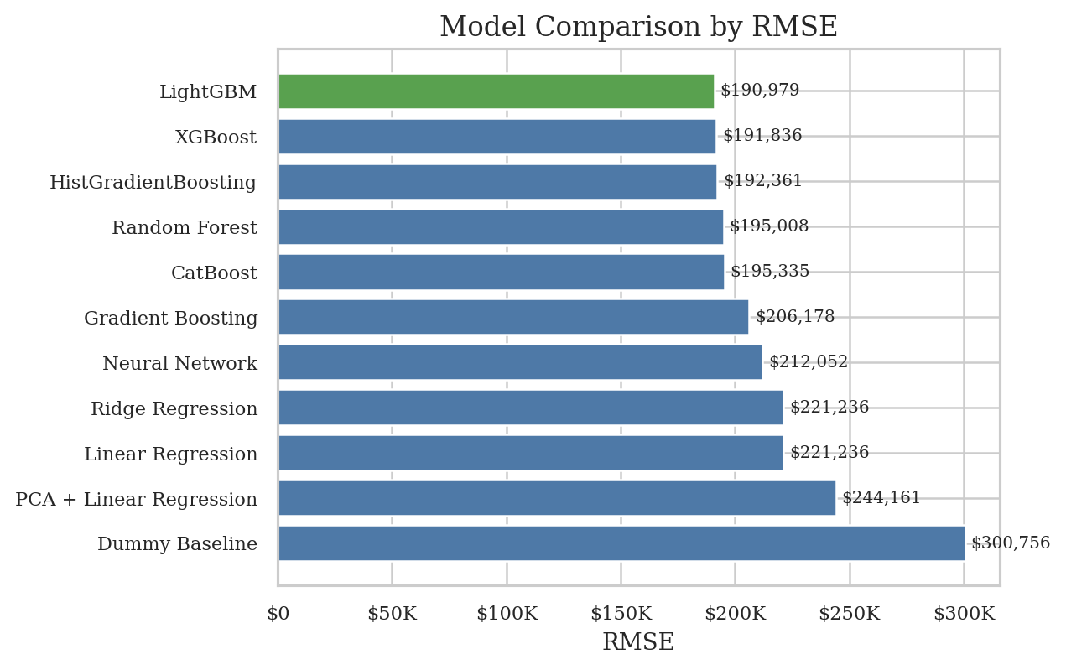
Figure 6: Comparison of test RMSE across all trained models.

Model Analysis:
LightGBM is the best model by RMSE. XGBoost and HistGradientBoosting are close, which confirms that boosted tree methods are a good match for this SBA loan amount task. Random Forest and CatBoost also perform well, while simple linear models trail because the relationship between loan amount, term, business size, geography, and industry is not purely linear.
The dummy baseline has a negative R2, meaning it performs worse than a useful model should. The boosted models provide a clear improvement, but the remaining error shows that the SBA data does not include every approval factor. Important missing predictors may include requested amount, business revenue, owner credit profile, collateral, and lender-specific policy details.

Conclusion:
The project was successfully changed from the earlier loan sanction dataset to the SBA National dataset while keeping the overall regression goal. The preprocessing now matches SBA loan records, leakage columns are removed, missing values are handled by feature type, and the model section has been expanded with stronger tabular models.
The final recommendation is to use LightGBM as the main model for this notebook because it has the lowest RMSE and strong overall accuracy with fast training time. Future work should test a time-based validation split, tune boosted model hyperparameters, evaluate errors by state and industry sector, and add richer borrower or business financial features if they become available.

