**AICTE Activity Point Programme Report**

Submitted in Partial Fulfilment for the Award of Degree of

Bachelor of Engineering

in

Electronic and Communication Engineering

Submitted by

Kushal K V

1NT21EC072

**Under the guidance of**

Dr. Viswanatha V

Associate professor

Dr. Raghunatha Reddy M V

Assistant professor



**2024-2025**

**AICTE Activity Point Programme CERTIFICATE**

This is to certify that the AICTE Activity Point Programme has been successfully carried out by Kushal K V bearing USN 1NT21EC072, Bonafide student of **Nitte Meenakshi Institute of Technology** in partial fulfilment of the requirements for the award of degree of **a** of **Visvesvaraya Technological University**, **Belagavi** during **20204-2025**. It is certified that all corrections/suggestions indicated for Internal Assessment have been incorporated in the report. The AICTE Activity Point Programme report has been approved as it satisfies the academic requirements in respect of AICTE Activity Point Programme for the said degree.

…………… …………… …….……

Signature Signature Signature

Dr. Raghunatha Reddy M V Dr. Parameshachari B D Dr. Karunakara Rai

/ Dr. Deepika K M

**CERTIFICATE PHOTOCOPY**

Issued by NGO/Organization

**DECLARATION**

I, Kushal K V bearing the USN:1NT21EC072, student of Bachelor of Engineering, **Electronics and Communication Engineering, Nitte Meenakshi Institute of Technology, Bengaluru,** hereby declare that the **AICTE Activity Point Programme** work has been carried out by me under the supervision and guidance of **Dr. Viswanatha V and**  **Dr. Raghunatha Reddy M V** submitted by me as a partial fulfilment for the award of Bachelor of Engineering degree in **Electronics and Communication Engineering** from **Visvesvaraya Technological University, Belagavi** during **2024-2025.**

I hereby declared that the AICTE activity point work has been carried out at following partner organizations:

1. YOUTH FOR SEVA
2. RASHTROTTHANA PARISHAT

**Signature**

Name: Kushal K V

USN:1NT21EC072

**ACKNOWLEDGEMENT**

I extend my heartfelt gratitude to Dr. H C Nagaraj, Principal of Nitte Meenakshi Institute of Technology; Dr. Visvanatha V and Dr. Raghunatha Reddy M V, Professors at Nitte Meenakshi Institute of Technology, Bengaluru; and Dr. Karunakara Rai, AICTE Activity Points Coordinator at Nitte Meenakshi Institute of Technology, for their unwavering support and provision of essential resources for the successful execution of this program.

I am also deeply thankful to Youth for Seva and Rashtrotthana Parishat for their invaluable support in offering meaningful volunteering opportunities and resources.

Lastly, I would like to express my sincere appreciation and respect to my parents, the teaching and non-teaching staff of the Department, and all my friends who have supported me, directly or indirectly, throughout my AICTE Activity Point Programme journey.

**Student Name: Kushal K V**

**USN number: 1NT21EC072**

**ACTIVITY SUMMARY**

|  |  |  |  |  |
| --- | --- | --- | --- | --- |
| **Si. No.** | **Activity Heads** | **From date**  **–**  **To date** | **Number of Days** | **Total Number of Hours** |
| **1.** | **Green Sunday**  **475** | **02/02/2025** | **1** | **4** |
| **2.** | **Green Sunday**  **479** | **02/03/2025** | **1** | **4** |
| **3.** | **Param Innovation** | **05/03/2025** | **1** | **8** |
| **4.** | **Green Sunday**  **480** | **09/05/2025** | **1** | **8** |
| **5.** | **Param Innovation** | **10/03/2025 -**  **11/03/2025** | **2** | **16** |
| **6.** | **RP**  **Goushaala**  **visit** | **31/05/2025** | **1** | **10** |
| **7.** | **RP**  **Medicinal Plantation visit** | **01/06/2025** | **1** | **10** |

**Rubrics for Activity Points**

|  |  |  |  |  |  |  |  |  |
| --- | --- | --- | --- | --- | --- | --- | --- | --- |
|  | **Very Good**  **(8-10)** | **Good**  **(6-7)** | **Average**  **(5)** | **Activity-1** | **Activity-2** | **Activity-3** | **Activity-4** | **Activity-5** |
| **Need Analysis** | Thoroughly identified and understood specific community needs. | Identified and addressed most key community needs | Identified some needs but lacked comprehensive analysis. |  |  |  |  |  |
| **Implementation** | Executed effectively with exceptional efficiency and impact. | Implemented well with minor improvements possible. | Implemented partially with noticeable gaps in execution. |  |  |  |  |  |
| **Community Involvement** | Engaged community fully with outstanding collaboration efforts. | Involved community well with some collaboration gaps. | Engaged community minimally with limited collaboration efforts. |  |  |  |  |  |
| **Impact Measurement** | Thoroughly measured impact with clear, measurable outcomes. | Measured impact with clear outcomes, though incomplete. | Measured impact partially with limited data or analysis. |  |  |  |  |  |
| **Total** | | | |  |  |  |  |  |
| **Grand Total** | | | | | | | |  |

**ABSTRACT**

The AICTE Activity Point Programme, under the initiative titled "Youth for Seva," and “Rashtrotthana Parishat” involved different activities related to environment, education, flora and fauna sustainability

Throughout the program, the first activity performed was titled "Green Sunday," organized by “Adamya Chetana” ngo where volunteers engaged in tree plantation efforts, introducing diverse species to enhance ecological balance and promote environmental conservation. This activity aimed to mitigate the effects of deforestation and climate change while fostering community awareness about sustainability. This event is organised every Sunday for the past ten years by the ngo in an effort to sustain environment and give our future generations a better life. I was given an opportunity to attend Green Sundays of the week 475, 479 and 480.

The second activity organized by “Param Innovation” involved assembling laser-cut components into intricate sculptures, namely *Snow-ball* and *Volcano*, designed by renowned mathematician and sculptor George W. Hart. Additionally, scientific images were arranged into photo frames for educational display purposes. This effort sought to merge art with science, enabling a creative approach to learning while reinforcing the importance of STEM education.

The third activity organized by “Rashtrothanna Parishat” involved many rigorous smaller activities related to animal care and farming related maintenance. The activities included removing weeds from farm fields such as Parthenium for better growth of the crops,

Putting manure to plants for their growth and increasing soil fertility, animal care such as putting fodder to cows and collecting manure from fields. We also got to visit the medicinal plantation forest where we were introduced to many species of medicinal plants and their uses in everyday life. These activities gave us an idea about sustainable practices and also and overview about farming and related practices.

Together, these activities underscored the significance of environmental responsibility and scientific engagement, contributing to both ecological preservation and educational enrichment.

**CONTENTS**

1. **CHAPTER 1**

INTRODUCTION (Brief introduction about all the activities head carried out) ………………………………… ……………..

1. **CHAPTER 2**

Details of activities (ACTIVITY HEAD- 1)

2.1. Overview ………………………………………………….

2.2. Use of Technology (if any) …………………………………………

2.3. Sustainable Development best practices ………………………

(ACTIVITY HEAD- 2)

2.1. Overview ………………………………………………….

2.2. Use of Technology (if any) …………………………………………

2.3. Sustainable Development best practices ………………………

**3.CHAPTER 3 (overall learnings)**

3.1. Innovative approaches taken

3.2. Research done

3.3. Knowledge and Understanding gained

3.4. Professional Values and best practices incorporated

3.5. Areas for further development

3.6. Challenges and solutions

3.7. Feedback and continuous improvement

**4. CHAPTER 4**

Documentation of Activities (includes Jio tag Photographs/ testimonials if any) …………………….

**5. CHAPTER 5**

**Conclusion**

**REFERENCE**

**CHAPTER 1: INTRODUCTION**

The AICTE Activity Point Programme, under the initiatives *Youth for Seva* and *Rashtrotthana Parishat*, provided a platform for volunteers to engage in meaningful activities focused on environmental conservation, education, and sustainability. These initiatives aimed to instill a sense of responsibility and awareness among youth regarding critical social and ecological issues while allowing them to contribute directly to positive change. As part of the program, I had the opportunity to participate in three major activities that emphasized environmental restoration, scientific engagement, and agricultural sustainability.

The first initiative, **Green Sunday**, was spearheaded by *Adamya Chetana*, an NGO committed to environmental preservation. This weekly event, conducted consistently for over a decade, brings together volunteers to plant trees and contribute to ecological restoration. The initiative seeks to combat deforestation, enhance green spaces, and mitigate the adverse effects of climate change. As a participant, I engaged in Green Sunday activities on three occasions—weeks 475, 479, and 480—where I was involved in planting diverse species of trees, learning about biodiversity, and understanding the impact of afforestation on climate resilience.

The second initiative focused on the intersection of science, technology, and creativity. Organized by *Param Innovation*, the activity involved assembling laser-cut components into intricate sculptures designed by renowned mathematician and sculptor *George W. Hart*. The sculptures, *Snow-ball* and *Volcano*, are artistic representations of geometric structures, blending art with mathematical precision. Additionally, scientific images were framed and curated to be used in educational settings, highlighting the significance of visual learning in science communication. This initiative provided insights into STEM education, demonstrating how technology and creativity can enhance scientific understanding.

The third initiative, conducted by *Rashtrotthana Parishat*, delved into agricultural sustainability and animal care practices. Volunteers engaged in hands-on farming activities such as weed removal, organic manure application, and livestock feeding. The activity also included a visit to a medicinal plantation forest, where participants were introduced to various species of herbal plants and their uses in daily life. This experience emphasized the importance of sustainable farming methods, biodiversity conservation, and ethical agricultural practices.

Each of these initiatives contributed to personal and professional development by fostering practical learning, teamwork, and environmental consciousness. Through participation in these

activities, I gained a deeper understanding of sustainable development, scientific engagement, and ecological responsibility. This report provides a comprehensive overview of the experiences, challenges, and learnings encountered throughout these initiatives, highlighting the significance of youth-driven efforts in shaping a more sustainable and knowledgeable society.

**CHAPTER 2: DETAILS OF ACTIVITIES**

**ACTIVITY HEAD – 1: GREEN SUNDAY**

**2.1 Overview:**  
Green Sunday, organized by *Adamya Chetana*, is a weekly tree plantation event that has been sustained for over a decade. The initiative aims to restore green cover and promote ecological consciousness. As a participant, I attended Green Sundays in weeks 475, 479, and 480, actively planting diverse tree species.

**2.2 Use of Technology:**  
The event primarily relied on traditional planting techniques, but digital mapping tools were used to record tree placements and monitor growth over time.

**2.3 Sustainable Development Best Practices:**  
The community garden followed organic farming practices, utilizing compost and natural pesticides. Watering schedules were based on seasonal rainfall patterns, and children were educated on ecological practices. This approach reflects the core principles of sustainability—environmental responsibility, resource conservation, and community awareness.

**ACTIVITY HEAD – 2: SCIENTIFIC AND ARTISTIC ASSEMBLY**

**2.1 Overview:**  
*Param Innovation* led a creative initiative combining science and art, where participants assembled laser-cut sculptures (Sno-ball and Volcano) designed by George W. Hart. Additionally, scientific images were curated into framed displays for educational outreach.

**2.2 Use of Technology:**  
Laser-cutting technology was used for precision sculpting, while digital tools were leveraged for designing scientific image presentations.

**2.3 Sustainable Development Best Practices:**  
Promoting STEM education through interactive learning, encouraging innovative approaches to science communication, utilizing eco-friendly materials for displays and sculptures.

**ACTIVITY HEAD – 3: AGRICULTURAL AND ANIMAL CARE PRACTICES**

**2.1 Overview:**  
With Rashtrotthana Parishat, various farming and animal care activities were carried out to understand sustainable agriculture. Tasks included weed removal (Parthenium), manure application, and feeding livestock. A visit to a medicinal plantation forest provided exposure to herbal plant species and their everyday uses.

**2.2 Use of Technology:**  
Traditional farming techniques were complemented with modern soil management methods, emphasizing organic manure application.

**2.3 Sustainable Development Best Practices:**  
Utilizing organic manure to enhance soil fertility, removing invasive weeds to protect crop yield and educating participants on animal care and ethical farming practices.

**CHAPTER 3: OVERALL LEARNINGS**

3.1 Innovative Approaches Taken:  
Throughout the activities conducted under the NGO initiatives, our team actively integrated scientific art with environmental sustainability, ensuring that the efforts combined creativity with ecological preservation. By engaging in hands-on STEM learning techniques, we provided a dynamic approach to understanding scientific concepts, making education more interactive and impactful.

3.2 Research Done:  
A significant amount of research was undertaken to strengthen our understanding of environmental conservation and scientific methodologies. We studied different tree species, analyzing their ecological contributions, such as carbon sequestration, soil stabilization, and biodiversity enrichment. Additionally, we explored the intricacies of laser-cutting techniques used in educational models, learning how geometric precision and artistic expression could be combined to create visually engaging scientific sculptures. Another area of research involved identifying medicinal plants within the plantation forest, examining their therapeutic uses, and understanding their relevance in natural healing practices. These investigations deepened our appreciation for the interconnectedness of nature, science, and sustainability, shaping a well-rounded perspective on ecological responsibility.

3.3 Knowledge and Understanding Gained:  
Through participation in various activities, we acquired practical insights into environmental conservation, witnessing firsthand the impact of afforestation and sustainable agricultural practices. The experience reinforced the crucial role of trees in mitigating climate change and preserving biodiversity, highlighting the necessity of continuous reforestation efforts. Additionally, working on scientific sculptures and assembling educational exhibits allowed us to understand how art serves as an effective medium in simplifying complex scientific concepts. The agricultural activities provided valuable knowledge regarding soil health, organic farming techniques, and ethical animal care practices, underscoring the importance of sustainability in food production and ecological preservation.

3.4 Professional Values and Best Practices Incorporated:  
The activities fostered leadership and teamwork, requiring us to collaborate effectively within diverse groups to achieve common goals. We also gained practical experience in resource management, learning how to optimize available tools and materials for maximum environmental benefit. Ethical considerations played a vital role, particularly in farming and scientific outreach, as we worked toward promoting sustainable development without compromising ecological integrity. These experiences reinforced essential professional values, equipping us with skills that will be invaluable in future initiatives aimed at social impact and environmental stewardship.

3.5 Areas for Further Development:  
While the activities were enriching, there are areas that require further development for greater impact. Expanding technological integration in tree monitoring would allow for better tracking of growth patterns and environmental changes, ensuring that afforestation efforts yield long-term benefits.

3.6 Challenges and Solutions:  
**Challenges Faced:** One of the key challenges encountered was limited accessibility to advanced technological tools, which restricted certain aspects of environmental monitoring and data collection. Additionally, initial unfamiliarity with farming methods made it difficult to execute agricultural tasks efficiently.

**Solutions:** To overcome these challenges, we leveraged local expertise, seeking guidance from experienced farmers and environmental specialists to gain practical knowledge of sustainable farming techniques. Exploring cost-effective solutions for enhancing environmental tracking, such as simple mobile applications and manual data collection, helped bridge the technological gap. These strategies ensured that we could continue to contribute meaningfully despite resource limitations, enhancing the effectiveness of our sustainability efforts.

3.7 Feedback and Continuous Improvement:  
The activities received positive feedback, particularly regarding the interactive nature of scientific exhibits and the hands-on approach to environmental conservation. Participants suggested expanding digital tracking methods to monitor the growth and health of planted trees, allowing for more precise measurements of their long-term impact.

**CHAPTER 4: Documentation of Activities**

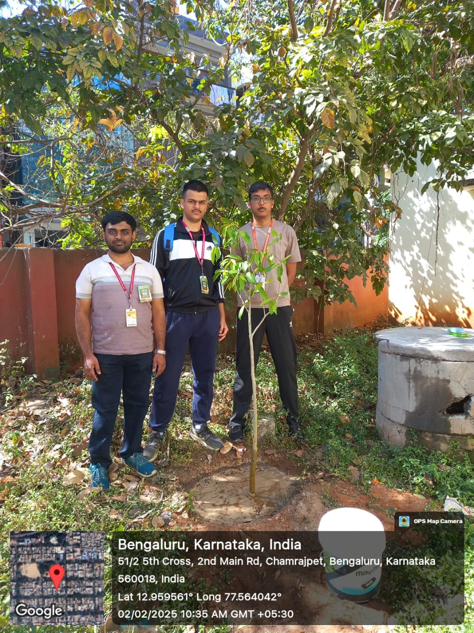

Fig 1. Green Sunday 02/02/2025

Fig 2. Green Sunday 02/03/2025

Fig 3. Green Sunday 09/03/2025

Fig 4. Param Innovation 05/03/2025

Fig 5. Param Innovation 10/03/2025

Fig 6. Param Innovation 11/03/2025

Fig 7. Rashtrotthana Parishat 31/05/2025 – 01/06/2025

(Rigorous activities)

**CHAPTER 5: CONCLUSION**

The AICTE Activity Point Programme, through its initiatives Youth for Seva and Rashtrotthana Parishat, provided an exceptional platform for volunteers to actively engage in environmental conservation, scientific exploration, and agricultural sustainability. Each of the activities undertaken during the program contributed significantly to fostering a deeper understanding of ecological responsibility, community service, and the interdisciplinary nature of STEM education in addressing global sustainability challenges. By participating in hands-on experiences, volunteers not only gained theoretical knowledge but also developed practical skills, teamwork, and a strong sense of social commitment.

The Green Sunday initiative, led by Adamya Chetana, reinforced the importance of afforestation as a key strategy for combating climate change, preserving biodiversity, and enhancing urban greenery. The opportunity to engage in tree plantation drives across multiple weekends allowed volunteers to witness firsthand the impact of environmental restoration efforts. Consistent participation in such initiatives highlights how small but sustained efforts can lead to large-scale positive environmental change. Additionally, the use of digital tools to track tree growth and ecological benefits showcases how technology can be leveraged to optimize sustainability practices.

Similarly, the Scientific and Artistic Assembly activities conducted by Param Innovation emphasized the role of interdisciplinary learning in STEM education. By assembling laser-cut sculptures and organizing scientific image displays, volunteers explored how scientific concepts can be transformed into visually engaging models that aid learning. These activities successfully combined creativity with technical precision, demonstrating that scientific literacy can be enhanced through innovative and artistic methodologies. This initiative also reinforced the importance of accessible and interactive learning experiences that make complex scientific principles more comprehensible to a wider audience.

The program also facilitated direct engagement with sustainable farming and animal care through activities organized by Rashtrotthana Parishat. Volunteers were introduced to crucial agricultural practices such as manure application, weed removal, and livestock management. The visit to the medicinal plantation forest provided exposure to various herbal plant species and their applications in traditional medicine, expanding participants’ knowledge of plant-based sustainability and its role in human health. The hands-on involvement in farming techniques illustrated the significance of organic methods and ethical agricultural practices in ensuring food security and ecological balance.

Beyond the tangible skills gained, this program instilled essential professional values such as leadership, teamwork, adaptability, and ethical responsibility. By collaborating with experts, local farmers, and fellow volunteers, participants strengthened their ability to work in diverse environments while contributing meaningfully to sustainability efforts. The challenges faced, such as limited accessibility to advanced tools and unfamiliarity with farming methods, were effectively addressed through innovative problem-solving, teamwork, and leveraging local expertise.

As the world increasingly shifts towards sustainability and environmental consciousness, initiatives like the AICTE Activity Point Programme play a vital role in equipping individuals with the necessary knowledge, skills, and experiences to contribute to meaningful change. The feedback received throughout the activities suggested ways to further improve and expand the program, including integrating AI-driven tools for farming, enhancing digital tracking for afforestation projects, and increasing community participation in conservation efforts. Moving forward, continuous engagement with such initiatives can drive long-term impact, fostering a generation of responsible individuals dedicated to sustainability, scientific innovation, and community service.

ACKNOWLEDGMENTS

I would like to express my sincere gratitude to all the individuals and organizations that made this experience enriching and impactful.

First and foremost, I extend my heartfelt appreciation to *AICTE* for initiating the *Activity Point Programme*, which provided an invaluable opportunity to engage in hands-on learning and contribute to environmental conservation, education, and sustainability. This initiative has been instrumental in fostering community-driven efforts aimed at creating a positive impact.

I would like to thank *Adamya Chetana* for organizing the *Green Sunday* program, a long-standing effort to protect the environment through continuous afforestation. Their dedication to sustainability and ecological restoration inspired me to actively participate and understand the significance of long-term environmental stewardship.

Special thanks to *Param Innovation* for their creative approach to STEM education, allowing me to engage in the assembly of scientific sculptures and educational displays. The experience provided insight into the integration of technology and artistic creativity, making complex scientific principles more accessible and engaging.

I am also grateful to *Rashtrotthana Parishat* for their agricultural and animal care initiatives. Their commitment to sustainable farming practices and biodiversity conservation provided hands-on exposure to organic farming, ethical livestock management, and medicinal plant research. Their guidance deepened my understanding of sustainability and rural livelihoods.

A huge thank you to the mentors, coordinators, and fellow volunteers who worked tirelessly to ensure the success of these activities. Their encouragement, knowledge, and collaborative spirit made the experience truly meaningful and insightful.

Lastly, I extend my gratitude to my family and friends for their unwavering support and motivation throughout this journey. Their encouragement reinforced my commitment to service and sustainability, allowing me to make the most of this opportunity.

This program has been an unforgettable learning experience, shaping my perspective on social responsibility, scientific exploration, and environmental sustainability. I look forward to applying these learnings in future initiatives that contribute to a better and greener world.