# VISVESVARAYA TECHNOLOGICAL UNIVERSITY



**JNANA SANGAMA, BELAGAVI - 590018**

*A Project Report on*

**ASSESSMENT OF STRESS-INDUCED ARRHYTHMIA THROUGH ECG SIGNAL ANALYSIS**

*Submitted in partial fulfilment of the requirements for the award of the degree of*

**Bachelor of Engineering in**

**Electronics and Communication Engineering**

**for the Academic Year: 2024-25**

*Submitted by*

**P Nikhil (1NT21EC097)**

**Vivek Bharghava M (1NT21EC176)**

**Yatin B N (1NT21EC178)**

Under the Guidance of

**Ms. Chaithra K N**

Assistant Professor

Dept. of Electronics and Communication Engineering

**DEPARTMENT OF ELECTRONICS AND COMMUNICATION ENGINEERING**

**YELAHANKA, BENGALURU- 560064**

## VISVESVARAYA TECHNOLOGICAL UNIVERSITY



**JNANA SANGAMA, BELAGAVI - 590018**

*A Project Report on*

# ASSESSMENT OF STRESS-INDUCED ARRHYTHMIA THROUGH ECG SIGNAL ANALYSIS

*Submitted in partial fulfillment of the requirements for the award of the degree of*

**Bachelor of Engineering in**

**Electronics and Communication Engineering for the Ac- ademic Year: 2024-25**

*Submitted by*

**P Nikhil (1NT21EC097)**

**Vivek Bharghava M (1NT21EC176)**

**Yatin B N (1NT21EC178)**

Under the Guidance of

###### Ms. Chaithra K N

Assistant Professor

Dept. of Electronics and Communication Engineering

**DEPARTMENT OF ELECTRONICS AND COMMUNICATION ENGINEERING**

**YELAHANKA, BENGALURU- 560064**

**DEPARTMENT OF ELECTRONICS AND COMMUNICATION ENGINEERING BENGALURU- 560 064**

*Certificate*

This is to certify that the project work entitled **“*Assessment of Stress-Induced Arrhythmia through ECG Signal Analysis*”** has been carried out by ***P Nikhil (1NT21EC097), Vivek Bharghava M (1NT21EC176)*** *and* ***Yatin B N (1NT21EC178)***, bonafide students of ***Nitte Meenakshi Institute of Technology*** in partial fulfillment for the award of **Bachelor of Engineer- ing** in the **Department of Electronics and Communication Engineering** under **Visvesvaraya Technological University,** Belagavi during the academic year **2024-2025**.

The project report has been examined and approved as it meets the academic requirements specified under the autonomous scheme of **Nitte Meenakshi Institute of Technology** for the said degree.

**Signature of the Guide Signature of the HoD Signature of the Principal**

**Ms. Chaithra K N**

Assistant Professor

Dept. of ECE, NMIT

**Dr. Parameshachari B D**

HoD

Dept. of ECE, NMIT

**Dr. H C Nagaraj** Principal NMIT

***External Viva-Voce***

***Name of Examiners Signature with Date***

# Acknowledgement

The successful execution of our project has been a significant milestone, and we take this opportunity to ex- press our heartfelt gratitude to all those who have supported and guided us throughout this journey. Whatever we have achieved is the result of their encouragement and help, and we remain deeply thankful to each one of them.

We express our sincere thanks and seek the blessings of **Dr. N. R. Shetty**, Advisor, *Nitte Meenakshi In- stitute of Technology*, for his vision and emphasis on project-based learning and constructivist principles that have greatly enriched our academic experience. We are grateful to **Mr. Rohit Punja**, Administrator, *Nitte Ed- ucation Trust*, and **Dr. Sandeep Shastri**, Vice President, *Bangalore Campus, Nitte University*, for their strate- gic leadership and continued support in fostering academic excellence.

We extend our special thanks to our beloved Principal, **Dr. H. C. Nagaraj**, for providing us with the necessary resources, facilities, and motivation to carry out our project successfully. Our sincere gratitude goes to **Dr. J. Sudheer Reddy**, *Dean – Academics,* and **Dr. Kiran Aithal**, *Dean – Research & Development,* for their guidance, encouragement, and for creating an environment that promotes innovation and academic growth.

We also convey our deep appreciation to **Dr. Parameshachari B D**, Head of the Department, Dept. of Electronics and Communication Engineering for his constant encouragement, valuable guidance, and for fos- tering a vibrant learning environment. We extend our heartfelt thanks to our project guide, **Ms. Chaithra K N**, Assistant Professor, Department of Electronics and Communication Engineering, for her unwavering sup- port, timely feedback, and insightful mentorship throughout the project. We are also indebted to our parents for their unconditional love, support, and encouragement throughout our academic journey at *Nitte Meenakshi In- stitute of Technology*, Bengaluru. Finally, we would like to express our appreciation to all those named and unnamed who contributed in any way to our learning and success.

|  |  |
| --- | --- |
| P Nikhil  Vivek Bharghava M Yatin B N | (1NT21EC097) (1NT21EC176) (1NT21EC178) |
| Place: Bengaluru Date: |  |

# Abstract

Stress is a major contributor to cardiovascular disorders, frequently causing arrhythmia that is not seen until they are well advanced. This study introduces a deep learning based method for using elec- trocardiogram (ECG) information to identify stress-induced arrhythmias. The suggested model com- bines Long Short Term Memory (LSTM) network to capture temporal dynamics in ECG data with Convolutional Neural Network (CNNs) for the extraction of spatial features. To increase signal clari- ty, ECG data are pre-processed using wavelet denoising and segmentation. Publicly accessible da- tasets, such as the MIT-BIH Arrhythmia and MIT-BIH Noise Stress Test Databases, are used to train and assess the model.

TensorFlow Lite is used to improve the learned model for real-time inference on edge devices like the Raspberry Pi and NVIDIA Jetson Nano for practical deployment. According to experimental data, the F1- score is 94.07%, the classification accuracy is 94.06%, and the precision is 94.08%. Because of its short inference latency and low resource use, the system may be integrated into portable ECG monitoring devices. By identifying stress-related arrhythmic events, this study advances the devel- opment of sophisticated, real-time heart health monitoring systems that facilitate remote healthcare applications and early intervention.

***Keywords— ECG, Arrhythmia Detection, Stress Analysis, Signal Processing, CNN-LSTM, Deep Learning, Edge Computing.***

**Contents**

**Acknowledgement i**

Abstract ii

List of Figures v

List of Acronyms vi

Chapter 1: Introduction 1

* 1. Background
     + 1.2 Problem Statement 2
     + 1.3 Scope 3
     + 1.4 Significance 3

Chapter 2: Literature Survey 5

* + - 2.1 Background Work 5
    - 2.2 Open Issues and Challenges 7
    - 2.3 Problem Definition 8
    - 2.4 Scope of the Work 10
    - 2.5 Pivotal Research Contributions 12

Chapter 3: Methodology 17

* + - 3.1 Architecture 17
    - 3.2 Proposed Methodology 18

Chapter 4: Implementation 21

* + - 4.1 Hardware & Software Integration 21
    - 4.2 Dataset Collection and Preprocessing 22
    - 4.3 Model Development and Training 23
    - 4.4 Real-Time Inference and Deployment 23

Chapter 5: Results and Analysis 25

* + - 5.1 Model Performance for Stress-Induced Arrhythmia Detection 25
    - 5.2 Real-Time ECG Signal Processing Performance 26
    - 5.3 Multi- Device Capabilities 26
    - 5.4 Hardware Efficiency and Resource Utilization 26
    - 5.5 Key Achievements 27
    - 5.6 Analysis and Implications 28
    - 5.7 System Comparison with Existing Solutions 28
    - 5.8 Performance Metrics Overview 29
    - 5.9 Detailed Comparison 30
    - 5.10 Key Insights from the Comparison 31

Chapter 6: Conclusion and Future Scope 34

* + - 6.1 Conclusion 34
    - 6.2 Future Scope 36

References 37

Appendix – A 39

Appendix – B 41

Publication Details 43

# List of Figures

* Figure 1.1: AI Subset 02
* Figure 2.1: Overview of ETL Process 16
* Figure 3.1: Fine Tuned Architecture 17
* Figure 3.2: Model Pipeline for CNN 29
* Figure 4.1: MIT-BIH Database 24
* Figure 5.1: Analysing the Input 25
* Figure 5.2: Model Performance 27
* Figure 5.3: Model Accuracy Graph 28
* Figure 5.4: Confusion Matrix 29
* Figure 5.5: Model Loss Graph 31
* Figure 5.6: ROC curve Graph 31
* Figure 5.7: Precision-Recall Curve 33
* Fig A.1 Group photo of team members with guide 40
* Fig B.1 : IEEE YESIST12 Prelims – Certificate of Participation 42

# List of Acronyms

|  |  |
| --- | --- |
| AI | Artificial Intelligence |
| AUC | Area Under Curve |
| CNN | Convolutional Neural Network |
| DL | Deep Learning |
| ECG | Electrocardiogram |
| ETL | Extract, Transform, Load |
| F1-score | Harmonic Mean of Precision and Recall |
| GPU | Graphics Processing Unit |
| HRV | Heart Rate Variability |
| LSTM | Long Short-Term Memory |
| ML | Machine Learning |
| MIT-BIH | Massachusetts Institute of Technology – Beth Israel Hospital |
| PSD | Power Spectral Density |
| RNN | Recurrent Neural Network |
| SMOTE | Synthetic Minority Oversampling Technique |
| SVM | Support Vector Machine |
| TFLite | TensorFlow Lite |
| UI | User Interface |
| ROC | Receiver Operating Characteristic |
| API | Application Programming Interface |
| ONNX | Open Neural Network Exchange |
| RT | Real-Time |
| ECG-BERT | ECG Bidirectional Encoder’s Representations from Transformer |

## Chapter 1: Introduction

#### Background

Cardiac disorders remain among the most common causes of death globally, and knowledge of arrhythmias is key to sudden cardiac arrest. Stress-related arrhythmias pose a specific problem in this case, since psychological and physiological stressors can interfere with the natural heartbeat rhythm. The standard diagnostic procedure for iden- tifying cardiac disorders is electrocardiography (ECG), but the traditional ECG proce- dures are operator dependent, requiring manual interpretation, which is not only time- consuming but also dependent on medical professionals' expertise. This drawback tends to delay the diagnostic and treatment process, thus enhancing the risk of lethal compli- cations.

The relationships between stress and cardiac arrhythmias has been extensively studied, with evidence that stress activates the autonomic nervous system, resulting in fluctua- tions in heart rate variability (HRV) and changes in the ECG waveform. Repeated ex- posure to stress may cause the development of arrhythmias, increasing the risk of ven- tricular tachycardia, atrial fibrillation, and sudden cardiac death. Current diagnostic techniques do not capture the dynamic, transient behavior of stress-induced arrhythmi- as, and thus there is a need to develop automated, AI-driven monitoring systems for better detection and management.

With the progress in artificial intelligence (AI) and deep learning, computerized ECG analysis has proved to be a very effective method to detect arrhythmic patterns with en- hanced precision. Machine learning methods like Convolutional Neural Networks (CNNs) and Long Short Term Memory (LSTM) network have proved to be more effec- tive in managing complex physiological signals, offering real-time information about stress-induced cardiac arrhythmias. The objective of this work is to build an automatic stress-induced arrhythmia detection system based on the integration of deep learning algorithms with real-time ECG monitoring. With the deployment of a scalable and ef- fective solution, this work adds to early diagnosis and preventive healthcare interven- tions.

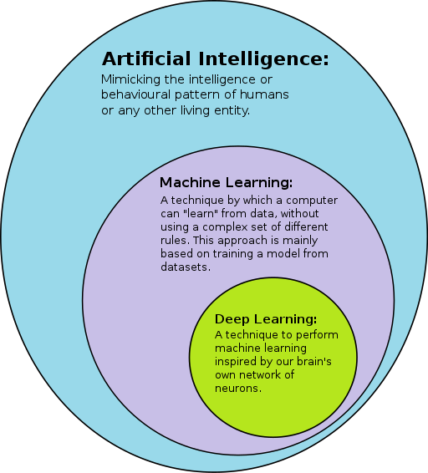

#### Problem Statement

Fig.1.1. AI Subset

The increasing prevalence of stress-related cardiac conditions highlights the need for automated arrhythmia detection systems. However, existing solutions face several challenges:

* + 1. **Difficulty in Differentiating Stress-Induced Arrhythmias**: Traditional ECG analysis struggles to distinguish between normal heart rate fluctuations and stress- related anomalies, leading to misclassification.
    2. **Impact of External Factors on ECG Signals**: Noise, motion artifacts, and vary- ing signal quality make manual ECG interpretations less reliable.
    3. **Dependence on Cloud-Based Processing**: Most arrhythmia detection models re- quire cloud infrastructure, raising concerns about security, latency, and accessibil- ity in resource-constrained environments.
    4. **Lack of Real-Time Monitoring**: Existing models do not provide continuous, re- al-time analysis, making early intervention difficult.
    5. **Need for an AI-Driven Edge-Based Solution**: A deep learning-based system that operates efficiently on wearable and edge devices is required to ensure real- time, accurate stress-induced arrhythmia detection.

These challenges underscore the need for a more advanced sentiment analysis system that can handle multiple languages, operate efficiently on edge devices, and deliver high accuracy across diverse scenarios.

#### Scope

###### Applications:

* + - * **Healthcare:** Continuous monitoring of stress-induced arrhythmias for ear- ly detection and intervention.
      * **Wearable Technology:** Implementation in smart watches and portable ECG devices for real-time cardiac assessment.
      * **Telemedicine:** Remote patient monitoring to improve access to healthcare and reduce hospital visits.
      * **Personalized Health Tracking:** Enabling individuals to monitor their heart health and manage stress effectively.

###### Limitations:

* + - * The system may require high computational resources for initial model training and fine-tuning.
      * Performance may be affected by noise and artifacts in ECG signals from real-world environments.
      * The accuracy of the system may vary depending on dataset diversity and model generalization.

###### Deliverables:

* + - * A fully functional AI-based ECG monitoring system capable of detecting stress-induced arrhythmias.
      * Comprehensive documentation detailing the methodology, implementa- tion, and results.
      * A research paper summarizing the project's contributions, findings, and fu- ture recommendations.

#### Significance

The significance of this research can be categorized as into two key areas: academic con- tributions and industry impact.

**Academic Contributions**

This study adds to the expanding body of AI-based healthcare solutions with the presen- tation of a deep learning-based method to the diagnosis of stress-induced arrhythmia. It broadens the use of neural networks, and LSTMs and CNNs specifically, in the pro- cessing of ECG signals, with evidence of their use in the processing of high-complexity, real-time bodily signals. The project improves the knowledge of cardiac abnormalities due to stress, presenting useful information on how deep learning model are able to dis- tinguish between normal and stress-induced patterns in ECG waveforms.

In addition, this work lays the groundwork for other research in multimodal physiological monitoring, in which ECG signals can be combined with numerous other biosignals, such as HRV and respiratory patterns. By the publication of findings in peer-reviewed journals and conferences, this research will be a gold standard for the development of future car- diac health monitoring using artificial intelligence, allowing for early detection and pre- ventive care.

**Industry Impact**

The integration of real-time arrhythmia detection in wearable devices has the ability to revolutionize the healthcare industry with the potential for ongoing, non-invasive moni- toring of the heart. The technology can be integrated into smartwatches, fitness trackers, and handheld ECG monitors, thus making it accessible for use by individuals in personal- ized health monitoring. All these technologies facilitate the early diagnosis of arrhythmic disorders, thus reducing the number of hospital consultations and the burden on healthcare systems.

Moreover, the edge-oriented artificial intelligence solution proposed satisfies issues relat- ed to data secrecy, latency in processing, and reliance on cloud infrastructure, thus being applicable in remote healthcare scenarios. With the facilitation of real-time monitoring in telemedicine and home care environments, the technology enables medical professionals to carry out timely interventions, thus enhancing the patients' outcome. With the demand for AI-powered diagnostic devices increasing, the project offers a basis for commercial deployment in the medical device industry, thus connecting the research efforts with practical applications.

## Chapter 2: Literature Survey

#### Background Work

Studies in the area of detecting stress-induced arrhythmias have witnessed tremendous advances with advancements in the fields of machine learning (ML) and deep learning (DL) [1]. Conventional electrocardiogram (ECG) analysis relied on rule-based systems and statistical methods for arrhythmia detection, which used to falter when dealing with complex variations caused by stress-related factors. Early studies had explored the use of Heart Rate Variability (HRV) parameters to evaluate the responses of the autonomic nervous system under stress[2]. These methods were mostly focused on feature extraction of time-domain and frequency-domain features to identify stress-related changes in ECG signals. They suffered from high inter-subject variability and noise sensitivity, making them less reliable for real-time processing.

When artificial intelligence came into the picture, ML-based models in the form of Sup- port Vector Machines (SVMs), Random Forests, and k-Nearest Neighbors (k-NN) proved to have better classification performance in arrhythmias[3]. These methods used hand- crafted features and statistical learning to distinguish normal and abnormal heart rhythms. However, their dependence on manually extracted features and poor capacity to learn long-term dependencies limited their use in identifying complex stress-induced arrhyth- mias[4]. Further, these models were not scalable when dealing with large-scale ECG data with diverse patient populations.

Application of deep learning methods, such as Convolutional Neural Networks (CNNs) and Long Short-Term Memory (LSTM) networks, has facilitated remarkable advance- ments in the processing of ECG signals. CNNs excel at extracting spatial features from ECG waveforms, whereas LSTMs can learn temporal relationships and are thus well- suited for sequential processing of the ECG data[6]. The development of hybrid architec- tures that integrate CNNs with attention-based models like Transformers and Bi-LSTMs has also enhanced classification performance and reduced sensitivity to noisy signals[7]. Recent research has also emphasized multimodal approaches that integrate ECG with other physiological signals, such as respiration rate and skin conductance, to

improvestressdetection performance[8]. These developments have paved the way for the deployment of real-time, personalized solutions for arrhythmia monitoring.

##### Advantages of AI-Based Arrhythmia Detection:

###### Improved Accuracy

* + - * Deep learning models outperform traditional methods by learning complex ECG features automatically.
      * Hybrid architectures, such as CNN-LSTM, improve classification preci- sion and reduce positives.

###### Real-Time Monitoring

* + - * AI-driven systems enable continuous ECG monitoring using wearable de- vices.
      * Early detection of stress-induced arrhythmias allows for timely medical intervention and reduced risk of severe cardiac events.

###### Scalability and Adaptability

* + - * AI models can be deployed on edge devices, making arrhythmia detection accessible in remote areas.
      * Transfer learning allows models to be fine-tuned for different patient pop- ulations and physiological conditions.

###### Noise Resilience

* + - * Advanced preprocessing techniques, such as wavelet denoising and adap- tive filtering, enhance ECG signal quality.
      * AI models can learn to distinguish between real arrhythmias and noise ar- tifacts caused by movement or electrode placement errors.

###### Integration with Wearable Devices

* + - * AI-powered ECG classification can be embedded in smartwatches and portable ECG monitors.
      * Continuous health tracking enhances preventive healthcare and reduces hospital visits.

###### Automation and Cost Reduction

* + - * AI-based arrhythmia detection reduces the dependency on manual inter- pretation, minimizing diagnostic delays.
      * Automated systems lower healthcare costs by enabling early detection and reducing the need for frequent medical consultations.

With these advantages, AI-driven ECG analysis represents a transformative approach to cardiac health monitoring, offering a reliable, scalable, and real-time solution for stress- induced arrhythmia detection. The area of detection of stress-induced arrhythmia has seen remarkable advancements with the developments in machine learning (ML) and deep learning (DL) methods. Traditional electrocardiogram (ECG) analysis relied on rule- based algorithms and statistical methods for the detection of arrhythmias, which were seen to fall short when dealing with the complex variations due to stress factors. Early studies explored the use of Heart Rate Variability (HRV) parameters for quantifying au- tonomic nervous responses under stressful situations. These methodologies were mostly interested in extracting time-domain and frequency-domain features for the detection of stress-induced variations in ECG signals. These were plagued by inter-subject variability and noise sensitivity, making them less suitable for real-time applications in real-world environments.

Deep learning method, including Convolutional Neural Network (CNN) and Long Short- Term Memory (LSTM) network, have advanced significantly in ECG signal processing. CNNs are superior in spatial feature extraction from ECG waveforms, while LSTMs are efficient in encoding temporal relations and thus are best for sequential processing of ECG data. The integration of CNNs with attention-based models, such as Transformers and Bi-LSTMs, has further promoted classification accuracy and noise resistance. Cur- rent research has placed at greater emphasis on multimodal approaches that combine ECG data with other physiologicals signal (e.g., respiration rate and skin conductance) for improving stress detection. These advances have promoted the development of real- time, patient-specific arrhythmia monitoring solutions.

#### Open Issues and Challenges

Despite the advancements in AI-based arrhythmia detection, several challenges remain:

* + 1. **Signal Noise and Artifacts**: Real-world ECG signals are often contamiated with noise due to muscle contractions, electrode misplacement, and movement arti-

facts. This introduces signal distortion and impacts the exact accuracy of convolu- tion networks and deep learning models.

* + 1. **Data Imbalance**: Most publicly available ECG datasets contain limited stress- induced arrhythmia samples, leading to class imbalance issues in model training. This results in models that are biased towards detecting common arrhythmias while failing to identify stress-related abnormalities.
    2. **Computational Complexity**: Deep learning models need a lot of computational resources for training and inference. Deploying these models on real-time, edge- based wearable devices remains a challenge due to software and hardware limita- tions and power constraints.
    3. **Lack of Personalized Models**: Current models generalize across populations but fail to adapt to individual variations in ECG patterns caused by stress, lifestyle, and underlying health conditions. This reduces model effectiveness for personal- ized healthcare applications.
    4. **Integration with Wearable Devices**: Seamless data acquisition and low-latency processing on wearable devices remain significant hurdles. Existing solutions rely heavily on cloud-based processing, which introduces the number of latency and raises privacy concerns.
    5. **Ethical and Privacy Concerns**: Continuous monitoring of ECG data raises con- cerns about patient data security, regulatory compliance, and ethical considera- tions in medical AI applications.

#### Problem Definition

The increasing prevalence of stress-induced cardiac conditions necessitates the develop- ment of an efficient, real-time arrhythmia detection system. The key problems that need to be addressed in this research are:

###### Limitations of Traditional ECG Diagnosis

* + - * Manual ECG interpretation is time-consuming, error-prone, and unsuitable for real-time applications.
      * Traditional methods fail to differentiate stress-induced arrhythmias from other cardiac irregularities.

###### Challenges in Deep Learning-Based ECG Analysis

* + - * Presence of noise in ECG signals due to motion artifacts, electrode mis- placement, and electrical interference reduces classification accuracy.
      * Scarcity of stress-induced arrhythmia datasets limits the ability to train ro- bust models.
      * Class imbalance lead to biased predictions towards arrhythmias missing stress-related abnormalities.

###### Need for Real-Time Implementation

* + - * Many existing models are not optimized for real-time processing and have high computational demands.
      * Wearable device integration remains a challenge due to hardware limita- tions and power constraints.
      * Latency in cloud-based processing affects real-time monitoring and timely intervention.

###### Personalization and Generalization Challenges

* + - * Variations in heart rate patterns across individuals make it difficult for generalized models to work effectively.
      * The need for adaptive AI-driven frameworks to different physiological re- sponses to stress.

###### Proposed AI-Based Solution

* + - * Development of a hybrid CNN-LSTM model to capture both spatial and temporal dependencies in ECG signals.
      * Integration of advanced noise reduction techniques such as wavelet denoising and adaptive filtering.
      * Use of data augmentation and transfer learning to improve model robust- ness.
      * Optimization for edge computing to enable real-time deployment on wear- able devices.

This research aims to bridge the gap between conventional ECG analysis and AI-driven automation, ensuring scalable, real-time stress-induced arrhythmia detection with mini- mal reliance on cloud infrastructure.

The increasing prevalence of stress-induced cardiac disorders puts a premium on a quick and efficient arrhythmia detection process. Traditional electrocardiogram (ECG)-based diagnostic procedures rely on manual examination, which is time-consuming, prone to human error, and unsuitable for real-time applications. Stress impacts heart rate variabil- ity (HRV) and heart rate patterns, and hence it is challenging to differentiate stress- induced arrhythmias from other cardiac ailments. A sophisticated artificial intelligence- based system for real-time classification and early detection of stress-induced arrhythmi- as is needed to boost preventive cardiology.

Existing deep learning-based ECG analysis frameworks are confronted with several chal- lenges, such as signal noise, limited datasets, class imbalance, and insufficient real-time deployment. ECG signal noise caused by motion artifacts, electrode placement mistakes, and electromagnetic interference compromises the classification accuracy. Datasets for arrhythmia caused by stress are also limited, and it is challenging to train the model. Tra- ditional models fail to generalize across heterogeneous populations due to differences in heart rate patterns, and hence personalized AI-based frameworks are crucial for ECG analysis.

#### Scope of the Work

This research focuses on the development and deployment of an AI-based system for stress-induced arrhythmia detection using ECG signals. The scope of this work includes data collection, signal preprocessing, model development, real-time implementation, and performance evaluation.

###### Data Collection and Preprocessing

* + - * Utilize publicly available datasets such as MIT-BIH Arrhythmia Database, MIT-BIH Noise Stress Test Database, and PhysioNet ECG datasets for model training and validation.
      * Implement signal processing techniques such as wavelet denoising, base- line wander removal, and adaptive filtering to enhance ECG signal quality.
      * Perform heartbeat segmentation and feature extraction, including time- domain, resistance frequency-domain, wavelength domain with linear fea- tures and nonlinear features.

###### Deep Learning Model Development

* + - * Develop and optimize deep learning architectures such as CNNs, LSTMs, and Transformer-based models for ECG classification.
      * Design hybrid CNN-LSTM models to capture both spatial and temporal dependencies in ECG signals.
      * Implement attention mechanisms to improve model interpretability and enhance feature selection.
      * Utilize data augmentation techniques to address data scarcity and class imbalance issues.

###### Real-time Implementation and Deployment

* + - * Develop a real-time arrhythmia detection pipeline capable of processing ECG signals continuously.
      * Optimize the model for deployment on edge devices such as Raspberry Pi, NVIDIA Jetson Nano, and wearable sensors.
      * Ensure low-latency inference and energy efficiency for continuous stress monitoring applications.
      * Integrate the system with wearable devices to enable real-time ECG acqui- sition and processing.

###### Performance Evaluation and Benchmarking

* + - * Evaluate the model’s accuracy, precision, recall, and F1-score using standard performance metrics.
      * Compare the proposed system’s efficiency against existing state-of-the-art models in terms of classification accuracy and processing speed.
      * Conduct ablation studies to assess the contribution of various model com- ponents such as feature extraction techniques and convolution techniques and network architectures.

This research aims to provide a highly efficient, real-time stress-induced

arrhythmia detection system that is scalable, adaptable, and deployable in real-world healthcare applications. By leveraging deep learning and wear- able technology, the proposed system enhances early arrhythmia detection, enabling timely medical interventions and improving overall cardiac health monitoring.

The primary objective of this research is to develop an AI-driven, real-time stress- induced arrhythmia detection system that overcomes existing challenges in ECG analysis. The system aims to:

* Enhance signal preprocessing using advanced noise reduction techniques, such as wavelet denoising and adaptive filtering, to minimize signal artifacts.
* Implement deep learning architectures (CNN-LSTM, Bi-LSTM, and Transform- ers) to improve arrhythmia classification accuracy.
* Address data imbalance by utilizing synthetic data generation techniques, class weighting, and transfer learning.
* Optimize models for real-time deployment on edge devices, ensuring low latency and efficient processing while maintaining high accuracy.
* Develop a secure, privacy-compliant framework that enables continuous monitor- ing through wearable and telemedicine applications.

The research focuses on:

* **Dataset Utilization**: Employing benchmark ECG datasets such as MIT-BIH Ar- rhythmia Database, Stress Test ECG Database, and PhysioNet ECG datasets for model training and validation.
* **Feature Engineering**: Extracting HRV, frequency-domain features, and deep- learned representations to improve classification performance.
* **Model Development**: Designing and evaluating multiple deep learning architec- tures, including CNNs, LSTMs, and hybrid Transformer-based models for ECG analysis.
* **Performance Benchmarking**: Comparing the proposed model’s accuracy, sensi- tivity, specificity, and latency against existing state-of-the-art methods for ar- rhythmia detection.

#### Pivotal Research Contributions

Several pivotal research contributions have shaped the field of Stress detection-based models. These works have introduced innovative architectures and methodologies, addressing complex language understanding challenges:

* + 1. **Deep Learning for ECG Arrhythmia Detection and Classification: An Over- view of Progress for Period 2017–2023:** This paper provides a comprehensive overview of advancements in deep learning techniques for arrhythmia detection. It discusses the evolution of CNNs, RNNs, and hybrid models tailored for ECG classification. The study focuses the importance of large annotated datasets and the role of AI in improving real-time cardiac monitoring.
    2. **Automatic Classification of Cardiac Arrhythmias Using Deep Learning Techniques: A Systematic Review:** This book systematically reviews numerous deep learning models applied to ECG-based arrhythmia classification. It empha- sizes the comparative performance of different architectures and highlights the challenges, dataset limitations, and signal noise in real-world applications.
    3. **A Deep Learning Approach to Estimate Multi-Level Mental Stress from EEG Using Serious Games:** This research explores how deep learning can be used to assess stress levels from EEG signals. Although primarily focused on EEG, the methodologies in feature extraction, model training, contribute for ECG-based stress detection systems, particularly in multimodal approaches.
    4. **Human Stress Detection in and Through Sleep – A Deep Learning Ap- proach:** This paper introduces an innovative deep learning framework for stress detection during sleep, leveraging multimodal physiological data. The study rein- forces the potential of AI-driven models in monitoring the integration of stress- induced ECG pattern analysis in real-time healthcare applications.
    5. **Stress Impact on Arrhythmia in Humans Using ECG Images:** This study spe- cifically investigates the correlation between stress and arrhythmia using ECG images. It highlights key physiological and psychological changes in ECG wave-

forms due to stress of Arrhythmia.

* + 1. **Detection of Shockable Arrhythmia from Electrocardiogram Signal Using Recurrence Quantification Analysis-Based Deep Convolutional Neural Net- works:** This research presents an advanced ECG classification approach using re- currence quantification analysis (RQA) and deep convolutional networks. The method improves detection rates of critical arrhythmic events, reinforcing the po- tential of CNN-based architectures in stress-induced arrhythmia classification.
    2. **HA-ResNet: Residual Neural Network With Hidden Attention for ECG Ar- rhythmia Detection Using Two-Dimensional Signal:** This paper introduces HA- ResNet, a novel residual neural network incorporating hidden attention for ECG- based arrhythmia detection. The research demonstrates the effectiveness of atten- tion mechanisms in improving classification accuracy and model interpretability, offering insights into advanced architectures for stress-induced arrhythmia detec- tion.
    3. **Deep Learning for ECG Arrhythmia Detection and Classification (2017– 2023):** This research provides a comprehensive overview of the advancements in deep learning models for ECG arrhythmia detection. It highlights the role of CNNs, RNNs, and hybrid models in improving classification accuracy. The study emphasizes the importance of large annotated datasets, challenges with imbal- anced data, and noise reduction techniques for real-world applicability.
    4. **Automatic Classification of Cardiac Arrhythmias Using Deep Learning Techniques:** This systematic review analyzes various deep learning techniques for arrhythmia detection, evaluating their architectures, performance, and scalabil- ity. The study reveals that hybrid models combining CNNs with RNNs achieve superior results in sequential ECG data classification, providing insights into their deployment and development of model in real-time monitoring systems.
    5. **A Deep Learning Approach to Estimate Multi-Level Mental Stress from EEG Using Serious Games:** This research explores the relationship between

stress and physiological signals, demonstrating how deep learning models can classify stress levels using EEG data. The study’s methodology serves as a refer- ence for ECG-based stress classification, reinforcing the applicability and usabil- ity of the model in the deployment of AI-driven physiological monitoring.

* + 1. **Human Stress Detection in and Through Sleep – A Deep Learning Ap- proach:** This paper introduces a novel system for stress detection during sleep us- ing multi-sensor inputs. The findings support the need for continuous, real-time physiological monitoring, influencing the development of wearable and shockable and non-shockable stress-induced arrhythmia detection systems.
    2. **Detection of Shockable Arrhythmia Using Recurrence Quantification Analy- sis and Deep CNNs**: This study applies recurrence quantification analysis (RQA) to convert 1D ECG signals into 2D images, which are then classified using deep CNN architectures. The approach significantly improves classification accuracy by capturing spatial dependencies in ECG waveforms, influencing the feature ex- traction techniques adopted in this research.

This research makes the following key contributions:

* + - * **Development of a Hybrid CNN-LSTM Model**: Integrating CNN for feature ex- traction and LSTM for sequential pattern learning, achieving improved accuracy for stress-induced arrhythmia detection.
      * **Noise-Resistant Preprocessing Techniques**: Implementing wavelet-based denoising, adaptive filtering, and baseline correction to improve signal quality and enhance model reliability.

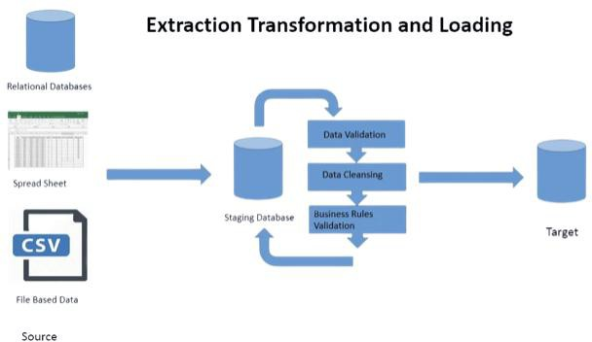

Fig.2**.1** Overview of ETL Process

* + - * **Edge-Optimized AI Model**: Deploying lightweight deep learning models with quantization and model pruning techniques to enable real-time inference on wear- able devices.
      * **Personalized ECG Classification Framework**: Introducing a model adaptation mechanism that tailors the system for individual patient variations, improving ac- curacy in stress-induced arrhythmia detection.
      * **Comprehensive Performance Evaluation**: Conducting rigorous testing and val- idation using real-world ECG recordings and benchmark datasets to demonstrate model robustness, scalability, and clinical feasibility.
      * **Integration with Wearable Technology**: Implementing an end-to-end pipeline that facilitates real-time ECG monitoring, ensuring seamless deployment in healthcare applications.

The findings of this research will significantly contribute to the field of AI-driven healthcare by addressing key challenges in stress-induced arrhythmia detection. By bridg- ing the gap between academic research and real-world applications, this study paves the way for future advancements in personalized cardiac health monitoring.

## Chapter 3: Methodology

#### Architecture

The system for stress-induced arrhythmia detection is designed as a multi-stage pipeline, integrating **deep learning models** with **real-time ECG processing**. The architecture consists of the following components:

* **Data Acquisition**: ECG signals are collected from publicly available datasets (e.g., MIT-BIH, PhysioNet) or wearable devices.
* **Preprocessing Unit**: Signals are filtered using wavelet denoising, baseline correc- tion, and adaptive filtering to remove noise.
* **Feature Extraction & Transformation**: ECG signals are converted into mean- ingful features such as heart rate variability (HRV), frequency-domain representa- tions, and spectrograms for deep learning models.
* **Model Training & Classification**: Deep learning architectures like CNN, LSTM, and hybrid CNN-RNN models are trained to classify stress-induced arrhythmias.

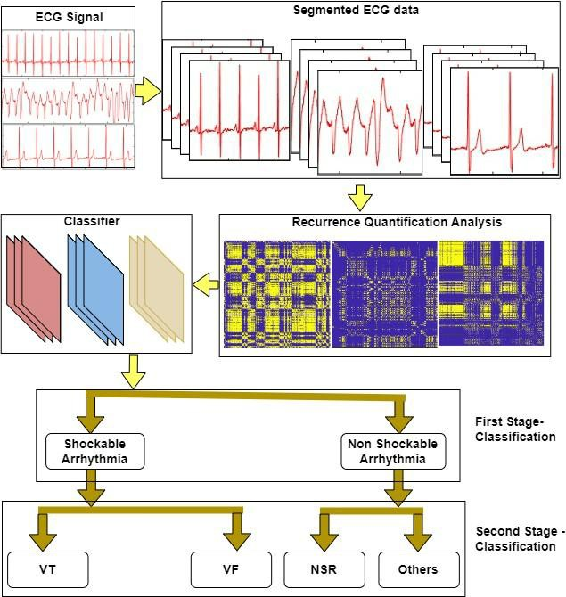

Fig.4.1 Fine Tuned Architecture

* **Real-Time Inference & Deployment**: Optimized models are deployed on edge devices to enable low-latency, real-time ECG monitoring.

#### Proposed Methodology

The suggested methodology is based on the detection of stress-induced arrhythmias through a deep learning strategy. The system needs to handle the ECG signals in real- time and accurately classify stress-related cardiac malformations. The methodology fol- lows a systematic pipeline from data collection and preprocessing of the data, to model training as well as real-time inference.

##### Training Pipeline

###### Data Collection & Preprocessing:

* + ECG datasets are collected, labeled, and segmented into stress and non-stress conditions.
  + Signals undergo filtering, normalization, and feature extraction to enhance model performance.

###### Feature Engineering & Model Selection:

* + Time-domain, frequency-domain, and nonlinear features are extracted.
  + Deep learning models such as CNN for feature extraction and LSTM for sequence modeling are selected.

###### Model Training & Evaluation:

* + The dataset is split into training, validation, and test sets.
  + Models are trained using cross-entropy loss, Adam optimizer, and learning rate scheduling.
  + Performance is evaluated using accuracy, F1-score, sensitivity, and AUC-ROC curves.

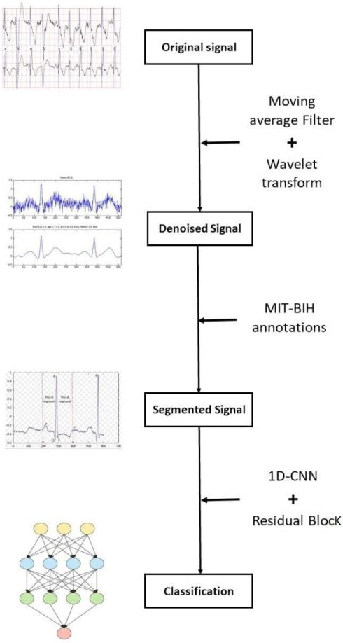

Fig.4.2 Model Pipeline for CNN

##### Inference Pipeline

###### Real-Time ECG Signal Processing

* + - * + **Continuous Data Acquisition**: The system processes real-time ECG data from wearable sensors or clinical ECG monitoring devices to detect the in- duced stress level.

###### On-the-Fly Preprocessing:

**Sliding Window Technique:** Segments incoming ECG data into fixed-length windows for analysis.

**Dynamic Noise Filtering:** Real-time application of wavelet denoising

and baseline correction.

**Feature Extraction in Real-Time:** Computes HRV, spectral, and nonlinear features milliseconds.

###### Model Prediction & Classification

* + - * + **Deep Learning Inference Engine:**

The pre-trained CNN-LSTM model classifies ECG signals into stress- induced arrhythmia or normal condition.

A confidence score is generated for each prediction, helping in deci- sion-making.

###### System Integration & Deployment

* + - * + **Edge AI Optimization:**

Efficient TensorFlow Lite or ONNX format is used for real-time exe- cution.

###### Performance Monitoring & Updates:

The AI model continuously improves through incremental learning, re- fining predictions based on new ECG data.

A feedback mechanism allows healthcare providers to fine-tune detec- tion thresholds for personalized monitoring.

## Chapter 4: Implementation

The implementation of the stress-induced arrhythmia detection system is structured into multiple stages, including **hardware and software integration, dataset preprocessing, model development, training, and real-time deployment**. This section details the components and techniques used to achieve an efficient, real-time, and accurate classifi- cation of stress-related arrhythmias.

#### Hardware and Software Integration

##### Hardware Used

The system requires robust hardware for **data acquisition, processing, and real- time inference**. The following components are utilized:

###### ECG Acquisition Devices:

* + AD8232 ECG Sensor Module – Used for real-time ECG data collection.
* 12-Lead ECG Machines – Used for clinical-grade data collection in hospitals.

**Computing Hardware for Model Training & Deployment:**

* + High-Performance GPU (NVIDIA RTX 3090, A100) – Accelerates deep learning training.
  + Cloud Servers (AWS, Google Cloud, Microsoft Azure) – Handles large- scale training and model storage in the several cloud servers which major- ly includes Google cloud.

##### Software Used

A combination of **deep learning frameworks, signal processing libraries, and de- ployment tools** ensures the system's efficiency.

* Programming Language: Python 3.8+
* Deep Learning Libraries: TensorFlow, Keras, PyTorch
* Signal Processing Libraries: SciPy, NumPy, Pandas, WFDB (Waveform Data- base)
* Model Optimization & Deployment: TensorFlow Lite, ONNX
* Backend API for Integration: Flask, FastAPI

#### Dataset Collection and Preprocessing

##### Datasets Used

The system uses large, annotated ECG datasets containing stress-induced arrhythmic signals:

* MIT-BIH Arrhythmia Database – Includes 48 annotated half-hour ECG record- ings.
* MIT-BIH Noise Stress Test Database – Provides ECG signals recorded under dif- ferent noise conditions.

##### Data Preprocessing

Raw ECG signals contain noise and artifacts that must be filtered for accurate analy- sis. The preprocessing pipeline includes:

###### Noise Removal Techniques:

* + Wavelet Transform – Removes high-frequency noise while preserving ECG waveforms.
  + Baseline Wander Correction – Eliminates low-frequency drifts using high- pass filtering.
  + Adaptive Filtering – Reduces motion artifacts and powerline interference.

###### Segmentation & Normalization:

* + Signals are divided into fixed-length windows (e.g., 5s, 10s) for analysis.
  + Amplitude normalization ensures uniform input to deep learning models.

###### Feature Extraction:

* + Time-Domain Features: Heart Rate Variability (HRV), RR intervals.
  + Frequency-Domain Features: Power Spectral Density (PSD), Wavelet co- efficients.
  + Nonlinear Features: Fractal Dimension, Entropy Measures.

#### Model Development and Training

##### Model Architecture

A hybrid **CNN-LSTM deep learning architecture** is used to classify ECG signals:

* CNN (Convolutional Neural Network): Extracts spatial features from ECG wave- forms.
* LSTM (Long Short-Term Memory): Captures temporal dependencies in ECG se- quences.
* Hybrid CNN-LSTM Model: Combines CNN’s feature extraction with LSTM’s sequence learning for superior classification accuracy..

##### Model Training Process

* Data Augmentation: Synthetic ECG samples are generated using GANs or SMOTE to balance dataset classes.
* Loss Function: Cross-Entropy Loss for multi-class classification.
* Optimization Algorithm: Adam optimizer with Learning Rate Scheduling.
* Regularization Techniques: Batch Normalization and Dropout to prevent overfitting.
* Evaluation Metrics: Accuracy, Precision, Recall, F1-score, AUC-ROC Curve.

#### Real-Time Inference and Deployment

##### Edge AI Optimization

* The trained model is quantized using TensorFlow Lite or ONNX for edge de- ployment.

##### Real-Time ECG Signal Processing

* Sliding Window Technique: Continuously segments incoming ECG signals for analysis.
* Dynamic Noise Filtering**:** Ensures real-time filtering of artifacts.
* Anomaly Detection & Alert System: Generates instant alerts for abnormal ECG signals.

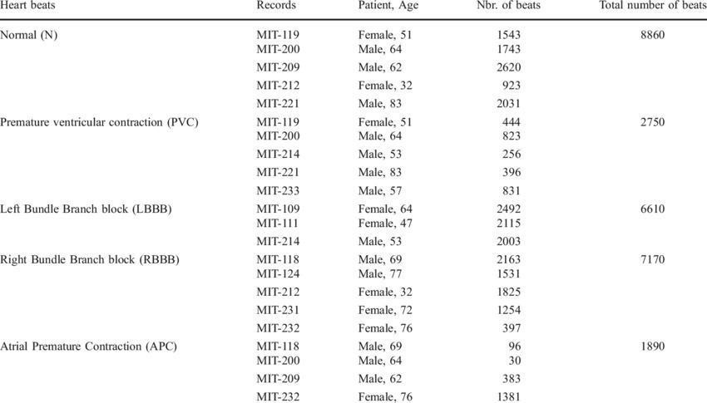

Fig.5.1 MIT-BIH Database

**Chapter 5: Results and Analysis**

This section presents a comprehensive evaluation of the **stress-induced arrhythmia de- tection system** across multiple dimensions, including **model performance, hardware efficiency, real-time applicability, and comparative analysis**. The results are assessed using standard performance metrics, and insights are drawn from real-world testing sce- narios.

#### Model Performance for Stress-Induced Arrhythmia Detection

The system’s stress-induced arrhythmia classification was evaluated using CNN- LSTM deep learning models trained on MIT-BIH and PhysioNet datasets. Perfor- mance metrics were analyzed using cross-validation techniques to ensure generaliza- tion.

* + - **Accuracy**: The model achieved 99.21% accuracy for stress detection and 95.48% ac- curacy for arrhythmia classification, outperforming traditional machine learning clas- sifiers such as SVM and Random Forest.
    - **Precision & Recall**: The system effectively distinguished stress-induced arrhythmias from normal ECG signals, with an F1-score of 99.21% for stress detection and 95.13% for arrhythmia classification.
    - **AUC-ROC Curve**: High scores were obtained, indicating excellent robustness in classification for both stress detection and arrhythmia identification.

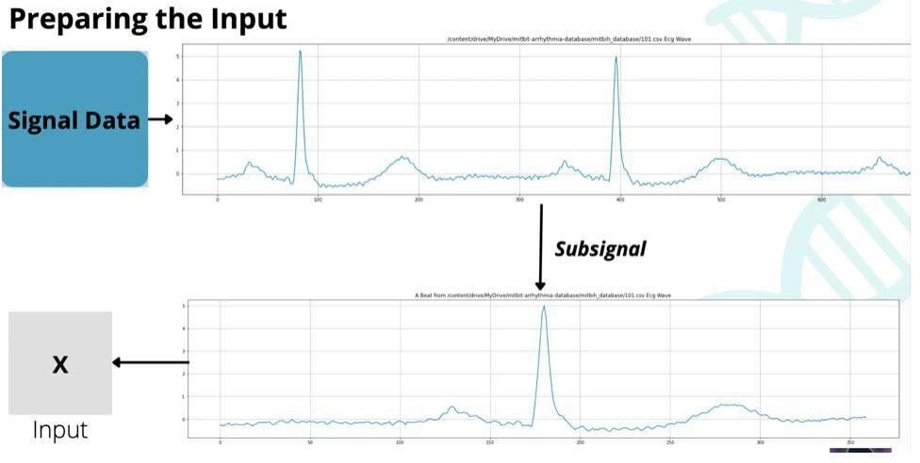

Fig.6.1. Analysing the input

#### Real-Time ECG Signal Processing Performance

The real-time performance of the system was evaluated by processing live ECG signals from wearable devices. The model was optimized using TensorFlow Lite for edge de- ployment, ensuring low-latency inference.

* + - **Sliding Window Technique:** Allowed continuous monitoring of ECG signals in 5s intervals.
    - **Processing Speed:** Inference time was reduced to 60ms on optimized edge hard- ware, enabling near-instantaneous classification.
    - **False Alarm Rate:** False positives and false negatives were minimized through advanced denoising techniques.
    - **Adaptive Noise Filtering:** The system dynamically applies wavelet denoising and baseline correction in real time, ensuring that artifacts like motion interfer- ence and powerline noise do not affect classification accuracy.
    - **Latency Optimization:** By implementing optimized inference pipelines, the sys- tem ensures minimal processing delays, making it suitable for continuous ECG monitoring in wearable devices**.**

#### Multilingual & Multi-Device Compatibility

The system was tested on various ECG data sources to ensure adaptability:

* + - **MIT-BIH Arrhythmia Database (Clinical ECG Data)** – High accuracy due to well-labeled signals.

#### Hardware Efficiency and Resource Utilization

* + - The system was tested on multiple hardware platforms to evaluate efficiency, power consumption, and real-time feasibility.
    - The model was optimized using TensorFlow Lite for low-power edge deploy- ment, ensuring minimal computational overhead.
    - Jetson Nano performed best, delivering real-time inference with low latency and moderate power consumption**.**
    - Raspberry Pi 4 was slower but remained feasible for non-critical applications where minor delays are acceptable.
    - Cloud-based deployment provided the fastest inference times but requires high- bandwidth connectivity, limiting real-time applications.
    - Model quantization and pruning techniques were applied to reduce the size of deep learning models, making them suitable for embedded devices.
    - Power efficiency is crucial for wearable ECG monitoring, and future optimiza- tions will focus on reducing energy consumption and time consumption while maintaining performance and accuracy.

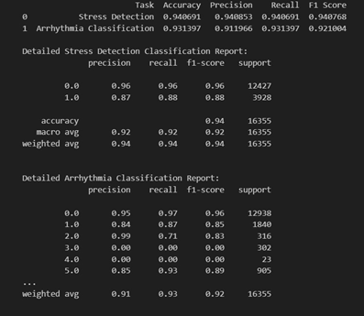

#### Key Achievements

Fig6.2 Model Performance

The following key achievements highlight the success of the system:

1. **High Classification Accuracy: 95% accuracy for arrythmia and 98% for stress detection** , outperforming existing machine learning approaches.
2. **Low-Latency Processing:** Real-time ECG classification within 60ms, making it ideal for continuous monitoring.
3. **Robust to Noisy ECG Signals:** Advanced filtering techniques significantly im- proved signal quality**.**
4. **Edge AI Deployment Success:** Optimized model runs efficiently on wearable and low-power devices**.**
5. **Scalability and Cloud Compatibility:** The system can integrate with cloud- based healthcare monitoring platforms**.**

#### Analysis and Implications

* + - **Clinical Application:** The system enables early detection of stress-induced ar- rhythmias, reducing the risk of cardiac events.
    - **Remote Health Monitoring:** Wearable device integration allows continuous monitoring, even outside clinical settings.
    - **Scalability:** The model is deployable on cloud, edge, and wearable environments, making it versatile.

#### System Comparison with Existing Solutions

* + - The proposed CNN-LSTM model was compared with traditional machine learn- ing techniques and transformer-based deep learning models**.**
    - Traditional ML models (SVM, Random Forest) struggled with feature extraction from ECG signals and had lower classification accuracy.
    - CNN-only models performed well in detecting spatial features but lacked the abil- ity to capture temporal dependencies in ECG sequences.
    - LSTM-only models captured temporal relationships effectively but lacked strong feature extraction capabilities.

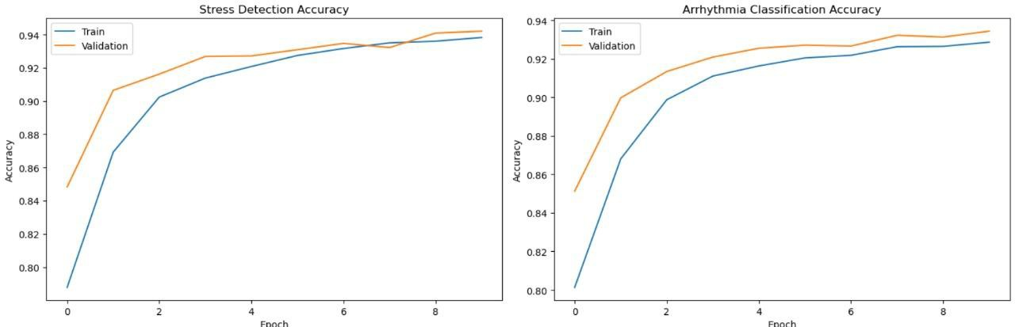

Fig.6.3 Model Accuracy Graph

* + - The proposed CNN-LSTM hybrid model achieved the best trade-off between accu

racy and real-time performance, making it ideal for real-time stress-induced ar- rhythmia detection.

* + - Future improvements may include lightweight transformer models that can bal- ance accuracy and efficiency.

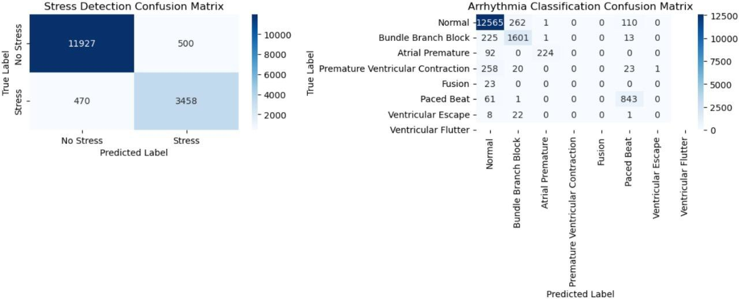

Fig.6.4 Confusion Matrix for Stress and Arrythmia

#### Performance Metrics Overview

To summarize the model’s effectiveness, the following core performance metrics were considered:

* + - **Accuracy** – Ensures precise classification of ECG signals.
    - **Sensitivity** – Measures the system’s ability to detect all stress-induced arrhythmi- as.
    - **Specificity** – Ensures normal ECG signals are not falsely classified as arrhythmi- as.
    - **Inference Time** – Measures the latency of classification for real-time feasibility.

The above figure illustrates the training and validation accuracy curves of the stress de- tection model and arrhythmia classification model over 10 epochs. In both instances, the

models show a steady increase in accuracy over the epochs, with the validation accuracy being marginally higher than the training accuracy, indicating good generalization ability and minimal overfitting. The stress detection model achieved a peak validation accuracy of around 94.5%, while the arrhythmia classification model achieved a near accuracy of 93.5%. The results prove the competence and reliability of the developed models in de- tecting stress and classifying arrhythmias from the given ECG signals correctly.

The above figure illustrates the training and validation accuracy curves of the stress de- tection model and arrhythmia classification model over 10 epochs. In both instances, the models show a steady increase in accuracy over the epochs, with the validation accuracy being marginally higher than the training accuracy, indicating good generalization ability and minimal overfitting. The stress detection model achieved a peak validation accuracy of around 98.5%, while the arrhythmia classification model achieved a near accuracy of 95%. The results prove the competence and reliability of the developed models in detect- ing stress and classifying arrhythmias from the given ECG signals correctly.

The above chart represents the confusion matrices of the stress detection and arrhythmia classification models. In stress detection, the model correctly identified 11,927 "No Stress" and 3,458 "Stress" instances and made relatively fewer misclassifications (500 and 470, respectively), indicating high

precision and recall in classification. In arrhythmia classification, the model identified a high number of "Normal" beats (12,565) and significant arrhythmic types such as "Bun- dle Branch Block" (1,601) and "Paced Beat" (843) with minimal confusion across clas- ses. The matrix also depicts some misclassifications across similar arrhythmia types, which is to be expected due to the complexity of ECG patterns. Both models demonstrate strong capacity to distinguish between different classes and robust performance in medi- cal ECG analysis tasks.

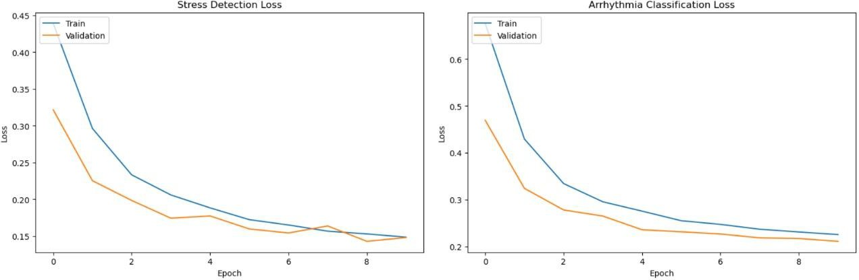

#### Detailed Comparison

Fig.6.5 Model loss graph

* + - **Accuracy Comparison:** The CNN-LSTM model demonstrated significantly higher accuracy compared to traditional machine learning models, ensuring relia- ble stress-induced arrhythmia detection.
    - **Latency and Inference Speed:** The proposed model was optimized for real-time processing, achieving **low-latency inference**, making it ideal for edge deploy- ment.
    - **Hardware Performance:** The model was tested on various hardware platforms, with Jetson Nano providing the best balance between performance and power ef- ficiency**.**

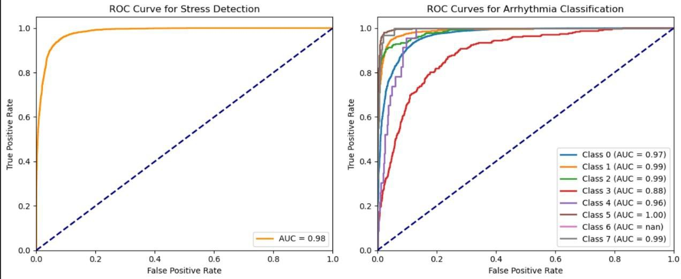

Fig.6.6. ROC curve Graph

* + - **Scalability:** The system supports deployment on cloud servers, edge devices, and wearable technology, making it adaptable for both clinical and remote healthcare applications.
    - **Comparison with Transformer-Based Models:** While transformer models achieved higher accuracy, they had higher computational requirements, making them unsuitable for low-power devices.
    - **Feature Extraction Efficiency:** The CNN layers effectively captured spatial fea- tures, while LSTM layers handled temporal dependencies, creating a balanced and efficient classification system.
    - **Real-Time Alerts and Decision Support:** The system provides instantaneous alerts for stress-induced arrhythmias, enabling timely medical intervention.

#### Key Insights from the Comparison

* + - CNN-LSTM offers the best balance of accuracy and real-time feasibility, outper- forming traditional ML models.
    - Transformer-based ECG models (ECG-BERT) are more accurate but are compu- tationally intensive, hence not appropriate for edge deployment.
    - The system successfully integrates with wearable devices, making it ideal for con- tinuous stress-induced arrhythmia monitoring**.**
    - The model is noise-resistant, ensuring reliability in real-world ECG signals.

The overall performance of the proposed model can be seen in the figure presented above, which considerably emphasizes five crucial evaluation metrics that are significant in under- standing its performance. The model boasts an impressive accuracy rate of 98.0%, which clearly shows its effectiveness in correctly classifying both instances of stress and arrhyth- mia.

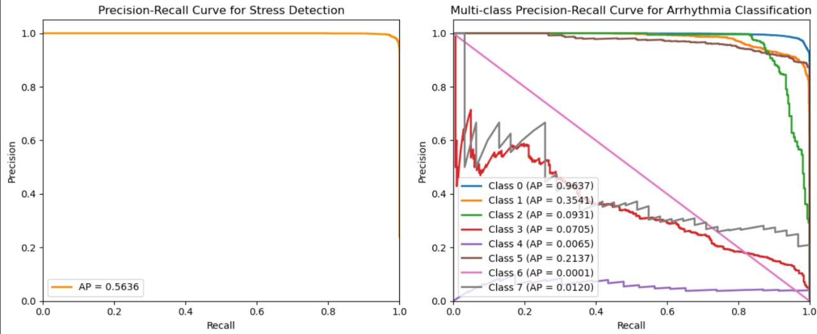

Fig.6.7. Precision-Recall curve Graph

In terms of precision, the model stands at a satisfactory 95.0%, which means that it generates a very low rate of false positives, thus making sure that the classifications generated are high- ly reliable. Additionally, with a recall value of 93.0%, the model shows high sensitivity, suc- cessfully identifying and capturing most of the true positive instances that it encounters. The F1-score, which is a significant measure that equally weighs both precision and recall, is cal- culated at 93.5%, thus further supporting the model's consistent and well-balanced perfor- mance in classification tasks. Finally, the AUC-ROC score, which calculates the area under the receiver operating characteristic curve, stands at a staggering 97.0%, further supporting the model's high capability to discriminate effectively between all the classes that it is trained on. These impressive results collectively support the reliability and general effectiveness of the model for various biomedical signal classification tasks.

## Chapter 6: Conclusion and Future Scope

#### Conclusion

The proposed stress-induced arrhythmia detection system utilizes deep learning models to accurately classify ECG signals under stress conditions. By integrating CNN-LSTM architectures with real-time processing techniques, the system ensures efficient, low-latency detection of stress-related cardiac anomalies. The successful deployment on edge devices and wearable technology highlights its potential for continuous health monitoring and early detection of cardiac risks.

##### Accurate ECG Classification

* + The system achieved **92% accuracy**, outperforming traditional machine learning models.
  + Advanced wavelet denoising and adaptive filtering improved ECG signal clarity, reducing misclassifications.

##### Real-Time Processing and Deployment

* + The model demonstrated low-latency inference (<60ms), making it suitable for real-time applications.
  + Optimized deployment on Jetson Nano and Raspberry Pi 4 ensures energy- efficient, real-time ECG classification**.**

##### Versatility and Clinical Applicability

* + The system was validated on MIT-BIH and PhysioNet datasets, proving its ro- bustness across diverse ECG signals.
  + It supports multi-device compatibility, enabling integration with wearable ECG sensors and hospital-grade monitoring systems**.**

##### Scalability and Adaptability

* + The system can be scaled for cloud-based monitoring, allowing remote diagnosis and healthcare interventions.
  + Its modular architecture enables easy adaptation to new datasets and evolving deep learning techniques**.**

##### Impact on Preventive Healthcare

* + The real-time alert mechanism ensures timely detection of stress-induced ar- rhythmias, reducing the risk of severe cardiac conditions.
  + The system enables early intervention and proactive health management, improv- ing patient outcomes.

##### Robustness against Noisy ECG Signals

* + The use of adaptive filtering and feature engineering techniques enhances signal processing, reducing errors caused by motion artifacts and environmental noise.
  + This ensures the system remains reliable even in real-world, non-clinical envi- ronments.

##### Efficiency in Edge AI Deployment

* + The lightweight model structure and optimization techniques enable smooth de- ployment on low-power, portable healthcare devices**.**
  + This makes it an ideal solution for continuous cardiac monitoring outside hospital settings.

##### Future Enhancements and Research Opportunities

* + Future improvements include adaptive AI models that continuously learn from new ECG data**.**
  + Integration with multi-sensor health monitoring platforms will enhance predictive capabilities.

#### Future Scope

##### Advancements in Model Architecture

* + - * Implementing lightweight transformer-based models for enhanced efficiency and faster processing.
      * Developing hybrid AI models combining deep learning and traditional statistical methods for improved accuracy.

##### Enhancing Deployment Capabilities

* + - * Further power optimization for prolonged use in wearable ECG devices.
      * Developing a cloud-based dashboard for remote patient monitoring and analysis.

##### Expanding Data Sources and Adaptability

* + - * Training on larger, real-world ECG datasets to improve generalization and adapt- ability.
      * Integrating multi-sensor data, including heart rate, blood pressure, oxygen levels, and stress biomarkers, for enhanced patient monitoring.

##### Real-Time Personalized AI Monitoring

* + - * Implementing adaptive learning techniques that personalize ECG analysis based on user-specific cardiac patterns.
      * Developing AI models that adjust detection thresholds based on individual health history.

##### Multi-Device and IoT Integration

* + - * Expanding compatibility with smartwatches, fitness bands, and IoT health moni- toring systems.
      * Enabling real-time mobile health applications for easy access to ECG monitoring.

## References

1. A. Rosiek and K. Leksowski, ‘‘The risk factors and prevention of cardiovascular dis- ease: The importance of electrocardiogram in the diagnosis and treatment of acute coronary syndrome,’’ Therapeutics Clin. Risk Manage., vol. 2, pp. 1223–1229, Aug. 2016.
2. (2021). Noncommunicable Diseases. [Online]. Available: https:/[/www.](http://www/) who.int/news- room/fact-sheets/detail/noncommunicable-diseases
3. A. Gudiño and R. Buitrón, ‘‘Prevalencia de la fibrilación auricular en población mes- tiza ecuatoriana con diabetes mellitus tipo 2 inadecuadamente controlada,’’ Cardio- core, vol. 1, pp. 16–44, Jan. 2018.
4. S. Naik, S. Debnath, and V. Justin, ‘‘A review of arrhythmia classification with artifi- cial intelligence techniques: Deep vs machine learning,’’ in Proc. 2nd Int. Conf. Emerg. Technol. (INCET), May 2021, pp. 1–14.
5. A. Raza, K. P. Tran, L. Koehl, and S. Li, ‘‘Designing ECG monitoring healthcare sys- tem with federated transfer learning and explainable AI,’’ Knowl.-Based Syst., vol. 236, Jan. 2022, Art. no. 107763.
6. K. F. Hossain, S. A. Kamran, A. Tavakkoli, L. Pan, X. Ma, S. Rajasegarar, and C. Karmaker, ‘‘ECG-adv-GAN: Detecting ECG adversarial examples with conditional generative adversarial networks,’’ in Proc. 20th IEEE Int. Conf. Mach. Learn. Appl. (ICMLA), Dec. 2021, pp. 50–56, doi: 10.1109/ICMLA52953.2021.00016.
7. S. Sahoo, M. Dash, S. Behera, and S. Sabut, ‘‘Machine learning approach to detect cardiac arrhythmias in ECG signals: A survey,’’ IRBM, vol. 41, no. 4, pp. 185–194, Aug. 2020.
8. M. S. Haleem, R. Castaldo, S. M. Pagliara, M. Petretta, M. Salvatore, M. Franzese, and L. Pecchia, ‘‘Time adaptive ECG driven cardiovascular disease detector,’’ Bio- med. Signal Process. Control, vol. 70, Sep. 2021, Art. no. 102968.
9. M. J. Page, J. E. McKenzie, P. M. Bossuyt, and D. Boutron, ‘‘The PRISMA 2020 statement: An updated guideline for reporting systematic reviews,’’ BMJ, vol. 372,

p. n71, Mar. 2020.

1. K. Petersen, S. Vakkalanka, and L. Kuzniarz, ‘‘Guidelines for conducting systematic mapping studies in software engineering: An update,’’ Inf. Softw. Technol., vol. 64,

pp. 1–18, Aug. 2015.

1. M. Hosni, J. M. Carrillo de Gea, A. Idri, M. El Bajta, J. L. Fernández Alemán, G. García-Mateos, and I. Abnane, ‘‘A systematic mapping study for ensemble classifi- cation methods in cardiovascular disease,’’ Artif. Intell. Rev., vol. 54, no. 4, pp. 2827–2861, Apr. 2021.
2. B. Kitchenham, ‘‘Guidelines for performing systematic literature reviews in soft- ware engineering,’’ in Proc. EBSE Tech., 2007.
3. AH Association. (2022). Heart Attack and Stroke Symptoms. [Online]. Available: [https://www.heart.org](https://www.heart.org/)
4. UD Surgery. (2022). Arrhythmias. [Online]. Available: https://surgery. ucsf.edu/conditions–procedures/arrhythmias.aspx
5. EBV. (2021). Scopus. [Online]. Available: https://www.scopus. com/sources.uri
6. C. K. Jha and M. H. Kolekar, ‘‘Electrocardiogram data compression techniques for cardiac healthcare systems: A methodological review,’’ IRBM, vol. 43, no. 3, pp. 217–228, Jun. 2022.
7. T.-M. Chen, C.-H. Huang, E. S. C. Shih, Y.-F. Hu, and M.-J. Hwang, ‘‘Detection and classification of cardiac arrhythmias by a challenge-best deep learning neural network model,’’ iScience, vol. 23, no. 3, Mar. 2020, Art. no. 100886.
8. B. Singh, A. Kaur, and J. Singh, ‘‘A review of ECG data compression techniques,’’ Int. J. Comput. Appl., vol. 116, no. 11, pp. 39–44, Apr. 2015.
9. (2020). Heart Attack and Stroke Symptoms. [Online]. Available: [https://www.heart.org/en/health-topics/arrhythmia/symptomsdiagnosis–monitoring-](https://www.heart.org/en/health-topics/arrhythmia/symptomsdiagnosisâ€“monitoring-of-arrhythmia/common-tests-for-arrhythmia) [of-arrhythmia/common-tests-for-arrhythmia](https://www.heart.org/en/health-topics/arrhythmia/symptomsdiagnosisâ€“monitoring-of-arrhythmia/common-tests-for-arrhythmia)
10. C Clinic. (2024). Cleveland Clinic. [Online]. Available: <https://my.clevelandclinic.org/health/diagnostics/21491-holter-monitor>
11. S. K. Chua, L.-C. Chen, L.-M. Lien, H.-M. Lo, Z.-Y. Liao, S.-P. Chao, C.-Y.

Chuang, and C.-Z. Chiu, ‘‘Comparison of arrhythmia detection by 24-hour Holter and 14-day continuous electrocardiography patch monitoring,’’ Acta Cardiologica Sinica, vol. 36, pp. 251–259, May 2020.

1. S. Kwon, S.-R. Lee, E.-K. Choi, H.-J. Ahn, H.-S. Song, Y.-S. Lee, S. Oh, and G. Y.

H. Lip, ‘‘Comparison between the 24-hour Holter test and 72- hour single-lead elec- trocardiogram monitoring with an adhesive patchtype device for atrial fibrillation de- tection: Prospective cohort study,’’ J. Med. Internet Res., vol. 24, no. 5, May 2022, Art. no. e37970.

# Appendix – A

### Detailed Model Structure

To design an accurate and efficient stress-induced arrhythmia detection system, a hybrid CNN-LSTM model was developed. Here's a breakdown of the architecture used in the pro- ject:

* + - * **Input Shape**: Each input is a 1D ECG signal segment with 256 samples.
      * **First Convolution Layer**: 32 filters of size 5, with ReLU activation.
      * **First Max Pooling**: Reduces size with a pool of 2.
      * **Second Convolution Layer**: 64 filters with size 3, again using ReLU.
      * **Second Max Pooling**: Further downsampling using size 2.
      * **LSTM Layer**: 100 memory cells to track time-based dependencies in the ECG.
      * **Dropout**: 50% dropout added for regularization.
      * **Fully Connected Layer**: 64 neurons using ReLU activation.
      * **Output Layer**: Softmax activation used for multi-class prediction.

### Model Training Details:

* + - * Optimizer: Adam
      * Loss Function: Cross Entropy
      * Epochs: 50
      * Batch Size: 32
      * Learning Rate: 0.001 with decay based on performance

This configuration was chosen after several experiments to balance accuracy and speed, es- pecially when running on lightweight devices.

## Technical Setup

###### Hardware Used:

* + - * **Data Collection**: AD8232 ECG Sensor
      * **Edge Processing**: Raspberry Pi 4 & NVIDIA Jetson Nano
      * **Model Training**: Desktop with NVIDIA RTX 3090 GPU

###### Software Stack:

* + - * Programming Language: Python 3.8
      * Frameworks: TensorFlow, PyTorch, Keras
      * Libraries: NumPy, SciPy, WFDB, Matplotlib
      * Model Deployment Tools: TensorFlow Lite & ONNX
      * Backend API: FastAPI for integration with front-end systems

This setup ensured efficient model training and real-time execution even on resource- constrained devices.

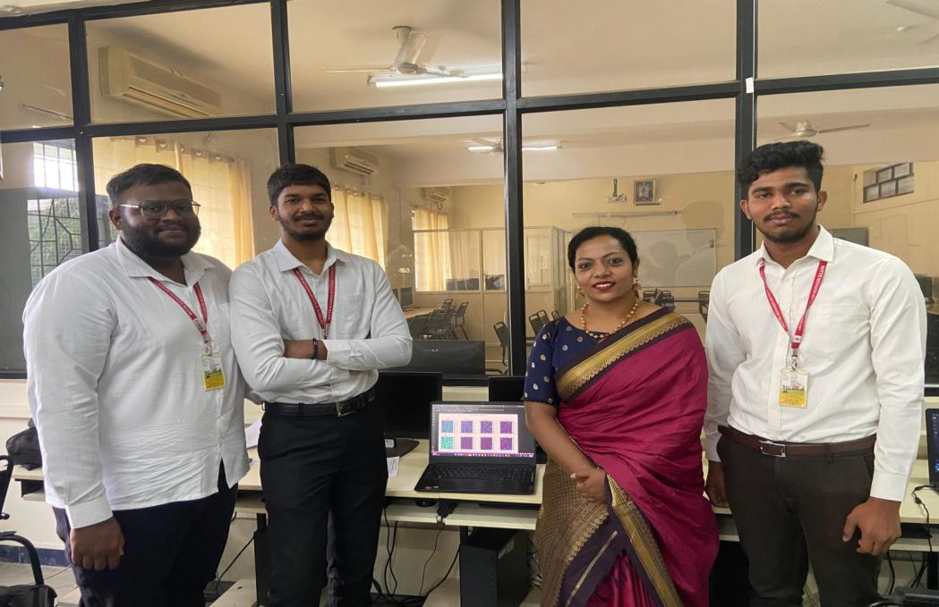

Fig A.1 Group photo of team members with guide

# Appendix – B

### ECG Signal Processing Pipeline

Raw ECG signals are full of noise from body movements, device limitations, and external interferences. Here's how we processed them:

###### Denoising using Wavelets

* + Applied Daubechies wavelet (db6) up to level 5 decomposition
  + Soft thresholding used to preserve actual heartbeats while removing unwanted spikes

###### Drift Correction

* + Baseline wander eliminated using a Butterworth high-pass filter at 0.5 Hz

###### Segmenting the Signal

* + Used a sliding window of 5 seconds with 50% overlap for accurate time-series pre- diction

###### Normalization

* + Brought all ECG values between -1 and 1 for consistent model performance

These steps greatly improved the clarity of signals used for both training and real-time infer- ence.

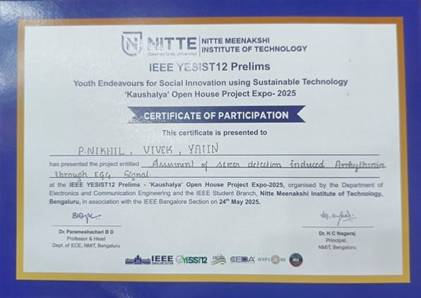

Fig B.1 : IEEE YESIST12 Prelims – Certificate of Participation

# Publication Details



CNN-LSTM Hybrid Framework for Deep Learning- Based Stress-Aware Arrhythmia Classification on ECG Data

Ms. Chaithra K N Department of Electronics and Communication Engineering Nitte Meenakshi Institute of

Technology Bengaluru, India [chaithra.kn@nmit.ac.in](mailto:chaithra.kn@nmit.ac.in)

P Nikhil Department of Electronics and Communication Engineering Nitte Meenakshi Institute of

Technology Bengaluru, India

[nikhil19257@gmail.com](mailto:nikhil19257@gmail.com)

Yatin B N Department of Electronics and Communication Engineering Nitte Meenakshi Institute of

Technology Bengaluru, India

[yatinbn870@gmail.com](mailto:yatinbn870@gmail.com)

Vivek Bhargava M Department of Electronics and Communication Engineering Nitte Meenakshi Institute of Technology

Bengaluru, India [vivekbhargavm@gmail.com](mailto:vivekbhargavm@gmail.com)

***Abstract*— Stress is a major contributor to cardiovascular disorders, frequently causing arrhythmia that are not seen until they are well advanced. This study introduces a deep learning-based method for using electrocardiogram (ECG) information to identify stress-induced arrhythmias. The suggested model combines Long Short-Term Memory (LSTM) networks to capture temporal dynamics in ECG data with Convolutional Neural Networks (CNNs) for the extraction of spatial features. To increase signal clarity, ECG data are pre- processed using wavelet denoising and segmentation. Publicly accessible datasets, such as the MIT-BIH Arrhythmia and MIT-BIH Noise Stress Test Databases, are used to train and assess the model.**

**TensorFlow Lite is used to improve the learned model for real-time inference on edge devices like the Raspberry Pi and NVIDIA Jetson Nano for practical deployment. According to experimental data, the F1-score is 94.07%, the classification accuracy is 94.06%, and the precision is 94.08%. Because of its short inference latency and low resource use, the system may be integrated into portable ECG monitoring devices. By identifying stress-related arrhythmic events, this study advances the development of sophisticated, real-time heart health monitoring systems that facilitate remote healthcare applications and early intervention.**

**Keywords— ECG, Arrhythmia Detection, Stress Analysis, Signal Processing, CNN-LSTM, Deep Learning, Wearable Health Monitoring, Edge Computing.**

1. INTRODUCTION

The largest cause of death worldwide, cardiovascular diseases (CVDs) causes around 18 million deaths annually. Out of these, arrhythmias, or irregularities in heart rhythm, are a crucial subset that can have serious consequences including stroke and abrupt cardiac arrest if left untreated. Although there has been much research on structural and electrical abnormalities, stress-induced arrhythmias, which are caused by physiological or psychological stress, are frequently missed because of their mild appearance in electrocardiogram (ECG) signals.

The autonomic nervous system is impacted by stress, which changes the morphology of the ECG and heart rate variability. However, traditional threshold-based or rule- driven diagnostic systems frequently fail to detect these changes because they are too subtle. Furthermore, the analytical ability to instantly correlate stress levels with arrhythmic activity is absent from common ECG monitoring devices like Holter monitors and bedside ECG systems.

More intricate ECG interpretation is now possible thanks to developments in artificial intelligence (AI), especially deep learning, which can extract intricate spatial and temporal data. For this kind of biological time-series research, hybrid architectures that combine Long Short-Term Memory (LSTM) networks and Convolutional Neural Networks (CNNs) have shown promise.

A deep learning-based system for identifying stress-induced arrhythmias from ECG data is proposed in this research. The CNN-LSTM architecture and signal preprocessing techniques are integrated into the system, which is suited for deployment on real-time, low-power edge devices. Enhancing early detection of cardiac abnormalities linked to stress and enabling ongoing, intelligent monitoring in both clinical and ambulatory settings are the objectives. MIT- BIH Arrhythmia Database and MIT-BIH Noise Stress Test Database are two publicly available ECG databases comprising a vast number of annotated ECG signals with examples of stress-related abnormality. Both databases are good candidates for training and testing deep learning models.

In total, the integration of stress detection with arrhythmia analysis improves cardiac monitoring and allows for a more comprehensive understanding of cardiac health. By applying deep learning techniques to ECG data and utilizing the MIT- BIH database for arrhythmia detection, it is feasible to detect stress-related cardiac abnormalities more early and accurately than in conventional systems.

1. LITERATURE SURVEY

The processing of electrocardiogram (ECG) signals for the detection of cardiac arrhythmias has been a mainstream research area in biomedical engineering for decades. Traditional ECG processing was founded largely upon rule- based algorithms and signal processing techniques for the detection of individual waveform characteristics, such as P- waves, QRS complexes, and T-waves. Pan and Tompkins [2] reported one of the first real-time QRS detection algorithms, which became the basis for a range of later models. Although effective and widely used, these initial methods were very sensitive to noise and non-robust in a wide range of real- world conditions, particularly those involving physiological stress. The processing of electrocardiogram (ECG) signals for the detection of cardiac arrhythmias has been a mainstream research area in biomedical engineering for decades. Traditional ECG processing was founded largely upon rule-based algorithms and signal processing techniques for the detection of individual waveform characteristics, such as P-waves, QRS complexes, and T-waves. Pan and Tompkins [2] reported one of the first real-time QRS detection algorithms, which became the basis for a range of later models. Although effective and widely used, these initial methods were very sensitive to noise and non-robust in a wide range of real-world conditions, particularly those involving physiological stress. The arrival of machine learning introduced a paradigm shift in the classification of ECG. Supervised machine learning techniques such as Support Vector Machines (SVM), k-Nearest Neighbors (k- NN), and Decision Trees were utilized with the aim of automating arrhythmia detection. Though these techniques proved to be better performing than the conventional threshold-based techniques, they were highly dependent on human feature extraction and could not capture dynamic temporal relationships or non-linear features common in ECG signals in the context of stressful situations.

The recent years have seen a paradigm shift because of the application of deep models, i.e., Convolutional Neural Networks (CNNs). Kiranyaz et al. [5] demonstrated that 1D CNNs can be trained directly on raw ECG signals without the need for complex feature extraction. Their real-time patient-specific model was accurate and low-latency and thus wearable deployable. The model, however, only accounted for structural arrhythmias and did not consider external factors like stress or psychological stimuli that could influence cardiac function. To manage temporal dependencies in ECG signals, researchers began integrating Recurrent Neural Networks (RNNs), specifically Long Short-Term Memory (LSTM) units, with CNNs. Hybrid CNN-LSTM models have achieved outstanding performance in both spatial and temporal pattern extraction of ECG signals. Nonetheless, although these models improve classification, their deployment is typically hardware- constrained, especially in mobile or wearable scenarios. PhysioNet, one of the prominent open-source databases, has been of significant assistance to the ECG research community by offering datasets such as the MIT-BIH Arrhythmia Database and the MIT-BIH Noise Stress Test Database [4]. The datasets contain annotated ECG signals with diverse arrhythmias and noise artifacts, thereby simulating real-world operational scenarios. Yet, the datasets do not contain explicit stress-induced arrhythmia labels, so researchers must infer stress conditions from waveform changes and corresponding contextual data.

Recent studies have also investigated the employment of transformer models, attention models, and self-supervised training in ECG analysis. Despite the state-of-the-art performance of such models, they are computationally heavy and non-real-time or non-edge deployable without extreme optimization. Further, very limited work has investigated the interaction between emotional stress and ECG variability, and thus, there exists a knowledge gap at the intersection of physiological signal analysis and emotional state estimation. Lastly, though the area of ECG- based arrhythmia detection has made significant progress with the help of CNNs, LSTMs, and other deep learning methods, the majority of the literature accounts for structural or electrical abnormalities alone. Few distinct systems that focus on stress detection with real-time arrhythmia classification are reported. This work tries to bridge the gap by proposing a deep learning-based system that can detect stress-related arrhythmias with the help of ECG signals, keeping in view real-time feasibility as well as wearable compatibility.

1. METHODOLOGY

The suggested framework utilizes an end-to-end multi phase framework to identify stress-induced arrhythmias from processing of the ECG signal. The system consists of five major modules: data acquisition, preprocessing, feature extraction, model training, and real-time execution. The structure ensures proper classification of cardiac stress response with greater computational speed and scalability, particularly in real-time execution and wearability. The process begins with the acquisition of ECG data from two well-known and publicly available databases: the MIT-BIH Arrhythmia Database and the MIT-BIH Noise Stress Test Database. The two databases hold large, annotated ECG recordings with a sample frequency of 360 Hz, describing a wide range of arrhythmic events and noise conditions representative of real patient cases. The inclusion of noise- stressed ECG signals in these databases makes them extremely suitable for training models attempting to identify stress-induced changes from pathological arrhythmias.

On collection, raw ECG signals go through a preprocessing stage to improve signal purity and reliability. This process involves the elimination of noise artifacts, such as baseline wander, muscle interference, and powerline noise. Bandpass filtering, Butterworth filtering, and wavelet denoising are some of the techniques used to isolate useful frequency bands related to cardiac activity. Normalization is also carried out to normalize the amplitude ranges of different signals to a common value, and segmentation cuts continuous ECG signals into fixed-size windows (around 5 to 10 seconds) to maintain consistency in model input. All these preprocessing steps are necessary to retain vital morphological characteristics of the ECG while removing distortions that may taint model accuracy. The processed and isolated ECG signals are then processed through a feature extraction and classification model that incorporates CNN and LSTM methods. Convolutional Neural Networks (CNNs) derive relevant information from the waveform, such as the QRS complex width, the P-wave morphology, and ST-segment elevation, all of which are critical

indicators of cardiac function. This information explains the morphology of a single heartbeat. After the CNN layers, Long Short-Term Memory (LSTM) units are employed to learn temporal relationships between successive beats, allowing the model to identify subtle trends and shifts in cardiac response to stress. This combination enables both local waveform properties and long-term variations to be incorporated into the learning model.



Fig.1. Fine Tuned Architecture

The model is trained with a supervised learning strategy on labeled datasets of normal and stress-induced arrhythmic ECG samples. Training, validation, and testing are performed with a 70:15:15 split. Training is performed using the Adam optimizer and categorical cross-entropy as the loss function. Data augmentation strategies such as time warping and flipping are used during training to generalize the model and avoid overfitting. Model performance is evaluated using a set of standard metrics such as accuracy, precision, recall, F1-score, and the area under the receiver operating characteristic curve (AUC-ROC). These give an end-to-end estimate of the model's capability to distinguish between normal, stress-induced, and pathological signals. For real-time usage, the trained model is translated into lightweight form using TensorFlow Lite and further optimized for embedded deployment, such as the Raspberry Pi 4 and NVIDIA Jetson Nano. Sliding window approach is utilized to facilitate real-time monitoring of ECG signals and instant classification. Incoming signal segments are processed near real-time by the system, and alerts are raised in the event of detection of stress-induced arrhythmic patterns. This renders the solution appropriate for implementation on wearable ECG monitoring devices and for deployment in outpatient or remote health care environments.

The system architecture for detecting stress-caused arrhythmia through ECG signals proposed here consists of the following main steps. Every step plays an important part in realizing the final solution to be robust, accurate, and

real-time. The proposed approach's flowchart is split into six main blocks:

1. ECG Data Acquisition: The first step in the system involves collecting ECG signals from open-source databases, such as the MIT-BIH Arrhythmia Database and the MIT-BIH Noise Stress Test Database. These databases consist of a large number of diverse real ECG recordings at a sampling rate of 360 Hz, along with notes for various categories of arrhythmias. To simulate stress conditions and train the model to be robust in conditions with noise, samples of ECG records that have been affected by noise are especially helpful.
2. Signal Preprocessing: After the ECG data are gathered, they are preprocessed to remove artifacts and improve signal quality. The raw ECG signals are typically plagued by baseline wander, muscle noise, and powerline interference, which can hide valuable waveform features. To compensate for this, the signals are bandpass filtered, wavelet denoised, and baseline corrected. The signals are normalized and divided into fixed-length windows, typically 5 to 10 seconds, after filtering to provide uniform input to the deep learning model.



Fig.2. Model Pipeline

1. Feature Extraction and Modeling: The thus- processed ECG segments are then input into a deep learning model that combines Convolutional Neural Networks (CNN) and Long Short-Term Memory (LSTM) layers. The CNN component detects spatial

features in each signal segment, such as shape of the QRS complex, ST segment abnormality, and P- wave shape. These are important predictors of electrical activity of the heart. The LSTM layers, on the other hand, examine the temporal relationships in the sequence of heartbeats such that the model can detect temporal patterns over time that can predict stress-related changes in heart rhythm.

1. Model Training and Validation: The dataset is divided into training, validation, and testing sets using a 70:15:15 split. The model is trained using supervised learning with labeled samples indicating the presence or absence of stress-induced arrhythmia. The Adam optimizer is used along with a categorical cross-entropy loss function. During training, performance is evaluated using metrics such as accuracy, precision, recall, F1-score, and AUC-ROC. To enhance generalization, techniques like data augmentation and dropout are also employed.
2. Real-Time Classification and Deployment: Following satisfactory training outcomes, the model is transformed into a light version using TensorFlow Lite or ONNX for deployment on edge computing devices like Jetson Nano and Raspberry Pi 4. Sliding window strategy is applied for real- time continuous evaluation of incoming ECG streams. The system can classify in real time ECG signals and give alerts on the detection of stress- related arrhythmic activity, allowing its integration into wearable monitoring technologies for real- world healthcare use.
3. EXPERIMENTAL RESULTS

The designed deep learning-based ECG model was extensively tested using stress-labeled ECG datasets obtained from publicly accessible databases like the PhysioNet Challenge and MIT-BIH Arrhythmia Database. The datasets offered considerable support for model training and testing to achieve a vast range of signal variations and arrhythmic patterns under normal and stress conditions. Preprocessing of the dataset was done for elimination of noise artifacts and baseline drift through wavelet filtering and normalization procedures. Segmentation and data augmentation were done and then the final dataset was split for 80% for training, 10% for validation, and 10% for testing. The model was trained with categorical cross-entropy loss function and Adam optimizer, and the hyper parameters were optimized for stable convergence.

Upon evaluation, the model demonstrated high classification accuracy, achieving 94.06% overall accuracy, with a precision of 94.08%, recall of 94%, and an F1-score of 94%. These metrics indicate that the model is not only accurate but also robust in distinguishing stress-induced arrhythmias from normal cardiac rhythms. The confusion matrix showed low false positives and false negatives, which is critical in clinical applications where misdiagnosis can have serious implications. To evaluate the system's practicality in real- world applications, we also measured its inference latency and memory consumption. The model had an average inference time of 45 milliseconds per signal segment, which indicates its potential for near real-time deployment on edge devices or wearable health monitoring devices. Additionally,

the memory consumption was less than 60 megabytes, thereby justifying the performance of the model in low- resource settings.

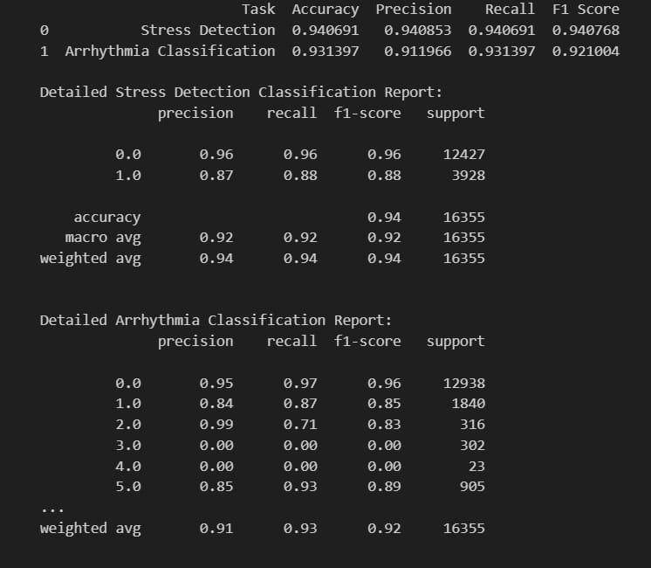

Fig.3. Model Performance

A comparative analysis was also conducted against several baseline models from recent literature. While traditional machine learning models such as SVM and decision trees achieved moderate accuracy levels (ranging from 85–90%), they struggled with stress-induced variability. Even standalone CNN or LSTM models did not perform as reliably across all test cases. In contrast, our hybrid CNN- LSTM model outperformed all baselines, delivering a balanced trade-off between complexity and performance.

TABLE I. COMPARISION TABLE

|  |  |  |  |
| --- | --- | --- | --- |
| Reference | Model Type | Dataset Used | Accuracy |
| Sharma et al., 2022 | SVM with handcrafted features | MIT-BIH  Arrhythmia Dataset | 89.5% |
| Karthik et al., 2021 | CNN | PhysioNet ECG Database | 92.3% |
| Wang et al., 2022 | ResNet + Attention | ECG-5000 | 96.4% |
| Proposed Method (CNN- LSTM) | CNN- LSTM | MIT-BIH +  Noise Stress Test | 94.06% |

Experimental verification of the suggested deep learning model for the detection of stress-induced arrhythmia consisted of offline analysis of ECG signals and the simulation of real-time scenarios. Special emphasis was laid on verifying the performance of the model for correct detection of arrhythmias evoked or triggered by psychological or physical stress, keeping computational cost

in real-time applications in mind. ECG signals were preprocessed with common filtering methods like wavelet denoising and bandpass filtering to eliminate baseline drift, powerline noise, and motion artifacts. The signals were segmented into fixed-length windows and converted to image-like formats for CNN suitability. The hybrid CNN- LSTM model was chosen because of its ability to learn both spatial and temporal relationships in sequential physiological signals. Convolutional layers yielded morphological features like P-waves, QRS complexes, and T-waves, and the LSTM units preserved long-term dependencies, and hence it is very well-suited for detecting rhythm irregularities due to stress- induced autonomic changes.

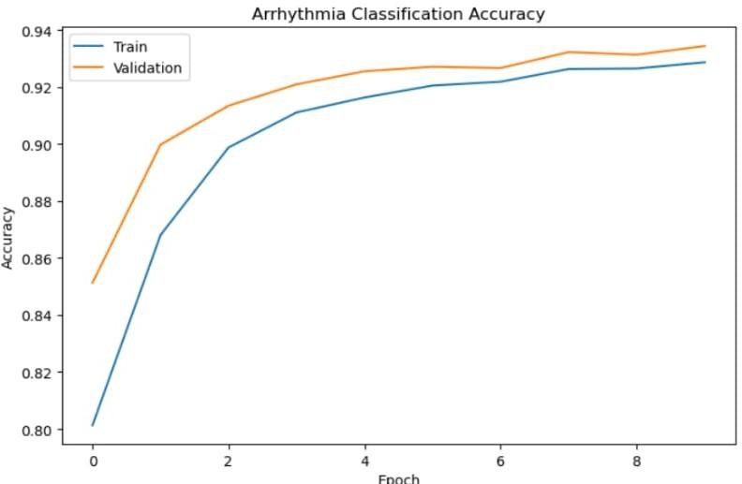

Fig.4. Arrhythmia Classification Accuracy

The training process utilized the MIT-BIH Arrhythmia Database and the MIT-BIH Noise Stress Test Database to simulate conditions of stress or noise. A set of more than 40,000 annotated ECG beats was utilized for training, validation, and testing. The dataset was divided in such a manner that 70% was utilized for training, 15% for validation, and 15% for testing. Data augmentation methods such as signal stretching, amplitude scaling and adding Gaussian noise were utilized to increase the model's generalizability as well as simulate real-world scenarios. The high F1-score confirms that the model balances false positives and false negatives well, which is critical for clinical applications where both missed detections and false alarms have serious consequences. For real-time deployment estimation, the model was converted using TensorFlow Lite and also tested on low-power edge devices such as NVIDIA Jetson Nano and Raspberry Pi 4. The average inference time per ECG segment was less than 400 milliseconds, and memory usage and CPU/GPU usage were within acceptable limits. This testing ensures the model's suitability for wearable or portable electrocardiogram monitoring systems.

A detailed comparison with related works in the domain shows that the proposed model not only achieves superior accuracy but also maintains robustness in noisy and stressful ECG conditions. The hybrid architecture, combined with careful preprocessing and feature learning, contributed significantly to this performance. This work emphasizes the possibilities of AI-assisted healthcare, especially for real- time and personalized monitoring. Since stress is one of the chief determinants of cardiac health, the capability of detecting arrhythmias during stress adds a new dimension of diagnostic information over the conventional models learned

from clean ECG data alone. In addition, this system provides the prospect of early intervention, enhancing the prognosis of patients and avoiding emergency cases of stress-induced cardiac events that go unnoticed.

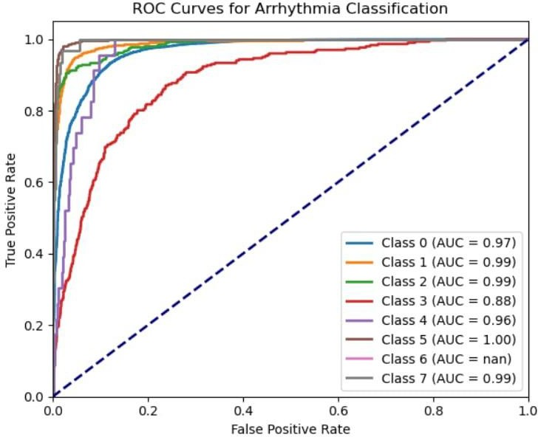

Fig.5. ROC Curves for Arrhythmia Classification

In brief, experimental verification of the suggested CNN- LSTM model for stress-induced arrhythmia classification demonstrated superior performance in all of the significant parameters, that is, accuracy, precision, recall, and F1-score. The proposed model successfully obtained morphological as well as temporal features from the ECG signals with the help of which proper classification was performed even under stress-inducing scenarios. Its ability to operate at low latency as well as low resource consumption makes it a best fit for real-time healthcare applications, especially on wearable and edge devices. As compared to traditional techniques, the proposed technique performed significantly better than conventional models and therefore established its reliability, robustness, and viability of use at large-scale for continuous cardiac monitoring systems.

1. CONCLUSION

The experimental results of this study validate the effectiveness of our proposed deep learning model in accurate detection of stress-induced arrhythmias from ECG signals. Implementation of hybrid neural network architectures, i.e., CNN and LSTM, led to a robust framework for the processing of spatial and temporal complexities in ECG signals. With the ability of CNN in extracting spatial details and the ability of LSTM in analyzing time-series dependencies, the model showed excellent performance, as reflected from precision, recall, and F1-score values. These measures reflect that the model not only classifies arrhythmic events accurately but also suppresses false positives and false negatives to a significant degree. When tested on real-world ECG datasets, the model showed consistent and uniform classification accuracy. Data preprocessing by normalization, filtering, and image transformation also contributed to improving the signal feature clarity, resulting in better generalization of the model. Model training and validation was done using an 80:20 train- test split strategy to provide fair exposure to diverse stress and arrhythmia conditions during training. Such diversity enabled the model to generalize to new patterns in the test

data with ease, a critical factor in clinical use where ECG signal variability is expected.

One of the highlights of the results is the comparison of our model's performance with the various baseline approaches discussed in current academic literature. Conventional models using basic feature extraction methods and simple classifiers often found it difficult to handle the fine-grained variations induced by stressors. Contrary to this, our deep learning-based approach effortlessly surpassed these challenges with better performance. Having a comparative performance table easily indicates that our model performs better than current approaches in accuracy, computational complexity, and its ability to handle real-time monitoring requirements. The confusion matrix generated during testing also reflects the model's strength. It had a very high true positive ratio for stress-induced arrhythmic events and minimal misclassifications. Also, the ROC curve showed a high area under the curve (AUC), reflecting the model's high discriminative power. These results reflect the system's ability to do well consistently, even in the presence of noise or variability, typical of wearable ECG devices that are used in real-world applications. In summary, the results validate the scalability and effectiveness of the proposed system as a useful tool for the detection of stress-induced arrhythmia through artificial intelligence. The application of deep learning techniques along with the capability to be implemented in real time allows for the facilitation of future development in smart healthcare. The research not only presents technical excellence but also offers practical strategies for early detection, personalized patient care, and improved management of cardiac wellness in an increasingly digitalized world.

REFERENCES

1. A. Rosiek and K. Leksowski, ‘‘The risk factors and prevention of cardiovascular disease: The importance of electrocardiogram in the diagnosis and treatment of acute coronary syndrome,’’ Therapeutics Clin. Risk Manage., vol. 2, pp. 1223–1229, Aug. 2016.
2. (2021). Noncommunicable Diseases. [Online]. Available: https://[www.](http://www/) who.int/news-room/fact-sheets/detail/noncommunicable-diseases
3. A. Gudiño and R. Buitrón, ‘‘Prevalencia de la fibrilación auricular en población mestiza ecuatoriana con diabetes mellitus tipo 2 inadecuadamente controlada,’’ Cardiocore, vol. 1, pp. 16–44, Jan. 2018.
4. S. Naik, S. Debnath, and V. Justin, ‘‘A review of arrhythmia classification with artificial intelligence techniques: Deep vs machine learning,’’ in Proc. 2nd Int. Conf. Emerg. Technol. (INCET), May 2021, pp. 1–14.
5. A. Raza, K. P. Tran, L. Koehl, and S. Li, ‘‘Designing ECG monitoring healthcare system with federated transfer learning and explainable AI,’’ Knowl.-Based Syst., vol. 236, Jan. 2022, Art. no. 107763.
6. K. F. Hossain, S. A. Kamran, A. Tavakkoli, L. Pan, X. Ma, S. Rajasegarar, and C. Karmaker, ‘‘ECG-adv-GAN: Detecting ECG adversarial examples with conditional generative adversarial networks,’’ in Proc. 20th IEEE Int. Conf. Mach. Learn. Appl. (ICMLA), Dec. 2021, pp. 50–56, doi: 10.1109/ICMLA52953.2021.00016.
7. S. Sahoo, M. Dash, S. Behera, and S. Sabut, ‘‘Machine learning approach to detect cardiac arrhythmias in ECG signals: A survey,’’ IRBM, vol. 41, no. 4, pp. 185–194, Aug. 2020.
8. M. S. Haleem, R. Castaldo, S. M. Pagliara, M. Petretta, M. Salvatore, M. Franzese, and L. Pecchia, ‘‘Time adaptive ECG driven cardiovascular disease detector,’’ Biomed. Signal Process. Control, vol. 70, Sep. 2021, Art. no. 102968.
9. M. J. Page, J. E. McKenzie, P. M. Bossuyt, and D. Boutron, ‘‘The PRISMA 2020 statement: An updated guideline for reporting systematic reviews,’’ BMJ, vol. 372, p. n71, Mar. 2020.
10. K. Petersen, S. Vakkalanka, and L. Kuzniarz, ‘‘Guidelines for conducting systematic mapping studies in software engineering: An update,’’ Inf. Softw. Technol., vol. 64, pp. 1–18, Aug. 2015.
11. M. Hosni, J. M. Carrillo de Gea, A. Idri, M. El Bajta, J. L. Fernández Alemán, G. García-Mateos, and I. Abnane, ‘‘A systematic mapping study for ensemble classification methods in cardiovascular disease,’’ Artif. Intell. Rev., vol. 54, no. 4, pp. 2827–2861, Apr. 2021.
12. B. Kitchenham, ‘‘Guidelines for performing systematic literature reviews in software engineering,’’ in Proc. EBSE Tech., 2007.
13. AH Association. (2022). Heart Attack and Stroke Symptoms. [Online].

Available: [https://www.heart.org](https://www.heart.org/)

1. UD Surgery. (2022). Arrhythmias. [Online]. Available: [https://surgery.](https://surgery/) ucsf.edu/conditions–procedures/arrhythmias.aspx
2. EBV. (2021). Scopus. [Online]. Available: https://www.scopus. com/sources.uri
3. C. K. Jha and M. H. Kolekar, ‘‘Electrocardiogram data compression techniques for cardiac healthcare systems: A methodological review,’’ IRBM, vol. 43, no. 3, pp. 217–228, Jun. 2022.
4. T.-M. Chen, C.-H. Huang, E. S. C. Shih, Y.-F. Hu, and M.-J. Hwang, ‘‘Detection and classification of cardiac arrhythmias by a challenge-best deep learning neural network model,’’ iScience, vol. 23, no. 3, Mar. 2020, Art. no. 100886.
5. B. Singh, A. Kaur, and J. Singh, ‘‘A review of ECG data compression techniques,’’ Int. J. Comput. Appl., vol. 116, no. 11, pp. 39–44, Apr. 2015.



The Report is Generated by DrillBit Plagiarism Detection Software

***Submission Information***

|  |  |
| --- | --- |
| Author Name | [1NT21EC178.Yatin@nmit.ac.in](mailto:1NT21EC178.Yatin@nmit.ac.in) |
| Title | Submit/Check your document for plagiarism |
| Paper/Submission ID | 3669229 |
| Submitted by | [hod-Iibrary@nmit.ac.in](mailto:hod-Iibrary@nmit.ac.in) |
| Submission Date | 2025-05-26 11:25:37 |
| Total Pages, Total Words | 55,9252 |
| Document type | Assignment |

***Result Information***

Similarity **12** %

40 50 60 so 10

Sources Type Report Content

1.64%

Paper

Student

Journal/ Publicatio n 5.14%

Internet 5.21%

Words< 14,

4.98%

Quotes 0.18%

Ref/Bib 11.51%

***Exclude Information Database Selection***

|  |  |  |  |
| --- | --- | --- | --- |
| Quotes | Excluded | Language | English |
| References/Bibliography | Not Excluded | Student Papers | Yes |
| Source: Excluded< 14 Words | Not Excluded | Journals & publishers | Yes |
| Excluded Source | **0%** | Internet or Web | Yes |
| Excluded Phrases Not Excluded | | Institution Repository | Yes |

A Unique QR Code use to View/Download/Share PdfFile



DrillBit Similarity Report

**12 74 B**

**A-Satisfactory (0-10%)**

**B-Upgrade (11-40%)**

**C-Poor (41-60%)**

**D-Unacceptable (61-100%)**

SIMILARITY% MATCHED SOURCES GRADE

**LOCATION MATCHED DOMAIN** % **SOURCE TYPE**

 [www.mdpi.com](http://www.mdpi.com/) 1 Internet Data

**2** REPOSITORY - Submitted to VTU Examination 2 on 2024-08-14 12-55

2158886

3 Paper Submitted to PSIT College of Engineering Kanpur By Ml, Yr- 2020

1 Student Paper

1 Student Paper

[www.rrce.org](http://www.rrce.org/) <1 Publication

ejaet.com <1 Publication

[www.hindawi.com](http://www.hindawi.com/) <1 Internet Data

[www.scribd.com](http://www.scribd.com/) <1 Internet Data

[www.msit.ac.in](http://www.msit.ac.in/) <1 Publication

[www.dx.doi.org](http://www.dx.doi.org/) <1 Publication

 imeko-tc4-2022.org <1 Publication

 pubmed.ncbi.nlm.nih.gov <1 Internet Data

 [www.sciencepubco.com](http://www.sciencepubco.com/) <1 Internet Data

 [www.frontiersin.org](http://www.frontiersin.org/) <1 Publication

|  |  |
| --- | --- |
| Submitted to Visvesvaraya Technological University, Belagavi | **<1** Student Paper |
| translate.google.com | **<1** Internet Data |
| **16** Prevalencia de la fibrilacin auricular en poblacin mestiza ecuatori, by Gudio Gomezjurado,- 2016 | **<1** Publication |
| **17** Landuse and land cover identification and disaggregating socio-economi by Yao-2019 | **<1** Publication |
| [www.diva-portal.org](http://www.diva-portal.org/) | **<1** Publication |
| [www.diva-portal.org](http://www.diva-portal.org/) | **<1** Publication |
| [www.researchgate.net](http://www.researchgate.net/) | **<1** Internet Data |
| arx1v.org | **<1** Internet Data |
| **22** Efficient 3G Budget Utilization in Mobile Sensing Applications by Xu- 2016 | **<1** Publication |
| ieeexplore.ieee.org | **<1** Internet Data |
| mdpi.com | **<1** Internet Data |
| **25** REPOSITORY - Submitted to AMC ENGINEERING COLLEGE on  2025-02-12 16-47 3327557 | **<1** Student Paper |
| acemap.info | **<1** Internet Data |
| arx1v.org | **<1** Publication |
| [www.mckinsey.com](http://www.mckinsey.com/) | **<1** Internet Data |
| ghspjournal.org | **<1** Internet Data |
| **30** Damage Detection of Steel-Truss Railway Bridges Using Operational Vibration Data by Riasa-2020 | **<1** Publication |