**VISVESVARAYA TECHNOLOGICAL UNIVERSITY JNANA SANGAMA, BELAGAVI - 590018**



*An Internship Report on*

**Full Stack Development (E-Commerce Platform)**

*Submitted in**partial fulfilment of requirements for award of the degree of*

**Bachelor of Engineering**

**in**

**Electronics and Communication Engineering**

for **Academic Year: 2024-25**

*Submitted by*

**Kushal K V (1NT21EC072)**

Under the Guidance of

**Dr. Karunakara Rai B**

Associate Professor

Department of Electronics and Communication Engineering

**External Guide**

**Preetha Krishnamurthy**

Intern   
Cognizant Technology Solutions, Chennai



**DEPARTMENT OF ELECTRONICS AND COMMUNICATION ENGINEERING**

**YELAHANKA, BENGALURU- 560064**

**VISVESVARAYA TECHNOLOGICAL UNIVERSITY JNANA SANGAMA, BELAGAVI - 590018**



*An Internship Report on*

**Full Stack Development (E-Commerece Platform)**

*Submitted in**partial fulfilment of requirements for award of the degree of*

**Bachelor of Engineering**

**in**

**Electronics and Communication Engineering**

for the **Academic Year: 2024-25**

*Submitted by*

**Kushal K V (1NT21EC072)**

Under the Guidance of

**Dr. Karunakara Rai B**

Professor

Department of Electronics and Communication Engineering

**Preetha Krishnamurthy**

Intern @ Cognizant Technology Solutions, Chennai



**DEPARTMENT OF ELECTRONICS AND COMMUNICATION ENGINEERING**

**YELAHANKA, BENGALURU- 560064**

**DEPARTMENT OF ELECTRONICS AND COMMUNICATION ENGINEERING**

**BENGALURU- 560 064**

***Certificate***

Certified that the internship work titled “**Full Stack Development”** is carried out by **Kushal K V** **(1NT21EC072)**, bonafide student of Nitte Meenakshi Institute of Technology submitted in partial fulfilment for the award of Bachelor of Engineering in Electronics and Communication Engineering of Visvesvaraya Technological University, Belagavi during the academic year 2024-2025. The internship report has been approved as it satisfies the academic requirement in respect of internship work prescribed as per the autonomous scheme of Nitte Meenakshi Institute of Technology, Bangalore for the said degree.

|  |  |  |
| --- | --- | --- |
| **Signature of the Guide** | **Signature of the HoD** | **Signature of the Principal** |
| **Dr.Karunakara Rai B**  Professor  Dept of ECE, NMIT | **Dr. Parameshachari B D** HoD  Dept of ECE, NMIT | **Dr. H C Nagaraj**  Principal  NMIT |

**Project Completion Certificate/Industrial Certificate**

I, **Kushal K V (1NT21EC072)**, hereby declare that the material presented in the Project Report titled "**Full Stack Development**" represents original work carried out by me in the Cognizant Technology Solutions, Chennai during the tenure 27 March, 2025 – 18 June, 2025.

With My signature, I certify that:

* I have not manipulated any of the data or results.
* I have not committed any plagiarism of intellectual property and have clearly indicated and referenced the contributions of others.
* I have explicitly acknowledged all collaborative research and discussions.
* I understand that any false claim will result in severe disciplinary action.
* I understand that the work may be screened for any form of academic misconduct.

Date: 22/05/2025 Student Signature:

In my capacity as the supervisor of the above-mentioned work, I certify that the work presented in this report was carried out under my supervision and is worthy of consideration for the requirements of the B.E. Internship Work.

External Guide Name: Preetha K Guide Name: Dr. Karunakara Rai B

External Guide Signature Guide Signature

##### Acknowledgement

The successful execution of our internship gives us an opportunity to convey our gratitude to each one who have been instrumental in paving path to our continuation of this internship work. Whatever we have done is due to such guidance and help and we would not forget to thank them all.

We would like to thank and seek the blessings from **Dr. N R. Shetty,** Advisor, **Nitte Meenakshi Institute of Technology**, for his thrust on project-based learning and constructivist principles in our institution.

We would like to express our gratitude to the **Nitte Meenakshi Institute of Technology** and our beloved Principal **Dr. H C. Nagaraj** forproviding us the support, facilities and motivation to carry out our project.

We express our deep sense of gratitude to **Dr. Parameshachari B D**, HoD, Department of Electronics and Communication Engineering, for his kind co-operation, valuable guidance and creating the best learning environment for us.

We wholeheartedly thank our guide **Dr. Karunakara Rai B,** Professor, Department of Electronics and Communication Engineering, for his/her support and guidance anytime we require.

We also thank and share this moment of happiness with our parents who rendered us enormous support during the whole tenure of our studies at Nitte Meenakshi Institute of Technology, Bengaluru.

Finally, we would like to thank all other unnamed who helped us in various ways to gain knowledge and have a good training.

Kushal K V (1NT21EC072)

Place: Chennai

Date:22/05/2025

##### Abstract

During my internship, I developed a comprehensive e-commerce web application using ASP.NET Core MVC, focusing on modular architecture, responsive design, and seamless user experience. The project was structured into five core modules: Product Management, Shopping Cart, Order Management, User Authentication, and Admin Dashboard — each designed to simulate real-world e-commerce functionality.

The Product Management Module enabled administrators to create, update, categorize, and display products with detailed attributes such as name, description, price, and image. The Shopping Cart Module allowed users to add or remove items, view cart contents, and dynamically calculate totals. For order processing, the Order Management Module handled order placement, shipping details, payment status, and order tracking.

User access and personalization were managed through the User Authentication and Profile Management Module, which supported secure registration, login, and profile updates. Administrative operations were centralized in the Admin Dashboard Module, offering tools for product and order management, customer insights, and sales analytics.

The application was built using Entity Framework Core for database integration, with data seeding to simulate a live environment. Razor views and Bootstrap were used to create a responsive, mobile-friendly frontend, while static assets were organized under the wwwroot directory. Development was carried out in Visual Studio, leveraging its scaffolding and debugging features to streamline the workflow.This project provided hands-on experience in full-stack development, combining traditional MVC patterns with modern UI/UX practices. It significantly enhanced my skills in building scalable, maintainable, and production-ready web applications.

**Contents**

Chapter 1 Introduction

1.1 Purpose of the Internship ……..7

1.2 Internship Objectives ……..7

1.3 Company Overview ……..9

Chapter 2 Internship Activities and Responsibilities

2.1 Job Description and Tasks …….11

2.2 Hardware and Software Requirements …….13

2.3 Learning Experiences …….15

2.4 Challenges and Solutions …….16

Chapter 3 Learning Outcomes and Skills Acquired

3.1 Technical Skills ……20

3.2 Personal and Professional Skills ……22

3.3 Knowledge Gained ……23

Chapter 4 Reflection on the Internship Experience

4.1 Technical Skills Enhancement ……24

4.2 Real world application of theoretical knowledge …….25

4.3 Exposure to Enterprise Practices ……26

4.4 Project Management & Agile Collaboration……26

4.5 Personal Growth and Soft Skills ……27

Chapter 5 Conclusion …..28

References Books, Tools, Articles, Documentation

##### List of Figures

Fig 2.1 MVC Architecture 13

Fig 2.2 Sample mssql window 14

##### List of Tables

Table 2.1 Project Development overview table 15

# Chapter 1 Introduction

In the digital era, the demand for robust, scalable, and user-friendly web applications has grown rapidly across industries. Organizations recognize the significance of leveraging cutting-edge technology to enhance operational efficiency and customer experience. One of the most transformative sectors in this technological revolution is e-commerce, which has reshaped traditional business models and consumer behaviors.

E-commerce platforms have evolved to meet the dynamic demands of online shoppers, offering seamless browsing, personalized recommendations, and secure transaction processing. Businesses now prioritize creating applications that are not only functional but also intuitive, secure, and optimized for diverse devices and screen sizes. Given the competitive landscape, modern e-commerce platforms must incorporate features like real-time inventory management, predictive analytics, and multi-channel integration to ensure a smooth shopping experience.

My internship at Cognizant Technology Solutions provided an invaluable opportunity to engage with the nuances of e-commerce application development. It enabled me to apply my theoretical knowledge in a real-world setting, deepening my understanding of enterprise-level software engineering practices. The hands-on exposure to live project development allowed me to collaborate with experienced professionals, understand agile methodologies, and implement best practices in coding and architecture.

The e-commerce web application I worked on was built using ASP.NET Core MVC, a robust framework tailored for dynamic, data-driven applications. The project incorporated several key technologies, each contributing to different facets of the application. Entity Framework Core was utilized for seamless database integration, ensuring efficient data retrieval and management. Razor views enabled server-side rendering, providing a structured and optimized approach to handling user interfaces. Additionally, Bootstrap was integrated for responsive and mobile-first design, ensuring cross-platform compatibility.

The application followed a modular design, incorporating distinct components such as:

* **Product Management:** Enabling the addition, deletion, and modification of product listings with optimized search functionality.
* **Shopping Cart Functionality:** Allowing users to manage their purchases efficiently with interactive cart updates.
* **Order Processing:** Streamlining order confirmation, payment transactions, and invoice generation.
* **User Authentication:** Implementing secure login, registration, and role-based access control.
* **Administrative Control:** Empowering administrators with analytical insights, user management capabilities, and performance tracking.

**1.1 Purpose of the Internship**

The primary objective of my internship was to bridge the gap between academic learning and real-world software development. While my coursework provided a strong foundation in programming principles, architectural patterns, and algorithmic problem-solving, the internship was an opportunity to apply these concepts in a professional ecosystem.

Throughout the internship, I aimed to achieve the following:

* **Exposure to Full-Stack Development:** Working with front-end and back-end technologies to build scalable web applications.
* **Deepening Understanding of MVC Architecture:** Learning how modular design improves maintainability and enhances development efficiency.
* **Writing Clean, Maintainable, and Testable Code:** Adopting industry best practices in coding standards, debugging, and optimization.
* **Developing Problem-Solving Skills:** Tackling real-world technical challenges, debugging issues, and implementing creative solutions.
* **Collaborative Development Experience:** Engaging with cross-functional teams, understanding project workflows, and participating in Agile methodologies.

Beyond technical skills, the internship provided insights into communication, teamwork, and professional adaptability—qualities essential for a successful career in software engineering. It reinforced the importance of meticulous documentation, version control, and testing methodologies to ensure application reliability and security.

This experience has been instrumental in shaping my perspective on enterprise application development. By working on a real-world project with tangible user impact, I gained confidence in my ability to contribute meaningfully to large-scale software systems. The challenges I encountered provided invaluable learning opportunities, allowing me to refine my approach to coding, debugging, and system architecture.

**1.2 Internship Objectives**

At the outset of my internship, I defined a set of personal and professional objectives to guide my learning journey. These objectives were designed to help me maximize the value of the internship and build a solid foundation for future roles in software engineering.

**Technical Objectives:**

The internship provided an opportunity to delve into full-stack development, leveraging industry-standard tools and frameworks to build a modular e-commerce web application. The technical goals were structured to enhance coding proficiency, ensure adherence to software architecture best practices, and promote scalability in web application design.

Key technical objectives included:

* **Designing and implementing a modular e-commerce web application using ASP.NET Core MVC:** This entailed structuring the project into logically separated layers for better maintainability and scalability.
* **Developing and integrating the following modules:**
  + **Product Management:** Implementing CRUD (Create, Read, Update, Delete) operations, product categorization for easier navigation, and efficient image handling for optimized loading.
  + **Shopping Cart:** Enabling dynamic addition and removal of items, real-time quantity updates, and accurate total price calculation to enhance user experience.
  + **Order Management:** Streamlining order placement, integrating shipping details, tracking payment status, and generating order confirmations.
  + **User Authentication:** Implementing secure login mechanisms, registration workflows, and profile management features using authentication protocols and best security practices.
  + **Admin Dashboard:** Developing an interface that allows administrators to oversee product and order management, track customer insights, and generate analytical reports.
* **Utilizing Entity Framework Core for ORM-based database operations and data seeding:** Ensuring efficient database integration, avoiding redundant queries, and maintaining consistency across records.
* **Building responsive Razor views using Bootstrap and managing static assets via wwwroot:** Prioritizing mobile-first design principles for an optimized user experience across different screen sizes and resolutions.
* **Ensuring cross-browser compatibility and mobile responsiveness:** Conducting thorough testing to ensure seamless functionality across various web browsers and devices.

**Professional Objectives:**

Beyond technical proficiency, the internship also aimed to enhance professional skills that are crucial for collaboration, software project management, and effective communication within a corporate setting. The experience reinforced industry-standard workflows and development methodologies.

The professional objectives of the internship included:

* **Gaining experience with Visual Studio for development, debugging, and scaffolding:** Understanding how to utilize the integrated development environment (IDE) effectively for faster development cycles and debugging.
* **Collaborating with team members using Git and participating in code reviews:** Leveraging version control for seamless collaboration and ensuring high-quality, optimized code through peer feedback.
* **Following best practices in software design, including separation of concerns and DRY (Don’t Repeat Yourself) principles:** Implementing structured coding techniques that enhance maintainability and prevent redundant code duplication.
* **Understanding the software development lifecycle (SDLC) in a corporate environment:** Learning how projects progress from conceptualization to deployment, and understanding iterative development through Agile methodologies.
* **Participating in sprint planning, daily stand-ups, and project retrospectives:** Engaging in Scrum-based teamwork to improve productivity, resolve challenges, and optimize development workflows.

This holistic approach ensured that the internship was not only technically enriching but also valuable in building soft skills and team collaboration abilities, preparing me for real-world software engineering challenges.

**1.3 Company Overview**

About Cognizant Technology Solutions

Cognizant Technology Solutions is a global leader in IT services, consulting, and digital transformation. The company is recognized for its commitment to technological innovation, customer-centric strategies, and the delivery of cutting-edge enterprise solutions.

Founded in 1994 and headquartered in Teaneck, New Jersey, Cognizant operates across more than 40 countries, boasting a workforce of over 350,000 professionals. With a mission to drive businesses toward digital excellence, Cognizant specializes in solutions that empower organizations to streamline operations, enhance user experiences, and leverage data-driven insights for strategic decision-making.

The company offers a broad range of services, including:

* Application Development and Maintenance: Building scalable, customized applications aligned with business requirements.
* Cloud Infrastructure and Migration: Facilitating seamless transitions to cloud-based architectures for improved agility.
* Artificial Intelligence and Machine Learning: Implementing AI-driven solutions for automation, efficiency, and predictive analytics.
* Enterprise Software Solutions: Developing robust ERP (Enterprise Resource Planning) systems and business applications.
* Digital Engineering and Automation: Modernizing legacy systems and automating key business processes for improved operational efficiency.

Cognizant is well known for its forward-thinking approach to technological advancements. With expertise spanning various industries—including healthcare, finance, retail, and manufacturing—the company continually adapts to evolving market trends to provide solutions that meet diverse client needs.

**Objectives of the Company**

Cognizant’s strategic objectives align with its commitment to digital innovation and business transformation:

* Deliver scalable and secure IT solutions tailored to client needs: Ensuring that technology solutions enhance business efficiency and drive long-term growth.
* Drive innovation through emerging technologies like AI, cloud, and data analytics: Leveraging data science and cloud architectures to deliver next-generation applications.
* Foster a culture of continuous learning and professional development: Encouraging employee upskilling and knowledge expansion through workshops, training programs, and research initiatives.
* Promote sustainability and digital inclusion through technology: Supporting green initiatives and using technology to create inclusive digital ecosystems.
* Ensure customer satisfaction through agile, collaborative development practices: Prioritizing iterative development, client feedback loops, and transparent project management for optimal results.

Cognizant’s dedication to excellence, combined with its ability to innovate and adapt, has cemented its position as a trusted partner for global enterprises seeking digital transformation.

# Chapter 2 Internship Activities and Responsibilities

**2.1 Job Description and Tasks**

As a **Full-Stack Developer Intern**, my role encompassed a diverse range of responsibilities that bridged frontend and backend development. The internship provided a **hands-on learning experience**, enabling me to **design, develop, test, and optimize** various components of an enterprise-level e-commerce platform. This real-world exposure deepened my understanding of software engineering principles, collaborative development workflows, and agile methodologies.

Key responsibilities included:

* **Designing and implementing core modules of the e-commerce application:** Structuring the project architecture to align with best development practices for modularity and maintainability.
* **Developing backend logic using ASP.NET Core MVC and Entity Framework Core:** Implementing business logic, database interactions, and request handling while ensuring scalability.
* **Creating dynamic and responsive frontend interfaces using Razor views and Bootstrap:** Designing an intuitive UI that enhances user experience while maintaining cross-browser compatibility.
* **Writing and maintaining clean, modular, and reusable code:** Adopting software design patterns, adhering to coding standards, and optimizing for efficiency.
* **Integrating database operations such as product listing, cart management, and order processing:** Ensuring data consistency, security, and efficient retrieval from the database.
* **Participating in code reviews, debugging sessions, and sprint planning meetings:** Engaging in peer collaboration, resolving technical bottlenecks, and refining features iteratively.
* **Collaborating with team members using Git and version control best practices:** Maintaining a structured development workflow with regular commits, branches, and pull requests.

This role provided exposure to full-stack development, allowing me to engage with both the server-side and client-side aspects of building a complex web application.

Throughout the internship, I contributed to the development of several key modules, each playing a vital role in the e-commerce application's functionality. These modules were structured to ensure seamless user interaction, data management, and system efficiency.

* **Product Management:** Implemented CRUD operations (Create, Read, Update, Delete), categorized products into different sections, and integrated image handling for optimized display.
* **Shopping Cart:** Designed a dynamic cart system where users could add/remove items, update quantities, and automatically calculate total pricing with applied taxes and discounts.
* **Order Management:** Developed order processing workflows, including **checkout procedures, shipping details, and payment status tracking**, ensuring smooth purchase transactions.
* **User Authentication:** Implemented **secure login and registration** using authentication protocols, encrypted passwords, and session management for seamless user access control.
* **Admin Dashboard:** Built an interactive dashboard providing **product and order management tools, customer insights, and analytics**, empowering administrators to track sales trends and monitor system efficiency.

Each module adhered to **scalability and security principles**, ensuring high performance even with growing data volumes and user interactions

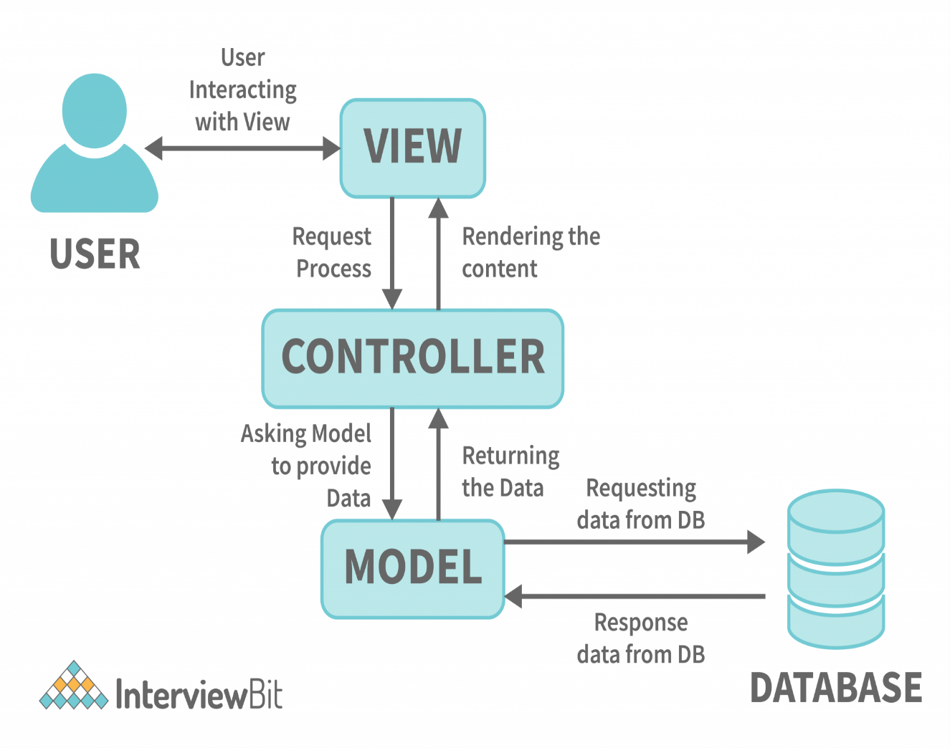

Fig 2.1. MVC Architecture

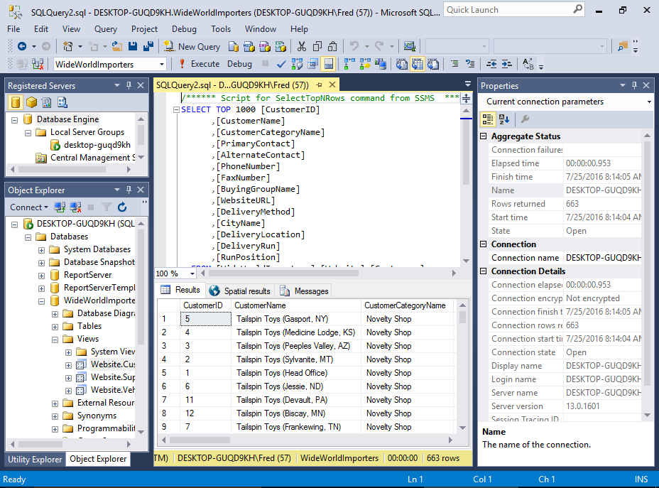

Fig 2.2. Sample mssql window

**2.2 Hardware and Software Requirements**

Developing an enterprise-level web application necessitated both **reliable hardware** and **specialized software tools** to ensure smooth implementation, testing, and deployment.

**Hardware Requirements:**

To handle development tasks efficiently, the following hardware specifications were essential:

* Laptop with Intel i5/i7 processor: Ensured smooth application execution, debugging, and handling resource-intensive tasks.
* Minimum 8 GB RAM: Provided sufficient memory for running Visual Studio, database servers, and browser-based testing simultaneously.
* Stable internet connection: Enabled remote collaboration, seamless code integration via GitHub, and communication through Microsoft Teams.

Software & Tools Used:

**Software Requirements**

The development process relied on a combination of industry-standard tools for coding, database management, debugging, and communication.

* Visual Studio 2022: Integrated development environment (IDE) for writing, debugging, and managing the ASP.NET Core project.
* .NET SDK: Essential framework for compiling, running, and deploying the application.
* SQL Server / SQLite: Database management systems used for structured data storage, queries, and indexing.
* Entity Framework Core: Object-relational mapper (ORM) to streamline data access, reducing complex queries and improving performance.
* Bootstrap 5: Frontend framework for ensuring mobile-first responsiveness, accessibility, and enhanced UI aesthetics.
* Git & GitHub: Version control system for collaborative coding, tracking changes, and integrating peer reviews.
* Postman: API testing tool used for validating backend responses and debugging HTTP requests.
* Microsoft Teams: Communication and meeting platform for seamless coordination, knowledge sharing, and development progress updates.

The combination of these tools facilitated efficient project management, streamlined debugging workflows, and maintained code quality standards.

| Module | Description | Technologies/Tools Used |
| --- | --- | --- |
| 1. Project Setup | Initialize ASP.NET Core MVC project, configure dependencies | ASP.NET Core, Visual Studio, NuGet |
| 2. Database Design | Design schema for products, users, orders, etc. | SQL Server, Entity Framework Core |
| 3. User Authentication | Implement login, registration, and role-based access | ASP.NET Identity, Razor Pages |
| 4. Product Management | CRUD operations for products, categories, and inventory | MVC Controllers, Views, EF Core |
| 5. Shopping Cart | Add to cart, update quantity, remove items | Session Management, TempData |
| 6. Checkout Process | Address input, order summary, payment integration | Razor Views, Payment Gateway API |
| 7. Order Management | Track orders, update status, view order history | Admin Panel, EF Core |
| 8. UI/UX Design | Responsive and user-friendly interface | Bootstrap, CSS, JavaScript, jQuery |
| 9. API Integration | Integrate third-party services (e.g., payment, shipping) | REST APIs, JSON |
| 10. Testing & Debugging | Unit testing, bug fixing, and performance optimization | xUnit, Debugging Tools |

Table 2.1. Project Development overview table

**2.3 Learning Experiences**

The internship provided **a wealth of knowledge and practical exposure**, bridging theoretical concepts with hands-on experience. Key learning experiences included:

* **Understanding the Model-View-Controller (MVC) architecture in depth:** Gained a clear insight into how **data, business logic, and UI layers interact**, ensuring structured application development.
* **Hands-on experience with Entity Framework Core for database integration:** Learned how ORM tools streamline data management, improve query efficiency, and maintain schema consistency.
* **Building responsive and accessible UIs using Bootstrap and Razor:** Ensured **cross-device compatibility, user-friendly navigation, and optimized loading speeds**.
* **Enhancing problem-solving and debugging skills in a real-world setting:** Developed **troubleshooting strategies**, identified performance bottlenecks, and refined application features.
* **Understanding the importance of code modularity, reusability, and scalability:** Learned best practices for creating loosely coupled components, reusable functions, and optimized database queries.
* **Collaborating effectively in a team environment using agile methodologies:** Experienced daily stand-ups, sprint planning, and retrospective meetings, fostering a structured development workflow.
* **Participating in code reviews and learning from feedback to improve code quality:** Implemented recommended improvements, followed industry standards, and refined debugging techniques.
* **Exploring deployment practices and enterprise application maintenance:** Understood **deployment pipelines, version control strategies, and application monitoring techniques**.

Beyond technical expertise, the internship strengthened **communication, teamwork, and adaptability**, essential qualities for professional growth. The challenges encountered throughout the project provided **valuable lessons in resilience, creative problem-solving, and strategic planning**.

**2.4 Challenges and Solutions**

Throughout my internship, I encountered numerous technical challenges that tested my problem-solving skills, adaptability, and knowledge of full-stack development. These challenges, while initially complex, provided valuable learning experiences and strengthened my ability to troubleshoot, optimize code efficiency, and apply best practices in web development.

**1. Complex Entity Relationships in EF Core**

**Challenge:**

Designing and managing relationships between **Product, CartItem, Order, and User** entities proved to be a complex task. Initially, improper configurations led to several issues, including circular references, lazy loading errors, and unexpected null values during data retrieval. These problems affected data integrity and hindered query performance.

**Solution:**

To address these challenges, I thoroughly studied the **Entity Framework Core documentation**, exploring both **data annotations** and **Fluent API configurations** to establish robust entity relationships. I created an **ER diagram** to visualize entity dependencies, which helped refine **one-to-many and many-to-many relationships** effectively. Additionally, I:

* Used explicit **foreign keys** in navigation properties for better clarity.
* Implemented **Eager Loading** where necessary to eliminate lazy loading errors.
* Used the **Include() method** in queries to fetch related entities efficiently. By optimizing these configurations, I successfully ensured smooth database transactions and enhanced query performance.

**2.Razor View Rendering and Model Binding Errors**

**Challenge:**

Developing dynamic pages such as **Product Details and Cart Views** exposed several issues, including Razor syntax errors, model binding mismatches, and null reference exceptions. These errors disrupted the rendering of views, causing inconsistent user experiences.

**Solution:**

I utilized **Visual Studio's debugger** and **browser developer tools** to inspect model data and pinpoint errors in binding. The following strategies proved beneficial:

* Implemented **null checks** to prevent runtime exceptions.
* Used **@model directives** consistently across views to maintain type safety.
* Modularized UI components using **partial views**, reducing redundancy and improving maintainability. Through these improvements, I ensured smoother model binding, proper data retrieval, and dynamic page rendering.

**3. Responsive UI and Cross-Browser Compatibility**

**Challenge:**

Achieving seamless **cross-browser compatibility** and ensuring the UI displayed correctly across various screen sizes was a recurring challenge, particularly for mobile users and administrators accessing dashboards on different devices.

**Solution:**

I adopted a **mobile-first design approach**, leveraging **Bootstrap's grid system and utility classes** to build responsive layouts. The following actions helped refine responsiveness:

* Tested the application on **multiple devices and browsers** to identify inconsistencies.
* Used **Chrome DevTools** to simulate different screen sizes and debug layout issues.
* Applied **CSS media queries** for fine-tuned responsiveness and UI adjustments. As a result, the application maintained a **consistent and user-friendly interface** across devices, providing an improved shopping experience.

**4. Session Management for Shopping Cart**

**Challenge:**

Ensuring **cart state persistence** across sessions posed a challenge, especially when users switched between guest and logged-in modes or refreshed their browsers.

**Solution:**

To provide a seamless shopping experience, I implemented:

* **Session-based cart storage** using **ASP.NET Core's session middleware** for guest users.
* **Database persistence for authenticated users**, ensuring carts remained intact across sessions.
* A **cart merging feature** that consolidates session and database carts upon login. These solutions effectively maintained shopping cart consistency and enhanced user experience.

**5. Role-Based Access Control for Admin Features**

**Challenge:**

Restricting access to **admin-only features** while ensuring role-based security was essential for maintaining data integrity and preventing unauthorized changes.

**Solution:**

I utilized **ASP.NET Core Identity** for **role-based authorization**, implementing:

* **Separate areas** for admin and user views to organize features efficiently.
* **[Authorize(Roles = "Admin")] attributes** to restrict access to admin features.
* A **dynamic UI layout** that reflected different user roles. These enhancements improved security, ensuring that administrative functionalities remained **accessible only to authorized users**.

**6. Form Validation and User Feedback Mechanism**

**Challenge:**

Users encountered difficulties submitting forms due to missing or **invalid data**, leading to frustration and poor user experience.

**Solution:**

I integrated **robust validation mechanisms** to improve form interactions:

* **Client-side validation** using **Data Annotations and jQuery Unobtrusive Validation** to provide instant feedback.
* **Server-side validation** for additional security and data integrity.
* **Bootstrap alert components** to clearly display success or error messages. These measures enhanced **usability and accessibility**, making form interactions more intuitive.

**7. Managing Static Assets and Performance Optimization**

**Challenge:**

As the project scaled, handling static assets—CSS, JavaScript, and images—became increasingly difficult, leading to **longer page load times**.

**Solution:**

To optimize performance, I:

* Organized static files into **logical subfolders** (e.g., /css, /js, /images).
* Used **bundling and minification** to reduce unnecessary file size overhead.
* **Optimized images** for faster loading and implemented **lazy loading** where applicable. These optimizations resulted in **improved loading speed**, better resource management, and an overall enhanced user experience.

# Chapter 3 Learning Outcomes and Skills Acquired

The internship at Cognizant Technology Solutions proved to be a transformative experience, both technically and professionally. Working on a real-world software system within a corporate environment provided a unique opportunity to apply academic knowledge, develop hands-on skills, and build a professional mindset essential for succeeding in the tech industry. This chapter highlights the technical competencies, soft skills, and industry knowledge I gained throughout the internship.

**3.1 Technical Skills**

**Full-Stack Web Development**

During my internship, I gained comprehensive experience in full-stack development, working on an enterprise-level e-commerce application that required both frontend and backend expertise. Understanding the Model-View-Controller (MVC) architecture helped me build structured, scalable, and maintainable code. I worked on:

* Implementing core e-commerce features, including product listing, product details, shopping cart functionality, order placement, and user authentication.
* Ensuring data integrity, efficient request handling, and modular component design, which enhanced application scalability.
* Learning best practices for frontend and backend integration, optimizing API calls, and managing state transitions..

**Backend Development**

My experience in backend development centered around ASP.NET Core MVC, where I:

* Designed models, controllers, and services to handle business logic and data flow effectively.
* Leveraged Entity Framework Core to implement efficient database operations, including data seeding, CRUD (Create, Read, Update, Delete) operations, and complex relationship mapping between key entities like Product, CartItem, Order, and User.
* Implemented asynchronous operations to improve database transaction speeds and system performance.

**Frontend Development**

On the frontend, I worked extensively with Razor views, HTML, CSS, and Bootstrap to develop responsive and user-friendly interfaces. Key enhancements included:

* Designing home pages, product details, cart functionality, and admin dashboards with a consistent theme and mobile-friendly layouts.
* Utilizing CSS animations, dynamic elements, and user-friendly interfaces to improve engagement.
* Enhancing cross-browser compatibility through rigorous testing and UI refinements.

**Database Integration**

I worked extensively with SQL Server, using Entity Framework Core for efficient data integration. This included:

* Structuring database schemas, mapping relationships, and writing optimized LINQ queries for efficient data retrieval.
* Implementing transaction management, ensuring data consistency across different modules.
* Creating stored procedures for optimized data retrieval, improving system performance.

**Authentication and Authorization**

Security was a critical aspect of the development process. I focused on:

* Implementing ASP.NET Core Identity for secure user authentication, ensuring data privacy and role-based access control.
* Developing a separate admin interface with restricted permissions to manage products and orders securely.
* Implementing session security mechanisms to protect against unauthorized access and data breaches.

**Version Control and Collaboration**

Working within a team-oriented development environment, I utilized Git and GitHub for version control:

* Maintained branching strategies for collaborative development.
* Participated in code reviews to enhance code quality and adopt industry-standard best practices.
* Used pull requests, commits, and tagging to ensure smooth integration and deployment processes.

**3.2 Personal and Professional Skills**

Beyond the technical skills, the internship contributed significantly to my personal growth and professional development. Working in a corporate environment with real-world expectations taught me a great deal about teamwork, accountability, and effective communication.

**Communication Skills**

One of the most important soft skills I honed during this internship was **clear and effective communication**. Whether it was presenting weekly updates, participating in stand-up meetings, or discussing feedback during code reviews, I learned to articulate my ideas precisely and confidently. My mentor emphasized documenting technical challenges and decisions, which helped me improve my written communication as well.

**Team Collaboration**

The project involved collaboration with cross-functional teams including backend engineers, DevOps professionals, and product stakeholders. This experience helped me:

* Learn to give and receive constructive feedback
* Understand group dynamics in an Agile environment
* Coordinate tasks efficiently to meet sprint goals
* Respect different perspectives and roles within a development cycle

**Time Management and Prioritization**

Interning in a fast-paced environment required me to balance learning with deliverables. I learned to **prioritize tasks**, estimate time for feature completion, and adjust my approach when faced with unforeseen blockers. Tools like **Jira** (used internally) helped me understand how tasks are tracked and how to manage deadlines effectively.

**Problem-Solving and Adaptability**

The development of a monitoring tool often involved unforeseen technical challenges—from parsing malformed files to dealing with data inconsistencies between systems. Each of these problems required a structured approach to identify root causes, explore alternatives, and implement practical solutions. Over time, I developed a problem-solving mindset that relied on:

* Breaking complex issues into smaller tasks
* Researching documentation and community forums
* Reaching out to team members when needed
* Testing and iterating based on feedback

This ability to adapt and respond effectively to real-world issues has been one of the most valuable lessons of my internship.

**3.3 Knowledge Gained**

During my internship at **Cognizant**, I had the opportunity to work on the development of an e-commerce website using the **ASP.NET Core MVC** framework. This experience significantly enhanced my technical and professional skills in web application development. Below is a summary of the key knowledge and skills I gained:

**Understanding of MVC Architecture**

* Gained a solid understanding of the **Model-View-Controller (MVC)** design pattern.
* Learned how to separate concerns effectively: Models for data, Views for UI, and Controllers for business logic and routing.

**Microservices Architecture**

By working with distributed systems, I gained an appreciation for the challenges and benefits of **microservices**. I learned how observability tools provide visibility across services, how service failures propagate, and how centralized logging and tracing help maintain system reliability.

**ASP.NET Core Framework**

* Worked extensively with **ASP.NET Core**, understanding its modular architecture and cross-platform capabilities.
* Learned to configure middleware, routing, and dependency injection.

### ****Database Integration****

### Implemented Entity Framework Core for database operations.

### Designed and managed SQL Server databases, including creating tables, relationships, and performing CRUD operations.

# Chapter 4 Reflection on the Internship Experience

The internship experience at Cognizant Technology Solutions proved to be immensely rewarding, allowing me to translate theoretical knowledge into practical, real-world software development. Working on a modular e-commerce web application provided exposure to enterprise workflows, team collaboration, and best coding practices in professional software engineering.

**4.1 Technical Skills Enhancement**

**Backend Development**

My skills in backend development improved significantly as I:

* Developed scalable APIs using ASP.NET Core MVC, handling complex business logic efficiently.
* Designed robust database models with Entity Framework Core, managing data integrity and transaction efficiency.
* Created optimized query logic using LINQ, improving database retrieval speeds.
* Implemented custom middleware to manage requests and enhance application security.

**Frontend Development**

On the frontend, I refined my ability to design visually appealing and user-friendly interfaces using:

* Razor Views and Bootstrap for seamless cross-device compatibility.
* JavaScript enhancements to improve dynamic UI interactions.
* State management strategies, ensuring user experience consistency across sessions.

**Database Integration**

Working with SQL Server, I:

* Developed complex queries and stored procedures to optimize data retrieval speed.
* Ensured proper relationship mapping between entities, minimizing redundant joins.
* Integrated transaction logging to track order statuses and cart interactions, improving reliability.

Authentication & Authorization

**Security played a critical role, and I successfully:**

* Implemented ASP.NET Core Identity to handle secure authentication, password encryption, and multi-role access management.
* Designed custom authentication flows, improving user security.
* Created role-specific dashboards, enhancing administrative control.

**4.2 Real-World Application of Theoretical Knowledge**

While my academic foundation provided a strong understanding of full-stack development principles, this internship offered a hands-on opportunity to apply those concepts in a structured and enterprise-driven environment. The transition from theory to practice helped solidify my knowledge, while exposing me to real-world complexities that cannot always be replicated in classroom settings.

Through this experience, I:

* **Designed and implemented complete workflows**—from user interactions on the frontend to data processing and business logic execution on the backend.
* **Developed and consumed RESTful APIs**, ensuring efficient data transmission between client and server while focusing on secure authentication mechanisms and optimized request handling.
* **Handled form validation**, improving user experience by preventing incorrect inputs and ensuring data integrity at both client-side and server-side validation layers.
* **Recognized the importance of modular architecture,** code reusability, and separation of concerns, allowing for scalable and maintainable applications.

The challenges I encountered in handling API requests, optimizing database queries, and improving UI responsiveness provided valuable learning opportunities, ensuring I gained practical experience rather than simply theoretical knowledge.

**4.3 Exposure to Enterprise Practices**

Working in a professional setting introduced me to industry-standard workflows, best practices, and software development tools, shaping my understanding of how large-scale projects are managed within corporate environments.

Throughout the internship, I:

* **Used Visual Studio** extensively for **development, debugging, and project structuring**, learning how to utilize its advanced debugging capabilities, breakpoints, watch variables, and performance profiling tools.
* **Worked with Git for version control**, ensuring smooth collaboration with team members by adhering to best practices in branching strategies, merging policies, and resolving merge conflicts.
* **Participated in code reviews**, learning how structured feedback improves code quality, enhances maintainability, and encourages best practices in software design.
* **Followed standard naming conventions**, helping maintain consistency and readability across the project's codebase.
* **Managed static assets within the wwwroot folder**, improving load times through bundling and minification techniques, ensuring optimal frontend performance.

Exposure to enterprise software development processes, including deployment practices, continuous integration strategies, and software lifecycle management, broadened my perspective on how professional teams build reliable applications.

**4.4 Project Management & Agile Collaboration**

Beyond technical implementation, my internship offered valuable insights into agile development methodologies, highlighting the importance of collaborative workflows and adaptive project management.

Key Agile practices I participated in:

* **Sprint planning sessions**, where we defined feature priorities, estimated completion times, and organized workloads into manageable tasks.
* **Daily stand-ups**, where I discussed project updates, blockers, and solutions, ensuring the team stayed aligned with development goals.
* **Retrospectives**, analyzing completed sprints to reflect on strengths, improvement areas, and workflow optimizations.

Collaboration played a significant role in my development as a software engineer:

* **Reviewed code with mentors and peers**, learning how to refine logic, improve efficiency, and write maintainable code.
* **Resolved bugs proactively**, focusing on efficient debugging techniques, version tracking, and iterative improvements.
* **Managed branches, pull requests, and issue tracking using GitHub**, understanding the importance of structured version control in team-based environments.

Exposure to project management practices and agile methodologies reinforced the importance of teamwork, adaptability, and iterative development, skills that will be instrumental in my future software engineering endeavors.

**4.5 Personal Growth and Soft Skills**

Beyond the technical aspects, my internship played a crucial role in developing personal and professional soft skills, preparing me for success in dynamic work environments.

Key personal growth areas:

* **Problem-Solving:** Tackled complex challenges in Razor views, database relationships, session management, and API integrations, improving my ability to troubleshoot and debug efficiently.
* **Communication:** Regularly interacted with team members, improving my ability to articulate technical concepts clearly and concisely in discussions, documentation, and presentations.
* **Confidence:** Became more self-assured in presenting my work, contributing to team discussions, and collaborating on complex project components.
* **Technical Documentation:** Developed structured documentation covering API behavior, module functionality, data schemas, and integration workflows, ensuring project continuity and knowledge transfer.

The internship provided a holistic learning experience, sharpening both technical capabilities and interpersonal skills that will be invaluable in my professional career.

## 

# Chapter 5 Conclusion

My internship at Cognizant Technology Solutions was an incredibly enriching experience, allowing me to bridge the gap between academic learning and practical application in real-world software development. Working on a full-stack e-commerce web application provided me with hands-on exposure to enterprise-grade tools and frameworks while deepening my understanding of building scalable, maintainable, and user-centric applications. Throughout the internship, I developed a strong technical foundation in ASP.NET Core MVC, Entity Framework Core, Razor views, and Bootstrap, equipping me with essential skills in backend logic implementation, database integration, and responsive UI design. This practical experience reinforced theoretical concepts, helping me grasp the nuances of modular architecture, structured documentation, and efficient collaboration using version control and Agile methodologies.

Beyond technical expertise, the internship significantly contributed to my personal and professional growth. I honed my communication skills by engaging in discussions with team members, articulating complex technical ideas, and presenting my work confidently. Managing tasks efficiently became second nature as I navigated multiple development cycles, deadlines, and feature implementations. Facing challenges such as debugging Razor views, ensuring seamless cart state management, and implementing secure authentication mechanisms tested my problem-solving abilities and strengthened my resilience. Each obstacle became an opportunity to refine my analytical thinking and improve my debugging strategies.

This experience has reinforced my confidence in tackling complex development tasks and collaborating effectively in professional environments. The exposure to enterprise workflows, structured development methodologies, and best coding practices has prepared me for future roles in the software industry. I am deeply grateful to Cognizant Technology Solutions for providing a supportive and dynamic learning environment that encouraged continuous growth. As I move forward in my career, I look forward to leveraging the skills, insights, and experiences gained during this internship to contribute meaningfully to real-world projects and further expand my expertise in software engineering.

**References**

* Microsoft Learn. (n.d.). Introduction to ASP.NET Core MVC. Retrieved from https://learn.microsoft.com/en-us/aspnet/core/mvc/overview
* GitHub – Deboraj Roy. (n.d.). ASP.NET Core MVC E-Commerce Project (.NET 8). Retrieved from https://github.com/Deboraj-roy/ASP.NET-Core-MVC-NET-8
* Dot Net Tutorials. (n.d.). Real-Time E-Commerce Application using ASP.NET Core Web API. Retrieved from https://dotnettutorials.net/lesson/e-commerce-real-time-application-using-asp-net-core-web-api/
* Microsoft Learn. (n.d.). eShopOnContainers Reference App – Cloud-Native Microservices with .NET. Retrieved from https://learn.microsoft.com/en-us/dotnet/architecture/cloud-native/introduce-eshoponcontainers-reference-app
* Bootstrap Documentation. (n.d.). Build responsive, mobile-first projects on the web. Retrieved from https://getbootstrap.com/docs/5.0/getting-started/introduction/
* Entity Framework Core Docs. (n.d.). Getting Started with EF Core. Retrieved from https://learn.microsoft.com/en-us/ef/core/
* ASP.NET Core Identity Docs. (n.d.). Introduction to Identity on ASP.NET Core. Retrieved from https://learn.microsoft.com/en-us/aspnet/core/security/authentication/identity
* Git Documentation. (n.d.). Git Basics – Git SCM. Retrieved from https://git-scm.com/doc
* Postman Docs. (n.d.). API Platform for Building and Using APIs. Retrieved from https://learning.postman.com/docs/getting-started/introduction/