STUDENT NAME: KUSHALL THORAT | ROLL NO - 39038

INDEX
SR NO | TOPIC NAME | PAGE NO
1 | PROJECT TITLE | 1
2 | PROJECT DESCRIPTION | 1
3 | SYSTEM WORKFLOW / INTEGRATION FLOWCHART | 2
4 | HOW ALL COMPONENTS ARE INTEGRATED | 3
5 | WEBSITE & MOBILE APP SCREENSHOTS | 5
6 | OUTPUT & DEMONSTRATION | 8

STUDENT NAME: KUSHALL THORAT | ROLL NO - 39038

1. PROJECT TITLE:
AI ARITHMETIC TUTOR – AN INTELLIGENT MOBILE LEARNING APPLICATION
2. PROJECT DESCRIPTION:
The AI Arithmetic Tutor is an Artificial Intelligence-based hybrid mobile and web application developed to assist elementary and middle school students in mastering fundamental arithmetic skills (Addition, Subtraction, Multiplication, and Division). Arithmetic represents the foundational cornerstone of mathematical literacy. However, due to individual learning paces, students frequently experience procedural errors, regrouping confusion, and conceptual gaps.
The objective of this project is to create an intelligent system that can dynamically generate practice questions, evaluate student answer submissions in real-time, explain mistake reasoning step-by-step using Google Gemini AI, and provide Socratic hints without directly revealing final numerical answers. The platform dynamically adjusts problem difficulty based on historical accuracy.
The application allows users to register, practice arithmetic operations across multiple difficulty levels (Easy, Medium, Hard, Challenge), attempt timed quiz marathons, interact verbally using Web Speech synthesis and speech recognition, and draw scratch calculations on an integrated canvas scratchpad. The backend is developed using Python Flask with an embedded SQLite database (tutor.db) for managing user accounts, operation mastery, quiz history, AI tutor interaction logs, and unlocked achievement badges.
Furthermore, the project includes an automated PDF report generator using ReportLab that synthesizes user performance statistics, accuracy percentages, mastery star levels, and AI recommendations into an exportable academic document. The application supports cross-platform hybrid deployment operating as a Web Application (Flask/Gunicorn), a Progressive Web App (PWA), and a Native Android WebView APK built automatically via GitHub Actions CI/CD.

STUDENT NAME: KUSHALL THORAT | ROLL NO - 39038

3. SYSTEM WORKFLOW / INTEGRATION FLOWCHART:
USER
|
v
[ Select Operation & Solve Arithmetic Problem ]
|
v
Frontend Mobile / PWA Interface (HTML5 + CSS3 + JS)
- Web Speech Voice Input & Canvas Scratchpad
|
v
Flask Backend Server REST API (app.py)
- Auth & Session Tracking
- Score & Streak Counter Update
|
v
Database Storage (tutor.db SQLite)
- Users, Progress, Quiz Results, Badges
|
v
AI Tutor Engine (ai_engine.py)
- Gemini API / Fallback Step-by-Step Solver
- Socratic Hint Generator
|
+----------------------+----------------------+
| |
v v
[ Step-by-Step Mistake Breakdown ] [ Adaptive Quiz & Score ]
| |
+----------------------+----------------------+
|
v
Progress Analytics Dashboard & PDF Report Export

STUDENT NAME: KUSHALL THORAT | ROLL NO - 39038

4. HOW ALL COMPONENTS ARE INTEGRATED:
The AI Arithmetic Tutor follows a structured software architecture where the mobile frontend, Flask REST backend, SQLite database, Gemini AI processing module, voice engine, and PDF generator work together to provide a complete interactive workflow.
1. Frontend and User Interaction Integration
The frontend acts as the first layer where users interact with the application:
• HTML5 for single-page application (SPA) screen structure.
• Vanilla CSS3 for an eye-friendly cool dark navy theme, glassmorphic UI cards, and responsive smartphone shell layout.
• JavaScript for app routing, practice problem evaluation, canvas scratchpad drawing, and Chart.js progress visualization.
• Web Speech API for reading questions aloud (TTS) and receiving spoken numeric answers.
2. Frontend Integration with Flask Backend
The Flask framework (app.py) serves as the communication bridge between the UI and AI module:
• Manages REST endpoints (/api/auth/*, /api/practice/*, /api/quiz/*, /api/ai/*, /api/progress/*).
• Validates answer submissions, updates practice streak counts, awards XP points (+10 XP per correct answer, +50 XP daily challenge), and checks badge criteria.
• Interacts with database.py to maintain user state and statistics.
3. Flask Backend Integration with AI Detection & Tutor Module
The AI module (ai_engine.py) connects directly to Google Gemini API:
• Calls Gemini 1.5/2.0 API to generate encouraging 3-step error explanations.
• Implements a Socratic Hint Generator offering 3 progressive clues without revealing the answer.
• Includes a Deterministic Step-by-Step Fallback Solver to guarantee 100% offline uptime if API keys are absent.
4. Database & PDF Report Generator Integration
• Database (tutor.db): Manages SQLite relational tables for Users, Questions, Quiz Results, Progress, AI History, and Badges.
• PDF Generator (pdf_generator.py): Leverages ReportLab to synthesize user statistics, operation accuracy percentages, unlocked badges, and AI teacher recommendations into an exportable academic document.

STUDENT NAME: KUSHALL THORAT | ROLL NO - 39038

5. WEBSITE & MOBILE APP SCREENSHOTS:
Figure 1: Home Dashboard Screen (Greeting, Daily Challenge Banner, Operations Grid, XP & Streak Pill)
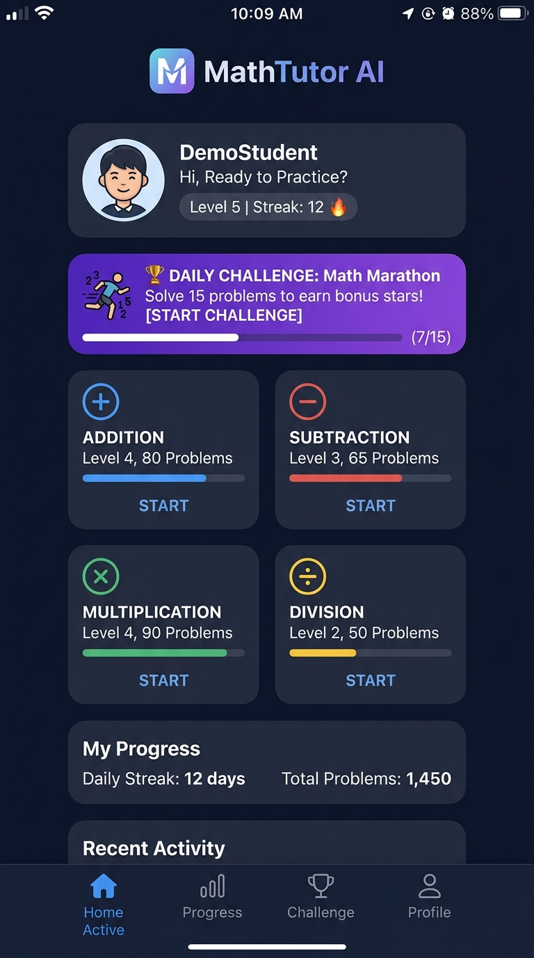
Figure 2: Addition Practice Screen (Question Card, Multiple Choice Grid, Voice & Hint Buttons)
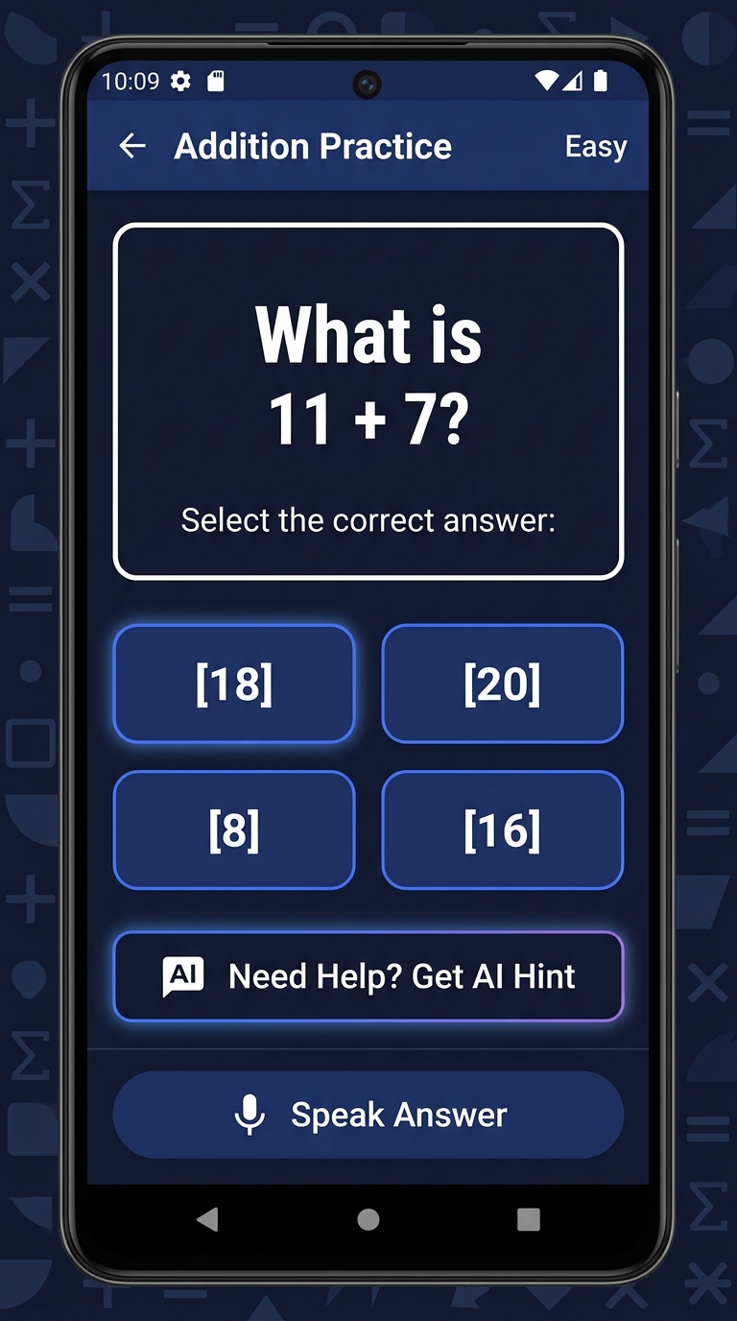
Figure 3: AI Tutor Chat Screen (Professor Owl Interactive Step-by-Step Explanation)
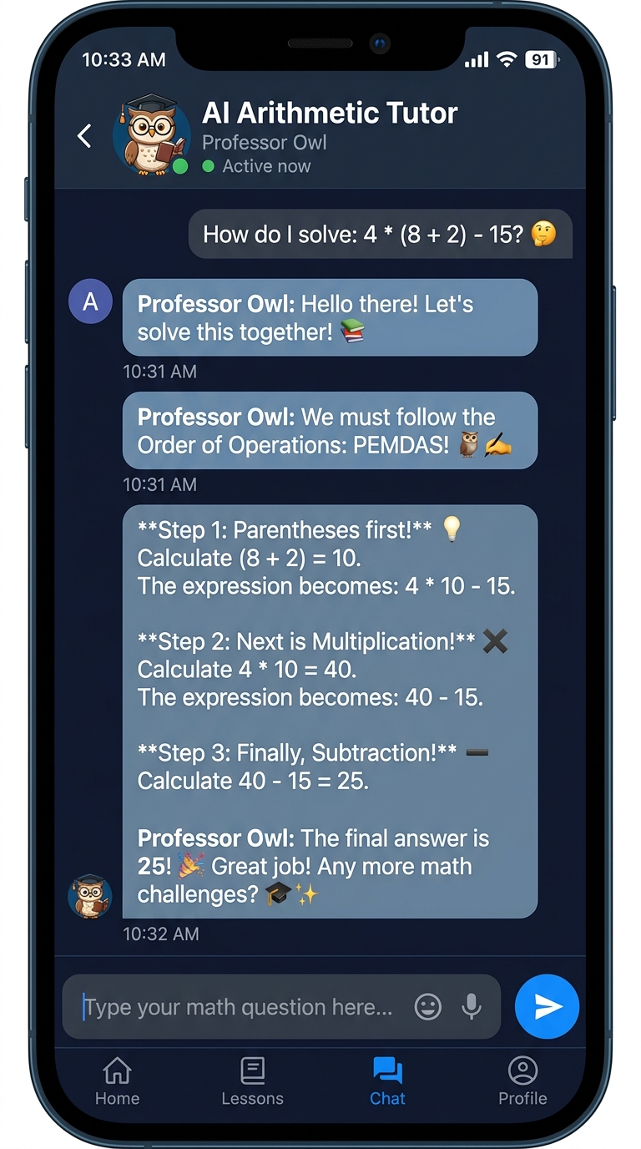
Figure 4: Learning Progress & Analytics Screen (Operation Mastery Bars & Accuracy Chart)
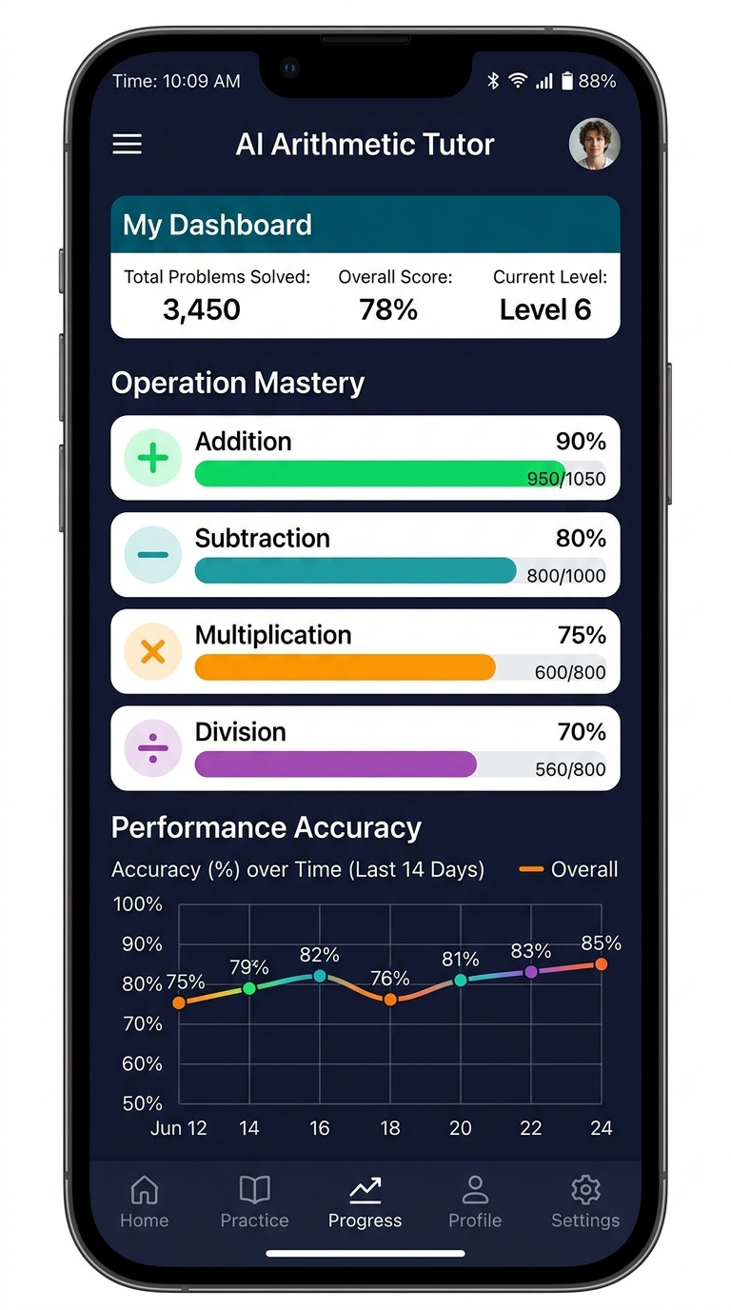
Figure 5: Profile & Settings Screen (DemoStudent Avatar, Grade Selector, Gemini API Input, PDF Export)
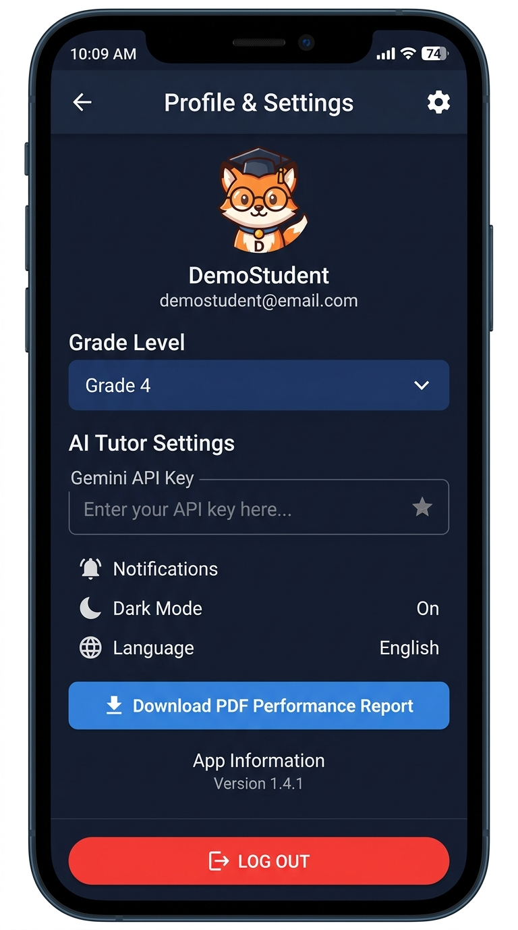

STUDENT NAME: KUSHALL THORAT | ROLL NO - 39038

6. OUTPUT & DEMONSTRATION:
The AI Arithmetic Tutor system produces real-time interactive outputs across practice sessions, AI tutor chats, and PDF report downloads.
Sample Output 1: AI Tutor Step-by-Step Mistake Breakdown
Input Problem: 14 + 8
Student Answer: 20 (Incorrect)
Correct Answer: 22
AI Professor Owl Explanation Output:
----------------------------------------------------------------------
🦉 Professor Owl's Step-by-Step Breakdown:
Great effort trying 14 + 8! Mistakes are just steps on the path to mastery.
Step 1: Start with the First Number -> Imagine you have 14 blocks.
Step 2: Add the Second Number -> Count forward 8 more: 14 + 1 + 1 + 1 + 1...
Step 3: Combine Total -> Combining 14 and 8 gives exactly 22!
Tip: You typed 20. You were very close! Check your ones column again.
----------------------------------------------------------------------
Sample Output 2: PDF Academic Performance Report Export
Generated Document: AI_Tutor_Report_DemoStudent.pdf
Student Summary: DemoStudent | Grade Level: Grade 4 | XP: 240 ⭐ | Streak: 3 Days 🔥
Operation Mastery:
- Addition: 20 Attempted, 18 Correct (90.0% Accuracy) [Level 3 ★★★☆☆]
- Subtraction: 15 Attempted, 12 Correct (80.0% Accuracy) [Level 2 ★★☆☆☆]
- Multiplication: 12 Attempted, 9 Correct (75.0% Accuracy) [Level 2 ★★☆☆☆]
- Division: 10 Attempted, 7 Correct (70.0% Accuracy) [Level 1 ★☆☆☆☆]
Badges Earned: 🚀 First Step, 🔥 On Fire
AI Recommendation: 'DemoStudent demonstrates solid consistency in fundamental addition. Recommended focus: Timed mixed division regrouping to achieve Level 3 mastery!'

