**Veer Narmad South Gujarat University, Surat.**

**Department of Information and Communication Technology**

**M.Sc. (Information Technology) Programme**

# Project Report

**8th Semester**

**M.Sc. (Information Technology)**

**5 Year Integrated Course**

Year 2022 – 2023

## Tour Booking System

|  |  |
| --- | --- |
| Guided By :  **Dr. Kamlendu Pandey (Internal Guide)** | Submitted By :  **Kushal Majiwala (E19110018000610059)**  **Samarth Dastanwala (E19110018000610019)** |

**Veer Narmad South Gujarat University, Surat.**

**Department of Information and Communication Technology**

**M.Sc. (Information Technology) Programme**

##### **Certificate**

This is to certify that Mr. **Kushal Majiwala** with Exam Seat Number: **16** and PG Registration Number: **E19110018000610059** has worked on his part time project work entitled **Tour Booking System** at **Department of ICT, VNSGU** as a partial fulfillment of the requirements for 8th ***Semester - M.Sc. (Information Technology) [5 Year Integrated course]***, during the academic Year 2022-2023.

Date : 21/12/2022

Place : Dept. of ICT, VNSGU, Surat.

|  |  |
| --- | --- |
| **Internal Project Guide**  **M.Sc.(I.T.) 7th Semester**  **Department of I.C.T.**  **Veer Narmad** **South Gujarat University, Surat** | **Head of the Department**  **Department of I.C.T.**  **Veer Narmad** **South Gujarat University, Surat** |

**Veer Narmad South Gujarat University, Surat.**

**Department of Information and Communication Technology**

**M.Sc. (Information Technology) Programme**

##### **Certificate**

This is to certify that Mr. **Samarth Dastanwala** with Exam Seat Number: **6** and PG Registration Number: **E19110018000610059** has worked on his part time project work entitled **Tour Booking System** at **Department of ICT, VNSGU** as a partial fulfillment of the requirements for 8th ***Semester - M.Sc. (Information Technology) [5 Year Integrated course]***, during the academic Year 2022-2023.

Date : 21/12/2022

Place : Dept. of ICT, VNSGU, Surat.

|  |  |
| --- | --- |
| **Internal Project Guide**  **M.Sc.(I.T.) 7th Semester**  **Department of I.C.T.**  **Veer Narmad** **South Gujarat University, Surat** | **Head of the Department**  **Department of I.C.T.**  **Veer Narmad** **South Gujarat University, Surat** |

**Index**

|  |  |  |
| --- | --- | --- |
| Sr. No | Topics | Page No |
| 1. | **Introduction** |  |
|  | 1.1 Project Profile |  |
|  | 1.2 Customer Profile |  |
|  | 1.2.1 Current System – about the existing system |  |
|  | 1.2.2 Customer Details |  |
| 2. | **Proposed System** |  |
|  | 2.1 Scope |  |
|  | 2.2 Objective |  |
|  | 2.3 Constraints |  |
|  | 2.3.1 H/W Constraints |  |
|  | 2.3.2 S/W Constraints |  |
|  | 2.4 Advantages |  |
|  | 2.5 Limitations |  |
| 3. | **Environment Specification** |  |
|  | 3.1 Hardware & Software Requirements |  |
|  | 3.2 Development Description |  |
| 4. | **System Planning** |  |
|  | 4.1 Feasibility Study |  |
|  | 4.2 Software Engineering Model |  |
|  | 4.3 Risk Analysis |  |
|  | 4.4 Project Schedule |  |
|  | 4.4.1 Task Dependency |  |
|  | 4.4.2 Timeline Chart |  |
| 5. | **System Analysis** |  |
|  | 5.1 Detailed SRS |  |
|  | 5.2 UML Diagram |  |
|  | 5.2.1 Use Case Diagram |  |
|  | 5.2.2 Class Diagram |  |
|  | 5.2.3 Activity Diagram |  |
|  | 5.2.4 Sequence Diagram |  |
|  | 5.3 E-R Diagram |  |
| 6. | **Software Design** |  |
|  | 6.1 Database Design |  |
|  | 6.2 Interface Design |  |
| 7. | **Testing** |  |
|  | 7.1 Unit Testing |  |
|  | 7.2 Integration Testing |  |
| 8. | **Future Enhancement** |  |
| 9. | **Reference** |  |

**1 – Introduction**

* 1. **Project Profile (Tour Booking System) :-**

This System is Web Application, that helps people to book tours where they want to go.

We Offer Some good places in affordable range for the middle class people. So people can visit our application and search for the tours they want to visit and can book the tour whichever they like.

* 1. **Customer Profile :-**

Cutomer Profile contains what kind of customers can use the application and what they can achieve from the application.

**2– Proposed System**

**2.1) Scope :-**

Tour Booking System is the playform for booking different tours which are available in our travels. If you are looking for going on a tour on your vacation, try using our application. Our application is easy to use for booking the tour. You can see all available tours without login.

**2.2) Objectives :-**

Anyone from anywhere can signup and use the application to Book any of the available tours.

**2.3) Constraints :-**

**2.3.1) H/W Constraints :-**

This application may not work in the old hardwares which are outdated.

**2.3.2) S/W Constraints :-**

You need to be logged in into the application in order to Book any of the available tours. Without logging in user can only view the available tours.

**2.4) Advantages :-**

* User Friendly User Interface.
* Easy to use Application.
* Easy to book tour.
* Affordable your price
* User can view the location of the tour place.

**2.5) Limitations :-**

Currently there are only limited tours available on our application. If any tour comes then it will be available on the application.

**3 – Environment Specification**

**3.1) Hardware and Software Requirements :-**

1. Hardware Requirements :-

* Processor : Intel Core 2 Duo Onwards
* RAM : 512 MB Onwards
* Hard Disk : Minimum 20GB

1. Software Requirements :-

* Operating System: Any OS from Windows, Linux or MacOS
* Web Browser : Any Web browser such as Google Chrome, Firefox or Microsoft Edge

**3.2) Development Description :-**

1. Back-End Technologies :-

* Java (Programming Language)
* MySql
* Spring Book (Rest Services)

1. Frontend Technologies :-

* Bootstrap
* JSF (Java Server Faces)
* Primefaces (Design Framework)
* CSS

1. Deployment :-

* Gitlab (For Project Managerment)

1. IDEs And Code Editors :-

* Netbeans 15

1. **– System Planning**

**4.1) Feasibility Study :-**

* A Feasibility study is an assessment of the practicality of a project or system.
* The feasibility of our project has been judged on the basis of time, technology, resources available, behavioural feasibility & cost of development.

**4.2) Software Engineering Model :-**

* This Software is developed using Agile Feature-Driven Development(FDD), The main motive of Feature-Driven Development is to provide timely updated and working software to the client. In FDD, reporting and progress tracking is necessary at all levels.

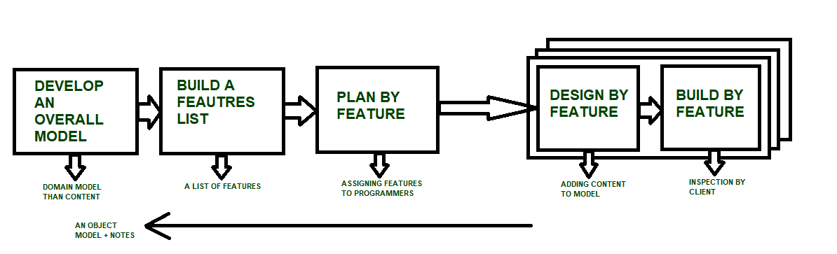

**4.3) Risk Analysis :-**

* Risk analysis involves examining how project outcomes and objectives might change due to the impact of the risk event.
* We Identified certain threats which can be harmful to the application and found the solution to that threats in order to smooth running of the application.

**4.4) Project Schedule :-**

* A Project Schedule is a listing of a project’s milestones, activities, and deliverables.

**4.4.1) Task Dependency :-**

* Task dependencies represent the order in which tasks must be performed. Dependencies enable you to work out the optimal task order, providing the fastest route through the project.
* We created the list of tasks and features and identified which task should be done first and which will be done after that so we created the order for each of the tasks and features.

**4.4.2) Timeline Chart :-**

* Timeline charts aim to describe the chronological order of past and future events on a time scale. In project management, this type of chart is often used to oversee team workload and understand the overall progress of a specific project.
* We created the number of tasks and features as per the due date of our project. So that all the requirements and features can be completed within that time period.

1. **– System Analysis**

5.1) Detailed SRS (Software Requirement Specification) :-

* A software requirements specification (SRS) is a document that describes what the software will do and how it will be expected to perform.

**Functional Requirements**

* Authentication :-

Those Users who have already registered themselves they can go to their dashboard by signing in using their username and password.

* Password Policy :-

A password policy is that in which the system does not allow the user to create password that is less than 8 characters long.

* Resource Activity :-

A User can Book and add the item to the cart and After payment for the tour user will be able to see his status. And User will also be able to remove cart item or cancel tour booking

* Edit Profile :-

A user can edit his profile or edit his password after user is logged in to the application

* Give Feedback :-

A user can give feedback and rating to the application.

* Add Complaint :-

A user can add complaint to the admin if user finds something wrong.

* View History:-

A user can view their history after the specific your is ended.

**Non-Functional Requirements**

* Portability :-

As this software is to work on multiple platforms and on different devices we ensured that application works properly on different screen size.

* User Friendly Interface :-

To make this application to reach maximum number of users we need to create a user friendly interface so that a person with low computer skill can also access it.

* Reusability :

The repository concept for database access allow us to reuse the same service provider to perform various task. We need not to code same block again and again.

* *Stability :*

As user requirements may change, the modules will be stable over time.

5.2) UML Diagram :-

* The Unified Modeling Language is a generatal-purpose, developmental modelling language in the field software enginnering that is intended to provide a standard way to visualize the design of a system.

5.2.1) Use Case Diagram (Tour Booking System) :-

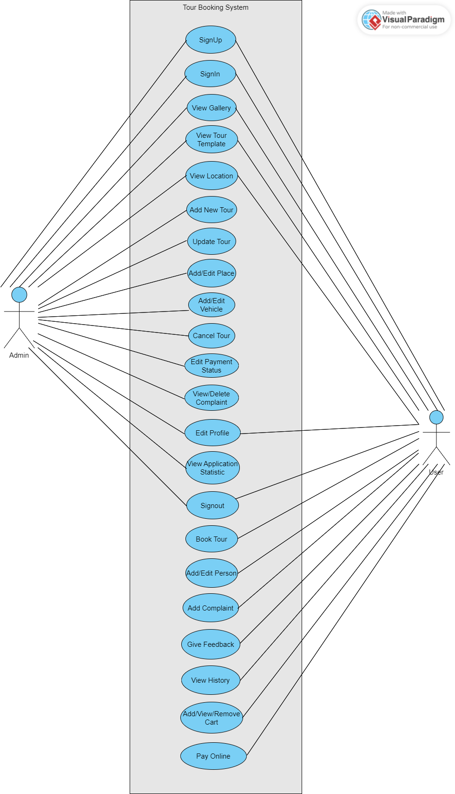

5.2.2) Class Diagram (Tour Booking System):-

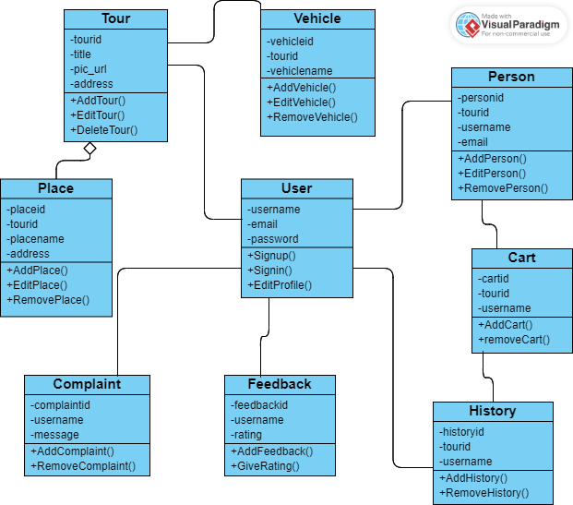

5.2.3) Activity Diagram (CV Management System):-

🡪Activity Diagram **(Login) :-**

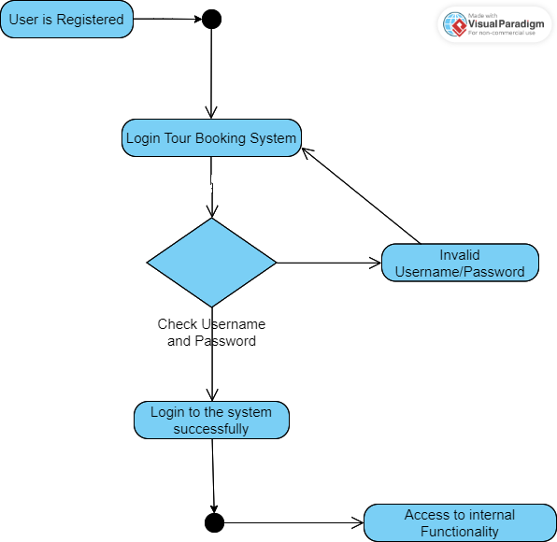

🡪Activity Diagram **(Admin):-**

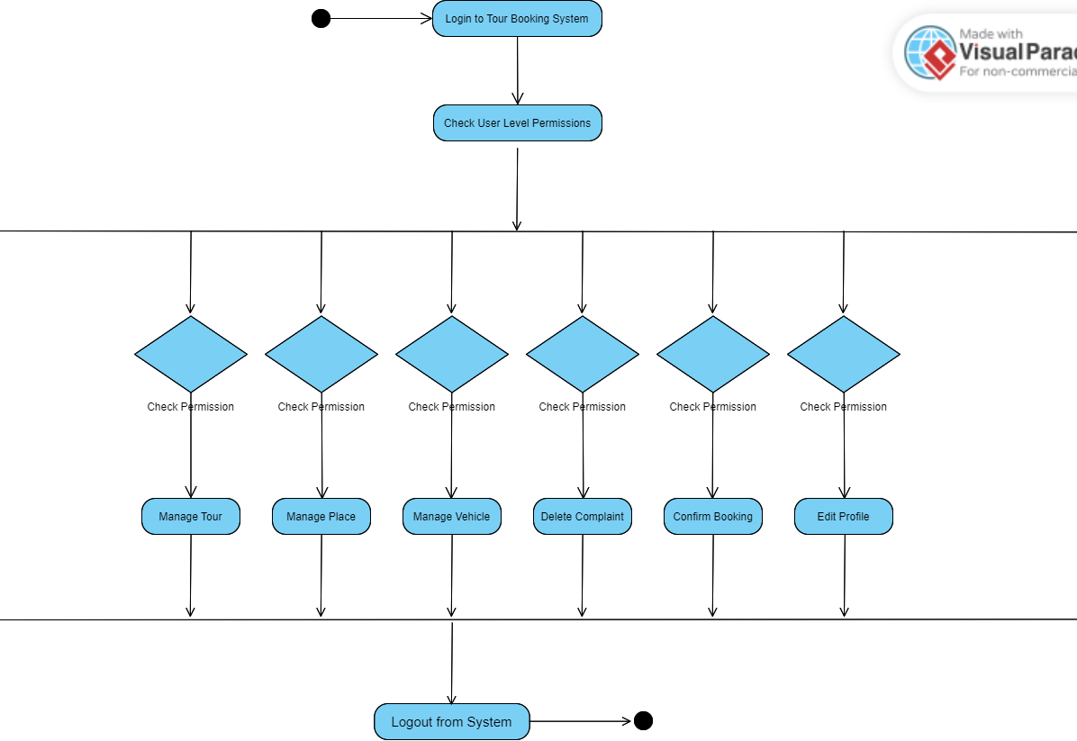

🡪Activity Diagram **(User):-**

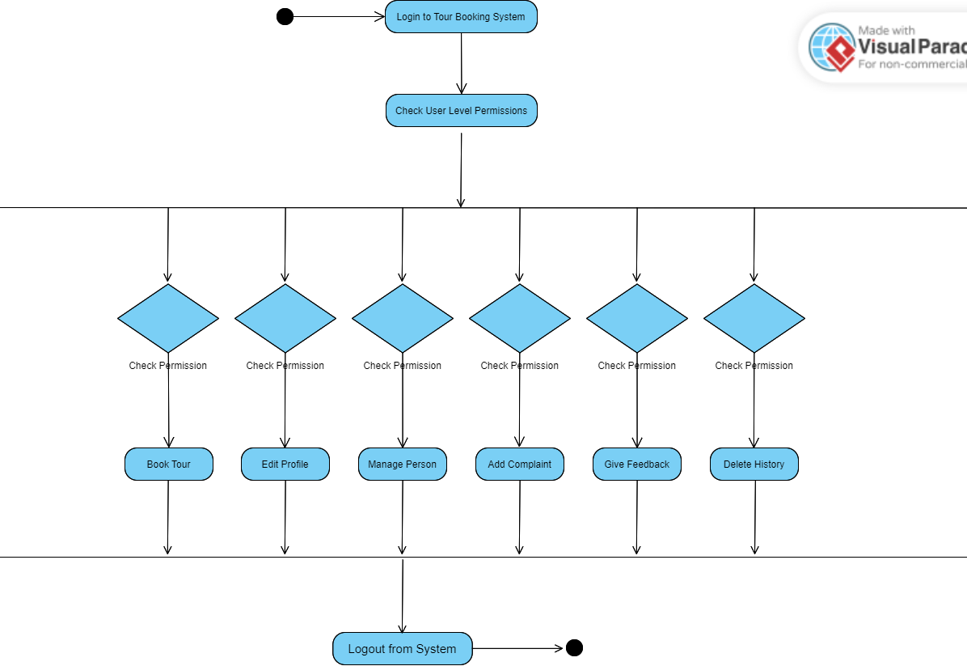

5.2.4) Sequence Diagram (Tour Booking System):-

🡪Sequence Diagram **(Sign In) :-**

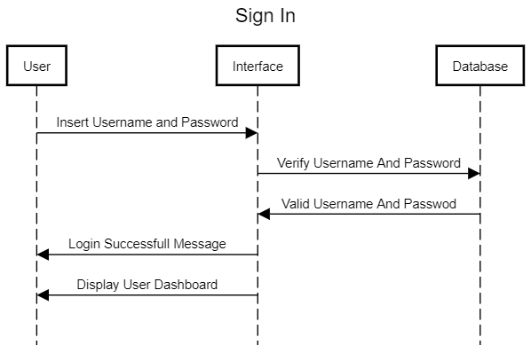

🡪Sequence Diagram **(Admin) :-**

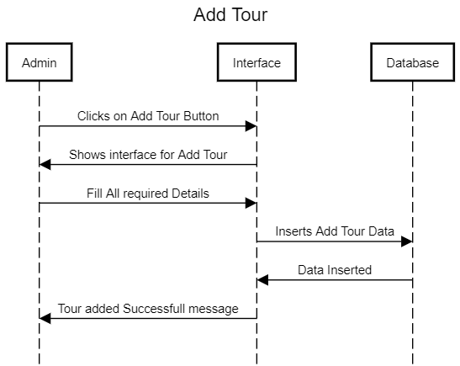

🡪Sequence Diagram **(Admin) :-**

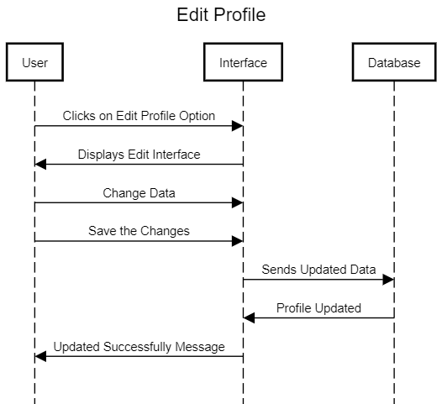

🡪Sequence Diagram **(Admin) :-**

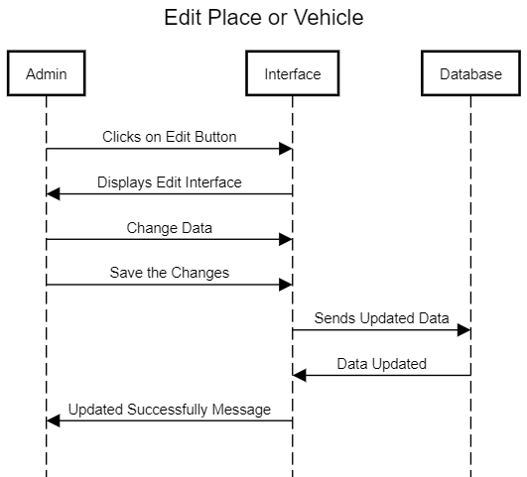

🡪Sequence Diagram **(Admin) :-**

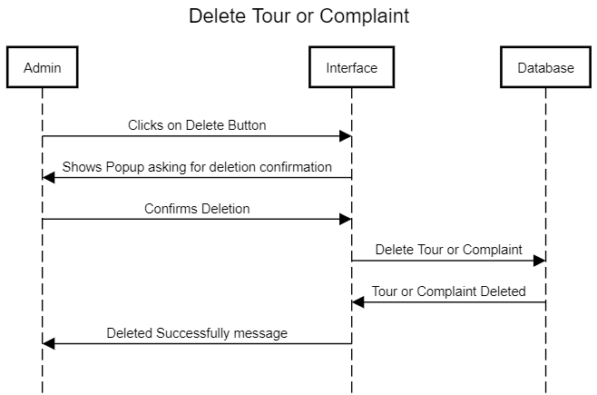

🡪Sequence Diagram **(User) :-**

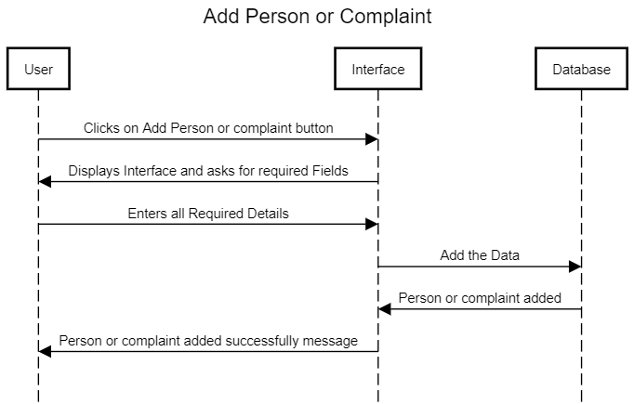

🡪Sequence Diagram **(User) :-**

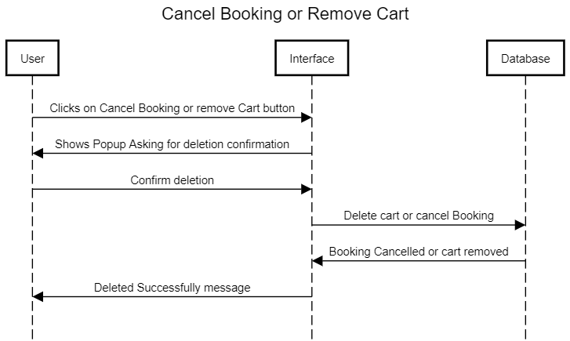

🡪Sequence Diagram **(User) :-**

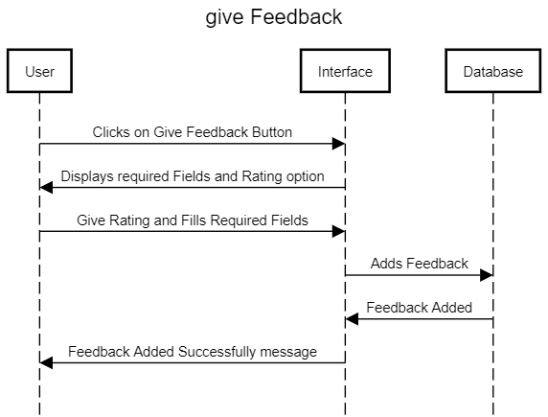

🡪ER Diagram **(Tour Booking System) :-**

