I have selected **Task 2**

P.S: **UNEMPLOYMENT ANALYSIS WITH PYTHON**

Unemployment is measured by the unemployment rate which is the number of people who are unemployed as a percentage of the total labour force. We have seen a sharp increase in the unemployment rate during Covid-19, so analyzing the unemployment rate can be a good data science project.

**Step 1:**

Downloaded Dataset from: <https://www.kaggle.com/datasets/gokulrajkmv/unemployment-in-india>

I have selected file: 'Unemployment_Rate_upto_11_2020.csv for the analysis/

Aim of the Learning

* How Covid-19 affects the employment
* how far the unemployment rate will go

**Programing using Python**

**Importing Necessary Library**

import pandas as pd

import numpy as np

import calender

**Loading CSV file**

unemployment_data=pd.read_csv('Unemployment_Rate_upto_11_2020.csv')

unemployment_data.info()

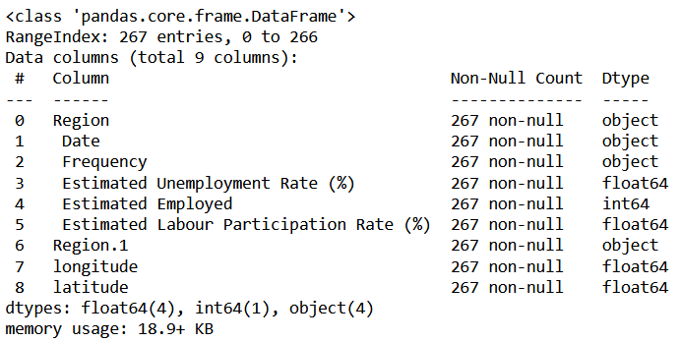

#**check for any null data**

print(unemployment_data.isnull().sum())

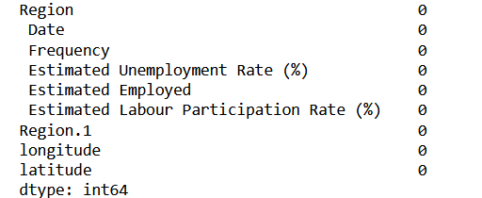

unemployment_data.count

#**updating column names**

unemployment_data.columns=['state', 'date', 'frequency', 'estimated unemployment rate', 'estimated employed', 'estimated labour participation rate', 'region', 'longitude', 'latitude']

#**print with updated columns name**

unemployment_data.head()

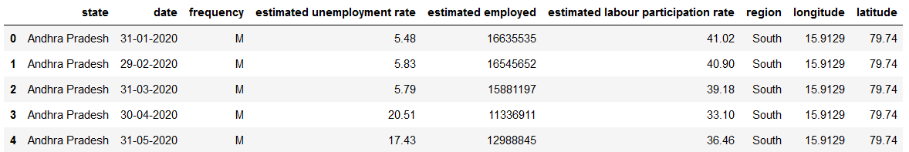

#**returns descriptive statistics about the data**

unemployment_data.describe()

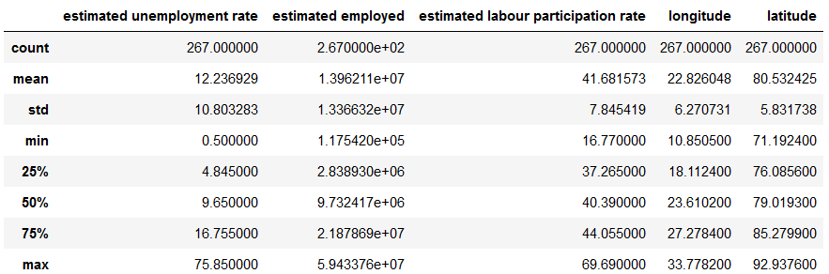

#**check whether any duplicate entry**

unemployment_data.duplicated().any()

False

#**list out statewise data count**

unemployment_data.state.value_counts()

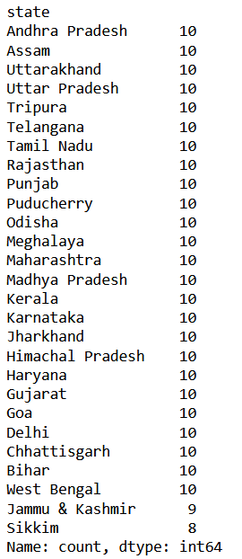

#**list out region wise data count**

unemployment_data.region.value_counts()

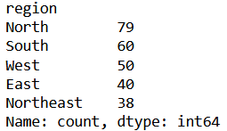

#**Changing the datatype of 'date' from object to datetime**

unemployment_data['date']=pd.to_datetime(unemployment_data['date'],dayfirst=True)

unemployment_data['month_num']=unemployment_data['date'].dt.month

unemployment_data.head()

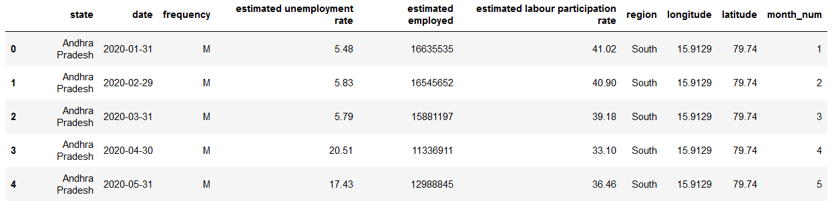

unemployment_data['month'] = unemployment_data['month_num'].apply(lambda x: calendar.month_abbr[x])

unemployment_data.head()

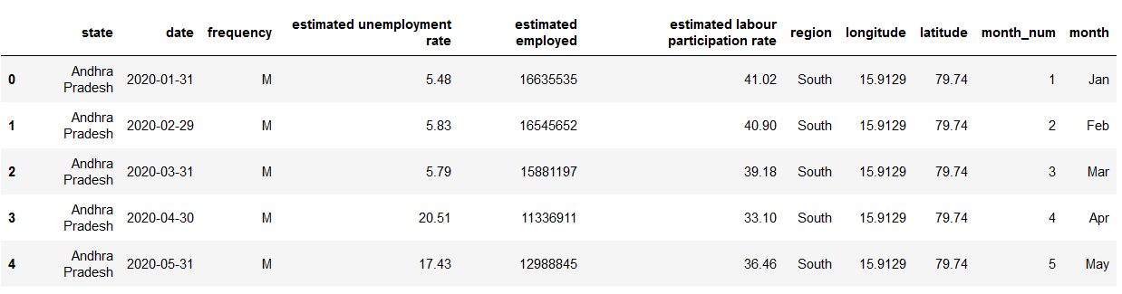

data = unemployment_data.groupby(['month'])[['estimated unemployment rate','estimated employed','estimated labour participation rate']].mean()

data=pd.DataFrame(data).reset_index()

**#plot Unemployment Rate, Labour Participation month wise**

import plotly.graph_objects as go

month = data.month

unemployment_rate = data['estimated unemployment rate']

labour_participation_rate = data['estimated labour participation rate']

#estimated_employed_data=data['estimated employed']

fig = go.Figure()

fig.add_trace(go.Bar(x = month,y = unemployment_rate,name = 'Unemployment Rate'))

fig.add_trace(go.Bar(x = month,y = labour_participation_rate,name = 'Labour Participation Rate'))

#fig.add_trace(go.Bar(x = month,y = estimated_employed_data,name = 'Estimated Employed'))

fig.update_layout(title = 'Unemployment Rate, Labour Participation month wise',

xaxis = {'categoryorder':'array','categoryarray':['Jan', 'Feb', 'Mar', 'Apr', 'May', 'Jun', 'Jul', 'Aug', 'Sep', 'Oct']} )

fig.show()

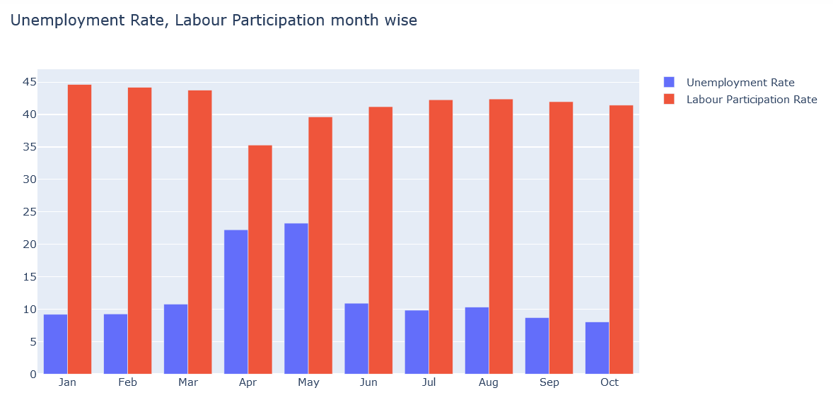

import plotly.express as px

#**plot estimated employed month wise**

fig = px.bar(data, x='month', y='estimated employed', color='month',

category_orders ={'month':['Jan', 'Feb', 'Mar', 'Apr', 'May', 'Jun', 'Jul', 'Aug', 'Sep', 'Oct']},

title='Estimated employed people from Jan 2020 to Oct 2020')

fig.show()

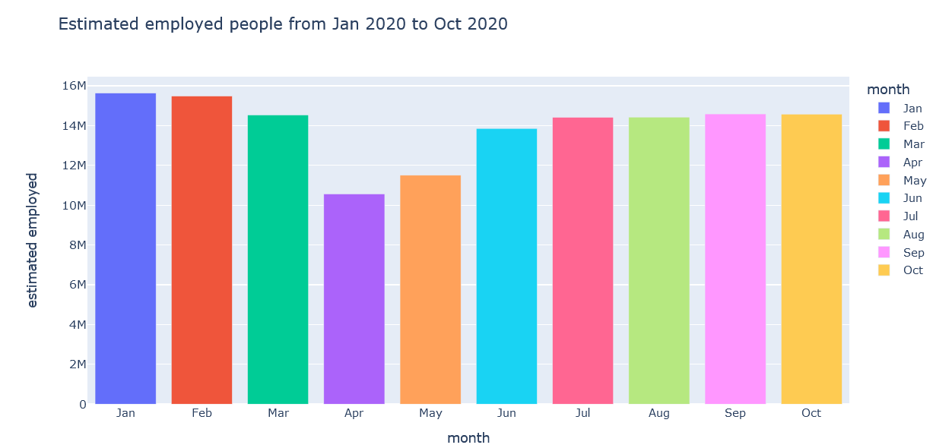

**#State wise Analysis**

state = unemployment_data.groupby(['state'])[['estimated unemployment rate','estimated employed','estimated labour participation rate']].mean()

state = pd.DataFrame(state).reset_index()

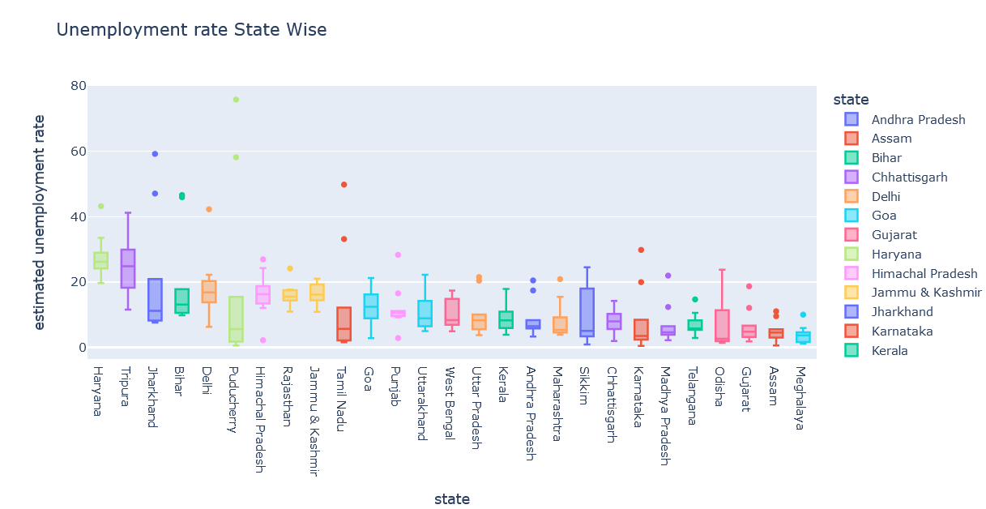

# Box plot

fig = px.box(data_frame=unemployment_data,x='state',y='estimated unemployment rate',color='state',title='Unemployment rate State Wise')

fig.update_layout(xaxis={'categoryorder':'total descending'})

fig.show()

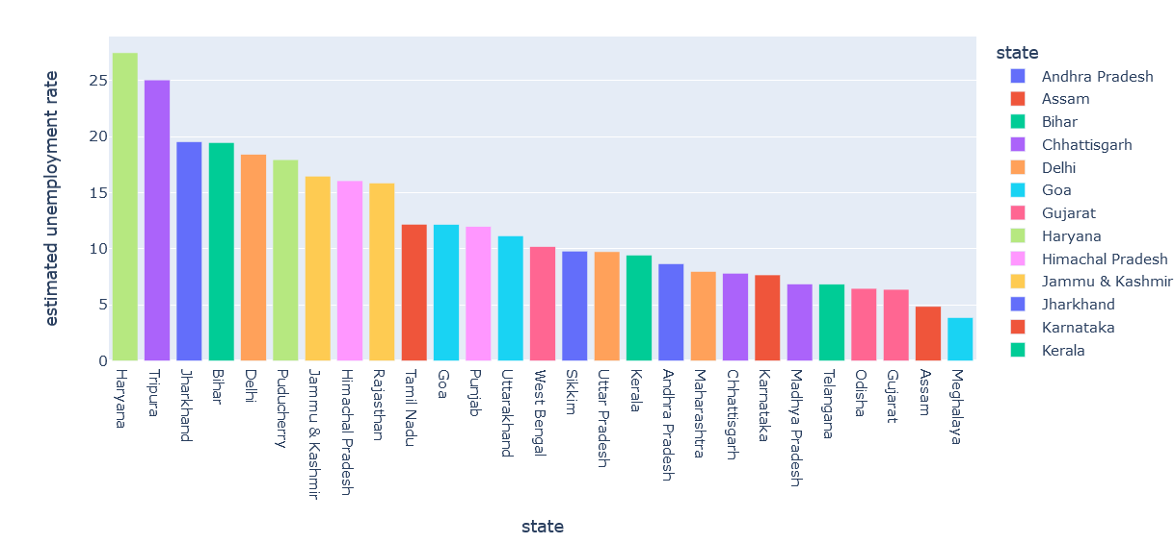

# **average unemployment rate using bar plot**

fig = px.bar(state,x='state',y='estimated unemployment rate',color='state',title='Average unemployment rate (State)')

fig.update_layout(xaxis={'categoryorder':'total descending'})

fig.show()

**#Hariyana and Tripura were having the highest average amount of Unemployment rate**

**#Meghalaya was having the lowest average amount of Unemployment rate**

# Bar plot Unemployment Rate (monthly)

fig = px.bar(unemployment_data,x='state',y='estimated unemployment rate',animation_frame='month',color='state',

title='Unemployment rate from Jan 2020 to Oct 2020(State)')

fig.update_layout(xaxis={'categoryorder':'total descending'})

fig.show()

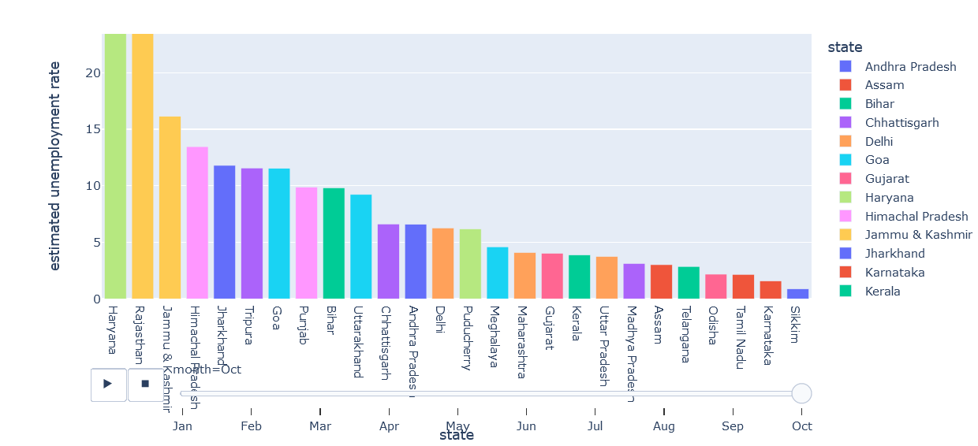

**#We can see monthwise unemployement rate at various state from Jan to Oct (Monthly Unemployment Rate)**

**#Monthly unemployment rate, By clicking play button we can see statewise unemployment rate**

fig=px.scatter_geo(unemployment_data,'longitude','latitude',color='state',

hover_name='state',size='estimated unemployment rate',

animation_frame='month',scope='asia',title='Impact of lockdown on employment in India')

fig.layout.updatemenus[0].buttons[0].args[1]['frame']['duration'] =2000

fig.update_geos(lataxis_range=[5,40],lonaxis_range=[65,100],oceancolor='blue',

showocean=True)

fig.show()

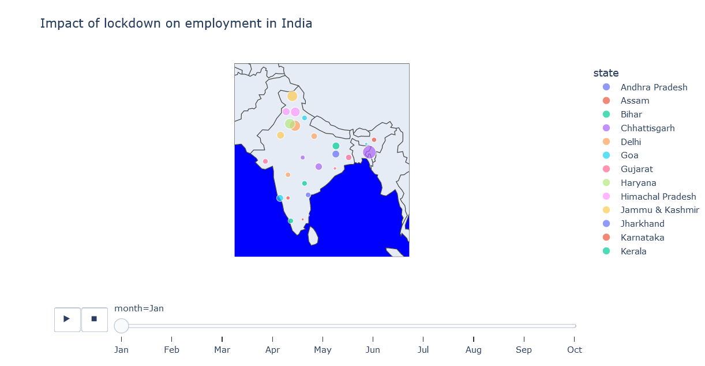

**#Regional wise Analysis**

unemployment_data.region.unique()

# data grouped by region

region = unemployment_data.groupby(['region'])[['estimated unemployment rate','estimated employed','estimated labour participation rate']].mean()

region = pd.DataFrame(region).reset_index()

#Scatter plot

pd.DataFrame.iteritems = pd.DataFrame.items

fig= px.scatter_matrix(unemployment_data,dimensions=['estimated unemployment rate'],color='region',title="Region vs Unemployement Rate")

fig.show()

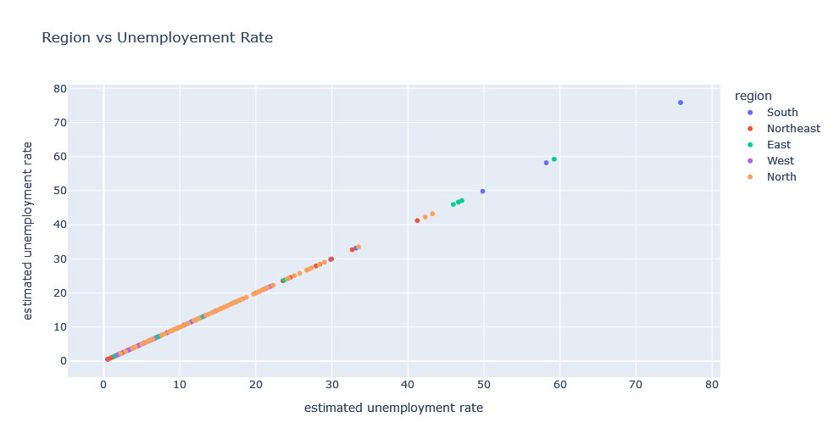

fig= px.scatter_matrix(unemployment_data,dimensions=['estimated employed'],color='region',title="Region vs estimated employed")

fig.show()

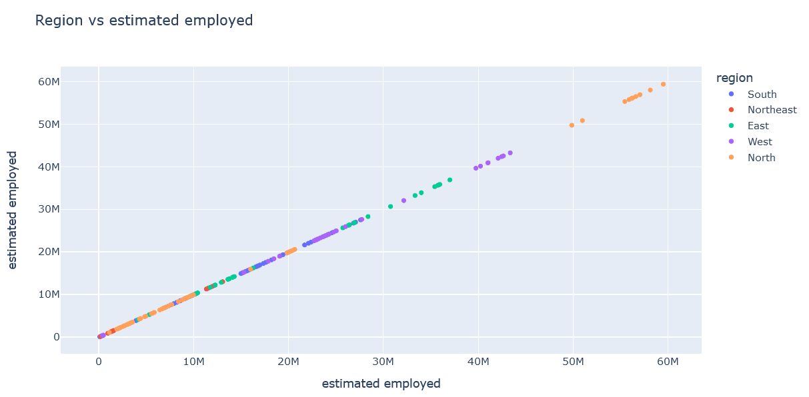

fig= px.scatter_matrix(unemployment_data,dimensions=['estimated labour participation rate'],color='region',title="Region vs estimated labour participation rate")

fig.show()

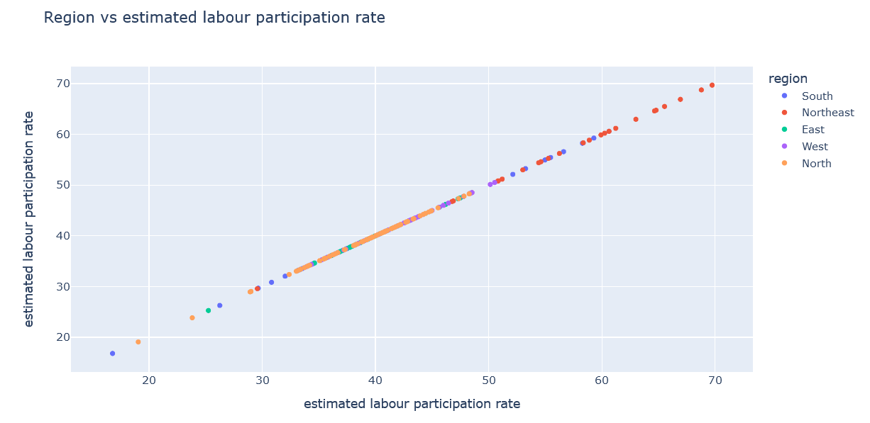

**# Average Unemployment Rate**

fig = px.bar(region,x='region',y='estimated unemployment rate',color='region',title='Average unemployment rate(region wise)')

fig.update_layout(xaxis={'categoryorder':'total descending'})

fig.show()

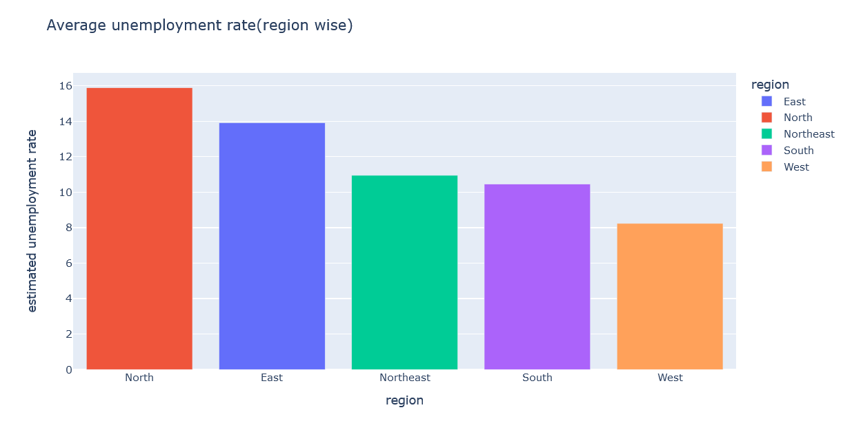

fig = px.bar(unemployment_data,x='region',y='estimated unemployment rate',animation_frame='month',color='state',

title='Unemployment rate from Jan 2020 to Oct 2020')

fig.update_layout(xaxis={'categoryorder':'total descending'})

fig.layout.updatemenus[0].buttons[0].args[1]['frame']['duration'] =2000

fig.show()

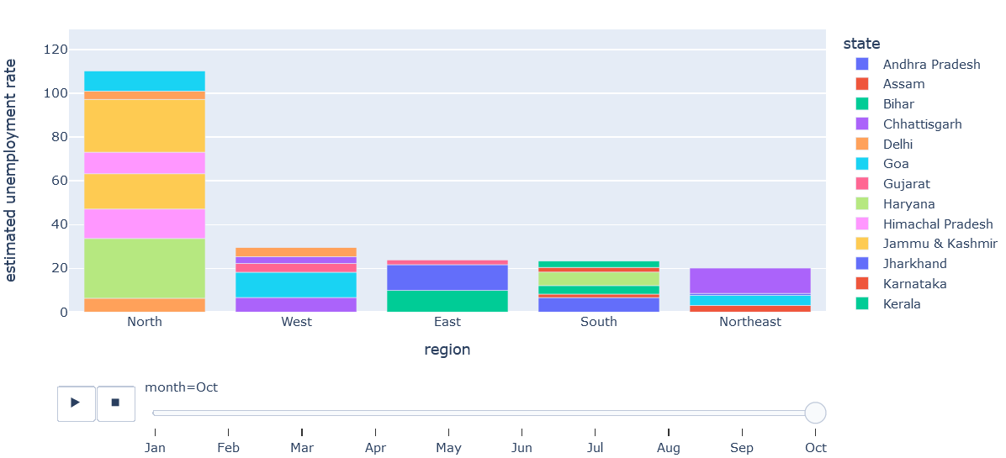

**#Region and State wise estimated unemployment Rate**

unemployment =unemployment_data.groupby(['region','state'])['estimated unemployment rate'].mean().reset_index()

unemployment.head(300)

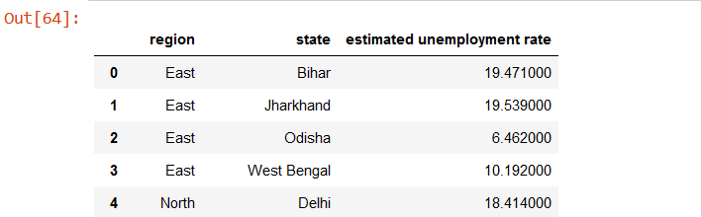

fig = px.sunburst(unemployment,path=['region','state'],values='estimated unemployment rate',

title ='Unemployment rate in state and region',height=600)

fig.show()

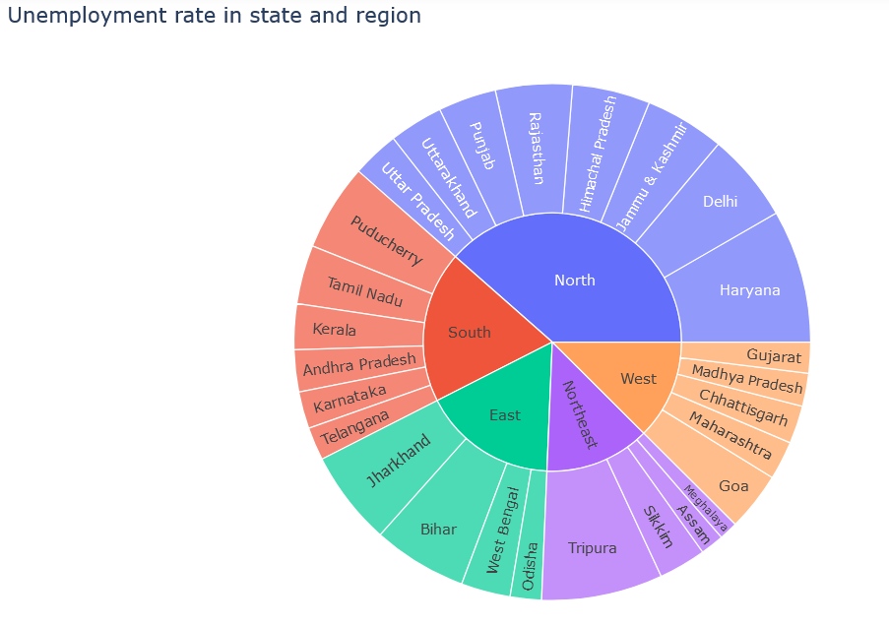

**# unemployment Rate before and after lockdown**

before_lockdown = unemployment_data[(unemployment_data['month_num']>=1) &(unemployment_data['month_num'] <4)]

after_lockdown = unemployment_data[(unemployment_data['month_num'] >=4) & (unemployment_data['month_num'] <=6)]

af_lockdown = after_lockdown.groupby('state')['estimated unemployment rate'].mean().reset_index()

lockdown = before_lockdown.groupby('state')['estimated unemployment rate'].mean().reset_index()

lockdown['unemployment rate before lockdown'] = af_lockdown['estimated unemployment rate']

lockdown.columns = ['state','unemployment rate before lockdown','unemployment rate after lockdown']

lockdown.head(26)

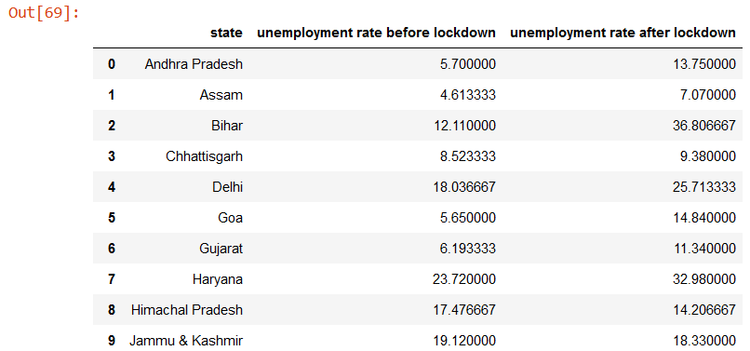

**# unenployment rate change after lockdown**

lockdown['rate change in unemployment'] =round(lockdown['unemployment rate before lockdown']-lockdown['unemployment rate before lockdown']

/lockdown['unemployment rate after lockdown'],2)

fig = px.bar(lockdown,x='state',y='rate change in unemployment',color='rate change in unemployment',

title='Percentage change in Unemployment rate in each state after lockdown',template='ggplot2')

fig.update_layout(xaxis={'categoryorder':'total ascending'})

fig.show()