Output

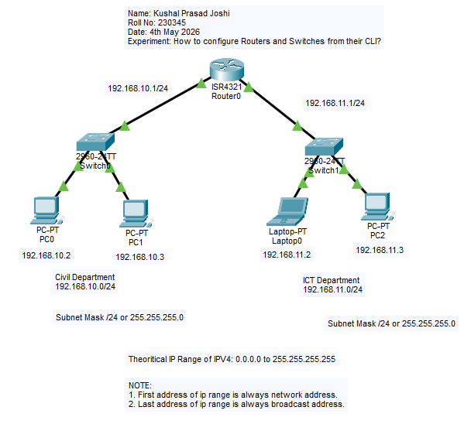
Figure 1: Configure Switch and Router with CLI

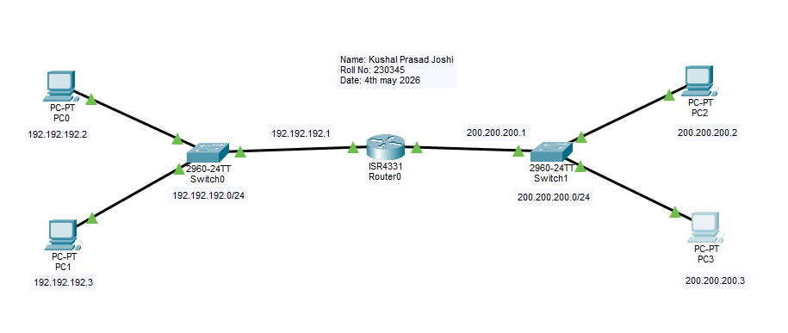
Figure 2: Configure Switch and Router with CLI practice

