Output

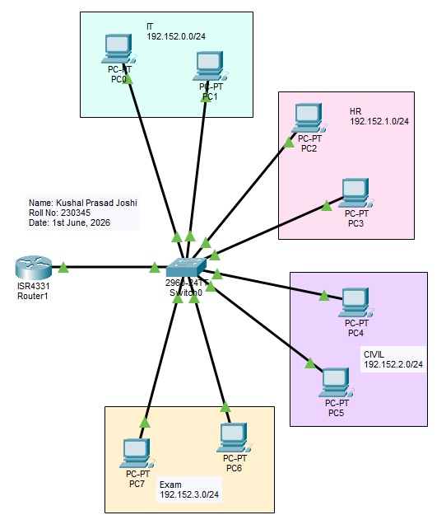
Figure 1: Multiple VLANs on single switch

