Output

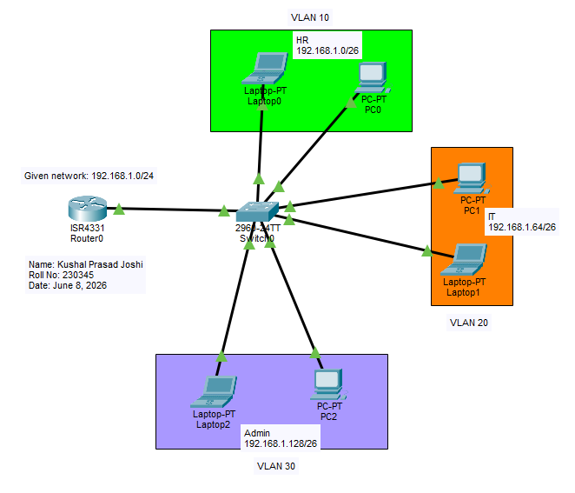
Figure 1: DHCP Configuration with 3 VLANs
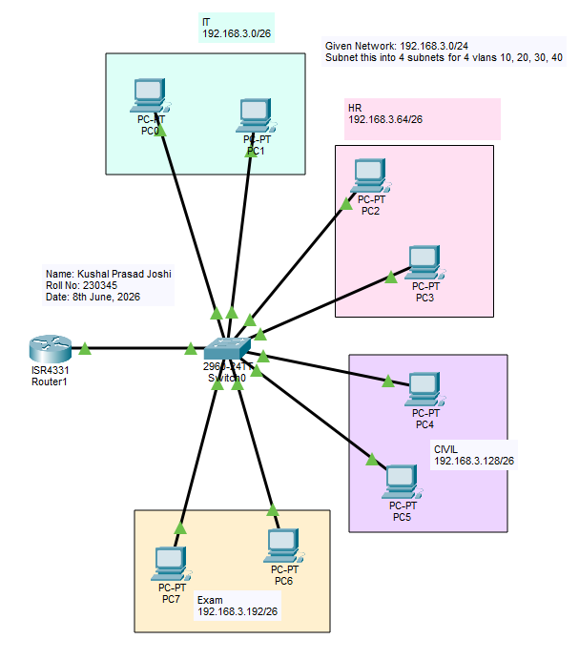
Figure 2: DHCP Configuration with 4 VLANs

