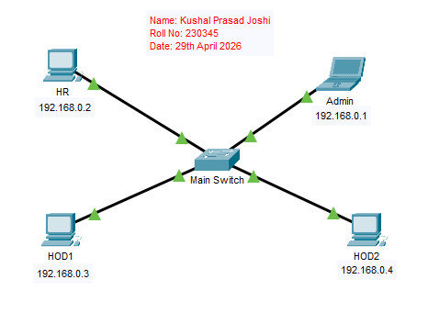
Figure 1: Single Switch Network (LAN 1)

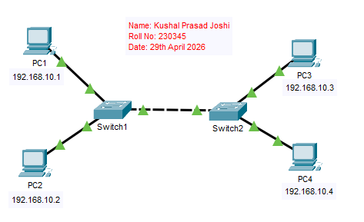
Figure 2: Multi-Switch Network (LAN 2)

