Output

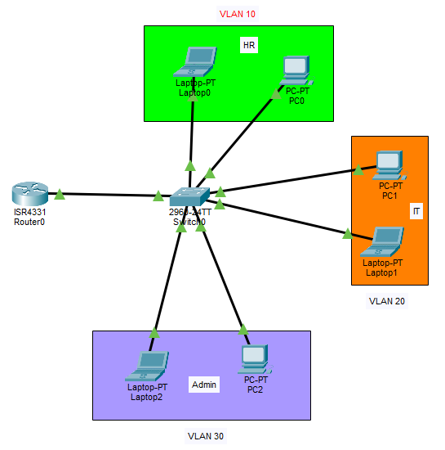
Figure 1: Virtual LANs

