Output

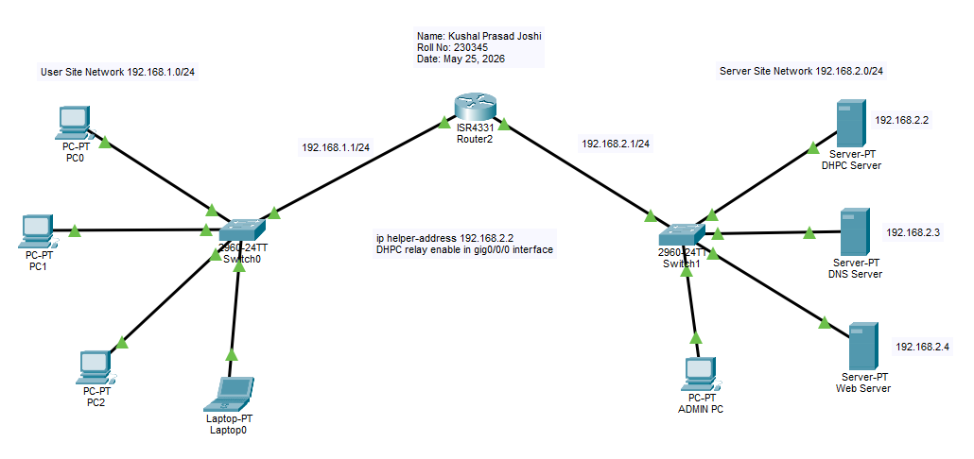
Figure 1: Configure DHCP, DNS and Web Servers

