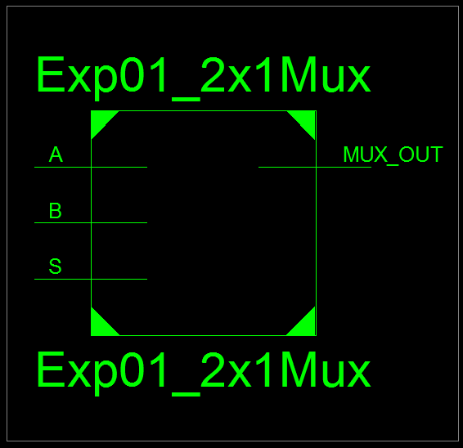
Figure 1: 2x1 Mux RTL Schematic Block
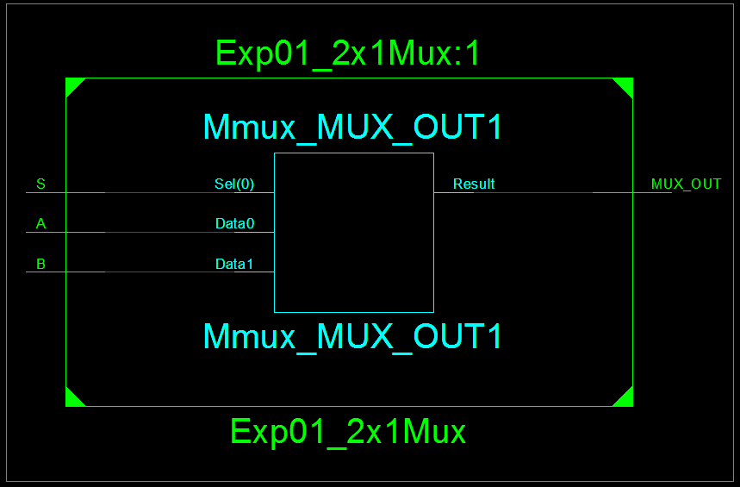
Figure 2: 2x1 Mux RTL Schematic Diagram
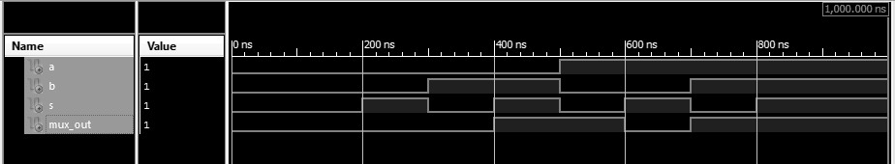
Figure 3: 2x1 Mux Test Bench
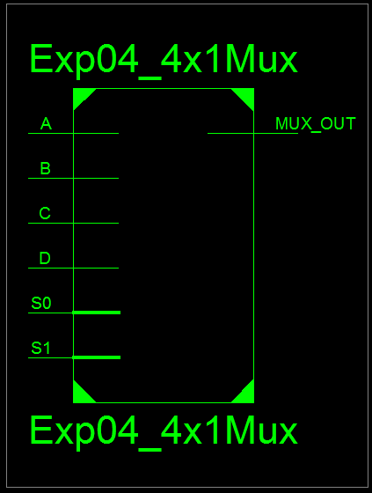
Figure 4: 4x1 Mux RTL Schematic Block
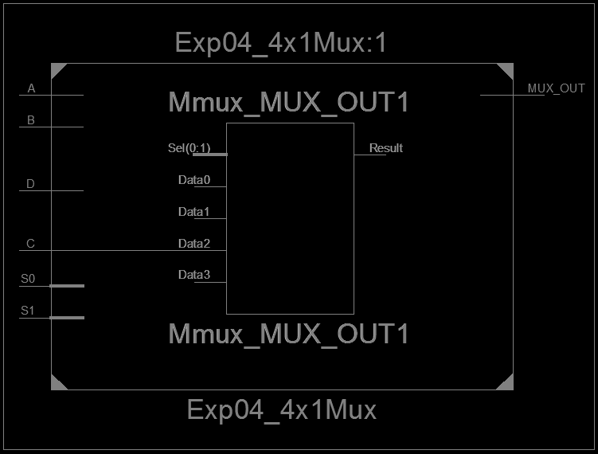
Figure 5: 4x1 Mux RTL Schematic Diagram
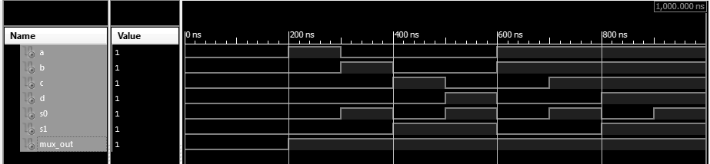
Figure 6: 4x1 Mux Test Bench

