OUTPUT

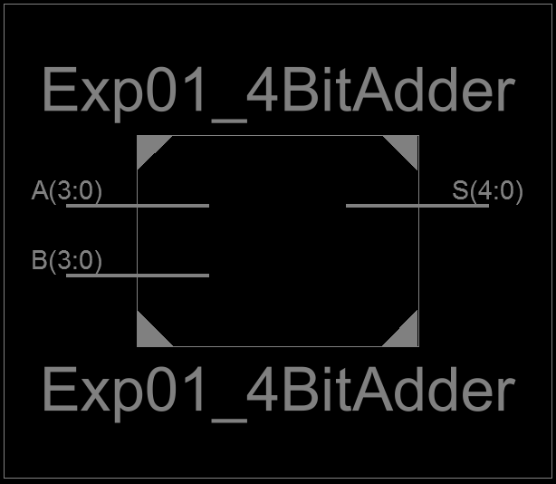
Figure 1: 4 Bit Adder Schematic Block

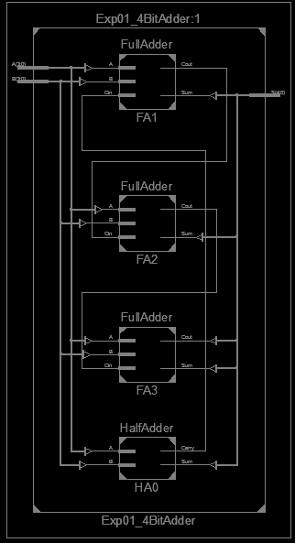
Figure 2: 4 Bit Adder RTL Schematic Diagram

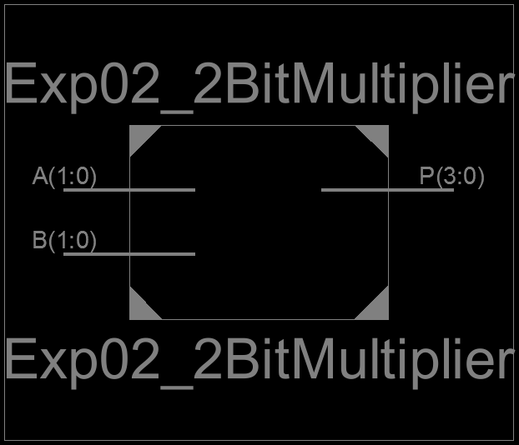
Figure 3: 2 Bit Multiplier RTL Schematic Block

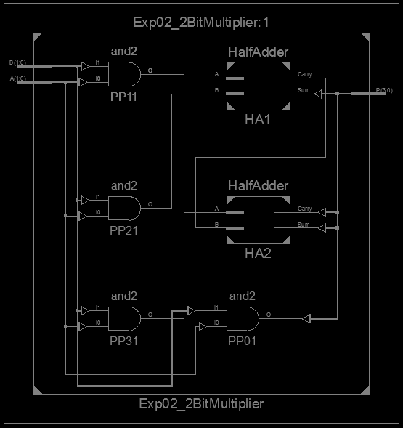
Figure 4: 2 Bit Multiplier RTL Schematic Diagram

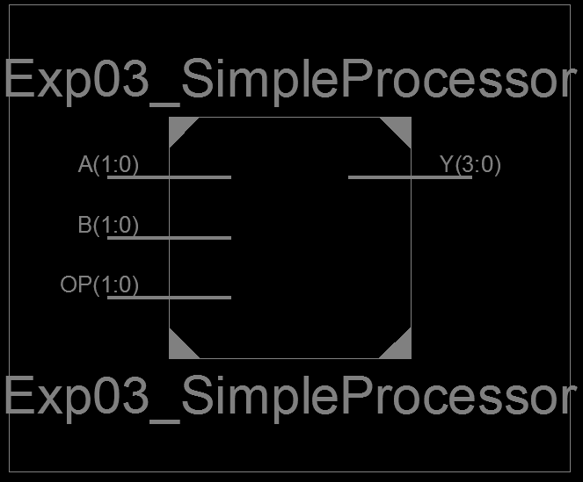
Figure 5: Simple Processor Block

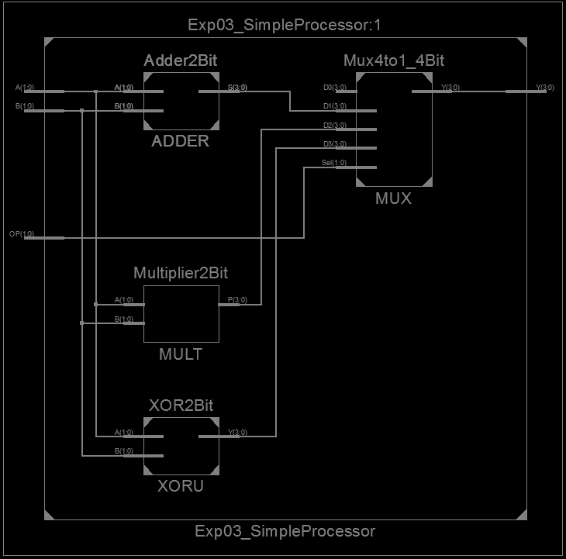
Figure 6: Simple Processor RTL Schematic Diagram

