OUTPUT

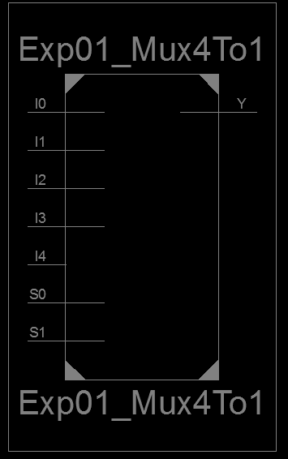
Figure 1: RTL Schematic Block of 4 to 1 Mux

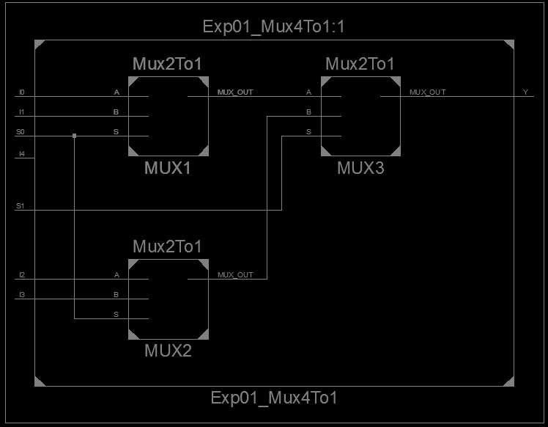
Figure 2: RTL Schematic Diagram of 4 to 1 Mux using 2 to 1 Mux

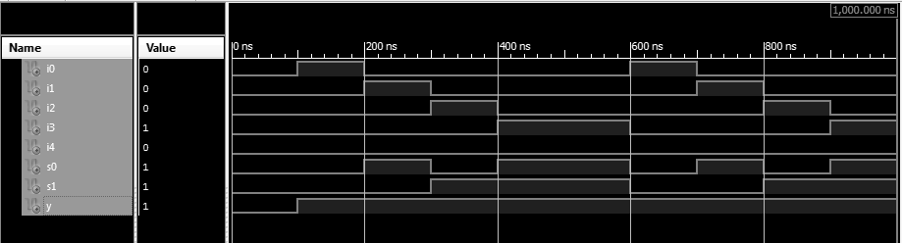
Figure 3: Test Bench of 4 to 1 Mux

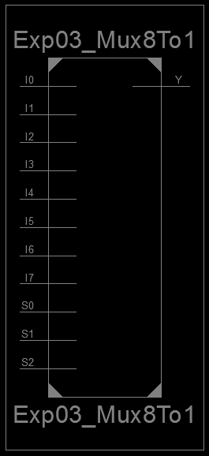
Figure 4: RTL Schematic Block of 8 to 1 Mux

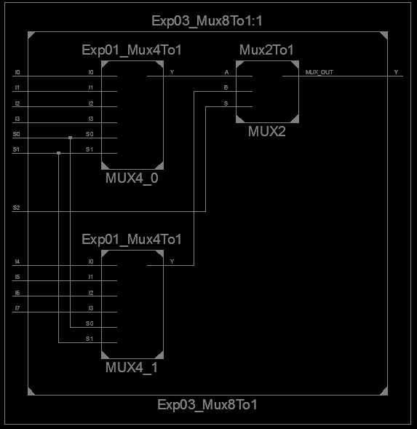
Figure 5: RTL Schematic Diagram of 8 to 1 Mux using the Muxes

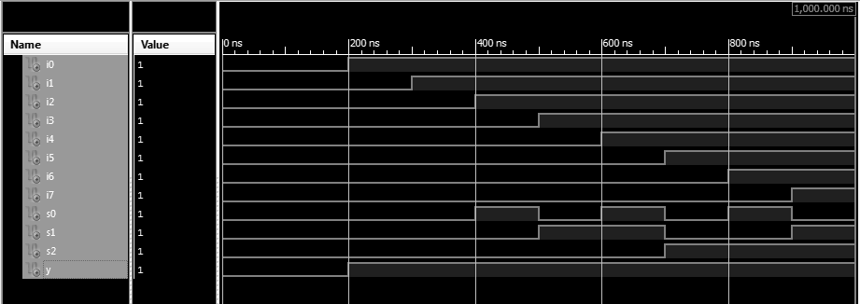
Figure 6: Test Bench of 8 to 1 Mux

