OUTPUT
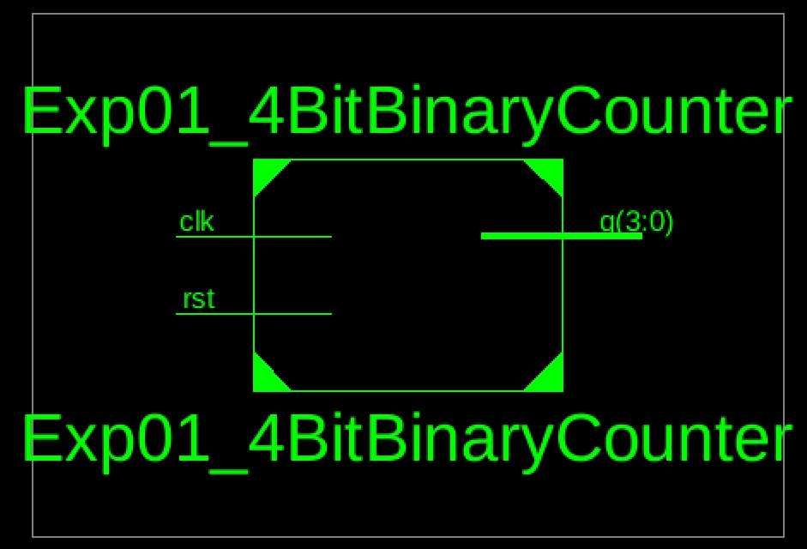
Figure 1: 4 Bit Binary Counter RTL Schematic Block
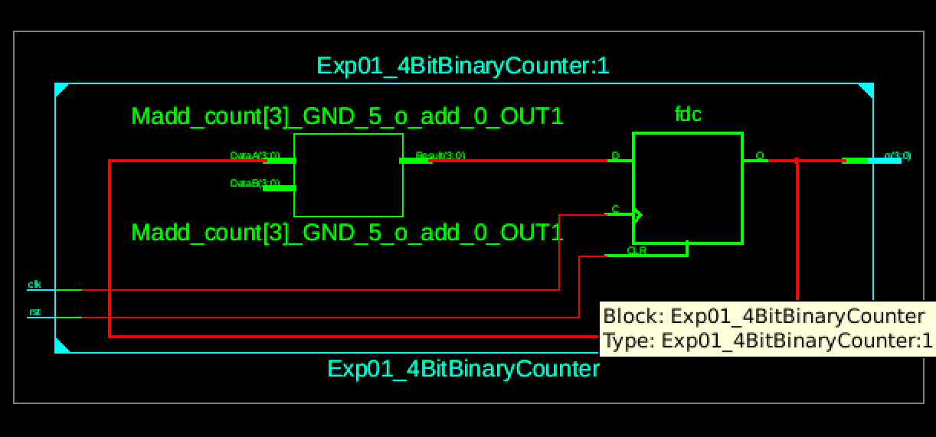
Figure 2: 4 Bit Binary Counter RTL Schematic Diagram
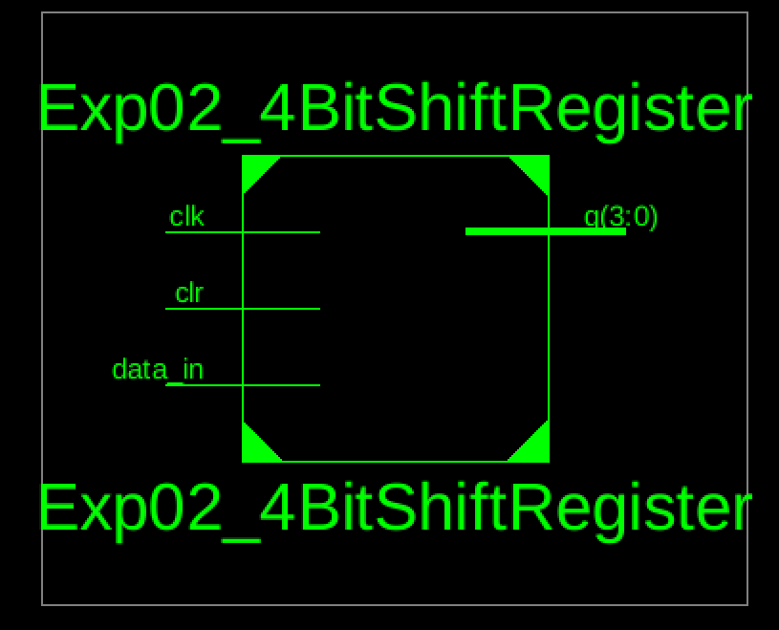
Figure 3: 4 Bit Shift Register RTL Schematic Block
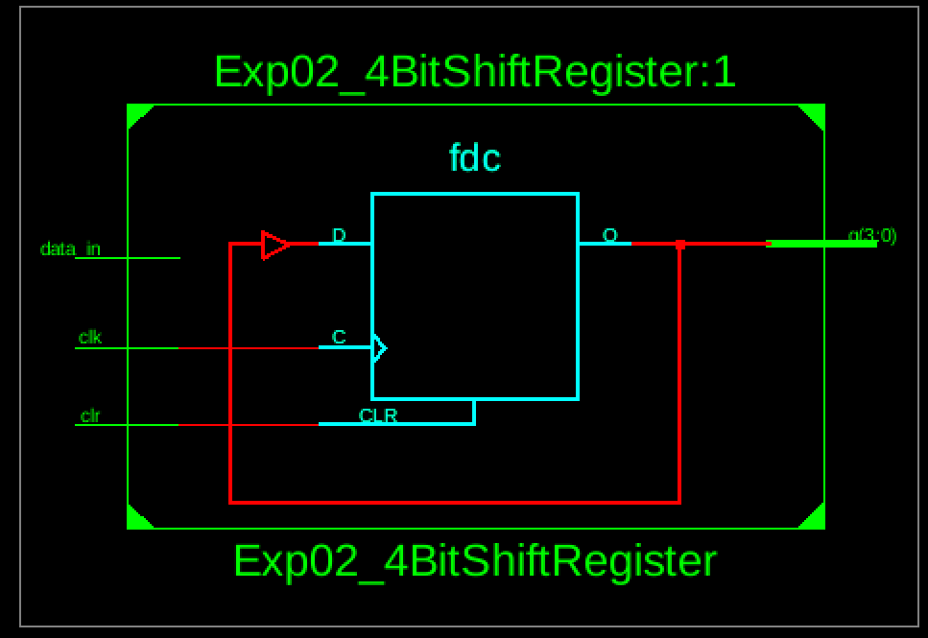
Figure 4: 4 Bit Shift Register RTL Schematic Diagram

