OUTPUT
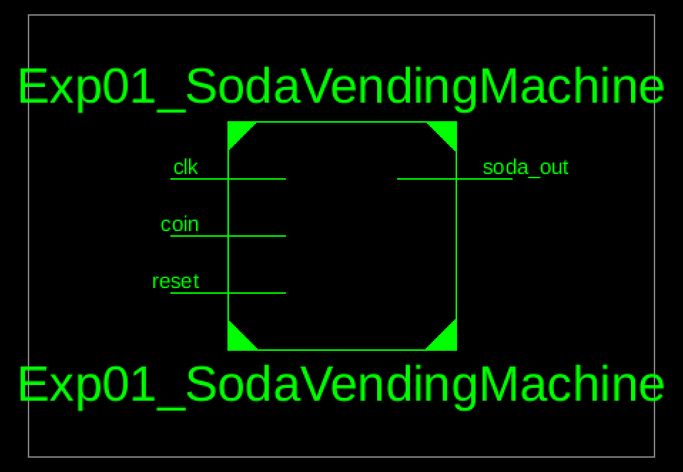
Figure 1: RTL Schematic Block of Soda Vending Machine
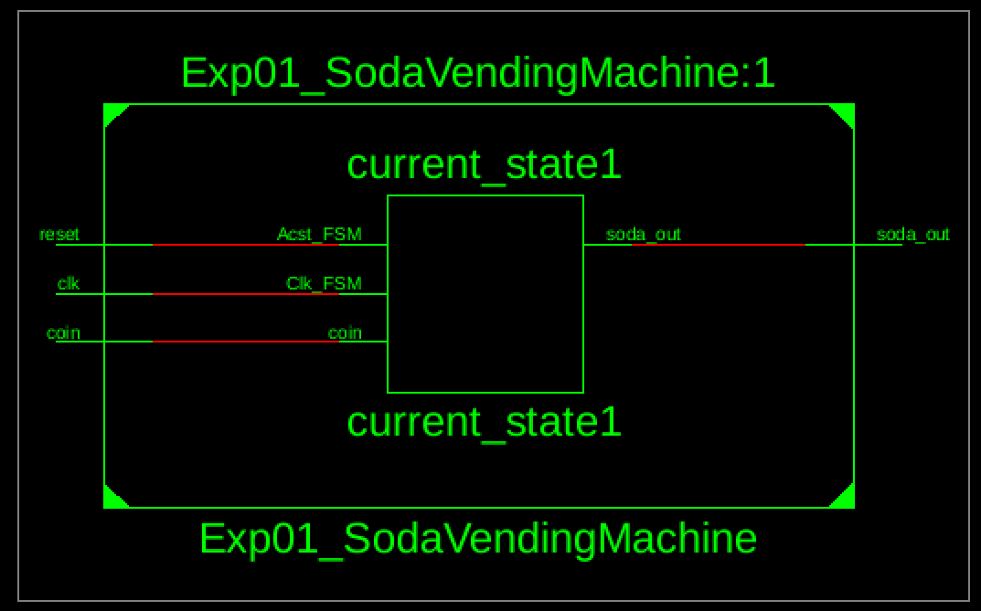
Figure 2: RTL Schematic Diagram of Soda Vending Machine

