OUTPUT

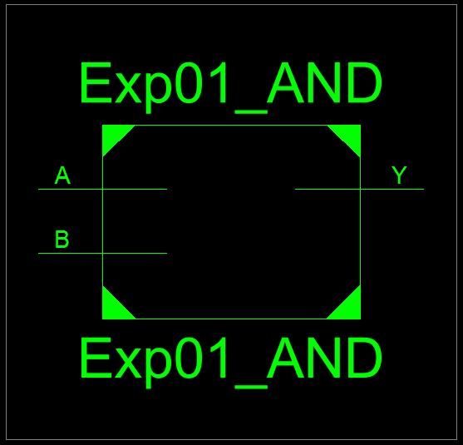
Figure 1: AND Gate RTL Schematic Block

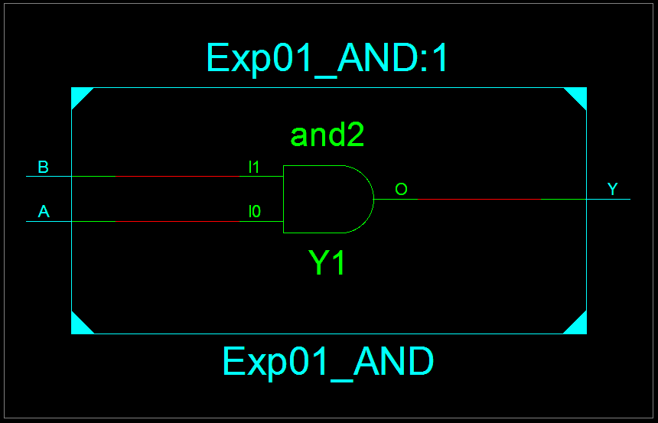
Figure 2: AND Gate RTL Schematic Diagram

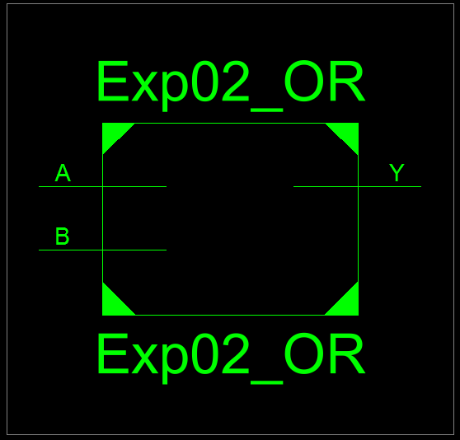
Figure 3: OR Gate RTL Schematic Block

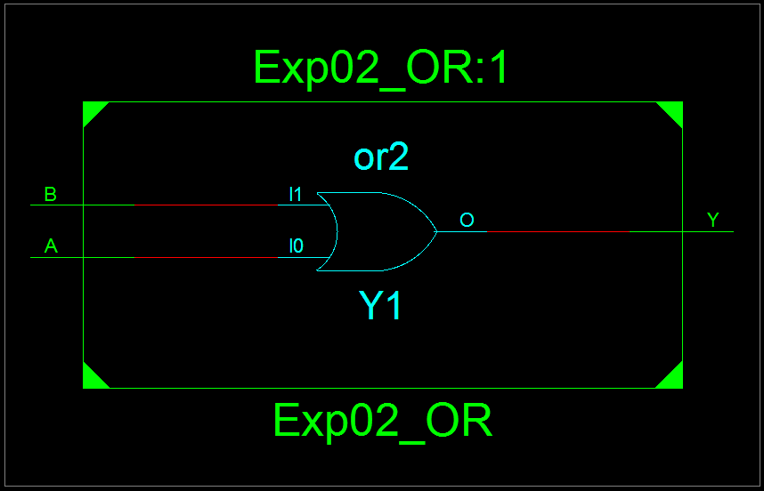
Figure 4: OR Gate RTL Schematic Diagram

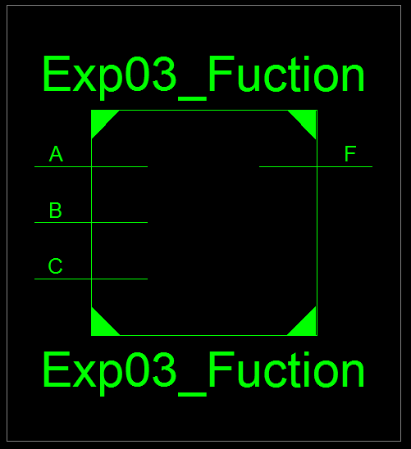
Figure 5: AB + C RTL Schematic Block

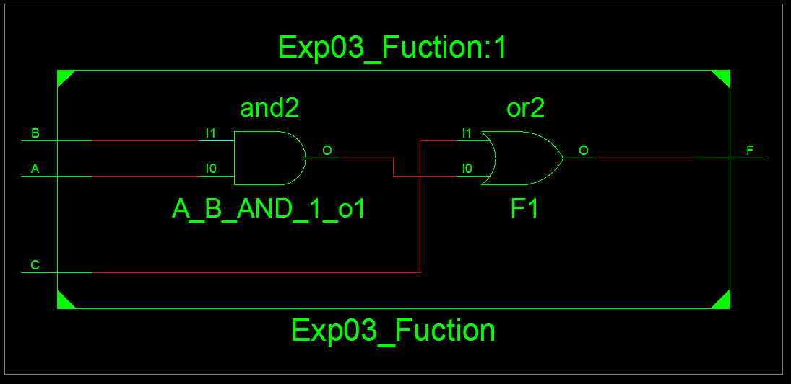
Figure 6: F = AB + C RTL Schematic Diagram

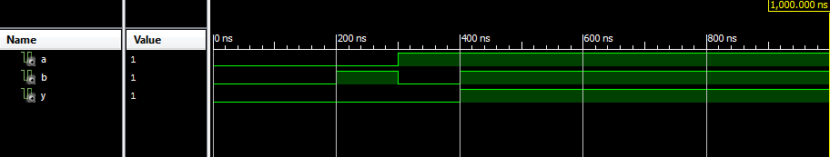
Figure 7: Test Bench of AND Gate

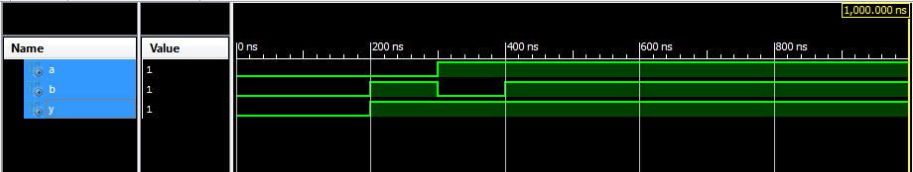
Figure 8: Test Bench of OR Gate

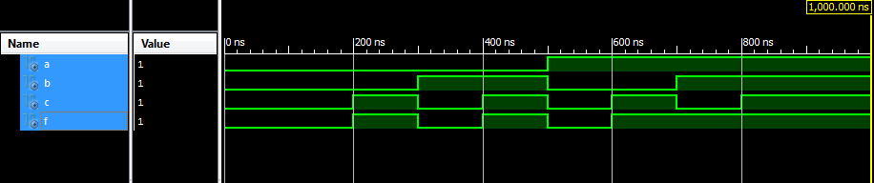
Figure 9: Test Bench of F = AB + C

