OUTPUT

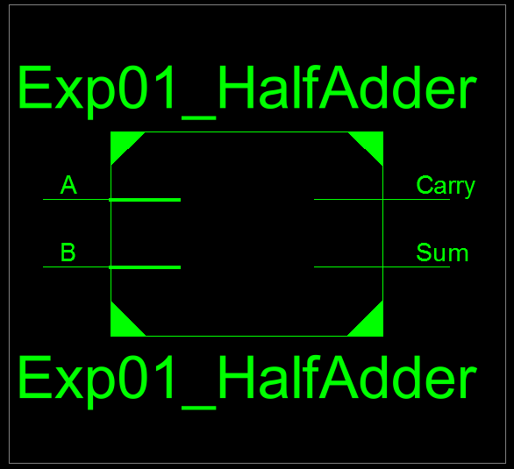
Figure 1: Half Adder RTL Schematic Block
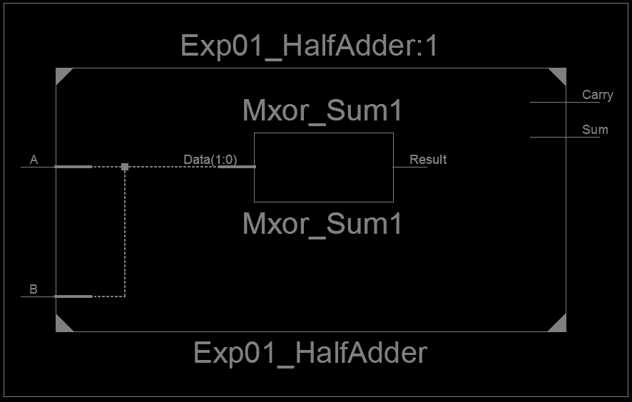
Figure 2: Half Adder RTL Schematic Diagram

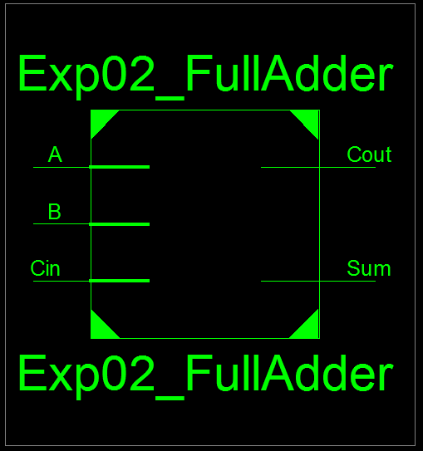
Figure 3: Full Adder RTL Schematic Block
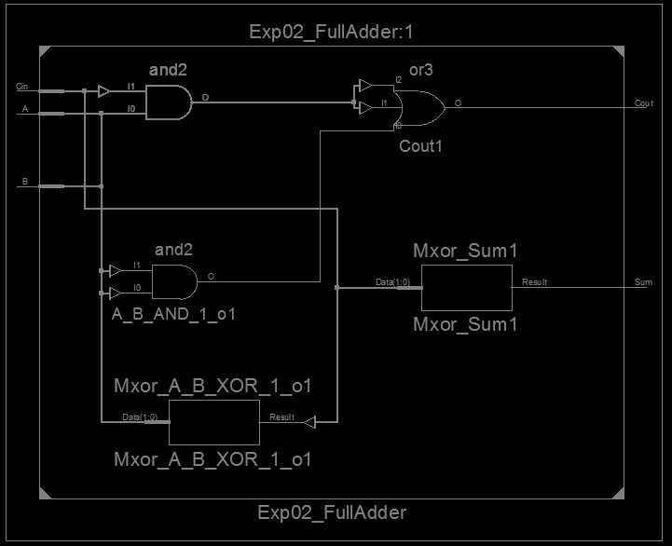
Figure 4: Full Adder RTL Schematic Diagram
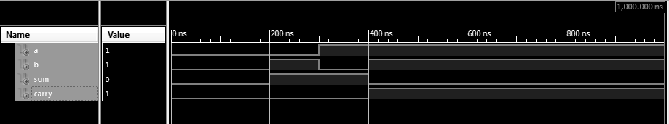
Figure 5: Test Bench of Half Adder
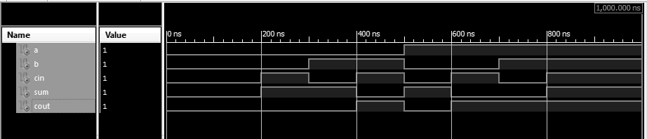
Figure 6: Test Bench of Full Adder

