**OBJECTIVE:** TO CREATE AND MANIPULATE VARIOUS DATABASE OBJECTS OF TABLE USING VIEWS.

**LAB EXERCISE:**

* **Creating a Database named ‘lab5’.**

CREATE DATABASE lab5;

USE lab5;

* **Creating Tables and Inserting data.**

**1) Customer Table :**

= CREATE TABLE customer (cid INT, name VARCHAR(50), age INT, address VARCHAR(50), salary DECIMAL(10, 2) );

**2) Order Table :**

= CREATE TABLE `order` (oid INT, order_date DATETIME, cid INT, amount DECIMAL(10, 2) );

**3) Employee Table :**

= CREATE TABLE employee ( eid INT, ename VARCHAR(50), job VARCHAR(50), did INT, salary DECIMAL(10, 2) );

**4) Department Table :**

=CREATE TABLE department (did INT, dname VARCHAR(50), location VARCHAR(50) );

**INSERTING DATA :**

**1) Customer Table:**

**=** INSERT INTO customer VALUES (1, 'ram', 32, 'kathmandu', 2000.00), (2, 'shyam', 25, 'patan', 1500.00), (3, 'hari', 23, 'dharan', 2000.00), (4, 'gopal', 25, 'pokhara', 6500.00), (5, 'sita', 27, 'bhaktapur', 8500.00), (6, 'gita', 22, 'illam', 4500.00), (7, 'rita', 24, 'banepa', 10000.00);

**2) Order Table:**

**=** INSERT INTO order VALUES (102, '2015-10-08 00:00:00', 3, 3000), (100, '2014-10-08 00:00:00', 3, 1500), (101, '2014-11-20 00:00:00', 2, 1560), (103, '2013-05-20 00:00:00', 4, 2060);

**3) Employee Table:**

**=** INSERT INTO employee VALUES (1, 'arjun', 'AP', 1, 10000.00), (2, 'rabi', 'JP', 2, 12000.00), (3, 'rohan', 'AP', 2, 15000.00), (4, 'krishna', 'AP', 1, 20000.00);

**4) Department Table:**

= INSERT INTO department VALUES (1, 'accounting', 'kathmandu'), (2, 'sales', 'patan'), (3, 'research', 'banepa'), (4, 'operations', 'bhaktapur');

**Problems:**

**1) Use view to display only the details of employees who are AP.**

CREATE VIEW ap_employees

AS (

    SELECT *

    FROM employee

    WHERE job = 'AP'

);

SELECT *

FROM ap_employees;

**2) Use view to display only name, salary and department of employee whose salary is greater than 10000.**

CREATE VIEW salary_view

AS (

    SELECT ename, salary, dname

    FROM employee

    INNER JOIN department

    ON salary > 10000

);

SELECT *

FROM salary_view;

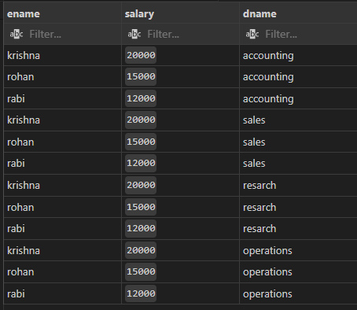

**3) Use view to display name, age of customer as well as order date and amount**

CREATE VIEW customer_view AS

SELECT c.name, c.age, o.order_date, o.amount

FROM customer AS c

INNER JOIN `order` AS o

ON c.cid = o.cid;

SELECT *

FROM customer_view;

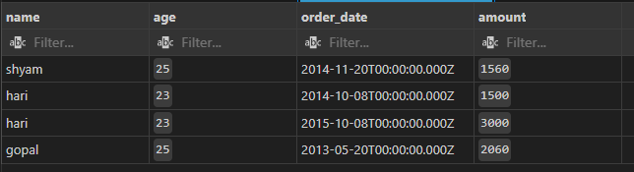

**4) Update view of Q.N.3 to include address and salary of customer.**

ALTER VIEW customer_view AS

SELECT c.name, c.age, c.address, c.salary, o.order_date, o.amount

FROM customer AS c

INNER JOIN `order` AS o

ON c.cid = o.cid;

SELECT *

FROM customer_view;

**5) Again, update view of Q.N.4 to include only salary greater than 5000.**

ALTER VIEW customer_view AS

SELECT c.name, c.age, c.address, c.salary, o.order_date, o.amount

FROM customer AS c

INNER JOIN `order` AS o

ON c.cid = o.cid

WHERE salary > 5000;

SELECT *

FROM customer_view;

