**OBJECTIVE:** IMPLEMENTING STORED PROCEDURE.

**LAB EXERCISE:**

* **Creating a Database named ‘lab6’.**

CREATE DATABASE lab6;

USE lab6;

* **Creating Tables and Inserting data.**

CREATE TABLE student_marks(

    stu_id INT PRIMARY KEY,

    total_marks FLOAT,

    grade VARCHAR(5)

);

INSERT INTO student_marks

VALUES

(1, 450, 'A+'),

(2, 490, 'A++'),

(3, 440, 'B'),

(4, 380, 'C'),

(5, 150, 'D'),

(6, 100, 'F');

**Problems:**

**1) Create a procedure that finds the marks of all the students**

DELIMITER //

CREATE PROCEDURE get_all_student_marks()

BEGIN

    SELECT * FROM student_marks;

END //

DELIMITER ;

CALL get_all_student_marks();

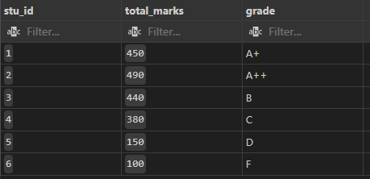

**2) Create a procedure that finds students who obtained marks > 200**

DELIMITER //

CREATE PROCEDURE get_students_above_200()

BEGIN

    SELECT * FROM student_marks WHERE total_marks > 200;

END //

DELIMITER ;

CALL get_students_above_200();

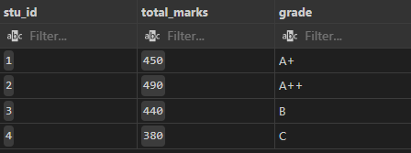

**3) Create a procedure that takes grade as parameter**

DELIMITER //

CREATE PROCEDURE get_students_by_grade(IN grade_param VARCHAR(5))

BEGIN

    SELECT * FROM student_marks WHERE grade = grade_param;

END //

DELIMITER ;

CALL get_students_by_grade('A+');

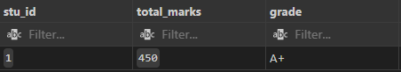

**4) Alter the procedure to change the proc to display only grade of student**

DELIMITER //

CREATE PROCEDURE get_student_grades()

BEGIN

    SELECT grade FROM student_marks;

END //

DELIMITER ;

CALL get_student_grades();

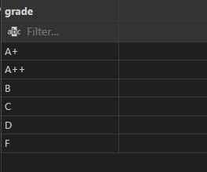

**5) Drop any procedure**

DROP PROCEDURE IF EXISTS get_all_student_marks;