**OBJECTIVE:** IMPLEMETING TRIGGERS

**INITIAL SETUP:**

**Step1: Create a database lab7**

CREATE DATABASE lab7;

**Step2: Use the database lab7**

USE lab7;

**Step3: Create a student table and insert some data**

CREATE TABLE student (

    id INT PRIMARY KEY,

    name VARCHAR(100),

    age INT,

    address VARCHAR(50)

);

INSERT INTO student (id, name, age, address) VALUES

(101, 'Maya', 19, 'Ktm'),

(102, 'Arnav', 18, 'Bkt'),

(103, 'Krishna', 19, 'Lalitpur');

**Step4: Create student audit table to store events**

CREATE TABLE student_audit (

    id INT PRIMARY KEY,

    audit_description VARCHAR(100)

);

**Step5: Show the student table**

SELECT * FROM student;

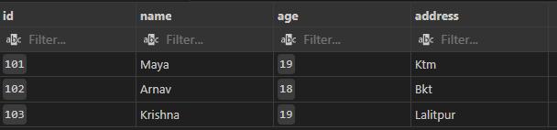

**Step6: Show the student audit table**

SELECT * FROM student_audit;

**LAB EXERCISE:**

* **Create a trigger called 'afterInsertStudent' which will be set to insert the audit details into the 'student_audit' table when a new row is added to 'student' table.**

**Step1: Create a trigger for after insert**

DELIMITER //

CREATE TRIGGER afterInsertStudent

AFTER INSERT ON student

FOR EACH ROW

BEGIN

    INSERT INTO student_audit (id, audit_description)

    VALUES (NEW.id, CONCAT('A new student has been added at time ', NOW()));

END //

DELIMITER ;

**Step2: Insert a new row into the student table**

INSERT INTO student (id, name, age, address)

VALUES

(104, 'Sita', 20, 'Pokhara'),

(105, 'Rita', 21, 'Dhanghadi');

**Step3: Show the student table**

SELECT * FROM student;

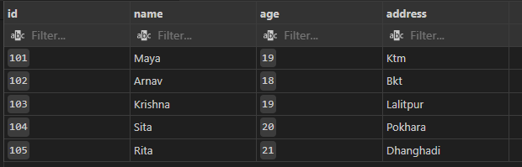

**Step4: Show the student audit table**

SELECT * FROM student_audit;

* **Create a trigger called 'afterUpdateStudent' which will be set to insert the audit details into the 'student_audit' table when a new row is added to 'student' table.**

**Step1: Create a trigger for after update**

DELIMITER //

CREATE TRIGGER afterUpdateStudent

AFTER UPDATE ON student

FOR EACH ROW

BEGIN

    INSERT INTO student_audit (id, audit_description)

    VALUES (NEW.id, CONCAT('Student with ID ', NEW.id, ' has been updated at time ', NOW()));

END //

DELIMITER ;

**Step2: Update a row in the student table**

UPDATE student

SET name = 'Maya Devi', age = 20, address = 'Kathmandu'

WHERE id = 101;

**Step3: Show the student table**

SELECT * FROM student;

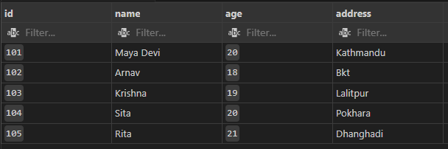

**Step4: Show the student audit table**

SELECT * FROM student_audit;

* **Cleanup**

DROP TABLE student;

DROP TABLE student_audit;