### Field Service WorkOrder Optimization

**1. Project Overview**

The Field Service Work Order Optimization System is designed to improve operations for companies specializing in installation and repair services. Utilizing a robust database and intelligent algorithms, the system assigns work orders to skilled technicians based on location, availability, and expertise.

The system prioritizes tasks strategically to maximize efficiency and minimize delays. Automated communication ensures real-time updates for technicians, fostering seamless coordination. Additionally, analytics tools deliver actionable insights to support continuous improvement.

This solution aims to enhance operational efficiency, reduce costs, and improve customer satisfaction in the dynamic field service industry.

**2. Objectives**

**Business Goals:**

**Operational Goals:**

* **Optimize Task Scheduling**
  + Automate work order assignments to minimize delays and improve service delivery times.
  + Allocate tasks to the most qualified and available technicians for maximum efficiency.
* **Improve Resource Allocation**
  + Assign tasks based on technicians’ expertise and proximity to the work location.
  + Minimize idle time and maximize productivity with better resource utilization.
* **Enhance Communication and Coordination**
  + Use real-time updates to ensure seamless communication between dispatch teams and field technicians.
  + Enable technicians to update work orders on-the-go via mobile access.
* **Deliver Excellent Customer Experiences**
  + Ensure timely service completion to improve customer ratings and reduce complaints.
  + Provide customers with real-time updates on technician arrivals and service schedules.
* **Enable Strategic Decision-Making**
  + Leverage analytics to monitor key performance indicators (KPIs) and identify bottlenecks.
  + Use data insights to refine workflows and continuously improve service quality.
* **Support Growth and Scalability**
  + Design the system to handle increasing workloads as the business grows.
  + Ensure seamless integration with enterprise systems to meet evolving needs.

**Key Outcomes:**

* **Efficient Task Assignments:**
  + Reduce the average time required to assign work orders.
  + Increase the percentage of tasks assigned to the most suitable technicians.
* **Reduced Operational Costs:**
  + Lower fuel and travel expenses with optimized task scheduling and routing.
  + Decrease administrative overhead through automation.
* **Enhanced Technician Productivity:**
  + Boost the number of tasks completed per technician per day.
  + Reduce downtime and enhance resource utilization.
* **Improved Customer Satisfaction:**
  + Achieve higher customer ratings with timely and reliable service.
  + Minimize complaints related to delayed or incomplete tasks.
* **Data-Driven Improvements:**
  + Track metrics such as resolution time and first-time fix rates.
  + Identify trends and areas for improvement with detailed analytics.
* **Scalable Operations:**
  + Maintain system efficiency with increasing workloads.
  + Adapt to changing business needs with flexible integration options.

**3. Salesforce Key Features and Concepts Utilized**

1. **Custom Objects and Relationships**
   1. **Work Order**, **Technician**, and **Assignment** objects created to model the field service process.
   2. Relationships:
      1. Lookup relationships between Work Order → Technician and Assignment → Work Order/Technician for linking related records.
2. **Data Modeling and Fields**
   1. Custom fields added to capture essential information:
      1. **Work Order**: Status, Priority, Service Type, and Description.
      2. **Technician**: Availability, Skills, Location, and Contact Details.
      3. **Assignment**: Assignment Date, Completion Date, Technician ID, and Work Order ID.
3. **UI Customization**
   1. **Tabs**: Custom tabs created for easy access to Work Order, Technician, and Assignment records.
   2. **Lightning App**: Consolidated these tabs into a unified interface for streamlined navigation.
4. **Automation with Apex**
   1. **Apex Triggers**:
      1. Automated status updates (e.g., updating Work Order status when Assignment is marked completed).
      2. Ensured Technician availability is updated after an Assignment is completed.
   2. **Apex Classes**:
      1. Implemented business logic for assigning technicians based on location, availability, and skills.
      2. Utility methods for efficient operations and system integration.
5. **Reports and Dashboards**
   1. Created comprehensive **Reports**:
      1. Monitor open Work Orders by status and priority.
      2. Technician performance metrics like task completion rate.
      3. Assignments completed within specified time frames.
   2. Built **Dashboards** for real-time visualization of KPIs, including workload distribution, service efficiency, and customer satisfaction metrics.
6. **Standard Salesforce Features**
   1. **Profiles and Roles**: Defined access levels to secure sensitive data and limit access based on user roles (e.g., Dispatcher, Technician).
   2. **Record Ownership**: Used the Owner field to track accountability for Work Orders and Assignments.
   3. **Chatter**: Enabled team collaboration on Work Order records for updates and discussions.
7. **Picklists and Validation**
   1. Standardized input with picklists for fields like Status, Priority, Service Type, and Technician Availability.
   2. Added validation rules to ensure data consistency (e.g., mandatory fields before completing a Work Order).
8. **Analytics and Metrics**
   1. **Custom Dashboards**:
      1. Track ongoing Assignments, high-priority Work Orders, and technician workload.
      2. KPIs like first-time resolution rate and average response time visualized effectively.
9. **Mobile Accessibility**
   1. Leveraged Salesforce’s mobile-ready features for technicians to access Assignments and update statuses in the field.
10. **Security and Compliance**
    1. Implemented role-based access control to secure records based on profiles.
    2. Used field-level security to protect sensitive data like customer contact details.

**4. Detailed Steps to Solution Design**

**Create Objects From Spreadsheet**

**1.Create Technician Object:**The **Technician** object stores critical details about field technicians, including their availability, skills, and location. It features key fields such as Technician ID, Name, Email, Phone, Availability (Picklist), Location (Picklist), and Skills (Picklist). Relationships are established with the Work Order and Assignment objects via lookup fields to link technicians to specific tasks and assignments.

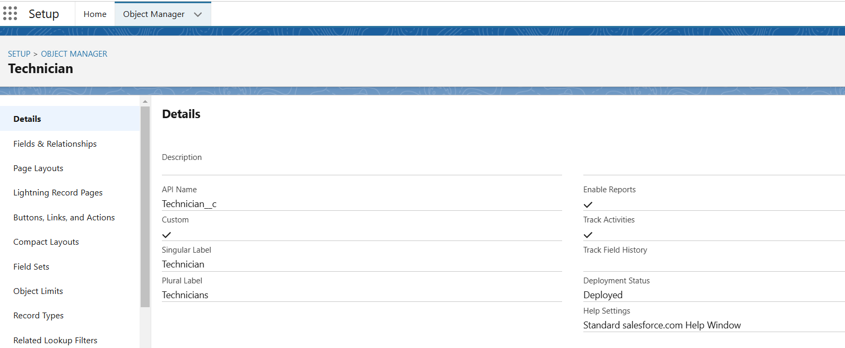

**2.Create WorkOrder Object:**The **WorkOrder** object represents service tasks, such as installations or repairs. It includes key fields like Work Order ID (Auto Number), Date, Description, Status (Picklist), Priority (Picklist), Service Type (Picklist), Location, and Email. Relationships are established with Technician and Assignment objects to link tasks to the appropriate resources.

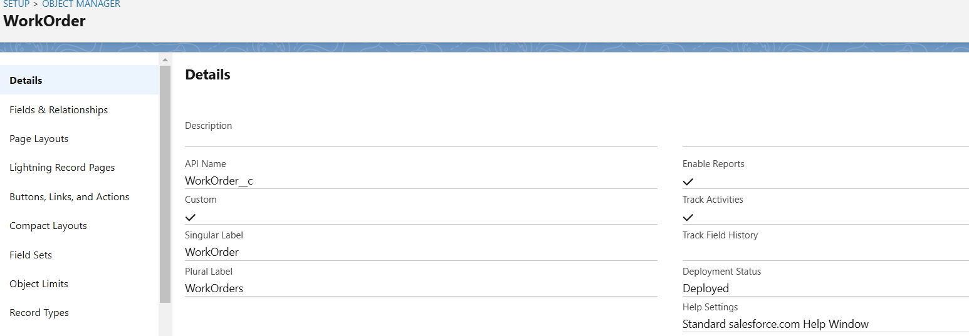

**3.Create Assignment Object:**The **Assignment** object tracks the allocation of technicians to specific work orders. It includes fields like Assignment ID (Auto Number), Assignment Date, Completion Date, Technician ID (Lookup), and Work Order ID (Lookup). This object links technicians to their assigned tasks, ensuring proper tracking of service completion.

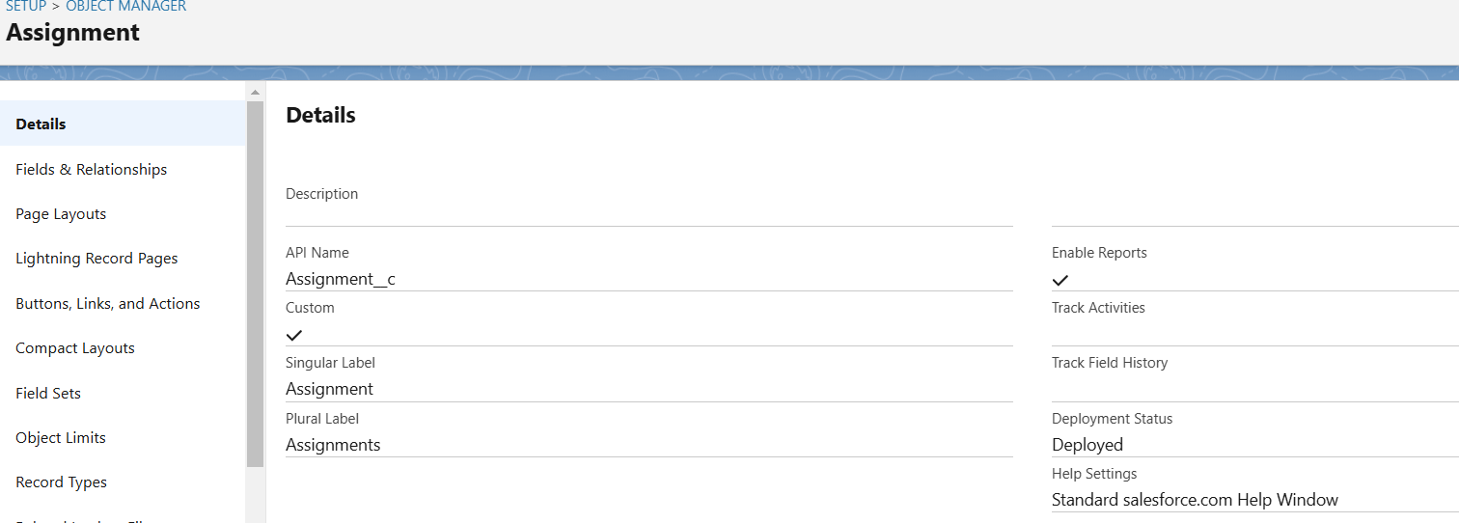

### Create A Custom Tab

**1.Assignment Object:**The **Assignment** tab is created to provide easy access to Assignment records. It allows users to view, manage, and track technician assignments for work orders. The tab is added to a **Lightning App** for seamless integration into the user interface, ensuring efficient navigation and task management.

**2.WorkOrder and Technician Object:**The **Work Order** and **Technician** tabs are **default created** as these objects are imported from a spreadsheet.

**Create The Lightning App**

A **Lightning App** is created to consolidate the **Work Order**, **Technician**, and **Assignment** tabs into a unified interface. This app provides users with easy access to all relevant records and ensures streamlined navigation across different objects. It enhances the user experience by organizing tasks and data in a single, efficient workspace.

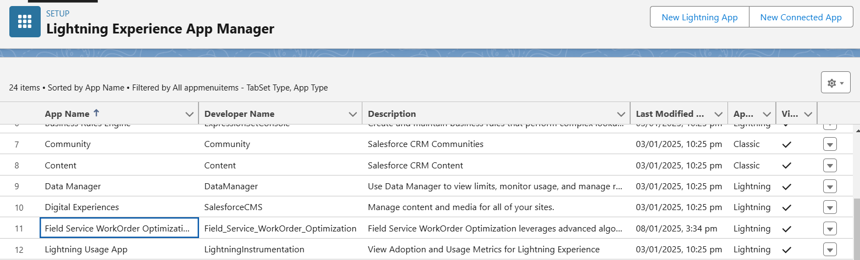

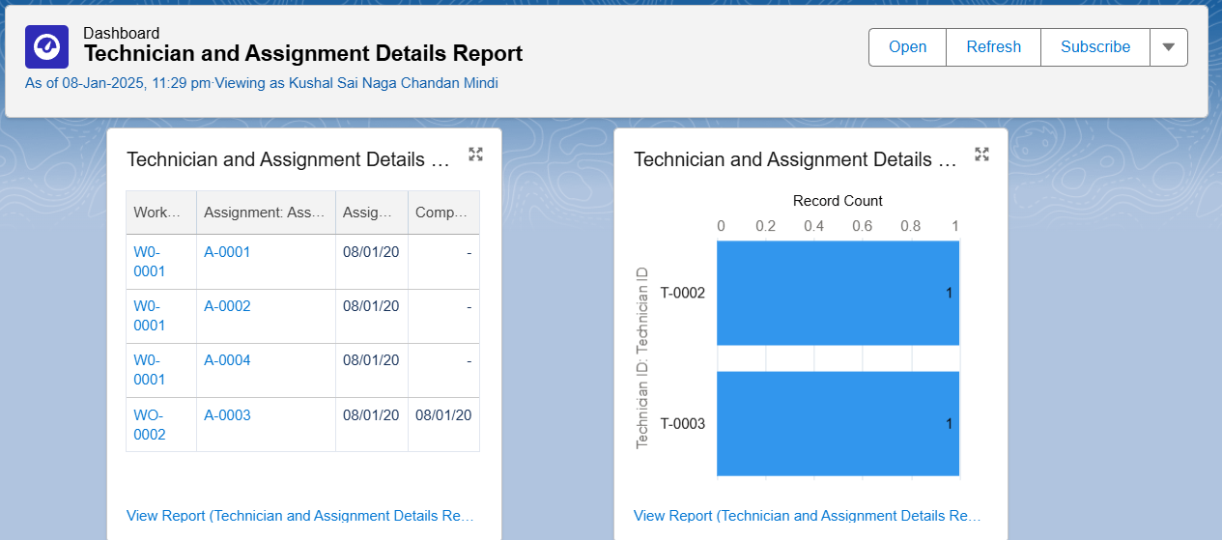

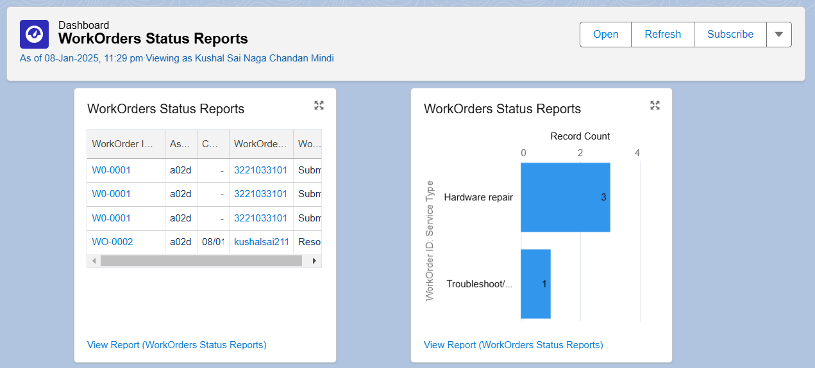

**Create Fields and Relationships**

1. **Technician**: Fields like Technician ID, Skills, Availability, and Location. Lookup to Work Order and Assignment.
2. **Work Order**: Fields like Work Order ID, Status, Priority, and Service Type. Lookup to Technician and Assignment.
3. **Assignment**: Fields like Assignment ID, Assignment Date, and Completion Date. Lookup to Technician and Work Order.

**1.Technician:**

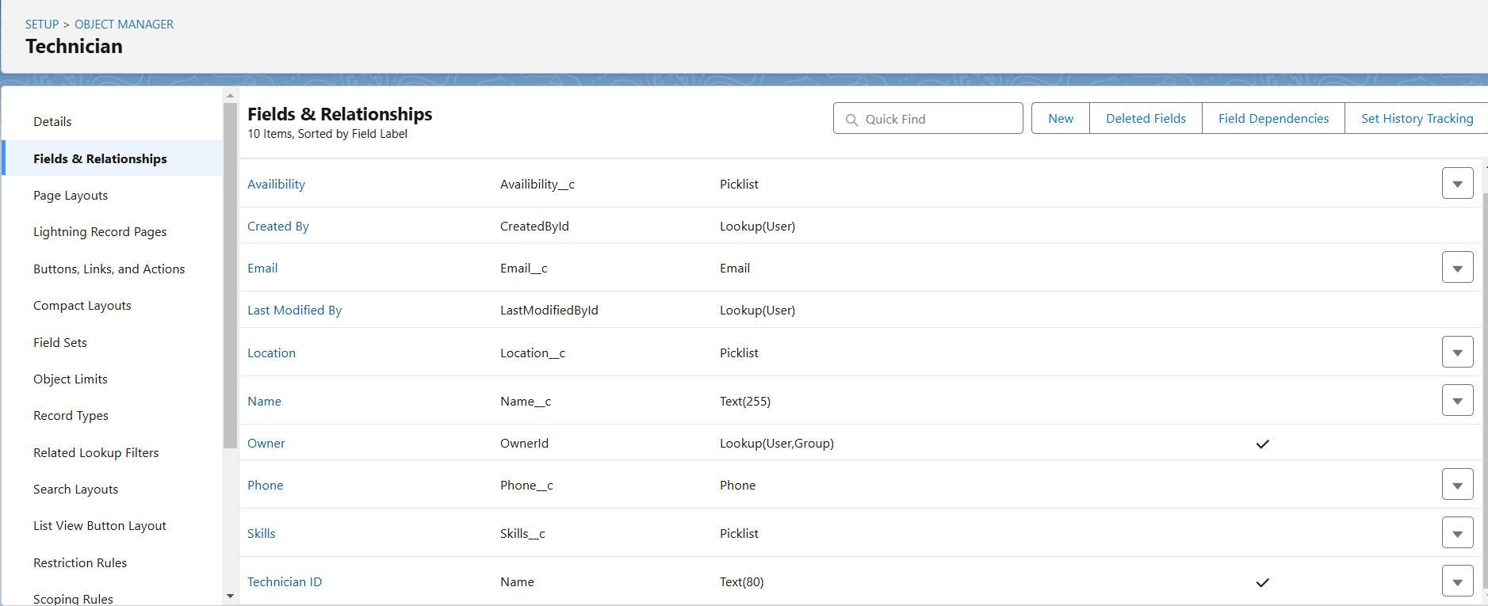

**2.WorkOrder:**

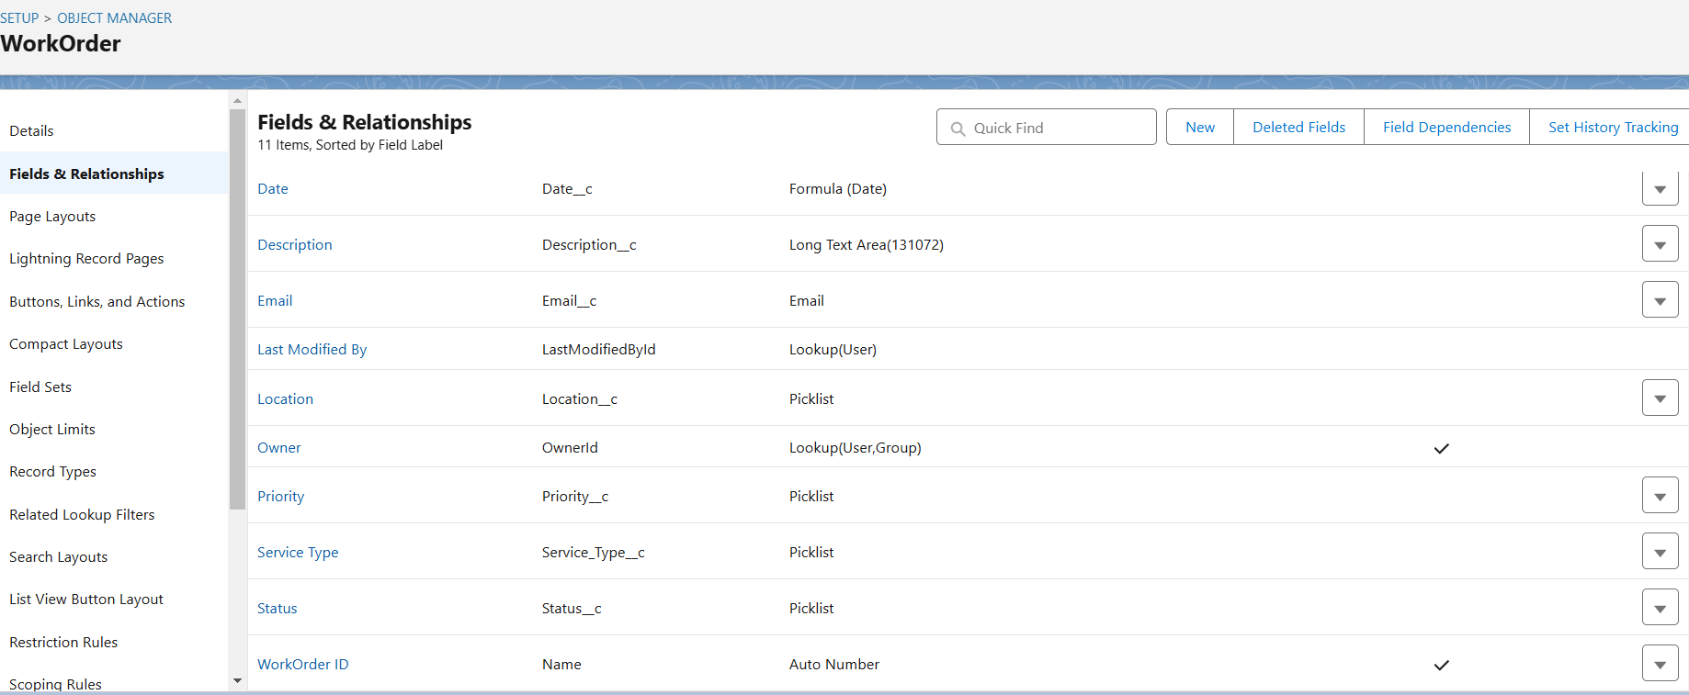

**3.Assignment**

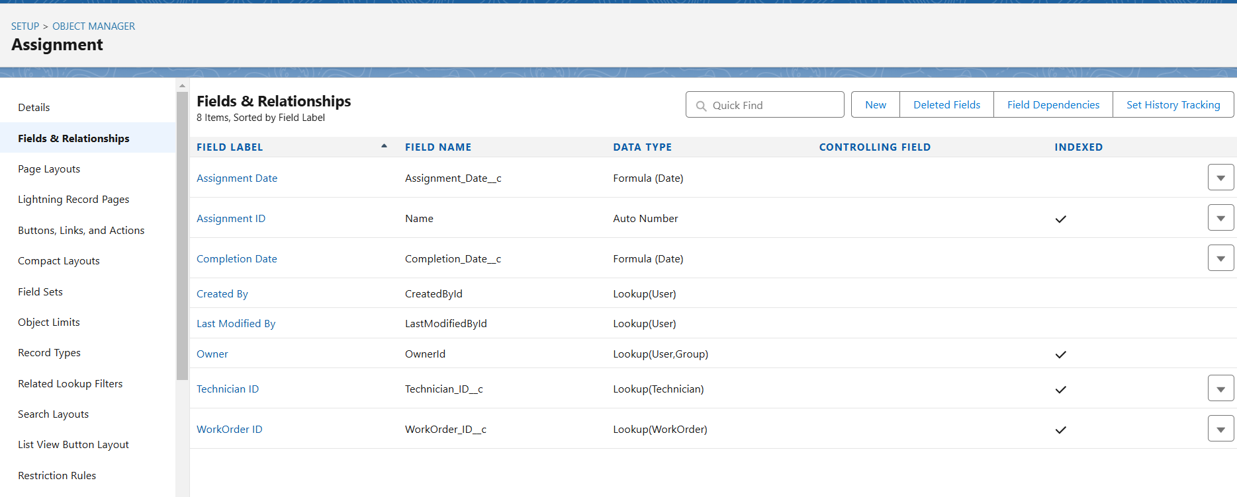

**Create Technician Profile**

The **Technician Profile** defines permissions and access for technicians in the Salesforce Org. It grants visibility to relevant objects like **Work Order** and **Assignment**, allowing technicians to view, update, and complete their tasks. Access is restricted to only records assigned to them, ensuring data security and streamlined operations.

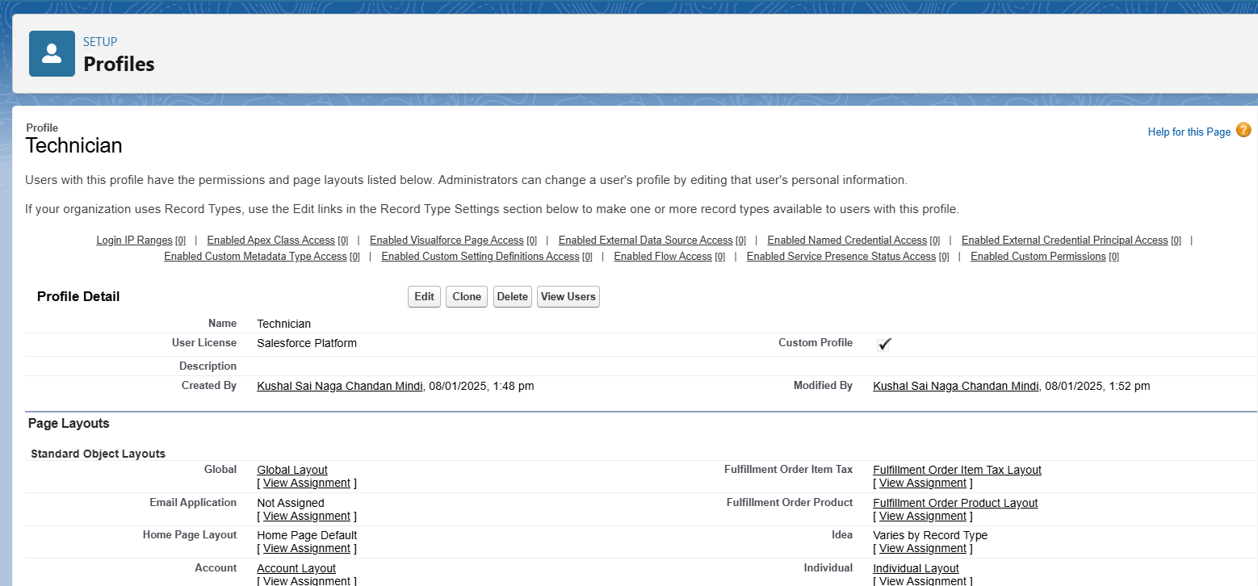

**Create Users**

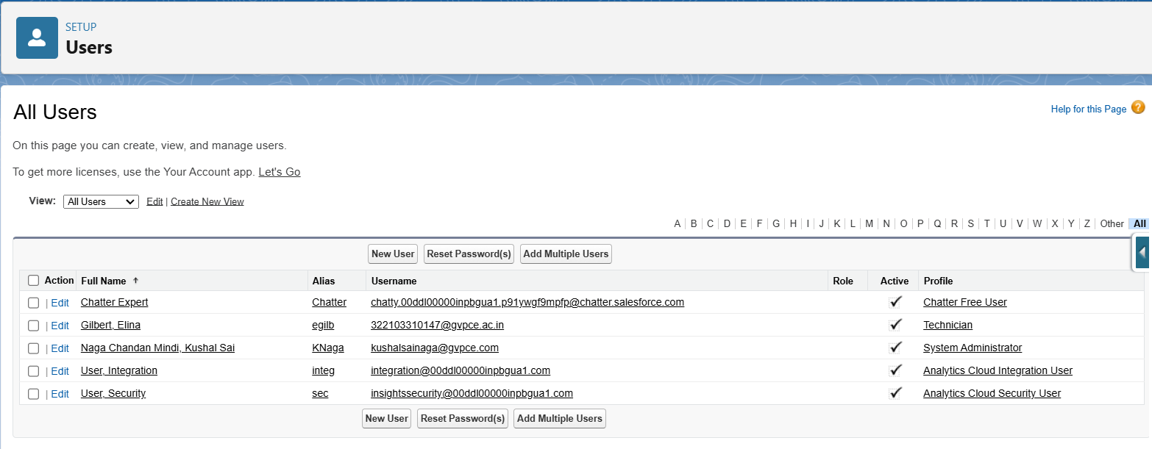

**Create Apex Classes & Triggers**

1.WorkOrder Class:

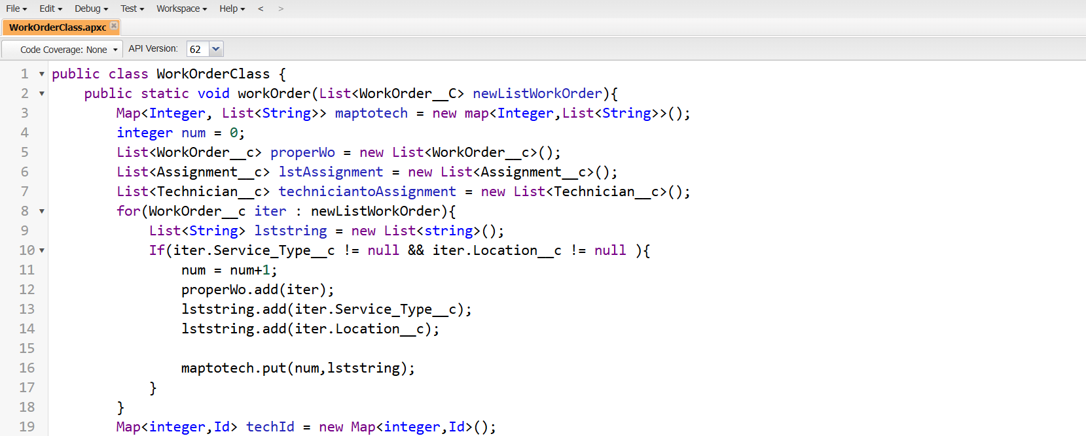

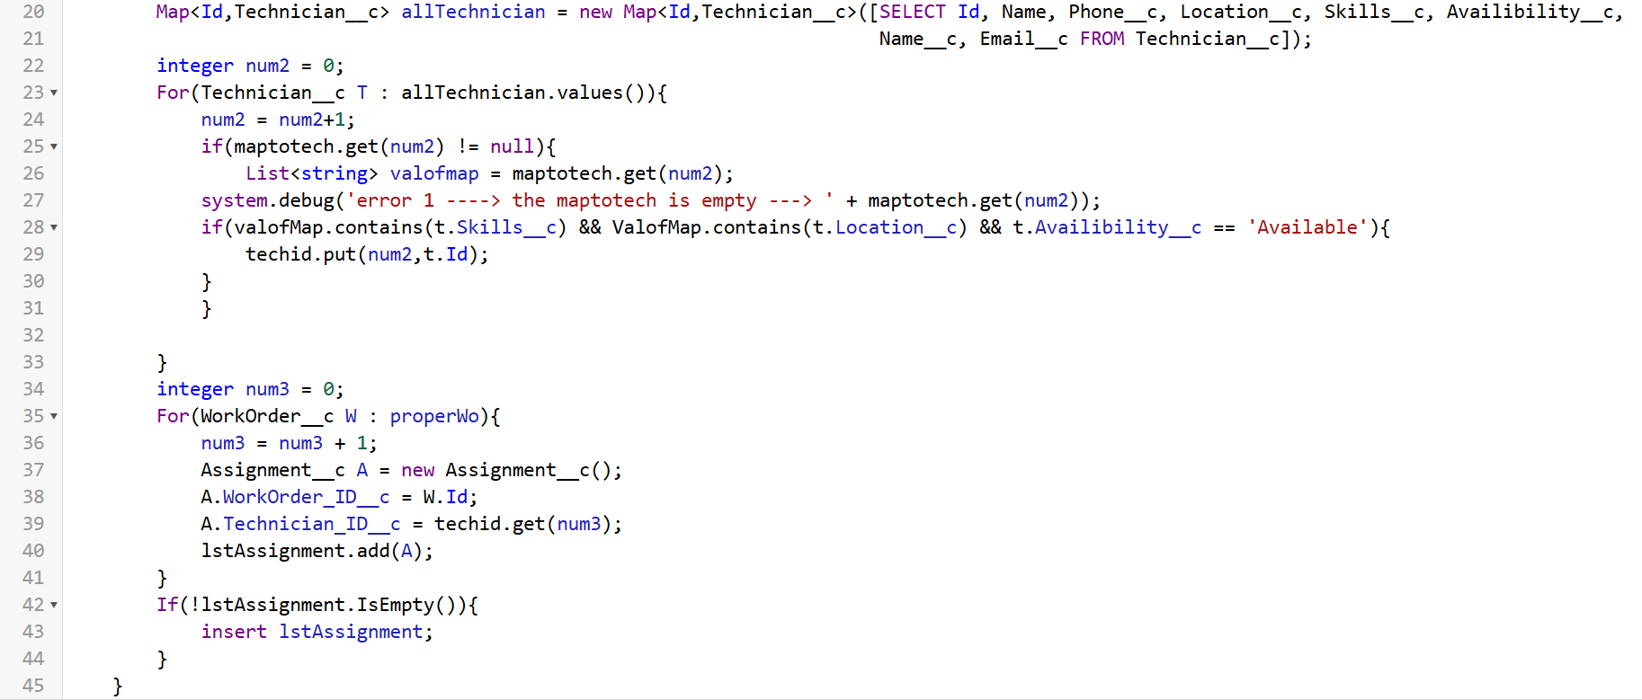

2.AssigningEMail Class :

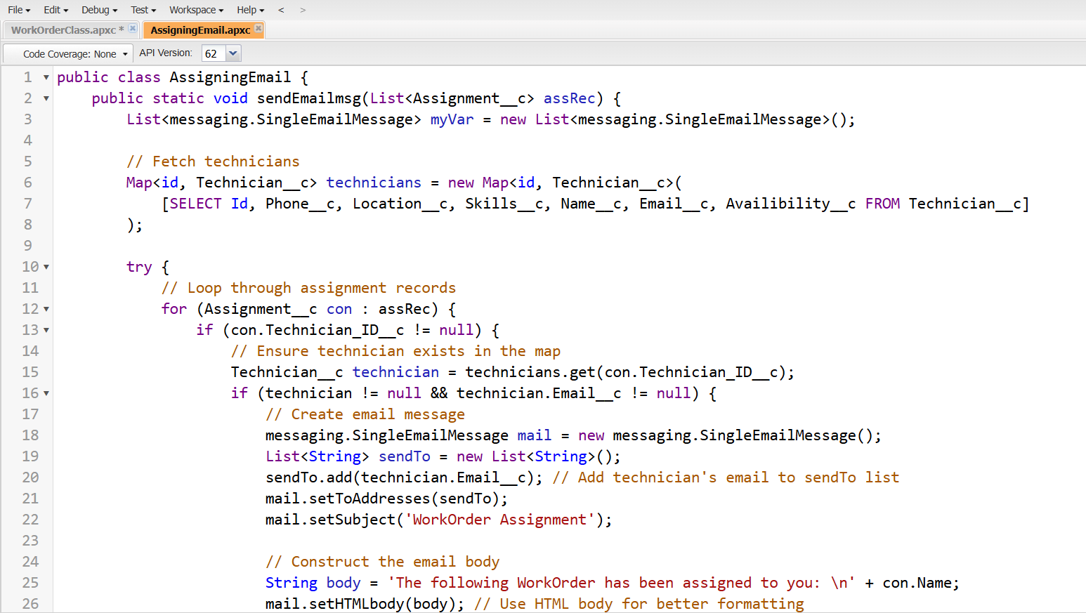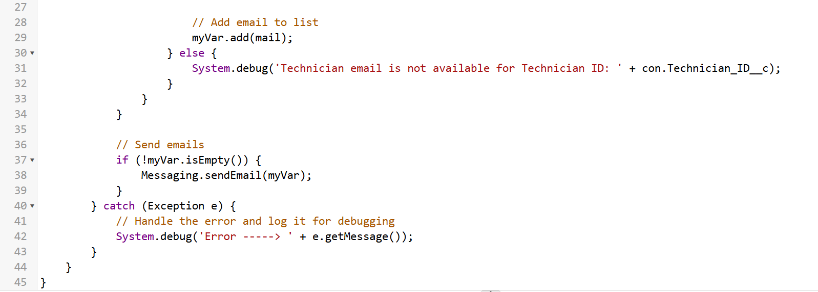

3.CompletionMail Class:

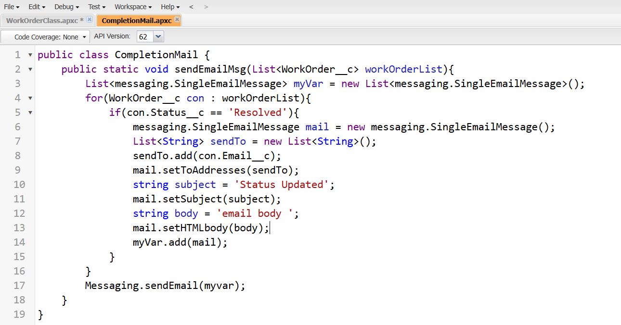

4.Schedule Class:

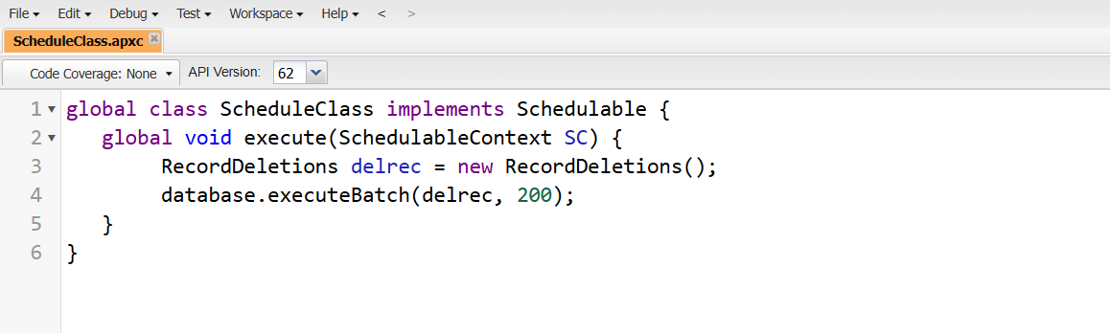

**5.Assignment Trigger**

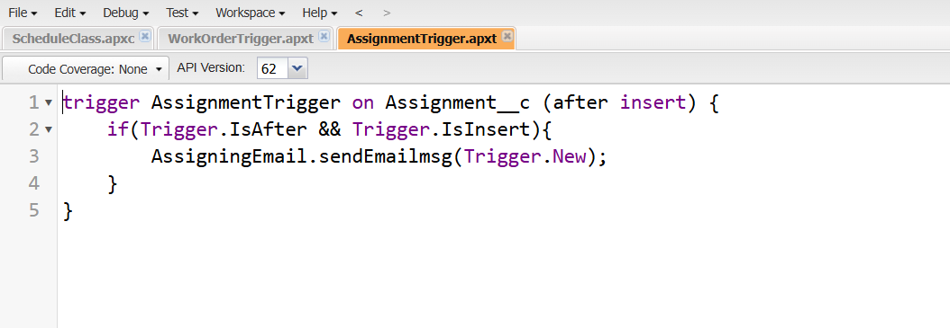

**6.WorkOrder Trigger**:

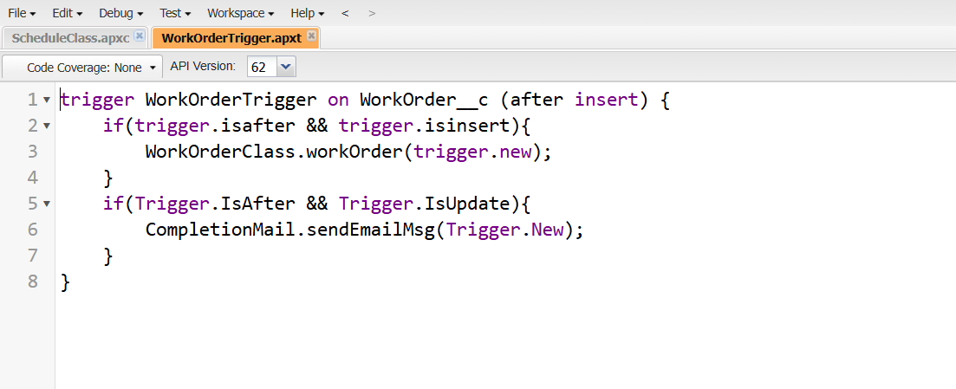

**Create Reports And Dashboards:**

**Reports:**

**1.Technician and Assignment Details Report**: Monitors technician assignments, including dates and completion status.

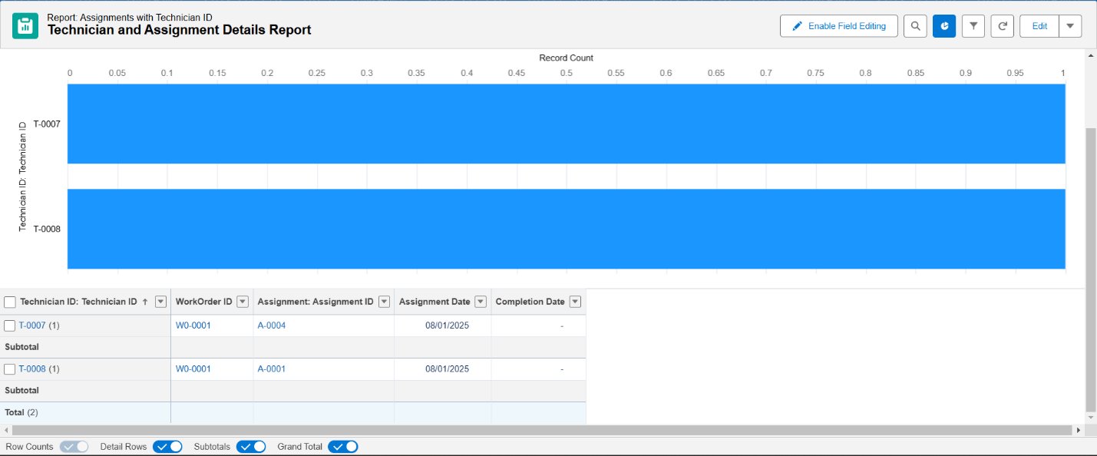

**2.Work Order Report**: Tracks work orders by status, priority, and service type.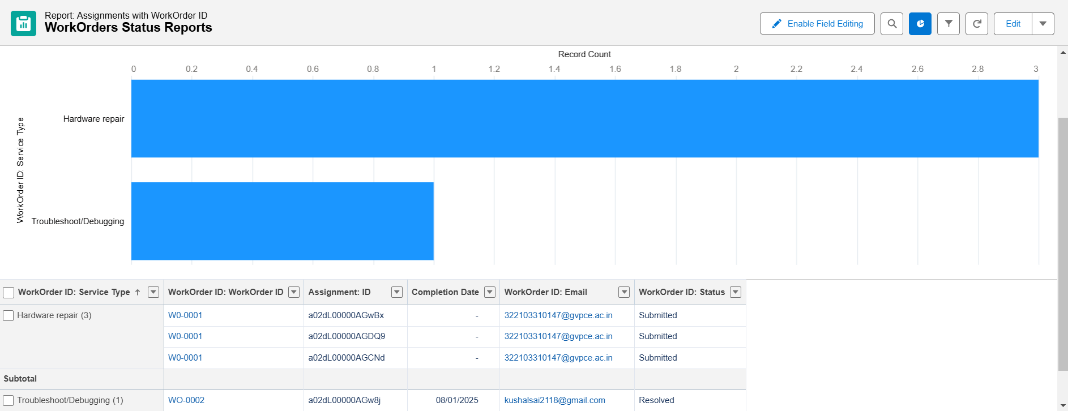

**Dashboards:**

**1.Work Order Status Dashboard:**

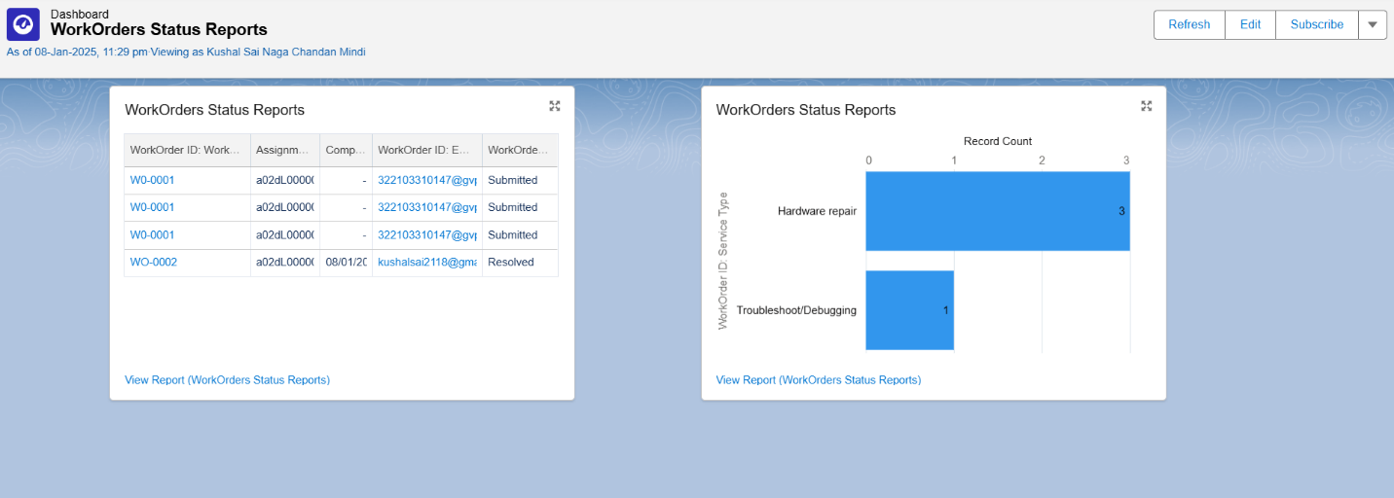

**2.Technician and Assignment Details Dashboard:**

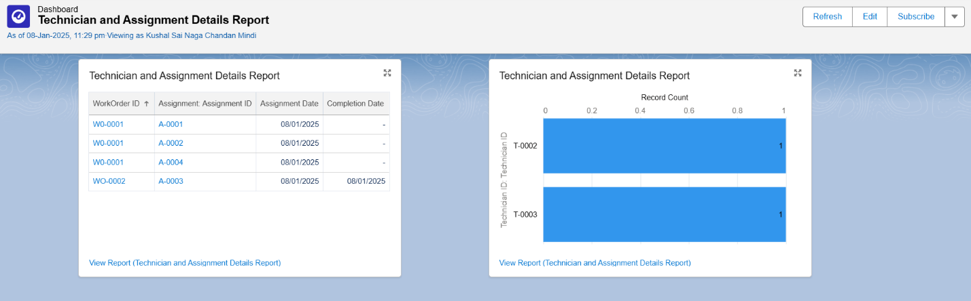

**Testing and Validation:**

**1.Create users under Technician profile such that a record is created in Technician Object with the Users details:(or)**

**Create users under Technician Profile directly:**

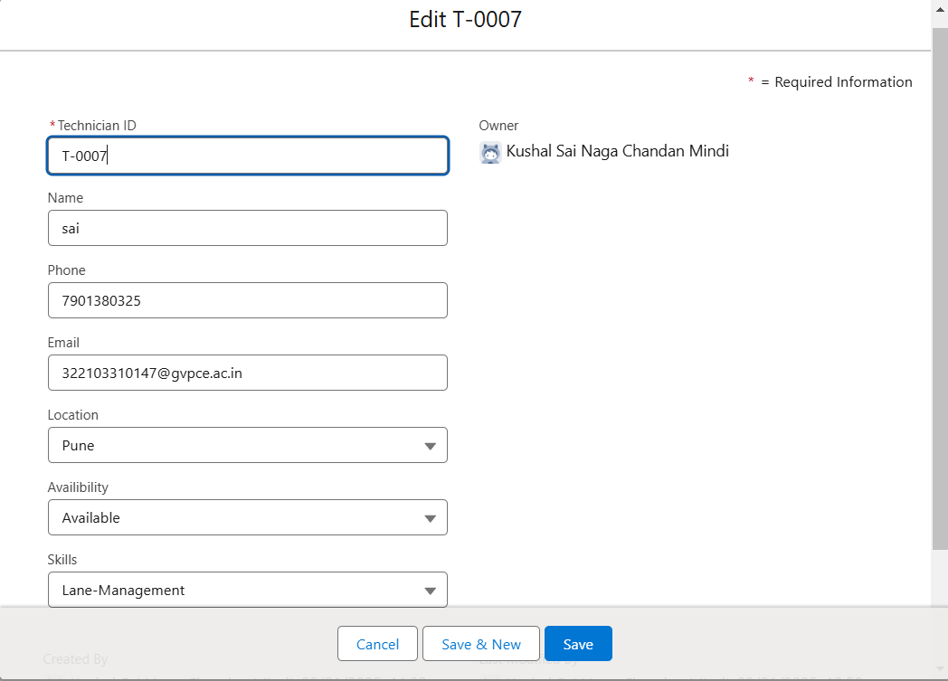

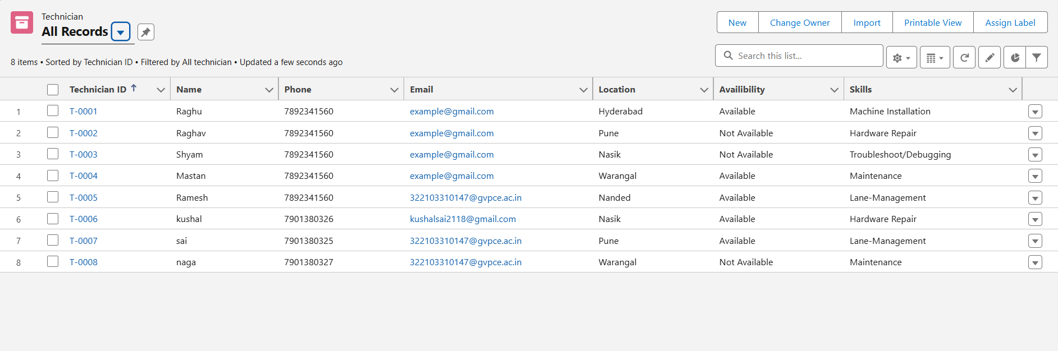

**2.Create WorkOrder Record which is the work that Customer assigns us:**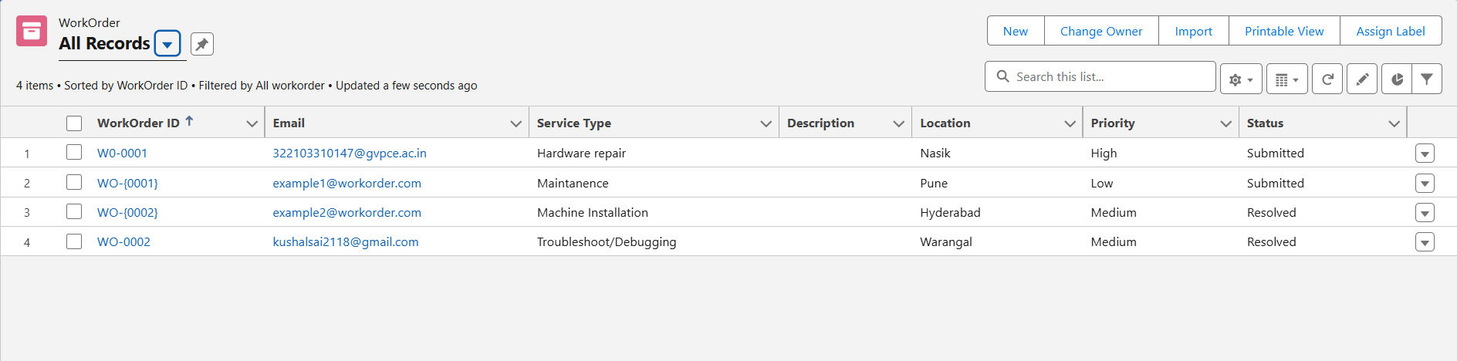

**Case 1:If the work order is assigned and there is a available technician then it assigns to then it assigns to the technician**

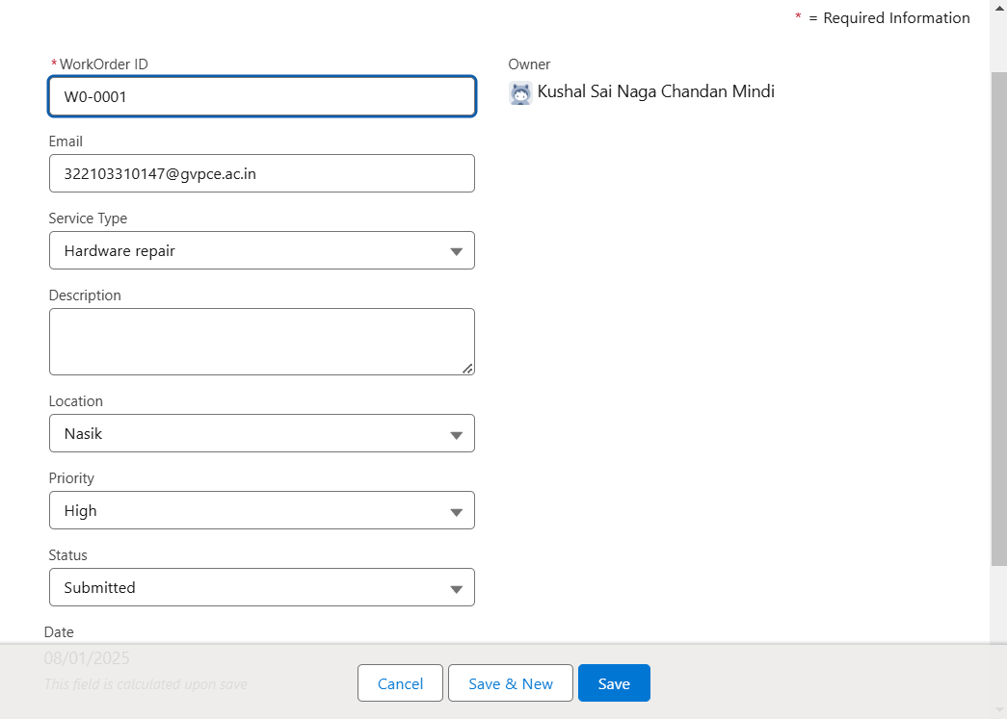

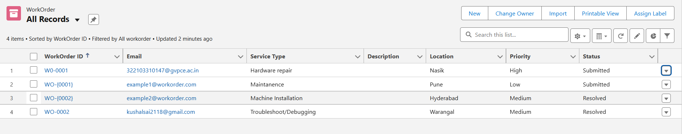

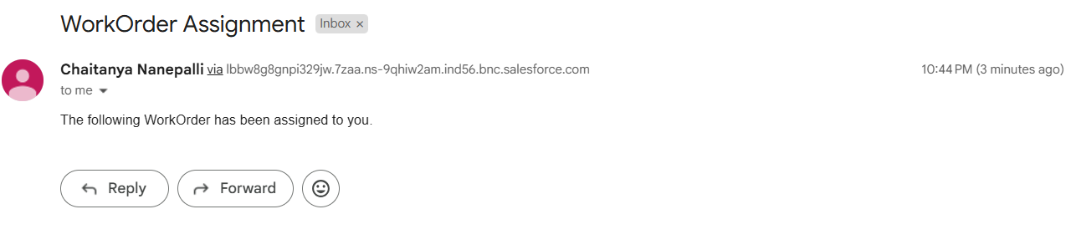

When a work order requirement matches with the technician Elina, it is assigned to her, an assignment record is created, and an email notification is sent to inform her about the assigned work. Upon assignment, the work order status is updated to **Assigned/In Progress**, and the technician's availability is updated to **Not Available**.

**Case 2:If a work order is created and no matching technician is currently available**

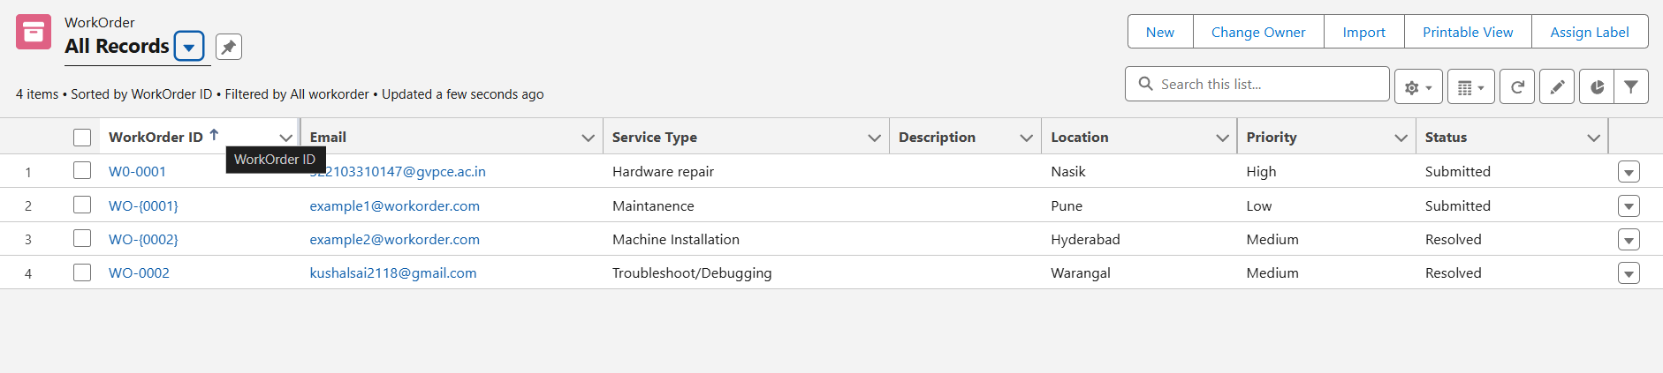

If a work order is created and no matching technician is currently available, the work order remains in a pending state. Once a suitable technician becomes available, the system automatically assigns the work order to them, creates an assignment record, sends an email notification to the technician, updates the work order status to **Assigned/In Progress**, and sets the technician's availability to **Not Available**.

**3.If the work order is completed:**



If the work is completed, the technician updates the work order status to **Resolved**. Upon this update, the system automatically changes the technician's availability status to **Available**.