Apache Jenkins Config
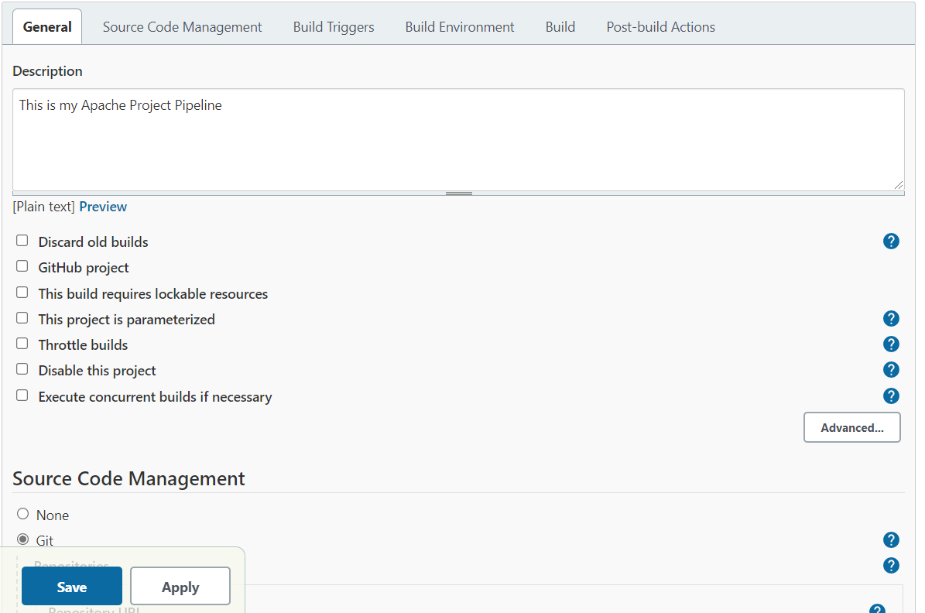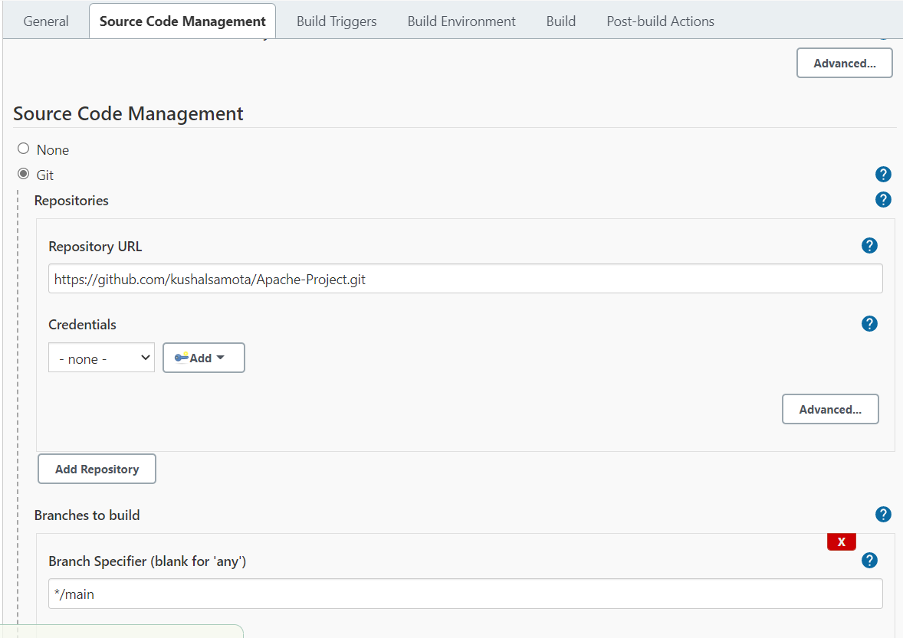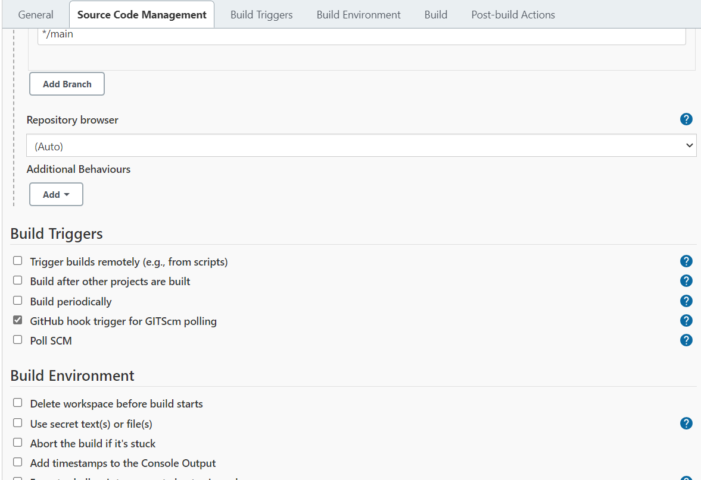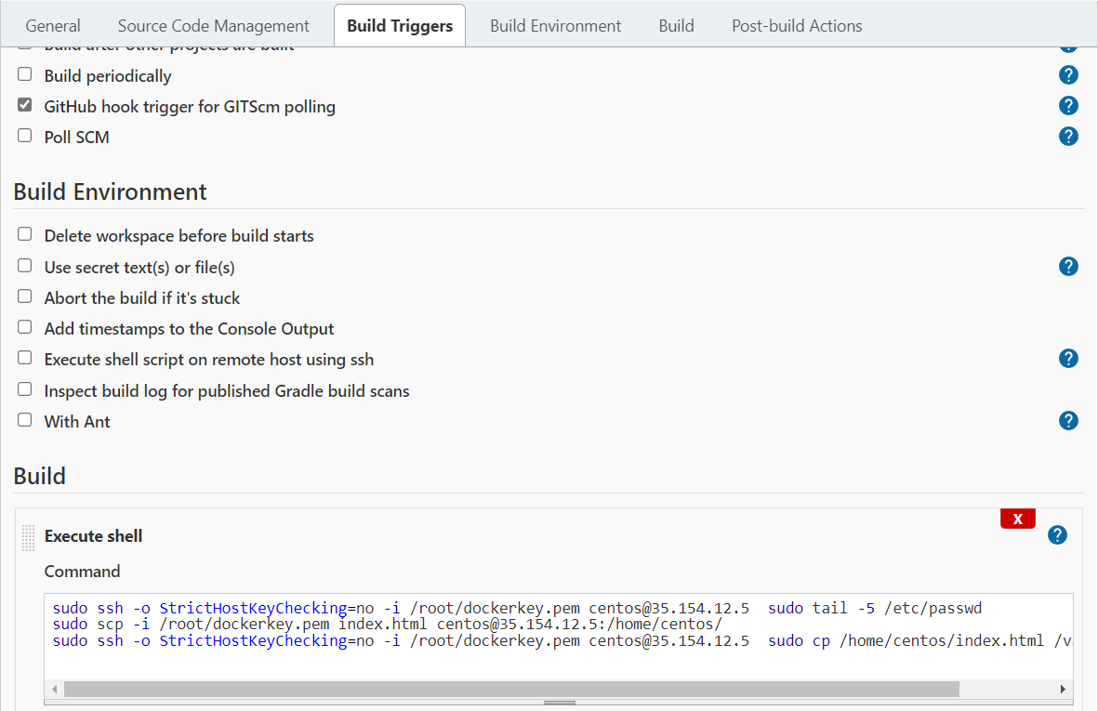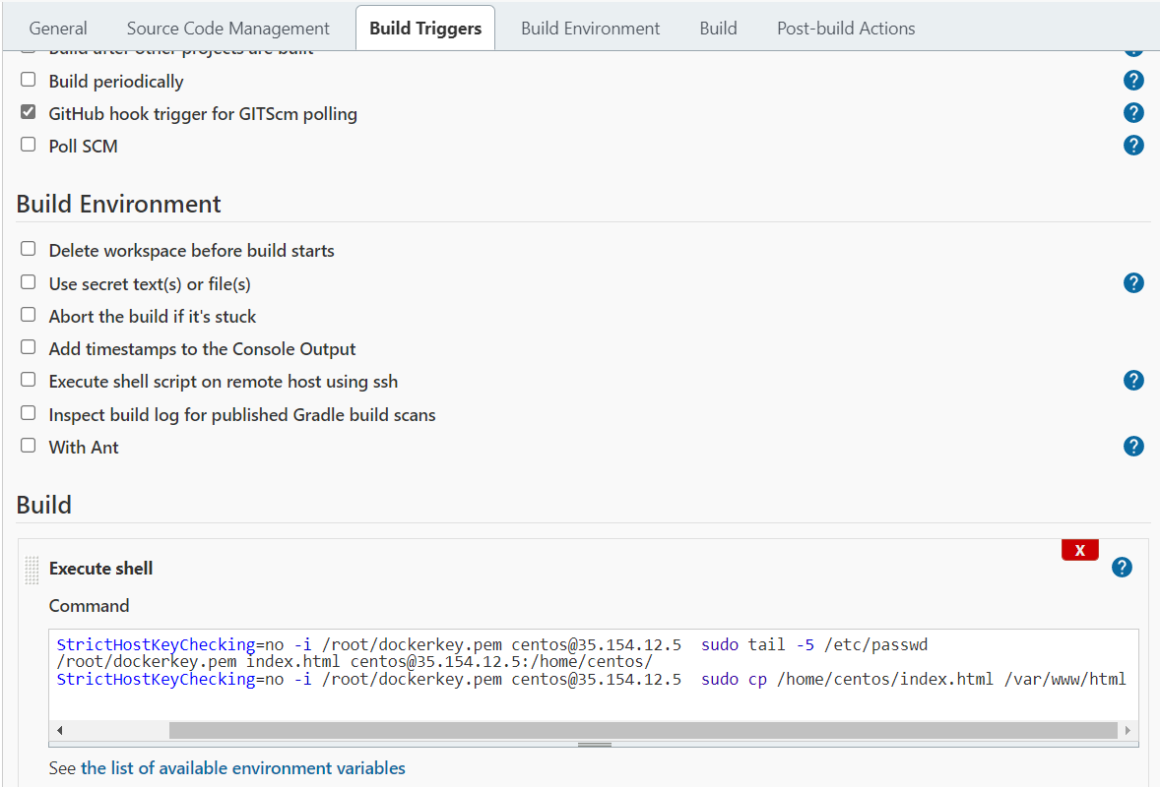

Jenkins server history
id
2 wget -O /etc/yum.repos.d/jenkins.repo https://pkg.jenkins.io/redhat-stable/jenkins.repo
3 yum install wget vim -y
4 wget -O /etc/yum.repos.d/jenkins.repo https://pkg.jenkins.io/redhat-stable/jenkins.repo
5 wget -O /etc/yum.repos.d/jenkins.repo https://pkg.jenkins.io/redhat-stable/jenkins.repo --no-check-certificate
6 ls /etc/yum.repos.d/
7 #jenkins is java tool so java must be installed
8 rpm --import https://pkg.jenkins.io/redhat-stable/jenkins.io.key
9 yum install epel-release java-11-openjdk-devel
10 yum install jenkins
11 systemctl daemon reload
12 systemctl daemon-reload
13 systemctl status jenkins
14 systemctl start jenkins
15 systemctl status jenkins
16 jenkins -version
17 jenkins --version
18 cd /var/lib/jenkins/
19 ls
20 vim config.xml
21 cd
22 cat /var/lib/jenkins/secrets/initialAdminPassword
23 yum install git -y
24 cd /var/lib/jenkins/workspace/
25 ls
26 cd Apache\ Project/
27 ls
28 cd
29 vim /etc/sudoers
30 vim dockerkey.pem
31 pwd
32 ls -l dockerkey.pem
33 chmod 600 dockerkey.pem
34 ls /var/lib/jenkins/

Prod server history
yum install httpd -y
2 systemctl start httpd
3 systemctl enable httpd
4 cd /var/www/html
5 ls
6 cd

Jenkins Docker Project Config
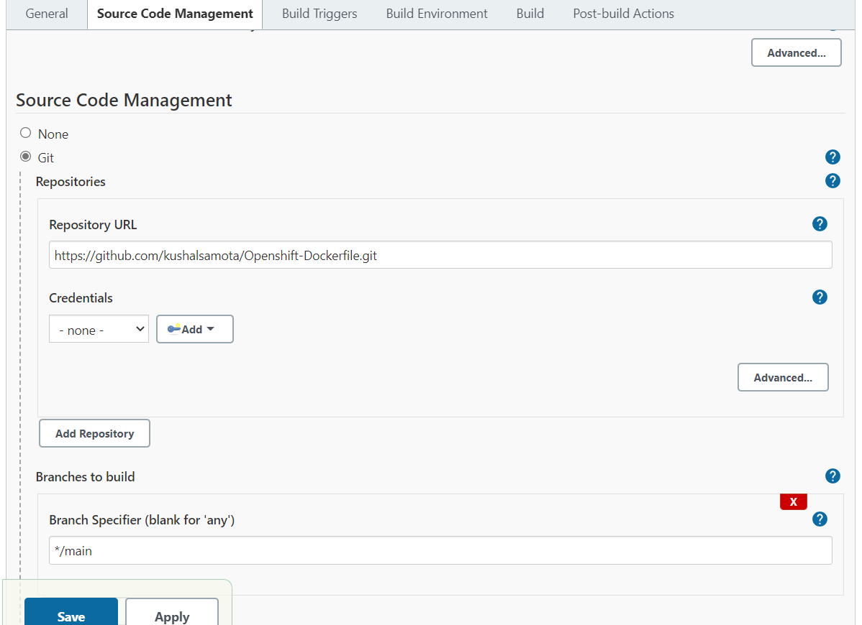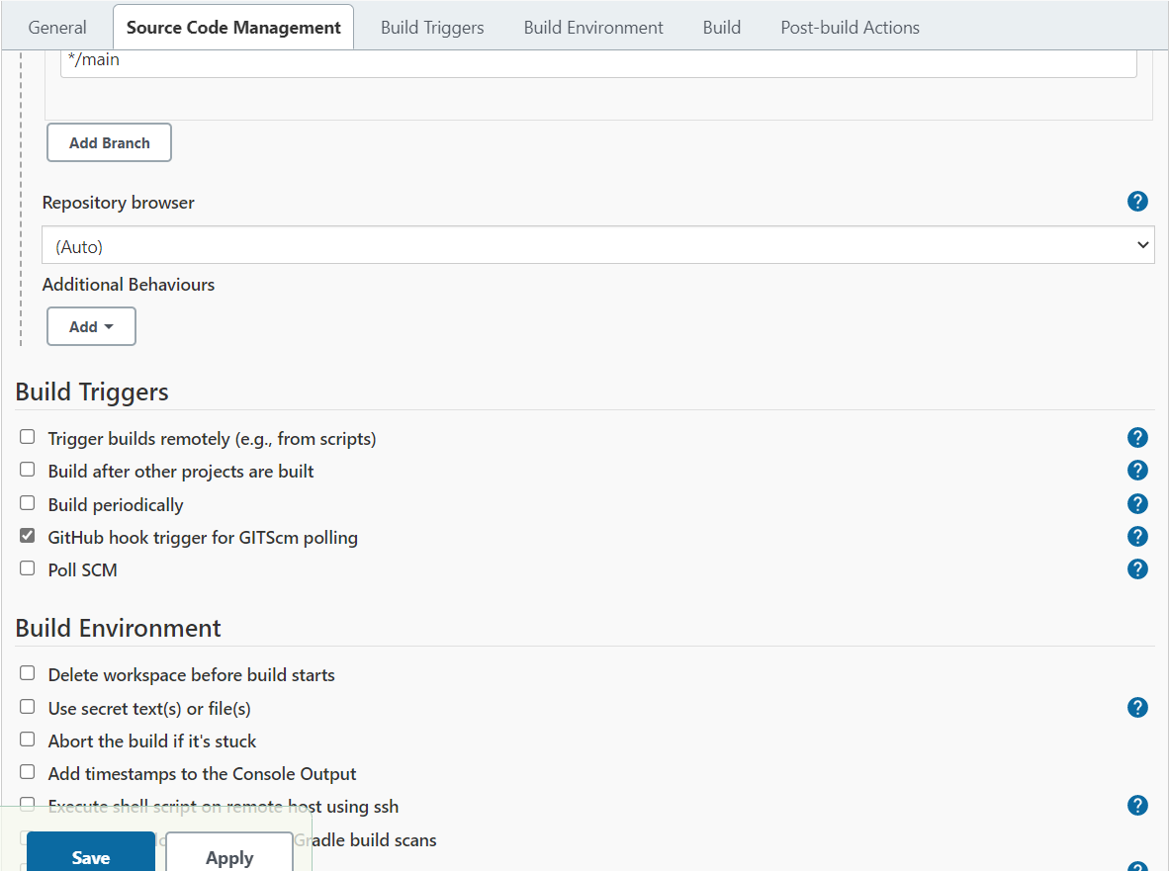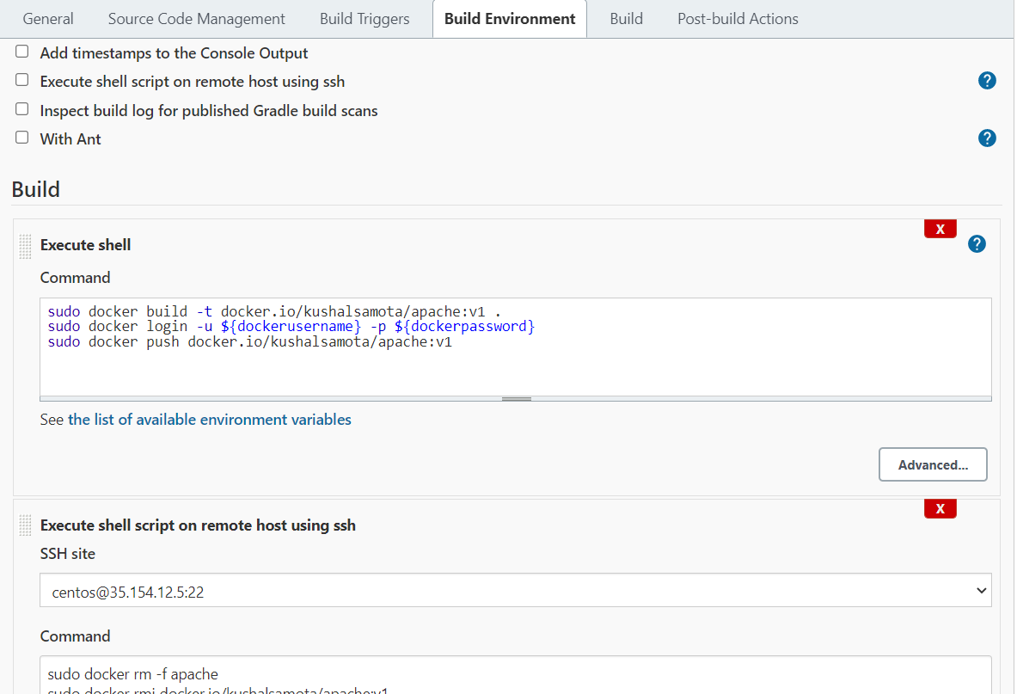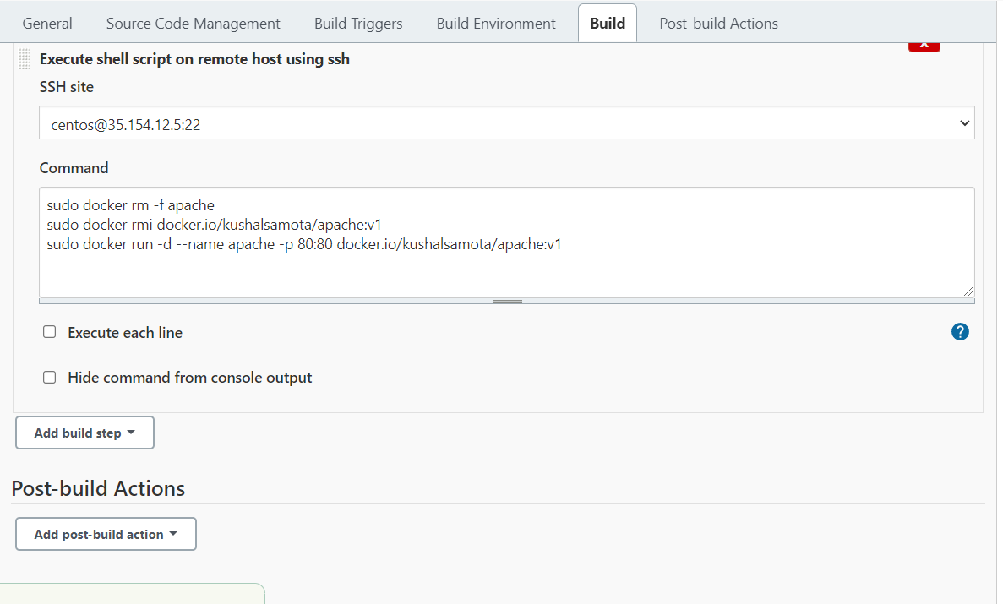
These steps needs to be configured in manage Jenkins.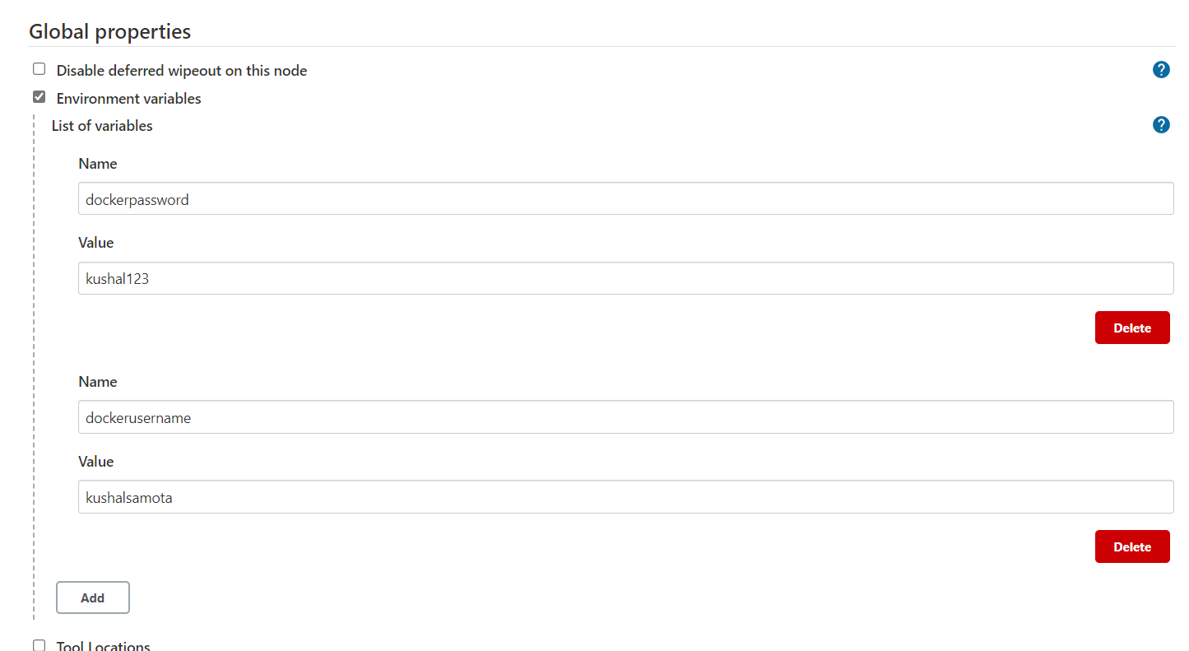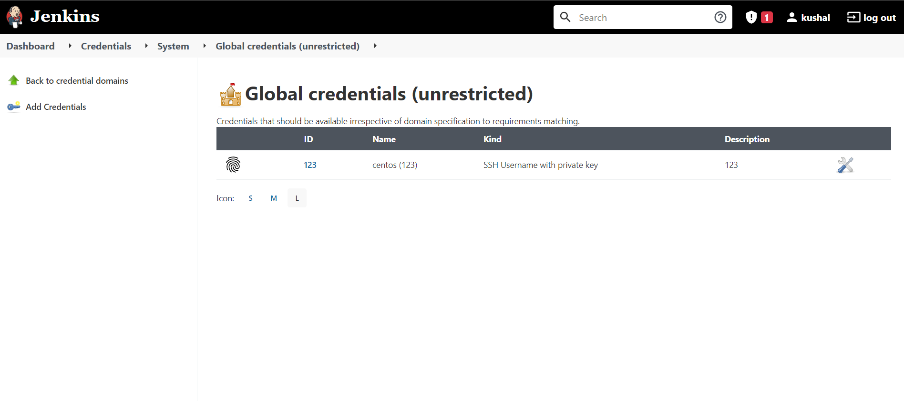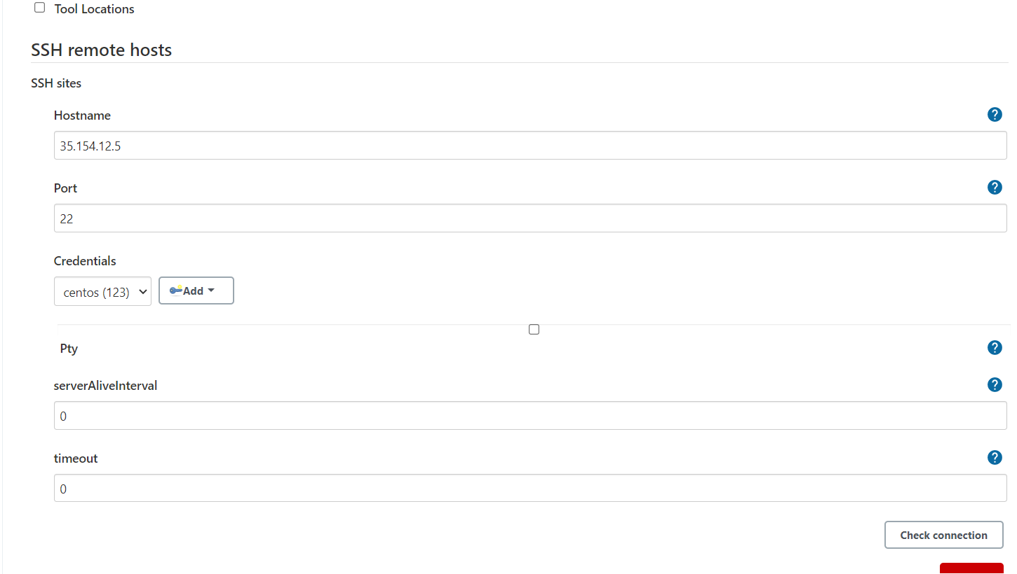

Jenkins Server History
35 yum install docker
36 systemctl start docker
37 docker login docker.io
38 docker logout
39 history
Prod server history
yum install docker -y
8 systemctl start docker
9 docker ps
10 systemctl stop apache
11 systemctl stop httpd
12 history

