**# Tttwordscount**

**This project was generated with [angular-cli](https://github.com/angular/angular-cli) version 1.0.0-beta.28.3.**

**Front end developed using Angular 2 that accepts a number to get top n number of most frequently occurring words from specified file at back end service.**

**## Development server**

**Run `ng serve` for a dev server. Navigate to `http://localhost:4200/`. The app will automatically reload if you change any of the source files.**

**## Getting Started**

**For running on local machine:**

**Make sure backend service ‘wordsplay’ is up and running.**

**Import ‘wordsplay’ project in any IDE of your choice and deploy it on port 8080.**

**To test whether service is up, simply hit below URL from any REST Client (e.g. Use POSTMAN client extension for Chrome)**

**http://localhost:8080/wordsplay/counter/test**

**It should return 200 Ok Status code with response message as ‘test succeed’.**

**To run UI follow below:**

**Run command from terminal (you must have installed latest node)**

**>>npm install**

**>>npm start**

**## Prerequisites**

**Install node - v8.9.4 or latest version**

**After that Run npm install, to install dependencies for the application**

**## Components**

**AppComponent is the main component for the application that accepts number from user and request AppService to get requested number**

**of words.**

**AppService is the service that request wordsplay REST API to get top n most frequently occurring words from the file specified by**

**the service itself.**

### Test ###

Test Scenarios:

Case 1. Enter a number for words count

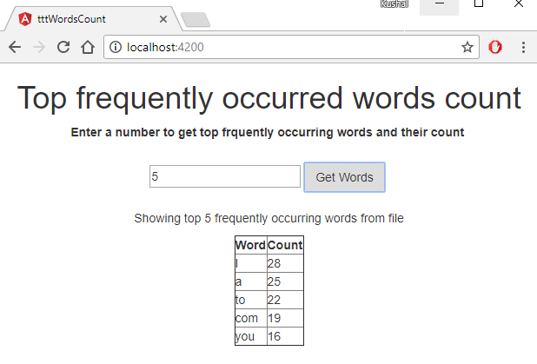

Result: You will get requested number of most frequently occurring words with their count in tabular format.

Case 2: Enter a number which is actually more than the total number of words. (If user enter such number mistakenly).

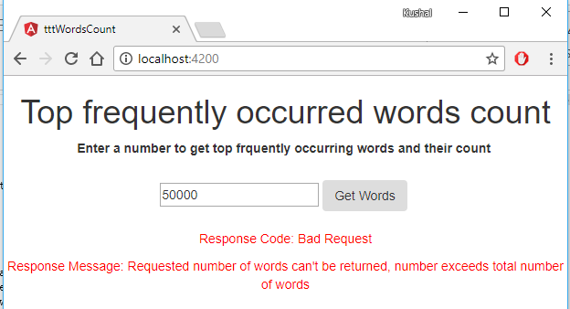

Result:

Error message is displayed with Bad Request response code along with the message specifying that entered requested number is more than the total number of words.

### wordsplay ###

A backend service developed in Java using Spring MVC REST architecture for tttwordscount angular application that gives REST end points for top words count from file.

### Getting Started -How do I get set up? ###

This is maven project. So you need to have maven installed in your IDE.

Once maven is installed, run command

>> mvn clean install

This will install all required dependencies for the application like spring-web.

Then deploy the generated war on any web container server like tomcat or jboss on port 8080.

Spring MVC framework is used to design RESTful webservice for client. This reads the file specified in property file

and then parses it get the top n requested most occurring words from it. File is parsed fetched and parsed only once per user request.

It means if same user calls the service the get next number of top words count then it will directly look in collection (HashMap) rather than

fetching file again. File url can be configured through property file if in case different file is needed to test.

### Prerequisites ###

You must have JDK or JRE 1.8 installed.

Tomcat or JBoss or any web container to deploy service on port 8080.

### Components ###

Depedencies used :

spring-webmvc[4.2.0] To get REST API support.

jackson-core [2.4.1]: To transform the response appropriately

EntryController is the rest controller for handling client requests. ConuterService is the service that fetches the file specified in properties file. Then parses it and stores it in Map collection. Any request to get top n most frquently occurring words is processed here and those words with their count is returned as json response.

@CrossOrigin annotation provided from spring 4.2 onwards is used to set header with Access-Control-Allow-Origin. As front-end angular application is running on 4200 port whereas wordsplay service is running on 8080. This resolves any request to wrodsplay REST service

### Test Scenarios ###

To test use any REST Client like Postman for Chrome and hit below urls:

1. To test whether service is running

[GET] http://localhost:8080/wordsplay/counter/test

This is will return 200 OK and response message as 'test succeed'

2. To get top number of most frequently occuring words

[GET] http://localhost:8080/wordsplay/counter/getwords?number=3

Here number is the query parameter that takes the number of words as input.

This will return top 3 most frequently occurring words as JSON response:

Ex.

{

"I": 28,

"a": 25,

"to": 22

}

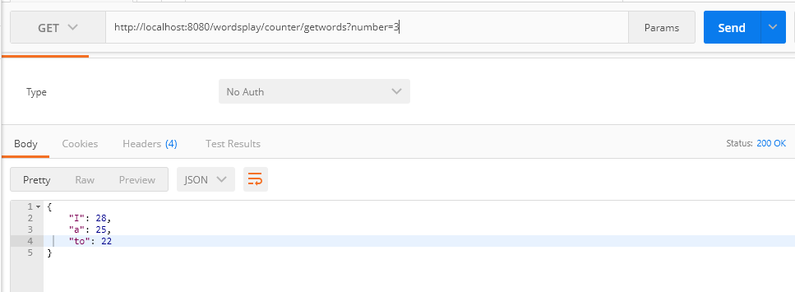

3. In case the number is more than total number of words from the file, then error is returned as below.

[GET] http://localhost:8080/wordsplay/counter/getwords?number=3000

Ex.

{

"httpStatus": "Bad Request",

"errorMessage": "Requested number of words can't be returned, number exceeds total number of words"

}

