Module Building – Frameworks and libraries

Front End

* React JS
* Next JS (react JS Framework)
* Sass: CSS preprocessor
* Font Awesome
* For animations (motions) – Gsap (ex – fade in, fade out)

Back End

* Node JS – Express JS
* Mongoose
* JWT tokens
* MongoDB
* RestAPI

Flow Diagram

Landing Page - displays the details about the application.

Authentication – Sign in / Sign up

If Signup:

* Create a user profile
* Setup the environment based on their interests
* Navigate to Home Page
* Types of Users:
* Students
* Professors
* Alumni
* Admin

If Sign in:

* Navigate to Home Page

Home Page

* Based on the User Profile feed section will be loaded

Use case diagram

Job Insights and Research Hub

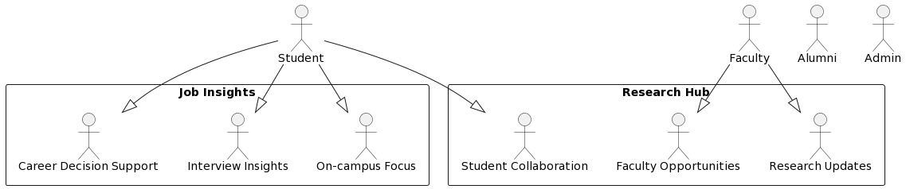

Community Connect and User Profiles

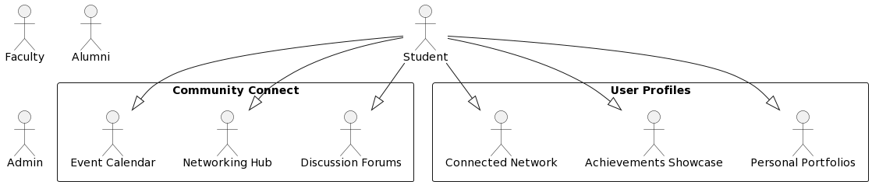

Alumni Network, Interactive Chat, and Admin Dashboard

