xiaomimimo ??? Token ???? / Agent ??????????
??? | ???????? AI ???? Agent

04 ?????
??????????? 04 ??
?????? AI ??????? AI ???? Agent?????????????????????????? AI ?????????????????????????????/????????????????????????? Agent??? Node.js ??????????? 5-7 ???? UI?Live2D/Three.js 3D ????????????????? persona prompt??????Skill ???????????????????????????????????????????????????????????????????????/??? Skill?????? user-profile ??????????????????????????????????? DeepSeek/?? OpenAI ???????????????????????????? TTS?OpenVoice ? GPT-SoVITS ???????? Live2D/3D ??????????? shima-rin-ai-offline????????????????????????????????? TTS???????????????? INF_A ?????????? Python ???????????????????/???/?????????????????????????????????????????????????????? civ6-city-decision-system???????????????????????????????????????? prompt????????????-????/??-?????-????-??/????-??????? Agent ????
?????? 771 ???????? 1200 ????

05 ?????????
? 05 ????/???
?????? AI ??????/????????????? GitHub ???????????????????????????? npm start ???? UI??? Skill ??????????Live2D/3D ??????????OpenVoice/GPT-SoVITS ????????????? TTS ???????????? INF_A??????????? civ6 ???????/??????????????? AI/Agent ???????????
????????
- ??? AI ????/???????????? Skill?????????????Live2D/3D ?????
- ?????? E:/shima-rin-ai ? E:/shima-rin-ai-offline ?? npm start?npm test ????
- ???????OpenVoice/GPT-SoVITS ??? TTS ???????/???? .tmp-audio?sound?gpt-sovits ????????
- ??????????????????????????????????????
- GitHub/?????INF_A?zyxz-tibet-job-helper-miniapp?civ6-city-decision-system ?????????????????

???????
?? | ??/?? | ???
??? AI ???? Agent | E:/shima-rin-ai???? E:/shima-rin-ai-offline | DeepSeek/???????????????????Skill ????????Live2D/3D?OpenVoice/GPT-SoVITS??? TTS?
AI/?????? INF_A | https://github.com/kushana-86/INF_A | ????????????????????????????Excel ????
????? ???? | https://github.com/kushana-86/zyxz-tibet-job-helper-miniapp | ?????????????????????????????????????
??????? | https://github.com/kushana-86/civ6-city-decision-system | ?????? Agent ??????????????????????????
??????? | ?????jiansuo/231001201_??? | ??? RAG/???????????????????? Word ???

?????
- ??? AI??????/??????? prompt??????Skill ??????????????? UI ????????? Agent ???
- ??????Top-1 0.667?0.750?Hit@5 0.833?1.000?MRR 0.742?0.840?nDCG@5 0.761?0.880?
- INF_A?35 ????????????????????????????????/??????????? R?=0.9450?
- ????????????????????????????/??/??????????????????

??????????
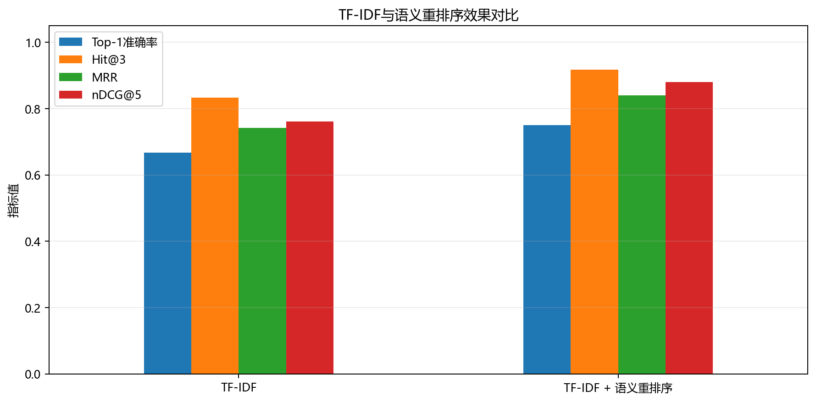
??????????

????????
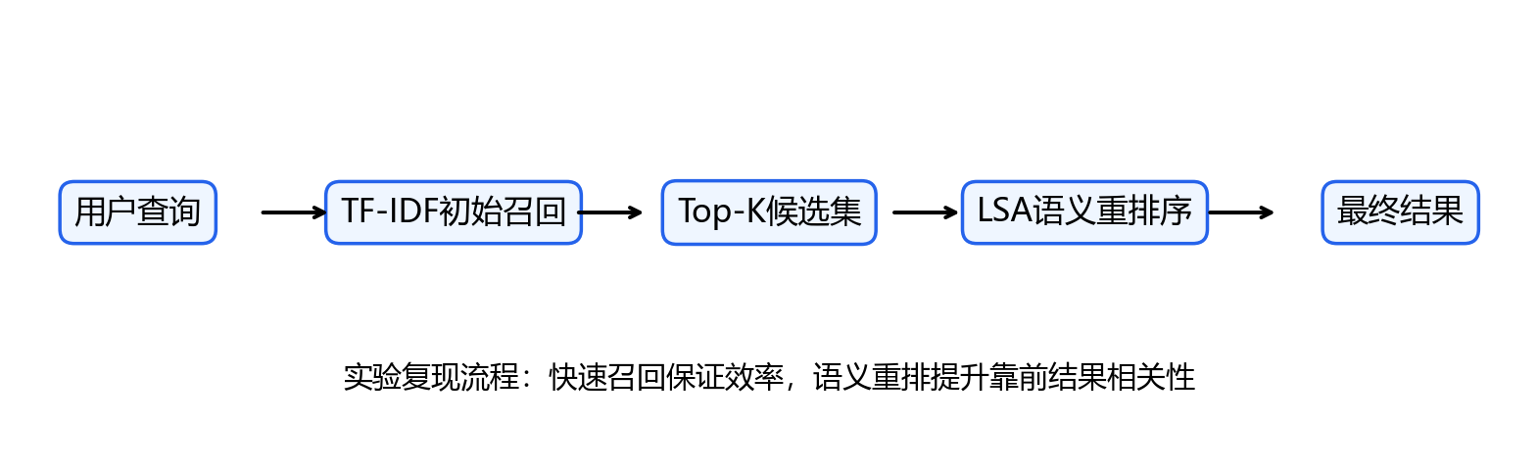
????????

????
????????????????? AI ????????????????????????????? GitHub ???????? 04 ???? Agent ????? 05 ???????????

