Written by: Yousuf Shah

Subject: EDA On Googleplaystore Dataset

Date: 06.04.2024

Email: contact.ys09@gmail.com

Google Playstore Data

About dataset
- Description The dataset was downloaded from kaggle,from the following Link

Context
While many public datasets (on Kaggle and the like) provide Apple App Store data, there are not many counterpart datasets available for Google Play Store apps anywhere on the web. On digging deeper, I found out that iTunes App Store page deploys a nicely indexed appendix-like structure to allow for simple and easy web scraping. On the other hand, Google Play Store uses sophisticated modern-day techniques (like dynamic page load) using JQuery making scraping more challenging.

Content
Each app (row) has values for catergory, rating, size, and more.

Acknowledgements
This information is scraped from the Google Play Store. This app information would not be available without it.

Inspiration
The Play Store apps data has enormous potential to drive app-making businesses to success. Actionable insights can be drawn for developers to work on and capture the Android market!

Import libraries
import pandas as pd
import numpy as np
import seaborn as sns
import matplotlib.pyplot as plt
%matplotlib inline
# %matplotlib inline for jupyter notebook to show the plot in the notebook itself instead of opening a new window for the plot
# Hide All Warnings
import warnings
warnings.simplefilter('ignore')

Data loading and Exploration or cleaning

Load the csv file
df=pd.read_csv('googleplaystore.csv')

Let's have a look on Top 5 rows of the data
df.head()
App Category Rating \
0 Photo Editor & Candy Camera & Grid & ScrapBook ART_AND_DESIGN 4.1
1 Coloring book moana ART_AND_DESIGN 3.9
2 U Launcher Lite – FREE Live Cool Themes, Hide ... ART_AND_DESIGN 4.7
3 Sketch - Draw & Paint ART_AND_DESIGN 4.5
4 Pixel Draw - Number Art Coloring Book ART_AND_DESIGN 4.3
Reviews Size Installs Type Price Content Rating Genres \
0 159 19M 10,000+ Free 0 Everyone Art & Design
1 967 14M 500,000+ Free 0 Everyone Art & Design
2 87510 8.7M 5,000,000+ Free 0 Everyone Art & Design
3 215644 25M 50,000,000+ Free 0 Teen Art & Design
4 967 2.8M 100,000+ Free 0 Everyone Art & Design
Last Updated Current Ver Android Ver Unnamed: 13
0 January 7, 2018 1.0.0 4.0.3 and up NaN
1 Pretend Play January 15, 2018 2.0.0 4.0.3 and up
2 August 1, 2018 1.2.4 4.0.3 and up NaN
3 June 8, 2018 Varies with device 4.2 and up NaN
4 Creativity June 20, 2018 1.1 4.4 and up

Important things to know
# Set option to see maximum rows and columns in dataset
pd.set_option("display.max_columns",None)
pd.set_option("display.max_rows",None)
# Print all columns name
df.columns
Index(['App', 'Category', 'Rating', 'Reviews', 'Size', 'Installs', 'Type',
'Price', 'Content Rating', 'Genres', 'Last Updated', 'Current Ver',
'Android Ver', 'Unnamed: 13'],
dtype='object')
# print how many rows and columns in our dataset
print(f'The number of Rows are : {df.shape[0]}')
print()
print(f'The number of Columns are : {df.shape[1]}')
The number of Rows are : 10841
The number of Columns are : 14
# Show info of our dataset
df.info()
<class 'pandas.core.frame.DataFrame'>
RangeIndex: 10841 entries, 0 to 10840
Data columns (total 14 columns):
# Column Non-Null Count Dtype
--- ------ -------------- -----
0 App 10841 non-null object
1 Category 10840 non-null object
2 Rating 9367 non-null float64
3 Reviews 10841 non-null int64
4 Size 10841 non-null object
5 Installs 10841 non-null object
6 Type 10840 non-null object
7 Price 10841 non-null object
8 Content Rating 10841 non-null object
9 Genres 10840 non-null object
10 Last Updated 10841 non-null object
11 Current Ver 10833 non-null object
12 Android Ver 10839 non-null object
13 Unnamed: 13 499 non-null object
dtypes: float64(1), int64(1), object(12)
memory usage: 1.2+ MB

Let's deal with the
- Size
- Installs
- Price
because python is showing that column into object even that is not object so we convert them into numeric

Size

remove M,k and Varies with device from Size

and in the place of Varies with device we place nan values

rest convert into MBs and convert Size column into float numbers
# Rename column
df.rename(columns={'Size':'size_in_MBs'},inplace=True)
df['size_in_MBs'].value_counts()
size_in_MBs
Varies with device 1695
11M 198
12M 196
14M 194
13M 191
15M 184
17M 160
19M 154
26M 149
16M 149
25M 143
20M 139
21M 138
10M 136
24M 136
18M 133
23M 117
22M 114
29M 103
27M 97
28M 95
30M 84
33M 79
3.3M 77
37M 76
35M 72
31M 70
2.9M 69
2.3M 68
2.5M 68
3.4M 65
2.8M 65
32M 63
3.7M 63
34M 63
3.9M 62
3.0M 62
3.8M 62
40M 62
44M 61
4.0M 61
36M 60
48M 59
46M 59
4.2M 59
5.0M 58
3.6M 57
3.1M 56
39M 56
3.2M 55
38M 55
4.3M 54
2.7M 53
4.1M 52
2.0M 51
3.5M 51
5.4M 51
4.9M 50
1.8M 50
2.6M 50
1.5M 48
2.4M 48
5.7M 48
41M 48
43M 47
4.6M 46
6.3M 45
2.2M 45
49M 45
50M 44
5.3M 44
5.1M 43
53M 43
4.4M 42
63M 41
42M 41
1.2M 41
1.7M 40
2.1M 40
45M 40
4.5M 40
6.9M 40
6.1M 39
99M 39
1.6M 39
8.7M 39
59M 38
47M 37
57M 37
5.9M 37
1.4M 37
7.3M 37
60M 36
8.5M 36
4.7M 36
1.3M 35
5.8M 35
52M 35
5.2M 35
4.8M 34
6.0M 34
6.5M 34
7.9M 33
5.5M 33
7.0M 33
51M 33
6.6M 33
9.2M 33
1.9M 32
67M 32
1.1M 32
62M 32
5.6M 31
56M 31
8.3M 30
7.2M 30
8.4M 30
55M 30
9.8M 30
6.2M 30
54M 29
7.8M 29
9.1M 29
7.6M 29
6.4M 29
9.9M 28
7.4M 28
8.9M 28
7.5M 28
6.8M 28
9.5M 28
8.2M 28
8.8M 27
76M 27
70M 27
8.1M 27
9.0M 27
61M 26
7.7M 26
58M 26
7.1M 26
96M 26
8.6M 25
6.7M 25
9.4M 24
9.7M 24
78M 23
8.0M 23
69M 23
91M 22
82M 21
97M 20
74M 20
72M 19
95M 18
68M 18
85M 17
94M 17
93M 16
100M 16
66M 16
98M 16
83M 15
92M 15
9.3M 15
9.6M 15
64M 15
73M 15
71M 14
88M 14
77M 13
87M 13
75M 13
80M 13
79M 11
81M 11
10.0M 10
65M 10
89M 9
84M 9
86M 8
1.0M 7
90M 6
201k 3
79k 3
118k 3
266k 3
375k 3
592k 2
29k 2
948k 2
323k 2
656k 2
33k 2
228k 2
72k 2
334k 2
417k 2
335k 2
192k 2
141k 2
70k 2
18k 2
473k 2
842k 2
206k 2
172k 2
26k 2
196k 2
58k 2
318k 2
17k 2
704k 2
51k 2
957k 2
364k 2
619k 1
144k 1
143k 1
190k 1
376k 1
970k 1
39k 1
879k 1
161k 1
626k 1
387k 1
860k 1
154k 1
467k 1
861k 1
921k 1
523k 1
329k 1
48k 1
270k 1
811k 1
688k 1
847k 1
562k 1
54k 1
500k 1
608k 1
903k 1
914k 1
193k 1
378k 1
899k 1
892k 1
754k 1
518k 1
24k 1
280k 1
784k 1
981k 1
862k 1
865k 1
953k 1
857k 1
241k 1
772k 1
713k 1
720k 1
853k 1
779k 1
920k 1
525k 1
544k 1
293k 1
91k 1
756k 1
730k 1
220k 1
371k 1
239k 1
314k 1
203k 1
746k 1
313k 1
540k 1
930k 1
251k 1
61k 1
545k 1
965k 1
475k 1
45k 1
169k 1
939k 1
81k 1
818k 1
902k 1
924k 1
78k 1
317k 1
14k 1
74k 1
717k 1
23k 1
695k 1
696k 1
980k 1
975k 1
444k 1
954k 1
549k 1
238k 1
976k 1
322k 1
121k 1
872k 1
93k 1
714k 1
655k 1
283k 1
442k 1
812k 1
421k 1
454k 1
383k 1
350k 1
175k 1
904k 1
306k 1
705k 1
308k 1
609k 1
210k 1
414k 1
11k 1
292k 1
41k 1
8.5k 1
624k 1
232k 1
556k 1
816k 1
496k 1
728k 1
460k 1
200k 1
429k 1
430k 1
721k 1
782k 1
478k 1
459k 1
412k 1
598k 1
437k 1
373k 1
191k 1
647k 1
840k 1
186k 1
319k 1
683k 1
778k 1
569k 1
243k 1
613k 1
887k 1
506k 1
27k 1
351k 1
554k 1
25k 1
963k 1
951k 1
511k 1
691k 1
55k 1
219k 1
222k 1
982k 1
585k 1
716k 1
597k 1
173k 1
499k 1
353k 1
209k 1
153k 1
116k 1
743k 1
898k 1
103k 1
551k 1
514k 1
913k 1
208k 1
82k 1
269k 1
961k 1
780k 1
837k 1
516k 1
97k 1
986k 1
643k 1
50k 1
237k 1
787k 1
801k 1
400k 1
411k 1
122k 1
809k 1
663k 1
257k 1
234k 1
160k 1
170k 1
89k 1
240k 1
226k 1
470k 1
526k 1
176k 1
940k 1
108k 1
221k 1
601k 1
881k 1
642k 1
749k 1
600k 1
498k 1
20k 1
485k 1
309k 1
994k 1
916k 1
636k 1
785k 1
775k 1
288k 1
28k 1
629k 1
245k 1
458k 1
164k 1
259k 1
942k 1
34k 1
874k 1
582k 1
1020k 1
885k 1
552k 1
67k 1
676k 1
44k 1
157k 1
404k 1
420k 1
253k 1
992k 1
658k 1
73k 1
246k 1
Name: count, dtype: int64

Observation
- Varies with device
- M
- k
# Missing values check
df['size_in_MBs'].isnull().sum()
np.int64(0)
- No missing values in Size column
# Find the values having 'M' in them
df['size_in_MBs'].loc[df['size_in_MBs'].str.contains('M')].value_counts().sum()
np.int64(8830)
# Find the values having 'k' in them
df['size_in_MBs'].loc[df['size_in_MBs'].str.contains('k')].value_counts().sum()
np.int64(316)
# Find the values having 'Varies with device' in them
df['size_in_MBs'].loc[df['size_in_MBs'].str.contains('Varies with device')].value_counts().sum()
np.int64(1695)

for conformation
len(df)
10841
1695+316+8830
10841
- Both are equal we are good to go
# define a funciton that convert size_in_MBs into numeric dtype
def convert_size(size_in_MBs):
if isinstance(size_in_MBs, str):
if 'k' in size_in_MBs:
return float(size_in_MBs.replace('k', '')) / 1024
elif 'M' in size_in_MBs:
return float(size_in_MBs.replace('M', ''))
elif 'Varies with device' in size_in_MBs:
return np.nan
return size_in_MBs
# Apply the function to the size_in_MBs column
# apply means convert_size funtion will implement on size_in_MBs
df['size_in_MBs'] = df['size_in_MBs'].apply(convert_size)
df['size_in_MBs'].dtype
dtype('float64')

Installs
- Remove + sign
- Remove comma
- convert the column into an integer not float because\ install is descrete values
df['Installs'].value_counts()
Installs
1,000,000+ 1579
10,000,000+ 1252
100,000+ 1169
10,000+ 1054
1,000+ 908
5,000,000+ 752
100+ 719
500,000+ 539
50,000+ 479
5,000+ 477
100,000,000+ 409
10+ 386
500+ 330
50,000,000+ 289
50+ 205
5+ 82
500,000,000+ 72
1+ 67
1,000,000,000+ 58
0+ 14
0 1
Name: count, dtype: int64
# Check null values
df['Installs'].isnull().sum() # No null values
np.int64(0)
# find how many values has '+' in it
df['Installs'].loc[df['Installs'].str.contains('\+')].value_counts().sum()
np.int64(10840)
# remove + sign form the Installs column in the last i give if condition it means
# if '+' sign is avaliable in x means Installs column then remove if rows has now '+'
# sign then keep it him same
df['Installs']=df['Installs'].apply(lambda x: x.replace('+','') if '+' in str(x) else x)
# removing comma
df['Installs']=df['Installs'].apply(lambda x: x.replace(',','') if ',' in str(x) else x)
# convert into integer
df['Installs']=df['Installs'].apply(lambda x: int(x))
# Making a new column name "install_category" which will have the category of Installs
bins=[-1, 0 , 10 , 1000 , 10000 , 100000 , 1000000 , 10000000 , 10000000000]
labels=['No' , 'Very Low' , 'Low' , 'Moderate' , 'More Than Moderate' , 'High' , 'Very High' , 'Top Notch']
df['install_category']=pd.cut(df['Installs'],bins=bins,labels=labels)
df['install_category'].value_counts()
install_category
Low 2162
High 2118
Very High 2004
More Than Moderate 1648
Moderate 1531
Top Notch 828
Very Low 535
No 15
Name: count, dtype: int64

Price

remove $ sign and convert into float numbers
# check missing values
df.Price.isnull().sum() # no null values
np.int64(0)
# check how many values have $ sign
df['Price'].loc[df['Price'].str.contains('\$')].value_counts().sum()
np.int64(800)
# count number of values in the price column contains 0 but does not contain $ sign
df['Price'].loc[df['Price'].str.contains('0')&(~df['Price'].str.contains('\$'))].value_counts().sum()
np.int64(10041)
# remove $ sign from Price column
df['Price']=df['Price'].apply(lambda x: x.replace('$','') if '$' in str(x) else x)
# Price is float column so we convert him into float numbers
df['Price']=df['Price'].apply(lambda x: float(x))
df['Price'].value_counts()
Price
0.00 10041
0.99 148
2.99 129
1.99 73
4.99 72
3.99 63
1.49 46
5.99 30
2.49 26
9.99 21
6.99 13
399.99 12
14.99 11
4.49 9
29.99 7
3.49 7
7.99 7
24.99 7
5.49 6
19.99 6
6.49 5
8.99 5
12.99 5
11.99 5
10.00 3
1.00 3
16.99 3
2.00 3
17.99 2
10.99 2
9.00 2
79.99 2
7.49 2
3.95 2
33.99 2
1.70 2
13.99 2
8.49 2
39.99 2
1.50 1
25.99 1
74.99 1
15.99 1
3.88 1
1.76 1
3.02 1
400.00 1
4.84 1
2.50 1
1.59 1
1.61 1
4.77 1
5.00 1
1.29 1
379.99 1
299.99 1
37.99 1
18.99 1
389.99 1
19.90 1
1.75 1
14.00 1
4.85 1
46.99 1
109.99 1
154.99 1
3.08 1
2.59 1
4.80 1
1.96 1
19.40 1
3.90 1
4.59 1
15.46 1
3.04 1
4.29 1
2.60 1
3.28 1
4.60 1
28.99 1
2.95 1
2.90 1
1.97 1
200.00 1
89.99 1
2.56 1
30.99 1
3.61 1
394.99 1
1.26 1
1.20 1
1.04 1
Name: count, dtype: int64
# summary of dataset
df.describe()
Rating Reviews size_in_MBs Installs Price
count 9367.000000 1.084100e+04 9146.000000 1.084100e+04 10841.000000
mean 4.191513 4.441119e+05 21.514141 1.546291e+07 1.027273
std 0.515735 2.927629e+06 22.588679 8.502557e+07 15.948971
min 1.000000 0.000000e+00 0.008301 0.000000e+00 0.000000
25% 4.000000 3.800000e+01 4.900000 1.000000e+03 0.000000
50% 4.300000 2.094000e+03 13.000000 1.000000e+05 0.000000
75% 4.500000 5.476800e+04 30.000000 5.000000e+06 0.000000
max 5.000000 7.815831e+07 100.000000 1.000000e+09 400.000000

Now jump into the missing values
# Find missing values
df.isnull().sum().sort_values(ascending=False)
Unnamed: 13 10342
size_in_MBs 1695
Rating 1474
Current Ver 8
Android Ver 2
Type 1
Category 1
Genres 1
Installs 0
App 0
Reviews 0
Last Updated 0
Content Rating 0
Price 0
install_category 0
dtype: int64
# Check missing values in percentage
round(df.isnull().sum()/len(df)*100,3).sort_values(ascending=False) # 3 means round upto 3 values
Unnamed: 13 95.397
size_in_MBs 15.635
Rating 13.597
Current Ver 0.074
Android Ver 0.018
Type 0.009
Category 0.009
Genres 0.009
Installs 0.000
App 0.000
Reviews 0.000
Last Updated 0.000
Content Rating 0.000
Price 0.000
install_category 0.000
dtype: float64
# Remove Unnamed: 13 column because it is not neccessary to our dataset and having above 70% of missing values
df.drop('Unnamed: 13',axis=1,inplace=True) # axis 1 means remove column and inplace True means updata my dataframe which i change
# Find total number of missing values
df.isnull().sum().sum()
np.int64(3182)
# plot of missing values
plt.figure(figsize=(9,5))
sns.heatmap(df.isnull(),cbar=False,yticklabels=False,cmap='viridis') # cbar hide colour legend , cmap is used for colormap
# and yticklabels hide rows number you can see yourself
# by practice this code
<Axes: >
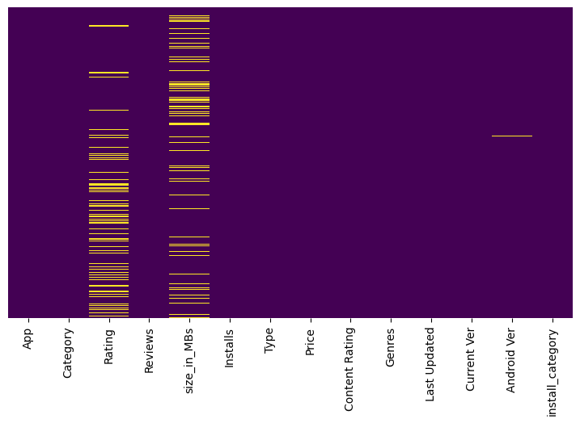
# make a plot for percentage missing values
# set figure size
plt.figure(figsize=(8,5))
# plot the null values by their percentage in each column
missing_perc=df.isnull().sum()/len(df)*100
missing_perc.plot(kind='bar')
# add the labels
plt.xlabel('Columns name')
plt.ylabel('percentage of missing value')
plt.title('Percentage of missing values in each column')
Text(0.5, 1.0, 'Percentage of missing values in each column')
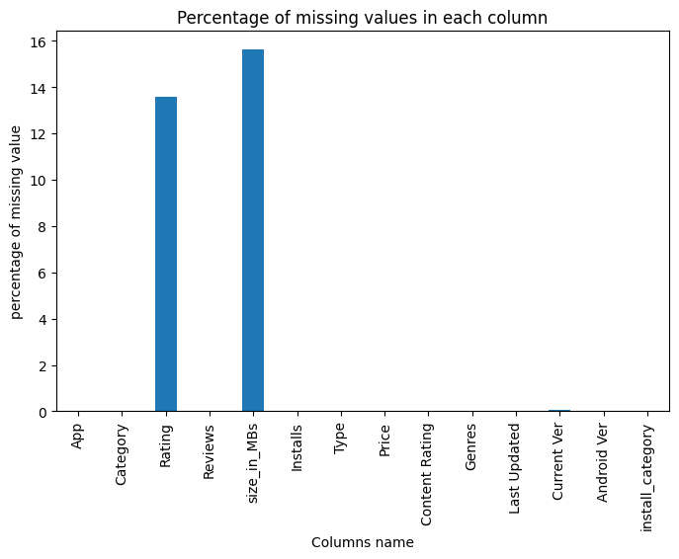
# set figure size
plt.figure(figsize=(8,5))
# print less then 1% missing values
missing_perc[missing_perc<1].plot(kind='bar')
# add the labels
plt.xlabel('Columns name')
plt.ylabel('percentage of missing value')
plt.title('Percentage of missing values in each column')
Text(0.5, 1.0, 'Percentage of missing values in each column')
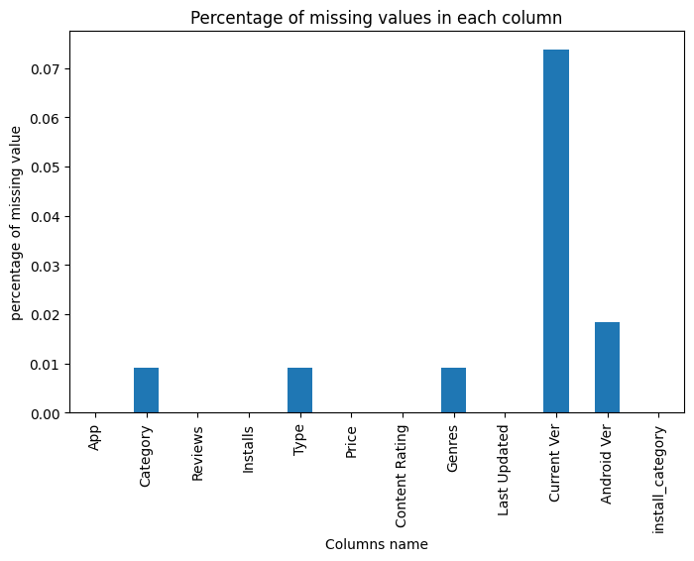
# this will show the number of null values in each column in descending order
df.isnull().sum().sort_values(ascending=False)
size_in_MBs 1695
Rating 1474
Current Ver 8
Android Ver 2
Category 1
Type 1
Genres 1
Installs 0
App 0
Reviews 0
Content Rating 0
Price 0
Last Updated 0
install_category 0
dtype: int64
# this will show the percentage of null values in each column
(df.isnull().sum() / len(df) * 100).sort_values(ascending=False)
size_in_MBs 15.635089
Rating 13.596532
Current Ver 0.073794
Android Ver 0.018448
Category 0.009224
Type 0.009224
Genres 0.009224
Installs 0.000000
App 0.000000
Reviews 0.000000
Content Rating 0.000000
Price 0.000000
Last Updated 0.000000
install_category 0.000000
dtype: float64

## Observations:
- We have 1695 missing values in the 'Size_in_bytes' and 'Size_in_Mb' columns, which is 15.6% of the total values in the column.
- We have 1474 missing values in the 'Rating' column, which is 13.6% of the total values in the column.
- We have 8 missing value in the 'Current Ver' column, which is 0.07% of the total values in the column.
- We have 2 missing values in the 'Android Ver' column, which is 0.01% of the total values in the column.
- We have only 1 missing value in Category, Type and Genres columns, which is 0.009% of the total values in the column.

2.3. Dealing with the missing values

We can not impute the Rating column as is is directly linked with the installation column. To test this Hypothesis we need to plot the Rating column with the Installs and Size columns and statistically test it using pearson correlation test.

Let's run the correlations
# These are numeric columns
df.describe()
Rating Reviews size_in_MBs Installs Price
count 9367.000000 1.084100e+04 9146.000000 1.084100e+04 10841.000000
mean 4.191513 4.441119e+05 21.514141 1.546291e+07 1.027273
std 0.515735 2.927629e+06 22.588679 8.502557e+07 15.948971
min 1.000000 0.000000e+00 0.008301 0.000000e+00 0.000000
25% 4.000000 3.800000e+01 4.900000 1.000000e+03 0.000000
50% 4.300000 2.094000e+03 13.000000 1.000000e+05 0.000000
75% 4.500000 5.476800e+04 30.000000 5.000000e+06 0.000000
max 5.000000 7.815831e+07 100.000000 1.000000e+09 400.000000
# Make a correlation matrix of numeric columns
# Make figure size
plt.figure(figsize=(15,10))
# Make a list of numeric columns
numeric_columns=["Rating","Reviews","size_in_MBs","Installs","Price"]
# Plot the correlation matrix
sns.heatmap(df[numeric_columns].corr(),annot=True)
<Axes: >
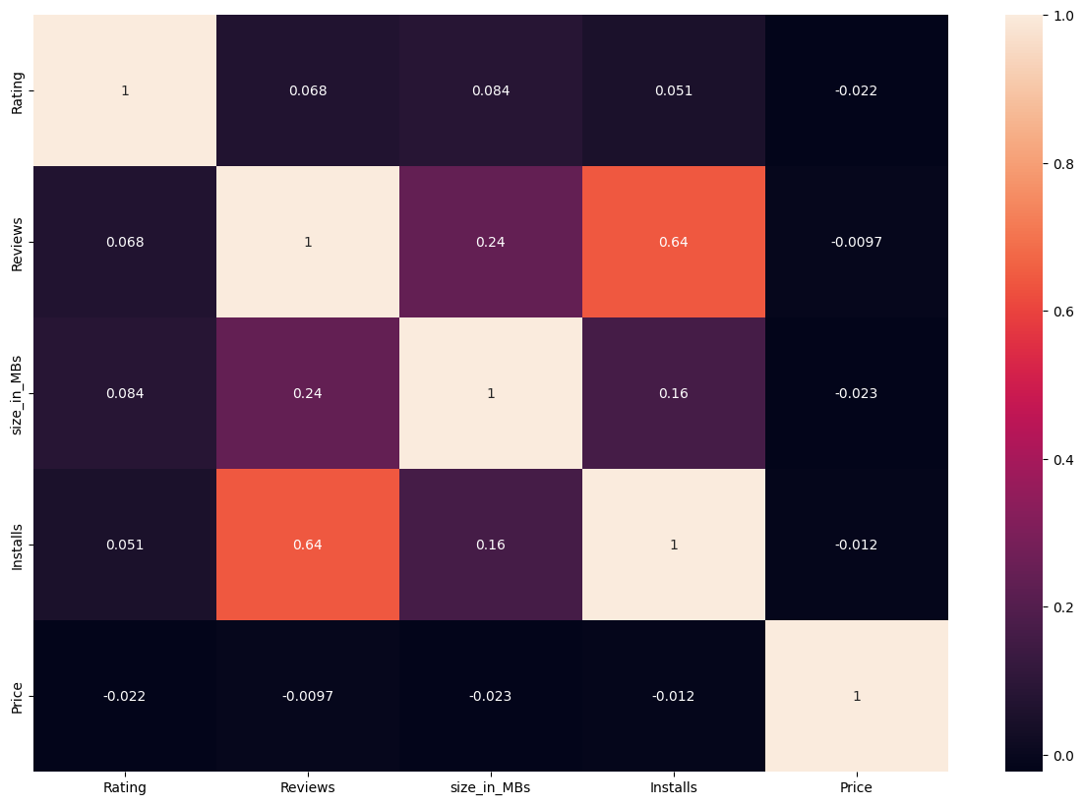
df['size_in_MBs'].describe()
count 9146.000000
mean 21.514141
std 22.588679
min 0.008301
25% 4.900000
50% 13.000000
75% 30.000000
max 100.000000
Name: size_in_MBs, dtype: float64
# we can also calculate the correlation matrix using pandas
df[numeric_columns].corr() # this will show the correlation matrix
Rating Reviews size_in_MBs Installs Price
Rating 1.000000 0.068147 0.084098 0.051393 -0.021851
Reviews 0.068147 1.000000 0.238218 0.643123 -0.009666
size_in_MBs 0.084098 0.238218 1.000000 0.164794 -0.023000
Installs 0.051393 0.643123 0.164794 1.000000 -0.011688
Price -0.021851 -0.009666 -0.023000 -0.011688 1.000000

Observations
- Lighter color shows the high correlation and darker color shows the low correlation
- We can see that the Reviews column has a high correlation with the Installs column, which is 0.64 according to corr(). Which is quite good.
  - This shows that the more the reviews the more the installs are for one app. If in any case we need to impute reviews we have to think of number of install.
    - If we have an ap with 2 installs and we imputer the reviews with 1000 or via average reviews then it will be wrong.

Installs is slightly correlated with Size_in_Mb or Size_in_bytes , which is 0.16, this also shows us the importance of size and Installs. But we can not depend on it as the Peason correlation is very low.
- Before going ahead, let's remove the rows with missing values in the Current Ver, Android Ver, Category, Type and Genres columns, as they are very less in number and will not affect our analysis.
# length before removing null values
print(f"Length of the dataframe before removing null values: {len(df)}")
Length of the dataframe before removing null values: 10841
# remove the rows having null values in the 'Current Ver', 'Android Ver', 'Category', 'Type' and 'Genres' column
df.dropna(subset=['Current Ver','Android Ver','Category','Type','Genres'],inplace=True)
# length after removing null values
print(f"Length of the dataframe after removing null values: {len(df)}")
Length of the dataframe after removing null values: 10829
- We have removed 12 rows having null values in the Current Ver, Android Ver, Category, Type and Genres columns.
# let's check the null values again
df.isnull().sum().sort_values(ascending=False)
size_in_MBs 1694
Rating 1469
Category 0
App 0
Reviews 0
Installs 0
Type 0
Price 0
Content Rating 0
Genres 0
Last Updated 0
Current Ver 0
Android Ver 0
install_category 0
dtype: int64

Observations
- Only Rating and size_in_MBs columns are left with missing values.
  - We know that we have to be carefull while deadling with Rating column, as it is directly linked with the Installs column.

In Size columns we already know about Varies with device values, which we have converted into null values, we do not need to impute at the moment, as every app has different size and nobody can predict that as nearly as possible.
df.columns
Index(['App', 'Category', 'Rating', 'Reviews', 'size_in_MBs', 'Installs',
'Type', 'Price', 'Content Rating', 'Genres', 'Last Updated',
'Current Ver', 'Android Ver', 'install_category'],
dtype='object')

Jump into the Rating column to fill missing values

I am going to do that in install_category No has mean NaN means 0 install so i fill this type of category with 0

and Very low will be fill by 4.6 , Low will be fill by 4.17 respectively remember all values we will fill in Rating column
# use group by function to find the trend of Rating in each install_category
df.groupby('install_category')['Rating'].describe()
count mean std min 25% 50% 75% max
install_category
No 0.0 NaN NaN NaN NaN NaN NaN NaN
Very Low 81.0 4.637037 0.845199 1.0 4.8 5.0 5.0 5.0
Low 1278.0 4.170970 0.825605 1.0 3.8 4.4 4.8 5.0
Moderate 1440.0 4.035417 0.604428 1.4 3.8 4.2 4.5 5.0
More Than Moderate 1616.0 4.093255 0.505619 1.6 3.9 4.2 4.5 4.9
High 2113.0 4.207525 0.376594 1.8 4.0 4.3 4.5 4.9
Very High 2004.0 4.287076 0.294902 2.0 4.1 4.3 4.5 4.9
Top Notch 828.0 4.374396 0.193726 3.1 4.3 4.4 4.5 4.8
# in which Install_category the Rating has NaN values
df['install_category'].loc[df['Rating'].isnull()].value_counts()
install_category
Low 880
Very Low 453
Moderate 88
More Than Moderate 31
No 14
High 3
Very High 0
Top Notch 0
Name: count, dtype: int64
# Now fill values base on install_category i mean to say group by filling with respect to install_category ]
# transform means fillin values by grouping
df['Rating'] = df.groupby('install_category')['Rating'].transform(lambda x: x.fillna(x.mean()))
df['install_category'].loc[df['Rating'].isnull()].value_counts()
install_category
No 14
Very Low 0
Low 0
Moderate 0
More Than Moderate 0
High 0
Very High 0
Top Notch 0
Name: count, dtype: int64
# 'No' has 14 means mean is NaN you can see in above code so we will fill Rating column with 0
df.Rating.fillna(0,inplace=True)
df['install_category'].loc[df['Rating'].isnull()].value_counts()
install_category
No 0
Very Low 0
Low 0
Moderate 0
More Than Moderate 0
High 0
Very High 0
Top Notch 0
Name: count, dtype: int64
# Now check missing values
df.isnull().sum()
App 0
Category 0
Rating 0
Reviews 0
size_in_MBs 1694
Installs 0
Type 0
Price 0
Content Rating 0
Genres 0
Last Updated 0
Current Ver 0
Android Ver 0
install_category 0
dtype: int64

Jump into the size_in_MBs

I will fill missing values same as Rating

but there category column name is Category
# in which Category the size_in_MBs has NaN values
df['Category'].loc[df['size_in_MBs'].isnull()].value_counts()
Category
FAMILY 139
GAME 129
COMMUNICATION 122
PRODUCTIVITY 121
TOOLS 104
SOCIAL 85
PHOTOGRAPHY 81
HEALTH_AND_FITNESS 77
SPORTS 73
NEWS_AND_MAGAZINES 67
TRAVEL_AND_LOCAL 66
BUSINESS 60
FINANCE 59
SHOPPING 59
ENTERTAINMENT 59
EDUCATION 45
VIDEO_PLAYERS 44
PERSONALIZATION 37
LIFESTYLE 37
BOOKS_AND_REFERENCE 34
MEDICAL 29
MAPS_AND_NAVIGATION 29
FOOD_AND_DRINK 27
WEATHER 25
DATING 22
HOUSE_AND_HOME 20
AUTO_AND_VEHICLES 10
COMICS 9
EVENTS 7
PARENTING 6
BEAUTY 6
ART_AND_DESIGN 3
LIBRARIES_AND_DEMO 3
Name: count, dtype: int64
# Now fill values base on Category i mean to say group by filling with respect to Category
# transform means fillin values by grouping
df['size_in_MBs']= df.groupby('Category')['size_in_MBs'].transform(lambda x:x.fillna(x.mean()))
# Now check null values
df.isnull().sum()
App 0
Category 0
Rating 0
Reviews 0
size_in_MBs 0
Installs 0
Type 0
Price 0
Content Rating 0
Genres 0
Last Updated 0
Current Ver 0
Android Ver 0
install_category 0
dtype: int64

Now visuilization part
# Make a box plot for Reviews column
plt.figure(figsize=(16, 6)) # make figure size
sns.boxplot(x='install_category', y= 'Reviews', data=df) # plot the boxplot
<Axes: xlabel='install_category', ylabel='Reviews'>
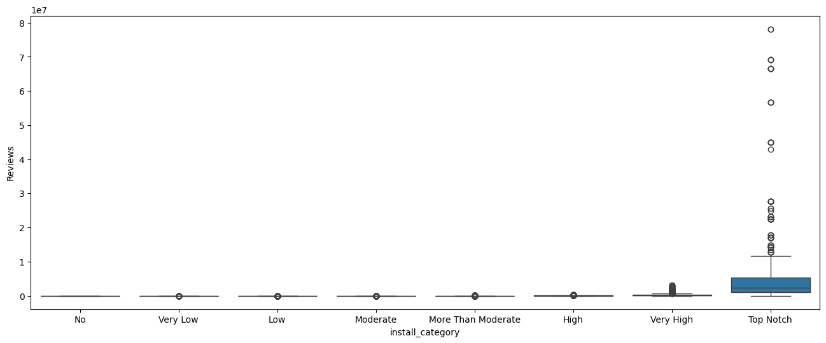

The data looks really imbalance, let's normalize the data using log transformation
# let's plot the same plots for Reviews column as well
plt.figure(figsize=(16, 6)) # make figure size
sns.boxplot(x='install_category', y= np.log10(df['Reviews']), data=df) # plot the boxplot
<Axes: xlabel='install_category', ylabel='Reviews'>
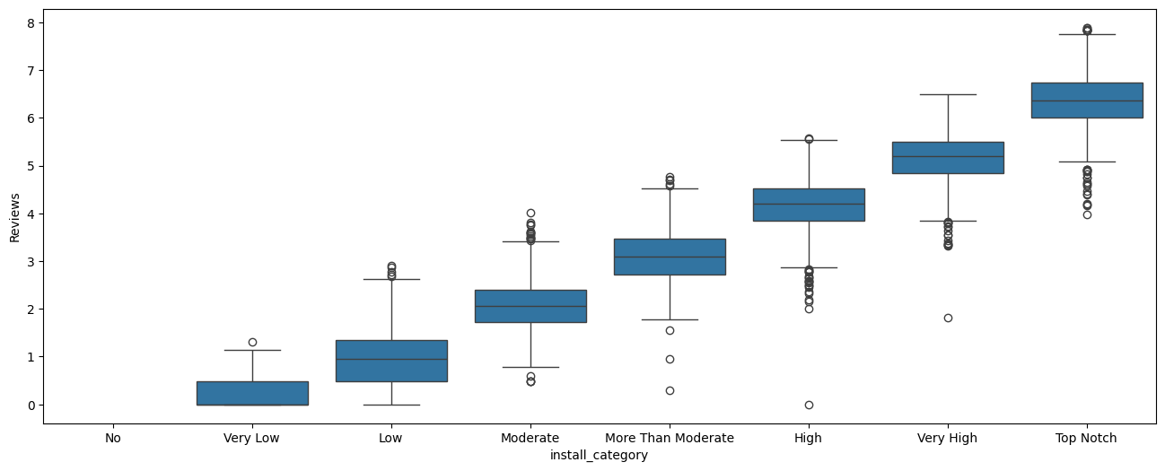

We also draw the scatter plot of the Rating and Review columns with the install_category column
# Draw a scatter plot among Review , Rating and Installs
plt.figure(figsize=(10,7)) # make figure size
sns.scatterplot(x='Rating' , y='Reviews' , hue='install_category' , data=df) # plot the scatter plot
<Axes: xlabel='Rating', ylabel='Reviews'>
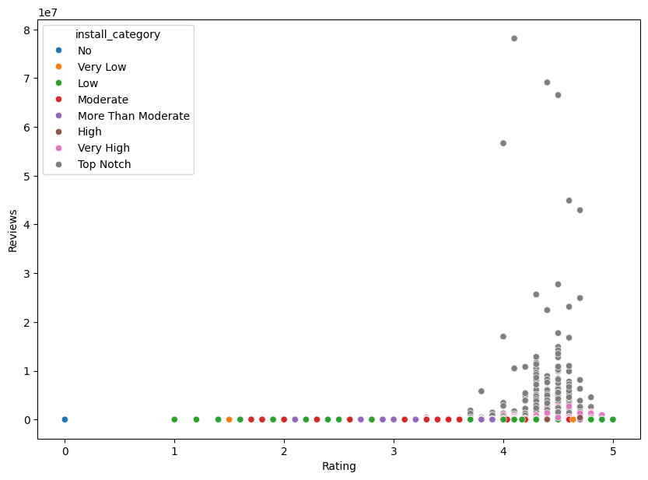

It doesn't show any trend, because, you should know that Rating is a categorical variable (Ordinal) and Reviews is a continuous variable, therefore, we can not plot them together.

Let's try with Reviews and Installs
# plot reviews and installs in a scatter plot
plt.figure(figsize=(16, 6)) # make figure size
sns.scatterplot(x='Reviews' , y='Installs' , data=df , color='yellow') # plot the scatter plot
# My dear sir Dr. Mohammad Ammar Tufail Favirout Colour 'Yellow' that's why i pic this colour
<Axes: xlabel='Reviews', ylabel='Installs'>
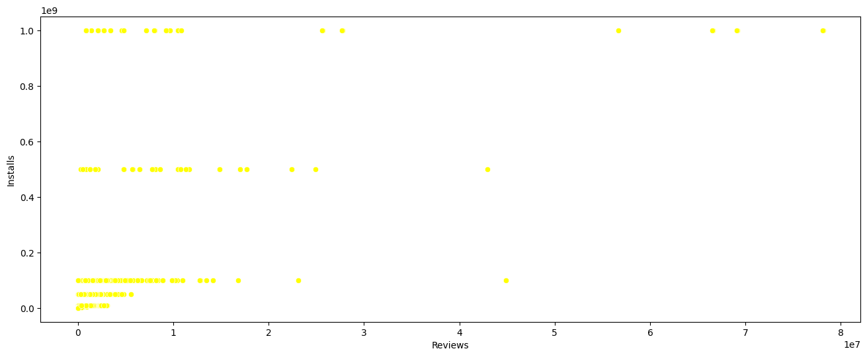

We did not see any trend and the issue is we need to normalize the data before plotting it, let's try with log transformation
# plot reviews and installs in a scatter plot
plt.figure(figsize=(10,7)) # make a figure size
sns.scatterplot(data=df , x=np.log10(df['Reviews']) , y=np.log10(df['Installs']) , color='yellow') # Plot the scatter plot
<Axes: xlabel='Reviews', ylabel='Installs'>
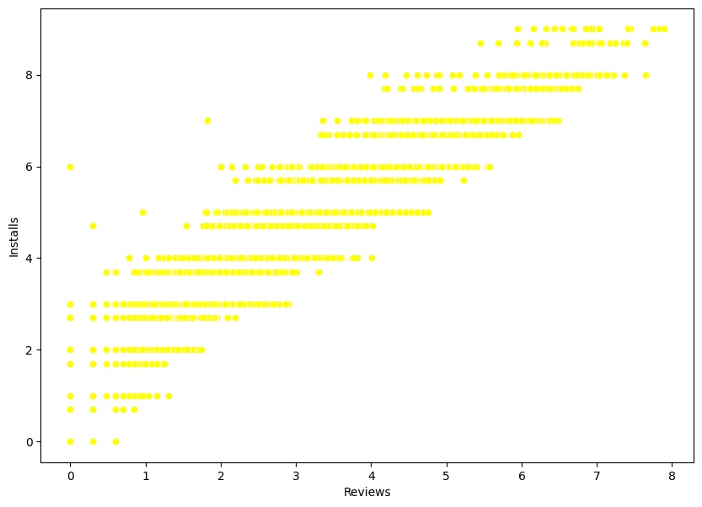

Let's plot a line plot to see the trend
# plot reviews and installs in a scatter plot with trend line
plt.figure(figsize=(16, 6)) # make figure size
sns.lmplot(x='Reviews', y='Installs', data=df) # plot the scatter plot with trend line
<seaborn.axisgrid.FacetGrid at 0x122ac2cabd0>
<Figure size 1600x600 with 0 Axes>
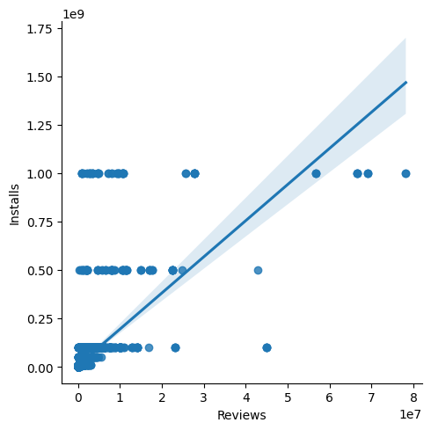

Here, we can see a nice trend, which shows that number of Reviews increases with the number of Installs, which is quite obvious.

Checking and removing duplicates
# print the number of duplicates in df
print(f"Number of duplicates in df are: {df.duplicated().sum()}")
Number of duplicates in df are: 483
# find exact duplicates and print them
df[df['App'].duplicated(keep=False)].sort_values(by='App').head(10)
App Category Rating Reviews \
1393 10 Best Foods for You HEALTH_AND_FITNESS 4.0 2490
1407 10 Best Foods for You HEALTH_AND_FITNESS 4.0 2490
2543 1800 Contacts - Lens Store MEDICAL 4.7 23160
2322 1800 Contacts - Lens Store MEDICAL 4.7 23160
2385 2017 EMRA Antibiotic Guide MEDICAL 4.4 12
2256 2017 EMRA Antibiotic Guide MEDICAL 4.4 12
1337 21-Day Meditation Experience HEALTH_AND_FITNESS 4.4 11506
1434 21-Day Meditation Experience HEALTH_AND_FITNESS 4.4 11506
3083 365Scores - Live Scores SPORTS 4.6 666521
5415 365Scores - Live Scores SPORTS 4.6 666246
size_in_MBs Installs Type Price Content Rating Genres \
1393 3.8 500000 Free 0.00 Everyone 10+ Health & Fitness
1407 3.8 500000 Free 0.00 Everyone 10+ Health & Fitness
2543 26.0 1000000 Free 0.00 Everyone Medical
2322 26.0 1000000 Free 0.00 Everyone Medical
2385 3.8 1000 Paid 16.99 Everyone Medical
2256 3.8 1000 Paid 16.99 Everyone Medical
1337 15.0 100000 Free 0.00 Everyone Health & Fitness
1434 15.0 100000 Free 0.00 Everyone Health & Fitness
3083 25.0 10000000 Free 0.00 Everyone Sports
5415 25.0 10000000 Free 0.00 Everyone Sports
Last Updated Current Ver Android Ver install_category
1393 February 17, 2017 1.9 2.3.3 and up High
1407 February 17, 2017 1.9 2.3.3 and up High
2543 July 27, 2018 7.4.1 5.0 and up High
2322 July 27, 2018 7.4.1 5.0 and up High
2385 January 27, 2017 1.0.5 4.0.3 and up Low
2256 January 27, 2017 1.0.5 4.0.3 and up Low
1337 August 2, 2018 3.0.0 4.1 and up More Than Moderate
1434 August 2, 2018 3.0.0 4.1 and up More Than Moderate
3083 July 29, 2018 5.5.9 4.1 and up Very High
5415 July 29, 2018 5.5.9 4.1 and up Very High

You can see complete row is duplicate

Remove duplicates means remove complete row from dataframe
# remove duplicate
df.drop_duplicates(inplace=True)
# Check duplicate
df.duplicated().sum()
np.int64(0)
# number of rows after removing duplicates
print(f'The number of Rows after removing duplicates {df.shape[0]}')
The number of Rows after removing duplicates 10346

Now we have removed 483 duplicates from the dataset. and have 10346 rows left.

Insights from Data

Which category has the highest number of apps?
# which category has highest number of apps
df['Category'].value_counts().head(10) # this will show the top 10 categories with highest number of apps
Category
FAMILY 1939
GAME 1121
TOOLS 841
BUSINESS 427
MEDICAL 408
PRODUCTIVITY 407
PERSONALIZATION 386
LIFESTYLE 373
COMMUNICATION 366
FINANCE 360
Name: count, dtype: int64

Which category has the highest number of installs?
# category with highest number of Installs
df.groupby('Category')['Installs'].sum().sort_values(ascending=False).head(10)
Category
GAME 31544024415
COMMUNICATION 24152276251
SOCIAL 12513867902
PRODUCTIVITY 12463091369
TOOLS 11452271905
FAMILY 10041632405
PHOTOGRAPHY 9721247655
TRAVEL_AND_LOCAL 6361887146
VIDEO_PLAYERS 6222002720
NEWS_AND_MAGAZINES 5393217760
Name: Installs, dtype: int64

Which category has the highest number of reviews?
# Category with highest number of Reviews
df.groupby('Category')['Reviews'].sum().sort_values(ascending=False).head(10)
Category
GAME 1415536650
COMMUNICATION 601273552
SOCIAL 533576829
FAMILY 396771746
TOOLS 273181033
PHOTOGRAPHY 204297410
VIDEO_PLAYERS 110380188
PRODUCTIVITY 102554498
SHOPPING 94931162
PERSONALIZATION 75192744
Name: Reviews, dtype: int64

Which category has the highest rating?
# Category with highest average Rating
df.groupby('Category')['Rating'].mean().sort_values(ascending=False).head(10)
Category
EVENTS 4.394346
EDUCATION 4.373794
BOOKS_AND_REFERENCE 4.358435
PERSONALIZATION 4.322099
ART_AND_DESIGN 4.298885
GAME 4.281926
HEALTH_AND_FITNESS 4.273890
PARENTING 4.259759
SHOPPING 4.253376
SPORTS 4.253041
Name: Rating, dtype: float64
# plot the rating distribution
plt.figure(figsize=(16, 6)) # set figure size
sns.histplot(df['Rating'], color="blue", kde=True, bins=25) # plot the distribution plot
<Axes: xlabel='Rating', ylabel='Count'>
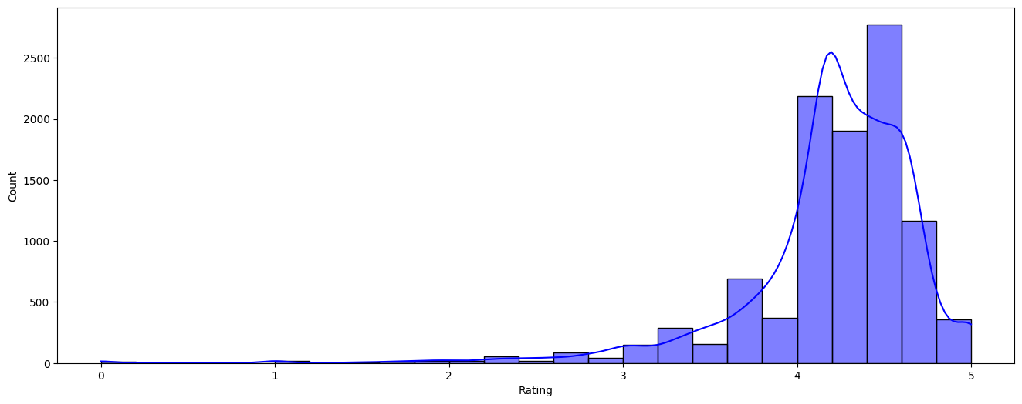

Check Distribution Through Shapiro Wilk Test

Shapiro Wilk Test
- Test Says If pvalue is greater Then 0.05 So We Fail To Reject Null Hypothesis: (H0) Means (Accept Null Hypothesis) Which Says Data Is Normal Distributed And Vice Versa
- Null Hypothesis: H0 : Rating Column is Normal Distributed
- Alternatinve Hypothesis: H1 : Rating Column is Not Normal Distributed
# Check Distribution Through Shapiro Wilk Test
import scipy.stats as stats
# Apply Test
statistic, pvalue=stats.shapiro(df['Rating'])
print(f'Statistic Value : {statistic}')
print()
print(f'Pvalue : {pvalue}')
print()
# See Results Throuhg if else conditions
if pvalue > 0.05:
print(f'pvalue:({pvalue}) is Greater Then 0.05 Fail to Reject Null Hypothesis')
else:
print(f'pvalue:({pvalue}) is less Then 0.05 Reject Null Hypothesis')
Statistic Value : 0.8268346720422337
Pvalue : 3.060062900573678e-74
pvalue:(3.060062900573678e-74) is less Then 0.05 Reject Null Hypothesis

Which content rating is most popular in installs
df['Content Rating'].value_counts() # this will show the value counts of each content rating
Content Rating
Everyone 8372
Teen 1146
Mature 17+ 447
Everyone 10+ 376
Adults only 18+ 3
Unrated 2
Name: count, dtype: int64

plot top 5 rated paid apps
plt.figure(figsize=(16, 6)) # make figure size
sns.barplot(x='App', y='Rating',
data=df[df['Type'] == 'Paid'].sort_values(by='Rating', ascending=False).head()) # plot the bar plot
<Axes: xlabel='App', ylabel='Rating'>
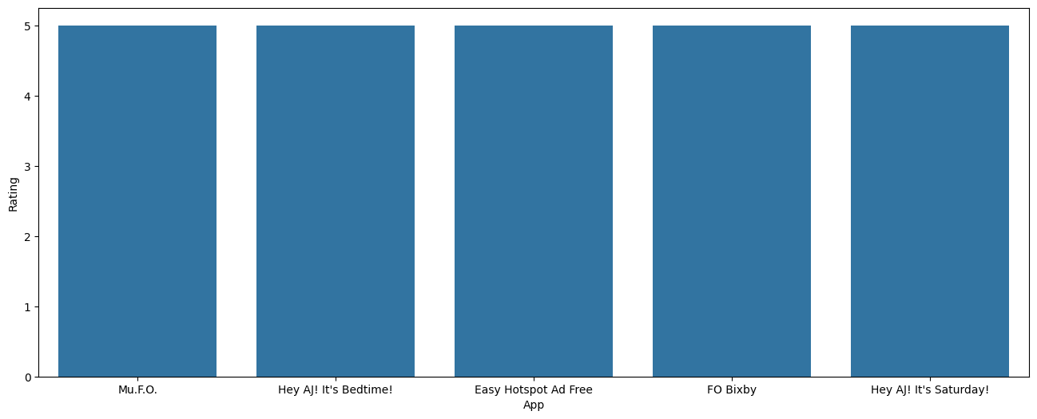
# This Will Show Top 5 Paid category Apps With Respect To Rating
df[df['Type'] == 'Paid'].sort_values(by='Rating', ascending=False).head(5)
App Category Rating Reviews \
10697 Mu.F.O. GAME 5.0 2
5246 Hey AJ! It's Bedtime! FAMILY 5.0 1
4988 Easy Hotspot Ad Free TOOLS 5.0 2
10690 FO Bixby PERSONALIZATION 5.0 5
5237 Hey AJ! It's Saturday! BOOKS_AND_REFERENCE 5.0 12
size_in_MBs Installs Type Price Content Rating Genres \
10697 16.00000 1 Paid 0.99 Everyone Arcade
5246 63.00000 10 Paid 4.99 Everyone Education
4988 3.30000 10 Paid 0.99 Everyone Tools
10690 0.84082 100 Paid 0.99 Everyone Personalization
5237 50.00000 100 Paid 3.99 Everyone Books & Reference
Last Updated Current Ver Android Ver install_category
10697 March 3, 2017 1 2.3 and up Very Low
5246 April 4, 2018 1.0.59 2.3 and up Very Low
4988 July 26, 2018 1.05 4.0 and up Very Low
10690 April 25, 2018 0.2 7.0 and up Low
5237 June 13, 2016 1.0.0 2.2 and up Low

plot top rated 5 apps in free category
plt.figure(figsize=(16, 6)) # set figure size
sns.barplot(x='App', y='Rating',
data=df[df['Type']=='Free'].sort_values(by='Rating', ascending=False).head())
<Axes: xlabel='App', ylabel='Rating'>
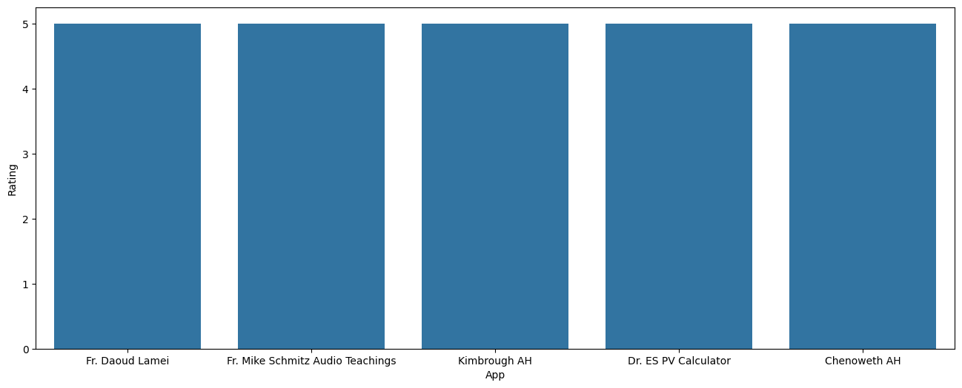
# Top 5 Free Category Apps With Respect To Rating
df[df['Type'] == 'Free'].sort_values(by='Rating', ascending=False).head(5)
App Category Rating Reviews \
10820 Fr. Daoud Lamei FAMILY 5.0 22
10837 Fr. Mike Schmitz Audio Teachings FAMILY 5.0 4
5148 Kimbrough AH MEDICAL 5.0 5
9806 Dr. ES PV Calculator TOOLS 5.0 19
5139 Chenoweth AH MEDICAL 5.0 1
size_in_MBs Installs Type Price Content Rating Genres \
10820 8.6 1000 Free 0.0 Teen Education
10837 3.6 100 Free 0.0 Everyone Education
5148 28.0 100 Free 0.0 Everyone Medical
9806 11.0 500 Free 0.0 Everyone Tools
5139 27.0 100 Free 0.0 Everyone Medical
Last Updated Current Ver Android Ver install_category
10820 June 27, 2018 3.8.0 4.1 and up Low
10837 July 6, 2018 1 4.1 and up Low
5148 September 21, 2017 300000.0.90 4.0.3 and up Low
9806 March 11, 2018 3.4.7.2.16 4.1 and up Low
5139 April 3, 2017 300000.0.78 4.0.3 and up Low

Plot top 5 FREE apps with highest number of reviews
plt.figure(figsize=(12 , 6)) # make figure size
sns.barplot(x='App', y='Reviews', width=0.5,
data=df[df['Type'] == 'Free'].sort_values(by='Reviews', ascending=False).head(5))
<Axes: xlabel='App', ylabel='Reviews'>
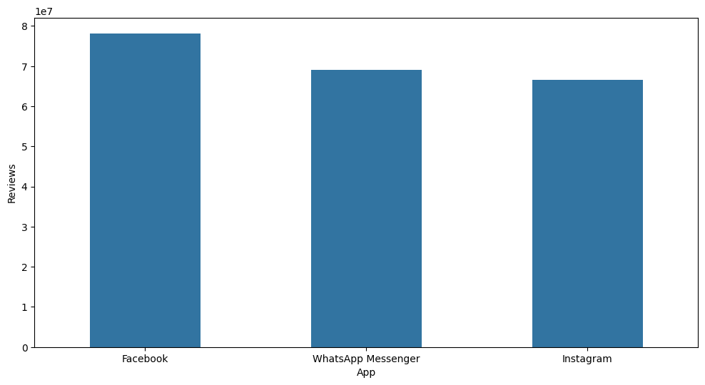
# Top 5 Free category Apps With Respect To Reviews
df[df['Type'] == 'Free'].sort_values(by='Reviews', ascending=False).head(5)
App Category Rating Reviews size_in_MBs \
2544 Facebook SOCIAL 4.1 78158306 17.681671
3943 Facebook SOCIAL 4.1 78128208 17.681671
336 WhatsApp Messenger COMMUNICATION 4.4 69119316 11.765673
3904 WhatsApp Messenger COMMUNICATION 4.4 69109672 11.765673
2604 Instagram SOCIAL 4.5 66577446 17.681671
Installs Type Price Content Rating Genres Last Updated \
2544 1000000000 Free 0.0 Teen Social August 3, 2018
3943 1000000000 Free 0.0 Teen Social August 3, 2018
336 1000000000 Free 0.0 Everyone Communication August 3, 2018
3904 1000000000 Free 0.0 Everyone Communication August 3, 2018
2604 1000000000 Free 0.0 Teen Social July 31, 2018
Current Ver Android Ver install_category
2544 Varies with device Varies with device Top Notch
3943 Varies with device Varies with device Top Notch
336 Varies with device Varies with device Top Notch
3904 Varies with device Varies with device Top Notch
2604 Varies with device Varies with device Top Notch

Plot top 5 Paid apps with highest number of reviews
plt.figure(figsize=(16, 6)) # make figure size
sns.barplot(x='App', y='Reviews',
data=df[df['Type'] == 'Paid'].sort_values(by='Reviews', ascending=False).head(5))
<Axes: xlabel='App', ylabel='Reviews'>
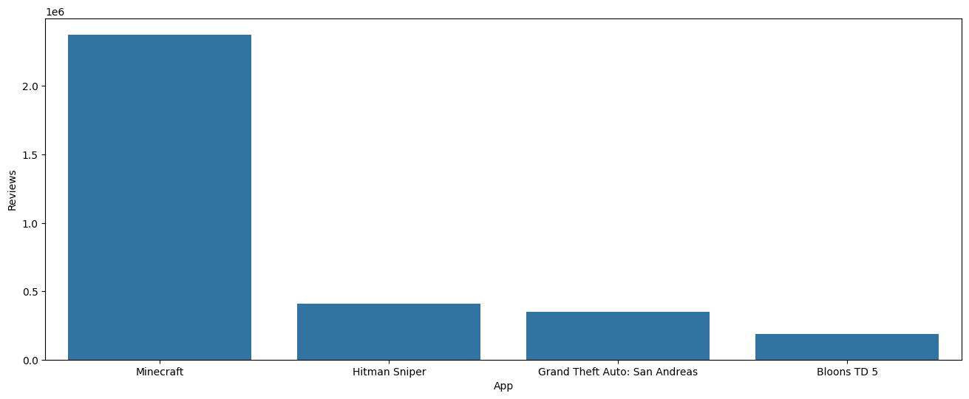
# Top 5 Paid Apps With Respect To Reviews
df[df['Type'] == 'Paid'].sort_values(by='Reviews', ascending=False).head(5)
App Category Rating Reviews size_in_MBs \
2241 Minecraft FAMILY 4.5 2376564 28.353764
4347 Minecraft FAMILY 4.5 2375336 28.353764
4034 Hitman Sniper GAME 4.6 408292 29.000000
7417 Grand Theft Auto: San Andreas GAME 4.4 348962 26.000000
8860 Bloons TD 5 FAMILY 4.6 190086 94.000000
Installs Type Price Content Rating Genres Last Updated \
2241 10000000 Paid 6.99 Everyone 10+ Arcade Action & Adventure
4347 10000000 Paid 6.99 Everyone 10+ Arcade Action & Adventure
4034 10000000 Paid 0.99 Mature 17+ Action July 12, 2018
7417 1000000 Paid 6.99 Mature 17+ Action March 21, 2015
8860 1000000 Paid 2.99 Everyone Strategy July 13, 2018
Current Ver Android Ver install_category
2241 July 24, 2018 1.5.2.1 Very High
4347 July 24, 2018 1.5.2.1 Very High
4034 1.7.110758 4.1 and up Very High
7417 1.08 3.0 and up High
8860 3.16 2.3.3 and up High

Plot Top 5 Expensive Apps
plt.figure(figsize=(16, 8)) # Set Figsize
sns.barplot(x='App', y='Installs', data=df.nlargest(5, 'Price'))
<Axes: xlabel='App', ylabel='Installs'>
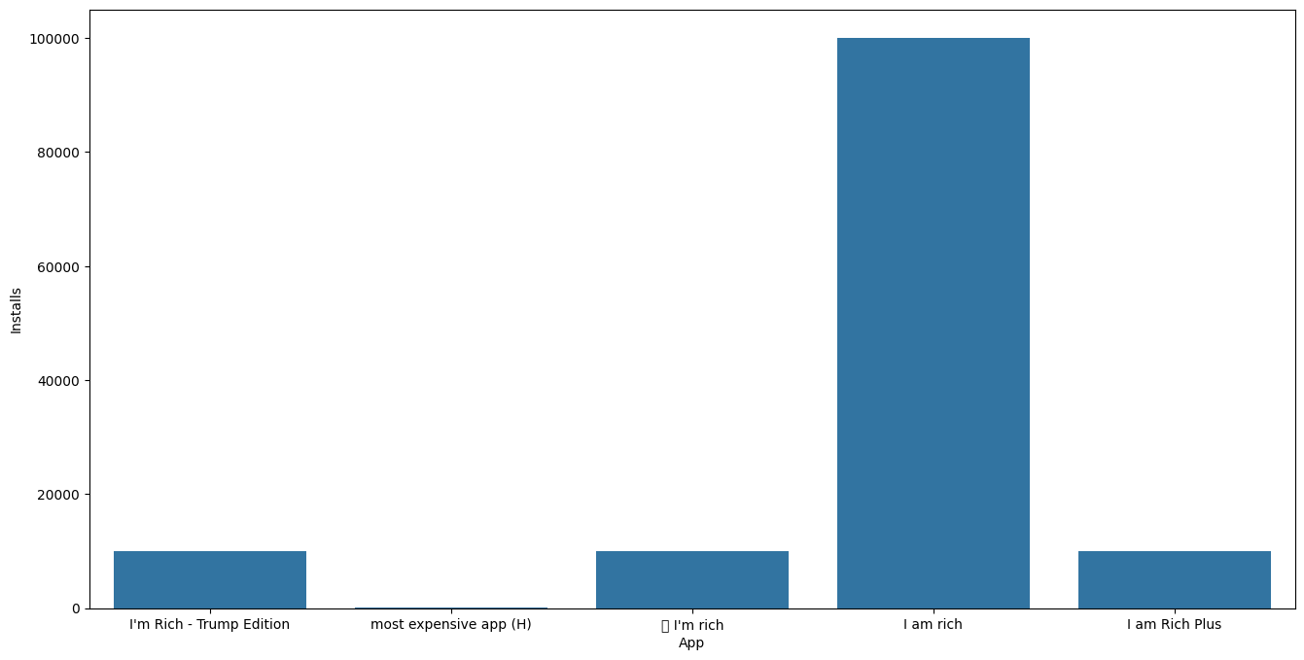
# Top 5 Expensive Apps
# Sorting the DataFrame by 'Price' in descending order and selecting the top 5
df.nlargest(5, 'Price')
App Category Rating Reviews size_in_MBs \
4367 I'm Rich - Trump Edition LIFESTYLE 3.6 275 7.3
4197 most expensive app (H) FAMILY 4.3 6 1.5
4362 💎 I'm rich LIFESTYLE 3.8 718 26.0
5351 I am rich LIFESTYLE 3.8 3547 1.8
5354 I am Rich Plus FAMILY 4.0 856 8.7
Installs Type Price Content Rating Genres Last Updated \
4367 10000 Paid 400.00 Everyone Lifestyle May 3, 2018
4197 100 Paid 399.99 Everyone Entertainment July 16, 2018
4362 10000 Paid 399.99 Everyone Lifestyle March 11, 2018
5351 100000 Paid 399.99 Everyone Lifestyle January 12, 2018
5354 10000 Paid 399.99 Everyone Entertainment May 19, 2018
Current Ver Android Ver install_category
4367 1.0.1 4.1 and up Moderate
4197 1 7.0 and up Low
4362 1.0.0 4.4 and up Moderate
5351 2 4.0.3 and up More Than Moderate
5354 3 4.4 and up Moderate

Good Luck

