

DATE: 21st May 2019

Project Proposal For Funding From VC’s Innovation Fund

1. Title of the Project:

**Rakshak**

1. Name of Project Leader:

Jasmita Walia (16CSU157) (+919871788799, [jasmitawalia@gmail.com](mailto:tamanna.sharma16ts@gmail.com))

1. Team Members:

Jasmita Walia (16CSU157),Nikhil Kushwaha (16CSU227), Himanshi Kumari (17CSU079)

1. Mentor:

Ms.Shakshi Sharma

1. Department:

Computer Science and Engineering

1. Subject Area:

AI, Deep Learning, Neural Networks.

1. Objectives: To design a device that:
   1. Captures the road scene and detects it as an accident scene or non accident scene using Deep Learning.
   2. Checks the nearest hospital and police station sends an emergency alert to them.
2. It should be precise and accurate.
3. Introduction:

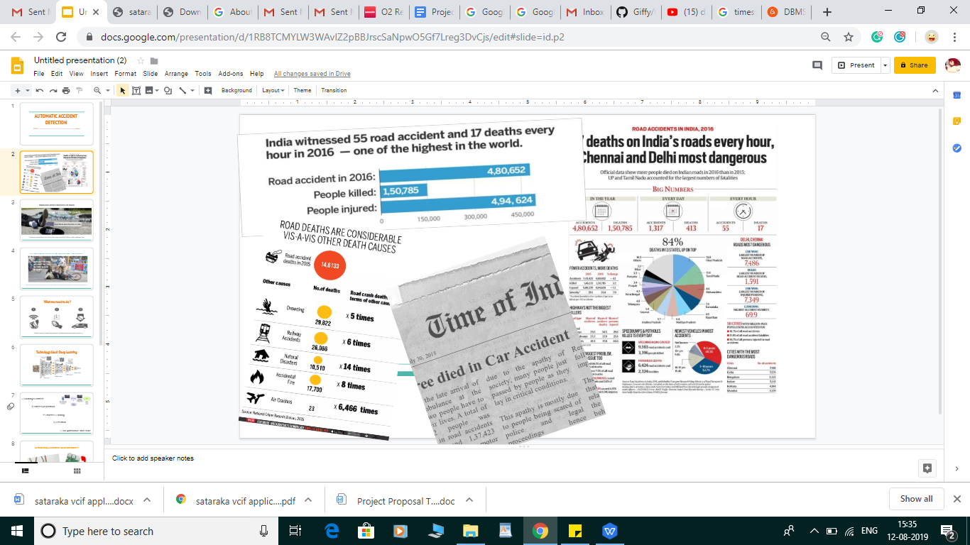

India accounts for about 10% of road crash fatalities worldwide. In terms of absolute numbers more people

die in road crashes in India than anywhere else in the world. As per the National Crime Records Bureau (NCRB),

in the year 2011 there were 440,123 road accidents resulting in the death of 136,834 people. The incidence of

accidental deaths increased by 44.2% in 2011 from 2001. This figure translates into one death every five minutes

on Indian roads and is expected to escalate to one death every three minutes by 2020.

Most victims are left to die on the streets even when hospitals are close by. While there is no denying that the general apathy of people makes matters worse, this is essentially a problem of unresponsive governance.

We have planned to build an automatic car accident detection system using Computer Vision. We will install cameras on the accident-prone roads, and a frame of the road scene will be extracted every 30 seconds out

of the video recording, and it will be sent to our model.

Our model will detect whether it is an accident scene or not. If the scene of the road is found out to be an

accident scene than an alert will be sent to the nearest police station as well as a hospital for the earliest help possible.

1. State of the Art:

Since the Convolutional Neural Networks can detect objects with more than 90% of accuracy, we can

use a fine-tuned neural network to detect an accident. The problem of CNNs and all other classifiers

is that they only can classify the whole image to an object and cannot localize that object in the image.

In this project, we are going to implement some techniques to detect the border of each object in the image and send these images to a well-known CNN and label that region.

Our model will detect whether it is an accident scene or not. If the scene of the road is found out to

be an accident scene than an alert will be sent to the nearest police station as well as a hospital for

the earliest help possible.

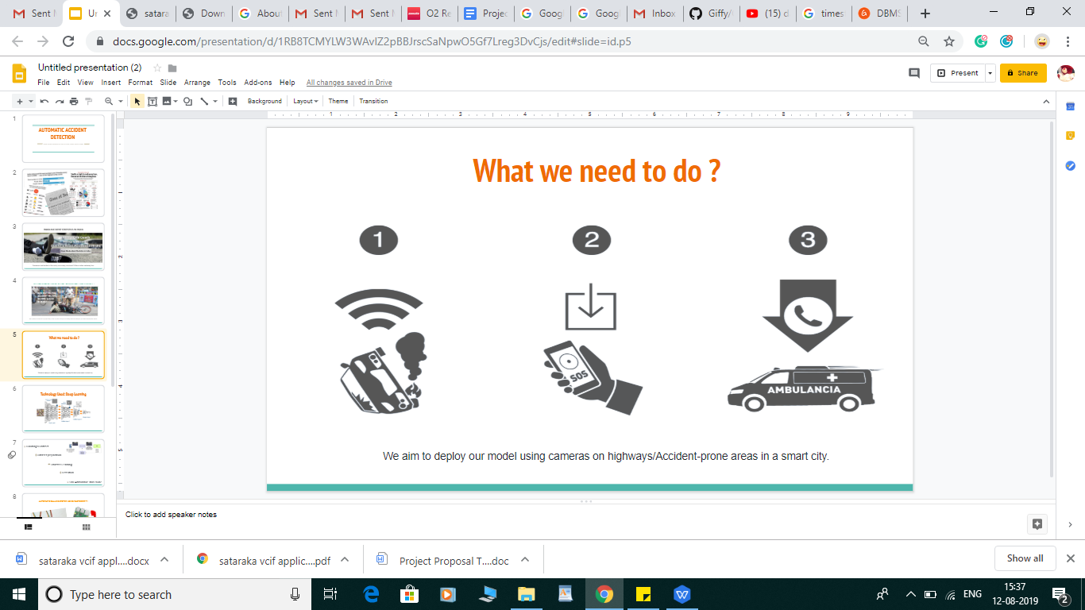

1. Justification:

A total of 4,69,882 people have been injured in road accidents in 2013 and 1,37,423 people have died in motor vehicle collisions. Many of these lives could have been saved, if they had received timely help. But due to the apathy of society many people just passed by people as they lay in critical conditions.This apathy is mostly due

to people being scared of police and legal proceedings hence hesitating to get victims the help they require.

We need to implement a plan so that help could be provided at the right time. A lot of lives could be

saved if help will be provided at these incidents.

1. Expected Output:
   1. Road Security: The camera clicks the picture of the road scene and can detect it as an accident scene saving a lot of lives.
   2. Intelligent ambulance detection system: It can also be used at detect an ambulance and manage the traffic light management system which would reduce delay for the arrival of ambulance.
2. Methodology

Our **vision** is to implement a model so that death rates can be reduced significantly after the car accident.

Our **Goal** is

1. “To build a neural network with high accuracy”

2. “To perform hyper-parameter optimization for reducing the false negatives”

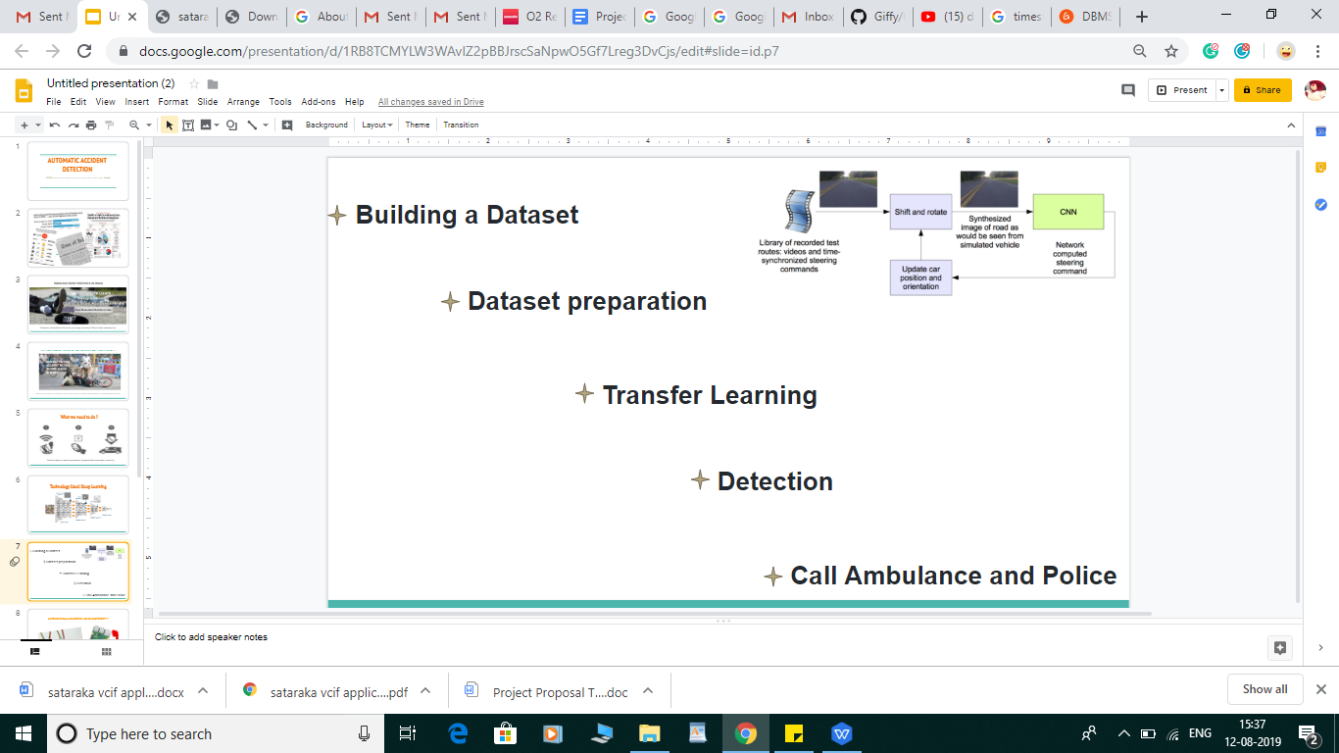

**Arduino Uno:** The digital and analog input/output pins equipped in this board can be interfaced to various expansion boards and other circuits. Serial communication interface is a feature in this board, including USB which will be used to load the programs from computer.

**Raspberry Pi Camera:** It can be used for features like time-lapse, slow-motion .It is preferred over a USB webcam because the camera module has got better specifications and quality than the webcam.

**AWS:** We will require high computational speed as well as storage area to process our demand. AWS will provide the on demand service as and when required.

Once we have achieved the prototype stage and have a working prototype along with the required software. We will strip down all the above parts into components.

Testing will be done both before and after the strip down.

1. Work Plan:

|  |  |  |
| --- | --- | --- |
| **Activity** | **Type Of Activity** | **Duration** |
| This phase consists of making a list of items that will be needed for the building of the prototype. It will also include deciding out of the many types of processors which would be best suitable for the final product. Also a language will be chosen to code the software. | Research and literature survey for needs assessment | 3 months |
| This phase will cover purchasing the hardware and also tracking down any experts who can be of help in building the prototype. Then designing of the blueprints of the prototype will begin. Modules will also be designed for the software in a top- down approach. | Concept generation and Design of prototype | 4 months |
| The prototype will be given shape as per the blueprints in this phase of the project. All the hardware will be assembled together to get the final product. All the final functionalities will also be added to the software. | Fabrication and assembly of prototype | 3 months |
| The final product will be tested in this phase with the software. Any glitches found will be corrected until seamless interaction is obtained. | Testing and results of prototype | 2 months |

1. Gantt Chart:

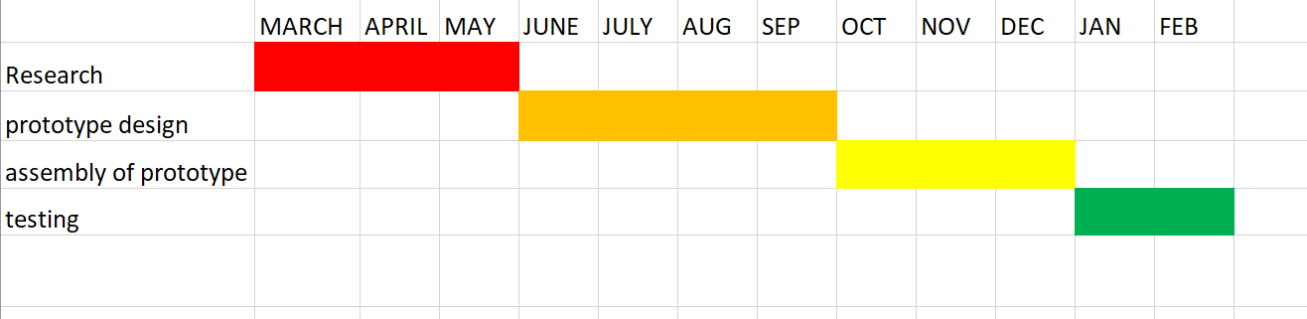

1. Budget Requirements:

|  |  |  |
| --- | --- | --- |
| S. No. | Description | Total |
| A | EQUIPMENTS |  |
| 1. | Raspberry Pi 3 Model B | Rs. 4,000 |
| 2. | Raspberry Pi Zero Wireless | Rs. 2,150 |
| 3. | Raspberry Pi Camera Module | Rs. 4,000 |
| 4. | AWS | Rs. 4,650 |
| 5. | Arduino Uno | Rs. 1500 |
| 6. | Wi-Fi Module | Rs. 800 |
| 7. | Infrared Lazer beam | Rs. 8,400 |
|  | Total Equipment | Rs. 25,500 |
|  |  |  |
| B. | MISCELLANEOUS |  |
| 1. | Testing Charges | Rs. 8,000 |
| 2. | Contigency & Others (Repair & Maintenance) | Rs. 5,000 |
|  | Total | Rs. 13,000 |
|  |  |  |
|  | Total (A+B) | Rs. 38,500 |
|  |  |  |
|  |  |  |

1. Extra Manpower required, if any: Not applicable at the moment.
2. Details of Collaboration, if any: Not applicable at the moment.
3. Success Criteria

A lot of lives could be saved if this system is implemented. Death rates can be reduced significantly after

the car accident has taken place.

