**IDBMS PROJECT REPORT**

GROUP NUMBER:-15

***Members:-***

1. Kush Gandhi 19ucs131

2. Manan Gandhi 19ucs130

3. Gunjan Pagdhar 19ucs101

4. Viren Saroha 19ucs152

5. Avik Maheshwari 19ucs138

TABLES IN DATABASE

1. Offermaster: Specifies promocodes and corresponding discount on total bill amount.

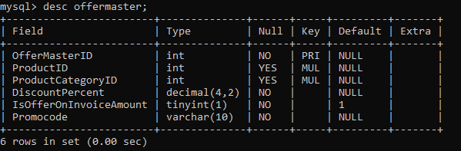

1. Orderdetails: Stores orderID , username , productname and quantity of each product ordered at one point of time.

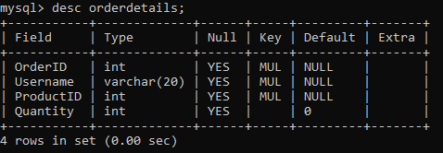

1. Orders: Gives unique orderID for each order placed and specifies the total price and username of the customer.

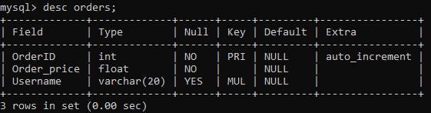

1. OrderStatus: Shows if order is queued or completed

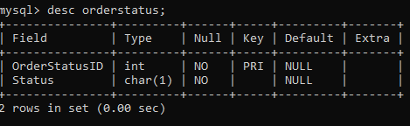

1. Product: stores details of each product and which category the product belongs to. Stores UnitPrice and if product is available or not

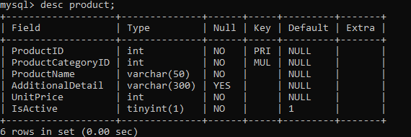

1. Productcategory: Shows different categories of product, its name and shows if particular category is available or not.

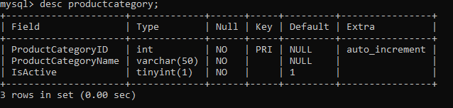

1. Userrole: specifies roleID for each of types of users i.e admin staff and customers

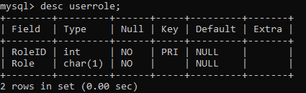

1. Users: shows username password fullname emailed and to which role a particular user belongs to.

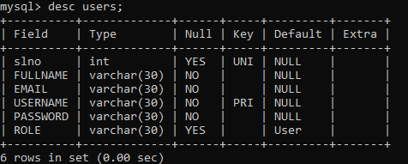

SNAPSHOTS OF PROJECT:

Home Page:-

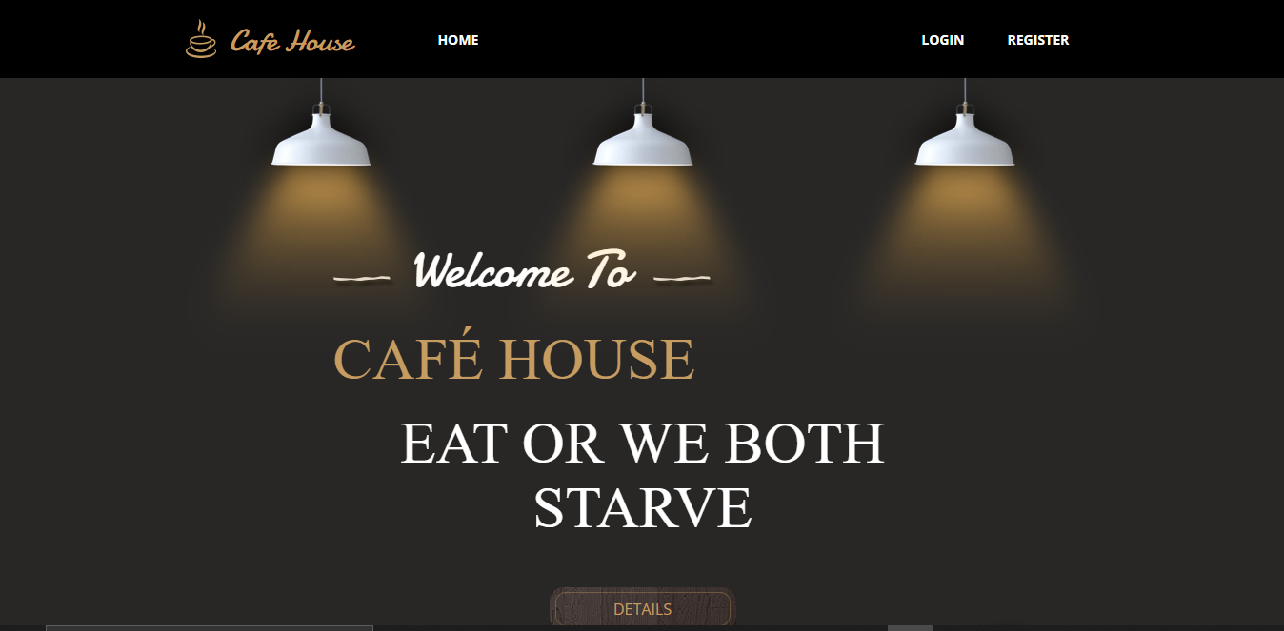

Description on Home Page:-

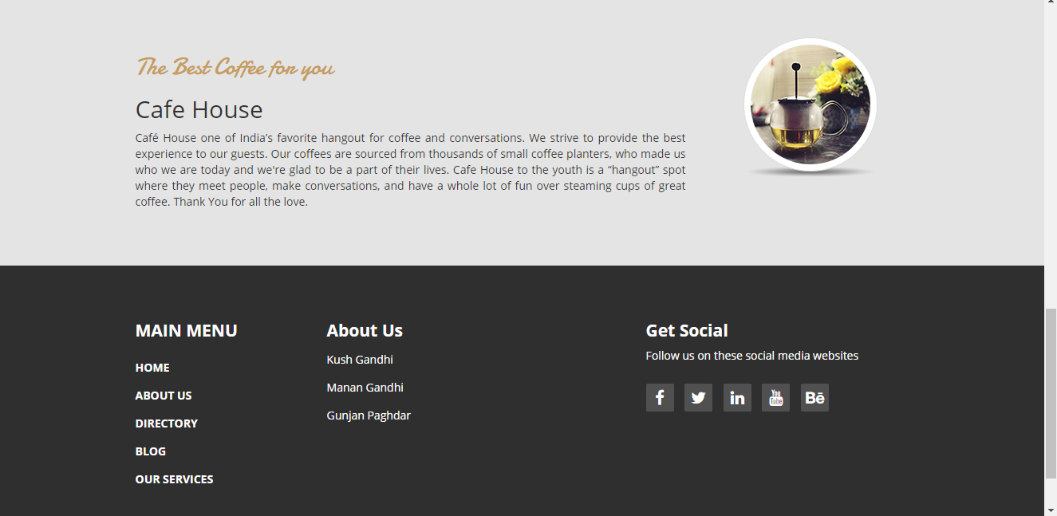

Login Page:-

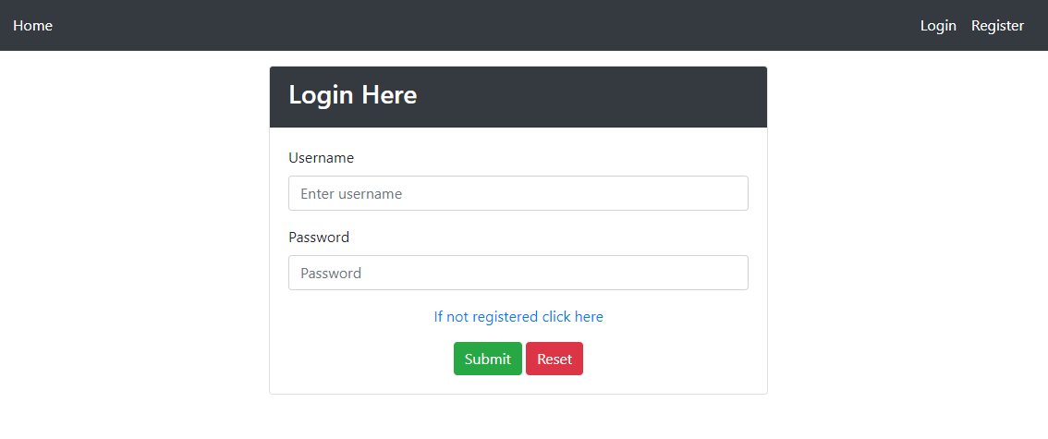

Register Page:-

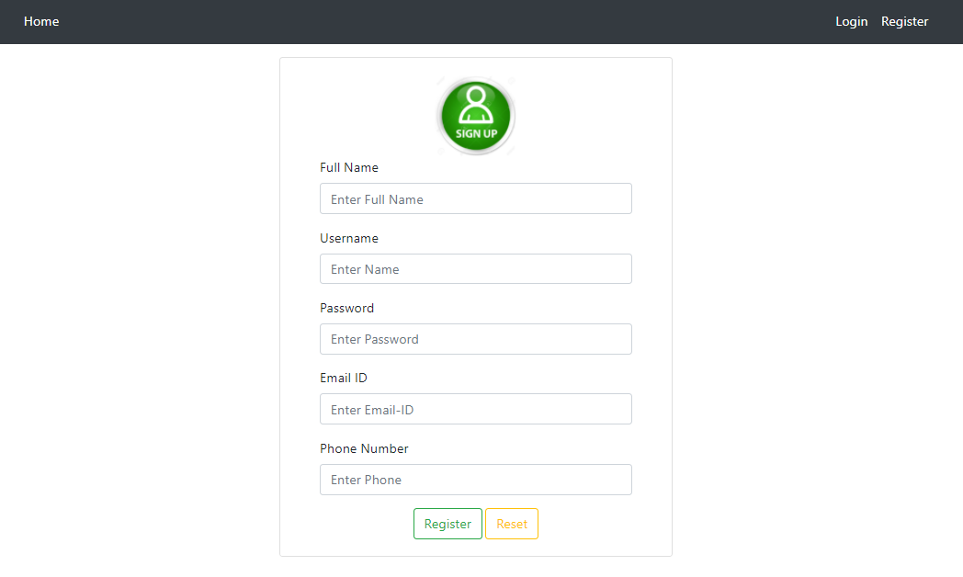

Admin Page:

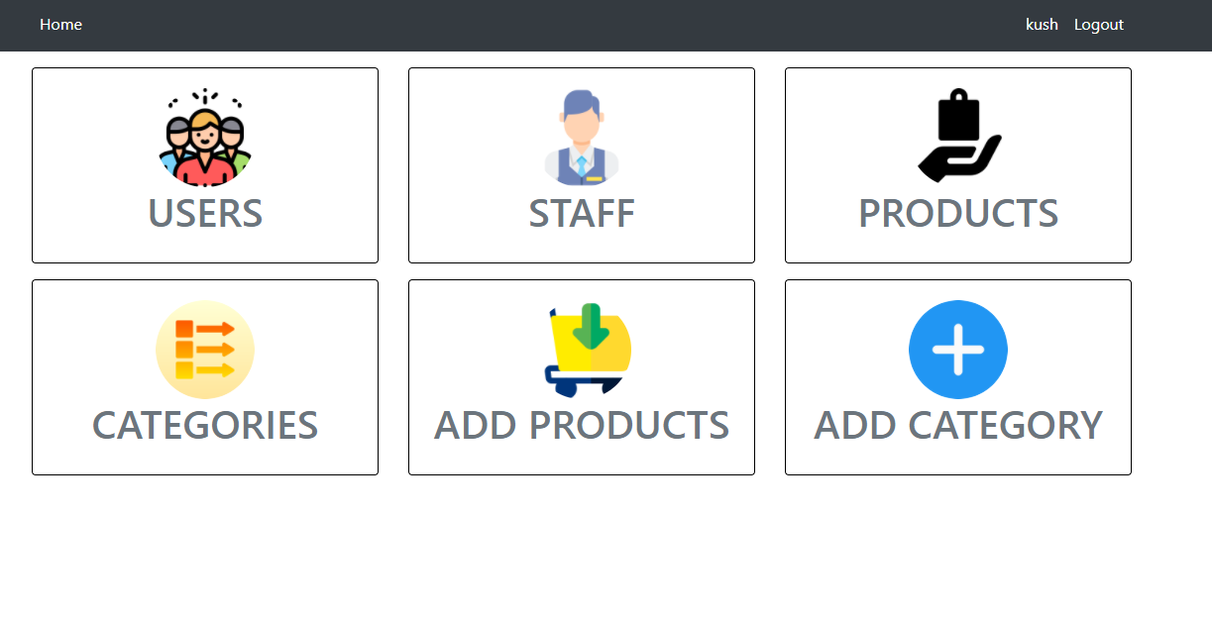

Add Product:-

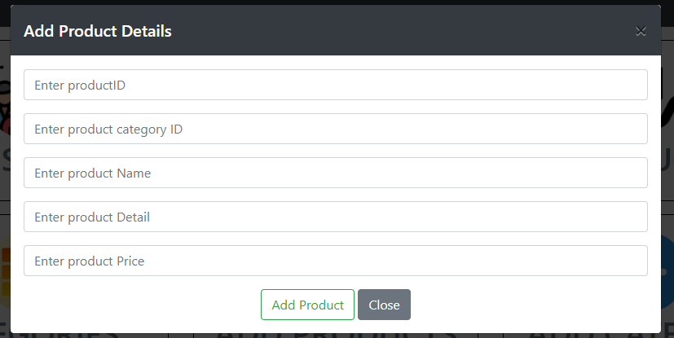

Add Category:-

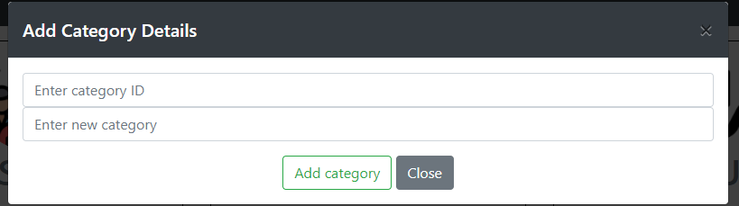

Menu Page:-

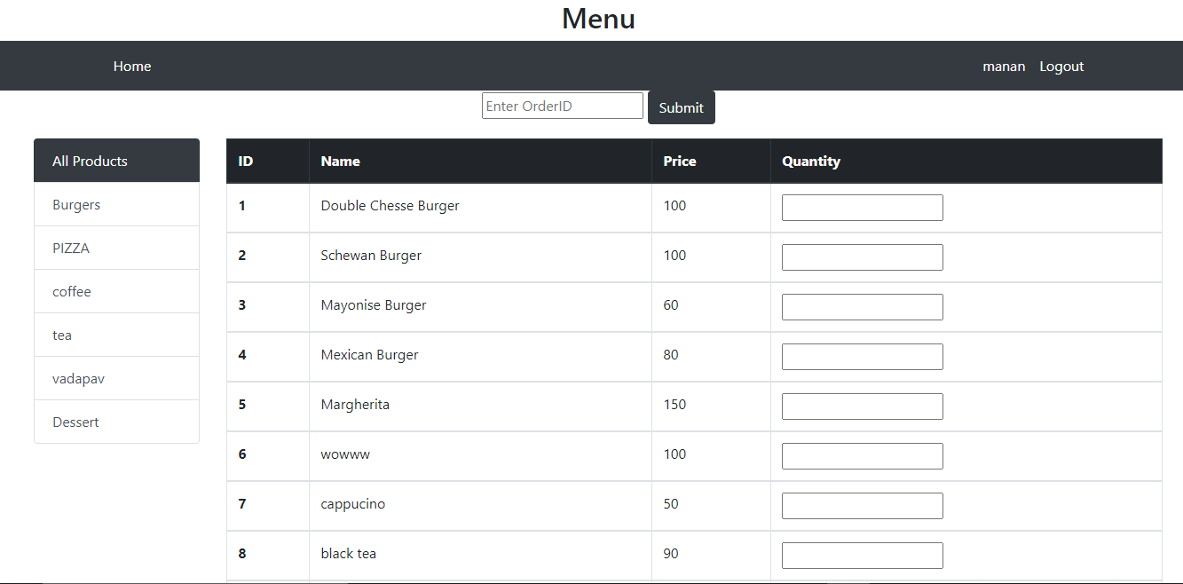

Display of products of one particular category:-

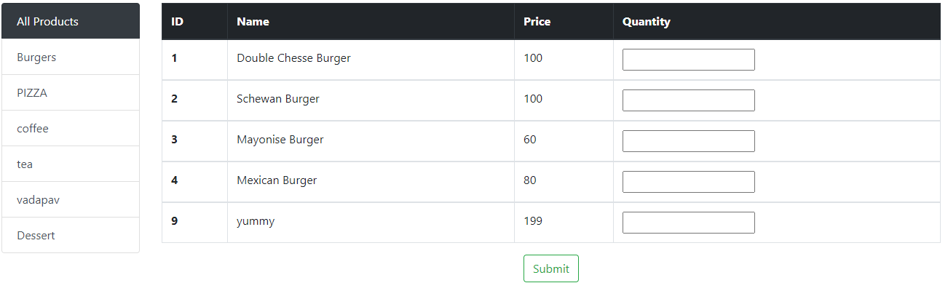

Order Page:-

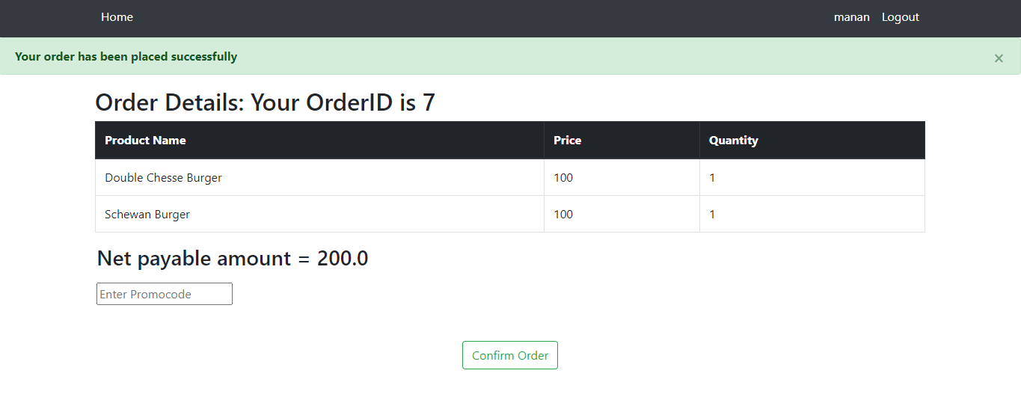

On application of promocode:-

