Kush Gupta

Programming Final Project

Ion Channel Gating

Problem #1, part a)

Graphs of Markov State vs. Time;

Mean vs. Standard Occupancy Times

At -20 volts:

Theoretical mean occupancy time for State 2: 0.181999

Actual mean occupancy time for State 2: 0.182691

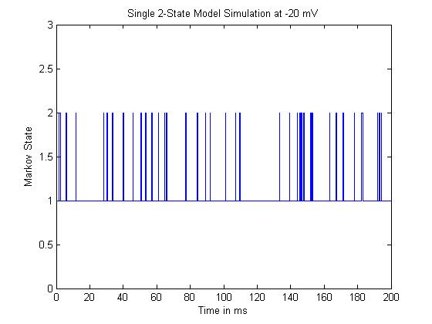

At 5 volts:

Theoretical mean occupancy time for State 2: 1.861249

Actual mean occupancy time for State 2: 1.843945

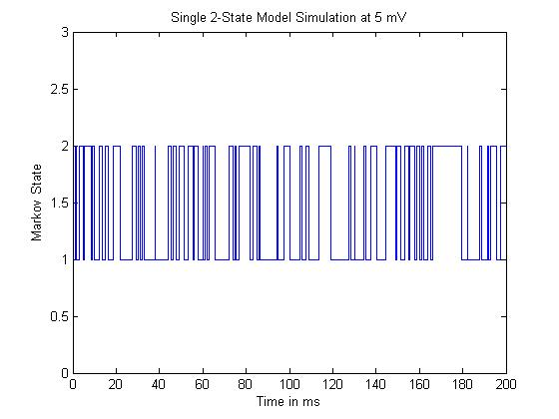

At 40 volts:

Theoretical mean occupancy time for State 2: 48.242854

Actual mean occupancy time for State 2: 48.184576

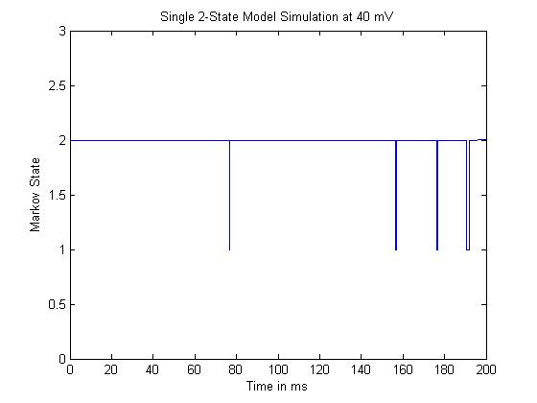

Problem #1, part b)

Graphs of Markov State vs. Time;

This model was formulated in a similar program as those from part 1.a)

Exponentially distributed random variables simulating dwell time were created for states 1 and 2 according to the exit rates from each state (determined by alpha and beta at the initial voltage of -100 mV).

Once the time reached 100 ms, the voltage changed from -100 mV to 5 mV, and the alpha/beta were adjusted, thus changing the random exponentially distributed numbers being created.

Specifically, voltage was held at -100 while t < 100; once t >= 100, the voltage changed to 5. A simple if/else statement was used to control this.

The changes in dwell time are apparent in the graph below. After the switch to 5 mV, dwell time in State 1 becomes significantly reduced, while dwell time in State 2 increases slightly on average.

Switch from -100mV to 5mV

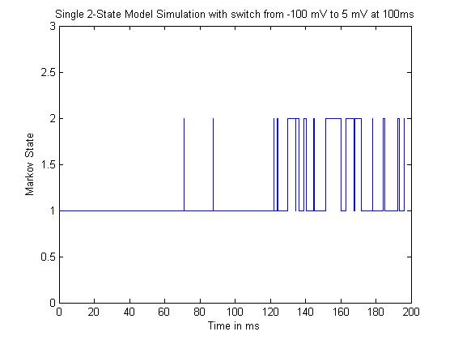

Switch from -100mV to 40mV

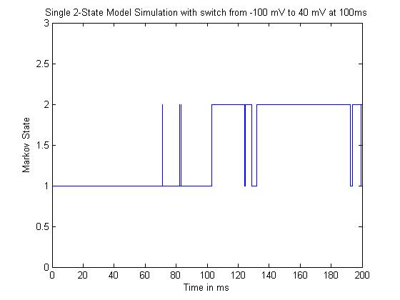

When the voltage changes from -100mV to 40mV, there is a dramatic difference in the observed state graph. In the first graph simulating the change from -100mV to 5mV, there were significantly more peaks from time 100ms to 200ms. The dwell times of both states 1 and 2 seemed relatively small, between 0 and 15ms.

As opposed to this, in the graph simulating the change from -100mV to 40mV, the graph seems to ‘flip’ upside down at 100ms. At 100ms, the dwell times of the two states appear to reverse; state 1 dwell times average around 3-5ms, while state 2 dwell times appear much longer, between 20 and 50ms.

Challenge Problem

Problem #2, parts a) and b)

In the graphs below, you can see the theoretical state 2 occupancy probability (as predicted by the differential equations) in red. This probability lies close to zero until 100ms when the voltage switches to 5mV; at this point, the probability jumps to around 0.4.

The calculated probability (as a ratio of the number of channels out of 50 / 500 in state 2 at a given point in time) is shown in blue. This calculated probability is somewhat similar to the theoretical. It, too, remains close to zero until the voltage jump at 100ms. However while the theoretical probability shows an immediate rise in probability to 0.4, the calculated probabilities show a slow, almost linear rise in probability over time. The graphs agree for the most part, but are slightly different.

The difference between the 50 and 500 channel simulations is noise, nothing else. Both show a linear increase in probability from time 100ms to time 200ms. The graph of the calculated probability is much ‘cleaner’ with a 500 channel sample – the variations in probability are smaller. This makes sense: with 50 channels, results will be more extreme, and ‘spikes’ will appear greater.

50 Channel Calculated State 2 Occupancy Probability

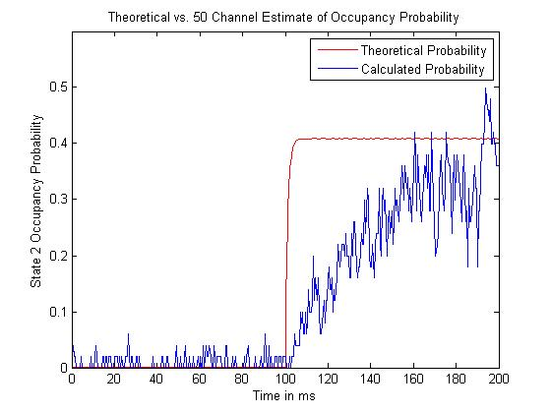

500 Channel Calculated State 2 Occupancy Probability

