Part1

1. Equation of b

**def funcb(w,b,x,y):**

**value1 = 0**

**for i in range(len(x)):**

**if(y[i]*(np.dot(w,x[i])+b))>= 1:**

**value1 += 0**

**else:**

**value1 += -y[i]**

**return c*value1**

**ii)**

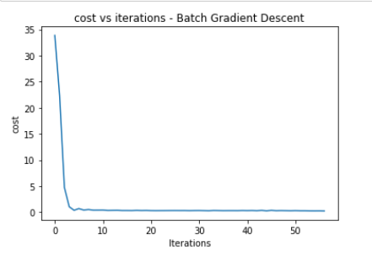

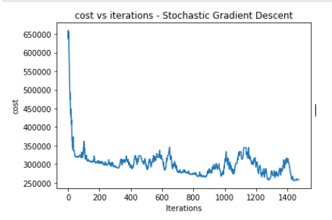

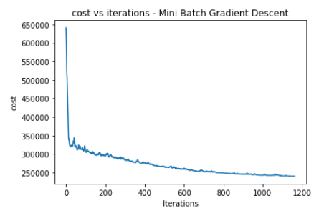

**iii)Code submitted**

**Part2)**

1. **Code submitted**
2. 