Report – Kushal Ganti

Part A:

A

1. CODE: submitted
2. Plots:

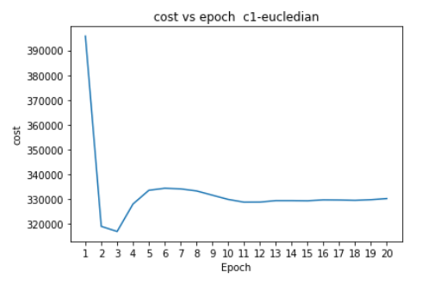

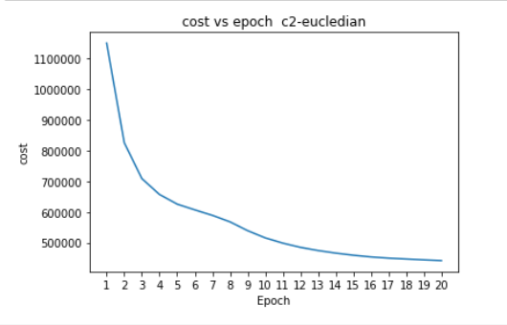

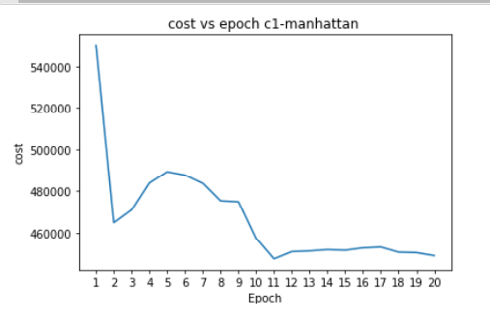

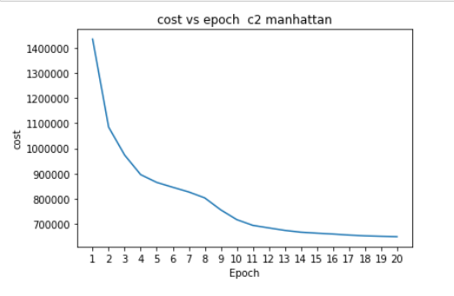

1b) Random generation of c1 is better than c2 in terms of cost for Euclidian distance. If you see the graph, we will notice a perfect elbow shaped plots for C1 using Euclidian. While for c2, it’s just a steady decrease. The Error/Cost for C1 at the end of 20 iterations is 330176 while for C2 it is 441696. We see that C1 performs better.

2b) For Manhattan also random generation using C1 is better in term of cost. If you see the graph the elbow curve is not perfect as we got for Euclidian. The C2 graph has a better curve. When we see the Error/Cost value of C1 is lesser than C2 that is it is 449009 at the end of 20 iterations while it is 649689 at the end of 20 iterations. C1 performance is better.

Part B:

1.

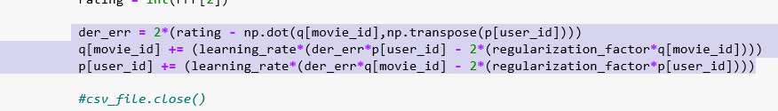

2. The lowest value of eta I got is 0.01. The lowest error that I got was 46664.

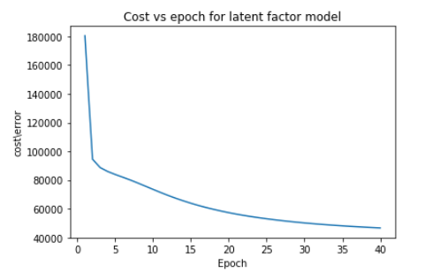

1. Code : Submitted