Fast Exact Non-Local Means
Reordering the computation, then studying the quality–runtime trade-off
Kush Tokas · 2023296 · DIP-CSE341
1. Assignment route and contribution
I chose Non-Local Means (NLM). My main contribution is an output-equivalent acceleration. Basic NLM repeatedly sums every K×K patch distance at each search displacement. I instead form one squared-difference image per displacement and aggregate it with a separable, constant-cost box operator. After verifying the same output, I explored D5 and selective fusion as separate quality–runtime extensions.
2. Basic NLM and exact acceleration
d²(p,q)=max(K⁻²||P(p)-P(q)||²₂-2σ²,0), w(p,q)=exp[-d²/h²], and Î(p)=Σw(p,q)Y(q)/Σw(p,q). The direct form costs O(NS²K²). For displacement t, I compute D_t(u)=[Y(u)-Y(u+t)]² and d²(p,p+t)=max(B_K[D_t](p)-2σ²,0), where B_K is a separable running box mean. This reduces the complexity to O(NS²) time with O(N) working memory. Reflect padding is used. The order of computation changes; the estimator does not.
3. D5 and selective fusion
D5 uses x_p=W^(1/2)(P(p)-μ), z_p=U^T x_p and query Q(p)=[z_p, λ_y y_p, λ_x x_p]. I use a KD-tree to find a bounded candidate set, rerank it with exact descriptor distance, and reconstruct from candidate centre intensities (R0). Because full D5 is expensive, fusion uses residual, gradient, variance, and expert-disagreement cues to send only the hardest 10%, 25%, or 35% of pixels to D5 at σ=10,25,50. Fusion lowers D5 cost, but it is still slower than fast exact NLM.
4. Protocol
I screened the 39 available USC-SIPI images at 128 px, excluding gate and calibration images. The fixed rule kept images where both D5 and fusion beat fast exact NLM in PSNR and SSIM at σ∈{10,25,50}. The selected images are 4.1.02 and 4.1.01 at 256×256, plus 7.1.04 and 7.1.03 at 512×512. I reran them at native size with a new seed, 20261029. The gate was trained on a separate four-image set using seed 20260827 and did not see the final images. Native comparison uses K=7, S=21; timers include complete calls and exclude I/O and metrics.
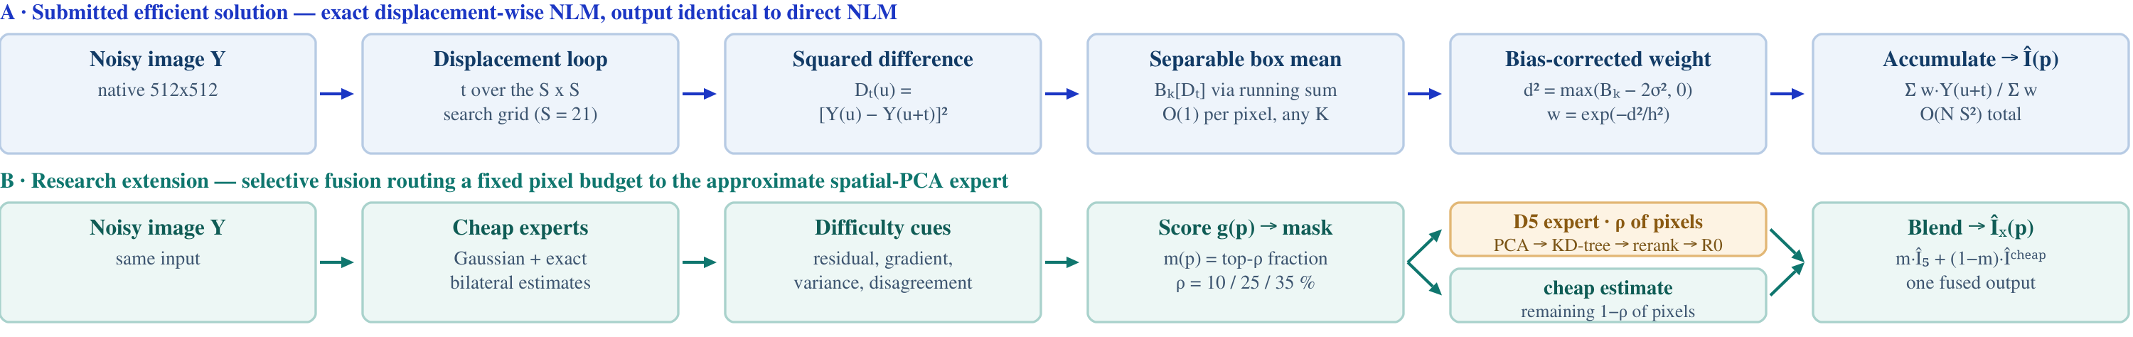
Figure 1. Both pipelines end to end. Lane A is the output-equivalent exact acceleration. Lane B is the selective spatial-PCA research extension; its pixel budget controls real retrieval work.

Native-resolution results
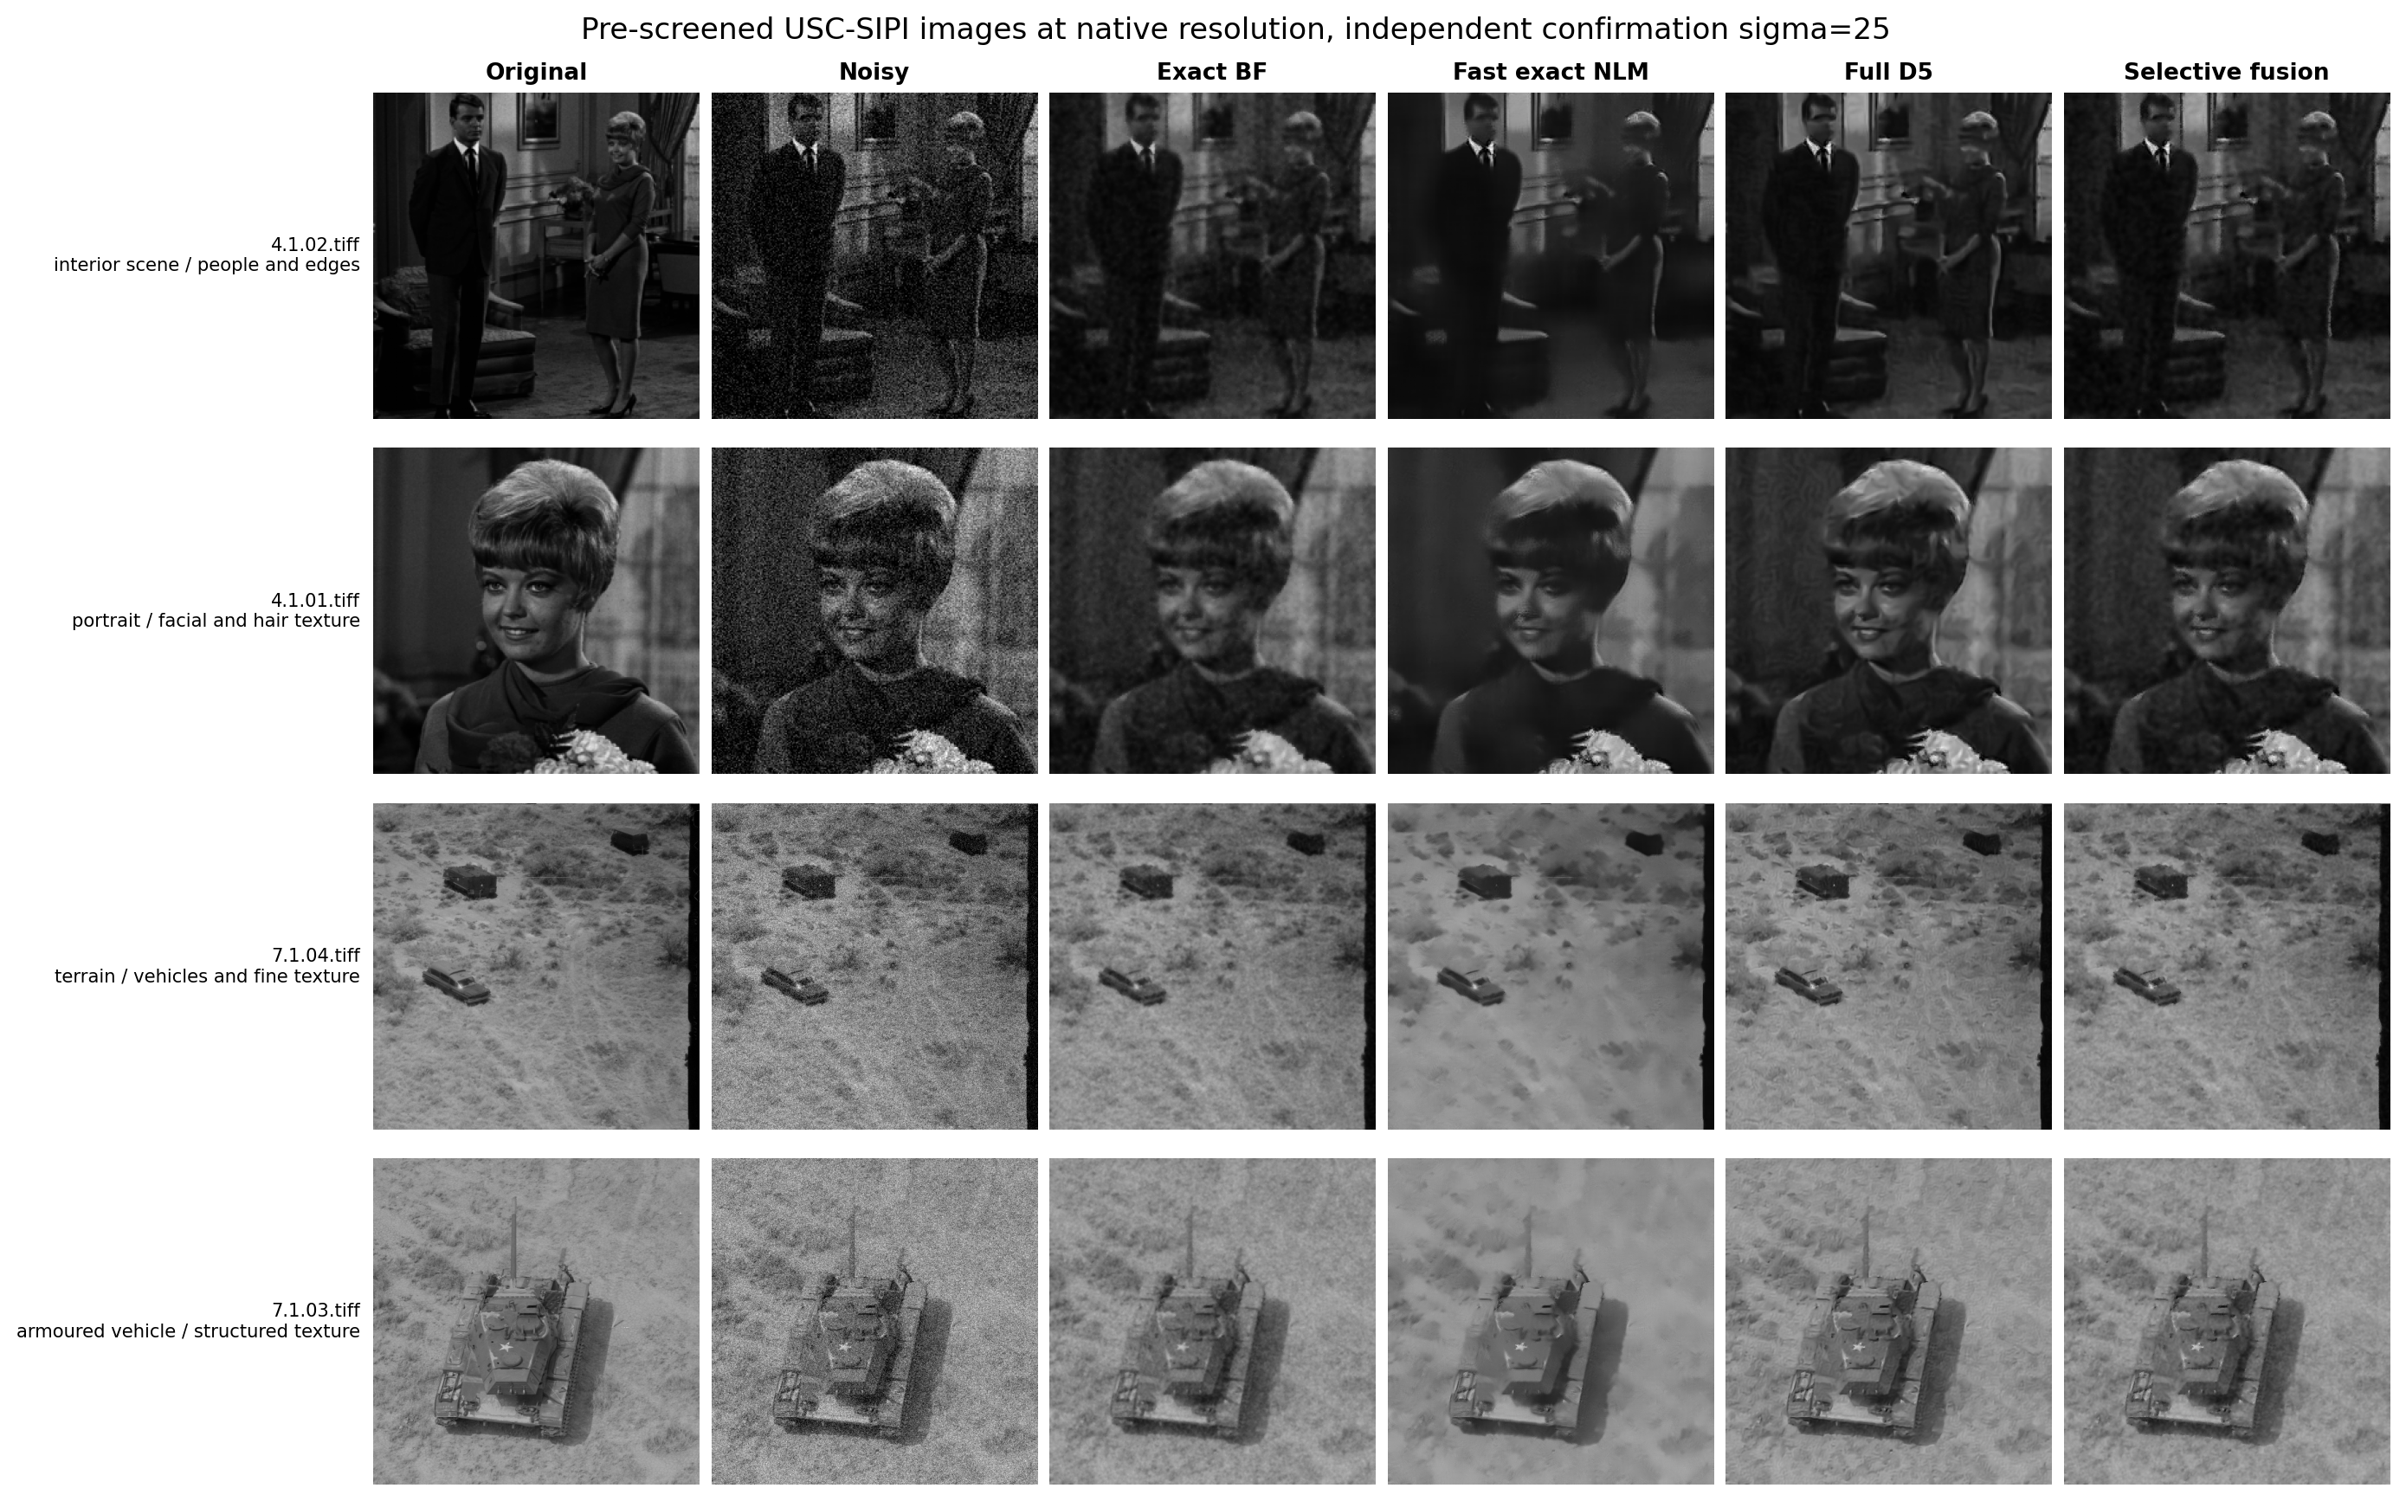
Figure 2. Original and processed images from the independent native-size confirmation at σ=25. Columns: original, noisy, bilateral, fast exact NLM, full D5 and selective fusion.
σ | Bilateral | Fast exact NLM | Full D5 | Fusion
10 | 33.350 / 0.8573 | 33.032 / 0.8466 | 33.766 / 0.8573 | 33.359 / 0.8523
25 | 29.360 / 0.7285 | 28.805 / 0.6796 | 30.048 / 0.7453 | 29.790 / 0.7383
50 | 25.952 / 0.5957 | 25.247 / 0.5385 | 26.251 / 0.6045 | 26.115 / 0.6040
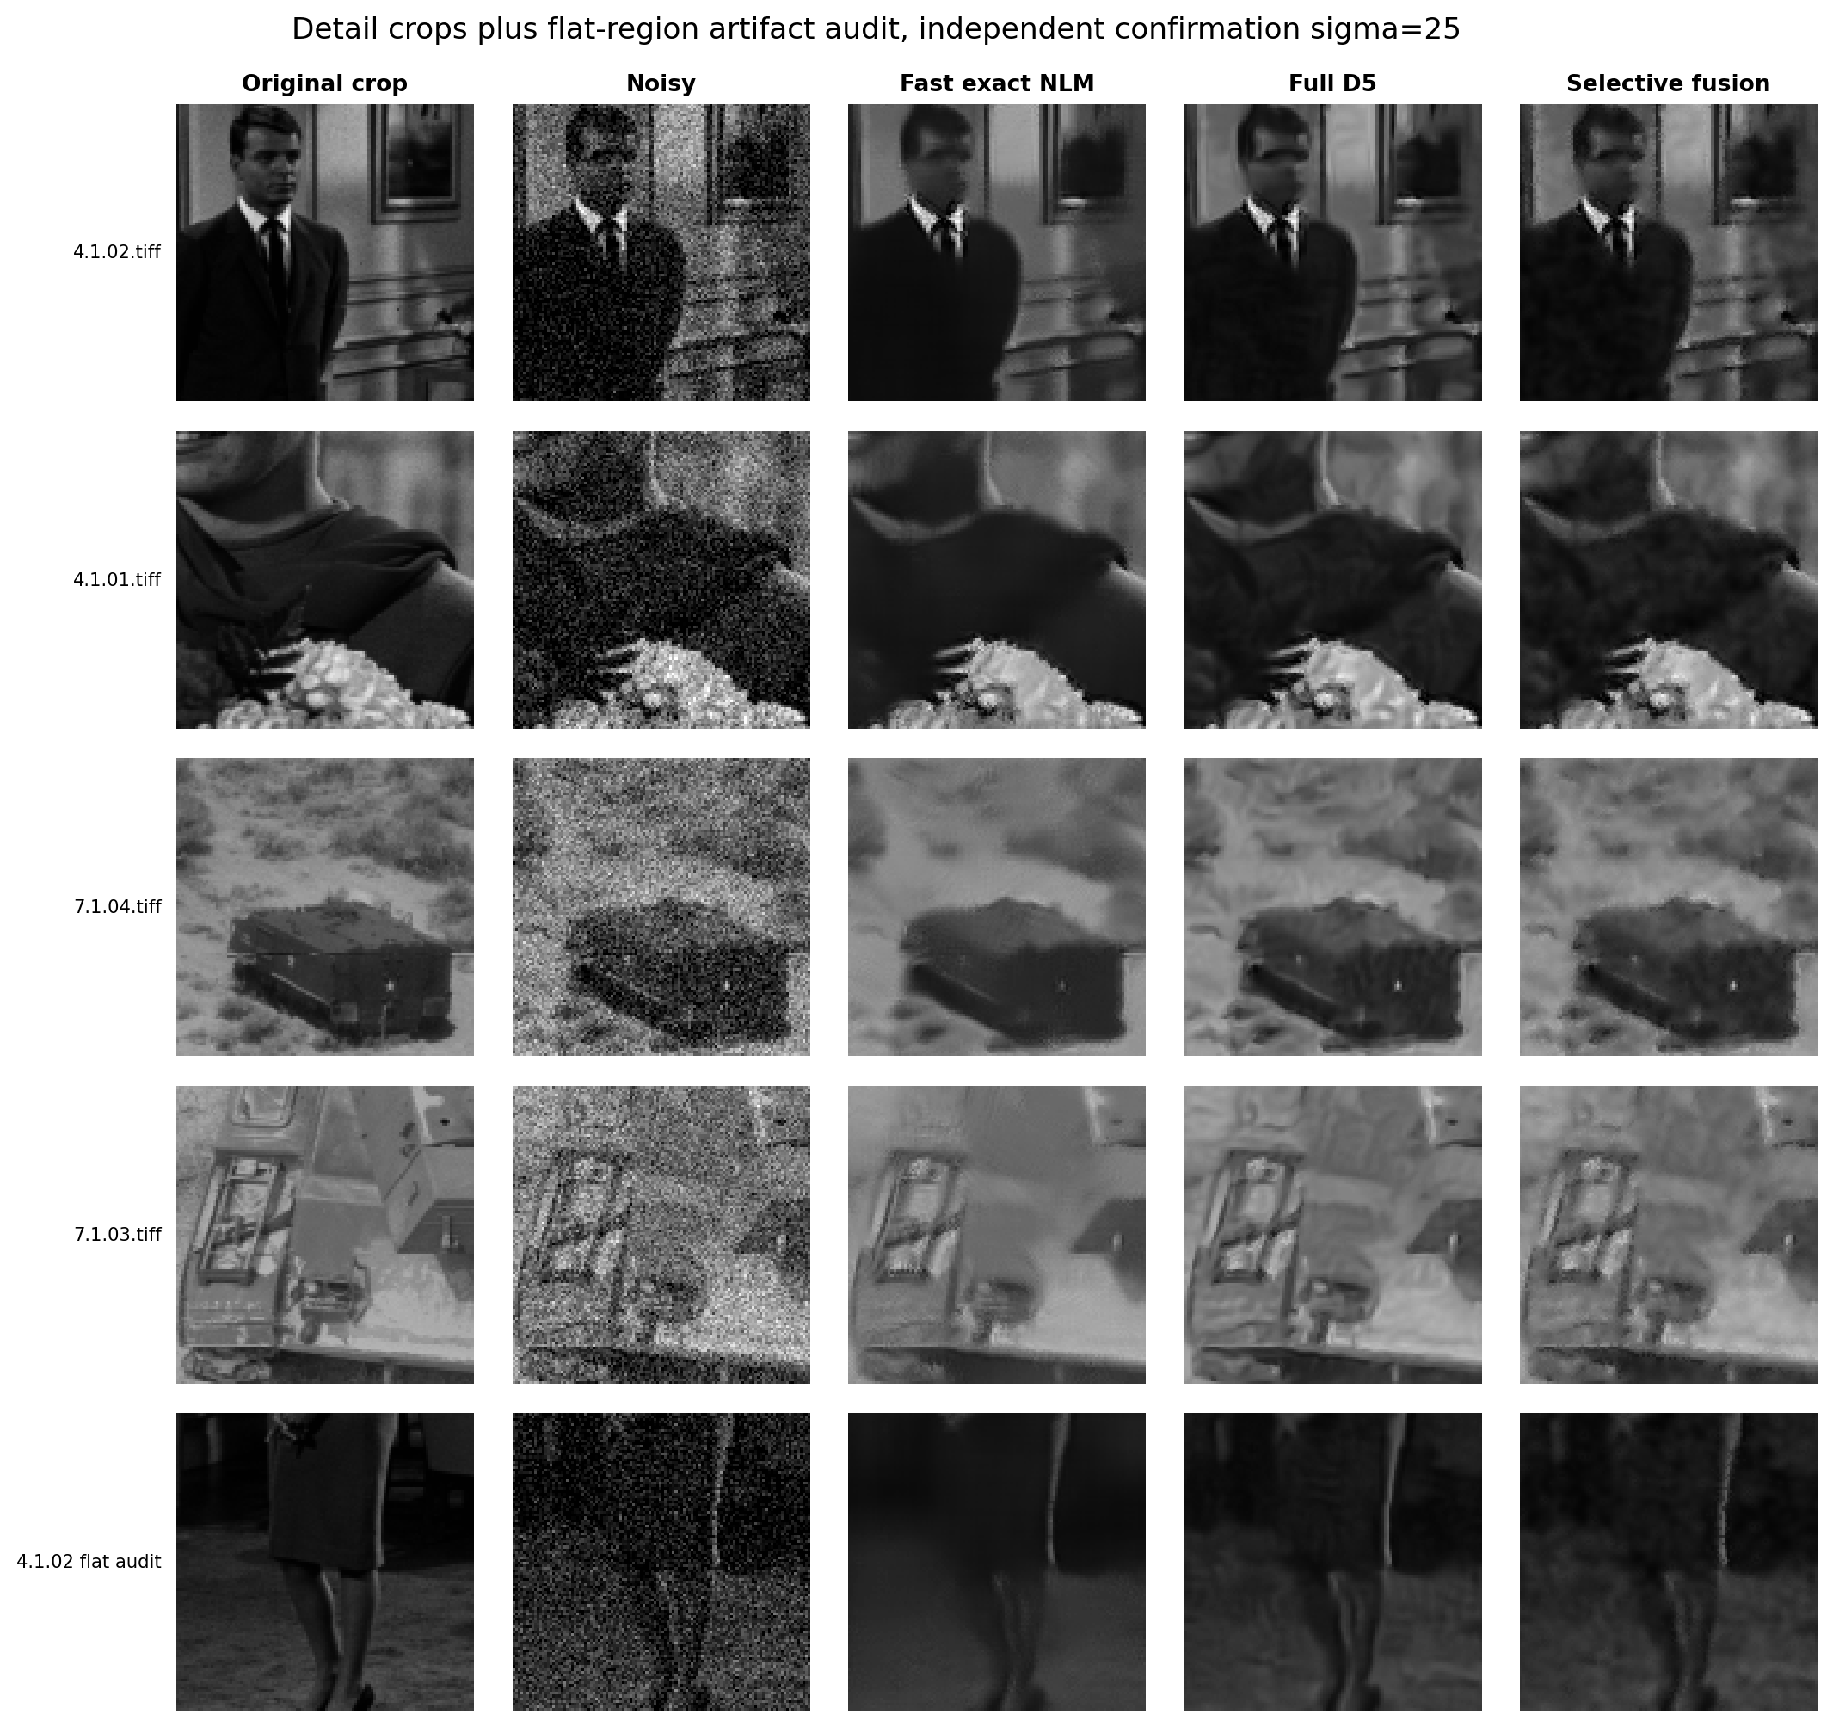
Figure 3. Automatically selected high-gradient crops plus a flat-region artifact audit; both selections use clean-image local gradient energy.

Efficiency, trade-offs, and conclusion
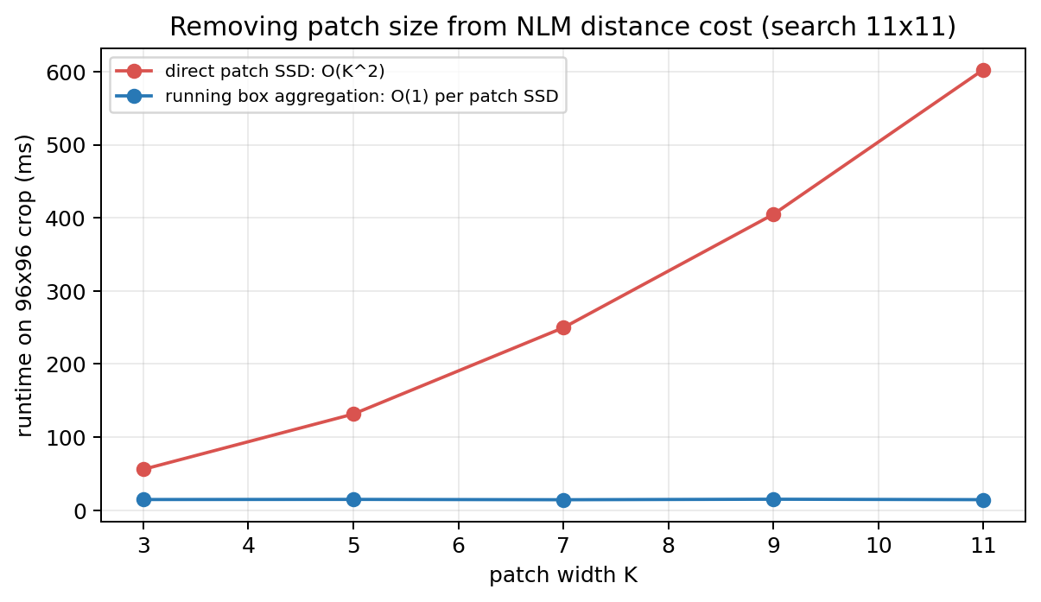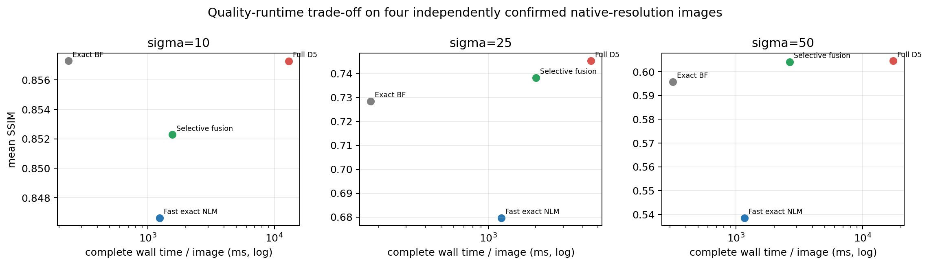
Figures 4–5. Exact patch-size scaling and the native-image quality/runtime trade-off. D5 and fusion improve selected-set quality; fast exact NLM remains the substantially cheaper NLM route.
Image | Direct ms | Fast ms | Speed-up | Max |Δ|
img_002 | 248.9 | 14.8 | 16.80× | 1.1e-13
img_001 | 248.6 | 14.2 | 17.52× | 1.4e-13
img_028 | 250.4 | 14.7 | 17.09× | 2.3e-13
img_027 | 249.1 | 14.1 | 17.65× | 2.0e-13
σ | BF 256/512 | Fast NLM 256/512 | D5 256/512 | Fusion 256/512
10 | 97.6 / 376.4 | 470.5 / 2007.0 | 3408.1 / 22633.9 | 698.8 / 2426.7
25 | 71.8 / 286.2 | 456.8 / 1972.4 | 1901.6 / 7135.0 | 836.7 / 3189.6
50 | 130.5 / 504.9 | 450.5 / 1886.8 | 2488.4 / 32345.5 | 1251.7 / 4049.9
Conclusion
The accelerated method matches direct NLM within 2.3e-13 and is 17.26× faster on average at K=7, S=11. On these four independently confirmed images, D5 and fusion beat fast exact NLM in both PSNR and SSIM at all three noise levels. Fusion recovers part of the D5 runtime but remains slower than fast NLM. I therefore submit fast exact NLM as the efficient solution and present D5 and fusion as supporting quality–runtime experiments. Since the images were pre-screened, their gains should be read as selected-set results rather than universal performance.
References
[1] Buades et al., CVPR 2005. [2] Tomasi and Manduchi, ICCV 1998. [3] Tasdizen, IEEE TIP 2009. [4] Darbon et al., ISBI 2008. [5] Wang et al., IEEE TIP 2004. [6] USC-SIPI Image Database.

