**ANSIBLE**:-

Ansible is a “configuration management tool” or “configuration automation tool”.

Ansible is simple open-source IT engine which automates application deployment.

By using Ansible we install, delete, and deploy applications to multiple servers at the time.

It use YAML scripting language which works on key – pairs.

It used python for back-end.

Ansible taken over by red-hat.

**How to set-up Ansible configuration on server**

First we launch 3 instances, one is Ansible master server and other two is remote servers.

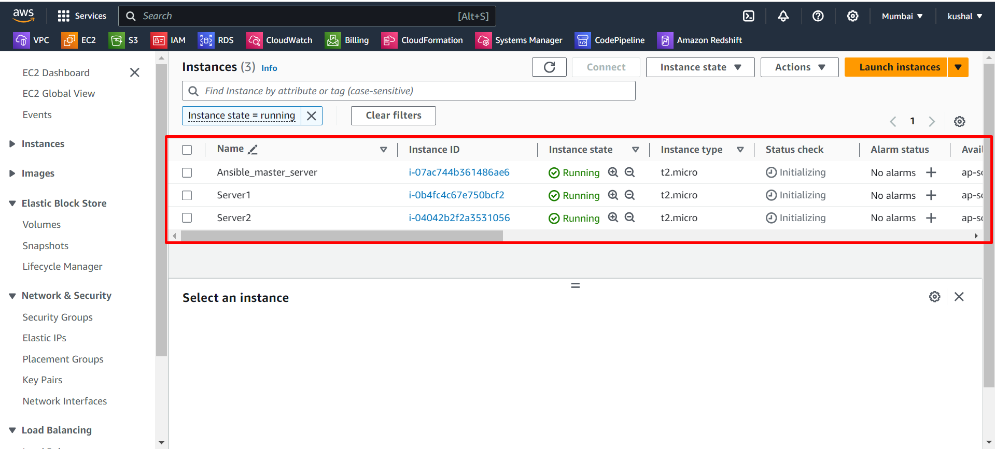

Now we connect master server with mobaXterm, copy the public IP of Ansible master server.

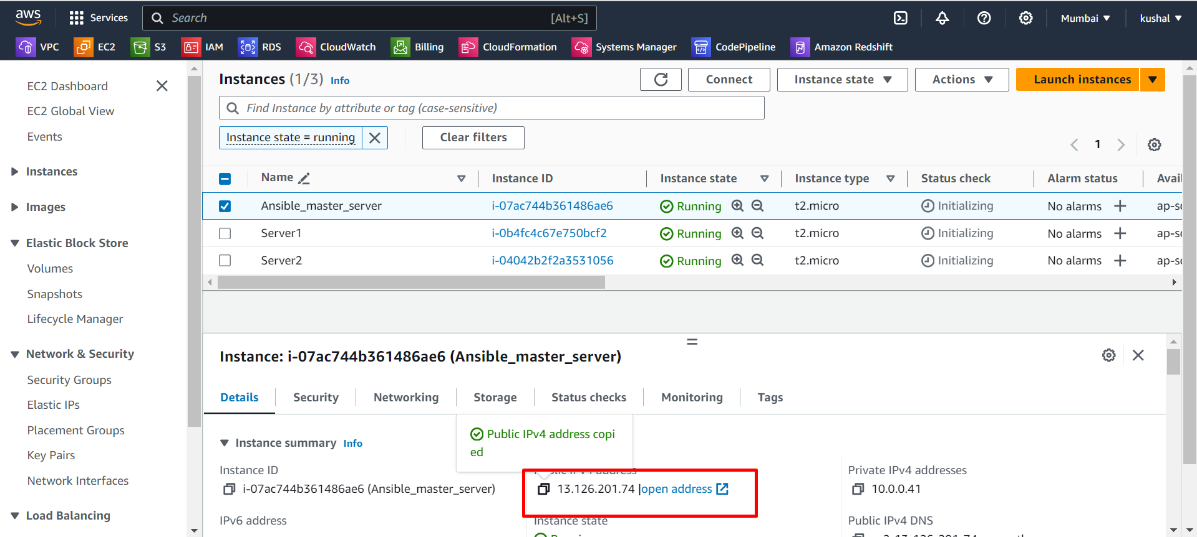

After that we paste that IP in Remote host in mobaXterm and specify username and also give pem key path then click on **OK**.

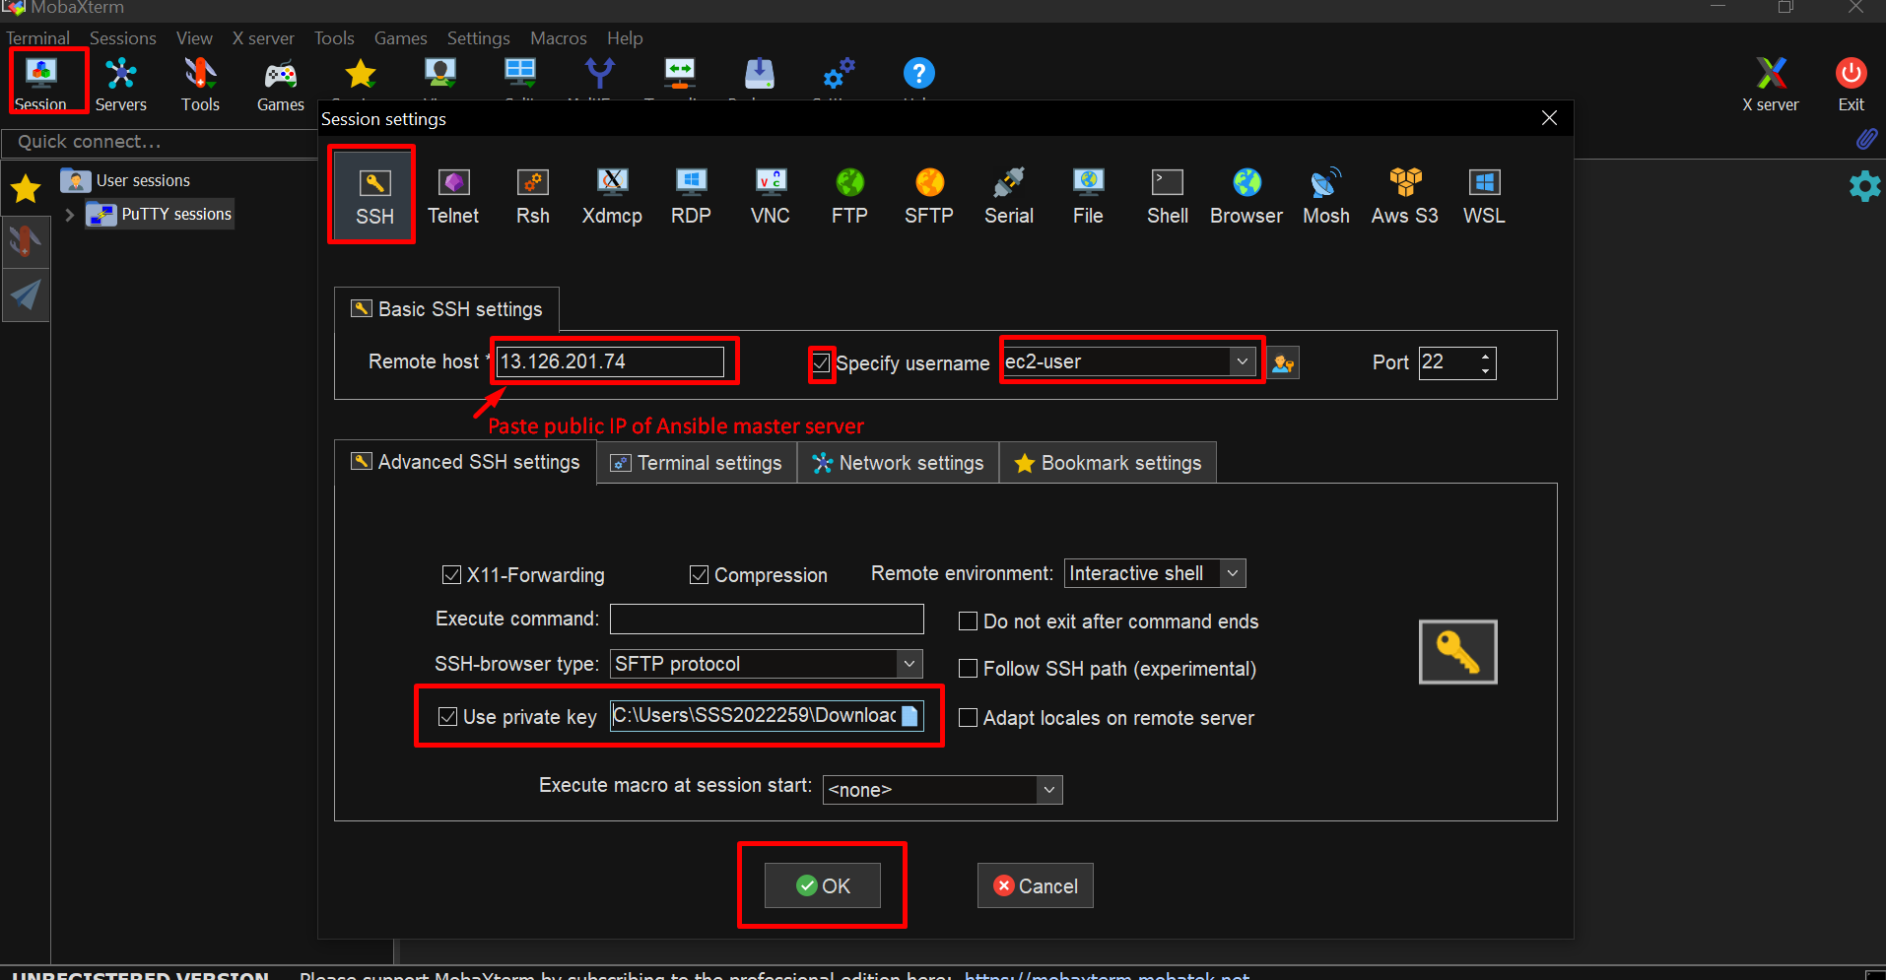

We successfully connected.

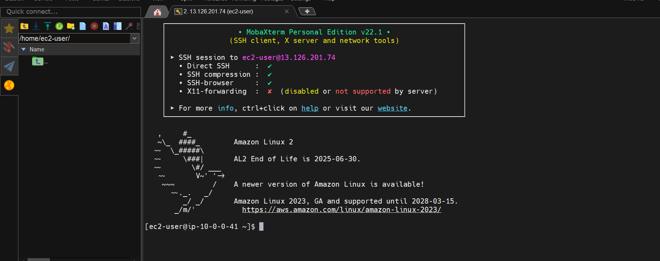

Now we change host-name for this server , this is not a mandatory, this for our reference.

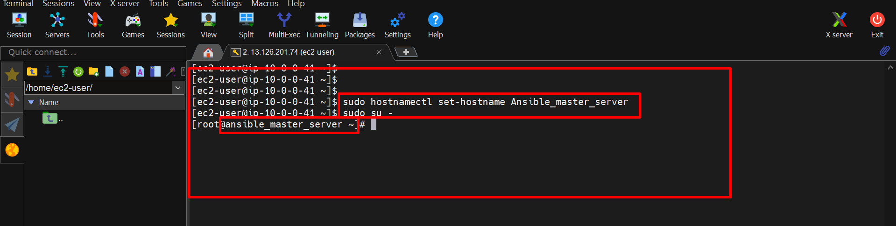

Same process done for remaining two remote server.(connect and change host-names).

This is server1.

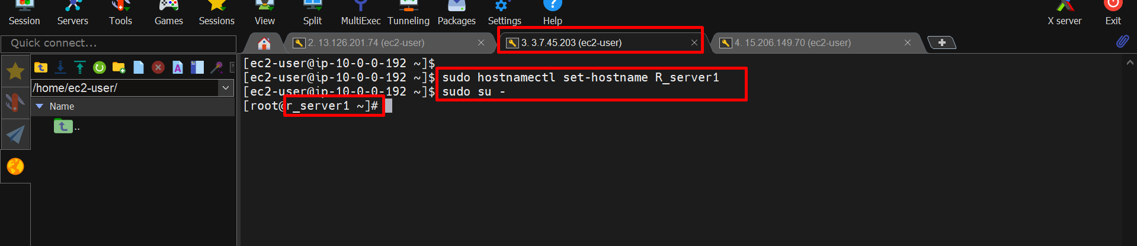

This is server2.

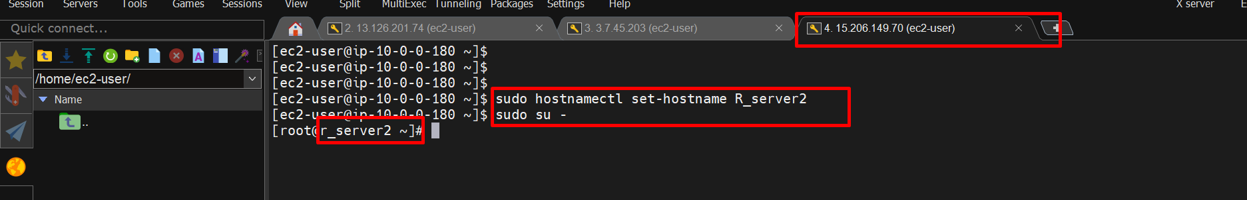

We successfully connected and changing host-names.

After that we install ansible on Ansible_master_server.

Installing commands:-

* sudo yum update -y
* sudo amazon-linux-extras install epel
* sudo yum install ansible -y
* ansible --version

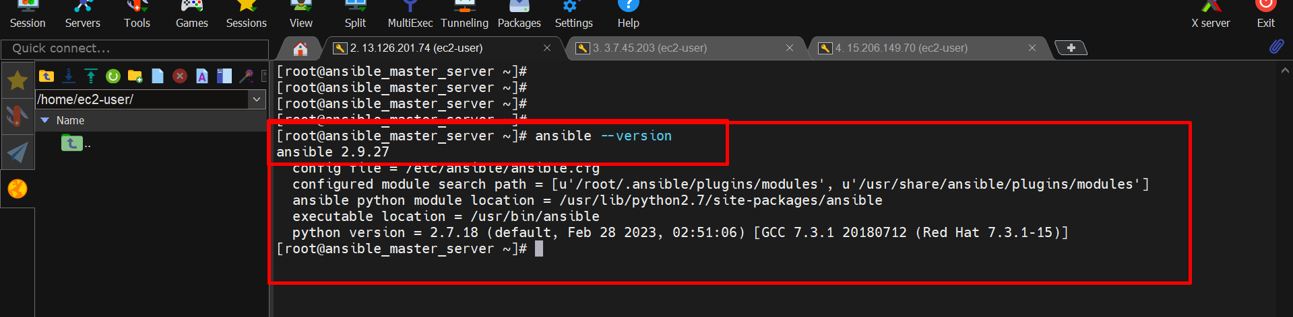

We successfully installed ansible on Ansible_master_server.

After that we add user ‘ansiuser’ this user similar for all servers.

Commands:- useradd ansiuser

Passwd ansiuser

After using this command ‘Passwd ansiuser’ , enter password two times.

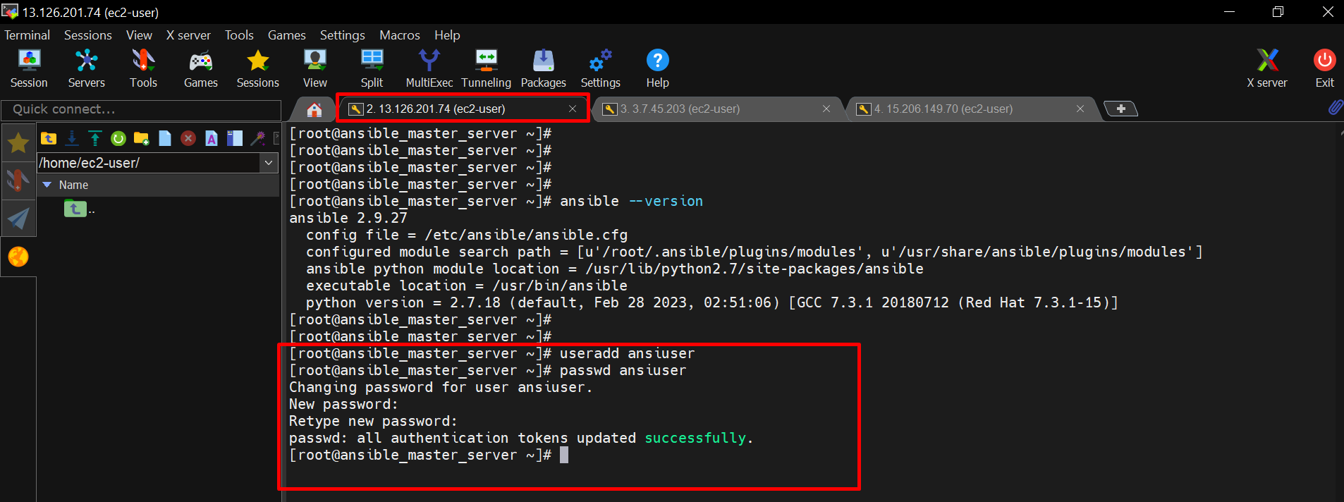

Similary add ansiuser and same password for all server (passwd for our use only like not forgettable so must use same password)

This is server1

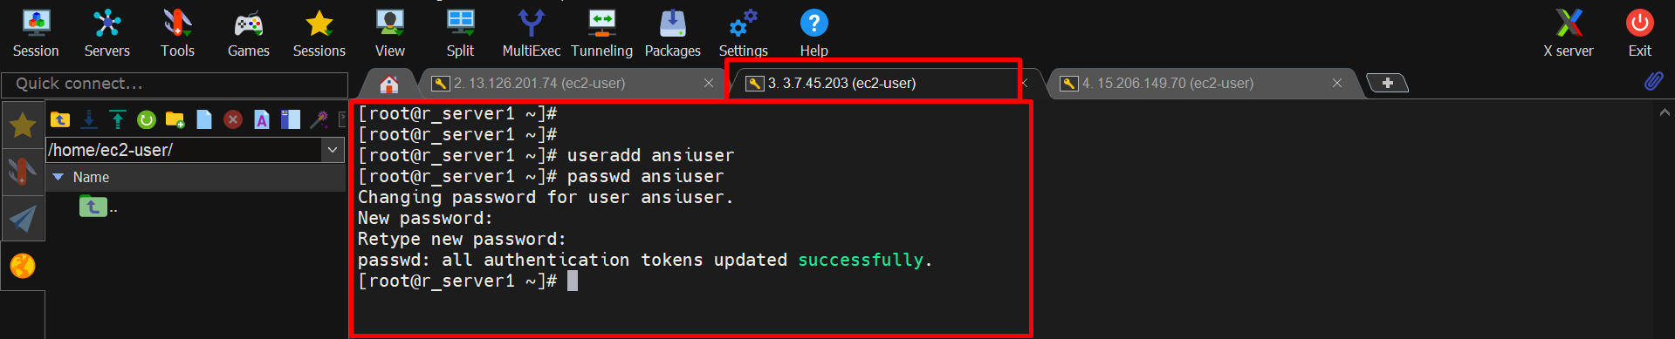

This is server2

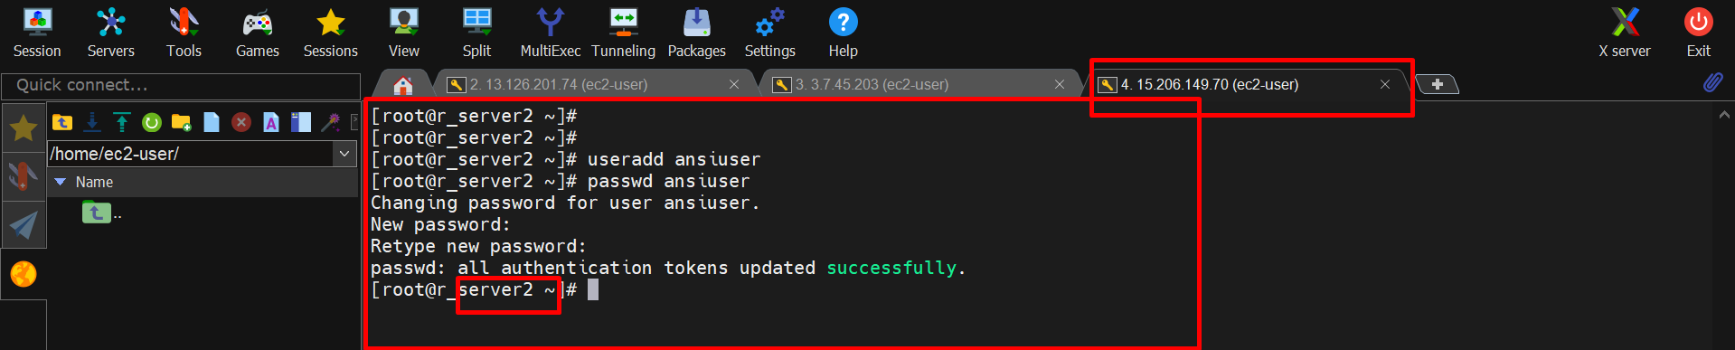

Now we add this ansiuser on **visudo** file.



Save the file using **wq** and enter.

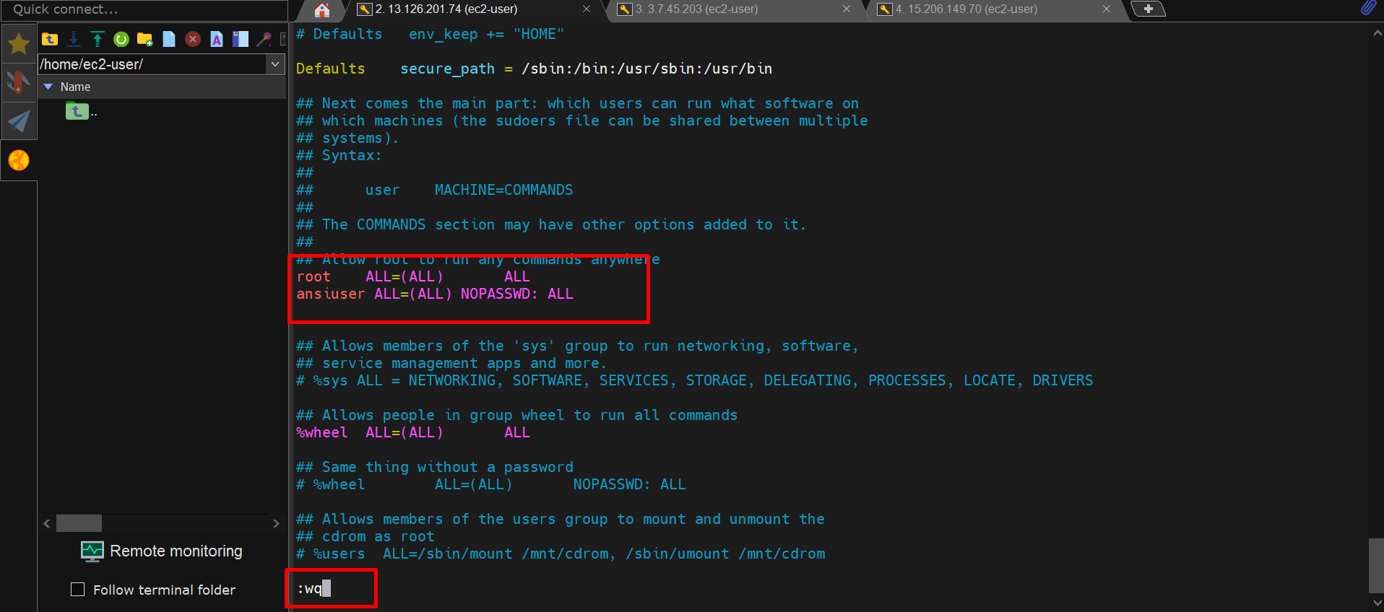

We successfully add ‘ansiuser’ in **visudo** file. Similary add **ansiuser** in visudo file on remote servers.

This is server1.

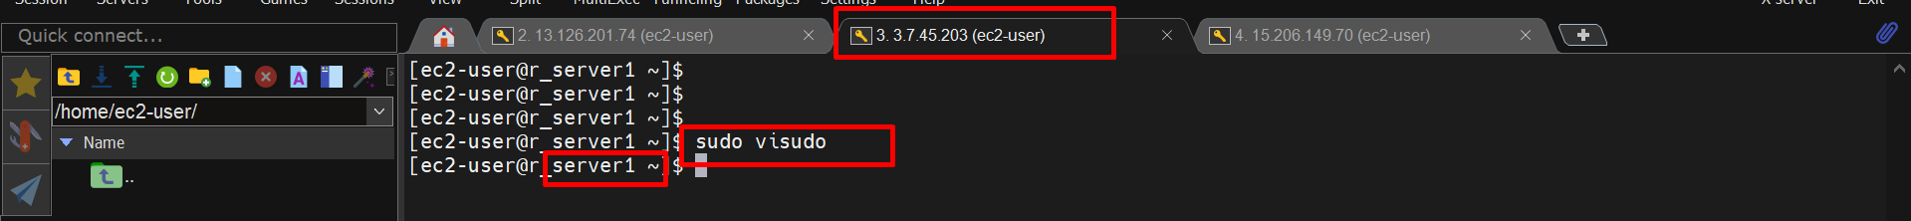

This is server2.



After that we modify sshd.config file for password authentication.

In this file PasswordAuthentication present in **no** we must edit this **yes**.

Path :- etc/ssh/sshd.config

Command:- sudo vim etc/ssh/sshd.config

Then change PasswordAuthentication **no** to **yes** And save that file using **:wq.**

After that we restart that sshd service again using command :- **sudo systemctl restart sshd**

This process are also do in all servers.

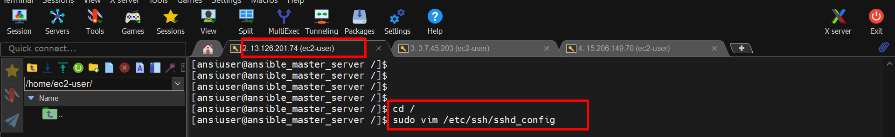

This is ansible master server.

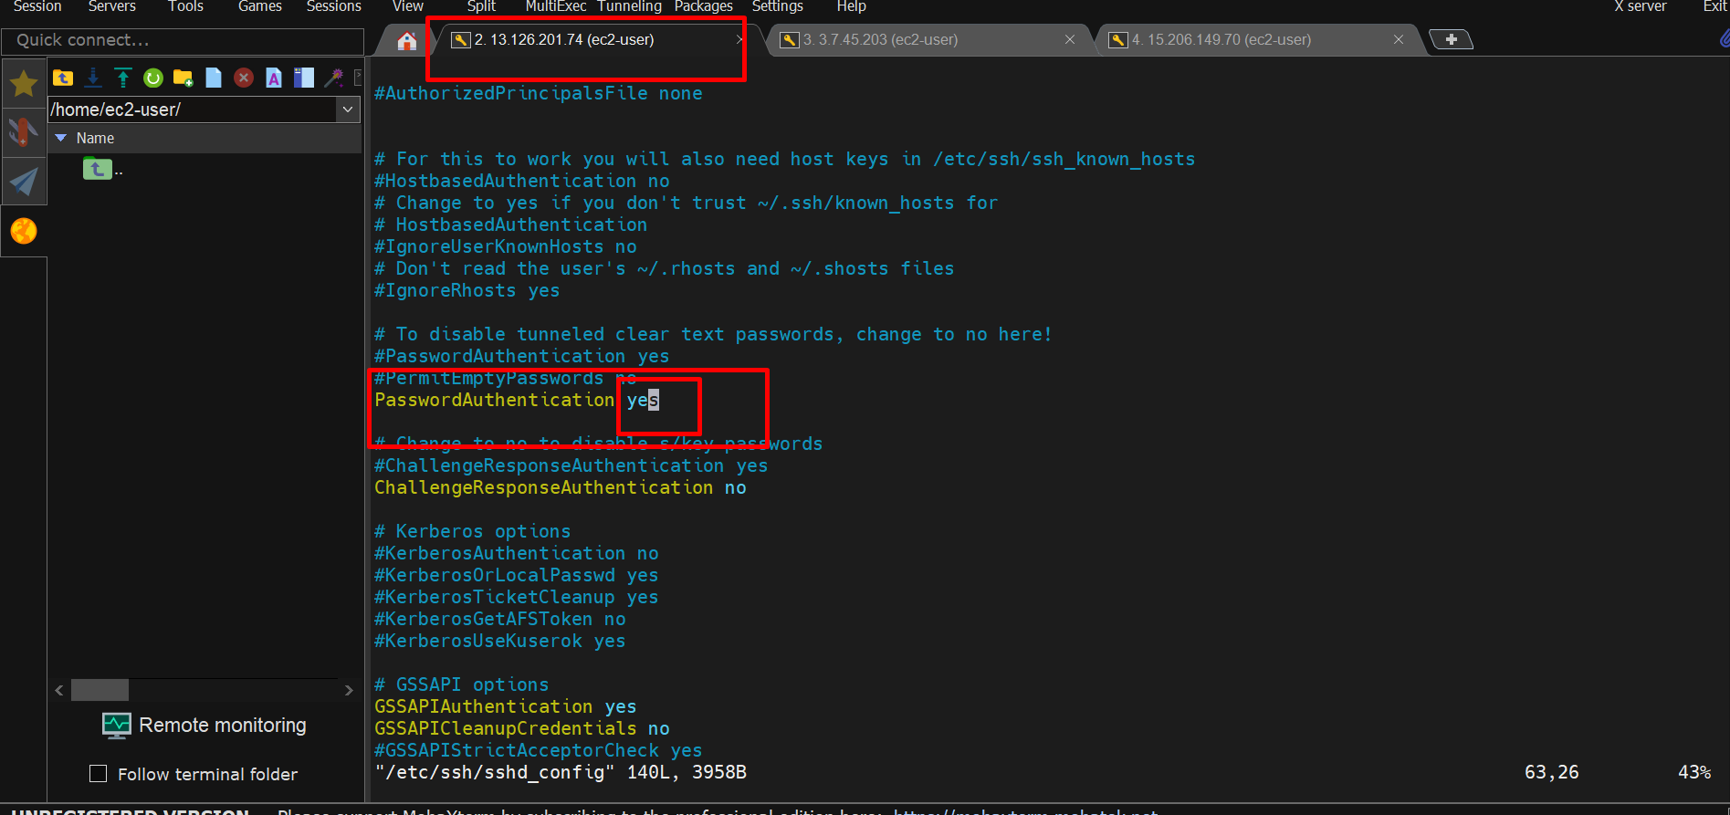

This is server1.

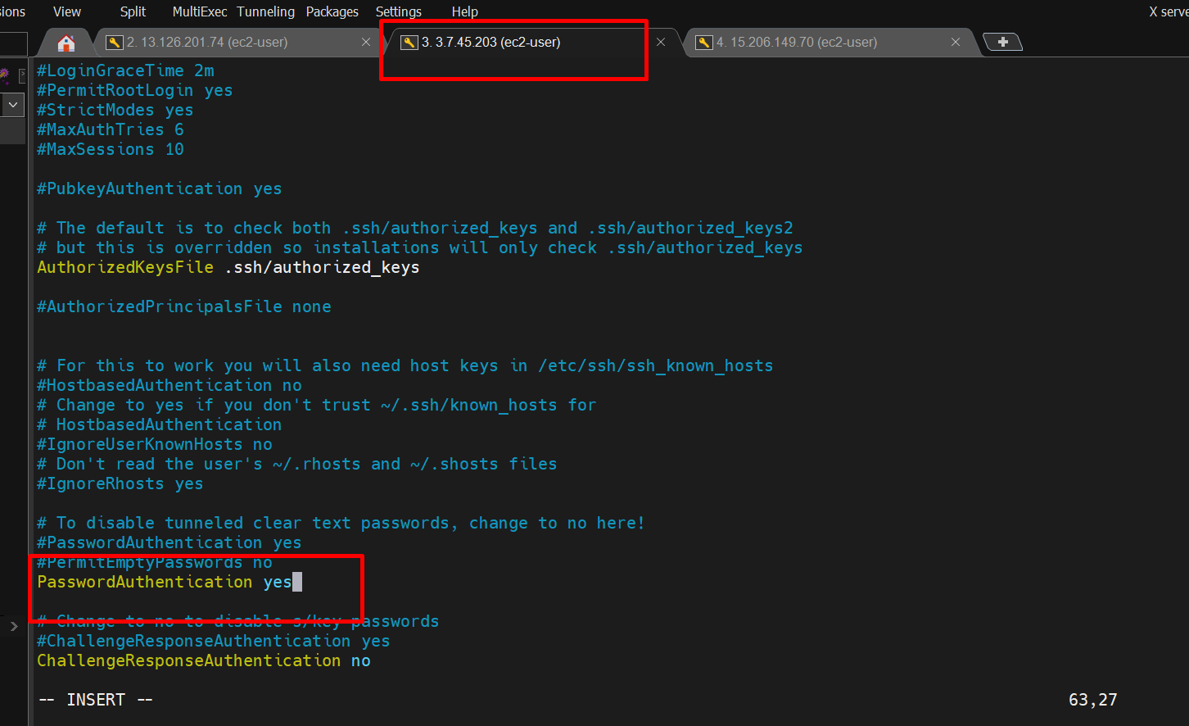

This is server2.

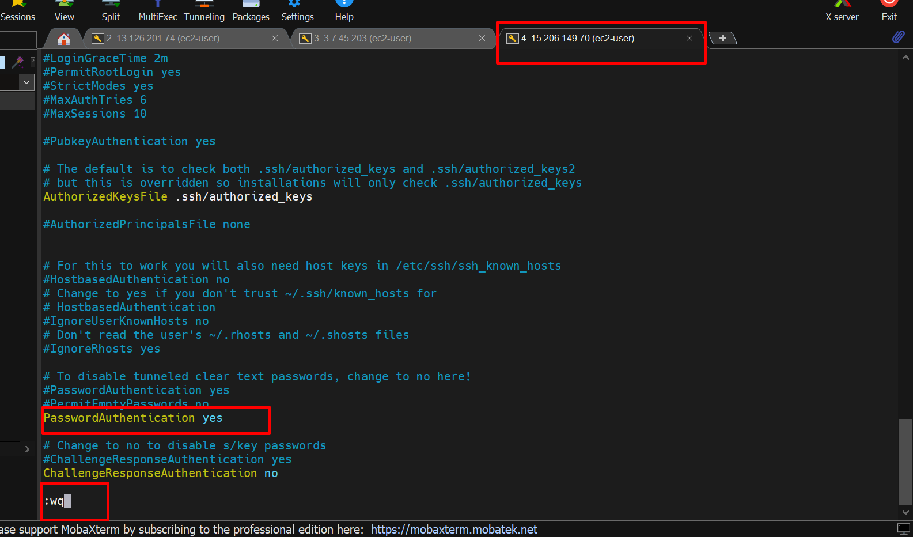

Restart sshd server on all servers.

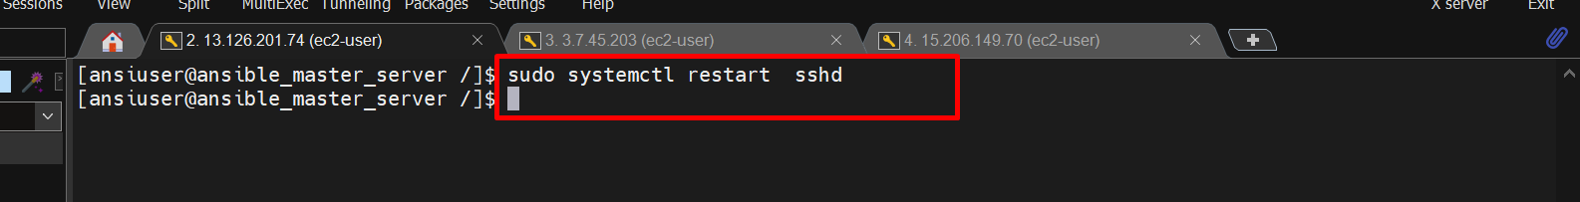

**Now we generate keys only in Ansible master server.**

Commands:- ssh-keygen

After that commonly click on **enter**

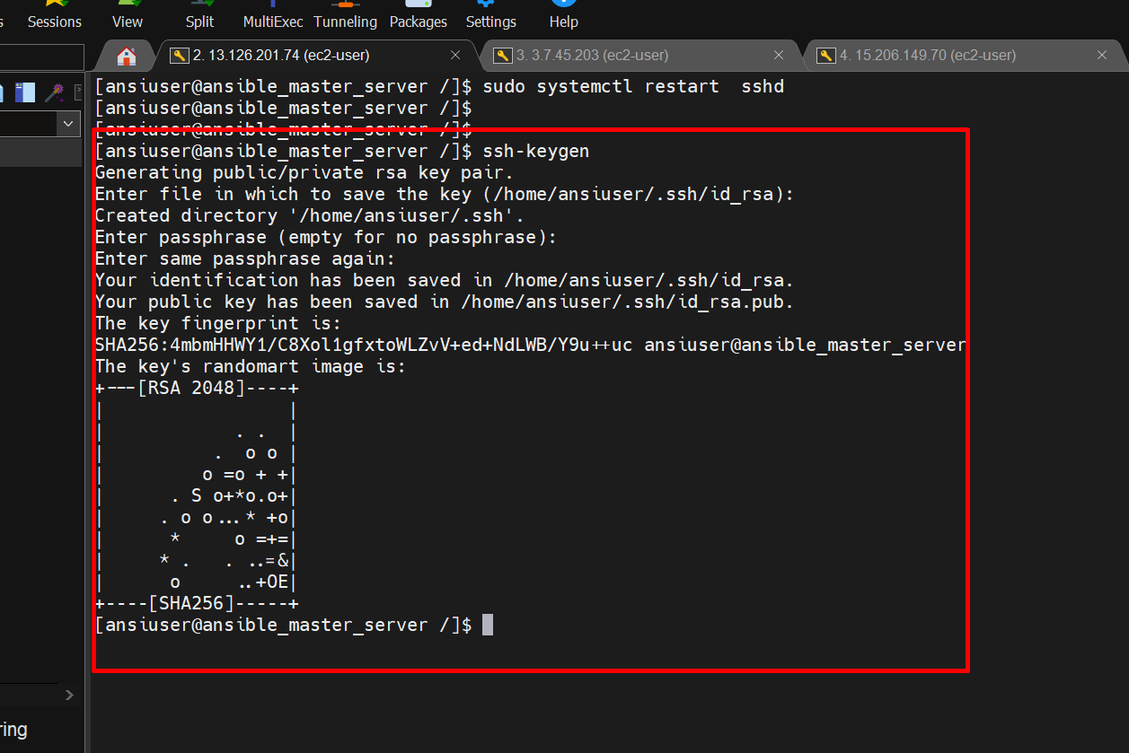

We successfully generated keys on ansible_master_server.

Now we want see our keys

Path = home/ansiuser/

cd home/ansiuser/

cd .ssh

This is our keys.

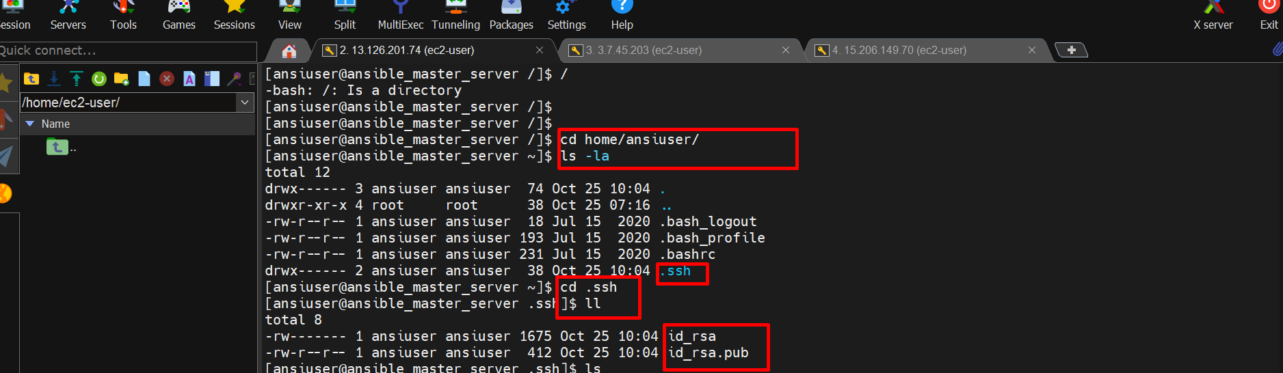

Now we send this keys to our remote servers.

Command:- ssh-copy-id ansiuser@public-IP-of remote server

in our case command :- ssh-copy-id ansiuser@3.7.45.203

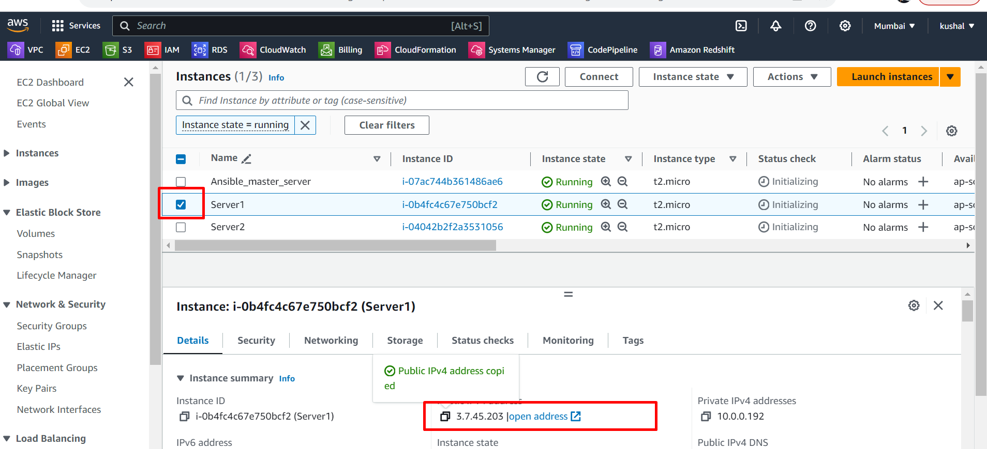

Copy public IP of server1 and paste that IP in command line.

Like **ssh-copy-id [ansiuser@3.7.45.203](mailto:ansiuser@3.7.45.203)**

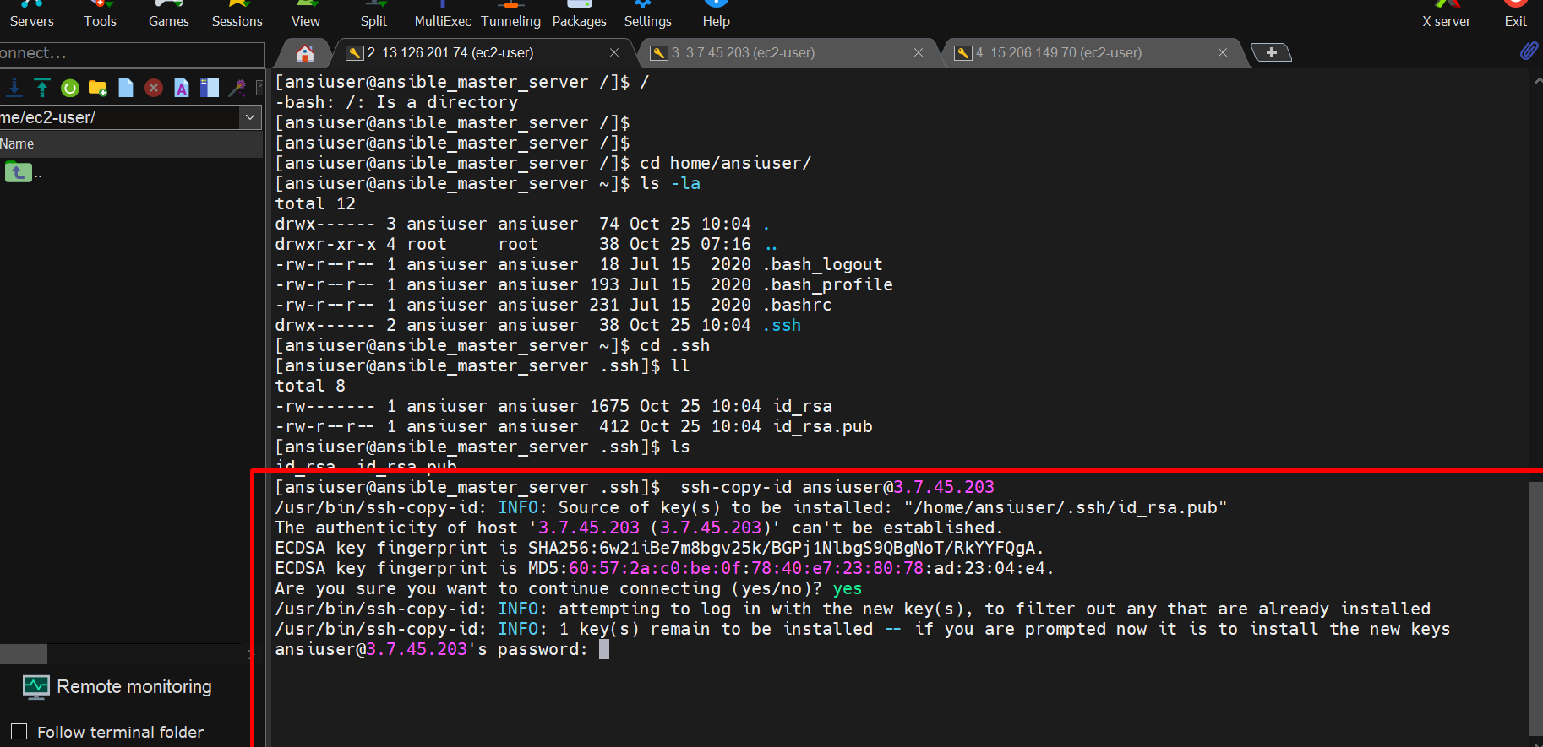

After using that command next press enter for password,First time asking password another times it do not ask password.

After that it will give one login command [‘ssh-ansiuser@3.7.45.203’](mailto:‘ssh-ansiuser@3.7.45.203’)

Use this command for login into remote server.

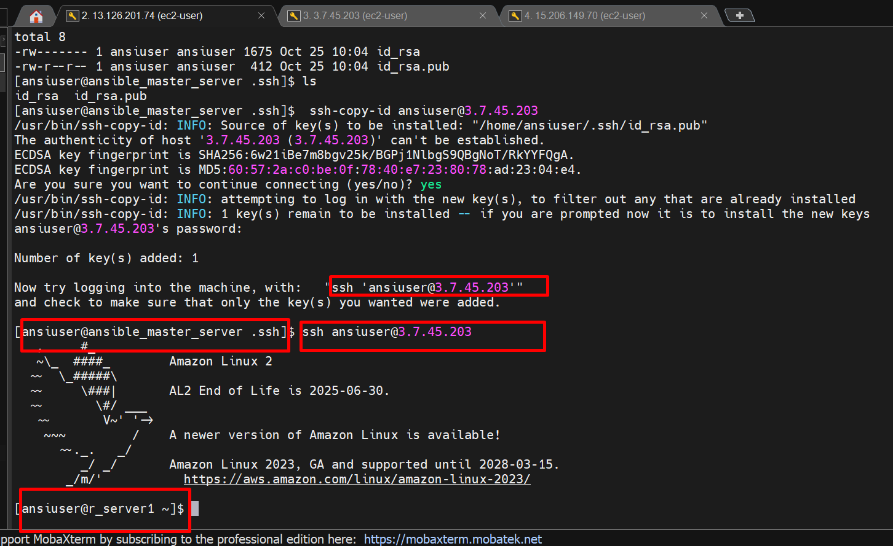

We successfully connected master server to remote server1.

Similary we connected server2.

