**What is a load balancer on AWS?**

In Amazon Web Services (AWS), a load balancer is a service that

Distributes incoming network traffic across multiple instances of an application running in multiple Availability Zones.

Load balancers play a crucial role in ensuring high availability,

Fault tolerance, and efficient distribution of traffic to provide a seamless and reliable experience for users.

**How to create an Elastic Load Balancer**

First, we install two or more servers.

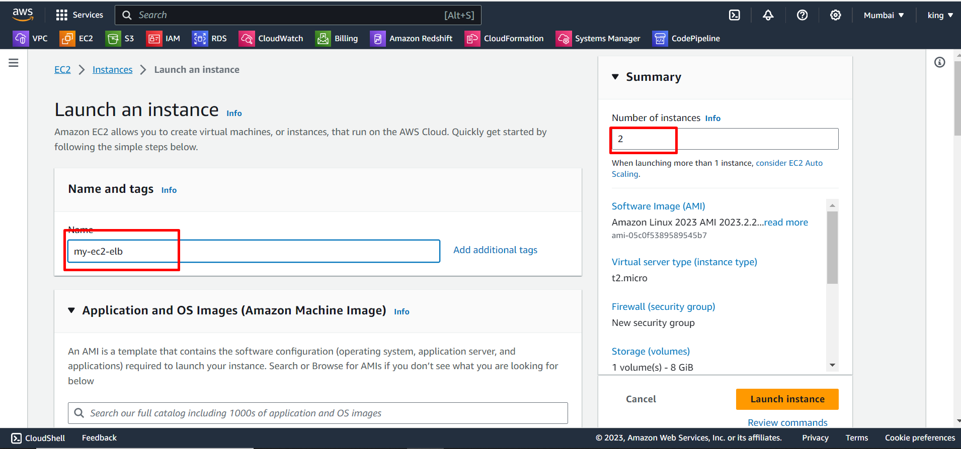

Next, we do all the processes for launching the instance and then click on the launch instance.

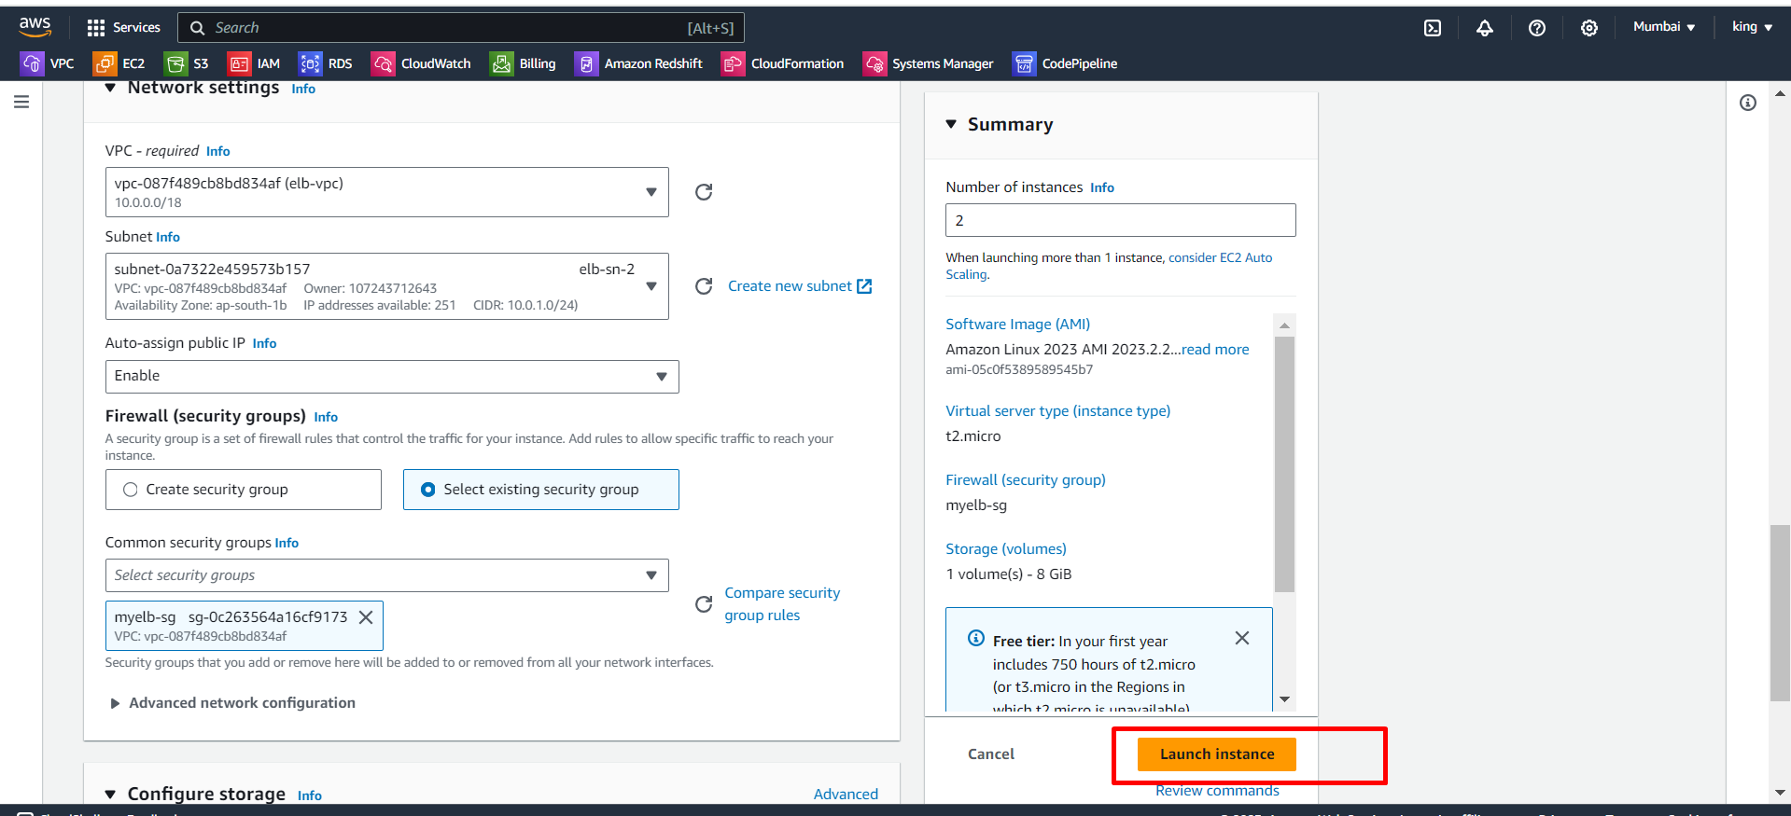

After that, we edit their names according to the requirements.

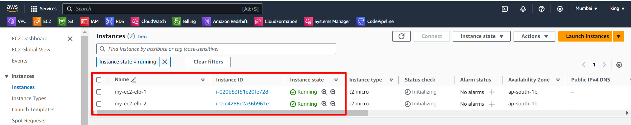

We successfully launched two instances.

Next, we use mobaxterm for connecting our ec2 servers.

We already know, how to connect ec2 on mobaxterm.

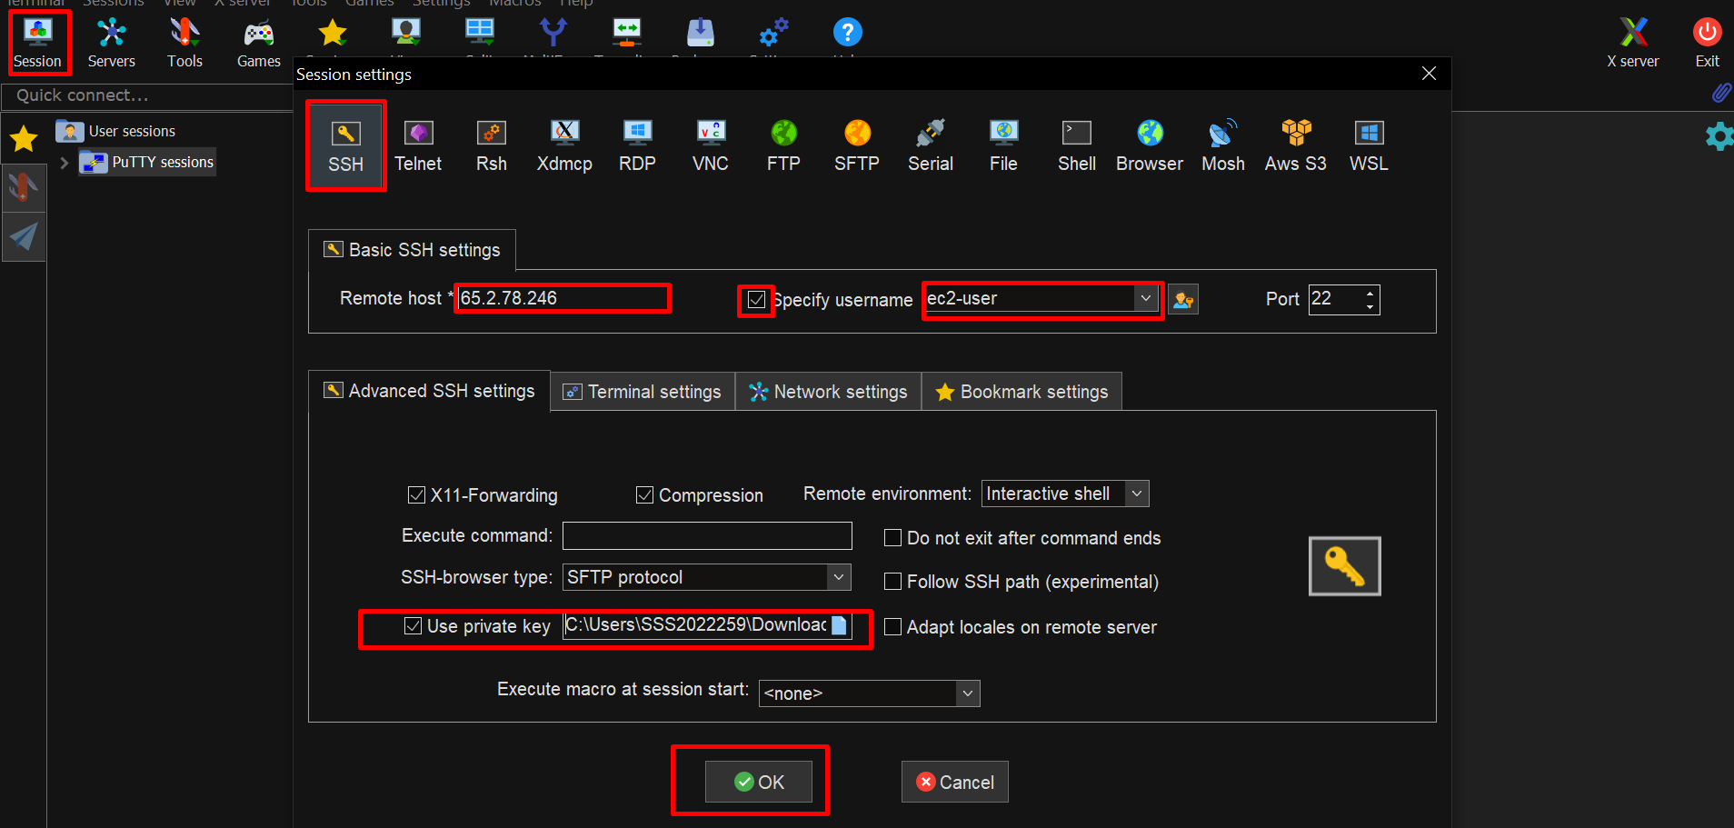

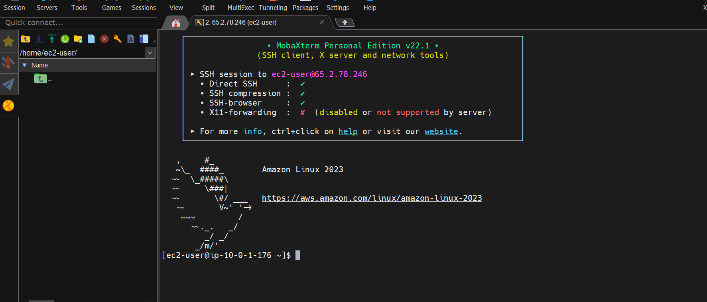

Connect another server also.

We successfully connected and changed their hostname for our references.

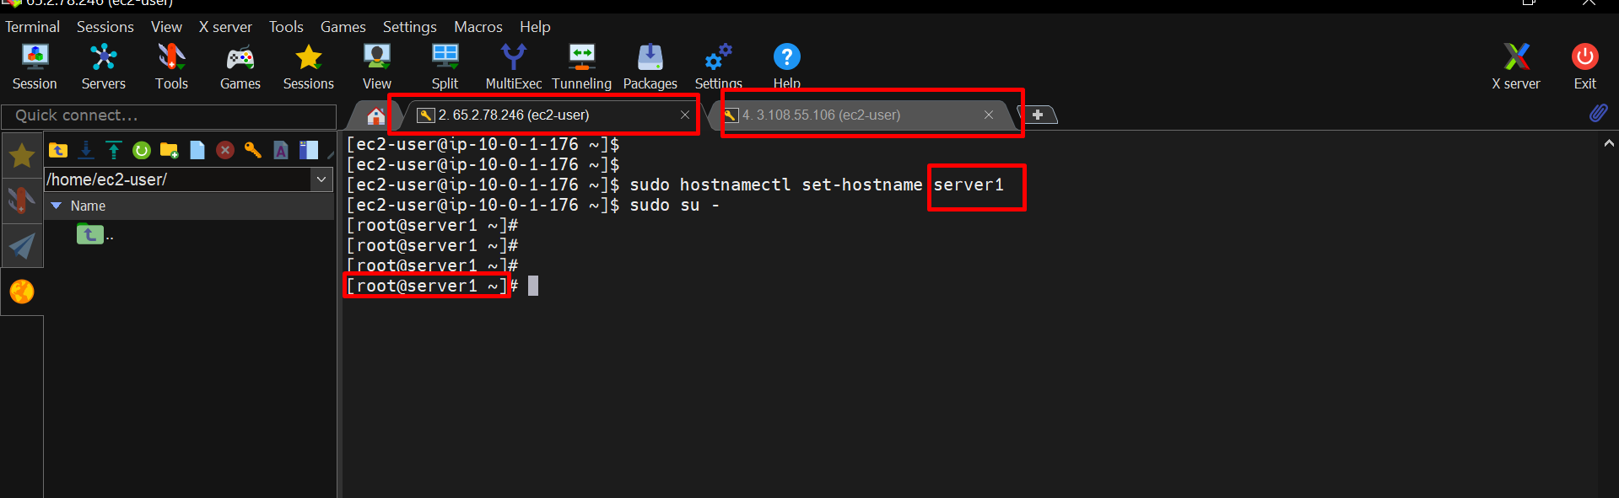

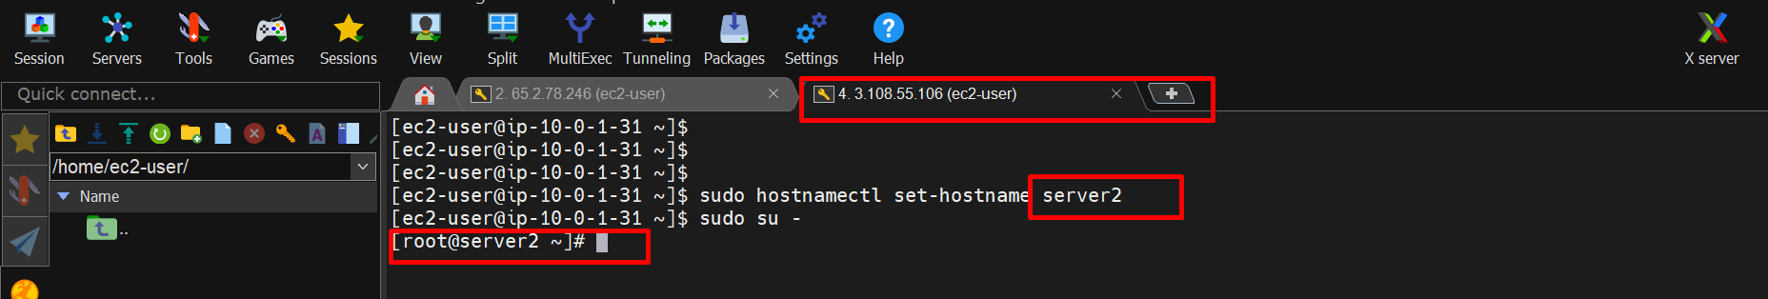

After that, we install httpd on both servers and also start that service then check the status.

Commands:- yum install httpd –y

systemctl start httpd

systemctl status httpd

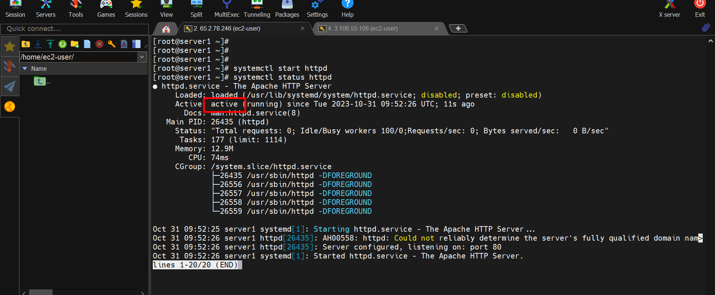

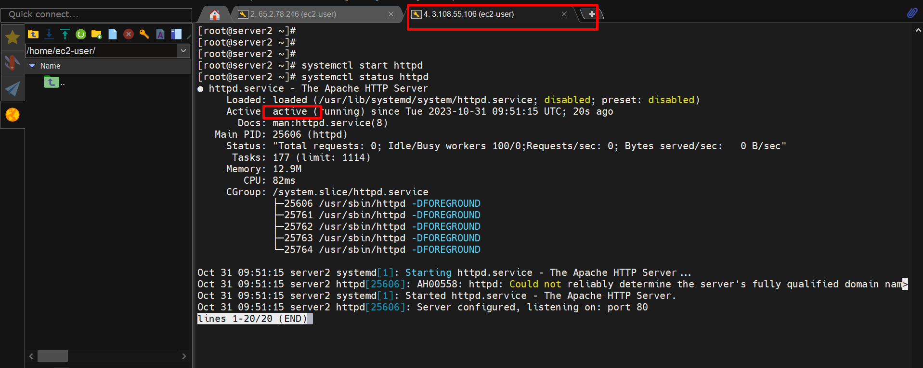

We successfully installed and active httpd.

Now we browse servers with public IPs.

Server1.

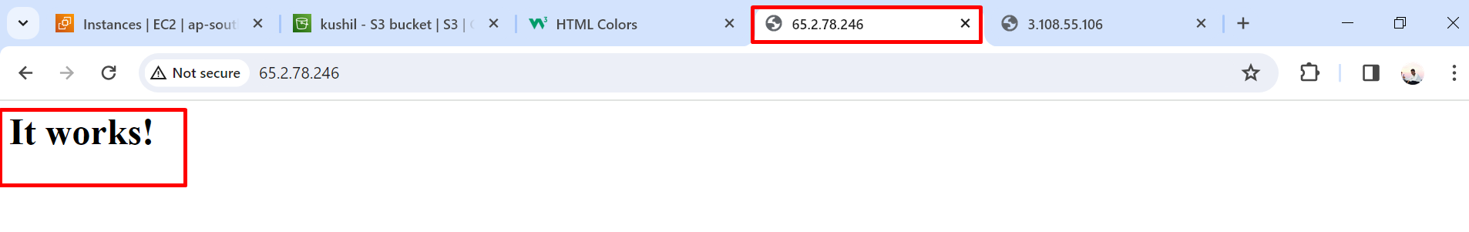

Server2.

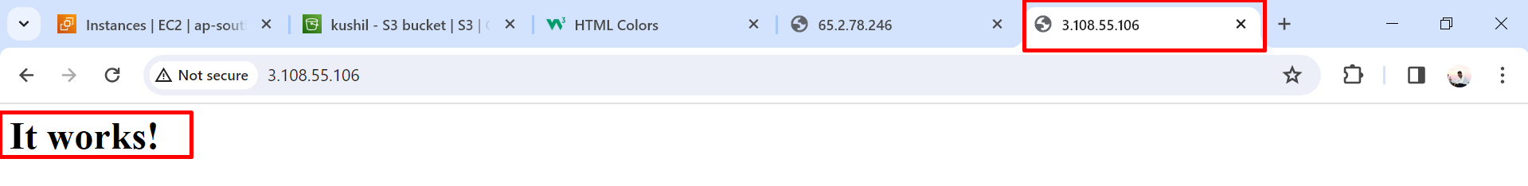

Next, we create an index.html file on the/var/www/html path on the httpd service on both servers.

This is server1.

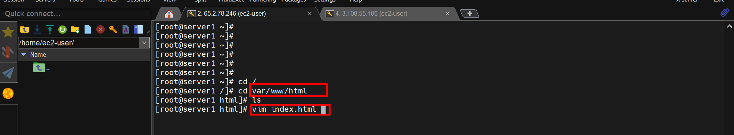

Index.html file data:

<html>

<h1 style="background-color:orange;"> This is a web page for testing load balancer on AWS, tested by KUSHIL</h1>

</html>

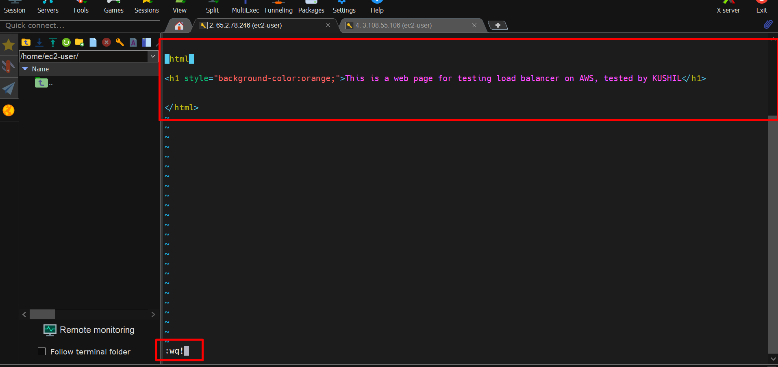

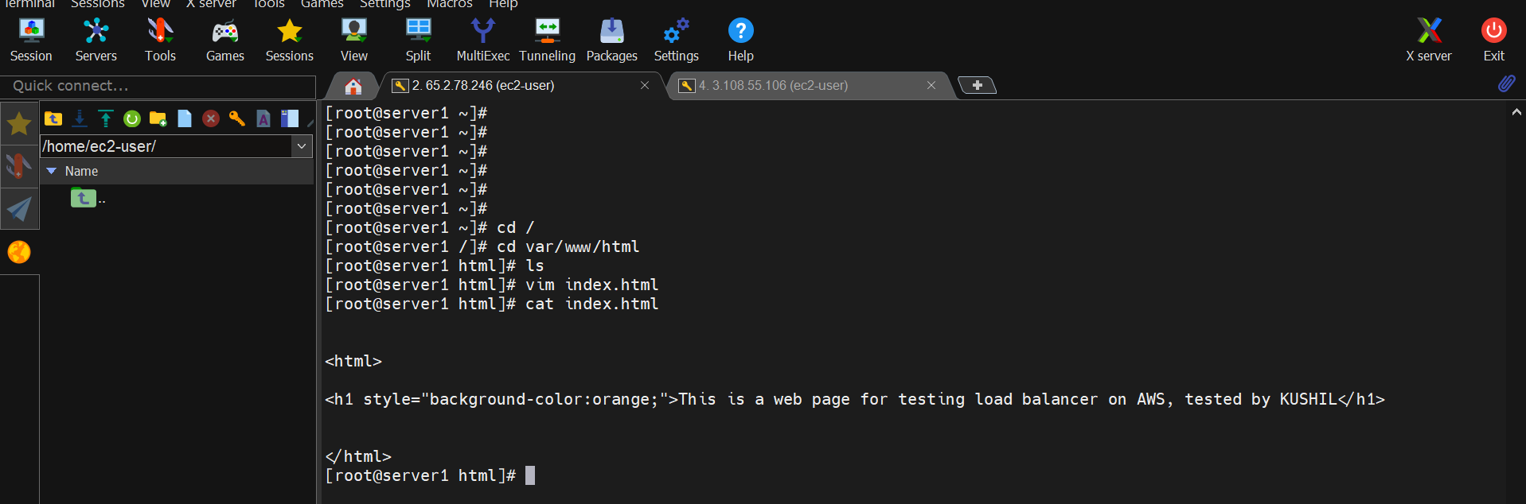

The same process applies on server2 but we change that color for our reference.

This is server2. Here we changed orange color to green.

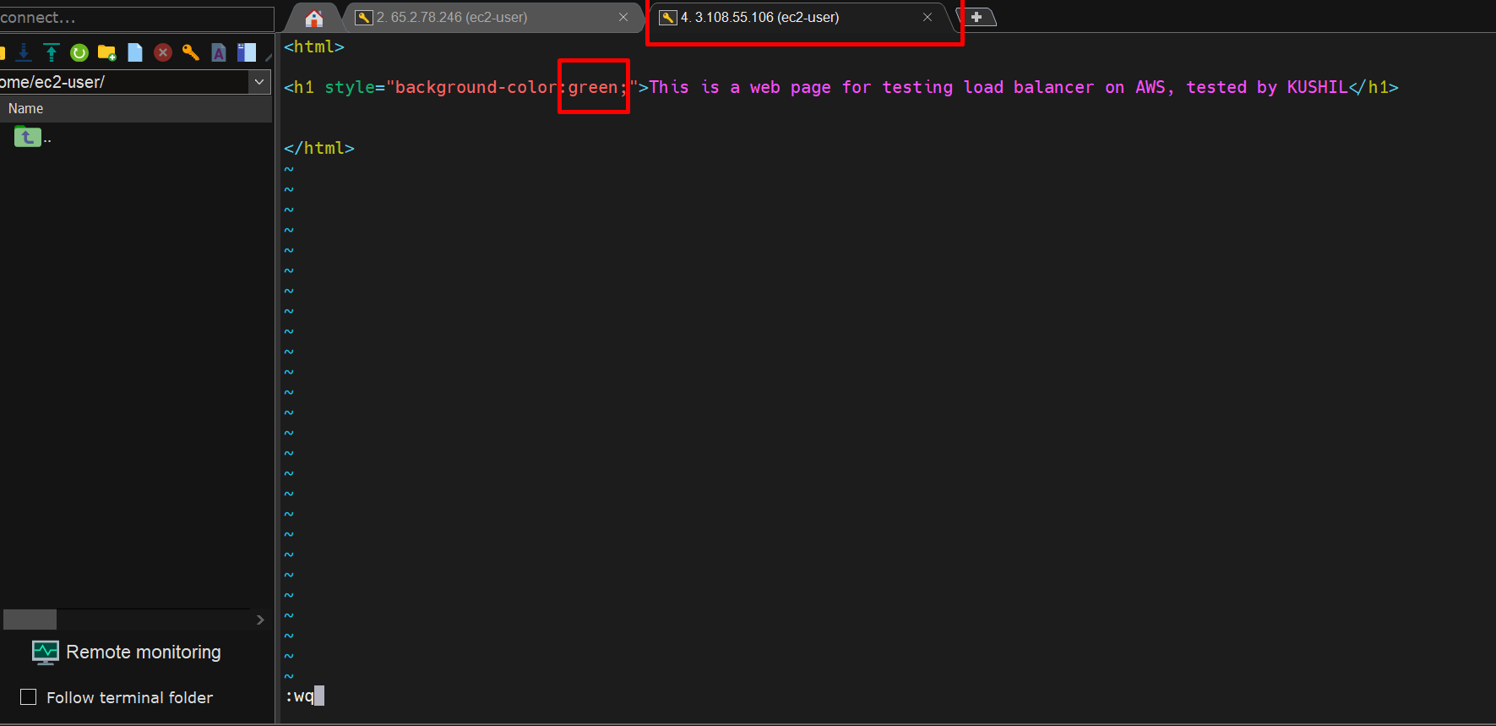

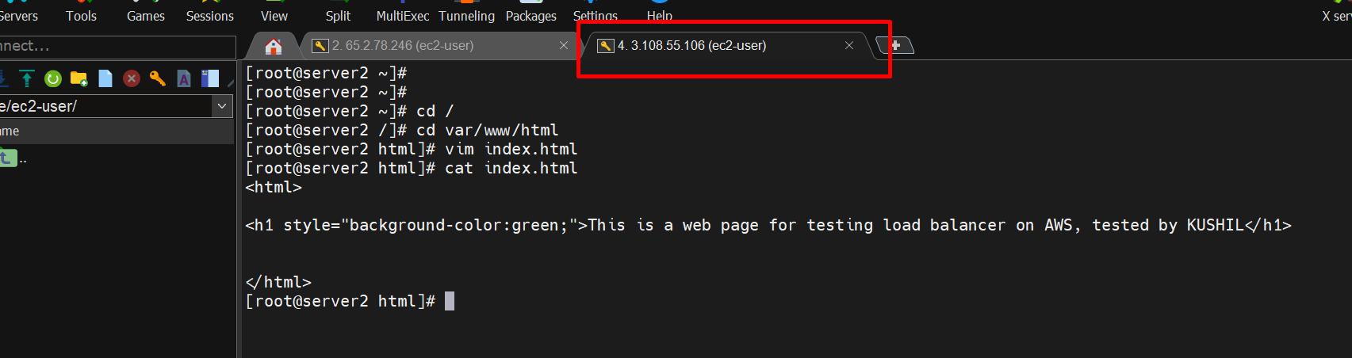

Now we refresh our servers on the browser.

Server1.

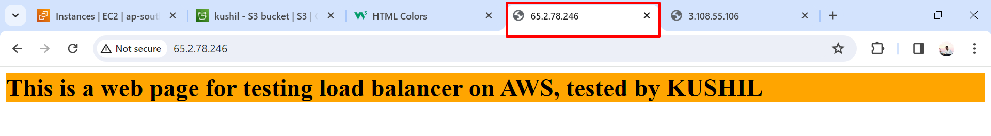

Server2

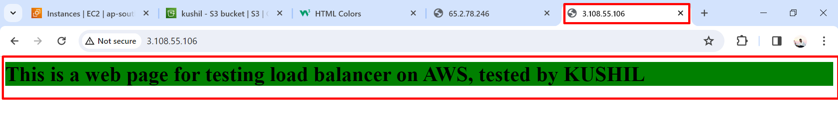

Now we create a load balancer for these servers.

First, we create a target group

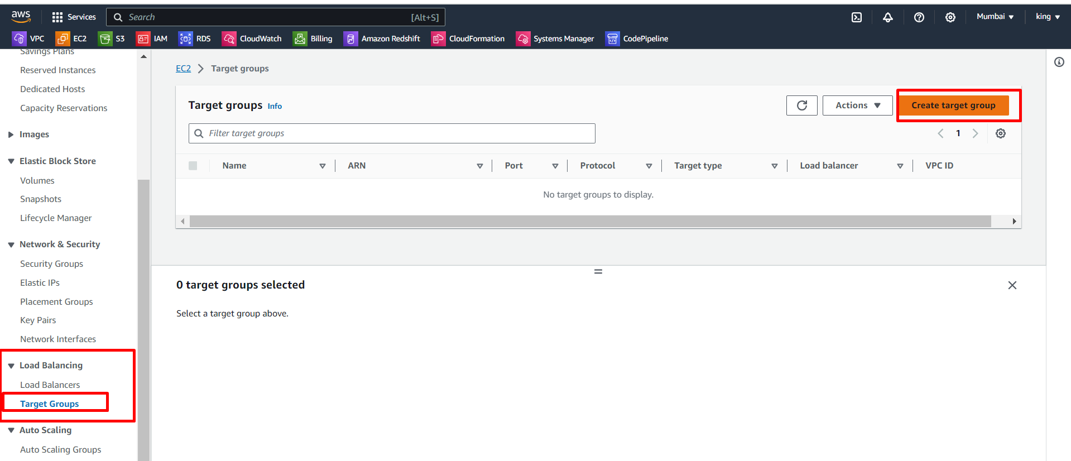

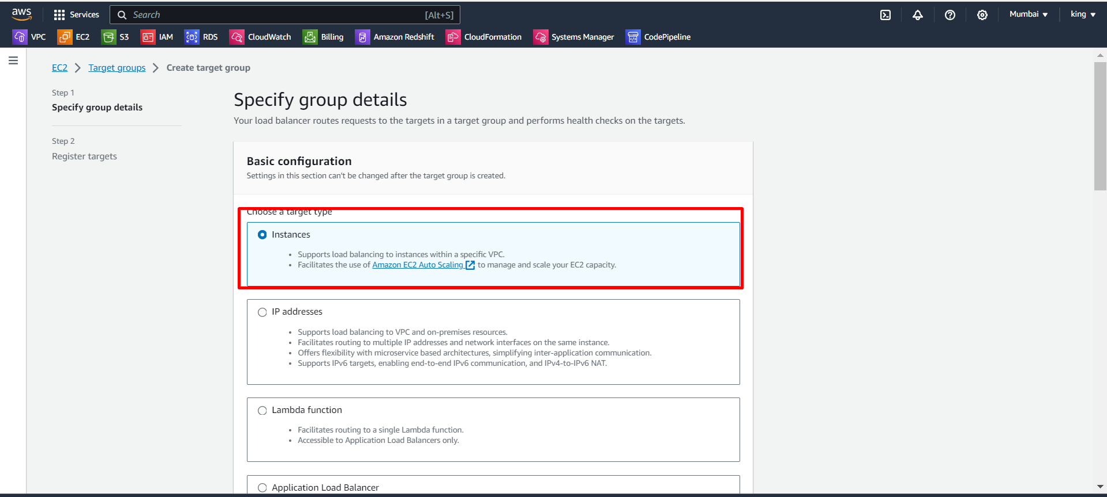

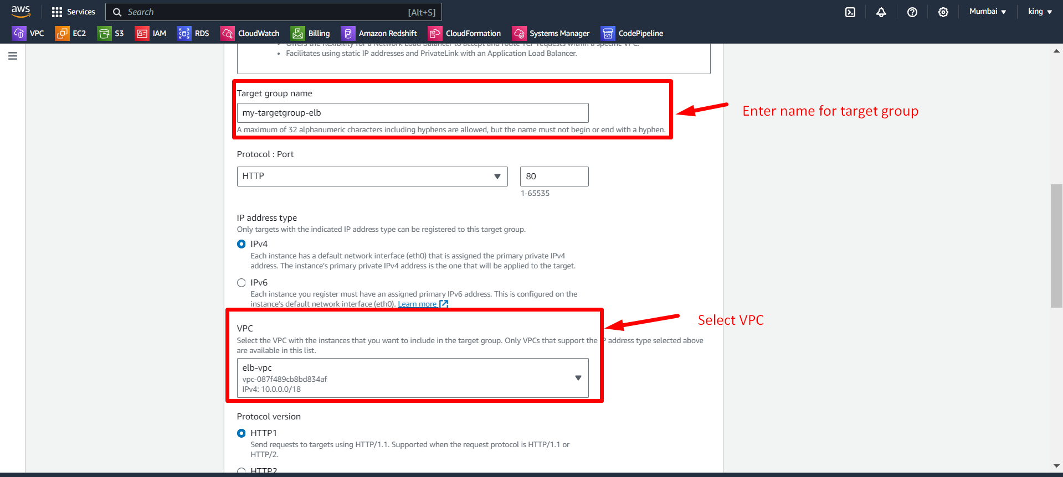

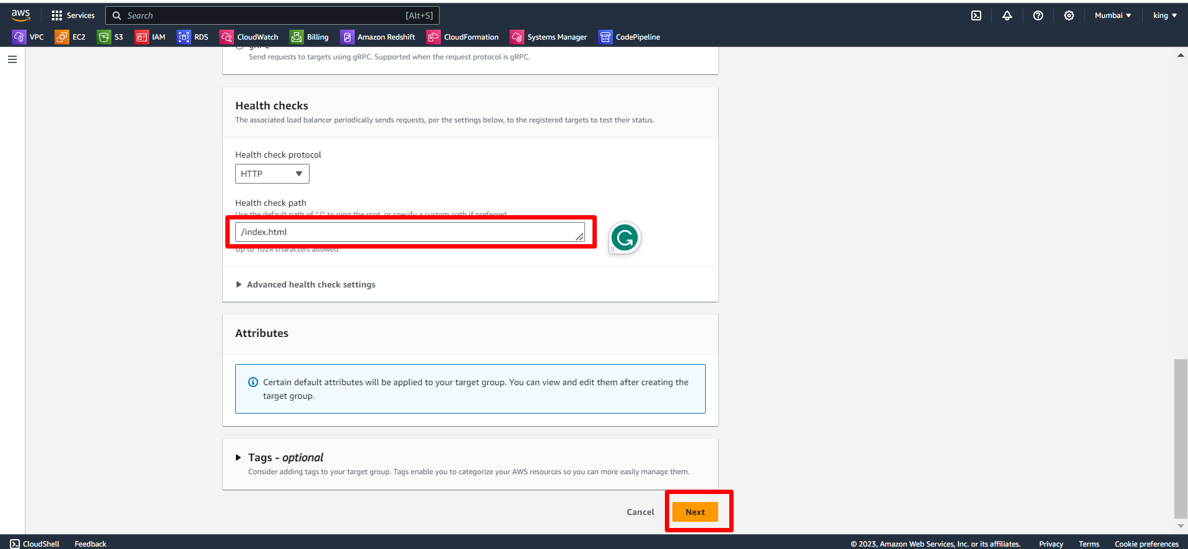

Now, we register the instances.

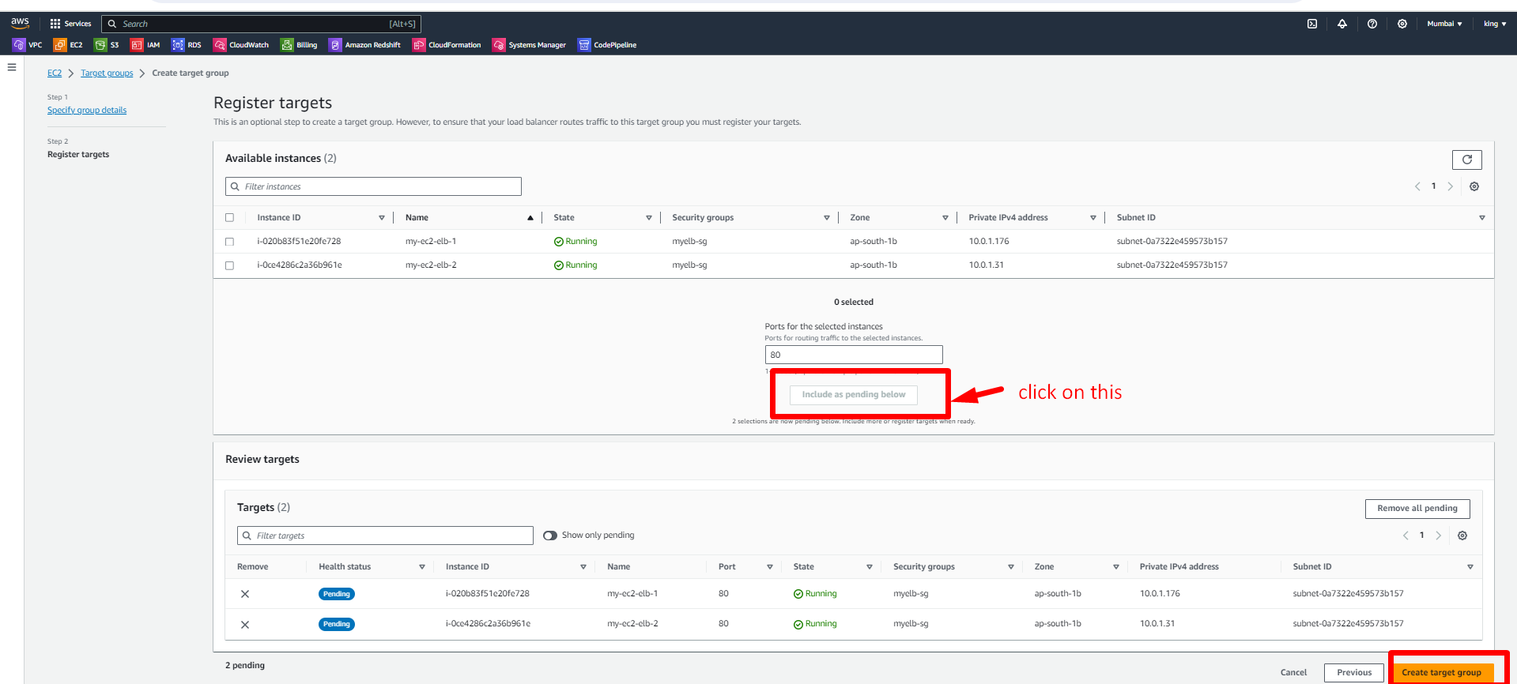

We successfully created and resisted the target group.

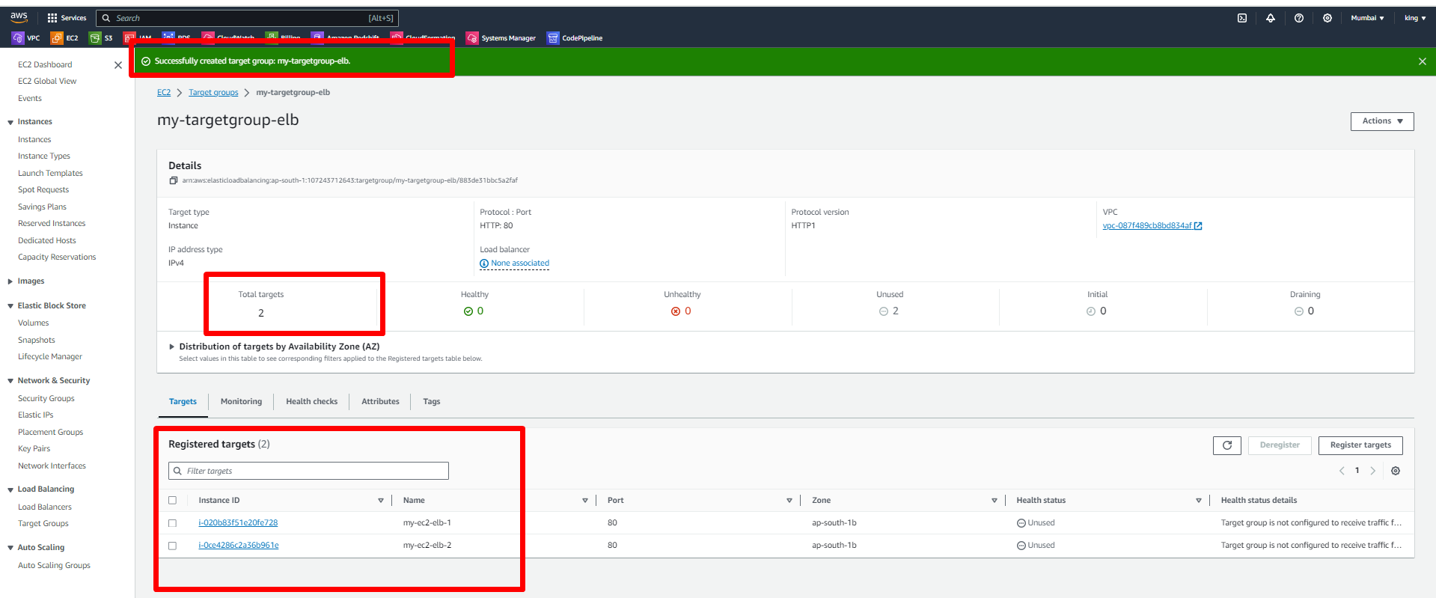

Now, we create the load balancer.

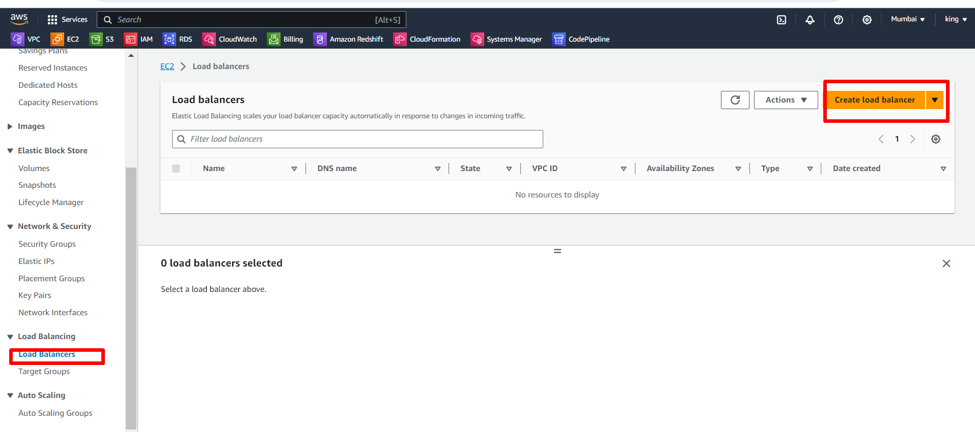

Select application load balancer because our servers are HTTP servers. 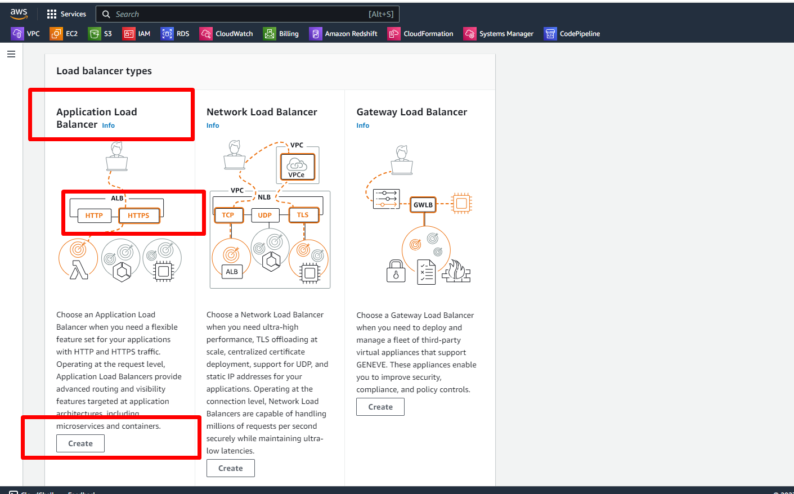

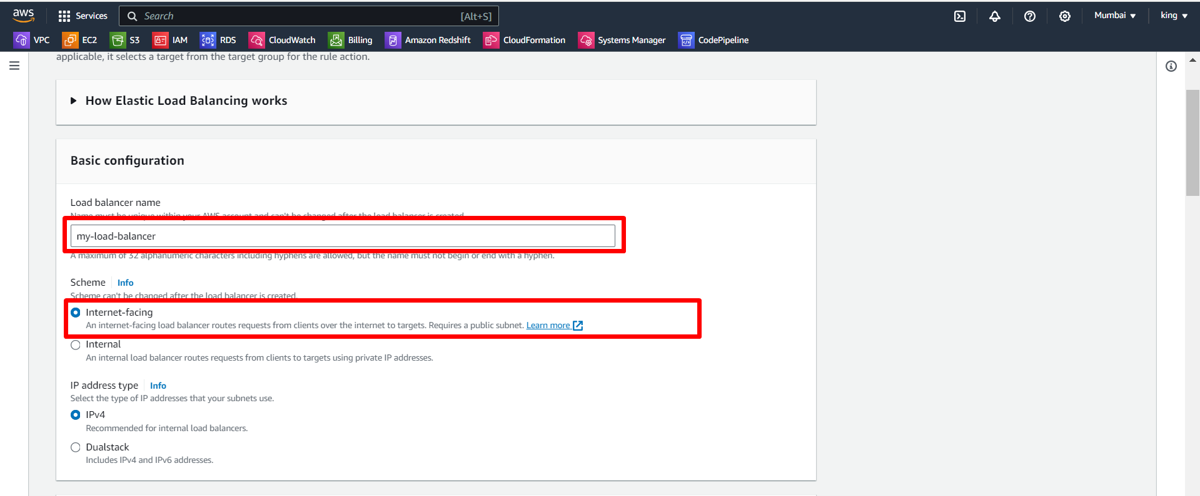

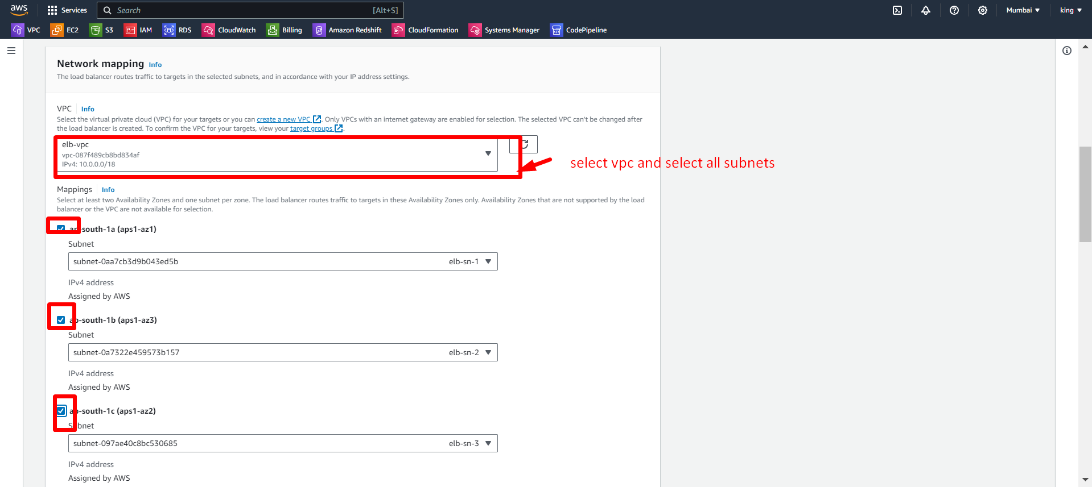

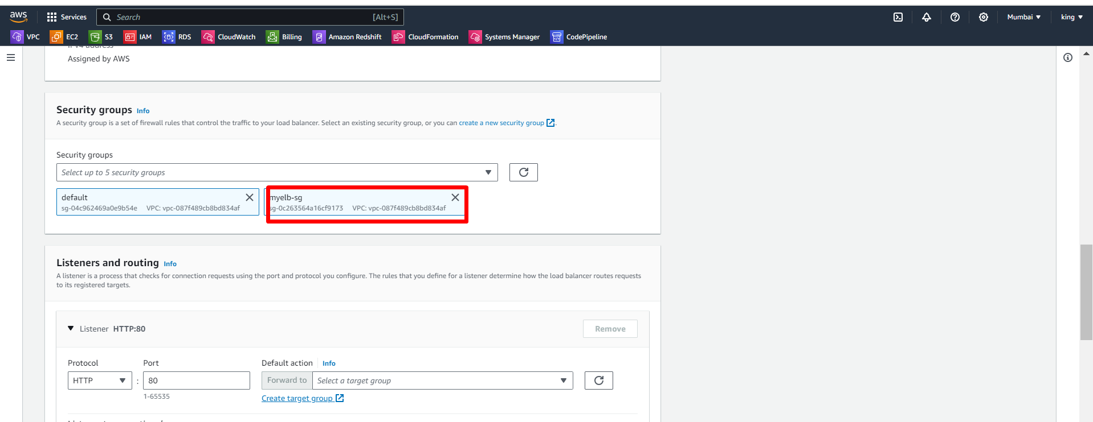

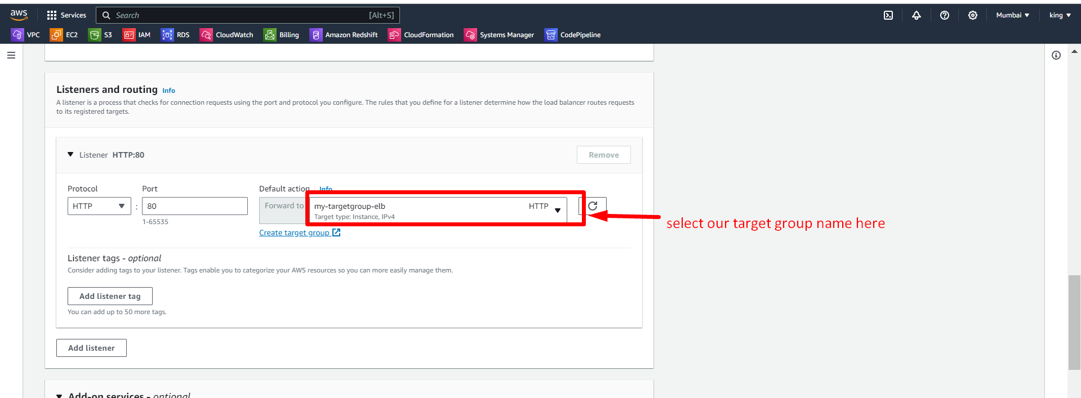

After doing all these processes then click on Create a load balancer.

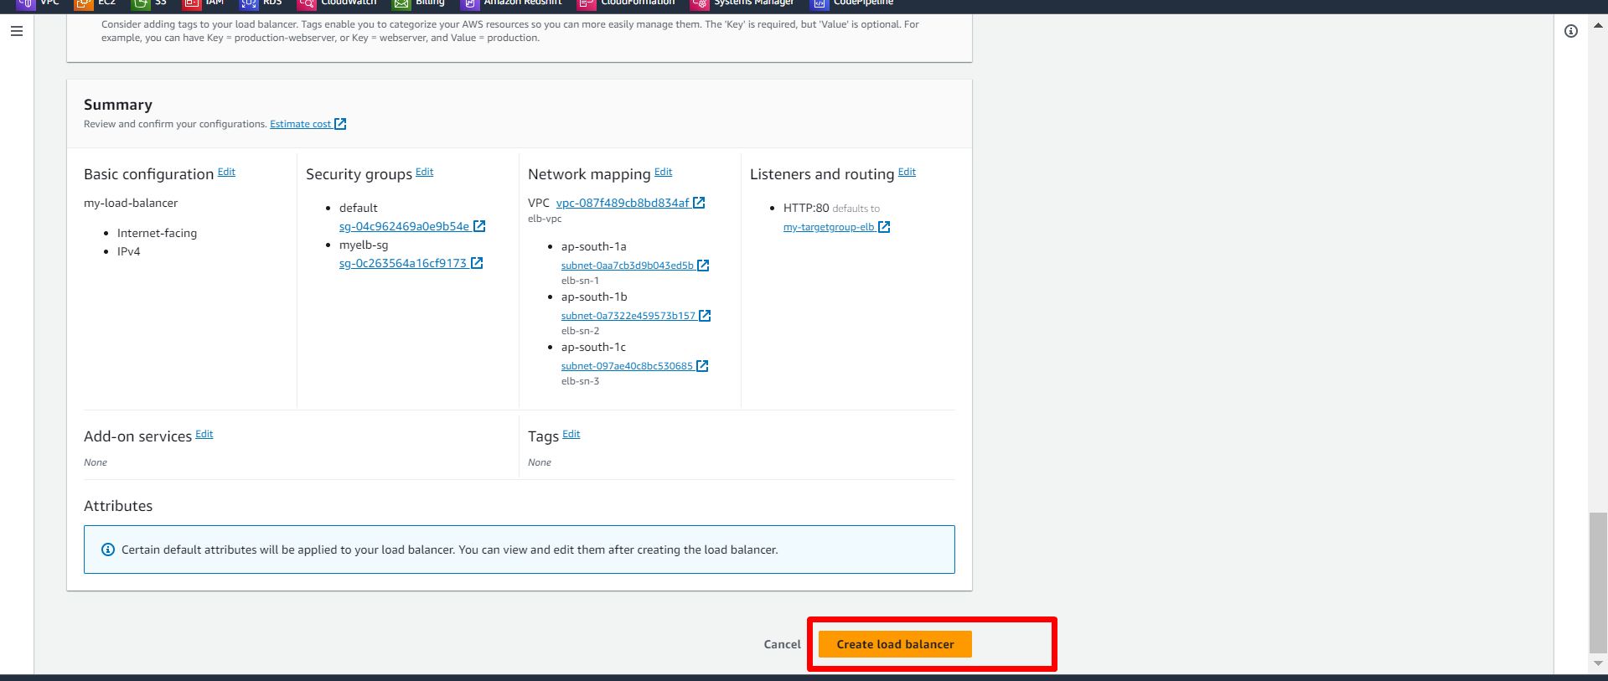

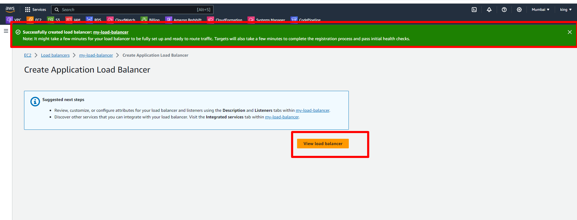

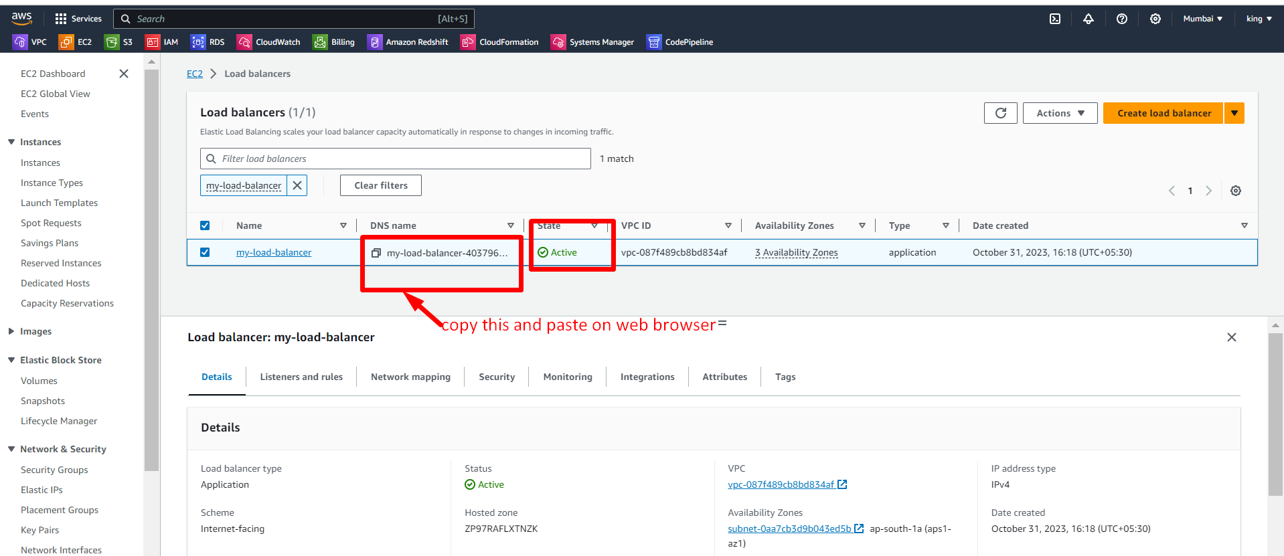

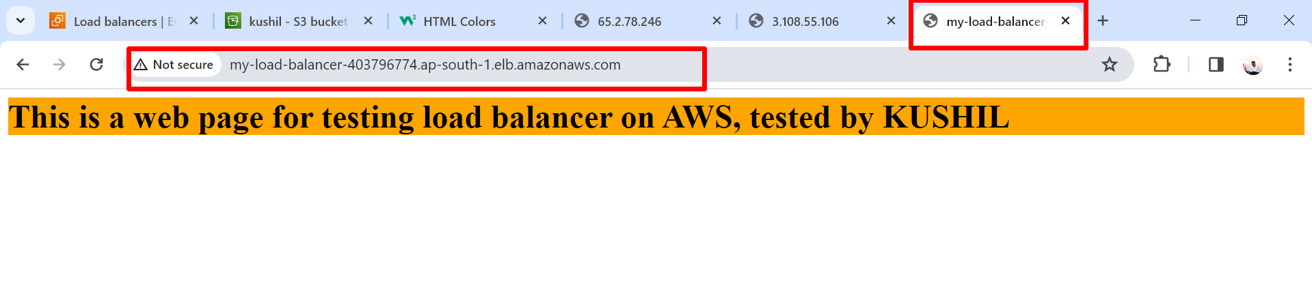Next we refresh that page

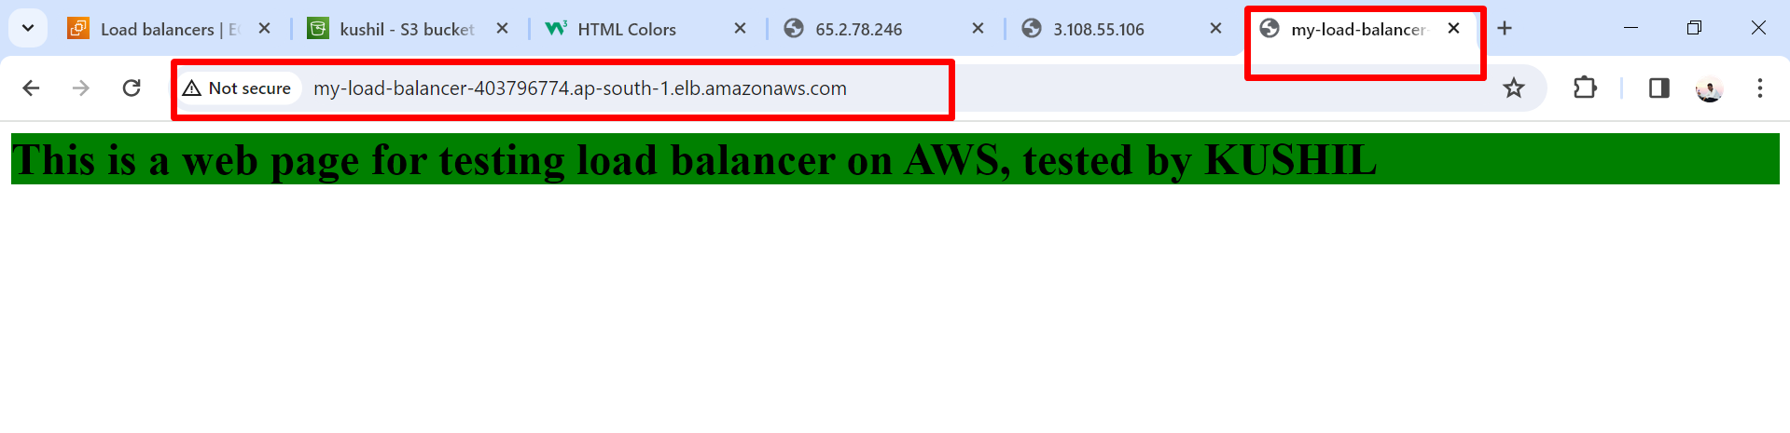

The first request was sent to server1 then we again refreshed that browser and then sent the request to server2.