**Kubernetes**

**What is Kubernetes:-**

Kubernetes is a portable, extensible, open-source platform for managing containerized workloads and services that facilitates declarative configuration and automation. It has a large, rapidly growing ecosystem. Kubernetes services, support, and tools are widely available.

**Kubernetes uses:-**

Kubernetes automates operational tasks of container management and includes built-in commands for deploying applications, rolling out changes to your applications, scaling your applications up and down to fit changing needs, monitoring your applications, and more—making it easier to manage

Applications.

**How to create an Elastic Kubernetes on AWS.**

**Requirements:-**

Must Install **Visual Studio code** on our PC.

Install **AWS CLI**

Install **KUBECTL**

Install **EKSCTL**

We must install this all and set up configurations correctly.

After that we open power shell or (cmd, git) we configure AWS configuration on this system.

Commands: **- aws configure**

After entering that we must configure our **AWS access key** and **secret access key IDs**.

After completion of that, next, we create an elastic Kubernetes cluster

Command: - eksctl create cluster --name clustername --nodegroup-name nodegroupname --node-type t2.micro --nodes 4 –managed

We should know one thing first, once the elastic Kubernetes cluster was created at that time VPC, subnets, all are instance set up, elastic IP,

And auto-scaling groups are created automatically.

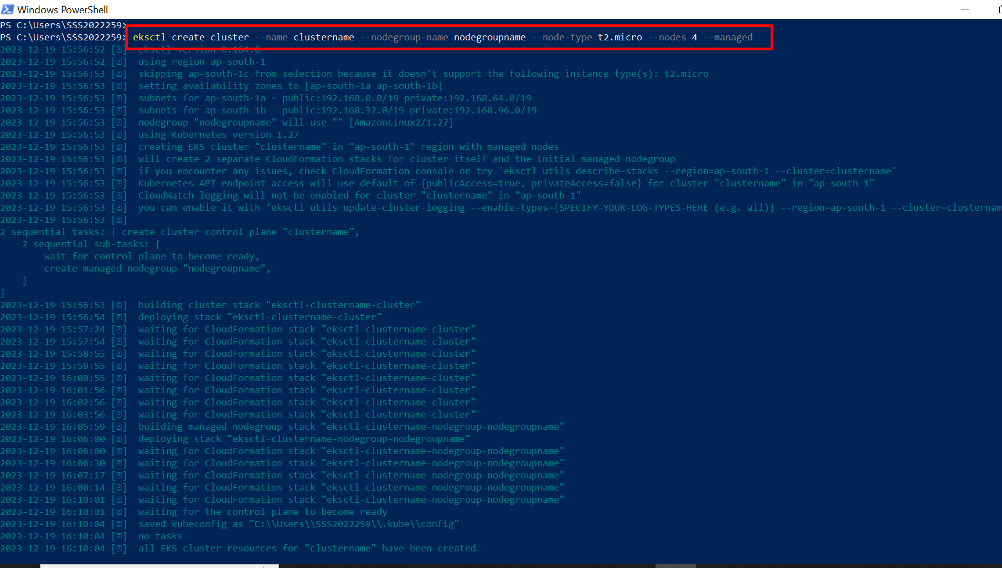

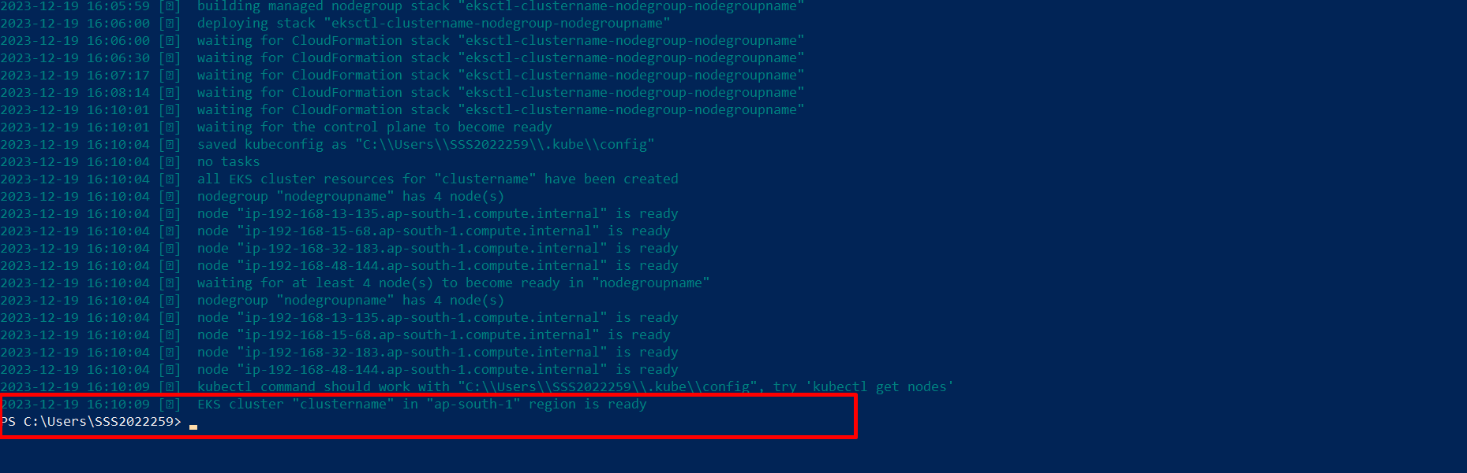

Now we see whether a cluster is created or not in AWS

Go to AWS – search Elastic Kubernetes and see if our cluster is created or not.

Here we successfully created an elastic Kubernetes cluster.

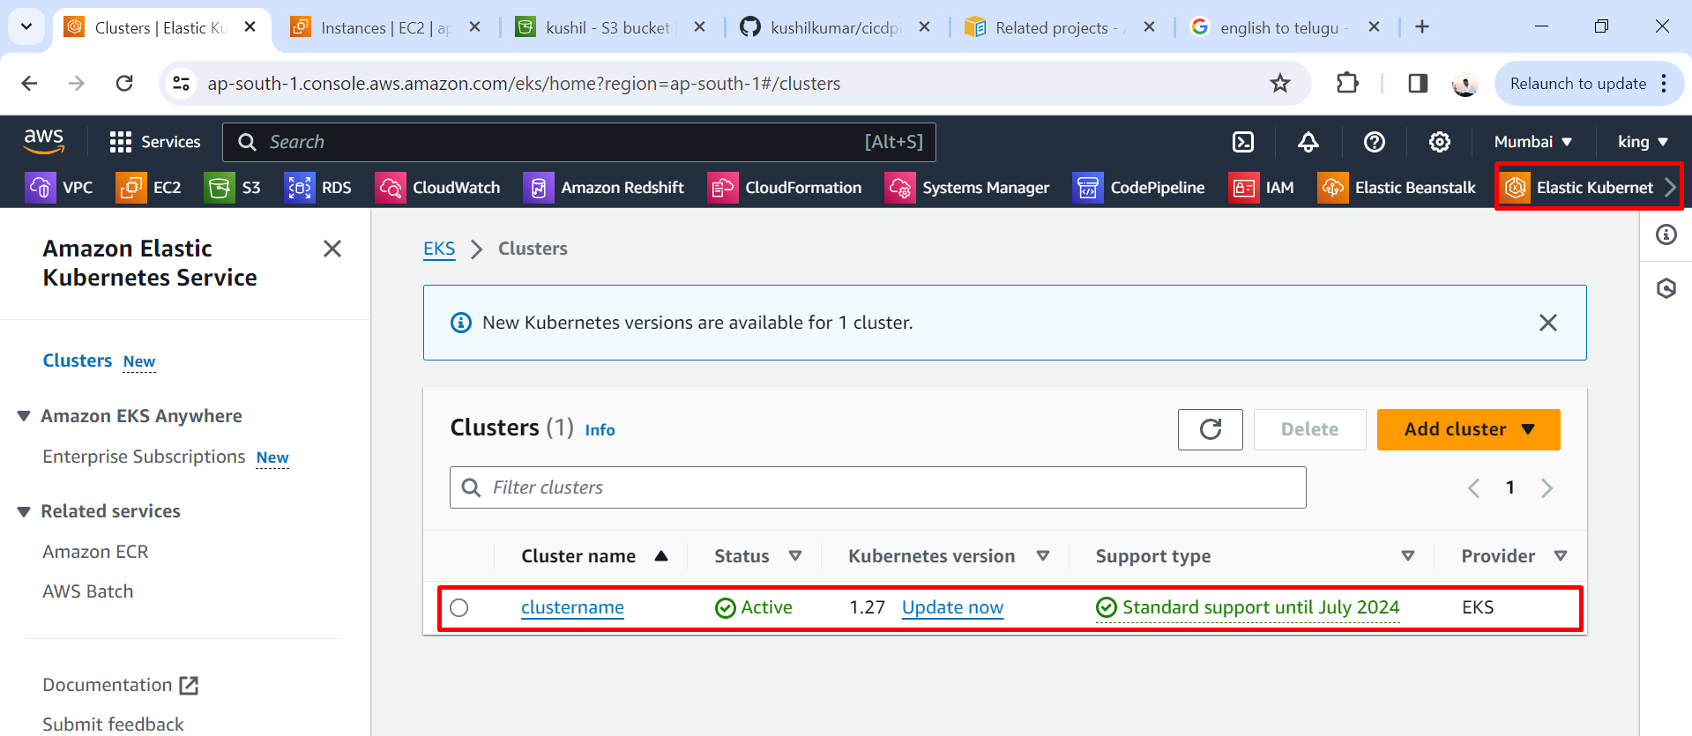

Now we check VPC, instances, and auto-scaling groups.

VPC are created automatically.

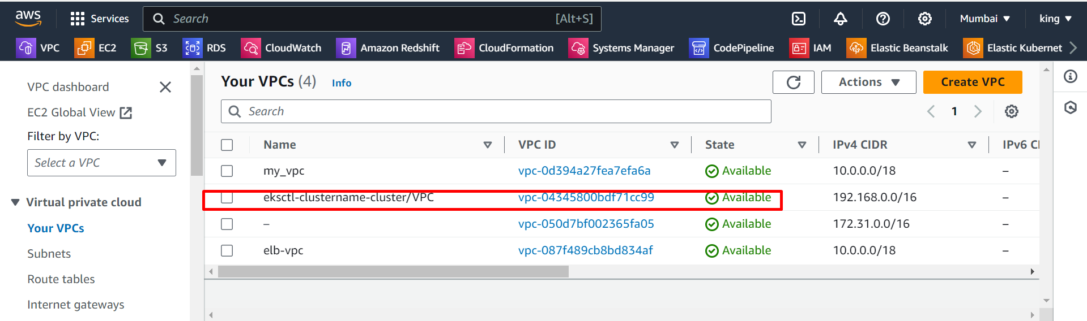

Instances are created automatically.

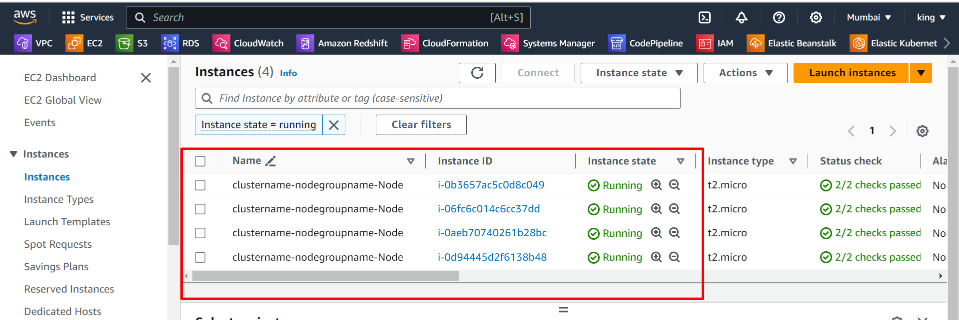

Auto-scaling group created automatically

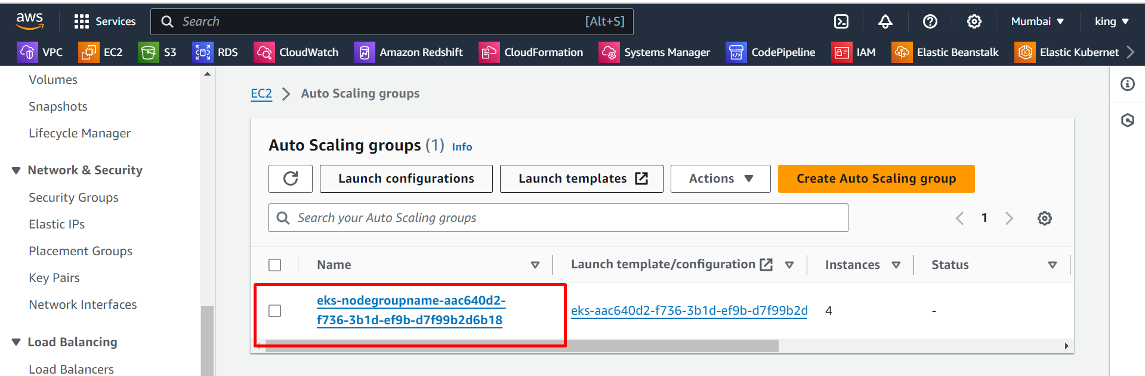

Elastic IPs are created automatically.

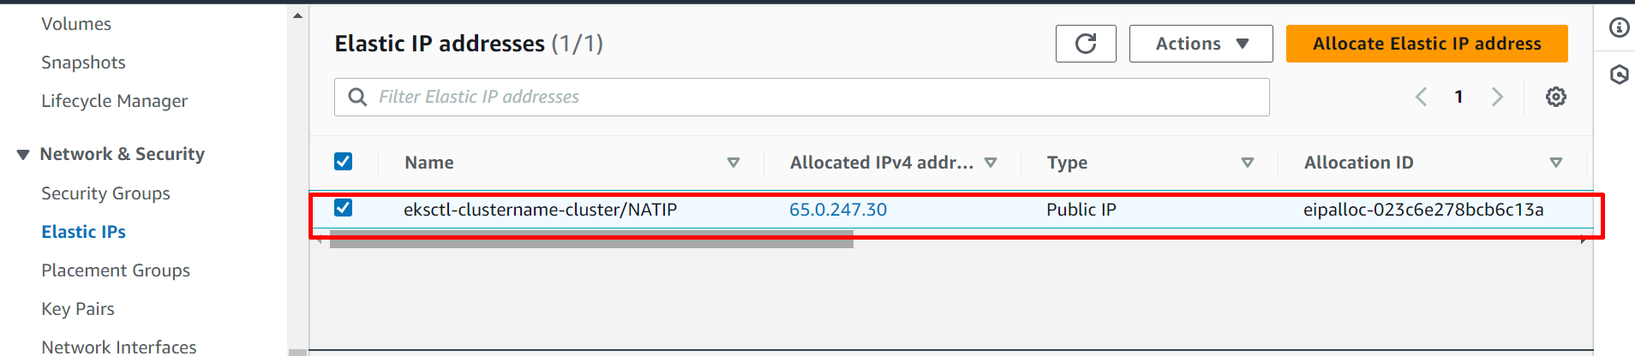

Total creation of instance set-up all are created automatically.

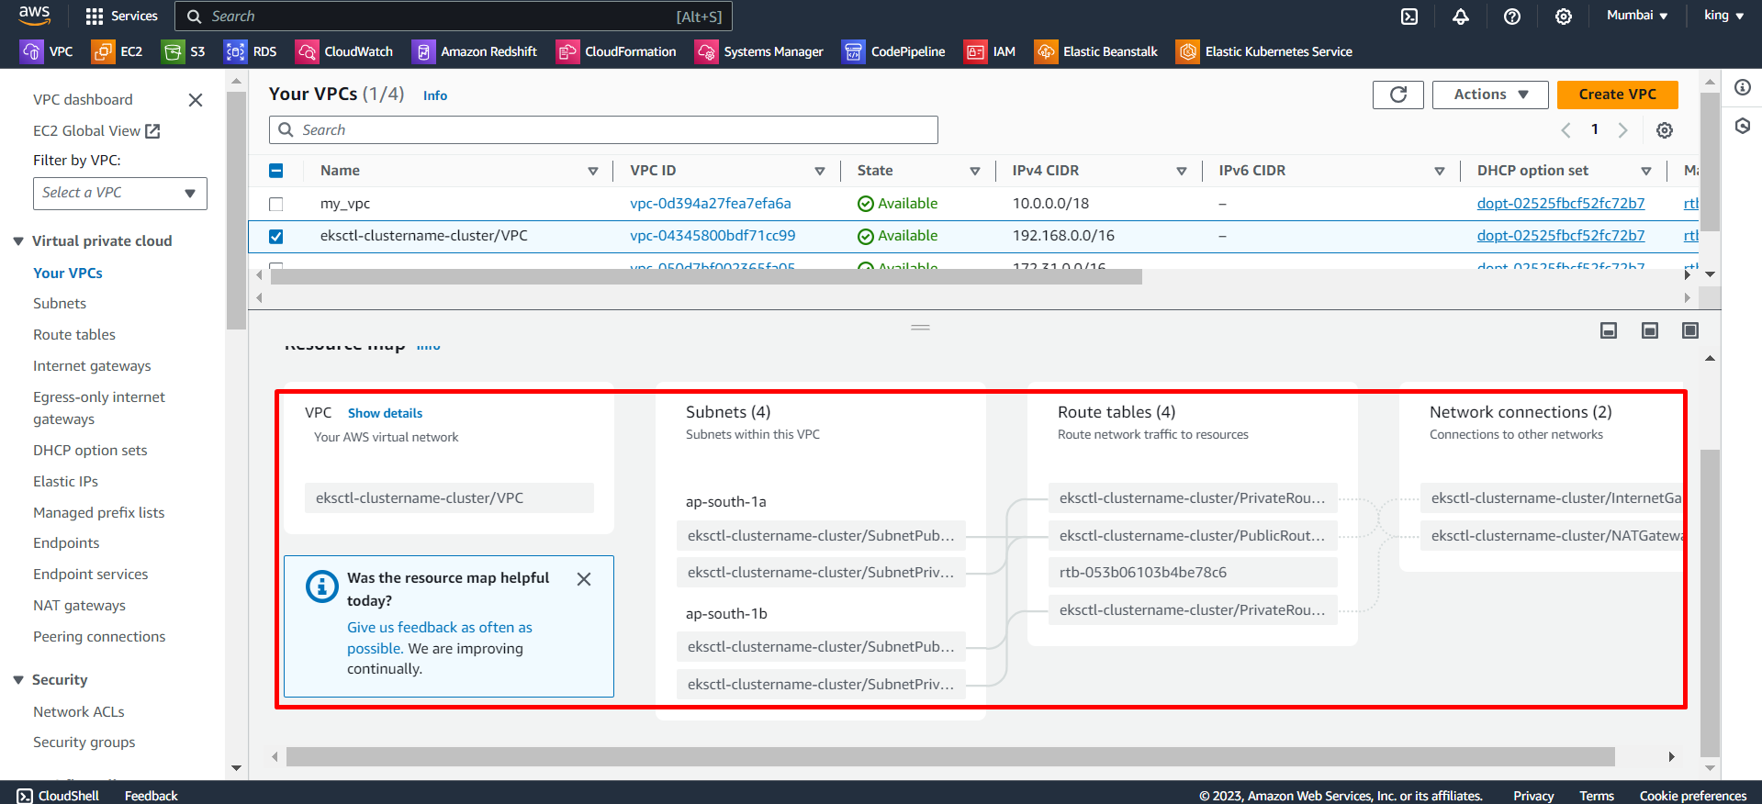

That is a way of creating an elastic Kubernetes cluster.

Now we delete that AWS cluster.

Command: - **eksctl delete cluster --name clustername**

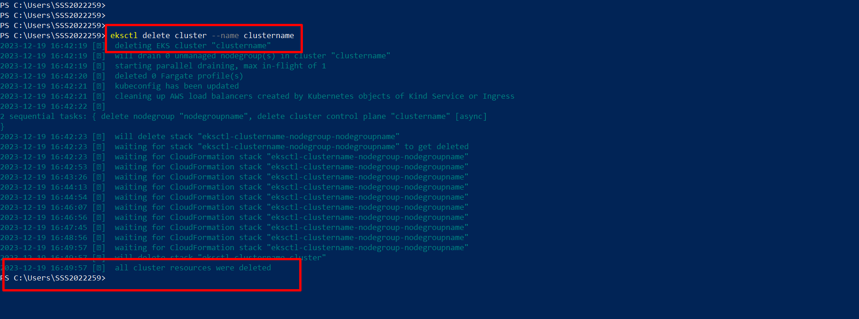

Once we delete the cluster using a command on PowerShell automatically delete all are resources of the cluster.

All set-up will be deleted.

