**MAVEN**

**What is maven: -**

Maven is one of the popular open-source build tools developed by the Apache Group for building, publishing, and deploying multiple projects for perfect project management. Maven provides software developers build & document the SDLC framework.

Maven is a build automation tool and project management tool.

Installing maven on windows:-

Installing Maven on windows for that first we need to present Java in our windows in case we java not present then it must be installed.

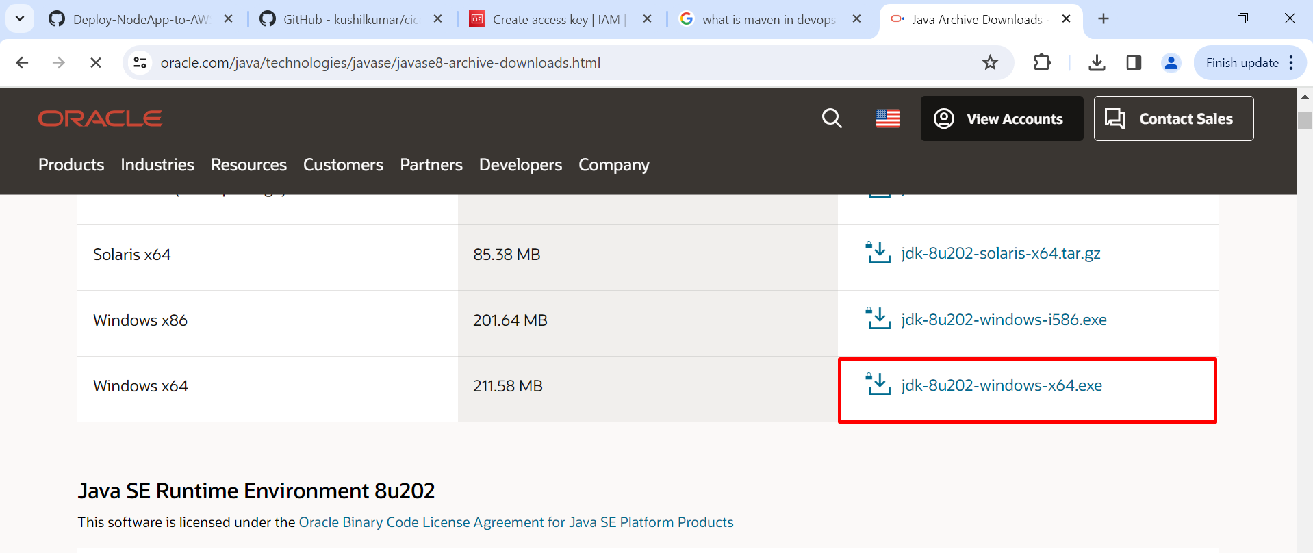

Click to install.

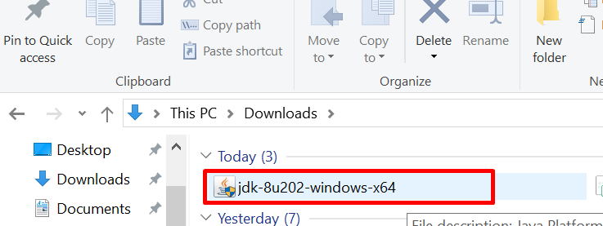

When we install Java on Windows java is presented on C:\Program Files\Java.

After that, we configure the Java path in Edit Environmental Variable.

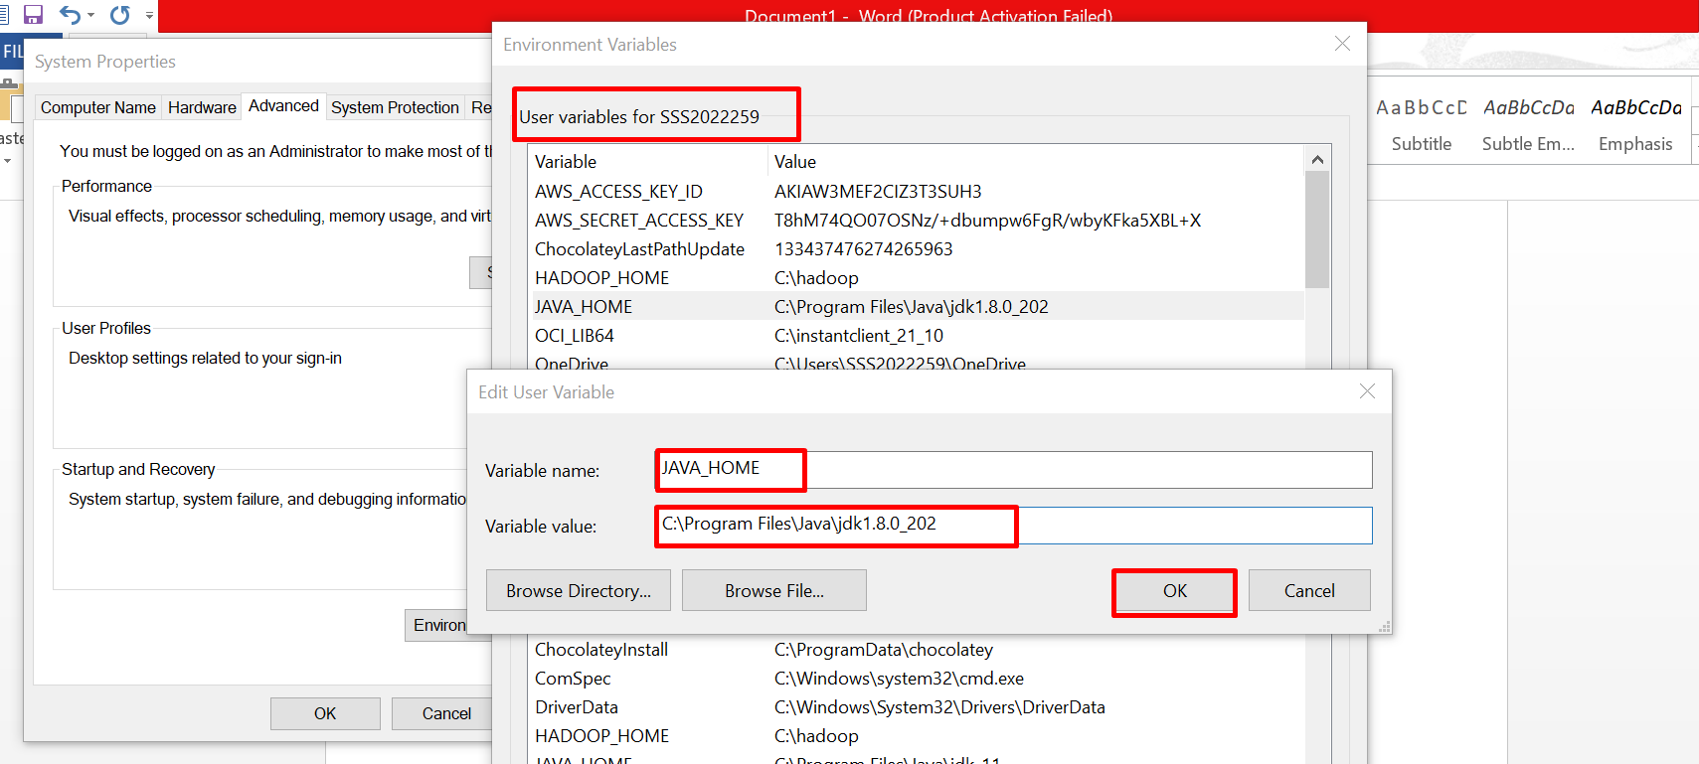

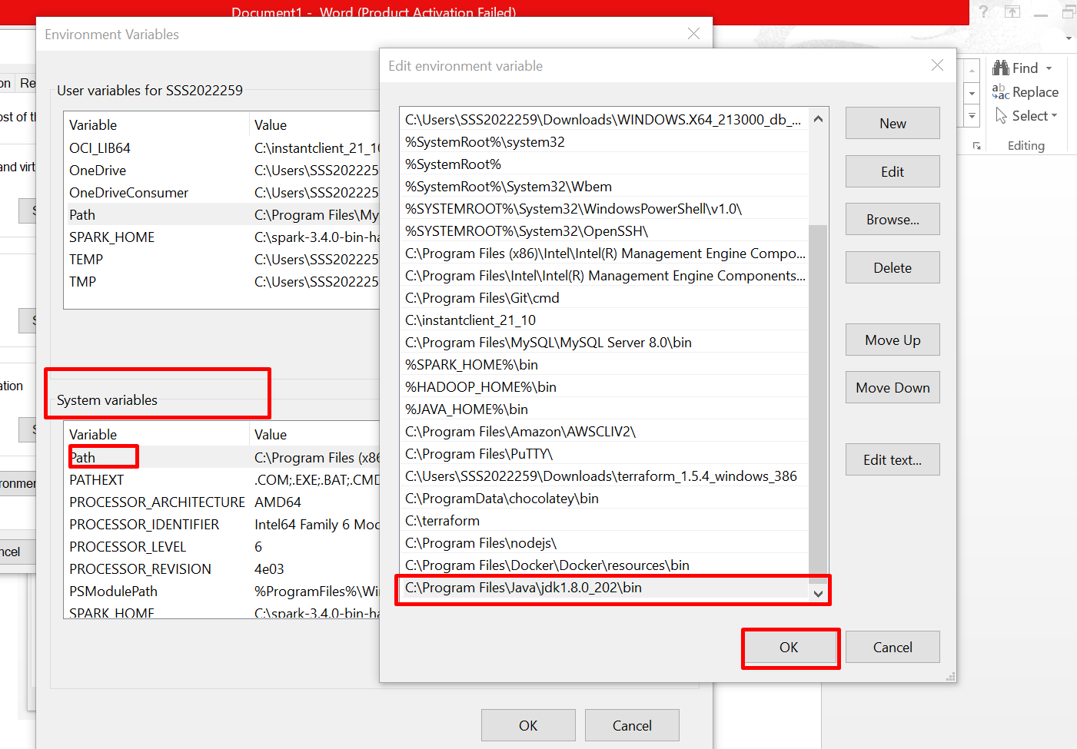

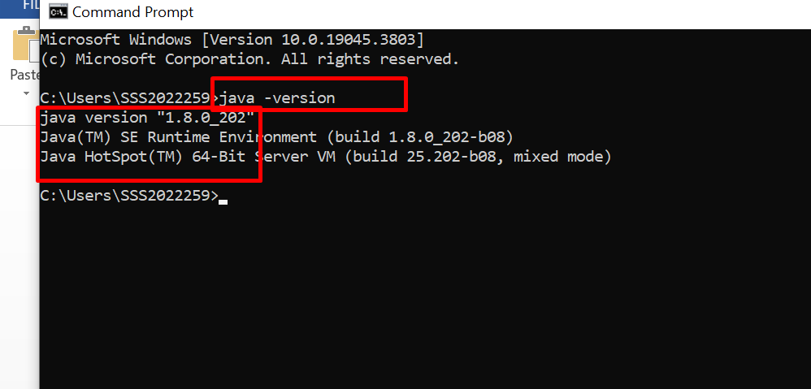

After that we install maven on windows

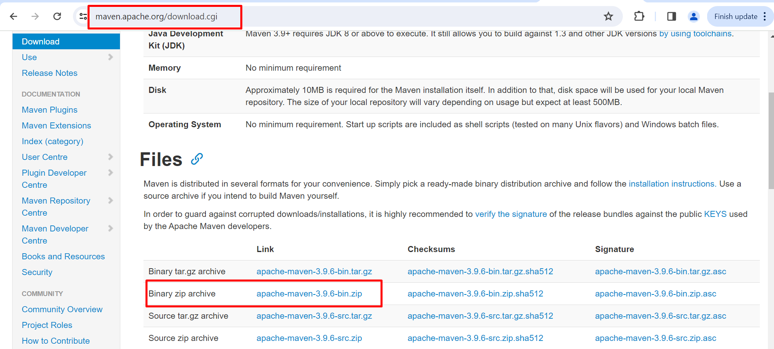

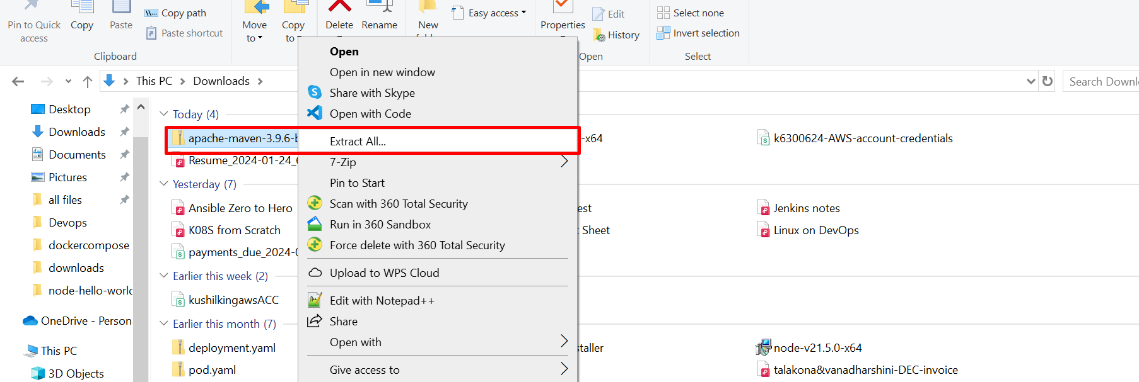

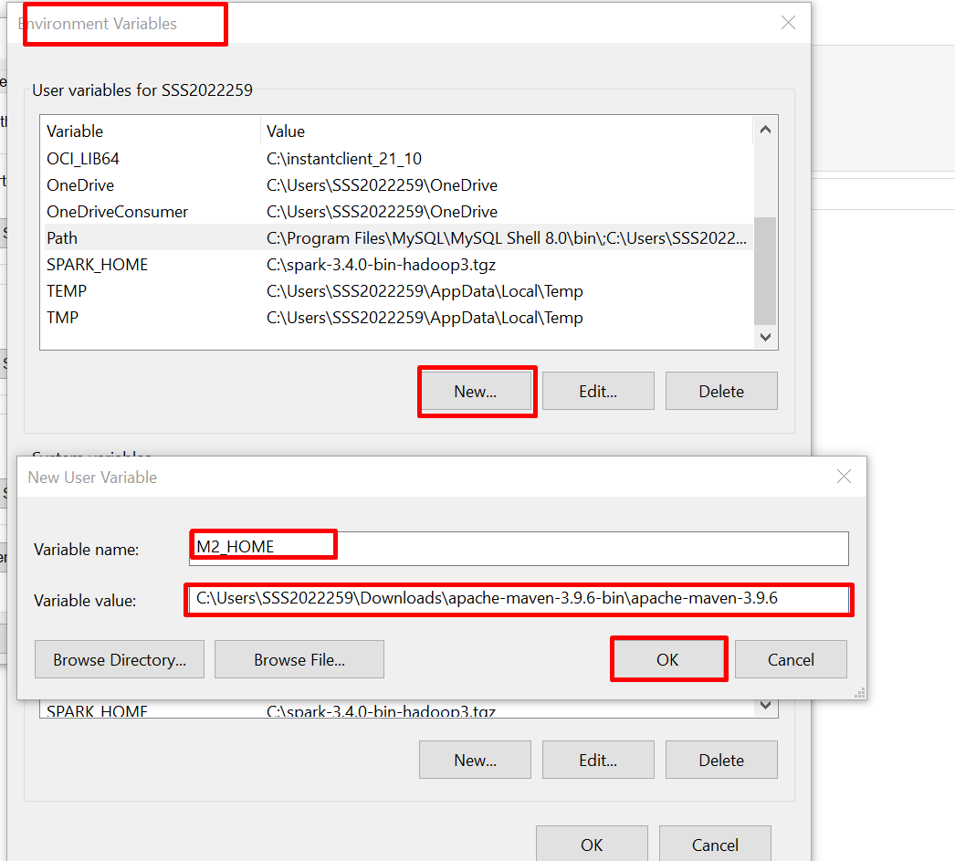

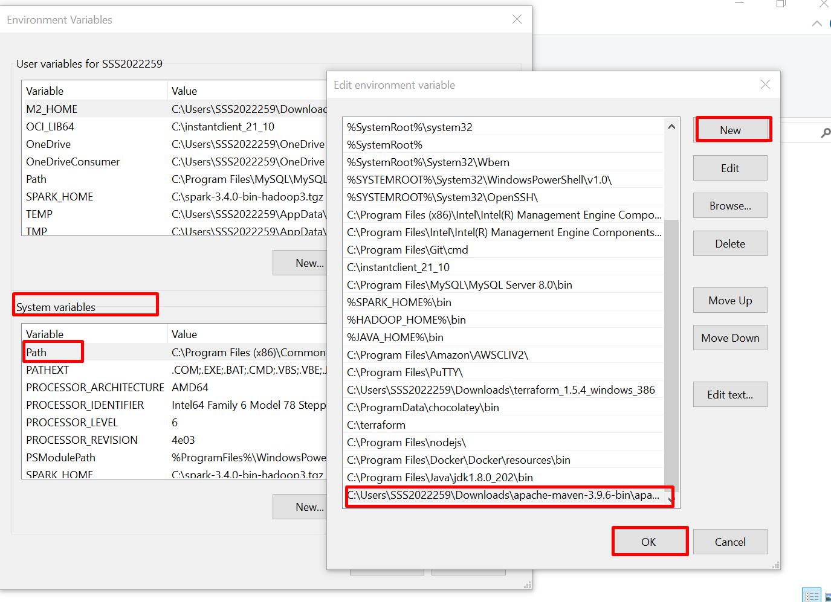

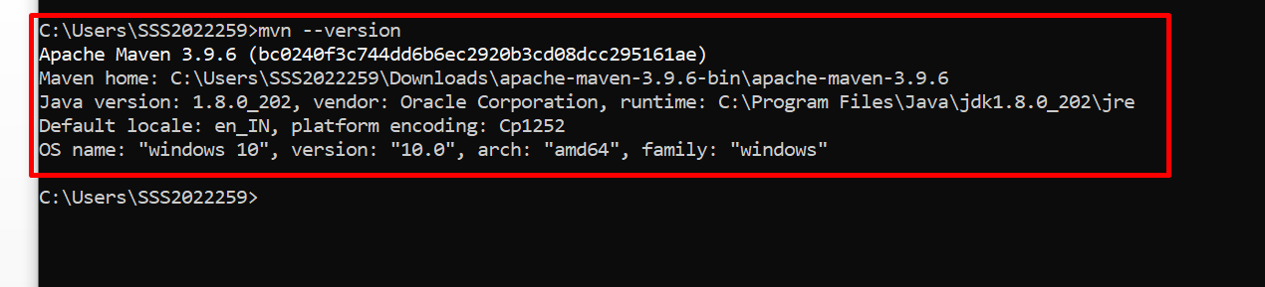

Now all set, we successfully installed and configured Java and Maven on Windows.